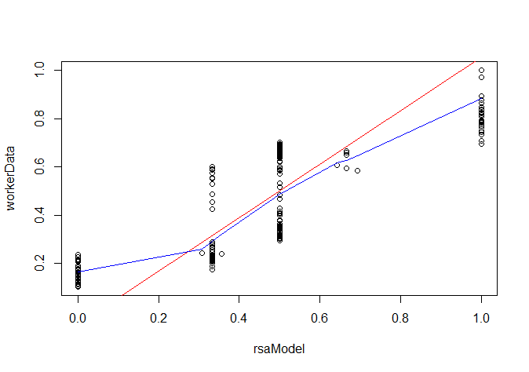**Non-Optimized RSA Model (0,0,1)**

Residuals:

Min 1Q Median 3Q Max

-0.27877 -0.13381 -0.05418 0.14468 0.28441

Coefficients:

Estimate Std. Error t value Pr(>|t|)

(Intercept) -0.05358 0.02174 -2.465 0.0146 *

workerData 1.10777 0.03772 29.369 <2e-16 ***

---

Signif. codes: 0 ‘***’ 0.001 ‘**’ 0.01 ‘*’ 0.05 ‘.’ 0.1 ‘ ’ 1

Residual standard error: 0.15 on 190 degrees of freedom

Multiple R-squared: **0.8195**, Adjusted R-squared: 0.8185

F-statistic: 862.5 on 1 and 190 DF, p-value: < 2.2e-16

> confint(model)

2.5 % 97.5 %

(Intercept) -0.09645443 -0.01070705

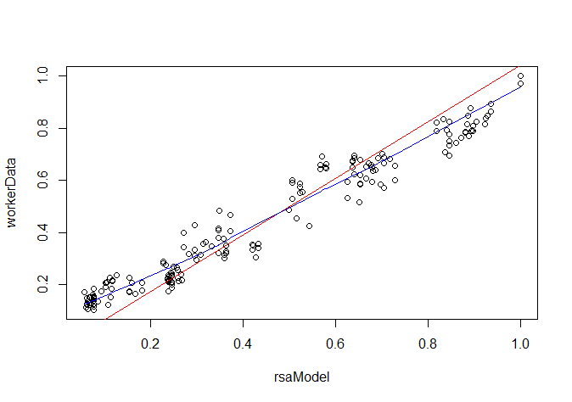workerData 1.03336371 1.18216812

**Non-Optimized RSA Model (0.1,0.1,1)**

Residuals:

Min 1Q Median 3Q Max

-0.138065 -0.042246 -0.007669 0.048877 0.137474

Coefficients:

Estimate Std. Error t value Pr(>|t|)

(Intercept) -0.04165 0.00878 -4.744 4.1e-06 ***

workerData 1.08390 0.01524 71.140 < 2e-16 ***

---

Signif. codes: 0 ‘***’ 0.001 ‘**’ 0.01 ‘*’ 0.05 ‘.’ 0.1 ‘ ’ 1

Residual standard error: 0.06058 on 190 degrees of freedom

Multiple R-squared: **0.9638**, Adjusted R-squared: 0.9636

F-statistic: 5061 on 1 and 190 DF, p-value: < 2.2e-16

> confint(model)

2.5 % 97.5 %

(Intercept) -0.05897282 -0.0243362

workerData 1.05384655 1.1139543

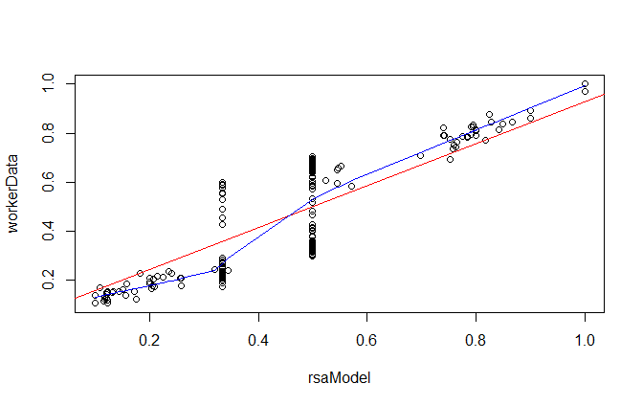

**Normally Optimized Full RSA Model (no cross-val)**

**1-Param Optimized (preference softness), full obedience.**

Residuals:

Min 1Q Median 3Q Max

-0.25298 -0.07143 0.01737 0.07332 0.17306

Coefficients:

Estimate Std. Error t value Pr(>|t|)

(Intercept) 0.07378 0.01426 5.174 5.79e-07 ***

workerData 0.85290 0.02475 34.466 < 2e-16 ***

---

Signif. codes: 0 ‘***’ 0.001 ‘**’ 0.01 ‘*’ 0.05 ‘.’ 0.1 ‘ ’ 1

Residual standard error: 0.09839 on 190 degrees of freedom

Multiple R-squared: 0.8621, Adjusted R-squared: 0.8614

F-statistic: 1188 on 1 and 190 DF, p-value: < 2.2e-16

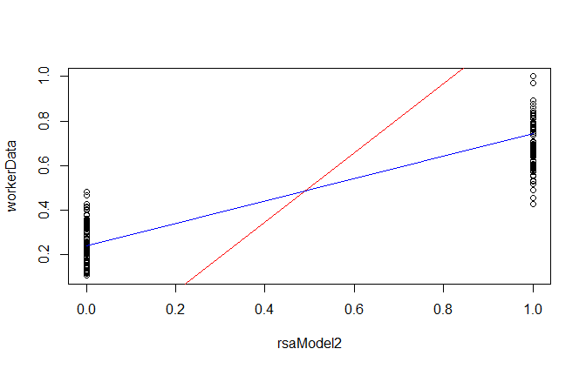> confint(model) 2.5 % 97.5 %

(Intercept) 0.04565502 0.1019108

workerData 0.80408691 0.9017122

**1-Param Optimized (obedience softness), full preference strength.**

Residuals:

Min 1Q Median 3Q Max

-0.47397 -0.20215 -0.00901 0.14545 0.61359

Coefficients:

Estimate Std. Error t value Pr(>|t|)

(Intercept) -0.27734 0.03284 -8.446 7.7e-15 ***

workerData 1.55552 0.05699 27.297 < 2e-16 ***

---

Signif. codes: 0 ‘***’ 0.001 ‘**’ 0.01 ‘*’ 0.05 ‘.’ 0.1 ‘ ’ 1

Residual standard error: 0.2266 on 190 degrees of freedom

Multiple R-squared: 0.7968, Adjusted R-squared: 0.7957

F-statistic: 745.1 on 1 and 190 DF, p-value: < 2.2e-16

> confint(model) 2.5 % 97.5 %

(Intercept) -0.3421098 -0.2125651

workerData 1.4431190 1.6679284

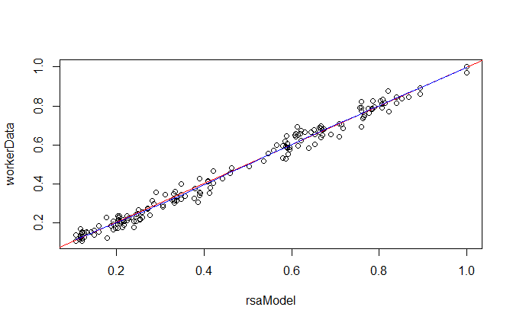**2-Param Optimized (alpha=1).**

Residuals:

Min 1Q Median 3Q Max

-0.078080 -0.017735 0.001374 0.017868 0.077538

Coefficients:

Estimate Std. Error t value Pr(>|t|)

(Intercept) 0.004250 0.004014 1.059 0.291

workerData 0.992041 0.006966 142.402 <2e-16 ***

---

Signif. codes: 0 ‘***’ 0.001 ‘**’ 0.01 ‘*’ 0.05 ‘.’ 0.1 ‘ ’ 1

Residual standard error: 0.0277 on 190 degrees of freedom

Multiple R-squared: **0.9907**, Adjusted R-squared: 0.9907

F-statistic: 2.028e+04 on 1 and 190 DF, p-value: < 2.2e-16

> confint(model) 2.5 % 97.5 %

(Intercept) -0.003668458 0.01216848

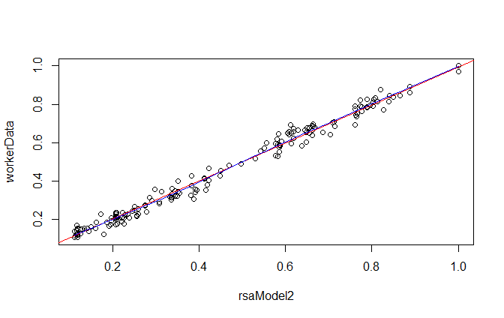workerData 0.978299700 1.00578283

**3-Param Optimized**

Residuals:

Min 1Q Median 3Q Max

-0.079877 -0.016654 0.002476 0.016554 0.079337

Coefficients:

Estimate Std. Error t value Pr(>|t|)

(Intercept) 0.005457 0.003971 1.374 0.171

workerData 0.989626 0.006892 143.597 <2e-16 ***

---

Signif. codes: 0 ‘***’ 0.001 ‘**’ 0.01 ‘*’ 0.05 ‘.’ 0.1 ‘ ’ 1

Residual standard error: 0.0274 on 190 degrees of freedom

Multiple R-squared: **0.9909**, Adjusted R-squared: 0.9908

F-statistic: 2.062e+04 on 1 and 190 DF, p-value: < 2.2e-16

> confint(model) 2.5 % 97.5 %

(Intercept) -0.002376651 0.01329024

workerData 0.976032374 1.00322040

**NOTE – Cross Validation Optimization from now onwards!:**

All the following plots are generated using cross-validation for single trials!

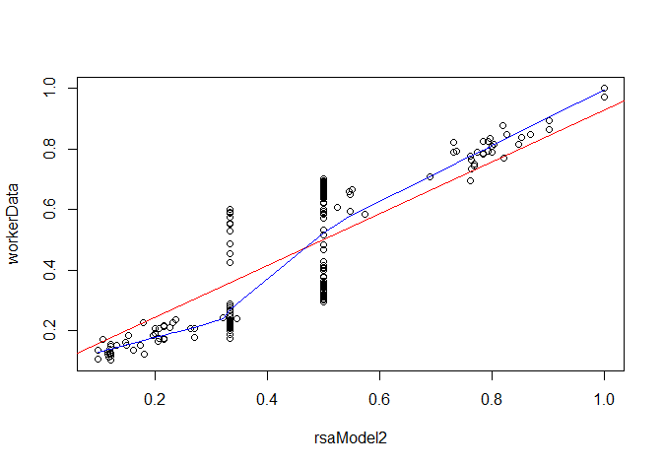[That is, parameters were optimized for all trials with different ambiguity codes except for the trial under consideration. Then, value predictions for the particular trial were generated using the RSA model with the parameter(s) that were optimized wrt the other trials.]

**1-Parameter RSA Model – hard obedience**

Residuals:

Min 1Q Median 3Q Max

-0.25304 -0.07299 0.01726 0.07301 0.17318

Coefficients:

Estimate Std. Error t value Pr(>|t|)

(Intercept) 0.07348 0.01433 5.129 7.16e-07 ***

workerData 0.85352 0.02486 34.330 < 2e-16 ***

---

Signif. codes: 0 ‘***’ 0.001 ‘**’ 0.01 ‘*’ 0.05 ‘.’ 0.1 ‘ ’ 1

Residual standard error: 0.09885 on 190 degrees of freedom

Multiple R-squared: **0.8612**, Adjusted R-squared: 0.8604

F-statistic: 1179 on 1 and 190 DF, p-value: < 2.2e-16

> confint(model)

2.5 % 97.5 %

(Intercept) 0.04521575 0.1017348

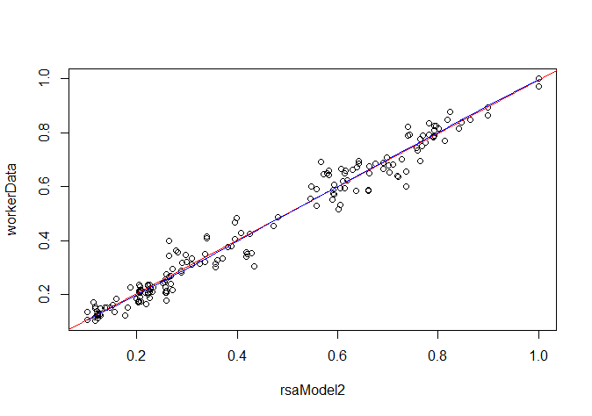workerData 0.80447416 0.9025562

**1-Parameter RSA Model –   
soft obedience set to 0.1**

Residuals:

Min 1Q Median 3Q Max

-0.13585 -0.01972 0.00425 0.02085 0.13531

Coefficients:

Estimate Std. Error t value Pr(>|t|)

(Intercept) 0.006323 0.005875 1.076 0.283

workerData 0.987894 0.010195 96.899 <2e-16 ***

---

Signif. codes: 0 ‘***’ 0.001 ‘**’ 0.01 ‘*’ 0.05 ‘.’ 0.1 ‘ ’ 1

Residual standard error: 0.04053 on 190 degrees of freedom

Multiple R-squared: **0.9802**, Adjusted R-squared: 0.9801

F-statistic: 9389 on 1 and 190 DF, p-value: < 2.2e-16

> confint(model) 2.5 % 97.5 %

(Intercept) -0.005265601 0.01791099

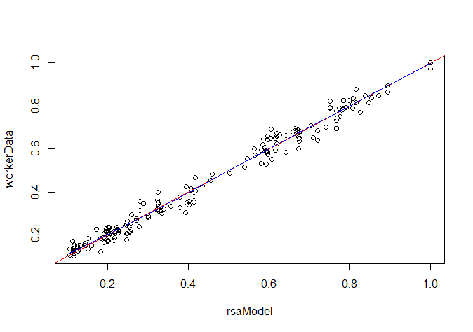workerData 0.967783521 1.00800375

**2-parameter RSA Model**

Residuals:

Min 1Q Median 3Q Max

-0.086492 -0.019094 0.001366 0.018551 0.085949

Coefficients:

Estimate Std. Error t value Pr(>|t|)

(Intercept) 0.002523 0.004566 0.552 0.581

workerData 0.995498 0.007924 125.627 <2e-16 ***

---

Signif. codes: 0 ‘***’ 0.001 ‘**’ 0.01 ‘*’ 0.05 ‘.’ 0.1 ‘ ’ 1

Residual standard error: 0.03151 on 190 degrees of freedom

Multiple R-squared: **0.9881**, Adjusted R-squared: 0.988

F-statistic: 1.578e+04 on 1 and 190 DF, p-value: < 2.2e-16

> confint(model)

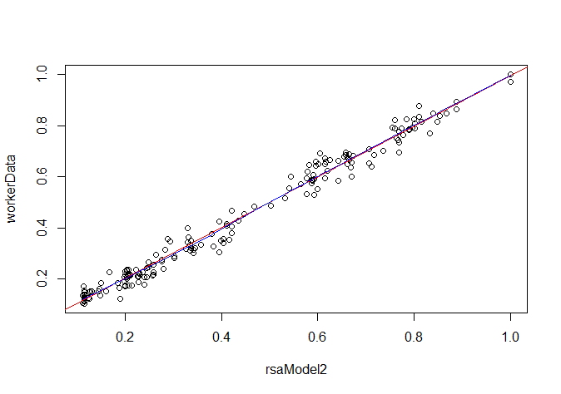 2.5 % 97.5 %

(Intercept) -0.006484548 0.01152973

workerData 0.979867179 1.01112882

**3-parameter RSA Model**

Residuals:

Min 1Q Median 3Q Max

-0.087175 -0.018599 0.002327 0.016032 0.086634

Coefficients:

Estimate Std. Error t value Pr(>|t|)

(Intercept) 0.004437 0.004524 0.981 0.328

workerData 0.991668 0.007850 126.325 <2e-16 ***

---

Signif. codes: 0 ‘***’ 0.001 ‘**’ 0.01 ‘*’ 0.05 ‘.’ 0.1 ‘ ’ 1

Residual standard error: 0.03121 on 190 degrees of freedom

Multiple R-squared: **0.9882**, Adjusted R-squared: 0.9882

F-statistic: 1.596e+04 on 1 and 190 DF, p-value: < 2.2e-16

> confint(model)

2.5 % 97.5 %

(Intercept) -0.004486363 0.01335939

workerData 0.976183465 1.00715265

**############## ############# ##############**

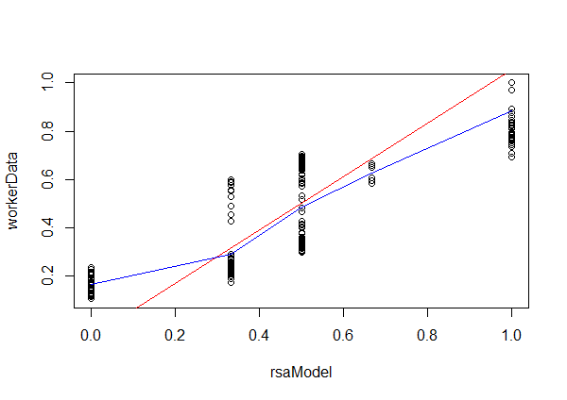**Non-Optimized Simple RSA Model (0,0,1)**

Residuals:

Min 1Q Median 3Q Max

-0.27877 -0.13381 -0.05418 0.14468 0.28441

Coefficients:

Estimate Std. Error t value Pr(>|t|)

(Intercept) -0.05358 0.02173 -2.466 0.0145 *

workerData 1.10776 0.03770 29.381 <2e-16 ***

---

Signif. codes: 0 ‘***’ 0.001 ‘**’ 0.01 ‘*’ 0.05 ‘.’ 0.1 ‘ ’ 1

Residual standard error: 0.1499 on 190 degrees of freedom

Multiple R-squared: **0.8196**, Adjusted R-squared: 0.8187

F-statistic: 863.2 on 1 and 190 DF, p-value: < 2.2e-16

> confint(model) 2.5 % 97.5 %

(Intercept) -0.09643497 -0.01072327

workerData 1.03339144 1.18213392

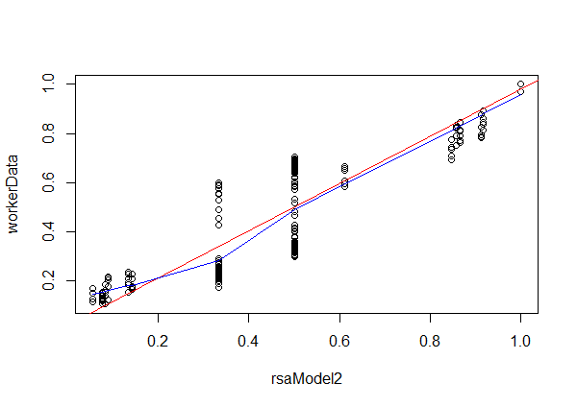

**Non-Optimized Simple RSA Model (0.1,0,1)**

Residuals:

Min 1Q Median 3Q Max

-0.26377 -0.09164 0.01996 0.09774 0.19470

Coefficients:

Estimate Std. Error t value Pr(>|t|)

(Intercept) 0.02048 0.01662 1.233 0.219

workerData 0.95955 0.02883 33.278 <2e-16 ***

---

Signif. codes: 0 ‘***’ 0.001 ‘**’ 0.01 ‘*’ 0.05 ‘.’ 0.1 ‘ ’ 1

Residual standard error: 0.1146 on 190 degrees of freedom

Multiple R-squared: **0.8536**, Adjusted R-squared: 0.8528

F-statistic: 1107 on 1 and 190 DF, p-value: < 2.2e-16

> confint(model) 2.5 % 97.5 %

(Intercept) -0.01229013 0.05325921

workerData 0.90267793 1.01643105

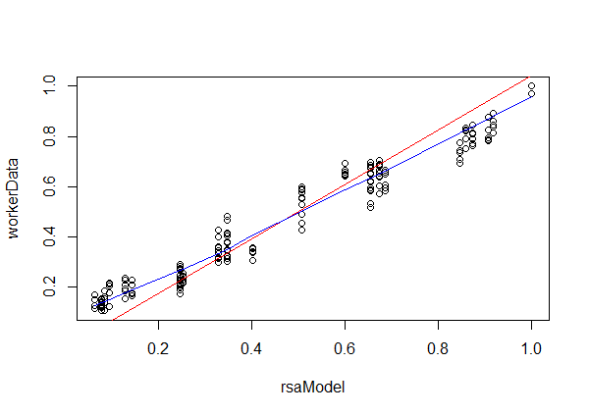

**Non-Optimized Simple RSA Model (0.1,0.1,1)**

Residuals:

Min 1Q Median 3Q Max

-0.135881 -0.042476 -0.004407 0.046279 0.135289

Coefficients:

Estimate Std. Error t value Pr(>|t|)

(Intercept) -0.041885 0.008211 -5.101 8.15e-07 ***

workerData 1.084361 0.014249 76.099 < 2e-16 ***

---

Signif. codes: 0 ‘***’ 0.001 ‘**’ 0.01 ‘*’ 0.05 ‘.’ 0.1 ‘ ’ 1

Residual standard error: 0.05665 on 190 degrees of freedom

Multiple R-squared: **0.9682**, Adjusted R-squared: 0.9681

F-statistic: 5791 on 1 and 190 DF, p-value: < 2.2e-16

> confint(model) 2.5 % 97.5 %

(Intercept) -0.05808126 -0.02568823

workerData 1.05625402 1.11246828

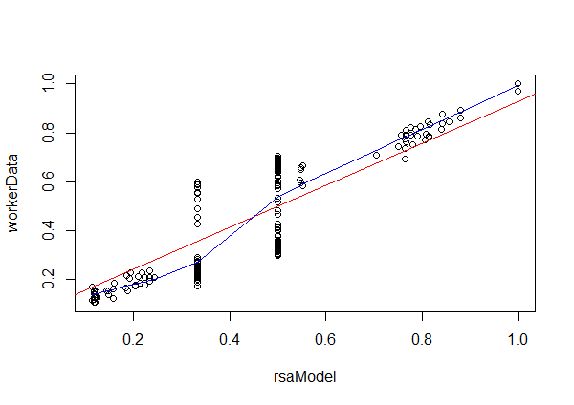**1-Parameter Simple RSA Model  
hard obedience**

Residuals:

Min 1Q Median 3Q Max

-0.25335 -0.07041 0.01773 0.07146 0.17381

Coefficients:

Estimate Std. Error t value Pr(>|t|)

(Intercept) 0.07192 0.01426 5.045 1.05e-06 ***

workerData 0.85662 0.02474 34.626 < 2e-16 ***

---

Signif. codes: 0 ‘***’ 0.001 ‘**’ 0.01 ‘*’ 0.05 ‘.’ 0.1 ‘ ’ 1

Residual standard error: 0.09836 on 190 degrees of freedom

Multiple R-squared: **0.8632**, Adjusted R-squared: 0.8625

F-statistic: 1199 on 1 and 190 DF, p-value: < 2.2e-16

> confint(model) 2.5 % 97.5 %

(Intercept) 0.04380445 0.1000440

workerData 0.80782039 0.9054175

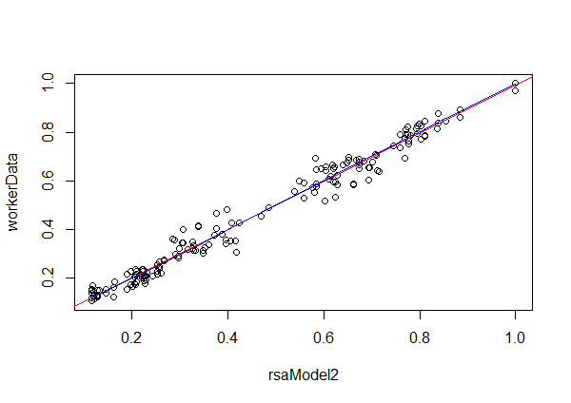

**1-Parameter Simple RSA Model – soft obedience set to 0.1**

Residuals:

Min 1Q Median 3Q Max

-0.108439 -0.020643 0.004433 0.020075 0.107899

Coefficients:

Estimate Std. Error t value Pr(>|t|)

(Intercept) 0.004973 0.005017 0.991 0.323

workerData 0.990594 0.008707 113.774 <2e-16 ***

---

Signif. codes: 0 ‘***’ 0.001 ‘**’ 0.01 ‘*’ 0.05 ‘.’ 0.1 ‘ ’ 1

Residual standard error: 0.03462 on 190 degrees of freedom

Multiple R-squared: **0.9855**, Adjusted R-squared: 0.9855

F-statistic: 1.294e+04 on 1 and 190 DF, p-value: < 2.2e-16

> confint(model) 2.5 % 97.5 %

(Intercept) -0.004923202 0.01486979

workerData 0.973419712 1.00776811

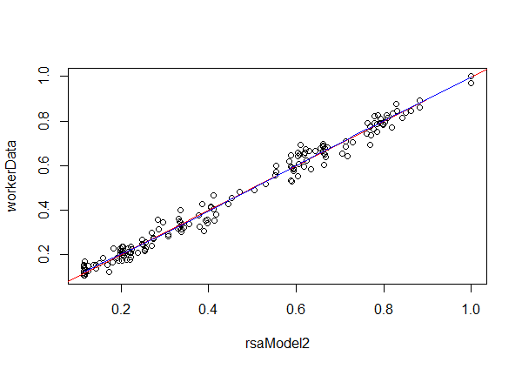**2-parameter Simple RSA Model**

Residuals:

Min 1Q Median 3Q Max

-0.082421 -0.015762 0.001731 0.016085 0.081878

Coefficients:

Estimate Std. Error t value Pr(>|t|)

(Intercept) 0.002275 0.004174 0.545 0.586

workerData 0.995994 0.007244 137.500 <2e-16 ***

---

Signif. codes: 0 ‘***’ 0.001 ‘**’ 0.01 ‘*’ 0.05 ‘.’ 0.1 ‘ ’ 1

Residual standard error: 0.0288 on 190 degrees of freedom

Multiple R-squared: **0.9901**, Adjusted R-squared: 0.99

F-statistic: 1.891e+04 on 1 and 190 DF, p-value: < 2.2e-16

> confint(model) 2.5 % 97.5 %

(Intercept) -0.00595859 0.01050836

workerData 0.98170546 1.01028190

**############## ############# ##############**

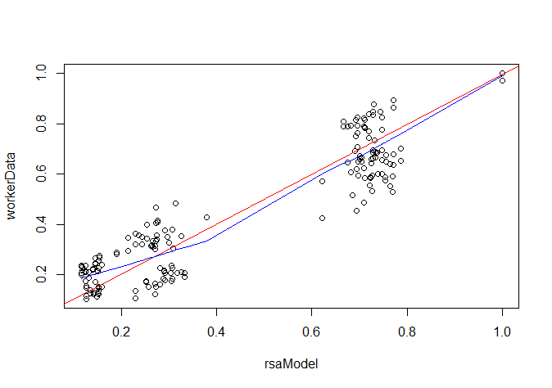**Simple Object Choice Preference Model**

**1-Parameter**

Residuals:

Min 1Q Median 3Q Max

-0.19409 -0.08639 0.00575 0.07459 0.24205

Coefficients:

Estimate Std. Error t value Pr(>|t|)

(Intercept) 0.006289 0.013952 0.451 0.653

workerData 0.987962 0.024212 40.804 <2e-16 ***

---

Signif. codes: 0 ‘***’ 0.001 ‘**’ 0.01 ‘*’ 0.05 ‘.’ 0.1 ‘ ’ 1

Residual standard error: 0.09626 on 190 degrees of freedom

Multiple R-squared: **0.8976**, Adjusted R-squared: 0.897

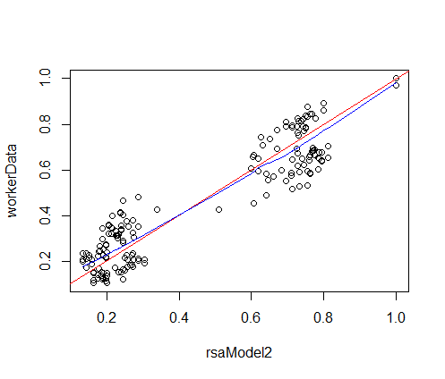F-statistic: 1665 on 1 and 190 DF, p-value: < 2.2e-16

> confint(model) 2.5 % 97.5 %

(Intercept) -0.02123211 0.03380959

workerData 0.94020241 1.03572075

**Simple Object Choice Preference Model**

**2-Parameter**

Residuals:

Min 1Q Median 3Q Max

-0.221732 -0.076742 0.002469 0.077340 0.221190

Coefficients:

Estimate Std. Error t value Pr(>|t|)

(Intercept) 0.003012 0.013390 0.225 0.822

workerData 0.994519 0.023237 42.798 <2e-16 ***

---

Signif. codes: 0 ‘***’ 0.001 ‘**’ 0.01 ‘*’ 0.05 ‘.’ 0.1 ‘ ’ 1

Residual standard error: 0.09239 on 190 degrees of freedom

Multiple R-squared: **0.906**, Adjusted R-squared: 0.9055

F-statistic: 1832 on 1 and 190 DF, p-value: < 2.2e-16

> confint(model) 2.5 % 97.5 %

(Intercept) -0.02340102 0.02942467

workerData 0.94868263 1.04035536