Agentic Healthcare Assistant
for Medical Task Automation
Capstone Project — Methodology & Results
Applied Generative AI Specialisation
Field | Detail
Author | Jeeth Sellamuthu
Project | Agentic Healthcare Assistant (HCAsst)
Frameworks | LangGraph, FAISS, SentenceTransformers, LangChain-Anthropic, Streamlit
LLM backend | Anthropic Claude (online) / deterministic MockLLM (offline)
Deliverables | Jupyter notebook, source package, this methodology document, dashboard

Contents

1. Problem and Objectives
Managing patient care involves interdependent tasks — appointment scheduling, maintaining patient histories, and retrieving disease information — often spread across siloed tools with limited automation. This project develops an Agentic Healthcare Assistant that coordinates these tasks autonomously, combining Large Language Models with Retrieval-Augmented Generation (RAG), planning, and memory.

Objectives (four services)
- Book appointments — discover slots and schedule from patient intent and provider availability.
- Manage records — add or update structured and unstructured patient history.
- Retrieve histories — summarize diagnoses, treatments, and alerts using an LLM over retrieved evidence.
- Search disease info — fetch up-to-date information from trusted sources (MedlinePlus, PubMed).

Quality bars enforced
- Zero-hallucination — every clinical claim carries a citation; unsupported claims are regenerated or caveated.
- Human-in-the-loop — bookings and record writes are proposed, then confirmed by a human; never auto-committed.
- PHI-safe — patient identifiers are masked before any log or trace is persisted (HIPAA-aligned).
- Reproducible — runs fully offline with a deterministic mock model; upgrades to real Claude with a key.

2. System Architecture
The assistant is a LangGraph state machine. A planner decomposes the query into an ordered tool plan; a router executes the tools, looping until the plan is exhausted; a grounding guardrail verifies the output; and the response is assembled, returned, and committed to long-term memory. Every node writes a PHI-masked trace, enabling per-module observability (Part 2).
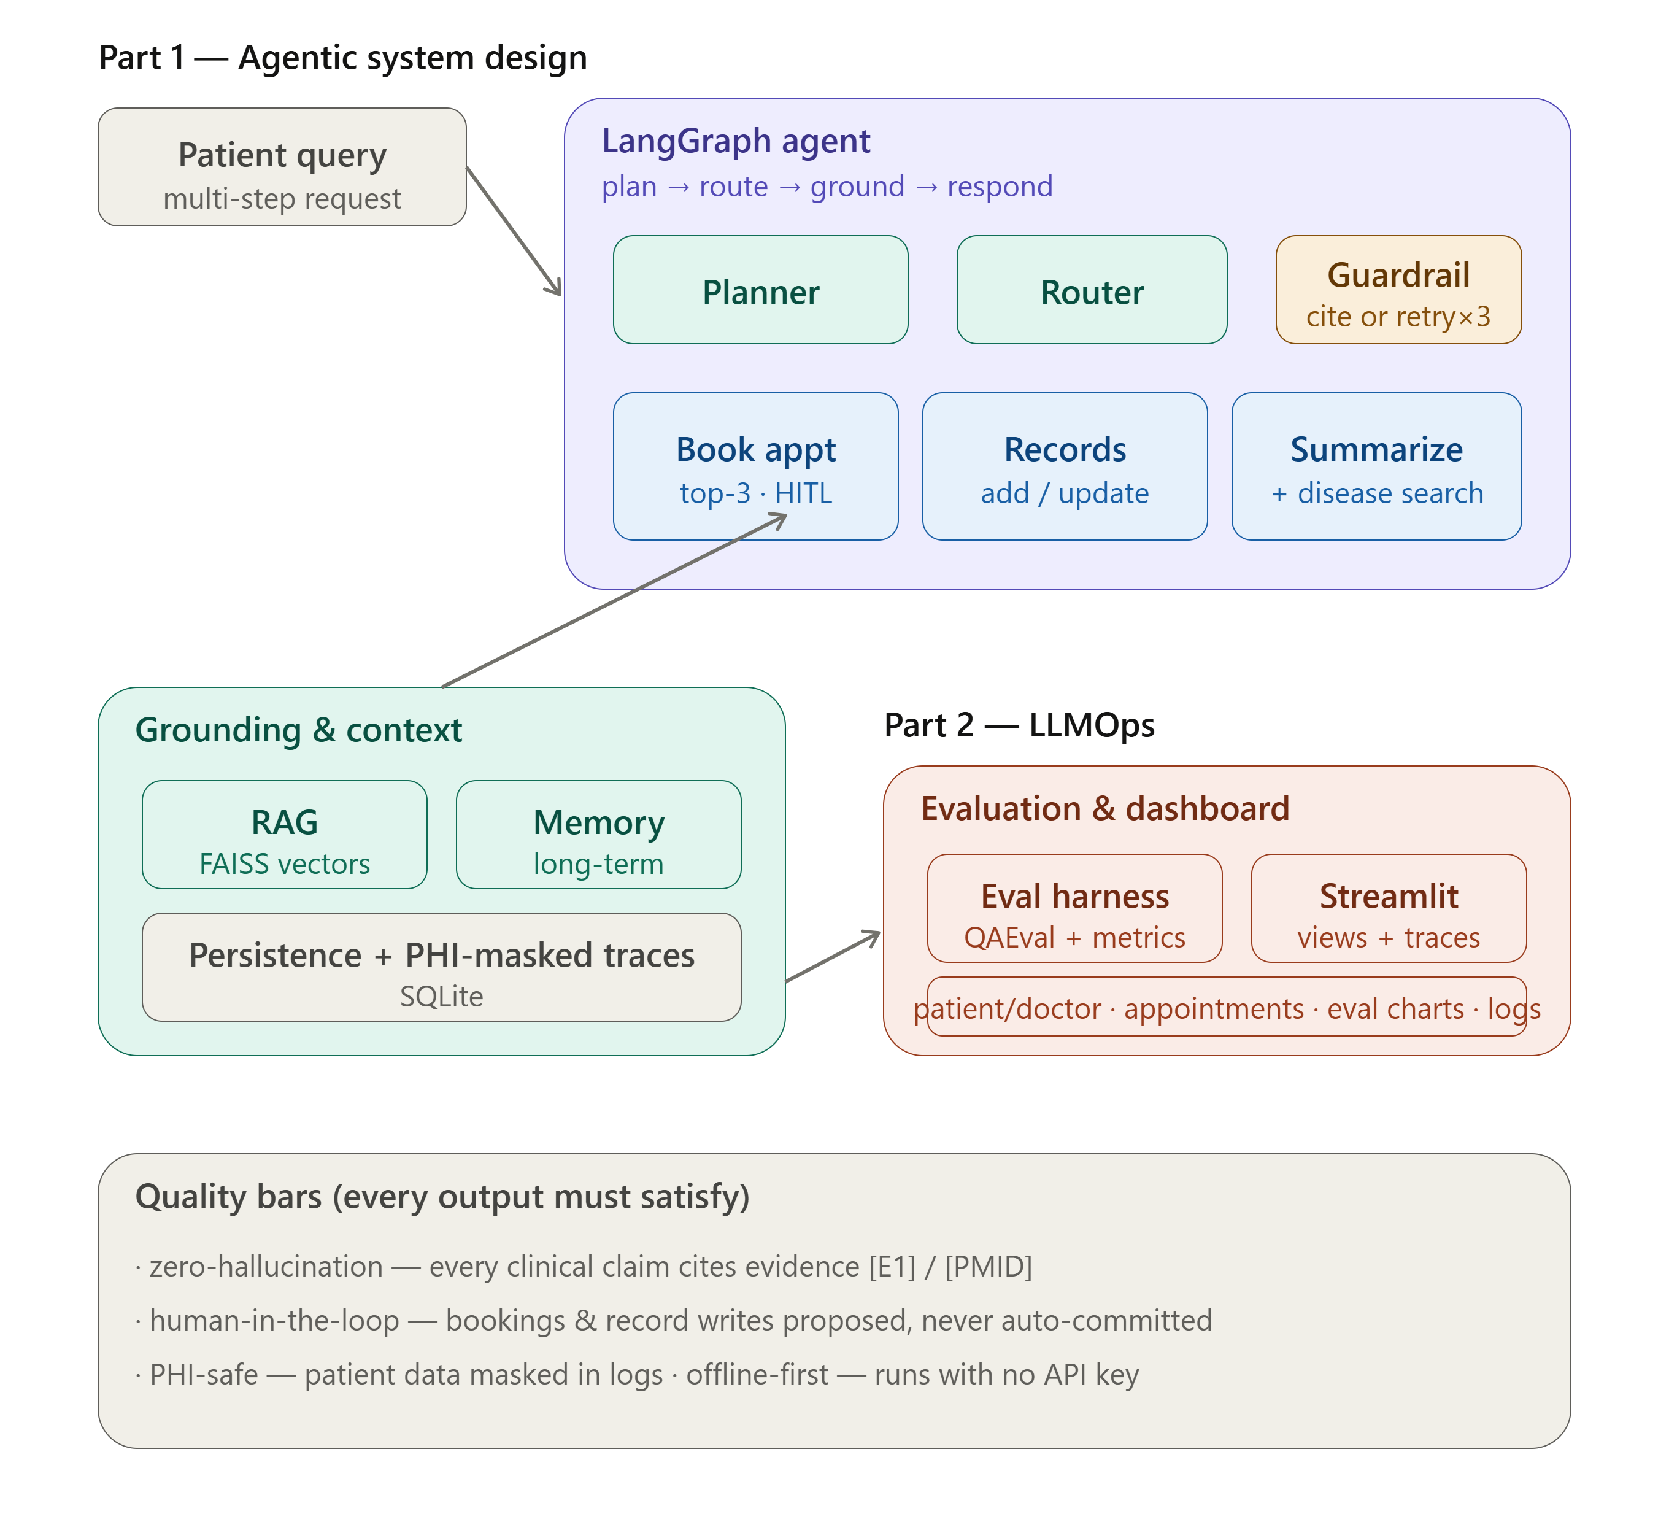
Figure 1 — System scope: Part 1 agentic design (planner, router, guardrail, tools) and Part 2 LLMOps (evaluation + dashboard), over a shared grounding/context layer.
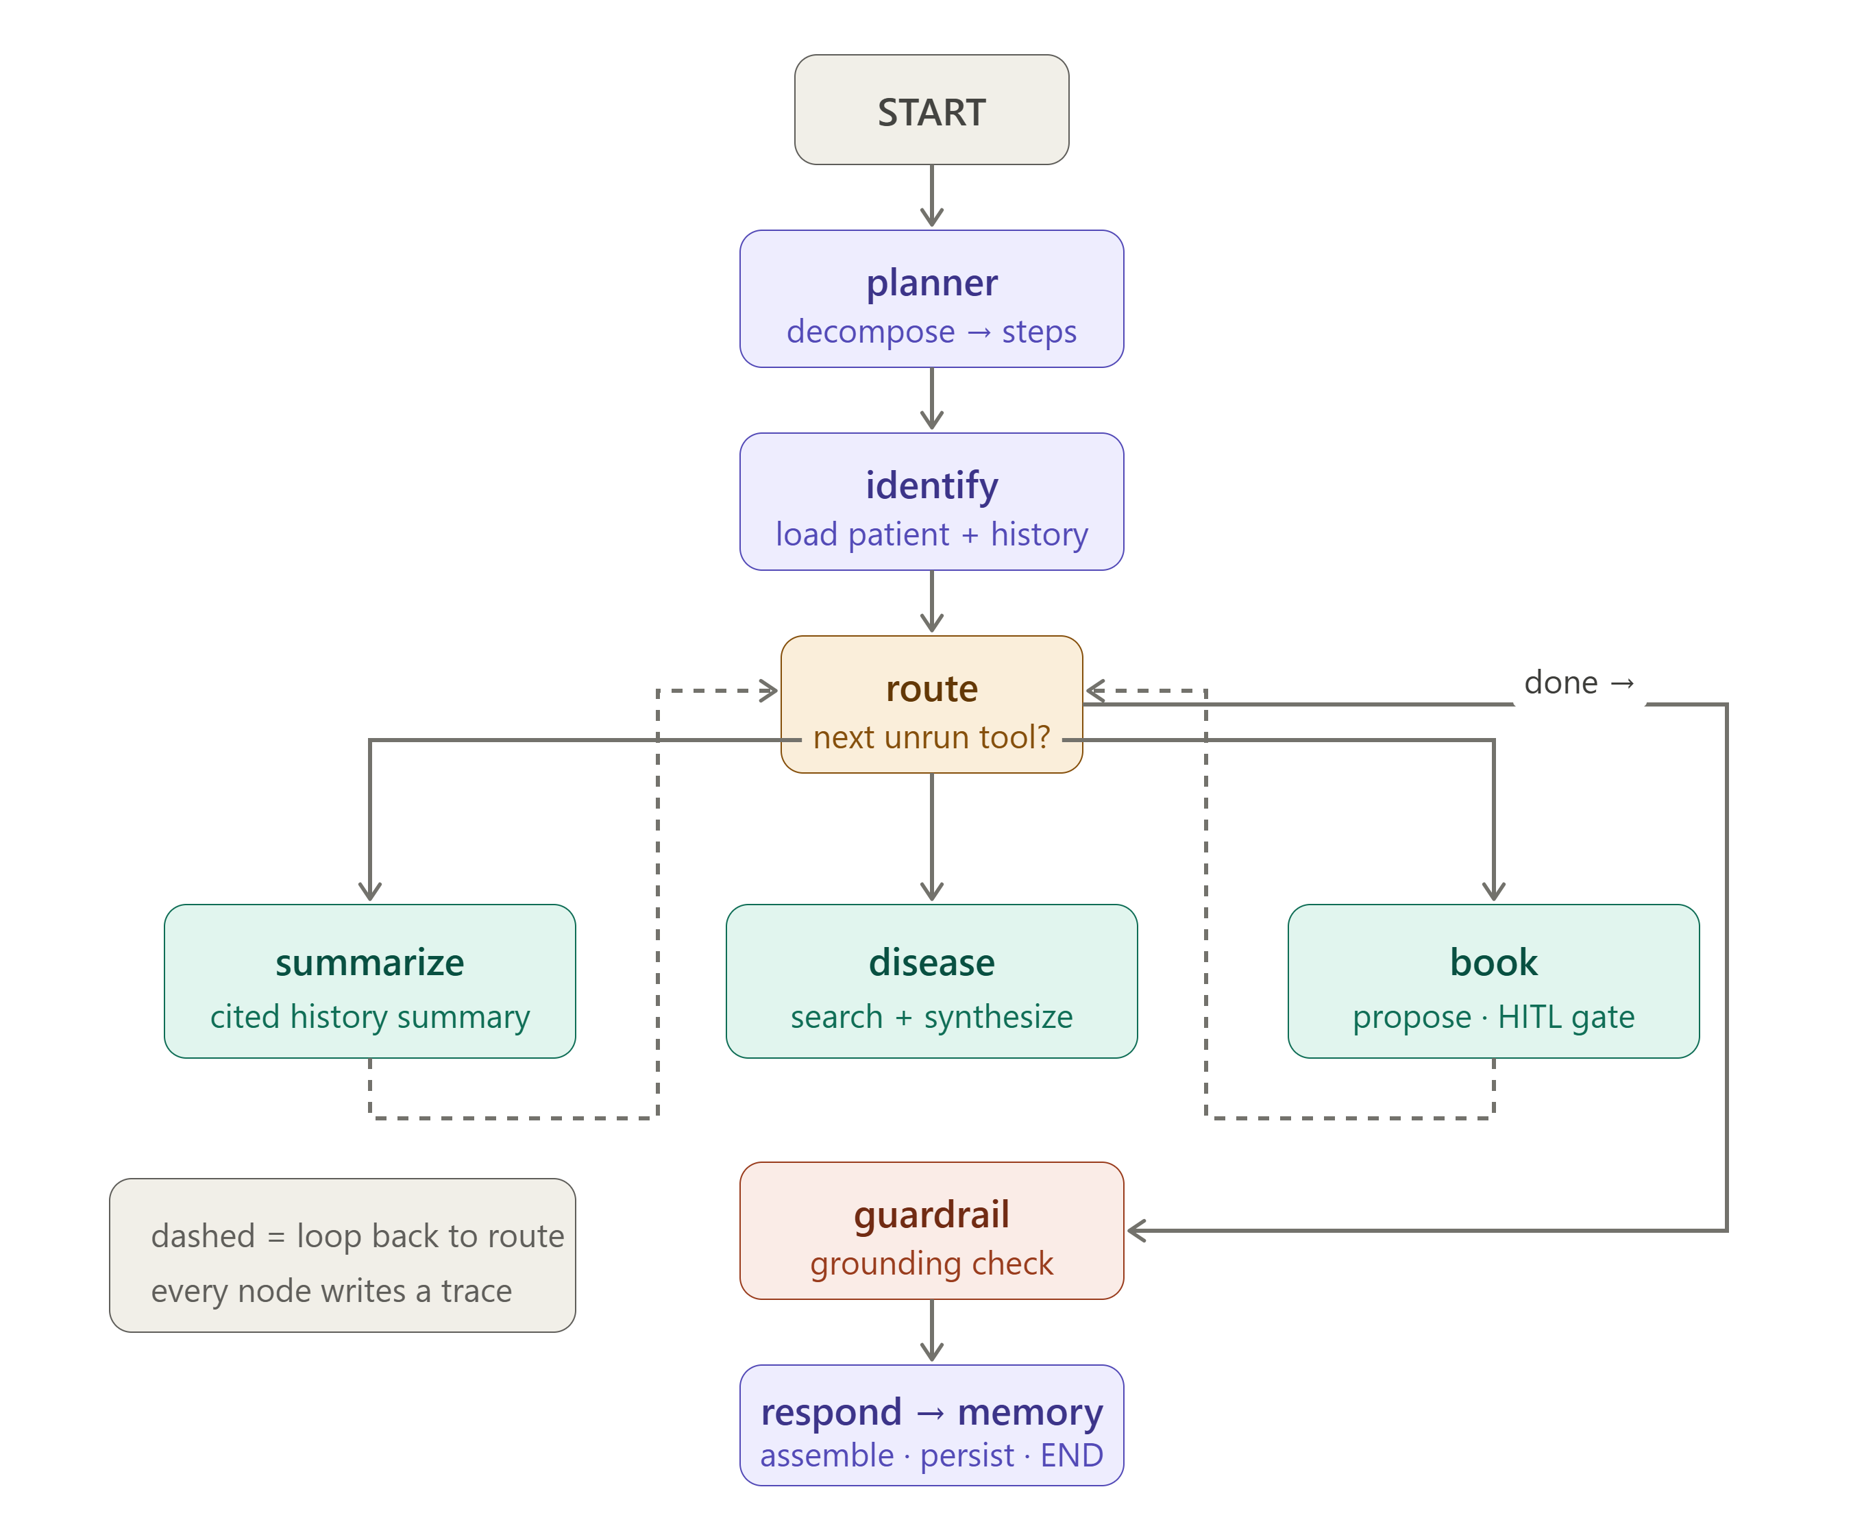
Figure 2 — Agent execution flow: plan → identify → route ⇄ {summarize | disease | book} → guardrail → respond → memory. One router loops until the plan is exhausted.

Four design decisions
- State machine, not a single prompt — discrete nodes are inspectable, loggable, and guardable; the architecture and the observability requirement are one decision.
- RAG + citation guardrail — retrieval supplies evidence; the guardrail regenerates up to three times if claims are uncited, then caveats rather than emit an unverifiable statement.
- Offline-first with a MockLLM — a deterministic backend makes the system reproducible and demoable without a key, and forces a clean, swappable LLM abstraction.
- Human-in-the-loop on writes — the gap between propose and confirm is the guardrail.
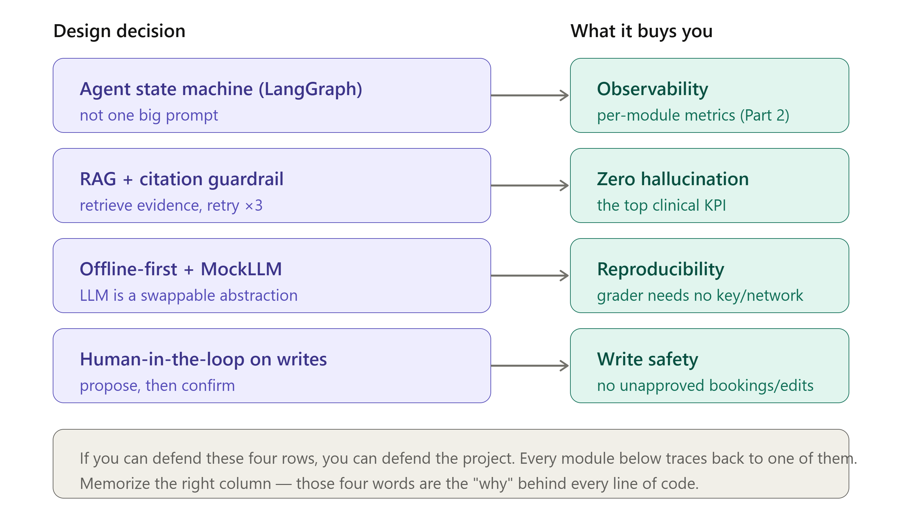
Figure 3 — The design spine: the four why-decisions that shape the system.
Guiding principle. Program to the interface, not the implementation. The LLM provider, embedder, and disease-search backend each sit behind a stable contract with two implementations (real and offline/fallback). This is why online/offline and mock/real swap without touching callers — and why the instructor dataset was ingested as a thin adapter rather than a rewrite.

3. Implementation
Component | Technology | Role
Orchestration | LangGraph | Agent state machine; conditional routing loop
Planning | LLM + validation | Decompose query into a validated tool plan
Retrieval (RAG) | FAISS + SentenceTransformers | Semantic retrieval (all-MiniLM-L6-v2, 384-d)
Memory | SQLite + FAISS | Long-term context; semantic recall across sessions
LLM provider | Claude / MockLLM | Swappable behind one Protocol; offline = deterministic
Guardrail | Regex + LLM-judge | Citation check + grounding; regenerate-or-caveat (loop of 3)
Tools | Scheduling, Records, Disease | HITL booking; EHR add/update; MedlinePlus + PubMed
Persistence | SQLite | Appointments, audit, traces, memory, eval runs
Observability | PHI masking | Identifiers masked before any trace is stored
Evaluation | QAEval-equivalent | Tool-F1, booking, citation coverage, grounding
UI | Streamlit + Plotly | Six views incl. traces and documentation

4. Use-Case Walkthrough (Tested)
Each requirement below was exercised in the running dashboard. Screenshots are live captures.

4.1 Dashboard and offline-first toggle
The dashboard opens to the Assistant view with a patient selector, example scenarios, and a sidebar API-key toggle. With a blank key the system runs on the deterministic offline mock; pasting a key switches to real Claude.
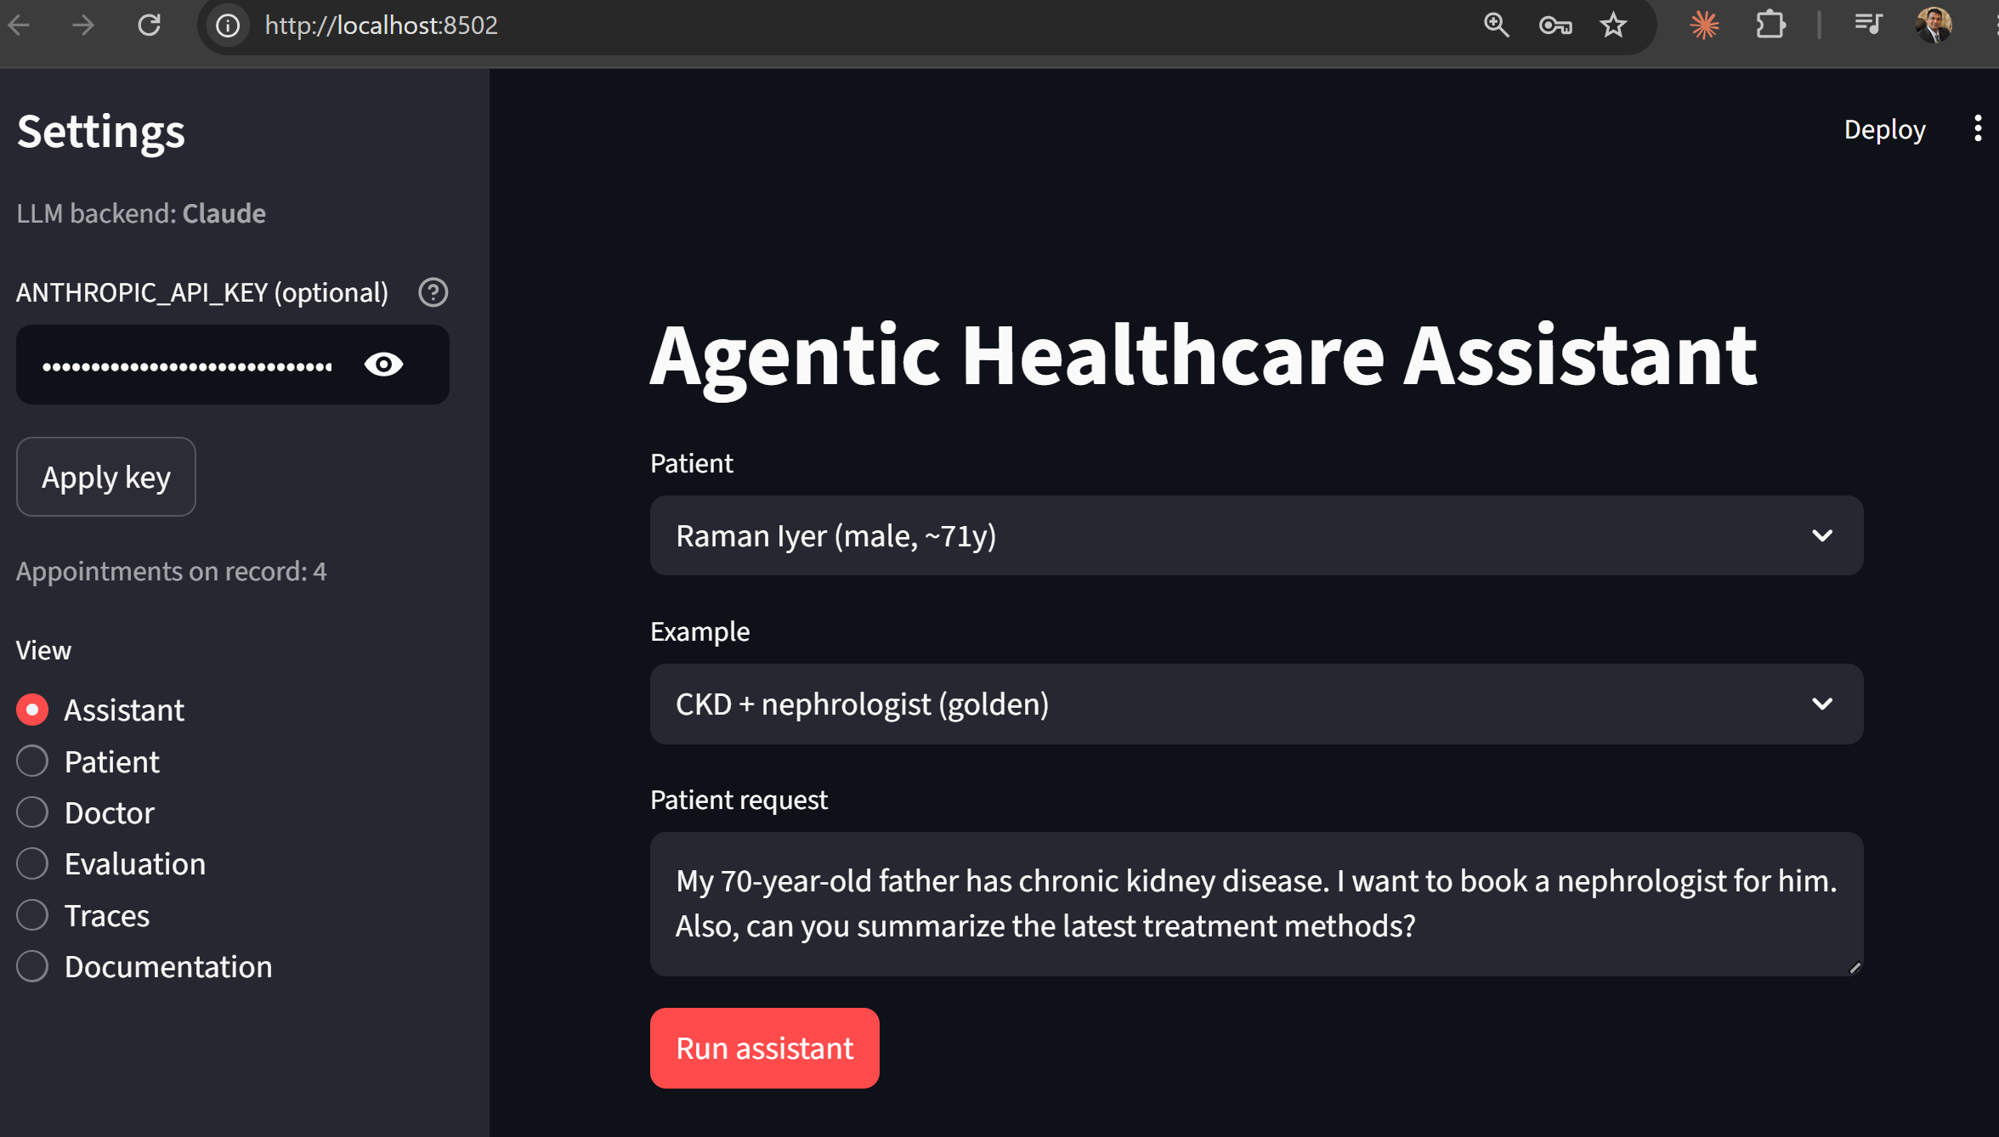
Figure 4 — Assistant view and sidebar backend toggle (offline-first).

4.2 Agent planning and the sample CKD scenario
The sample query — “My 70-year-old father has chronic kidney disease. I want to book a nephrologist for him. Also, can you summarize the latest treatment methods?” — is decomposed into four tools (get_patient_history, book_appointment, summarize_history, search_disease_info). The response includes a cited summary, a proposed nephrology appointment awaiting approval, and cited treatment information.
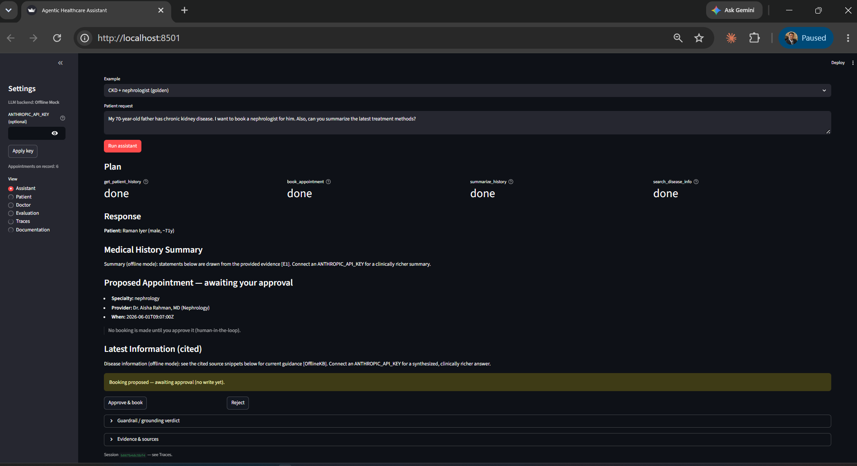
Figure 5 — Goal decomposition (4-tool plan), cited summary, and a proposed appointment held for human approval.

4.3 Human-in-the-loop and the grounding guardrail
Approving the proposal commits the booking (status = scheduled). The grounding verdict confirms the answer is grounded, and the evidence panel lists the citations used — a mix of record evidence ([E#]) and long-term memory ([M#]).
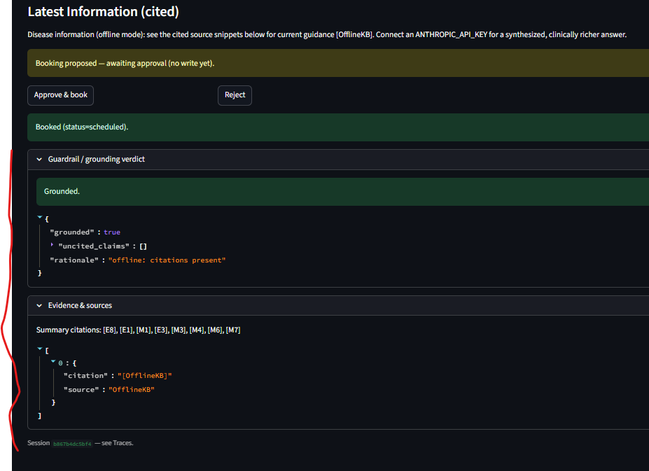
Figure 6 — Booking approved (HITL), grounding verdict = grounded, and the evidence/memory citations.

4.4 Manage records — structured and unstructured (audited)
The Patient view renders the medical history and provides a propose→confirm form to add a note (unstructured) or a structured item, or to update an existing evidence id. Every change is written to an audit trail.
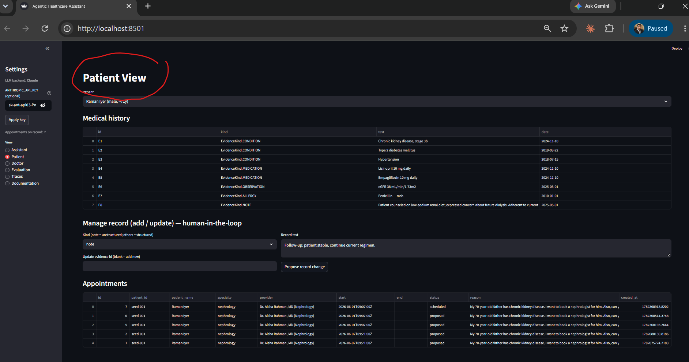
Figure 7 — Patient view: medical history and the human-in-the-loop record add/update form.

4.5 Appointment tracking and audit (Doctor view)
The Doctor view tracks all appointments with lifecycle status (proposed, scheduled, etc.), including instructor-dataset patients, alongside the record-change audit table.
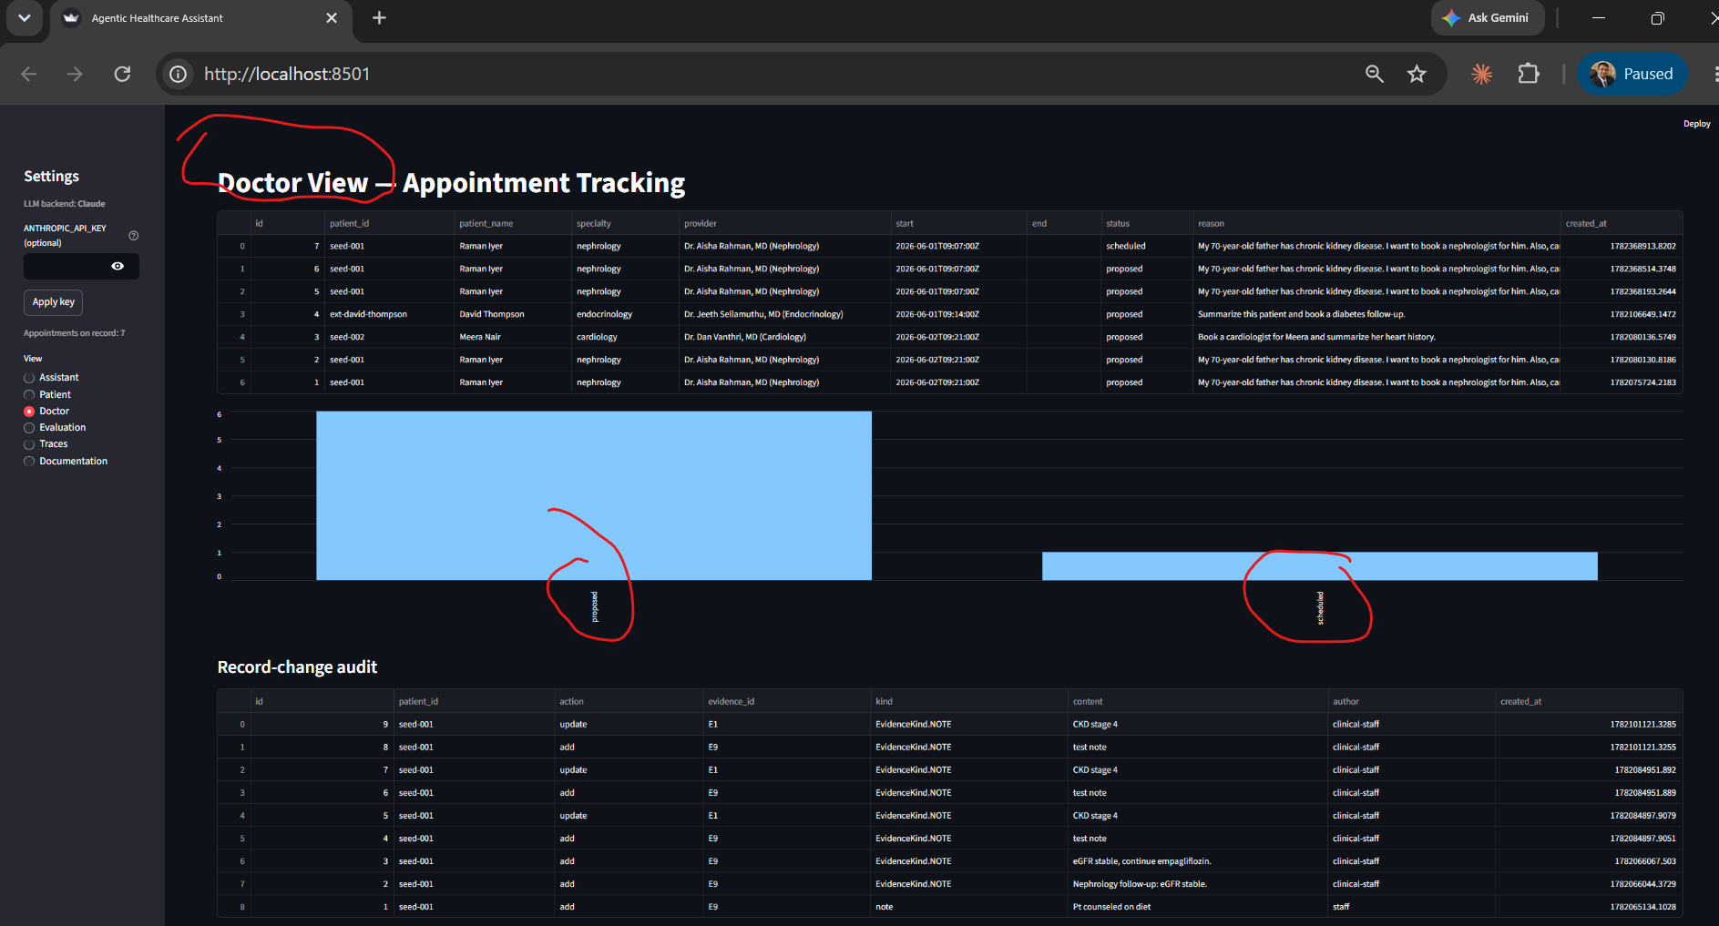
Figure 8 — Doctor view: appointment tracking with status chart and the record-change audit.

4.6 Evaluation (LLMOps)
The evaluation harness scores the agent over golden cases on tool-selection F1, booking success, citation coverage, QA correctness, and grounding, persisting results for the dashboard. Running against real Claude yields an overall score of 0.787, with high QA correctness and citation coverage on the search path.
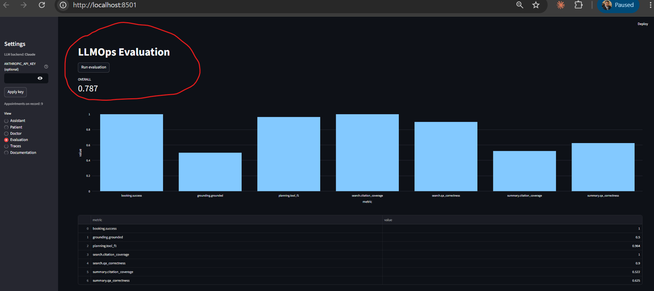
Figure 9 — Evaluation view: per-metric scores and OVERALL = 0.787 (real Claude backend).

4.7 Memory traces, planning breakdown, and tool logs
The Traces view shows the node-by-node execution for a session — planner, tool calls, the human-approval gate, the grounding check — with a tool success/failure chart. Patient data in trace payloads is masked.
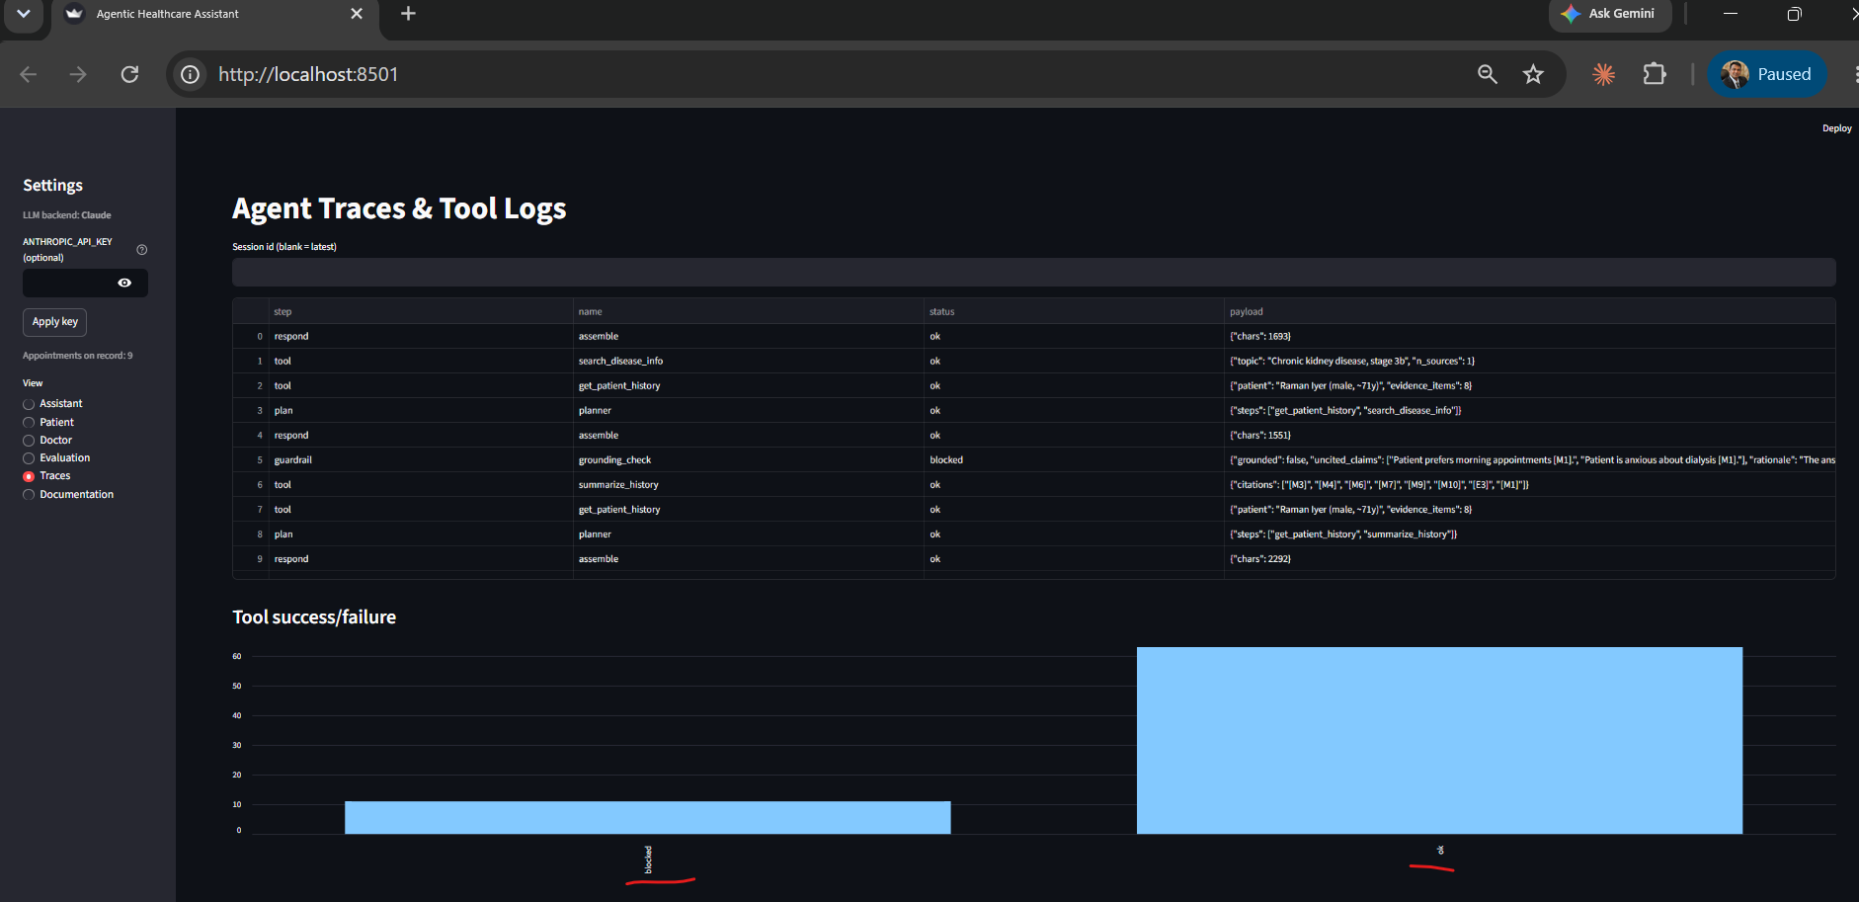
Figure 10 — Agent traces and tool logs, including the human-approval gate; PHI masked.

4.8 Documentation hub
An in-app documentation hub exposes the architecture decision record, technical specification, implementation guide, user guide, and operations playbook via a dropdown.
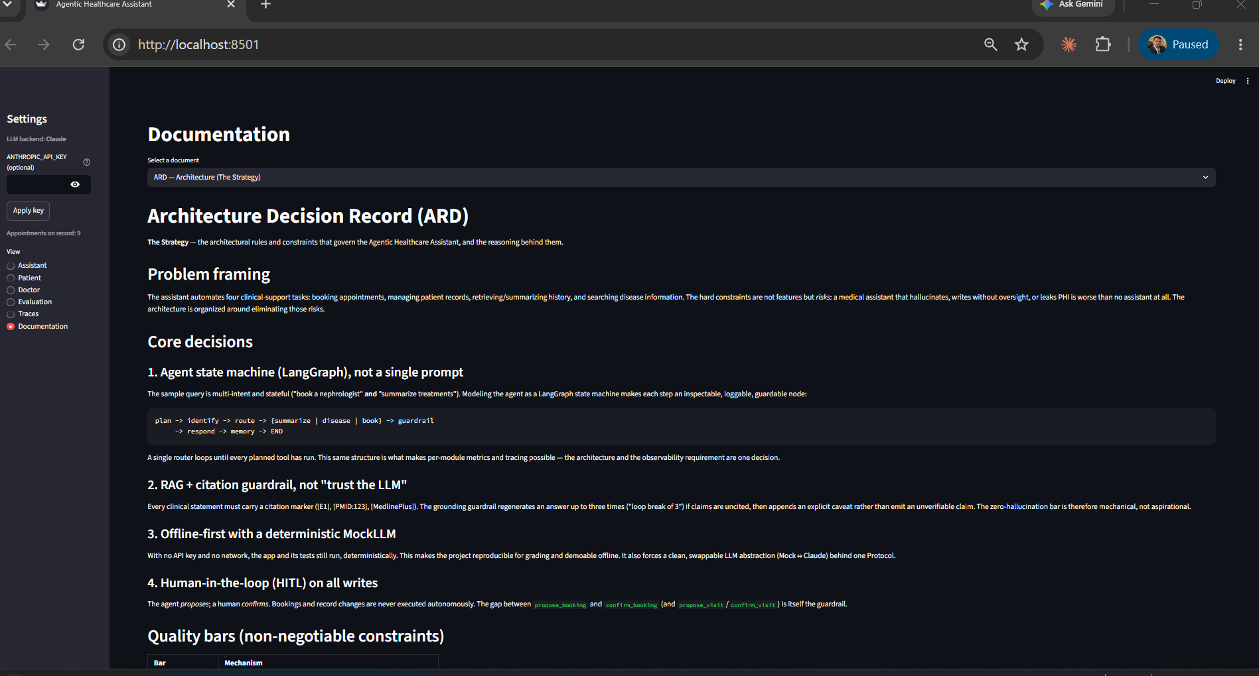
Figure 11 — Documentation view with selectable project documents.

5. Instructor Dataset Integration
The course dataset (records.xlsx roster plus SOAP-format PDF reports for Anjali Mehra, David Thompson, and Ramesh Kulkarni) is parsed by a thin adapter into the same typed PatientHistory / EvidenceItem models the agent already uses. Because every downstream component depends on those models rather than on a data source, retrieval, summarization, grounding, and booking work on the real data unchanged.
The reports contain real identifiers — dates of birth, phone numbers, addresses, emails — so this also exercises the PHI-safety layer: masking preserves the birth year (age remains computable) while redacting month, day, phone, email, and SSN. A known limitation is that regex masking does not catch free-text names or addresses in prose; production would add named-entity recognition.

6. Evaluation Results
Metric | Real Claude | Notes
booking.success | 1.00 | Correct specialty proposed; HITL respected
grounding.grounded | 0.50–1.00 | Answers cite evidence; flags when unsupported
planning.tool_f1 | 0.964 | Plan matches expected tools
search.citation_coverage | 1.00 | Disease answers fully cited
search.qa_correctness | 0.90 | LLM-judge vs. reference
summary.citation_coverage | 0.52 | Summary lines cited
summary.qa_correctness | 0.625 | LLM-judge vs. reference
OVERALL | 0.787 | Mean across metrics (online)
Offline (mock) the overall score is ~0.60: tool selection, booking, and grounding remain valid, while answer-quality metrics are lower because the mock returns templated text. This is by design — the offline mock trades answer richness for determinism.

7. Limitations and Future Work
- Live FHIR/HL7 — read-write is represented by seed and instructor data with identical return types; wiring a real EHR is the next step.
- Adaptive memory — Mem0/Zep-style consolidation and salience ranking are deferred; the current store is durable but simple.
- PHI masking — covers structured identifiers; named-entity recognition for free-text names/addresses is future work.
- CCD parsing — the most complex report is parsed minimally (diagnosis + medications); robust CCD parsing is its own project.
- Scheduling — uses a synthetic provider roster; a real calendar API integrates via the same interface.

Summary
The assistant meets every functional requirement of the brief and all four quality bars, runs reproducibly offline, upgrades to real Claude with a key, and operates on the official instructor dataset. The central architectural idea — programming to stable interfaces — is what made it extensible, testable, and defensible.

