Monotonicity on Identification with Neural Nets

Guillermo B. Sentoni  Univesidad Argentina de la Empresa  School of Engineering and Sciences  Lima 717  Buenos Aires, C1073AAO  ARGENTINA | and | Lorenz T. Biegler  Carnegie Melon University  Dpt. of Chemical Engineering,  Pittsburgh, PA 15217  USA

Abstract:

This paper presents a training scheme to obtain a monotonic function approximation for a Single Hidden Layer Perceptron from sample data. A monotonic function is defined as having the property either of being never increasing or of being never decreasing as the values of the independent variable increase. If the function is multivariable with input dimension d, the definition still holds by input-output pairs: for example the input i changes while the other inputs are held at a constant value.

There exists cases in which monotonicity is a desirable property for an aproximator, specially in those applications in which a priori process knowledge is handy and well established. In those cases, process or system knowledge dictates that the relationship between some input/outputs pairs must be monotonically increasing or decreasing. Among other examples, models in Model Predictive control must fit the right static gain among inputs-outputs pairs. Achieving this requirement is not easy, even more, when sample data is drawn from noisy process.

The objective of this training algorithm is to approximate a function through sample data while at the same time meeting given gains. The information provided to the algorithm are the training samples and a set of indexes that explain the gain of an input-output pair. Doing so, the user is able to specify if a input-output pair is monotonic descendent or monotonic ascendant, or runs free. The goal is to get a monotonic approximation of the underlying function represented by the data by constraining some of the weights of the neural network. Establishing the right constraints on the weights of the network will enforce monotonicity in a very elegant way. Results will be provided by testing the algorithm with data coming from a polymerization process with 11 inputs and 1 output.

Problem definition
The objective of this section is to sketch the solution to the approximation of a function through sample data, where given gains have also to fulfilled. The Following data is provided/defined by the user:

Data
N: measured data pairs, 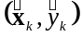, where 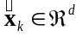 is the input, and 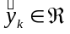 is the output
H: is the number of hidden neurons
: 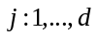, –1: monotonic descendent function
0: unspecified
-1: monotonic ascendant function

The Network
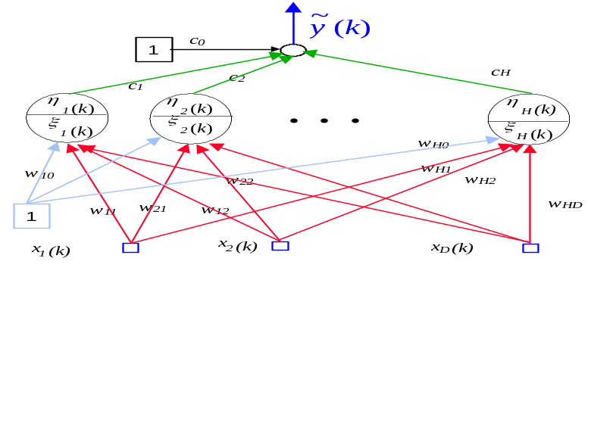
Figure 1 Schematic Diagram of the utilized Neural Network

Proposed Solution
Motonicity is obtained by constraining the weights of the network as it is explained in he following problem statement:

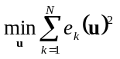
s.t.
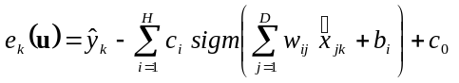, 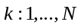
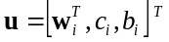,
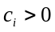, 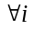
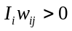, for specified i’s and 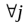

Results

The results of this section were obtained by using Aspen provided data. The results an original data can be recovered from the Matlab storing file polymer.mat. The variables used and their respective constrains are the following:

H2_Ratio: 1
C4_Ratio: 0
C_C2: 1
F_C2: 1
C_C4: 0
F_C4: 1
C_H2: 0
F_H2: 1
Temp: 1
Press: -1
Level: 1

The Dependent variable is R_MI as solicited. All the input variables were scaled between –1 and 1 to facilitate the training. No separation between test set and training set were performed, employing all the data available to train the Neural Net (NN). The NN chosen has:
11 inputs, 3 hidden Neurons, 1 Output

Tow different pieces of code were employed:

- A full Matlab code implementation where the optimizer used is the Interior Point method that comes with the version 2.0 of the Optimization Toolbox.

- A mixed Matlab-Fotran implementation where the Matlab environment is used to call a Fortran optimization routine. In this case, an Interior Point method implemented in Fortran in professor’s Biegler group is utilized.

The results will be presented for both cases. First, it will be shown a plot of the approximation and the error the approximation, and then a plot of the monotonicity of the requested variables. This is done, by sweeping the input range [-1,1] on each input holding the other ones at a constant values of : -.5, 0, .5 The graphics are presented in the following order:

H2_Ratio: 1 | C4_Ratio: 0
C_C2: 1 | F_C2: 1
C_C4: 0 | F_C4: 1
C_H2: 0 | F_H2: 1
Temp: 1 | Press: -1
Level: 1 | R_MI output

Observation
It can be appreciated in the results a complete consistency with the requested specifications.

Full Matlab Implementation: Results

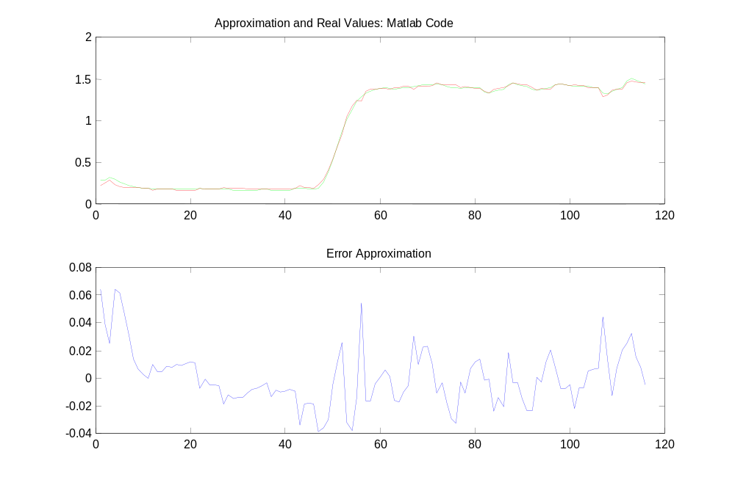
Figure 2 Full Matlab Solution: Approximation and Error

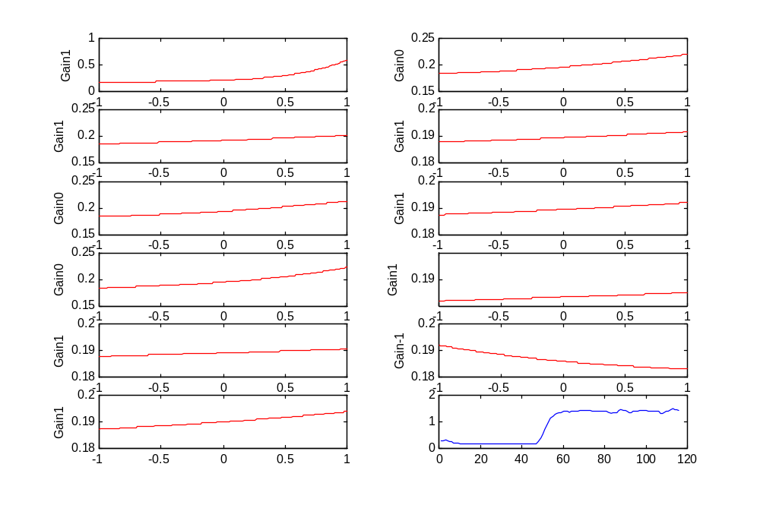
Figure 3 Full Matlab Solution: Variables held at -.5
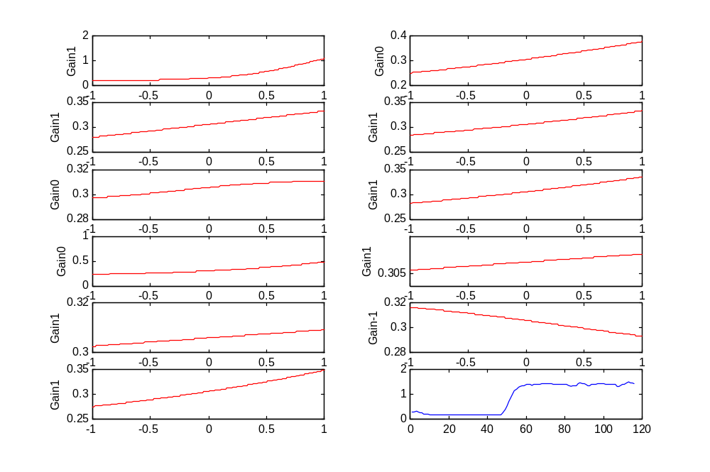
Figure 4 Full Matlab Solution: Variables held at 0

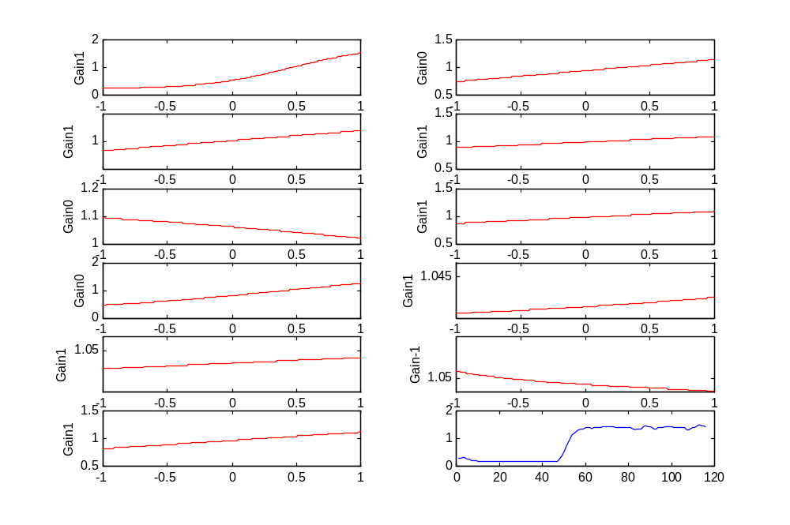
Figure 5 Full Matlab Solution: Variables held at .5

Matlab-Fortran Implementation: Results

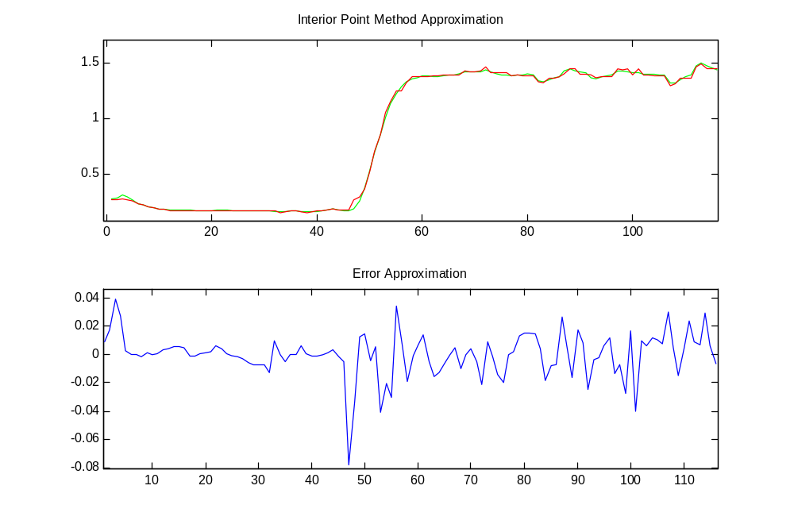
Figure 6 TnConsIpOpt Solution: Approximation and Error

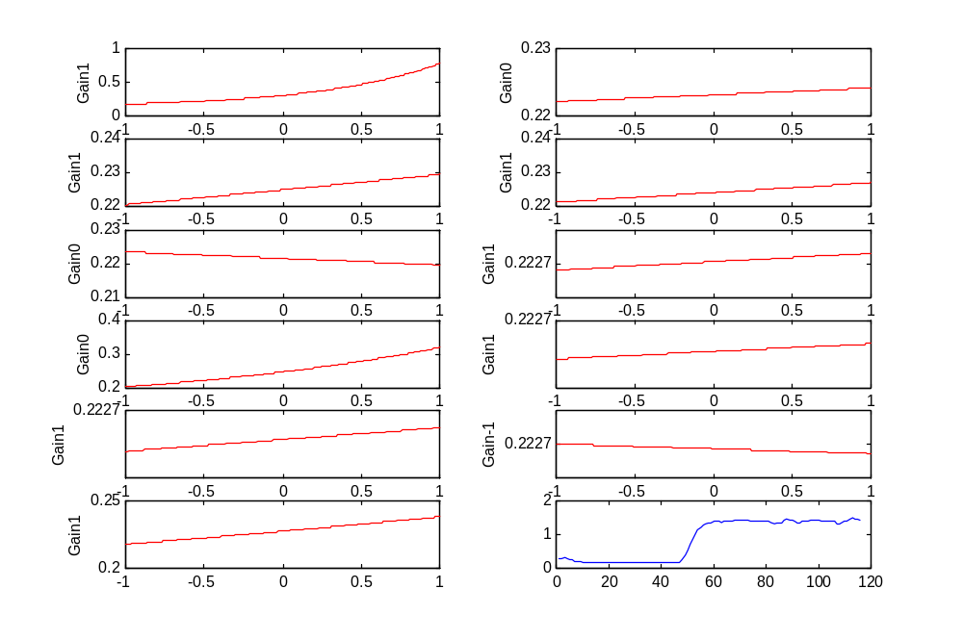
Figure 7 TnConsIpOpt Solution: Variables held at -.5
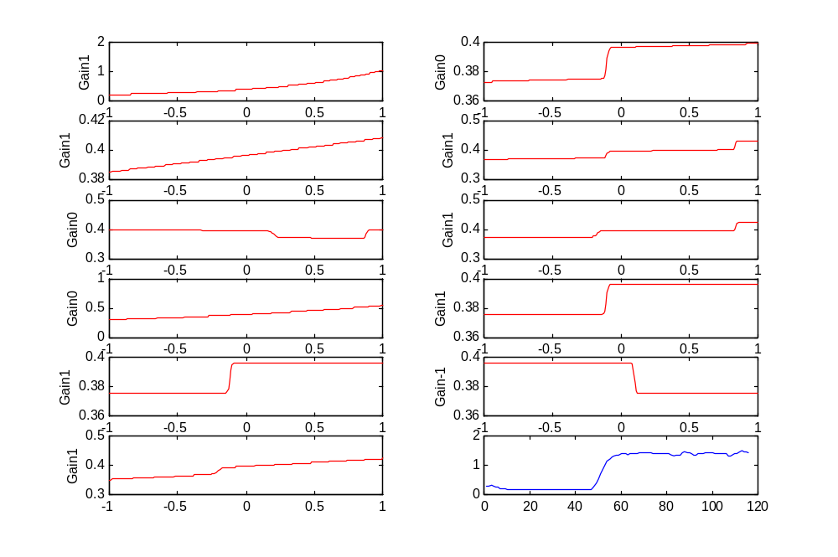
Figure 8 TnConsIpOpt Solution: Variables held at 0

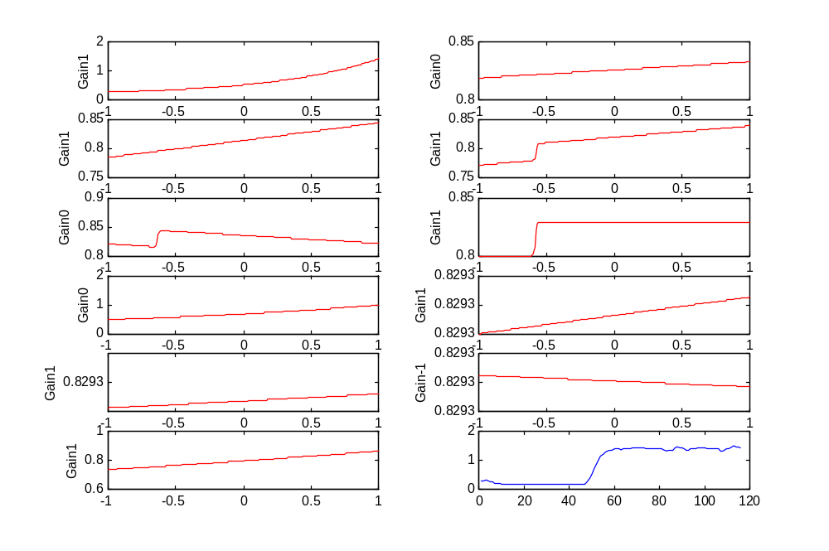
Figure 9 TnConsIpOpt Solution: Variables held at .5

