Each patient is associated with only 1 practitioner, also with 1 organisation
Encounters are multiple
Encounters have many observations
1 practitioner to many organisations
1 practitioner to many patients

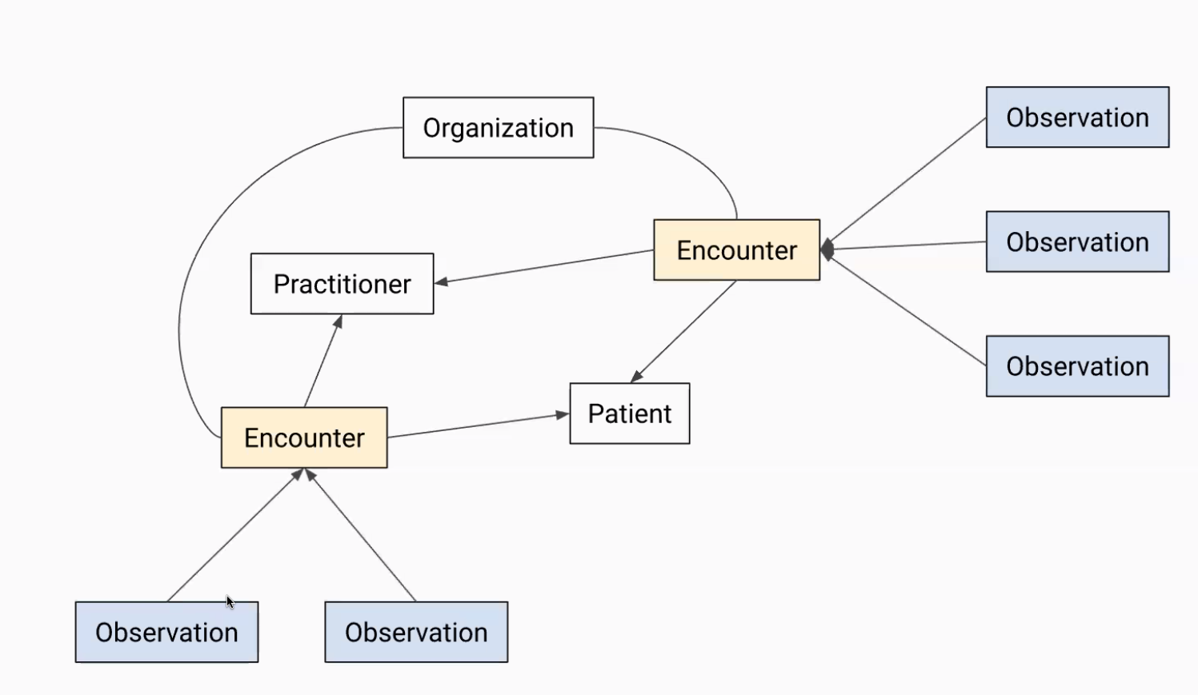
A “bundle” is an array that combines all of this objects.
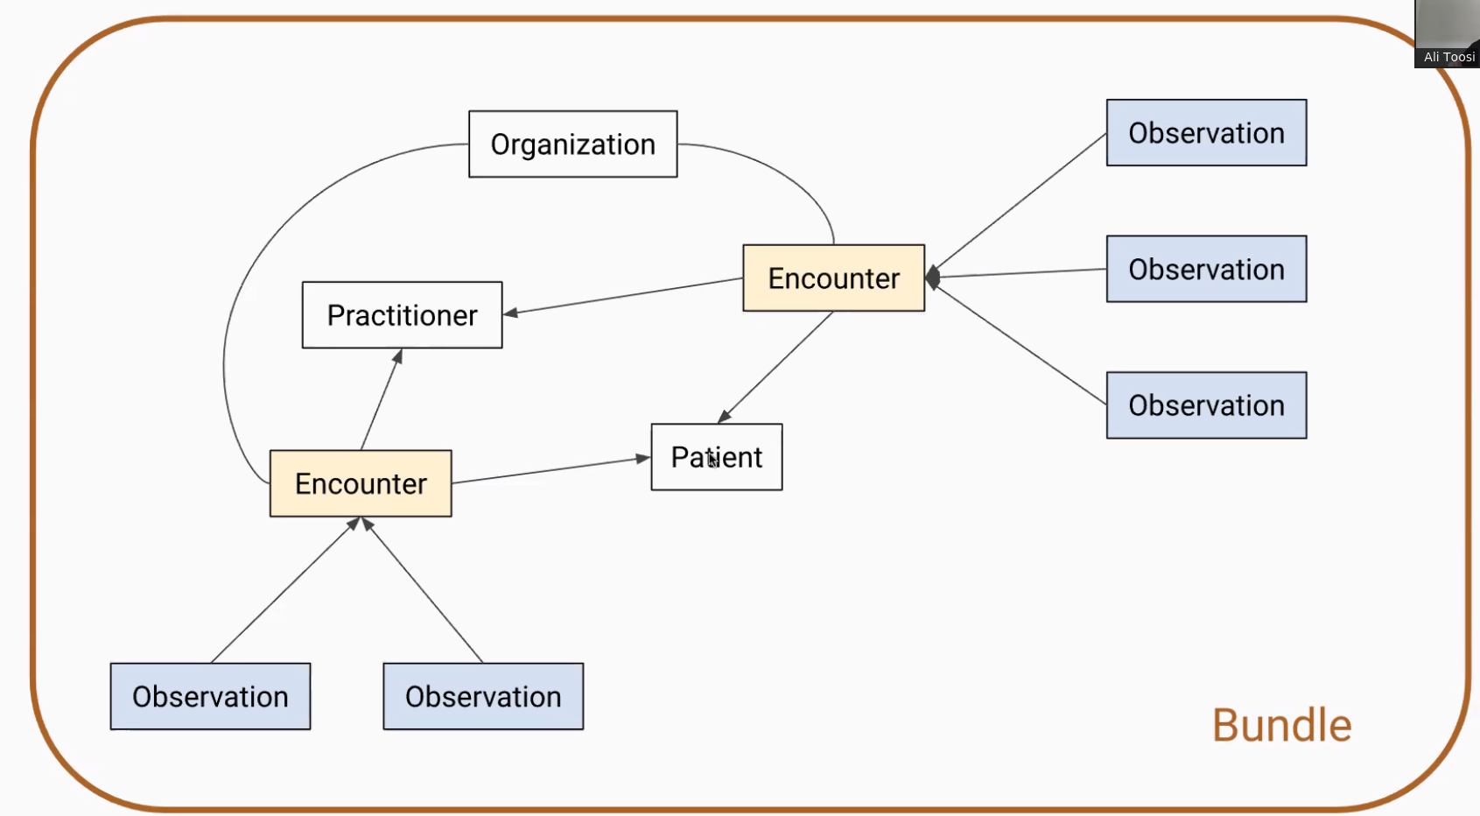
Everything in a bundle is related (all the objects contained in a bundle).
The json will be a bundle of bundles of patients. We will download several json files. Each file will be a bundle of bundles.
A practitioner can be related to many organisations.

Competition:

If results are tied, delivery time can be a tie-break criterion.
20 MB size limit to uploading files. Zip or txt.

