FIT5147 – Narrative visualisation project

Semester 2 – 2020

Australian 2019-2020 summer bushfires and the effects on air-quality conditions in NSW.

Author: Gonzalo Sepulveda.
Student ID: 29505445

Tutors: Bruno Vasquez – Ying Yang
Monash University
Table of Contents
1 Introduction 3
2 Design 3
2.1 Sheet 1: brainstorm 3
2.2 Sheets 2, 3 and 4: proposed layouts 4
2.2.1 Sheet 2 4
2.2.2 Sheet 3 5
2.2.3 Sheet 4 6
2.3 Sheet 5: Final design 7
3 Implementation 9
4 User guide 9
4.1 Map 9
4.2 Active fires bar plot 10
4.3 Air quality plots 12
5 Conclusion 13
6 Bibliography 13
7 Appendix 13

Introduction
Australia’s last bushfires were unprecedented. They had devastated a huge area of SE Australia, taking human lives, destroyed homes and infrastructure, covered cities in smoke and caused a tremendous loss of wildlife flora and fauna (The Guardian, 2020). The most affected state was New South Wales (State of NSW and Department of Planning, Industry and Environment, 2020).
From the human health point of view, air pollution caused by bushfires can mean high risk to the population. One of the 10 major health risks in Australia relate to air pollution (mostly particular matter pollution) (IHME, 2020). Watts et al. (2015) has shown the relationship between fires, particulate pollution and respiratory and cardiovascular diseases.
Several pollutants are continuously being monitored by the Government of NSW across the state. This work describes the development process of a visualisation tool that allows the user to explore and better understand how the 2019-2020 summer bushfires were related to air quality conditions in NSW, in space and time. The tool was implemented using the D3 javascript library.
The visualisation included the most relevant insights obtained from the previous data exploration task. The visualisations included allow to have answered two of the three original research questions:
1. What was last bushfire season’s wildfires dynamic across New South Wales?
2. How are wildfire events related to air-quality conditions?
The research question “Which air pollutant is the most sensitive to wildfire events?” was not taken into account since it was straightforwardly answered in the exploration part of this project, and did not represent sufficient input to be included in the interactive visualisation.
The narrative message of the visualisation aims to provide a clear picture of how many fires occurred in the study period, how they were spatially distributed, in what times of the study period they occurred and how air pollution reacted to the different scenarios. Using the tool to analyse bushfire events and air pollution in space and time simultaneously, the user will be able to understand how these two phenomena are related.
The visualisation’s target audience is the professional and scientific community already involved in environmental issues. It includes professionals and researchers from environmental sciences, earth sciences and climate sciences, as well as from the bushfires and human health fields. It is also targeted to interested citizens also already involved in environmental matters, who are expected to have some background knowledge about the environment dynamics and used to visual representations of data. It is assumed that all targeted users are familiar to data graphs and to the ways in which they are read.

Design
To design the visualisation tool, the five design sheet methodology was used. The most relevant outcomes are set out below.

Sheet 1: brainstorm
Many ideas for the brainstorm step of the methodology were obtained from the previous data exploration stage of the project. 13 sketches were designed including maps, line plots, bar plots, Gantt plots, bubble charts and a heatmap (Figure 1, left). 6 of these sketches were discarded since they represented design difficulties, such as different scales of data series. Others required relatively confusing aggregations that would have made the plots harder to understand, and others simply did not represented the data in an effective way. Out of the 7 remaining sketches, 4 were combined into 2 (Figure 1, right) leaving finally 5 graphs to the subsequent layout design steps.
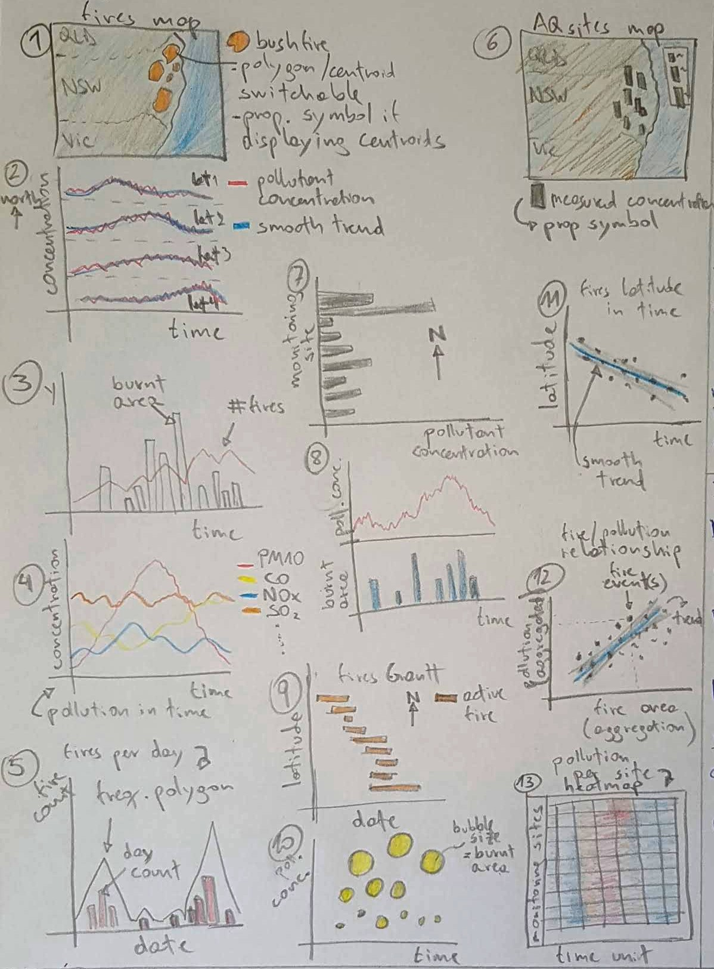
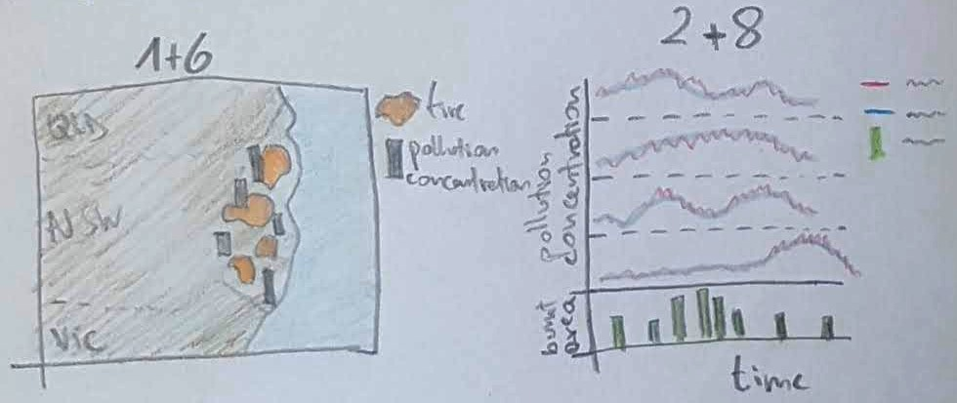
Figure 1: Sheet 1 brainstorm sketches (left) and combinations (right).

Sheets 2, 3 and 4: proposed layouts
All layouts designed were intended to contain all the available data in a single screen. Although this could result in an overwhelming amount of data to digest, the intention was to give the user access to all available data and interaction results without having to scroll the screen or switch tabs.
Since the underlying data was about bushfires in space and time, all proposed layouts included a map. All the following proposed designs considered the 5 data representations filtered during the brainstorm stage.

Sheet 2
The layout is shown in Figure 2. It included the following operations:
- A - Interactive map: the user can zoom in/out and drag. Tooltips on mouse over fire polygons.
- B – Radio buttons to switch between fire polygons and polygon centroids, or to show/hide monitoring site pollution concentration bars.
- C – Radio buttons to allow selection of pollutant to display.
- D – Date range selector for showing in the map starting fires in the specified period.
The pros and cons of this layout are specified in Table 1.

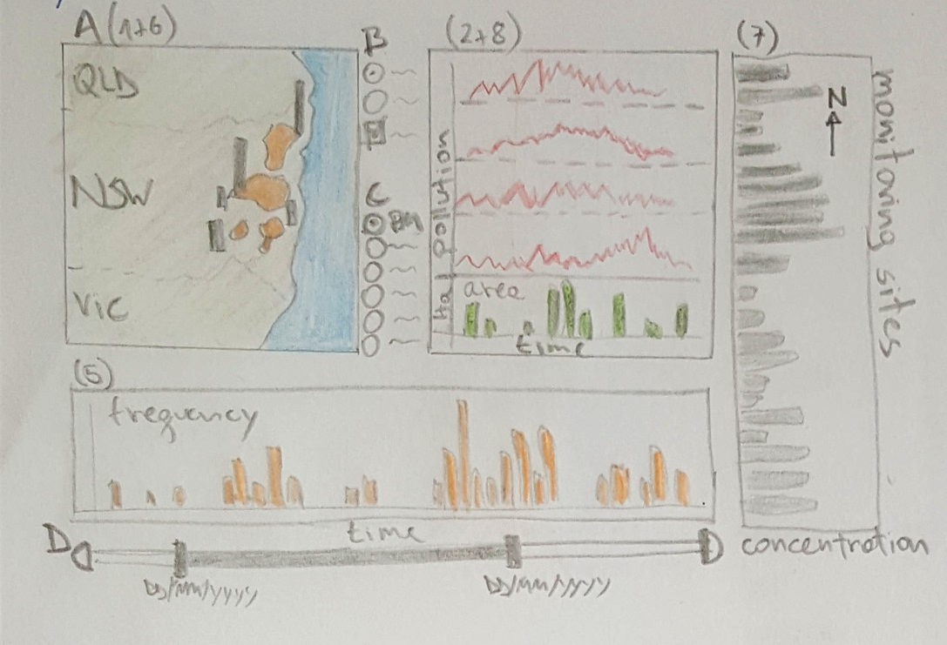
Figure 2: Sheet 2 layout.

Table 1: Advantages and disadvantages of proposed layout.
Pros | Cons
- Display depth of data, general and specific information.  - Interactions would allow full dataset exploration. | - It could look a bit cluttered in the screen.  - Showing general information (map and line plots) and detailed information (monitoring sites bar plot) at a same level can be confusing.

Sheet 3
This layout included a bigger map box to facilitate fire polygons exploration (Figure 3). It included a summary box at the bottom right corner to show specific data about date range period selected.

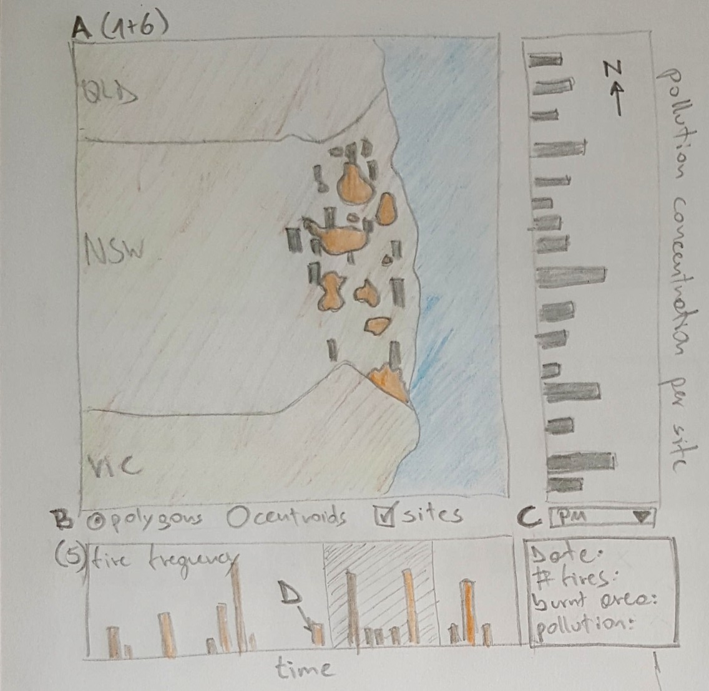
Figure 3: Sheet 3 layout.

Operations:
- A – Interactive map: the user can zoom in/out and drag. Tooltips on mouse over fire polygons.
- B – Radio buttons to switch between fire polygons and polygon centroids, or to show/hide monitoring site pollution concentration bars.
- C – Drop down menu to allow selection of pollutant to display.
- D – Date range selector included in bar plot of fire frequency per day, as part of the plot’s interactivity.
Table 2: Advantages and disadvantages of proposed layout.
Pros | Cons
- Big map display allows easier fires inspection.  - Date selection incorporated in plot allows to save space for data display. | - Does not show fire area and air pollution relationship.  - Makes it difficult to understand pollution dynamic in time.

Sheet 4
This layout now included a heat map to show the general dynamics of pollution in time, for every single monitoring site (Figure 4). All operations considered were exactly the same to the ones of the previous sheet:
- A – Interactive map: the user can zoom in/out and drag. Tooltips on mouse over fire polygons.
- B – Radio buttons to switch between fire polygons and polygon centroids, or to show/hide monitoring site pollution concentration bars.
- C – Drop down menu to allow selection of pollutant to display.
- D – Date range selector included in bar plot of fire frequency per day.

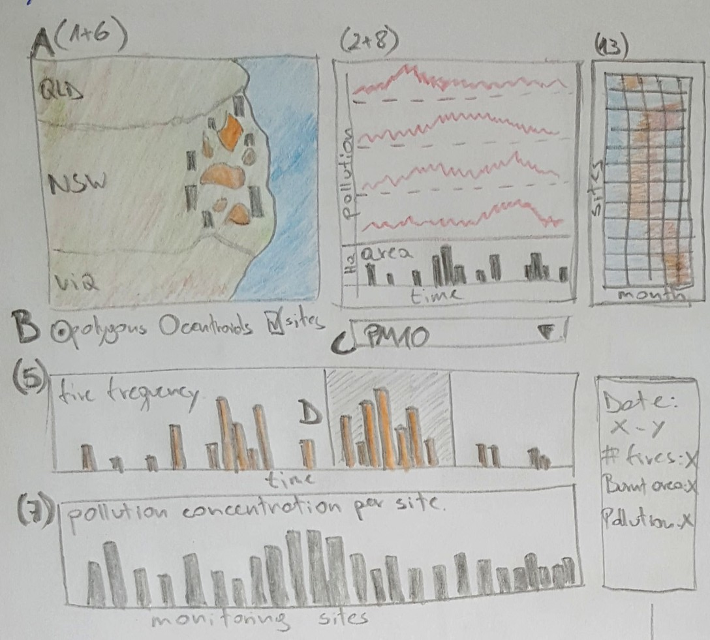
Figure 4: Sheet 4 layout.

Table 3: Advantages and disadvantages of proposed layout.
Pros | Cons
- It shows all information in depth.  - No different information levels mixed at the same visualisation levels. | - Pollution concentration (bars) cannot be displayed in latitudinal order.  - This layout might need scroll the screen down.  - Pollutant selector (operation C) would update plots visually separated (pollution lines and pollution bars).

Sheet 5: Final design
Finally, taking into account all layouts proposed in sheets 2, 3 and 4 and their advantages and disadvantages, the final design consisted in a mixture of all of them. It included the map, pollution line plots and fires burnt area, fire frequency per day as date range selector and a summary box. In relation to the heat map and pollution per sites bar plot, these two plots were decided to take the same space in the screen, giving the user the ability to switch from one to the other (Figure 5).

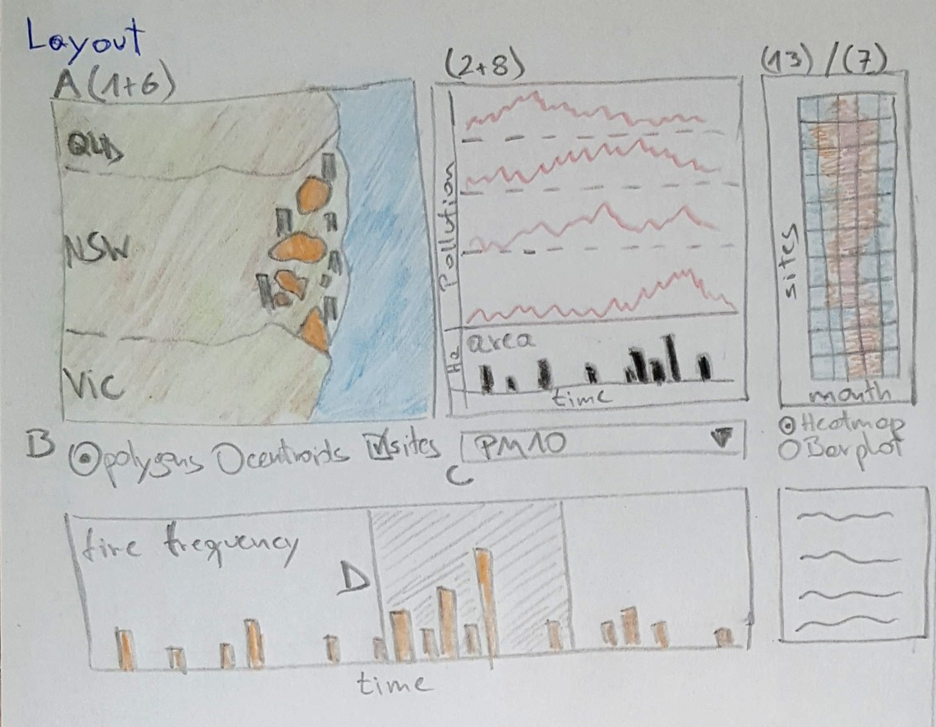
Figure 5: Sheet 5 final design layout.

The focus of the final design consisted mainly in three actions. These would allow the user to get specific data values from the general picture in the following ways (Figure 6):
- Switching the heat map to the bar plot when specific pollution concentration values of a given site were needed.
- Summary box would allow the user to have the exact values of the number of fires, burnt area and pollution concentration values for a given date range selected.
- Tooltips would provide specific values of interactive objects when mouse hovers over fire polygons, heat map and pollution bar plot, pollution line plots and fire frequency bar plot.

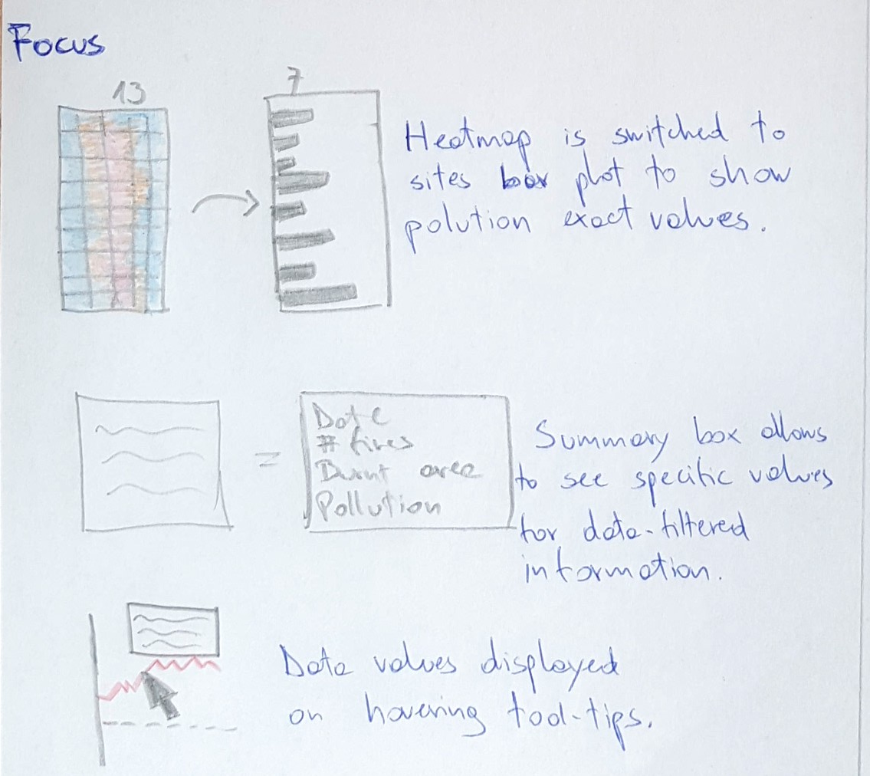
Figure 6: Sheet 5 focus techniques.

Final design operations were the same as sheet 4 operations. The only difference was to include interaction to be able to switch between heat map and bar plot:

- A – Interactive map: the user can zoom in/out and drag. Tooltips on mouse over fire polygons.
- B – Radio buttons to switch between fire polygons and polygon centroids, or to show/hide monitoring site pollution concentration bars.
- C – Drop down menu to allow selection of pollutant to display.
- D – Date range selector included in bar plot of fire frequency per day, as part of the plot’s interactivity.
- Radio buttons to switch between heat map and pollution bar plot.
As per the details of implementation, the following were considered:
- At least two source datasets would be required to develop the proposed visualisations.
- Data wrangling algorithms would be necessary to create aggregations required by data filtering and pollution line plots.
- The visualisation tool would be developed using D3 javascript library.
- The data wrangling steps would be performed in R using mainly tidyverse, lubridate and sf libraries to get it ready to be read by D3.
The final layout was considered to be the best mixture of all data and sketches available at this design stage of the project, since it covered in depth the information from all the data available.

Implementation
All the data required by the visualisation tool was manipulated and wrangled using R. For this purpose, the sf, tidyverse, lubridate and geojsonsf libraries were used.
The visualisation was implemented using javascript, specifically the D3 library, version 4. Also d3-scale-chromatic and d3-format extensions were included.
The final implementation layout did not include all the proposed graphs in the final design sheet, nor all of its functionalities. The heat map and the pollution bars per site were discarded. During the implementation, these two plots showed to be no valuable additions. The heat map was found to be unclear given the amount of days in the study period. Squares inside the plot area looked completely overlapped. This could have been solved by grouping days in bigger time units, although this would have introduced noise to the visualisation since all other plots’ time scales considered days as units. As per the pollution bar plot, it was not found to be useful since there were too few sites that showed interesting variability. Considering the proposed design, it was to be very hard and user unfriendly to find the days were these sites showed high variability by selecting specific date slices. The pollution bars per site in the map were also excluded due to the same reasons.
On other hand, an accumulated burnt area plot replaced the originally proposed burnt area per fire started on a given day. This change was made because the information provided by accumulated burnt area was more useful and represented a clearer relationship with pollution levels. At the same time, the daily fire frequency plot was replaced by an active fires count plot per date unit. Again, active fires showed to be better at explaining pollution levels compared to the amount of fires started on a given day. The latter data values were included in a tooltip.
In addition, the proposed summary box was eliminated, replaced by tooltips on interaction.
Finally, the map included a non previously designed feature. Besides showing only the fire polygons in the territory for the whole study period, it also showed in different colours active and already inactive fires up to certain date chosen by the user. This feature provided more insight about the relationship between active fires and pollution levels at different latitudinal sections of NSW. It also was considered more relevant than switching from polygons to centroids, the reason why this originally proposed feature was left out of the implementation.

User guide
The final implementation was simpler than the original design, but not less informative. Figure 7 shows its presentation.
The tool contains an informative text to the right side of the screen, which explains how to interact with it. The text appears along with the user interaction, although it is not necessary to follow these instructions to start interacting.

Map
The implemented map is based on the javascript Leaflet library, so interactions with it include dragging and zooming in/out. Hovering over fire polygons will show a tooltip with name and date period of the corresponding fire, and also the area this fire burned. Polygons are highlighted in red when hovering over (Figure 8).
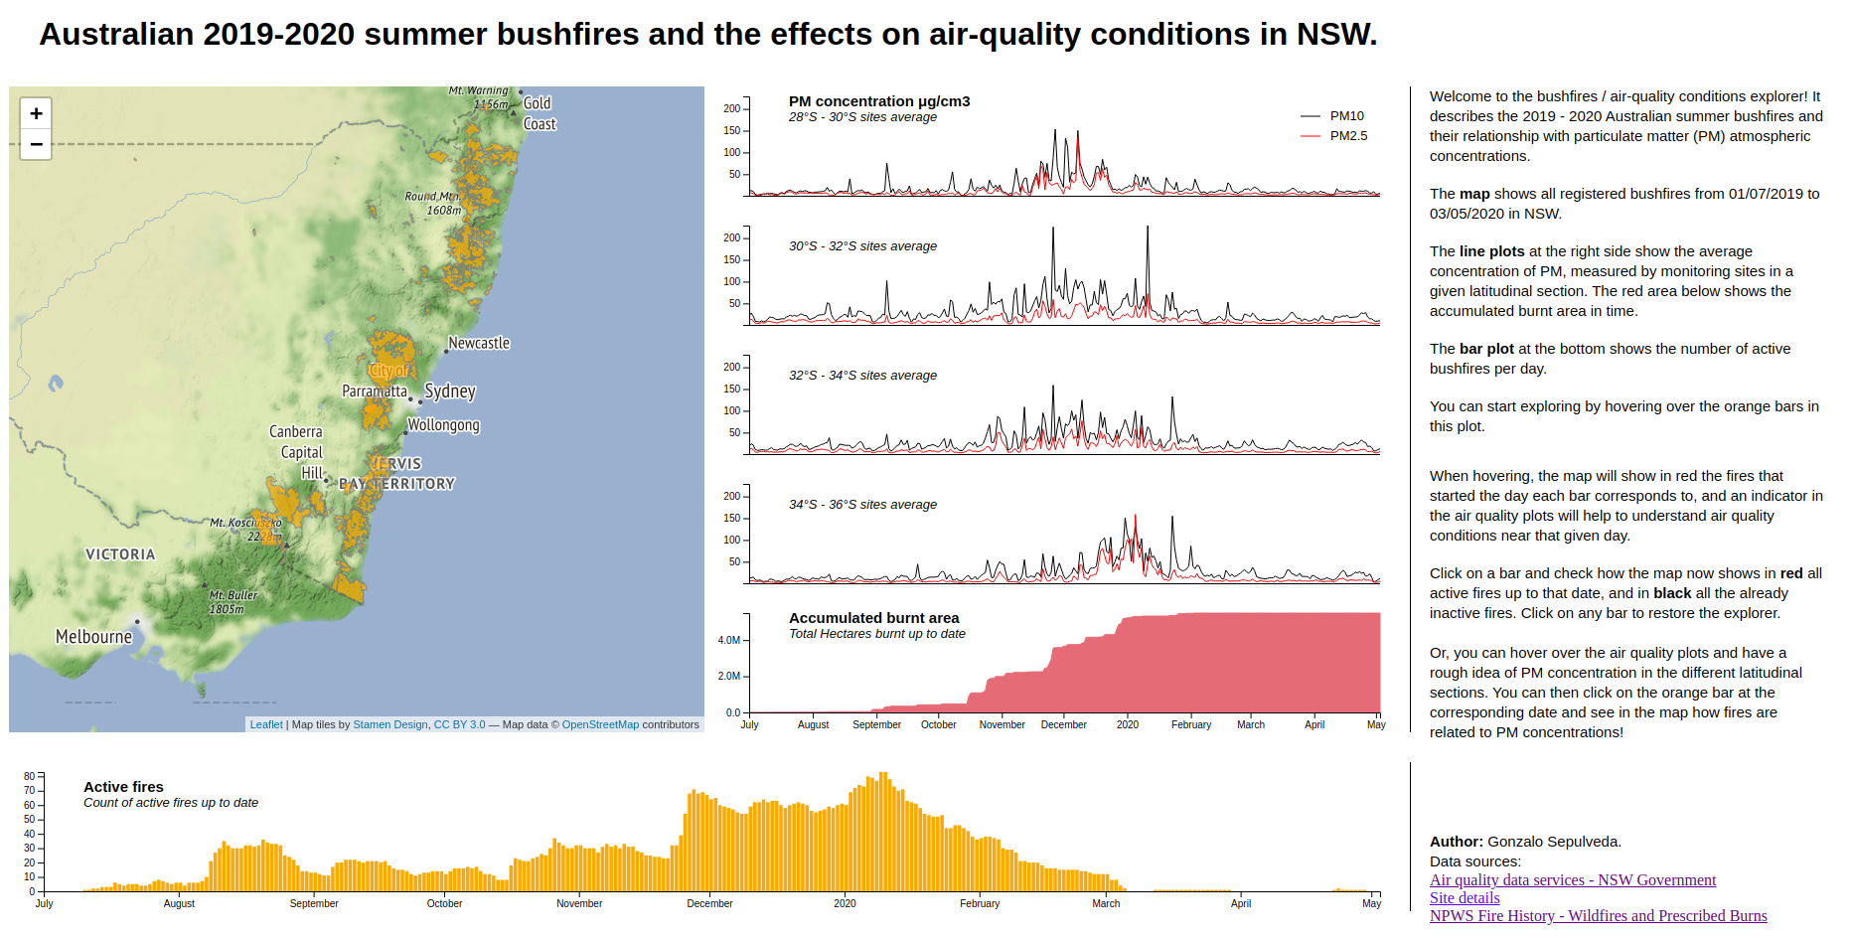
Figure 7: Bushfires visualisation tool screenshot.

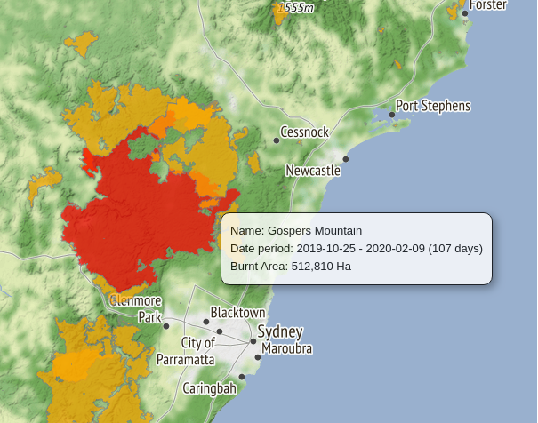
Figure 8: Fire polygons interaction. Red highlighting and tooltip is showed when hovering over with the pointer.

Active fires bar plot
This plot is the central feature of the visualisation. It acts as the main discovery instrument, since bars can be hovered over and also clicked.
When hovered over, a tooltip will be displayed indicating the corresponding date selected, the number of fires started that day, and also the exact number of fires actives by that date (Figure 9).
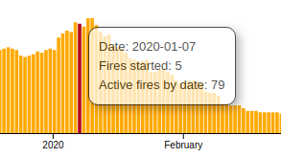
Figure 9: Active fires bar plot hovering tooltip.

At the same time, hovering over this bars will display a vertical line in the air quality line plots, indicating the corresponding date (Figure 10, right). This way, the user can straightforwardly explore the effect of the amount of active fires in air pollution levels. Fires started the day of the corresponding hovered bar will be highlighted in red (Figure 10, left).

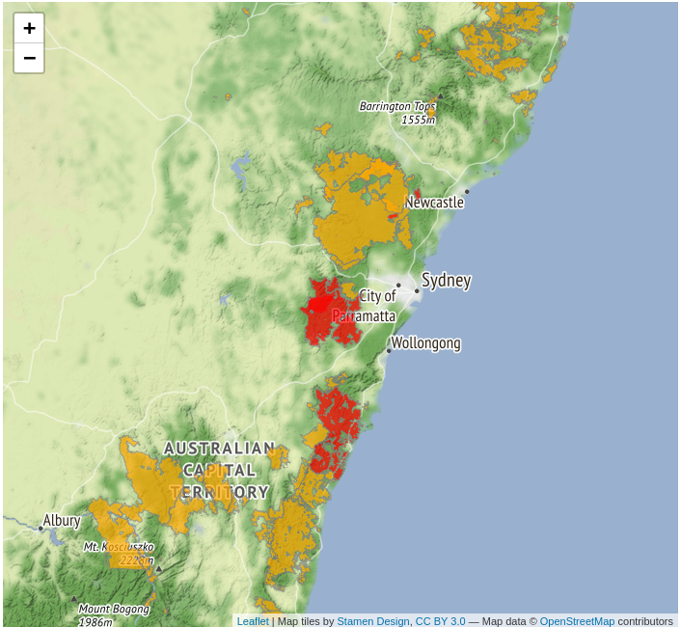 | 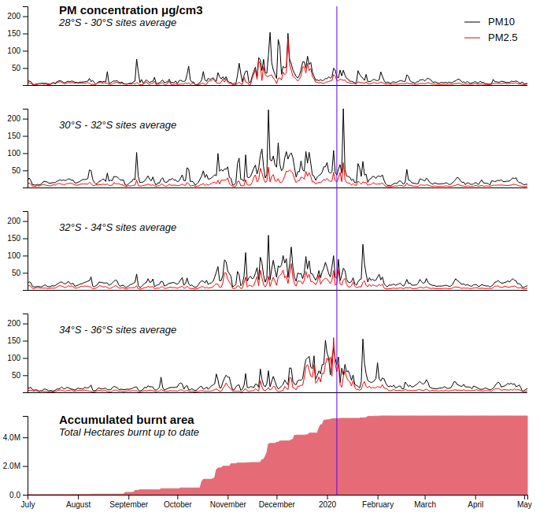
Figure 10: Hovering over active fires bar plot highlights fire polygons (left) and displays vertical indicator in air quality plots (right).

By clicking on a bar on any given day, the map will display fires only from past days up to the selected day. Active fires will be displayed in red, while already extinguished fires will be shown in black (Figure 11). The blue vertical indicator in the air quality plots will remain displayed while the user interacts with the map, exploring active and inactive fires.
Clicking again on any bar will restore the original behaviour of the tool.

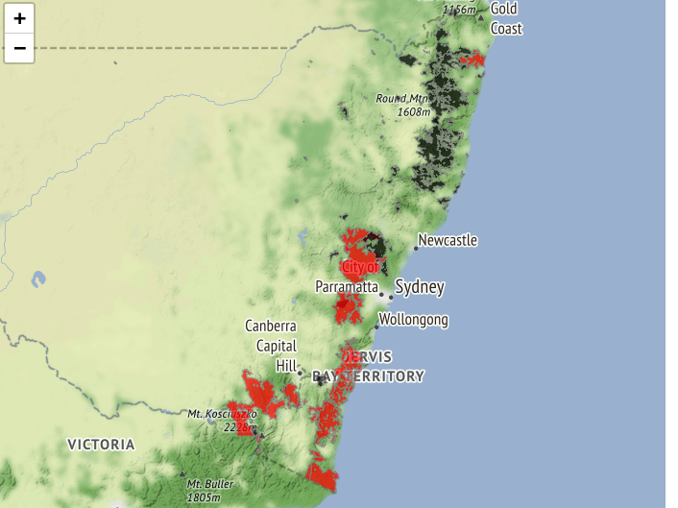
Figure 11: Clicking on any bar will make the map show active fires in red and extinguished fires in black.

Air quality plots
Finally, interaction with air quality plots is very simple. On hover, they will display a horizontal bar from the line value to the y-axis, allowing the user to get a rough idea of the PM10 pollution concentration. This was meant to be like this, since exact values are not as important as the general trends of the data series.
Simultaneously, a vertical indicator will be displayed accordingly in the accumulated burnt area plot to facilitate comparison between pollution concentration and area already burnt in the study area (Figure 12).

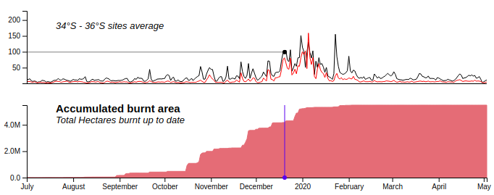
Figure 12: Hovering over pollution concentration plots will display horizontal and vertical guides.

Conclusion
The most immediate conclusion from this work is how different original design and final implementation can be. Many of this differences are due to having the wrong idea about effective visual data representations at the design stage. It is easy to imagine useful plots that, once implemented, do not fit well in the tool or do not make any contribution to the message it is intended to convey. On the other hand, many new ideas can be a product of the implementation process itself. They can arise along with the code development as the tool is being tested, to improve usability, interactivity and data understanding.
As per the programming language, it can be concluded that it is really not difficult to learn. Having knowledge and experience using other programming languages, understanding javascript and D3 is not very difficult to achieve. It is, however, more time consuming than other visualisation tools and requires a lot of more work in comparison. On the bright side, time consumption is fully compensated by how powerful D3 and flexible D3 can be, allowing the programmer to implement any idea she can come up with. I all will depend on programming skills and the project time frame.
Although D3 is not so difficult to understand and learn, experience in javascript coding is a huge advantage. This work was the first real experience coding D3 and javascript, which can be clearly reflected in a not so efficient script. Undoubtedly, efficient and tidy code can be achieved with experience, which is encouraging to keep programming visualisations in D3 when the situation requires it.
Other important idea consolidated during the development of this work is that the simpler, the better. Too fancy interactivity, graphs and animations can be distracting and deviate the user’s attention away from the visualisation’s message. Simple and traditional plots can help to get faster understanding of the underlying data and also to generalise to a wider audience, at the same time being sufficiently clear and effective.
Finally, it can be concluded that valuable experience was obtained while working on this data visualisation project, which is completely beneficial for professional development and skills enhancing.

Bibliography

- Bostock, M (2012). D3 + Leaflet. Retrieved from https://bost.ocks.org/mike/leaflet/
- Government of NSW and Department of Planning, Industry and Environment. (2020). NSW Fire and the Environment 2019–20 Summary. Retrieved from https://www.environment.nsw.gov.au/-/media/OEH/Corporate-Site/Documents/Parks-reserves-and-protected-areas/Fire/fire-and-the-environment-2019-20-summary-200108.pdf
- Holtz, Y. Customizing heatmap in d3.js. The D3.js Graph Gallery. Retrieved from
https://www.d3-graph-gallery.com/graph/heatmap_style.html
- IHME. (2020). Retrieved from http://www.healthdata.org/australia
- Leaflet. A JavaScript library for interactive maps. Retrieved from https://leafletjs.com/
- Mackay, M. (2016). Make an element follow a path. Retrieved from http://bl.ocks.org/methodofaction/3824661
- Murray, S. (Ed.). (2017). Interactive Data Visualization for the Web. An introduction to designing with D3 (2nd ed.). United States of America: O’Reilly Media, Inc.
- shimizu. (2018). D3 v4 – Leaflet. Retrieved from http://bl.ocks.org/shimizu/983c7f833c586e854e42716495e4fb11
- The Guardian: https://www.theguardian.com/environment/ng-interactive/2020/feb/11/counting-the-cost-of-australias-summer-of-dread
- Watts, N., Adger, W. N., Agnolucci, P., Blackstock, J., Byass, P., Cai, W., . . . Costello, A. (2015). Health and climate change: policy responses to protect public health. The Lancet, 386(10006), 1861-1914.

Appendix

