Booking management System
REQUEST FOR PROPOSAL

  - June 10, 2016
EPAM Systems Inc.
41 University Drive
Newtown, PA 18940
Tel 267-759-9000
Fax 267-759-8989
www.epam.com

Executive Summary
Established in 1993, EPAM Systems, Inc. (NYSE: EPAM) is recognized as a leader in software product development by independent research agencies and widely recognized as one of the world's premier software engineering firms with deep understanding in verticals including Retail, Banking and Finance, Media and Entertainment, Travel and Hospitality, ISVS and Technology, Life Sciences and Healthcare.
Headquartered in the United States, EPAM serves clients worldwide utilizing its award-winning global delivery platform and its locations in over 26 countries across North America, Europe, Asia and Australia. EPAM employs over 19,000 professionals. It requires frequent traveling of employees across different EPAM’s and clients’ offices.
EPAM procured in average 5000 hotels rooms and 1000 taxis in 2015 year. EPAM employs mostly manual approach for booking, which requires significant amount of time for communication with employees, travel department and hotel and transport suppliers.
EPAM is looking for robust booking management system for hotel and transport suppliers which can incorporate all current and planned future level of accommodation and transport management requirements.

Project Overview
EPAM wants to work with a Supplier to create a SaaS-based booking management system which the Supplier will then host and support. This system will become the sole source of accurate Hotel and Transport bookings allowing access for our travel department, transport suppliers and employees to manage their confirmed bookings.

EPAM is opened to recommendations on system design to fulfil the high-level objective of creating a single system to become the sole source of accurate Hotel and Transport bookings as detailed in functional and non-functional requirements. Supplier should meet the requirements in a cost efficient manner.
Key aspects of the system must take in to account:
  - Cost Reduction: centralized reporting tool for day-to-day management, improved hotel management and financial budgeting.
  - Automation: enhanced automation to remove existing manual processes.
  - Integration: integrated with EPAM’s Cost Tracking Center (API), UPSA (API) and SSO (Documentation).
  - Simplistic and Intuitive: common look and feel for all users throughout the entire system, built on business processes which are clear, concise and logical.
  - Flexibility: a highly configurable solution which can support EPAM’s evolution.
  - Performance: a highly performant system which operates to support high demand and support critical instances such as major disruption situations.

This context and scope diagram provides an overview of our vision and should be used in addition to the requirements.

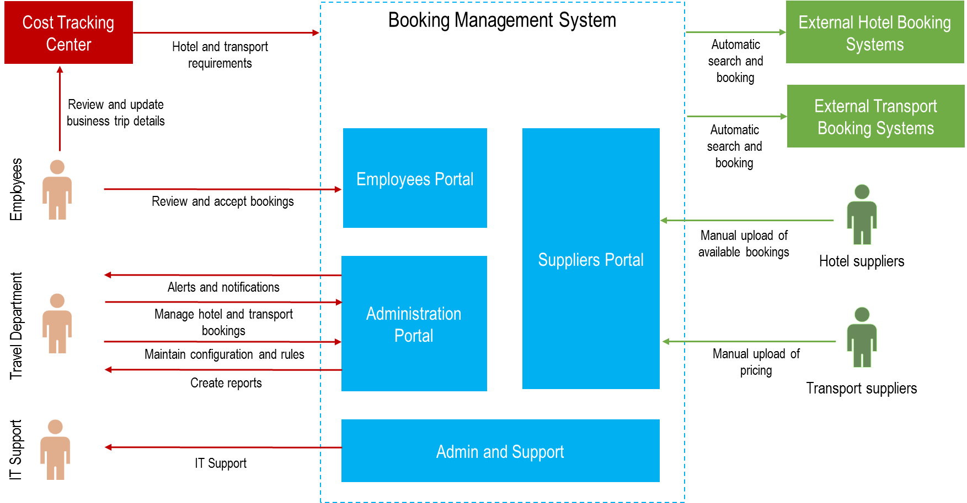

Requirements

Functional Requirements

Supplier Search and Prioritization
System should support intelligent search across multiple third-party systems and manually uploaded bookings based on requirements specified in the system. Prioritization should be done based matching to specified booking requirements and custom rules defined by Travel Manager in Administration Portal. Booking requirements are initially defined in Cost Tracking Center and could be amended by appropriate employee in Employees Portal or by Travel Manager in Administration portal. The prioritization may change over time as booking requirements or rules are changed.

Approval and Booking
System should provide robust support of approval and booking processes. It should support various stages of booking, such as Proposed, Accepted/Rejected, Approved/Declined, Booked/Canceled and Paid. Stage changes should be supported by notifications via email and SMS. System should provide ability to change and extend booking process in future.
Along with automatic booking, system should support ability for manual hotels booking, managed by Travel Manager, and allowing to passing all booking details via web site forms.

Changes Management
System should support frequent integration to CTC to update booking requirements. New requirements, changes to existing requirements and cancellations are driven by the content of these frequent updates. New changes should be merged according to defined policy in case of any conflicts, appropriate alerts should be send to parties. System should support the ability to manually change selected hotel for various reasons as required.

3rd Party Hotel Suppliers
3rd party hotel suppliers should be able to get access to the system, and manually upload available booking, pricing and other details. Booking process in this case will be handled manually.

Support Transport Suppliers
System should support only one transport supplier (Uber), all other suppliers will be integrated in a manual way. Pick-up and drop-off locations should be initially loaded from CTC, but could be amended in Employees and Administration portal. System should provide ability to override defined pick-up and drop-off locations.

Transport Combining Opportunities
System should support combining of multiple transport bookings.

3rd Party Transport Suppliers
3rd party transport suppliers should be able to get access to the system, and manually upload available pricing details. Booking process in this case will be handled manually.

Employees Portal
Employees require access to view information related to upcoming hotel and transport bookings, including:
- Ability to view details of each booking along with it status. All necessary booking information is available and accurate.
- Ability to confirm hotel and transport reservations.
- View and print confirmed reservations.
- Seamless access portal vis SSO
System should provide ability to capture feedback from employees and associate it to a particular booking.

Administration Portal
Administration Portal should provide capabilities for Travel Manager to interact with the system configuration, provide visibility of booking statuses and provide reporting abilities, along with providing abilities to fulfil other requirements. The portal will be the front end user interface to access all the functions available to administer the system and control the configuration etc.

Reporting Capabilities
System should provide reporting capabilities, to support following types of reports:
- Booking details
- Suppliers reporting
- Financial reporting

Non-Functional Requirements
Category | Requirement
Usability | The system will use modern web based technologies to deliver a fresh, clean and intuitive end user experience which seamlessly aids the user in their activities.
Usability | The system will support multiple display resolutions, including mobile/portable devices, without degrading usability.
Architectural | The system will include a scalable, high performing structured database platform capable of storing and processing large volumes of data.
Architectural | You will ensure that the system utilizes and maintains ‘up to date’ technologies for the system/platform. This will entail periodic reviews of the suitability of the current versions and planning upgrades where necessary.
Architectural | The system will be designed in a manner which enables a high level of configurability to react to emerging changes in legislation, internal policy, business process or organization structure (as examples).
Availability & Performance | The system is expected to perform in line with modern user expectations.  For example, simple screen load times will appear almost instantaneous (e.g. <2 seconds) and reports generating large amounts of data will not take an excessive amount of time as to cause frustration to end users. Performance criteria will be defined in the design stage.
Disaster Recovery | The system will be highly available and resilient in order to minimize the risk of service failure.
Configuration Management | The supplier shall adopt adequate configuration management and version control across all environments and documents.
Deployability | The supplier will employ robust procedures for the promotion of any code/patch/release/change into a live environment with the aim of minimizing negative impacts to business operations.
Scalability | The system must be designed and implemented in a manner which enables the solution to grow in the future.
Data Security | All authenticated client traffic must be transmitted via encrypted channels using TLS1.2 as a minimum.
Data Security | Management and transmission of customer data must comply with the Data Protection Act.

