Here is collected the formulas used in utility programs for calculations of differential cross section.

LS coupling: (utility dif_sec_LS)
See also:
1. Salvini A A (1982) CPC 27, 25
2. Griffin D C and Pindzola M S (1990) Phys. Rev. A 42, 248

The scattering amplitude for electron-ion scattering from an initial states
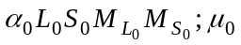
to a final state
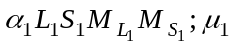
in LS coupling is given by
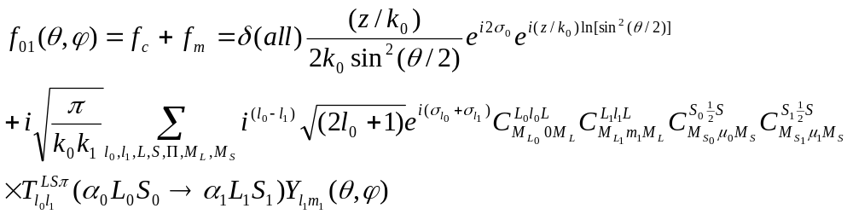
where first term represent purely Coulombic scattering in the elastic channel; k₀ and k₁ are the linear momenta of the incident and scattering electrons, respectively; l₀,m₀,μ₀ and l₁,m₁,μ₁ are the orbital angular momentums, orbital magnetic, and spin magnetic quantum numbers of the incident and scattering electrons, respectively; σ_{l} is the Coulomb phase shift, 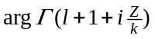; 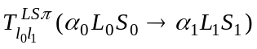 is an element of the T-matrix for a give total angular momentum L, total spin S and parity Π. In the above formula we assume the z axes is chosen along the direction of the incident beam. As consequence, m₀=0 and m₁=M_{L1}-M_{L}, are not free parameters.
The DCS is then determined by squaring the scattering amplitude, averaging over the initial states, summing over the final states, and multiplying by the ratio of the final and initial linear momenta:
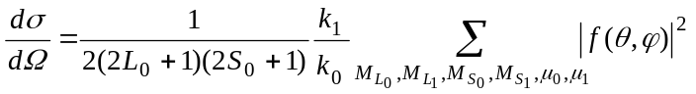
with
After summation over magnetic numbers, we have:
The first term, purely Coulombic scattering, is
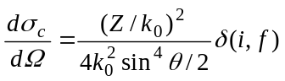
The second term, interference term, can be represented as
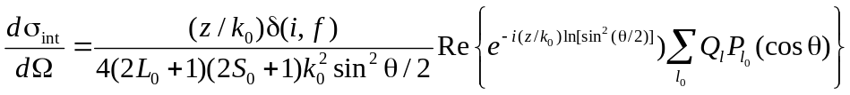
where
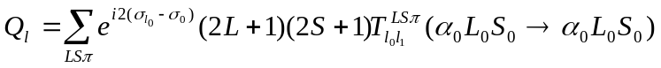
Finally, the third term is given by
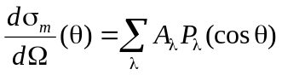
where
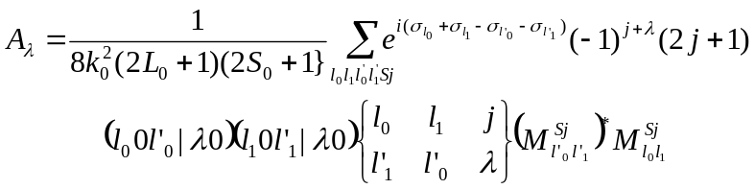
and j is the momentum transfer, i.e. the angular omentum actually transferred during the collision from the incident electron to the target:
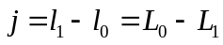
In neutral case:
ICS: (angle-integrated cross section):
Momentum transfer:
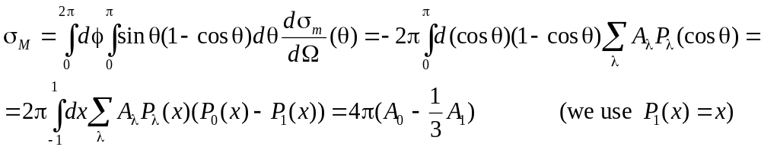
JK –coupling: (utilities sec_dif_JK, sec_dif_JK_ampl)
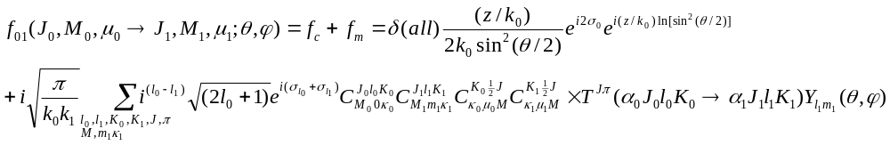
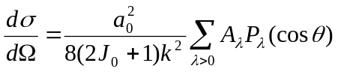

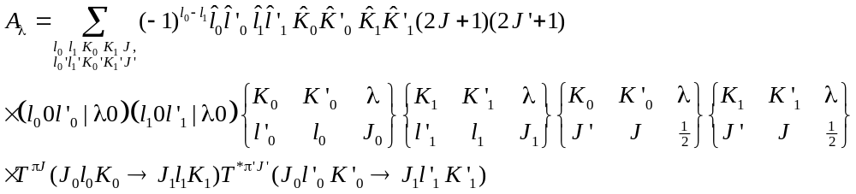
(see also MJK program by A.Grum-Grzhimailo, CPC, 152 (2003) 101)

JJ –coupling (utility sec_dif_JJ_ampl)

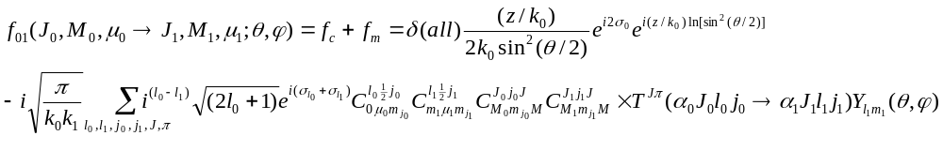
(relative phase between the Coulomb and potential part (±i) is different in different publications)
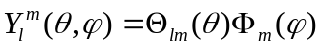
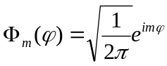
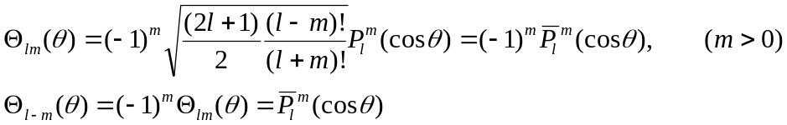
Considering φ=0, we may rewrite expression as
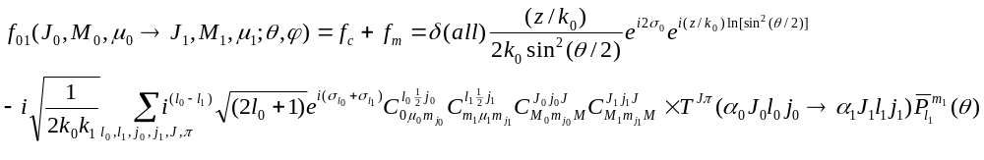
( 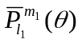 - is given by program ALEGFM)
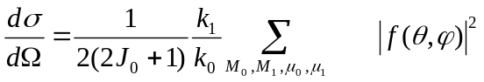
So, we may use direct calculation of scattering amplitude for different M’s and them sum their modules.
Angle-integrated cross sections (if needed) are then obtain direct integration of dσ by angles.
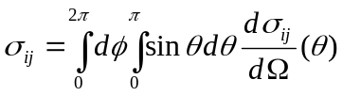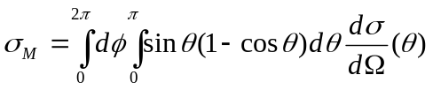

JJ –coupling (utility sec_dif_JJ)
In neutral case:
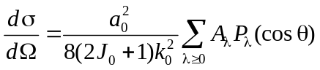
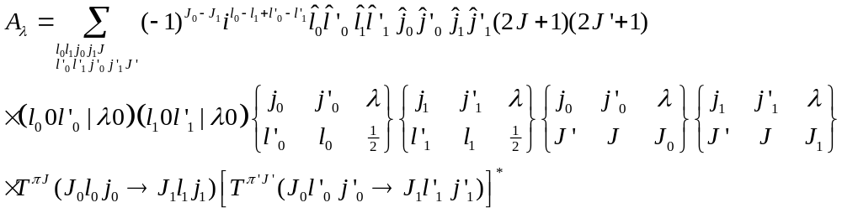
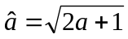;
Angle-integrated and momentum-transfer cross section can be express as:

Coulomb case: We again can express DCS as pure Coulomb scattering, interference term and potential term (first two only for elastic scattering, when initial, i, state equal final, f ).
