Description of utility-programs for treating radial functions from the HF/MCHF programs (folder UTILS/RADIAL)

S L A T E R _ W
Description: | transfers Slater-type orbitals to MCHF format
Input files: | name.slw
Output files: | name.w
Call: | slater_w name.slw

The Slater orbitals are supposed to be given as in the RMATRX1 code, i.e.,
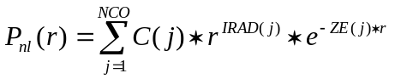.
The formatted file name.slw contains the Slater-type orbital parameters in the form:
1. Z, atom, term - nuclear charge, and optional identification for atom and term
2. nwf - number of radial wave functions
3. n,l,k - quantum numbers for given orbital
4. NCO
5. IRAD(1:NCO)
6. ZE(1:NCO)
7. C(1:NCO)
Repeat records 3-7 nwf times

