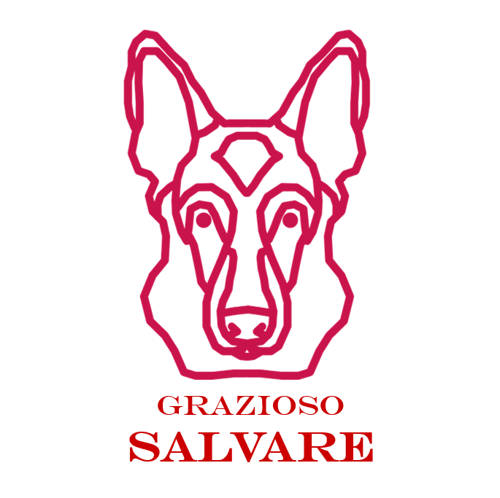
CS 340 Project Two README
Grazioso Salvare Rescue Animal Dashboard
Student: Shaban Ghaith

Project Functionality
For this project, I completed a client/server dashboard for Grazioso Salvare. The dashboard connects to the Austin Animal Center Outcomes data through my AnimalShelter CRUD module, displays the records in an interactive table, and lets the user filter rescue candidates by the three required rescue categories. When a filter is selected, the data table, breed chart, and geolocation map all update together.
- Water Rescue filters for dogs matching preferred water-rescue breeds, intact female sex, and training age from 26 to 156 weeks.
- Mountain or Wilderness Rescue filters for preferred mountain/wilderness breeds, intact male sex, and training age from 26 to 156 weeks.
- Disaster or Individual Tracking filters for preferred tracking breeds, intact male sex, and training age from 20 to 300 weeks.
- Reset returns the dashboard to the full unfiltered dataset.

Dashboard Proof Screenshots
The screenshots below are used as proof that the dashboard widgets work. Each screenshot should show the Grazioso Salvare logo and my unique identifier on the page.
[Screenshot placeholder] Starting state / Reset view showing all widgets
Replace this line with a screenshot that shows the dashboard logo and the unique identifier: Created by Shaban Ghaith | CS 340 Project Two.
[Screenshot placeholder] Water Rescue filter applied
Replace this line with a screenshot that shows the dashboard logo and the unique identifier: Created by Shaban Ghaith | CS 340 Project Two.
[Screenshot placeholder] Mountain or Wilderness Rescue filter applied
Replace this line with a screenshot that shows the dashboard logo and the unique identifier: Created by Shaban Ghaith | CS 340 Project Two.
[Screenshot placeholder] Disaster or Individual Tracking filter applied
Replace this line with a screenshot that shows the dashboard logo and the unique identifier: Created by Shaban Ghaith | CS 340 Project Two.
[Screenshot placeholder] Reset filter applied after using the rescue filters
Replace this line with a screenshot that shows the dashboard logo and the unique identifier: Created by Shaban Ghaith | CS 340 Project Two.

Tools Used and Rationale
Tool | Why I used it
MongoDB | MongoDB works well as the model layer because the animal records are document-style data. It stores flexible JSON-like documents, supports direct query filters, and works smoothly with Python through PyMongo.
Python | Python was used for the dashboard logic and database interface because it has strong data handling libraries and fits the existing Project One CRUD module work.
AnimalShelter CRUD module | This module keeps database access separate from the dashboard code. The dashboard calls read queries through the module instead of embedding raw database logic everywhere.
Dash / JupyterDash | Dash provides the web application view and controller structure. The layout defines the view widgets, and callbacks work as the controller by reacting to filter changes and updating the table/charts.
dash-leaflet | dash-leaflet displays the geolocation map using each animal record?s latitude and longitude fields.
Plotly Express | Plotly Express creates the breed pie chart and updates it dynamically based on the currently filtered table data.
Pandas | Pandas converts MongoDB records into DataFrames, which makes it easier to clean data and pass records into Dash tables and charts.

Resources and Software Links
- MongoDB / PyMongo: https://pymongo.readthedocs.io/
- Dash documentation: https://dash.plotly.com/
- Dash DataTable documentation: https://dash.plotly.com/datatable
- Plotly Express documentation: https://plotly.com/python/plotly-express/
- dash-leaflet project: https://www.dash-leaflet.com/
- Pandas documentation: https://pandas.pydata.org/docs/

Steps Taken to Complete the Project
- I reviewed the dashboard specifications document and identified the required filters, table, geolocation chart, second chart, logo, and unique identifier requirements.
- I created the AnimalShelter CRUD module so the dashboard can retrieve records directly from MongoDB using the aacuser account.
- I built MongoDB queries for the three rescue categories using animal type, breed, sex, and age_upon_outcome_in_weeks.
- I completed the ProjectTwoDashboard.ipynb layout with the Grazioso Salvare logo, my name, radio button filters, interactive Dash DataTable, Plotly pie chart, and dash-leaflet map.
- I connected the widgets with Dash callbacks so changing the rescue filter updates the table, chart, record count, and map.
- I added a CSV fallback so the dashboard code can still be reviewed or tested in an environment where MongoDB is not available.
- I prepared this README with reproduction steps and screenshot slots for final testing evidence.

Reproduction Instructions
- Open the project folder that contains ProjectTwoDashboard.ipynb, animal_shelter.py, Grazioso Salvare Logo.png, and aac_shelter_outcomes.csv.
- Make sure MongoDB is running and the AAC.animals collection contains the Austin Animal Center Outcomes dataset.
- Make sure the database user exists and set the password through the MONGO_PASSWORD environment variable.
- Install the needed Python packages if they are not already available: dash, jupyter-dash, dash-leaflet, pandas, plotly, pymongo, matplotlib, and numpy.
- Open ProjectTwoDashboard.ipynb in Jupyter Notebook or Codio.
- Run the notebook cell. The dashboard should start and show the Grazioso Salvare branded page.
- Use the radio buttons to test Reset, Water Rescue, Mountain or Wilderness Rescue, and Disaster or Individual Tracking.
- Take screenshots of each required state and replace the screenshot placeholders in this README document.

Challenges and How I Handled Them
The biggest challenge was keeping the dashboard connected cleanly across all layers. I handled this by separating the model code into animal_shelter.py and keeping the dashboard focused on layout and callbacks. Another challenge was making sure the breed filters matched real shelter data, since breed values often include mixed-breed labels. I used MongoDB regular expression matching so records such as Labrador Retriever Mix or German Shepherd Mix can still be found. I also added checks for empty filtered results so the chart and map do not crash when a filter returns no rows.

Files Included in the Code Submission
- ProjectTwoDashboard.ipynb - completed dashboard notebook
- animal_shelter.py - MongoDB CRUD module
- Grazioso Salvare Logo.png - dashboard branding image
- aac_shelter_outcomes.csv - local testing fallback dataset
- requirements.txt - Python package list

AI Use Acknowledgment
I used generative AI as a support tool to help organize the README wording and check the project structure. I reviewed the code, requirements, and final files before submission.

