Evaluator Test-Bench
Brief: This file includes the criteria and scores for evaluating the system.

Purpose: The Evaluator measures how well the pipeline performs against a benchmark - not a single pass/fail judgment, but a per-stage assessment against ground truth, run both as a one-time measurement and as a repeatable regression tool for comparing pipeline versions over time (e.g., after a prompt change or model swap).

Functionality: There are two distinct testing categories:
- Compliance Testing - Answers the questions: Did the process follow its own rules? Was the result correct?
- Accuracy Testing- based on human labeled data, comparison against labeled samples.

Dataset
The dataset will include:
- PCAPs and textual narratives describing attacks, protocols and regular traffic.
- Manually extracted list of actors, resolved to corresponding ips in the pcap file
- Manually extracted list of steps describing the traffic. Each step in the list will be manually grounded to a set of packets in the PCAP file.

Format
- Base PCAPs: of attacks, protocols and general network traffic, sourced from existing labeled datasets (e.g., ATT&CK-labeled traffic sets).
- Descriptions and step-level ground truth: authored and annotated manually, since no existing dataset provides claim-to-packet granularity.
- Annotation process: single annotator with a double-pass reconciliation process (label, wait, re-label independently, reconcile disagreements) - full multi-annotator inter-rater agreement validation is deferred to future work, appropriate for POC scope.

Dataset Composition
Target ~10 PCAPs for POC, diversity-prioritized over volume:
- 2-3 PCAPs: small, clean, single attack-type - basic pipeline flow proof
- 2-3 PCAPs: large enough to force real compression (thousands of packets, includes scan/flood pattern) - proves Preprocessing's core value
- 1-2 PCAPs: deliberately exceeds token budget - proves R4 fail-loud behavior
- 1-2 PCAPs: protocol-conformance description (not attack) - proves domain generality
- PCAP: ordinary/benign traffic description - proves the "no attack" case works

Additional PCAPs may be added if evaluation reveals coverage gaps in the fixed set (e.g., a code path or grounding status no PCAP in the initial set exercises). Additions are logged with the specific gap they address, not made to adjust aggregate results after the fact.

Structure
The Evaluator forms a scoring report using the following sub modules:

Preprocessor_Eval

Compliance Testing (no ground truth required). Runs automated assertions against Preprocessing's output to confirm R1–R5 hold, for every run.

Requirement | Automated Check
R1 (Referential Integrity) | Iterate through all packets and check that every aggregated packet and packet metadata resolve back to the original packet
R2 (Temporal Order) | Output timestamps are monotonically non-decreasing, matching original capture orde
R3 (Aggregate Traceability) | Iterate through all packets and check that every aggregated packet and packet metadata resolve back to the original packet
R4 (Budget Compliance) | On budget-respecting inputs: estimated_tokens_out <= Token_Budget.  On inputs deliberately exceeding budget: Budget_status == "exceeded” is correctly set, with a valid stopping-point reference - not silent truncation
R5 (Protocol Agnosticism) | Running Preprocessing on two PCAPs with structurally identical traffic patterns but different attack-type labels produces structurally identical compression behavior (can be checked manually)

Output: binary PASS/FAIL per requirement, per test PCAP.

Grounder_Eval
Accuracy Testing (requires ground truth). Compares the Grounder's steps[], their linked packets and their grounding.status against manually labeled ground truth (claim text + correct linkage, per the annotation process established earlier).

Metrics produced:
- Extraction precision/recall - of steps the Grounder extracted, how many are genuine (precision)? Of steps that genuinely exist in the description, how many did it catch (recall)?
- Grounding precision/recall per status - of steps labeled `grounded` by the Grounder, how many are correctly grounded per ground truth? Of steps that should be `unsupported`, how many were correctly identified as such?
- Breakdown by claim type — accuracy split by steps with clean structured `expected_indicators` vs. steps relying on the free-text `indicator_description` fallback, to reveal whether errors concentrate in one path.

Extracted Actors Accuracy:
Comparing against the actors extracted manually for the dataset sample:
- How many actors are existing in the dataset and the LLM result?
- How many unnecessary actors were added by the LLM?
- How many actors are semantically synonymous with other actors in the dataset?

Extracted Steps Accuracy:
- How many steps exist in the dataset and the LLM result?
- How many unnecessary steps were added by the LLM?
- How many steps are semantically synonymous with other steps in the dataset?

Matching Evidence to Actors:
- How many actors were resolved to the correct ip or domain? How many actors were not resolved to the correct ip or domain?
- How many actors failed to be resolved at all?

Matching Evidence to Steps:
- How many steps were resolved to the same list of packets existing in the dataset sample or to packets with the same fingerprint?
- How many packets matched to a step are not indicative of the step?
- How many packets indicative of the step were missed?
- How many steps failed to be resolved at all?

Validator_Eval

Meta-Accuracy Testing (requires ground truth). Checks whether the Validator's own flags (Ex_FP/Ex_FN/MA_FP/MA_FN with suspicion scores) match ground truth.

Metrics produced:
- Validator precision - of steps the Validator flagged as suspicious, how many were genuinely wrong (per ground truth)?
- Validator recall - of steps that were genuinely wrong, how many did the Validator catch (vs. silently passing them through unflagged)?

Visual Evaluation

4.2 Automatic Test

4.2.1 Structure:
- DiagramEval (2025):
  - Node Alignment
  - Path Alignment
- Graph Edit Distance (GED) between the LLM diagram's graph structure and the manual/ground-truth graph, as a structural-similarity complement to DiagramEval.

4.2.2 Visualization and Style:
- Visual Density:
$$graph density =\frac{edges}{\left[nodes × \left(nodes - 1\right)\right]}$$
Flags diagrams that are too cluttered (hard to read) or too sparse (missing relationships).

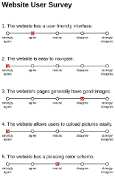
4.3 Qualitative Manual Test
- Human expert Likert-scale ratings (1–5) on
  - interpretability
  - correctness
  - operational usefulness
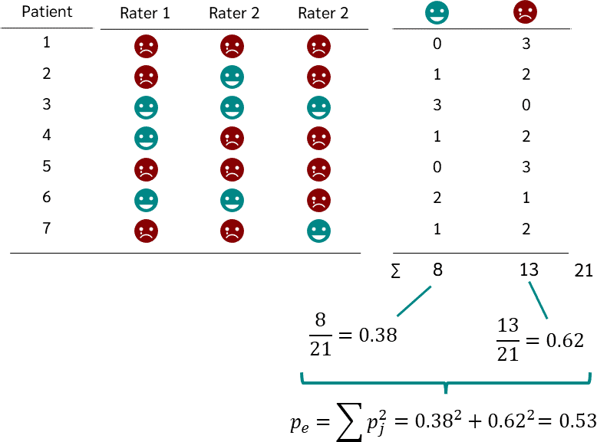
  - visuality

- Reliability of agreement: Inter-rater agreement (Cohen's/Fleiss' kappa) across multiple human evaluators to check consistency of the manual scoring.

4.4 Additional Testbench Ideas

4.4.1 Designing a Dataset
- Labeled PCAPs with ground-truth attack input descriptions
- Include benign and attack traffic to avoid FPs.
- Sources: DARPA intrusion-detection datasets, CICIDS2017, or CTF traffic captures

4.4.2 System Prompt
- Vary prompt structure (zero-shot, few-shot examples, chain-of-thought...) to see which prompting strategy most improves Coverage and Sequence Fidelity.

4.4.3 Robustness – Different input description
- Noisy inputs: use benign traffic or messy attack structures to test Noise Filtering Rate.
- Vary the input description details granularity to isolate what drives diagram quality.
- Scalability: measure how diagram quality degrades as PCAP duration/size grows, especially for long multi-stage attacks.
- Consistency: re-run the same PCAP + description multiple times (varying temperature/seed) to measure output variance — a benchmark should penalize high run-to-run instability.

4.4.4 Efficiency and Cost
Costs depend on:
  - LLM inference latency
  - Token amount and cost per diagram
  - Model used
- Measure cost and latency over:
  - Different models
  - Instructions of different detailing levels
  - Differing Input PCAPs/descriptions

Evaluation Implementation Summary

Challenges

- Minimizing LLM calls –

Structural Correctness – Coverage

Ensures the LLM diagram includes all components: Significant Actors, Attack Phases, Steps.
- No False Negatives (Recall): Do all components in the ground-truth appear in the evaluated content?

$$Recall =\frac{matched components}{ground-truth components}$$

- No False Positives (Precision): Are there components in the evaluated content that don't exist in the ground-truth?
$$Precision = \frac{matched components}{ total predicted components}$$
- Final Coverage Score: Component-level F1 harmonic mean of the two above.

3.1.2 Sequence Fidelity
- Does the diagram preserve the correct causal ordering of components (attack phases and steps) as appear in the Ground Truth?
Measurement Methods:
  - Longest Common Subsequence (LCS) between the ground-truth step order and the evaluated content's order.
    - LCS Cares more if a step was dropped (False Negative) than addition of steps - noise (False Positive)
    - How much of the “main story” is correct?
$$\text{True}=\left[\text{Scan}, \text{Exploit} ,\text{Brute_Force} ,\text{C2} , \text{Exfil}\right]$$
$$\text{Pred}=\left[\text{Scan}, \text{ARP_Noise}, \text{Exploit}, \text{C2}, \text{DNS_Query}, \text{Exfil}\right]$$
$$LCS:Scan→Exploit→C2→Exfil$$
$$4 out of 5→0.8 (normalized)$$
  - Edit distance (Levenshtein) between the two step sequences – used to indicate how much edits need to be done to correct what’s wrong
    - Punishes for redundant steps.
    - Shows how far the diagram is from a manual diagram (“needs 3 fixes”)

  - Kendall's Tau / Spearman rank correlation between step orderings, for a normalized ordering score. Looking for “big mistakes” (for example, too many inversions)

0
+1
-1
Completely out of order
Same order in GT and EC
Opposite order

Follow up questions:
- The Semantic Synonymy Problem – PCAPs and descriptions are written in “different languages”. It is better to use LLM first to extract steps from both files in the same format and tokens.

Advarsarial agent – check semantic precision.

