PAnDA - Pipeline and Evaluation
LLM Network Diagram Creator from PCAP Files and Attack/Protocol Description

Preprocessing

Preprocessing is used to avoid LLM token waste and dealing with small window constraints.

Algorithmic Preprocessing

Basic Tcpdump filtering
Initial packet filtering is done using logical rules, such as:
- Summing up patterns – repeating occurrences of the same packets are summed to avoid repetition. Patterns are set by special signals that are decided by the type of protocol and flags within the protocol *.

LLM Preprocessing

Advanced Tcpdump Rules
- Feeding a small agent with a summary of the pcap/input description
- LLM creates a relevant Tcpdump filter
- The software executes the filter on the PCAP

Generation
- Inputs:
  - Attack/Protocol PCAP file
  - Attack/Protocol Input Description
- Outputs:
  - Diagram JSON - Split into:
    - Definitions and Terms Dictionary
    - Actors Dictionary
    - Steps $→$ Packets Dictionary
- Instructions:
  - Uniformity: Follow example JSON attack/protocol diagram format
  - Evidence Grounding: Match steps to relevant packets
  - Semantic Precision: Define every term and variable within the diagram JSON
- The complete Generator algorithm will be:
  - Model creates an AST/ Graph in JSON format defines the:
    - Nodes (actors)
    - Edges (phases and steps)
    - Connections (chronological, hierarchy...)
  - A Small model will define the type of diagram (sequence diagram/venn/flowchart..)
  - Geometrical layout engine

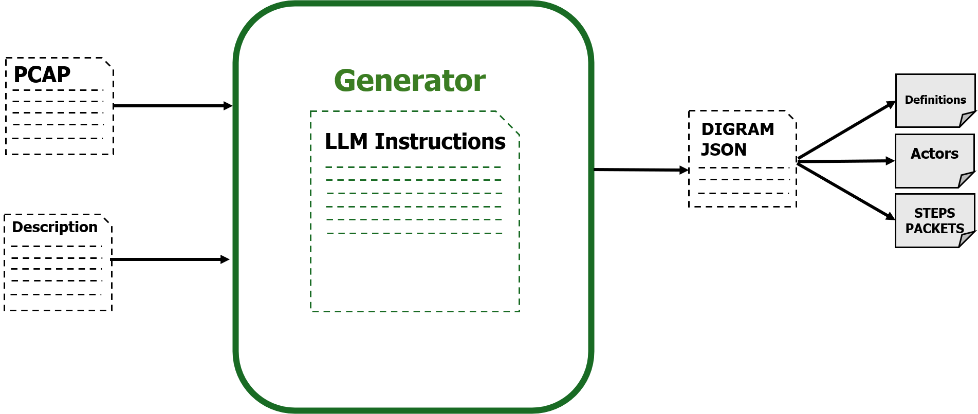

Rendering engine

Grid based diagrams

The cassowary algorithm –
- Implementation of Simplex
- Solve a system of constraints:
  - Create a compact diagram
  - No object is allowed to go on top of another
  - Allow for dynamic placement of objects

Improvement

Verification

LLM Based – Verify Diagram against Description

Code Based – Verify Diagram against PCAP

- קודם לבדוק שהדיאגרמה נכונה מול התיאור, וברגע שזה נכון לבדוק שזה נכון מול הpcap
- JSON Format & Syntax Check– every diagram must be 100% syntactically correct
  - Try to fix small edit distances algorithmically
  - Otherwise back to Generator LLM
- Logical rules:
  - Check FPs:
For-each step in step-packets dict.keys:
    - For each packet in step.values:
      - Does this packet exist?
      - Does the step metadata match the packet metadata (src, dst, protocol..)
      - Additional logical rules
      - If all passed: continue:
      - Otherwise: throw packet – indicate!
  - Check FNs:
Residual packets = filtered packets that were not used
interesting_keywords = database of keywords that make packets not ignorable
For-each packet in all Residual packets:
If packet contains a keyword from interesting_keywords:
Check again!
- Working with labeled PCAPs
  - Marking important packets
  - Giving a score based on FPs and FNs

Structural Correctness – Coverage

Ensures the LLM diagram includes all components: Significant Actors, Attack Phases, Steps.
- No False Negatives (Recall): Do all components in the ground-truth appear in the evaluated content?

$$Recall =\frac{matched components}{ground-truth components}$$

- No False Positives (Precision): Are there components in the evaluated content that don't exist in the ground-truth?
$$Precision = \frac{matched components}{ total predicted components}$$
- Final Coverage Score: Component-level F1 harmonic mean of the two above.
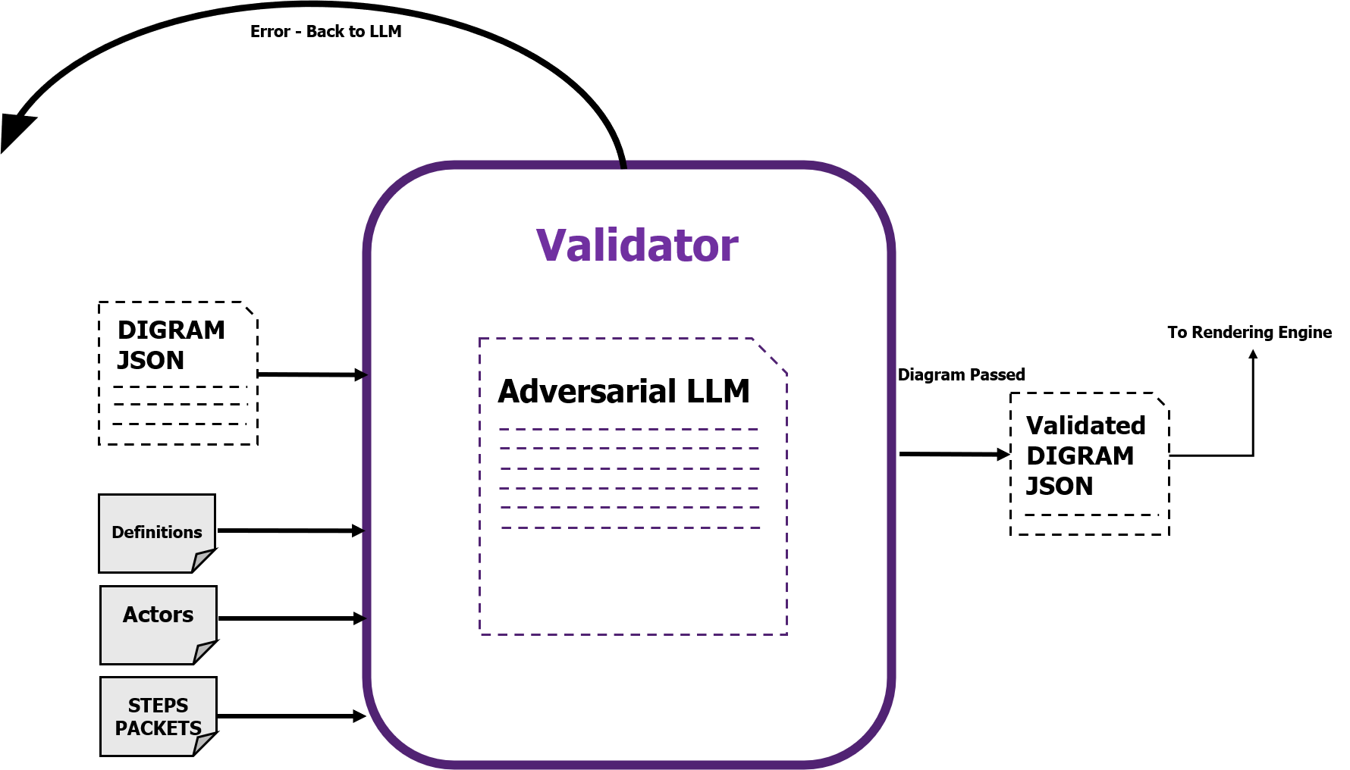

3.1.2 Sequence Fidelity
- Does the diagram preserve the correct causal ordering of components (attack phases and steps) as appear in the Ground Truth?
Measurement Methods:
  - Longest Common Subsequence (LCS) between the ground-truth step order and the evaluated content's order.
    - LCS Cares more if a step was dropped (False Negative) than addition of steps - noise (False Positive)
    - How much of the “main story” is correct?
$$\text{True}=\left[\text{Scan}, \text{Exploit} ,\text{Brute_Force} ,\text{C2} , \text{Exfil}\right]$$
$$\text{Pred}=\left[\text{Scan}, \text{ARP_Noise}, \text{Exploit}, \text{C2}, \text{DNS_Query}, \text{Exfil}\right]$$
$$LCS:Scan→Exploit→C2→Exfil$$
$$4 out of 5→0.8 (normalized)$$
  - Edit distance (Levenshtein) between the two step sequences – used to indicate how much edits need to be done to correct what’s wrong
    - Punishes for redundant steps.
    - Shows how far the diagram is from a manual diagram (“needs 3 fixes”)

  - Kendall's Tau / Spearman rank correlation between step orderings, for a normalized ordering score. Looking for “big mistakes” (for example, too many inversions)

0
+1
-1
Completely out of order
Same order in GT and EC
Opposite order

Follow up questions:
- The Semantic Synonymy Problem – PCAPs and descriptions are written in “different languages”. It is better to use LLM first to extract steps from both files in the same format and tokens.

Advarsarial agent – check semantic precision.

Evaluation

LLM
Diagram
Manual Diagram

4.1 LLM Evaluation
- Ask an LLM to describe the attack/protocol shown in the LLM diagram.
- Compare the LLM description to the input description using:
  - Cosine similarity
  - BERTScore
- LLM-as-judge: rubric-scored (1–5) rating of factual accuracy, clarity, and completeness, to complement the similarity metrics with a more interpretable score.

4.2 Automatic Test

4.2.1 Structure:
- DiagramEval (2025):
  - Node Alignment
  - Path Alignment
- Graph Edit Distance (GED) between the LLM diagram's graph structure and the manual/ground-truth graph, as a structural-similarity complement to DiagramEval.

4.2.2 Visualization and Style:
- Visual Density:
$$graph density =\frac{edges}{\left[nodes × \left(nodes - 1\right)\right]}$$
Flags diagrams that are too cluttered (hard to read) or too sparse (missing relationships).

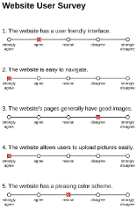
4.3 Qualitative Manual Test
- Human expert Likert-scale ratings (1–5) on
  - interpretability
  - correctness
  - operational usefulness
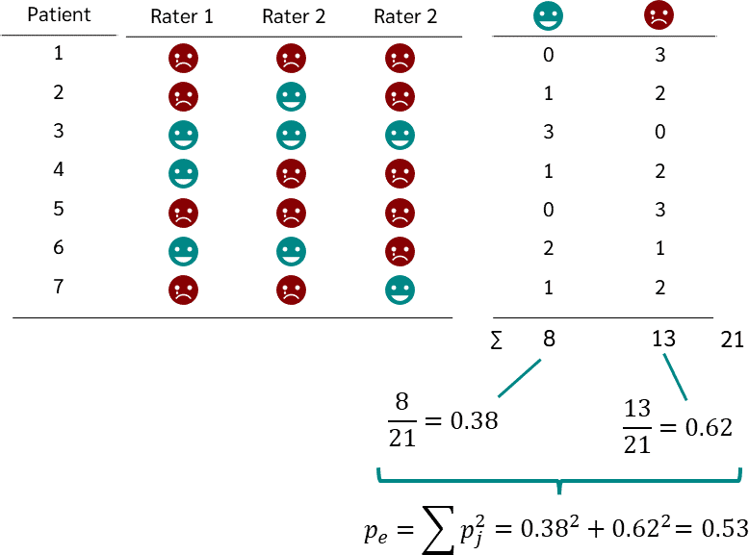
  - visuality

- Reliability of agreement: Inter-rater agreement (Cohen's/Fleiss' kappa) across multiple human evaluators to check consistency of the manual scoring.

4.4 Additional Testbench Ideas

4.4.1 Designing a Dataset
- Labeled PCAPs with ground-truth attack input descriptions
- Include benign and attack traffic to avoid FPs.
- Sources: DARPA intrusion-detection datasets, CICIDS2017, or CTF traffic captures

4.4.2 System Prompt
- Vary prompt structure (zero-shot, few-shot examples, chain-of-thought...) to see which prompting strategy most improves Coverage and Sequence Fidelity.

4.4.3 Robustness – Different input description
- Noisy inputs: use benign traffic or messy attack structures to test Noise Filtering Rate.
- Vary the input description details granularity to isolate what drives diagram quality.
- Scalability: measure how diagram quality degrades as PCAP duration/size grows, especially for long multi-stage attacks.
- Consistency: re-run the same PCAP + description multiple times (varying temperature/seed) to measure output variance — a benchmark should penalize high run-to-run instability.

4.4.4 Efficiency and Cost
Costs depend on:
  - LLM inference latency
  - Token amount and cost per diagram
  - Model used
- Measure cost and latency over:
  - Different models
  - Instructions of different detailing levels
  - Differing Input PCAPs/descriptions

Evaluation Implementation Summary

PCAP ↔ Input Description ↔ LLM Diagram ↔ Manual Diagram

 | PCAP | Input Description | LLM Diagram | Manual Diagram

