# Kickstarting with Excel

## Overview of Project

### Following are the purpose of this analysis

#### Learn to use charts in excel to understand or communicate the large dataset. Also, the charts revel the import relationship and pattern among data points.

## Analysis and Challenges

### I performed the analysis by looking at the overall treads. The period the launch was successful vs failure. The correlation between success and failure in the period.

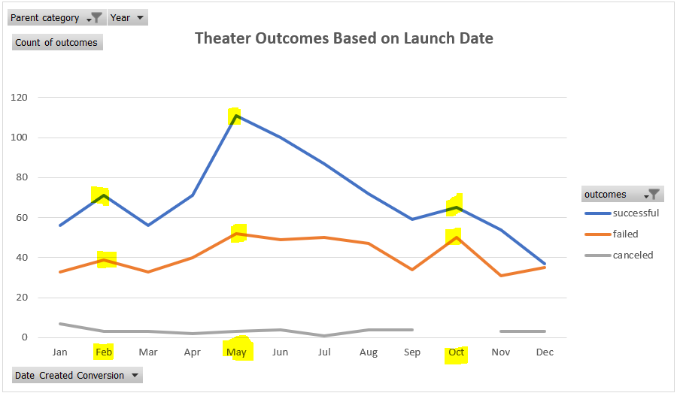

## Analysis of Outcomes Based on Launch Date

### Challenges and Difficulties Encountered

#### I did not face challenge creating the pivot table or the chart associated to the theater outcomes exercise. The challenge we could have faced is if selecting wrong column for the pivot rows.

### What are two conclusions you can draw about the Outcomes based on Launch Date

####Based on analysis it has been discovered month May has the highest theater launch outcomes; the success at 67%, higher than median of success. and failure at 31% less than median of failure.

Also, month December has the lowest theater launch outcomes; the success at 49%, lower than median of success. and failure at 47% higher than median of failure.

## Analysis of Outcomes Based on Goals

### Challenges and Difficulties Encountered

####The challenges that I faced during the process is writing the formula and selecting the right columns. If you do not read the given instruction you can select the wrong data column. For the formula I watched the video that was provide within the Module and it is extremely helpful.

### What can you conclude about the Outcomes based on Goals

####Based on analysis the less than $1000 goal has the highest success rate of 76% and lowest failure rate of 24%. Anything above the $45,000 giving 100% failure rate.

### What are some limitations of this dataset?

####The Data set did not provide when the campaign ended even though there was deadline it could have been ended earlier or later than the deadline.

### What are some other possible tables and/or graphs that we could create?

####Following tables/graphs can be created for furthermore analysis.

####Table to show Median, Max, Min in length of campaign comparable to other subcategories.