Studor PathAI: Technical Report
Open University Learning Analytics Dataset (OULAD) — Behavioral Scoring, Week 6 Disengagement Prediction, and Course Recommendation

Executive Summary
This report documents the end-to-end PathAI prototype built on one semester of OULAD behavioral data. The pipeline converts raw clickstream, assessment, and demographic records into three product-facing assets: (1) a weekly 0–100 engagement score; (2) a Week 6 disengagement risk model; and (3) a next-module recommendation engine.
The dataset contains 32,593 enrolments across 7 modules. Overall risk rate is 52.8%. The Week 6 urgent tier alerts 57.7% of the test cohort at recall 83.3% and precision 76.2% (ROC-AUC 0.872). The engagement score band gradient runs from 98.4% withdraw/fail (0–20 band) to 19.0% (80–100 band). Collaborative filtering hit@3 is 59.4% versus 11.1% for content-based recommendations.

1. Data Foundation and Cleaning Decisions

1.1 Enrolment Grain
The enrolment key is (id_student, code_module, code_presentation). Student ID alone is not unique because learners can take multiple modules simultaneously.

1.2 Table Inventory
Table | Rows | Columns | Missing cells
courses | 22 | 3 | 0
student_info | 32,593 | 12 | 1111
registration | 32,593 | 5 | 22566
assessments | 206 | 6 | 11
student_assessment | 173,912 | 5 | 173
vle | 6,364 | 6 | 10486
student_vle | 10,655,280 | 6 | 0

1.3 Consistency Checks
Check | Issue count | Policy
studentInfo key uniqueness | 0 | Use student-module-presentation as the enrolment key.
studentRegistration key uniqueness | 0 | Use student-module-presentation as the enrolment key.
Unregistered enrolments not labelled Withdrawn | 9 | Audit only; official final_result remains the supervised target.
Withdrawn enrolments without unregistration date | 93 | Do not use date_unregistration as a predictive feature because it can occur after Week 6.
Missing score rows | 173 | Keep missing scores as missing; median-impute only inside model preprocessing.
Invalid score rows outside 0-100 | 0 | Invalid values would be excluded from score aggregates.
Assessment rows with missing due date | 11 | Exclude missing-date assessments from weekly due/submission features.
Negative VLE activity dates (pre-start engagement) | 688988 | Valid pre-presentation activity; date is days before module start. Used as proactivity signal.
VLE activity after module presentation length | 0 | Exclude from weekly engagement panel.
Missing VLE week_from/week_to metadata | 10486 | Do not use week_from/week_to as model features.

688,988 VLE events have negative dates — valid pre-presentation activity before module day 0. These feed proactivity features across all three tasks. In-week aggregates still use day 0+ only.

1.4 Leakage Controls
Candidate feature | Available Week 6? | Used? | Reason
Pre-start VLE activity (negative dates) | Yes | Yes | Observed before day 0; reflects eagerness to begin course materials.
Week 1-6 VLE clicks | Yes | Yes | Observed before the Week 6 prediction point.
Week 1-6 active days | Yes | Yes | Observed before the Week 6 prediction point.
Week 1-6 activity diversity | Yes | Yes | Observed before the Week 6 prediction point.
Early non-exam assessment submissions | Yes | Yes | Only due/submitted work by Week 6 is used.
Student demographics/context | Yes | Yes | Known at registration or course enrolment.
Engagement score | Yes | Yes | Computed from Week 1-6 behavior using train-derived score weights.
Final result | No | Target only | Used only to train/evaluate the supervised label.
Final exam score | No | No | Not available by Week 6.
Full-semester total clicks | No | No | Would leak future engagement behavior.
date_unregistration after Week 6 | No | No | Would leak withdrawal timing/outcome.

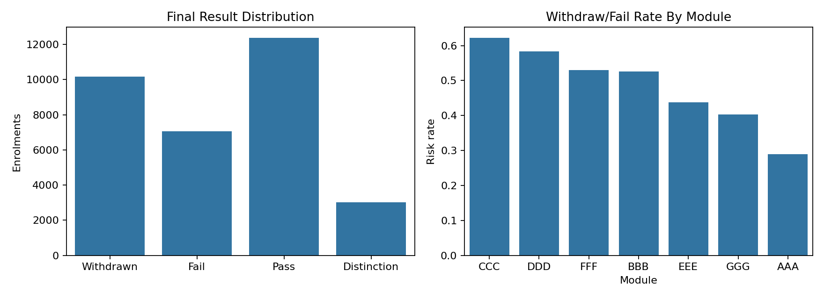
Figure 1. Outcome distribution and withdraw/fail rate by module.

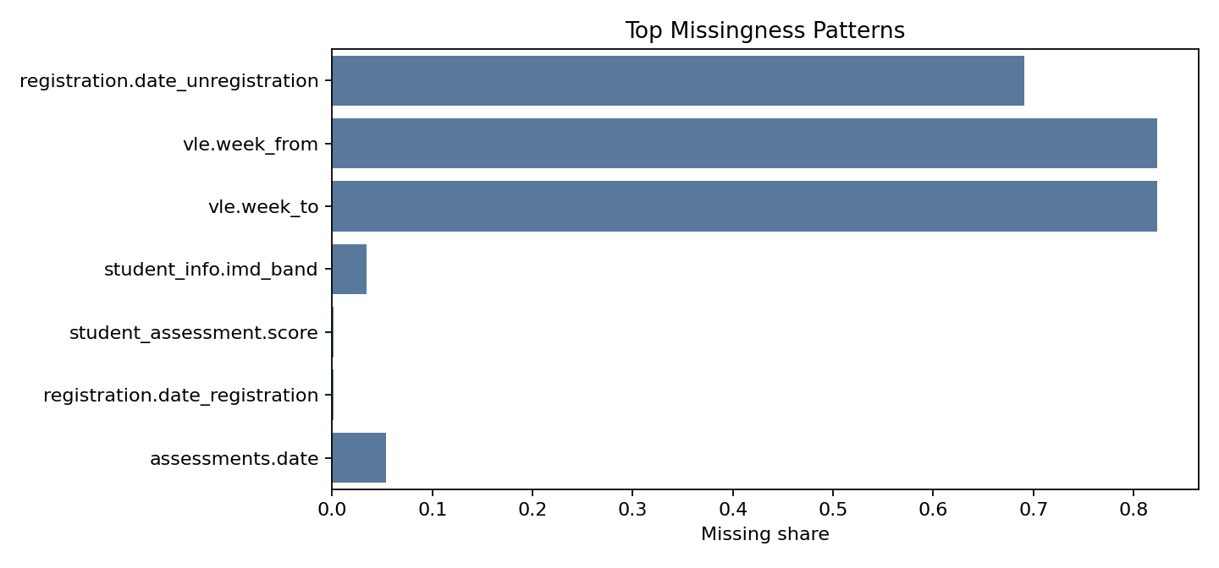
Figure 2. Top missingness patterns.

2. Feature Engineering

2.1 Pre-Start Proactivity (Negative VLE Dates)
Negative dates count days before the official module start. We aggregate pre_start_clicks, pre_start_active_days, days_before_start, and material-study signals into p_pre_start_proactivity.
pre_start_clicks: withdraw/fail mean = 40.42, pass/distinction mean = 94.41 (r = -0.209).
days_before_start: withdraw/fail mean = 7.64, pass/distinction mean = 10.80 (r = -0.211).
pre_start_active_days: withdraw/fail mean = 2.38, pass/distinction mean = 4.34 (r = -0.255).
pre_start_proactivity_raw: withdraw/fail mean = 0.42, pass/distinction mean = 0.59 (r = -0.332).
Population check: 23,809 of 32,593 enrolments (73.0%) show pre-start activity. Risk rate with pre-start: 44.7%; without: 74.9%.

2.2 In-Semester VLE and Assessment Features
Task 1 features are grouped into six interpretable buckets: activity volume, consistency and rhythm, recency and disengagement gaps, resource diversity and intent, course-pace alignment, and assessment behaviour and recovery.
weekly_clicks_norm: Log-scaled click volume, peer-normalized within module/presentation/week. withdraw/fail mean = 0.38, pass/distinction mean = 0.64 (r = -0.468).
unique_sites_wk: Distinct VLE sites accessed in the week. withdraw/fail mean = 2.95, pass/distinction mean = 7.33 (r = -0.336).
active_days_last_7: Distinct active days in the week. withdraw/fail mean = 1.10, pass/distinction mean = 2.85 (r = -0.420).
study_regularity_score: Active days divided by seven. withdraw/fail mean = 0.16, pass/distinction mean = 0.41 (r = -0.420).
burstiness_score: Share of weekly clicks concentrated on the busiest day. withdraw/fail mean = 0.31, pass/distinction mean = 0.54 (r = -0.306).
week_to_week_volatility: Rolling instability in weekly click volume. withdraw/fail mean = 27.00, pass/distinction mean = 48.65 (r = -0.234).
days_since_last_click: Recency of last observed click. withdraw/fail mean = 255.91, pass/distinction mean = 12.56 (r = +0.357).
inactive_last_14_days: Flag for two-week absence. withdraw/fail mean = 0.45, pass/distinction mean = 0.06 (r = +0.439).
longest_inactive_gap_so_far: Largest inactivity gap observed so far. withdraw/fail mean = 410.73, pass/distinction mean = 132.96 (r = +0.314).
activity_diversity: Distinct VLE activity types used. withdraw/fail mean = 1.60, pass/distinction mean = 3.64 (r = -0.410).
activity_entropy_wk: Balance of clicks across VLE activity types. withdraw/fail mean = 0.57, pass/distinction mean = 1.25 (r = -0.394).
material_active_days: Frequency of learning-material study activity. withdraw/fail mean = 0.69, pass/distinction mean = 1.86 (r = -0.360).
material_click_share: Share of clicks focused on learning materials. withdraw/fail mean = 0.15, pass/distinction mean = 0.31 (r = -0.275).
recent_material_active_days_2w: Recent learning-material study rhythm near Week 6. withdraw/fail mean = 1.59, pass/distinction mean = 3.98 (r = -0.393).
forum_active_days: Discussion-board/help-seeking participation. withdraw/fail mean = 0.52, pass/distinction mean = 1.65 (r = -0.331).
on_schedule_click_ratio: Metadata-covered clicks that align with the planned course weeks. withdraw/fail mean = 0.03, pass/distinction mean = 0.09 (r = -0.161).
planned_material_coverage: Cumulative share of expected planned materials accessed. withdraw/fail mean = 0.20, pass/distinction mean = 0.41 (r = -0.297).
assessment_submitted_ratio: Cumulative non-exam assessment completion. withdraw/fail mean = 0.56, pass/distinction mean = 0.96 (r = -0.486).
missed_assessments_cum: Cumulative assessments due but not submitted. withdraw/fail mean = 0.61, pass/distinction mean = 0.06 (r = +0.453).
pre_assessment_clicks_7d_cum: Preparation clicks in the seven days before due dates. withdraw/fail mean = 63.35, pass/distinction mean = 126.05 (r = -0.233).
cram_ratio_week: Share of preparation clicks occurring in the final two days. withdraw/fail mean = 0.03, pass/distinction mean = 0.04 (r = -0.052).
low_weight_completion_ratio: Low-weight assignment completion. withdraw/fail mean = 0.70, pass/distinction mean = 0.97 (r = -0.377).
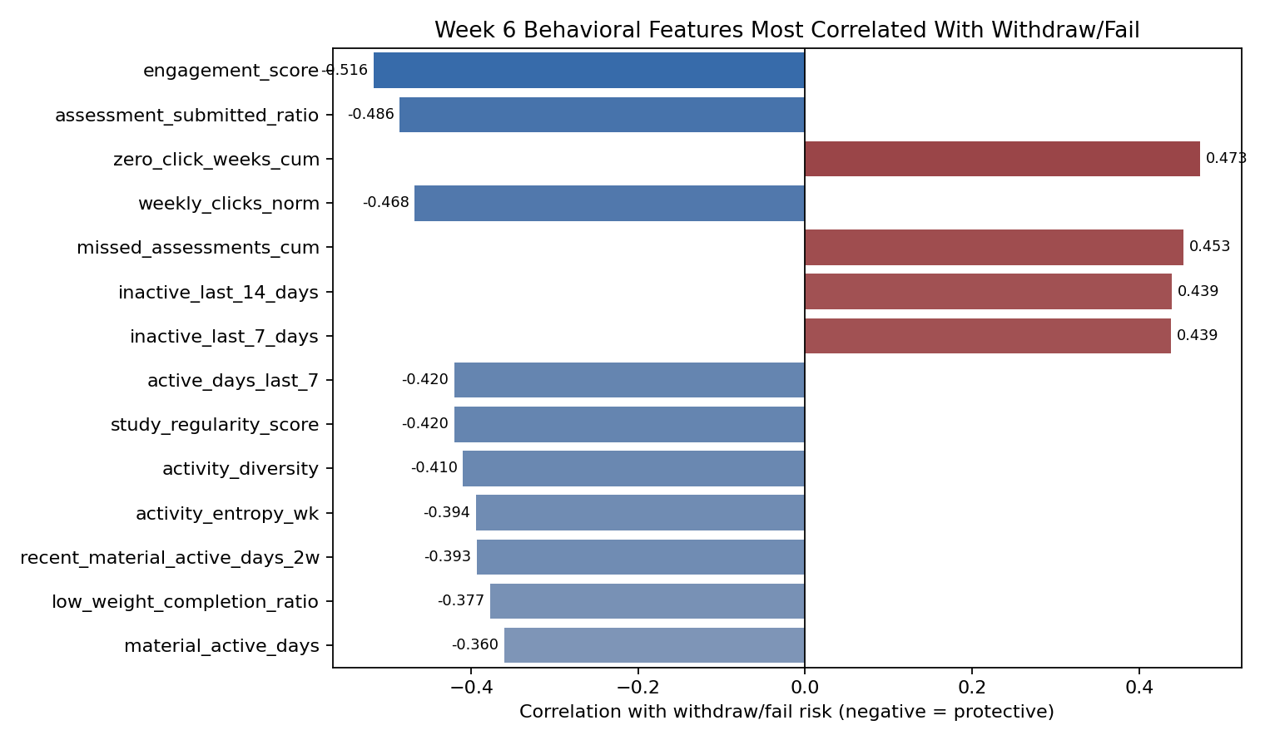
Figure 3. Week 6 feature correlations with risk.

3. Dynamic Engagement Score
Ten peer-normalized components (including pre-start proactivity) are combined with train-derived weights into a 0–100 weekly score.
Component | Success AUC | Final weight
Peer-normalized click volume | 0.774 | 15%
Module-material study frequency | 0.741 | 15%
Activity diversity | 0.762 | 15%
Recent activity | 0.773 | 15%
Pre-start course material engagement | 0.690 | 10%
Active-day consistency | 0.778 | 10%
Assessment completion | 0.718 | 10%
Low-weight assignment completion | 0.684 | 10%
Three-week trend | 0.481 | 0%
Assessment punctuality | 0.469 | 0%

Scorecard guardrail: any component with train success AUC at or below 0.50 receives 0% weight. Those signals can still be inspected as exploratory features, but they do not move the trusted administrator-facing engagement score.
Score band | Enrolments | Withdraw/fail rate | Avg score
0-20 | 4224 | 98.4% | 17.3
20-40 | 8237 | 73.6% | 29.7
40-60 | 7015 | 46.5% | 51.2
60-80 | 10549 | 30.7% | 69.9
80-100 | 2568 | 19.0% | 83.9

Week 6 engagement score correlation with risk: r = -0.516.
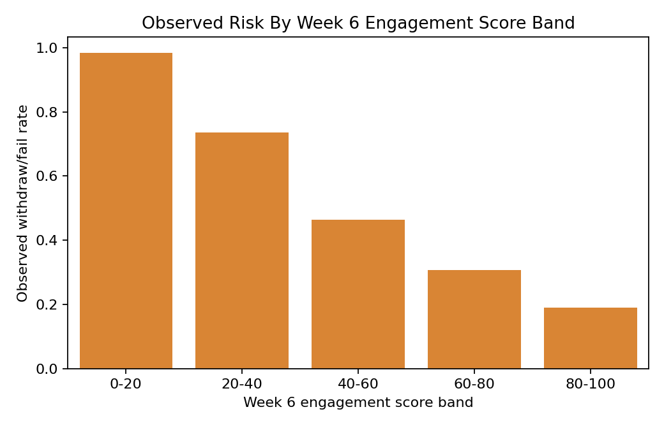
Figure 4. Risk by engagement score band.

Archetype | Description | Feature signature
Steady Engager | Maintains consistently strong engagement across the semester. | High mean engagement score, low score volatility, strong active-day consistency.
Early Dropout | Disengages early and does not recover. | Sharp negative early-to-late score delta, low late score, often withdrawn final result.
Late Recoverer | Starts weakly but improves later in the semester. | Large positive score delta from early weeks to late weeks.
Sporadic / Burst Engager | Works in intense, irregular bursts rather than a steady rhythm. | High score range, high max score, and several zero-click weeks.
Perfectionist Procrastinator | Delays participation or submissions while still producing high-quality work. | Successful/high-scoring enrolment with late submissions and lower punctuality.
Surface Level / Compliance Engager | Does the minimum required to pass or complete the task. | High assessment completion but low activity diversity and low material-study frequency.
Opportunistic Engager | Selectively engages when material appears useful or interesting. | High material-click share and engagement spikes, but weaker active-week consistency.

Representative archetypes: Perfectionist Procrastinator: student 414350, module BBB, result Distinction; Sporadic / Burst Engager: student 420724, module BBB, result Fail; Surface Level / Compliance Engager: student 327940, module BBB, result Pass; Steady Engager: student 635416, module CCC, result Pass; Opportunistic Engager: student 525635, module DDD, result Fail; Early Dropout: student 548415, module FFF, result Withdrawn; Late Recoverer: student 569093, module GGG, result Pass.
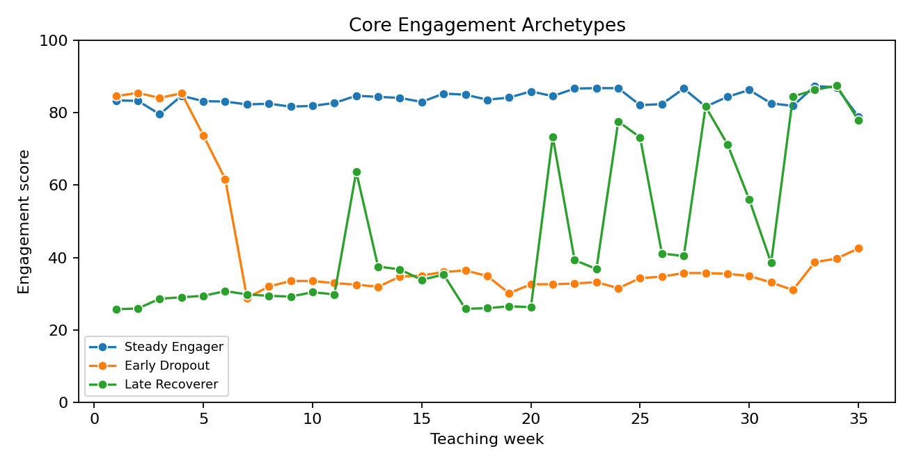
Figure 5a. Core engagement archetypes.

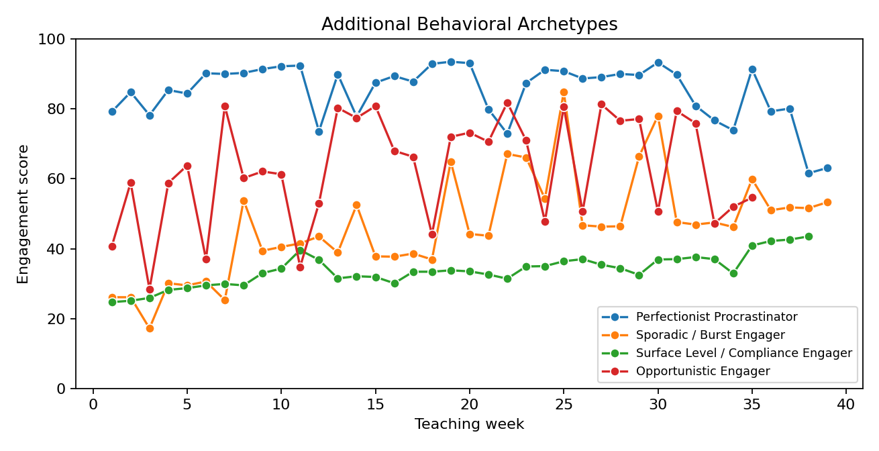
Figure 5b. Additional behavioral archetypes.

4. Week 6 Disengagement Model
Binary classifier: Withdrawn/Fail vs Pass/Distinction. Stratified holdout: 8,149 test enrolments (25.0% of labelled Week 6 cohort).
The notebook compares Logistic Regression, Random Forest, KNN, calibrated Linear SVC, XGBoost, a regularized XGBoost variant, and Soft Voting. The urgent-alert classifier is chosen by cross-validated F1, with PR-AUC and ROC-AUC used as secondary checks. A broader watchlist keeps a separate higher-recall F2 threshold.
Task 2 now carries forward the Task 1 engagement framework directly: the model includes engagement_score_6, a Week 6-safe behavioural archetype, train-only archetype/profile risk priors, ordered education and age features, IMD midpoint, module-normalized credit load, resource-mix ratios, and selected interaction terms.
Threshold | Value | Precision | Recall | FN | FP
urgent_balanced_f1 | 0.384 | 0.762 | 0.833 | 717 | 1119
watchlist_f2 | 0.188 | 0.603 | 0.970 | 128 | 2750
urgent_recall85 | 0.352 | 0.735 | 0.859 | 605 | 1330
selected_cv_max_f1 | 0.384 | 0.762 | 0.833 | 717 | 1119
capacity_10pct | 0.994 | 1.000 | 0.199 | 3446 | 0
capacity_20pct | 0.915 | 0.994 | 0.377 | 2678 | 10
capacity_30pct | 0.719 | 0.942 | 0.555 | 1916 | 146
fixed_0.25 | 0.250 | 0.653 | 0.935 | 281 | 2136
fixed_0.35 | 0.350 | 0.734 | 0.861 | 597 | 1344
fixed_0.50 | 0.500 | 0.840 | 0.736 | 1134 | 603
fixed_0.65 | 0.650 | 0.920 | 0.614 | 1660 | 229
fixed_0.75 | 0.750 | 0.951 | 0.526 | 2037 | 117

Urgent tier (threshold 0.384): precision 0.762, recall 0.833, F1 0.796, alerts 4704 (57.7% of test cohort), ROC-AUC 0.872. Capacity tier: precision 99.4%, recall 37.7%. AUC is threshold-independent, so threshold tuning changes alert volume, precision, recall, and F1, but not the model's ranking quality.
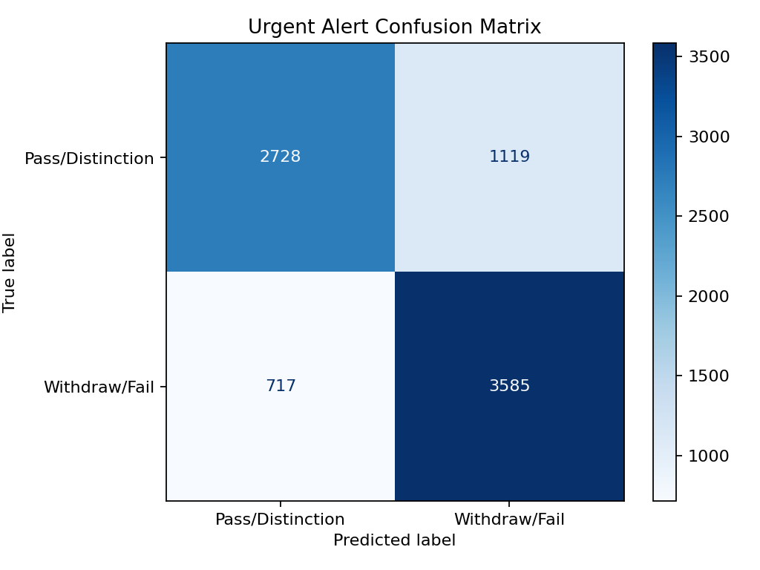
Figure 6. Urgent-tier confusion matrix.

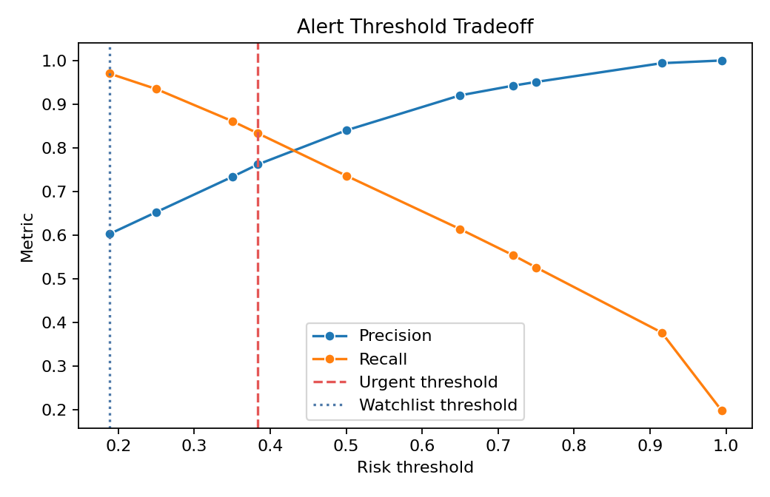
Figure 7. Threshold tradeoff.

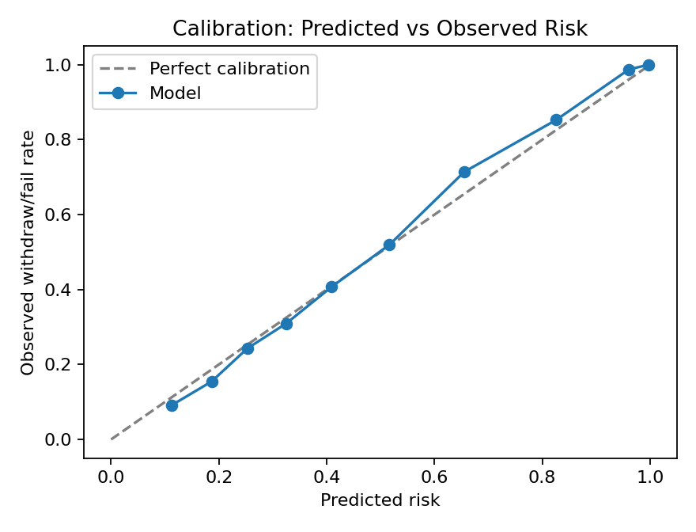
Figure 8. Calibration curve.

Driver group | Feature | Mechanism
Overall | avg_score_so_far_6 | Early academic struggle may signal content difficulty before final failure.
Overall | first_click_day_6 | High-ranking model driver.
Overall | module_code | High-ranking model driver.
Behavioral | engagement_score_6 | Combines recency, consistency, diversity, and assessment behavior into a trajectory signal.
Behavioral | assessment_submitted_ratio_6 | Missing early assessments is both predictive and directly actionable for advisors.
Behavioral | weekly_clicks_norm_6 | Advisor-actionable engagement or assessment behavior.

Top driver: assessment completion (withdraw/fail mean 55.9% vs 96.4% for successful students). Advisor alert at balanced urgent threshold 0.38 or high-recall watchlist 0.19 includes risk tier, calibrated probability, engagement trajectory, assessment context, and top drivers.
PathAI Advisor Alert | Example
Student | S-10482
Course | DDD-2014J
Risk tier | Urgent
Predicted risk | 78%
Why flagged | No VLE activity in 12 days; engagement score dropped from 61 to 34 over two weeks; first assessment due by Week 6 was not submitted.
Suggested action | Send check-in within 48 hours. Ask about workload, access issues, and confidence with course material. Offer academic support session.

5. Course Recommendation Engine
Primary user: students planning next semester. Content-based scoring uses demographics, engagement band, and pre-start proactivity history. Collaborative filtering uses cosine similarity with a boost for proactive peers.
Metric | Value
Holdout students | 2479
Content hit@3 | 11.1%
CF hit@3 | 59.4%
Cold start (proactive) | AAA, EEE, GGG

6. Reproducibility
Run: python3 -m venv .venv && .venv/bin/pip install -r requirements.txt && .venv/bin/python src/run_pipeline.py. CSV/JSON artifacts go to outputs/; figures and reports to reports/.

