**Griffin Shelor**

**Lab 4 Answer Sheet**

**Introduction to Python**

**Due 10/4/2024, 5 pm**

**Instructions**. Fill out all questions in the designated spaces below where you are prompted on steps 2 through 11 to provide either answers to questions, screenshots, or code snippets. Please type your answers in a readable color other than black.

When complete, upload your answer sheet, complete with answers, screenshots, code snippets, etc for the prompts in steps 2-11. Then zip your two program files (.py) from steps 9 & 10 into a zipped folder. Submit your word doc and zipped program files to WebCampus.

1. Step 2

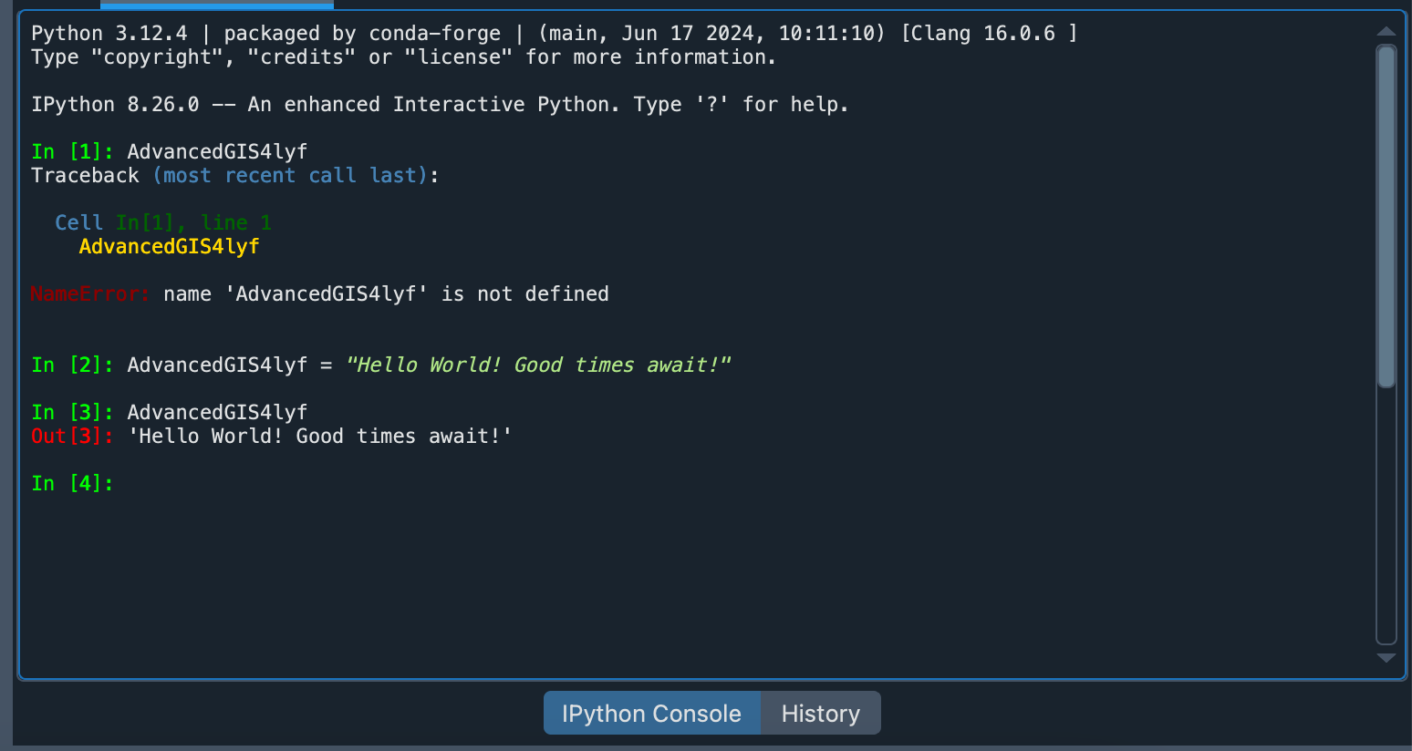

1. Step 3

The type is string.

1. Step 4

The output is a list of strings. The purpose of the split command is to split the string into separate units of a list based on some separator. The default is any space.

1. Step 5

If I wanted to overwrite the output from step 3, I would assign the output of AdvancedGIS4lyf.split() to the same variable name, AdvancedGIS4lyf.

AdvancedGIS4lyf = AdvancedGIS4lyf.split()

Now, AdvancedGIS4lyf is a list.

1. Step 6

This tool works by sorting the items in the list alphabetically, with capitalized words or letters if the letters are included individually in the list being sorted alphabetically before lower-cased words/letters are sorted. If I wanted to sort the list in reverse order, I would simply use “AdvancedGIS4lyf.sort(reverse = True)”.

1. Step 7

x = "Ok, I'm starting to get the hang of this."

y = x.upper()

y

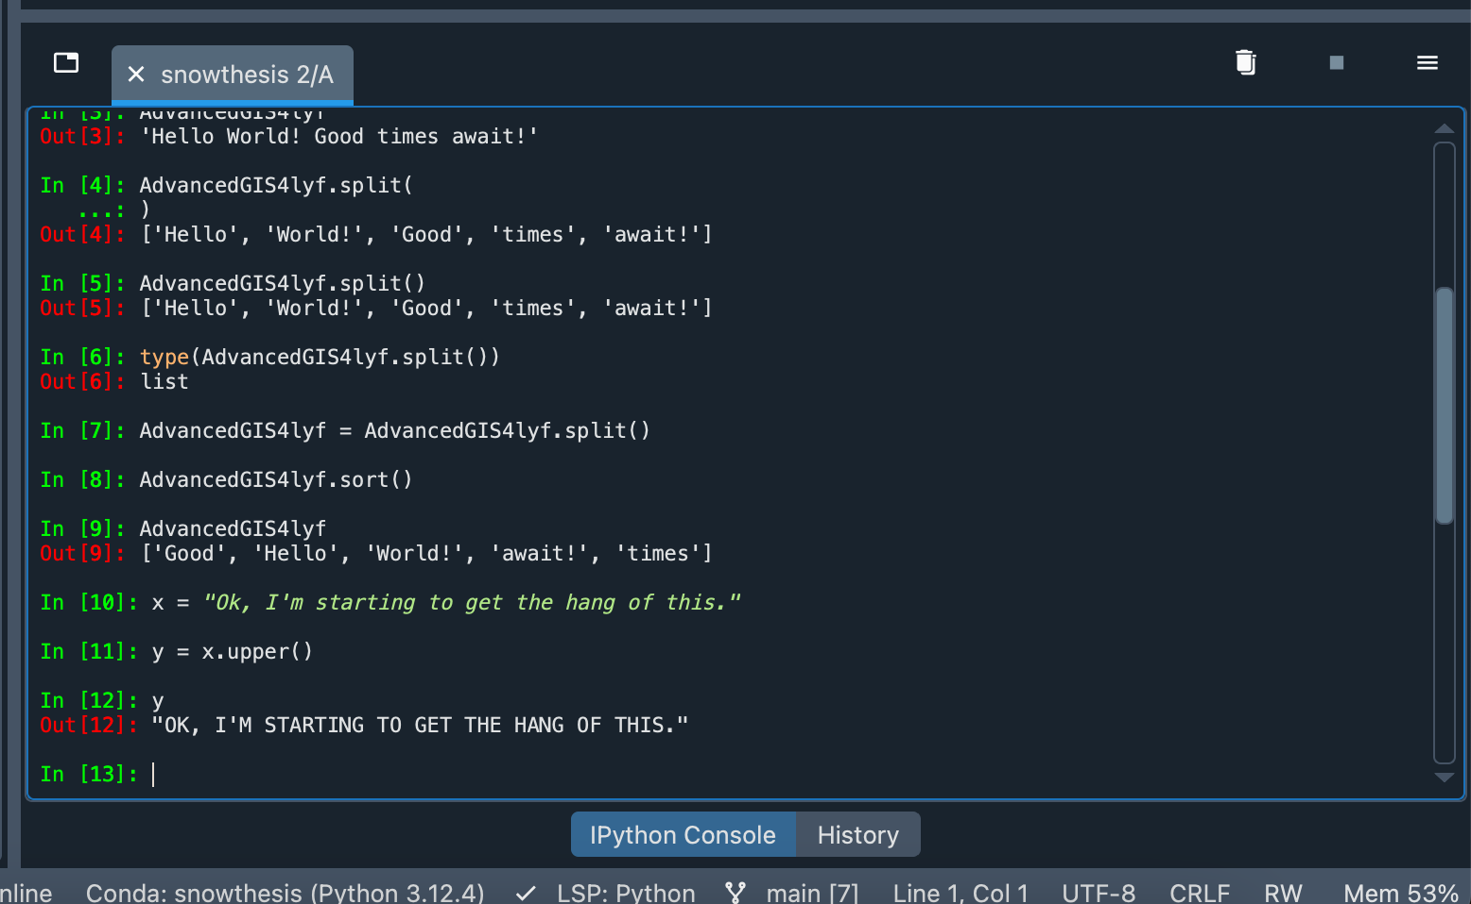

1. Step 8

Ths “upper()” function did not work on AdvancedGIS4lyf becaused AdvancedGIS4lyf is a list, and upper() only works on strings.

1. Step 9

### taking input elevation in meters

elev_m = input("Enter an elevation in meters: ")

### converting to ft

elev_ft = float(elev_m) * 3.28084

print(f'The elevation in feet is {round(elev_ft, 1)} feet.')

1. Step 10

#2017 Population Estimates - ACS

NVPopulations2017 = ["Carson City: 54745","Churchill: 24230","Clark: 2204079","Douglas: 48309","Elko: 52649","Esmeralda: 850","Eureka: 1961","Humboldt: 16826","Lander: 5693","Lincoln: 5223","Lyon: 54122","Mineral: 4457","Nye: 44202","Pershing: 6508","Storey: 4006","Washoe: 460587","White Pine: 9592"]

### printing the items in the list one by one

for x in NVPopulations2017:

print(x)

### making a copy of the list

NVPopulations_reverse = NVPopulations2017.copy()

### sorting the list in reverse

NVPopulations_reverse.sort(reverse = True)

### putting an empty string here in between printing lists so I can read it more easily

print(" ")

### printing the reverse-sorted list items one by one

for y in NVPopulations_reverse:

print(y)

1. Step 11

