Griffin Shelor
11-11-2024
GEOG 607
Lab 7: Spatial Autocorrelation and LISA measures
Due 11/13/24 at 5 pm

Assignment Introduction and Overview
In this assignment, you will get a chance to explore the process of how to evaluate global spatial autocorrelation and identify LISA clusters and outliers using data that you find (or your own data), prepare that data for appropriate analysis, conduct ESDA and report results. This activity is intentionally more open-ended, as this is good practice for conducting this kind of work on your own. The general steps of the activity will include:
- Either find a GIS dataset or use one you already have that contains an attribute of interest to you.
- Prepare that data (including the attribute) so that you can properly evaluate global spatial autocorrelation for that dataset, and identify LISA spatial clusters and spatial outliers.
- Conduct ESDA
- Report a global Moran’s I score for that data and produce a map of LISA spatial clusters and outliers, and interpret the results.
Tips for Data:
- polygon shapefile (similar to Lab #6) is ideal for this kind of analysis
- dataset with spatially distributed values (ex. census tracts, counties, etc)
- a numeric field associated with each spatial feature (ex. population density, temperature, etc)
- confirm appropriate projected coordinate system
Instructions
Find a GIS dataset (or use one that you have access to) that contains an attribute of interest to you. Assess its suitability for computing a global Moran’s I value and LISA clusters/spatial outliers. It might be worth reading through all of the steps of this lab before proceeding. When you have a dataset in hand and you are ready to begin, move to Question 1 below.

- What is the name of the GIS data file that you found and will use in this analysis? Describe it to us: what does the data represent and how current is it? (0.25 points)
My GIS data file will be the EPA Level III Ecoregions shapefile, clipped to only include ecoregions within Colorado, Utah, and Wyoming for the sake of using a smaller area to make operations for this lab easier to perform computationally. Each ecoregion represents an area where the geology, topography, soils, hydrology, land use, and wildlife are relatively similar. The ecoregions were most recently updated by the EPA in 2013.
- Who produced this file and what is its coordinate reference system (0.25 points)?
The EPA produced this file. Its coordinate system is USA Contiguous Albers Equal Area Conic USGS version (EPSG code “ESRI:102039”). Since I will be using this dataset on a larger scale for my thesis, I will leave it in that CRS for this lab.
Transform the data (if necessary) to a CRS that has a meaningful linear unit of measure
Now, describe the attribute of interest in the data that you’d like to evaluate

- What attribute do you plan to evaluate for spatial autocorrelation in this GIS data? What interested you about this attribute (0.5 points)?
The attribute that I plan to model will be average Snow Water Equivalent (SWE) over the time period of Water Year 1993 - Water Year 2020. I am interested in this variable because I will be modeling this variable for my thesis work and thus am interested in seeing how it varies over my study area.
Chances are, you will need to make some adjustment(s) to get this attribute ready for further analysis in GeoDa. For example, will you need to standardize, and if so, what are you standardizing to? Will you need a new field (column) in the table to be able to do so? Think about what you’ll need to do to get this ready for evaluation and report it to us.

- What processes did you conduct to ensure you can effectively evaluate spatial autocorrelation for the attribute of interest? (0.5 points)
This data was taken from the SNOTEL network which is monitored by the USDA Natural Resources Conservation Service (NRCS). I then made a simple IDW model with an IDP of 2.5 so I would have a raster that I could aggregate to the polygon level using the EPA Level III Ecoregions polygons. This dataset also has temperature and precipitation data for January which was taken from the climate dataset Daymet, which provides daily gridded datasets of climate/weather variables including maximum and minimum temperature, precipitation, incoming solar radiation, water vapor, and snow water equivalent. The data came in the form of daily netCDF files at 1000m resolution. I then took the tmax and tmin files and averaged them to produce daily mean temperature rasters for each year of my study period. I then took all of this data and aggregated it by month. I then took the monthly aggregates and averaged them across my entire study time period to create a “climatology” dataset. The climatologies were then resampled to 300m resolution to match with a landcover dataset I am using for my thesis. I then selected the tmean and prcp climatology data to specifically work with for this lab and used zonal statistics to aggregate the mean January temperature and precipitation data to the Ecoregion level. Now that the data is aggregated to the polygon level, it is suitable for evaluating spatial autocorrelation.

- Thinking about more than just the attributes, are there other steps you need to do in order to get this data suitable for evaluating spatial autocorrelation in GeoDa (think about neighborless observations, null data, etc.)? Describe these steps, if you had to conduct them (1.5 points)
The aggregation process ignores null values so by the time zonal statistics are calculated for each ecoregion there is no null data. I selected a subset of my study area to avoid issues with neighborless observations.
Load the now-ready dataset into GeoDa. Using the various options available to you there, conduct some ESDA before proceeding. Conduct four (4) distinct ESDA operations and interpret what you found
- For each, produce a screenshot (0.5 point each) of the ESDA output

- Interpret the results of each output. What does the output suggest about the distribution of your data? What does the output suggest about possible spatial structure in your data (use brushing and linking to get a sense of where the high/low values are in your data, for example) (0.5 point each)

Place each of your four (4) screenshots and accompanying interpretations below (4 points total)

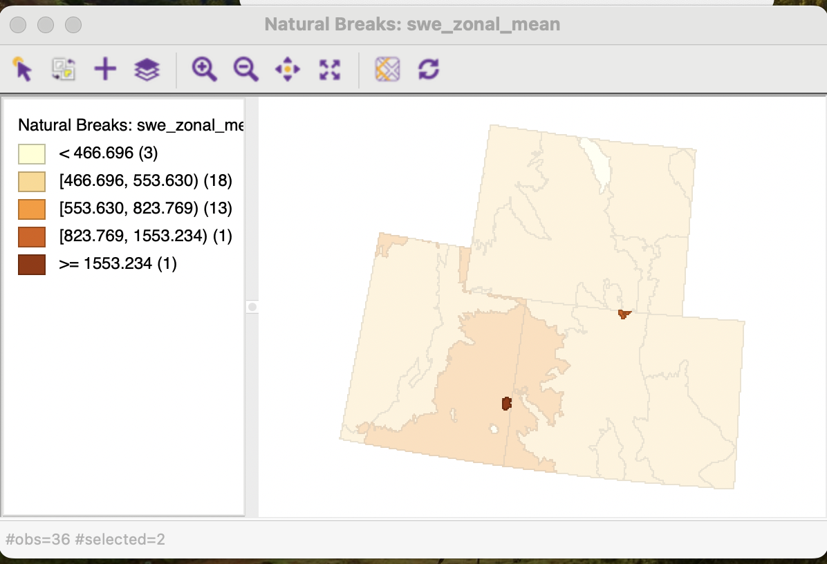

The above picture represents a natural breaks map of mean peak SWE, which can be useful for potentially visually identifying clusters of polygons with high or low mean peak SWE. This map suggests that the spatial structure of my data is hidden behind 2 separate outlier values which much higher SWE values than the rest of the study area. I selected the 2 highest mean peak SWE polygons to highlight them in this map. Given that they are so small, it is possible that there is something unique about them which may drive higher SWE values such as higher elevation. This trend continues even if I change the number of natural breaks to use when making the map.

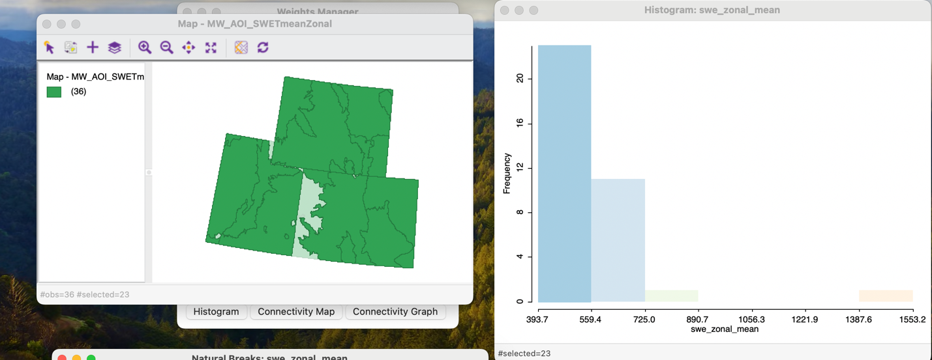

This histogram reflects the distribution of mean peak SWE values between my different ecoregions in these states. As I’ve previously identified, there are 2 obvious outliers. Without these outliers it is possible that the data would appear closer to being normally distributed. With only the bin with the lowest SWE values selected, I can see that it highlights most of the area in the map, further increasing my suspicions that the spatial structure of the mean peak SWE values will be difficult to interpret with these sorts of outliers present in the data.
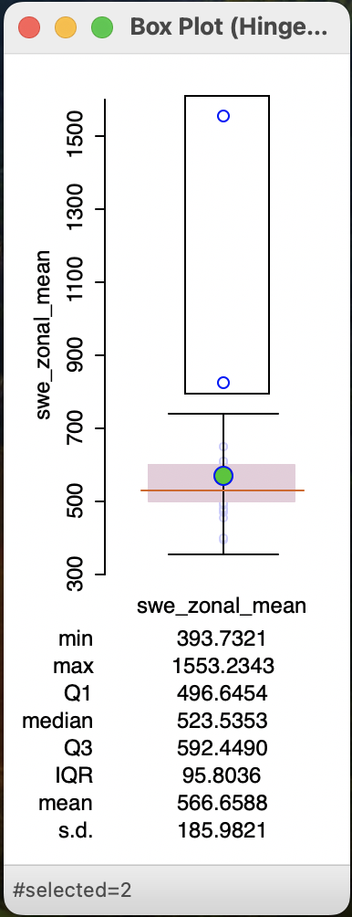
This boxplot also reveals 2 outliers, with 1 point in particular being well beyond the highest horizonal line in the boxplot. The standard deviation being as large as it is seems to be indicates to me that the 2 outliers are likely having an effect on how GeoDa understands the spread of the data. The mean and median do not appear extremely far apart, however, which makes me wonder if perhaps the outliers being in some of the smaller polygons present in this subset of my data is causing me to underestimate how well I might be able to understand the spatial structure of this dataset. It could be that smaller polygons are more susceptible to extreme values when doing zonal statistics as I have done to create this dataset.
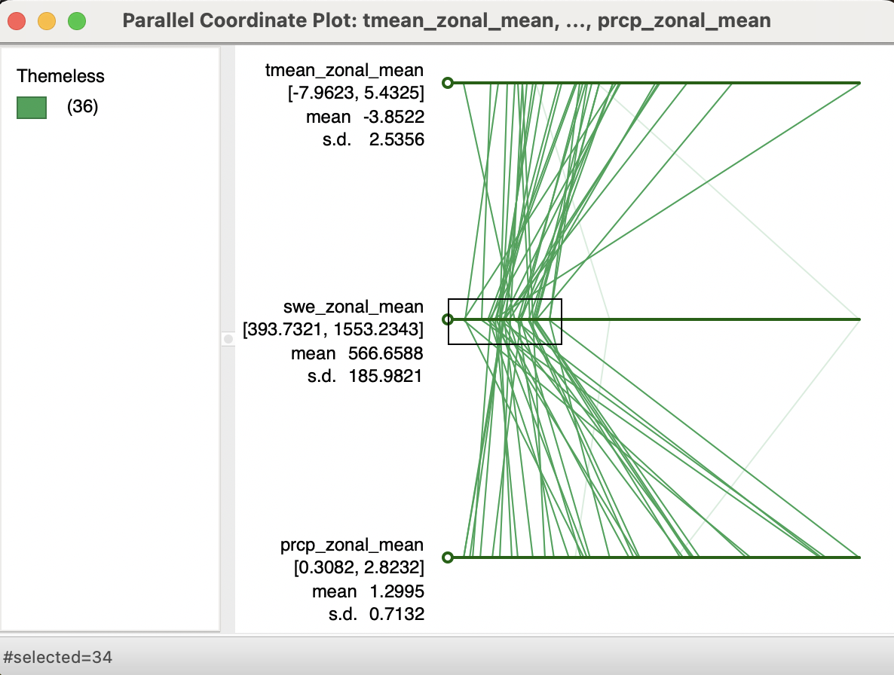
This parallel coordinate plot is useful for potentially understanding connections between different variables in my dataset which may serve as underlying causes of spatial autocorrelation in mean peak SWE. However, when ignoring the 2 SWE outliers, it is difficult to ascertain any trend between mean peak SWE and January precipitation and mean temperature. There are polygons with high precipitation values but SWE values close to the median, which could be related to precipitation falling as rain, or have a weak correlation due to precipitation in other months which are not examined here. The peak SWE value could occur in almost any month outside of the summer, so January precipitation and temperature by themselves may not be enough to explain where higher or lower SWE values occur.
Next, generate a spatial weights matrix to assess the spatial structure in your data
- What are the parameters of the spatial weights matrix that you chose? (2 point)
I chose Queen contiguity with first order neighbors.

- Describe and defend why you choose the parameters you did instead of others you could have chosen (1 point)
Given that I am working with polygon data, it makes much more sense to use contiguity weights instead of distance-based weights, especially with polygons of varying sizes like these. Contiguity weights also make more sense with climate-related data, where wild shifts in climate are likely to be somewhat similar between adjacent polygons, but unlikely to be very similar beyond that, hence the use of first order neighbors instead of second-order.

Compute the Global Moran’s I score
- Report the score. Then, interpret what that score means in plain language (2 point).
The Moran’s I score is 0.014. What this value indicates is that there is hardly any spatial structure to these mean peak SWE values, but that to the extent there is, it is positive and very weak, meaning that similar values tend to cluster together, but only barely.
- Place a screenshot of the Moran’s I plot below (2 points)

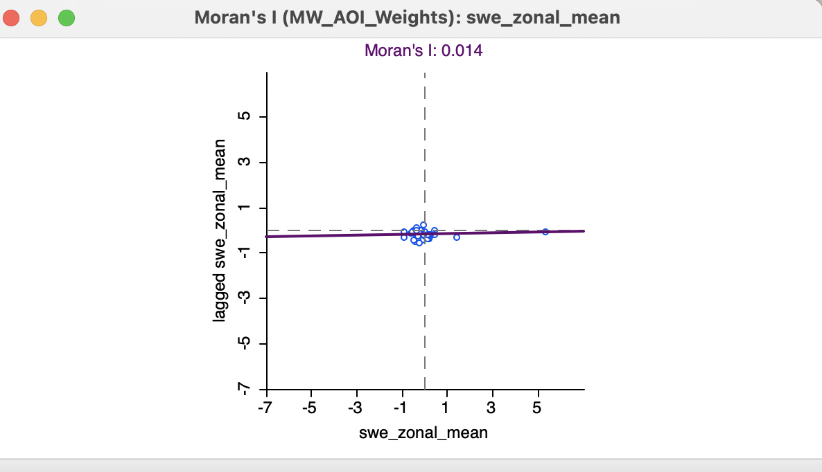

- Using the Moran’s I plot and the map of your data, through the process of brushing and linking, where do the values that contribute to positive spatial autocorrelation tend to occur in your data? (2 point)
There are not really any values which contribute to positive spatial autocorrelation, but to the extremely limited extent that there are, they are largely clusters near the border of Utah and Colorado, where the highest mean peak SWE values also happens to be located.

- Using 999 random permutations, how does your observed Moran’s I score compare to the pseudo-distribution created by the randomization process? What is the z-value? (1 point)
My Moran’s I value is very close to the middle of the pseudo-distribution created by the randomization process, indicating that there is not spatial autocorrelation in this data. The z-value also indicates this with a value of 0.5399.
Run the Local Moran’s I analysis to produce a cluster map that shows the LISA spatial clusters and spatial outliers in your data (if you have any).
- Place a screenshot of your LISA cluster map below. Interpret the findings (For example, where are the spatial clusters? What about the spatial outliers? Is this what you expected?) (2 points)
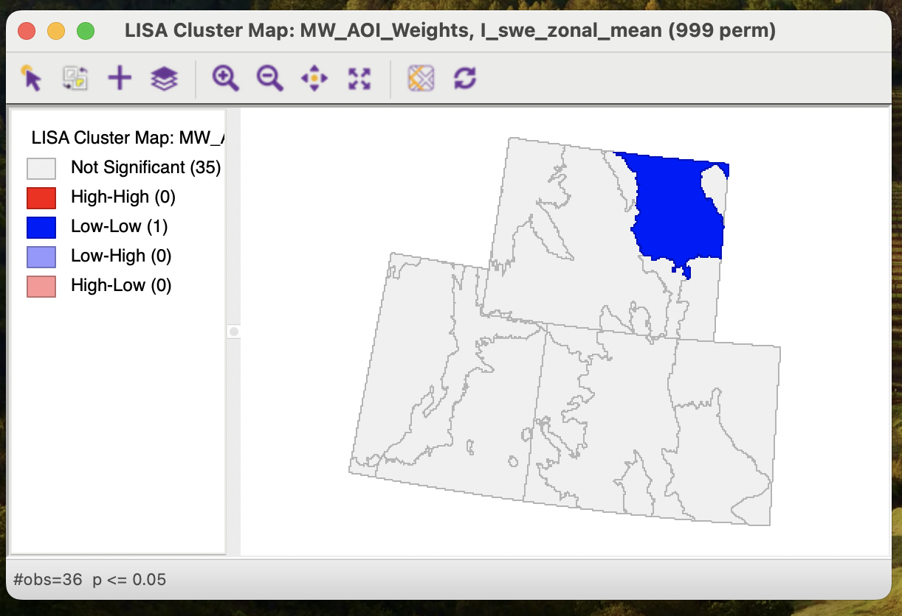

There are not really any clusters, since there is only 1 significant polygon, a cold spot where there are low SWE values surrounded by other low SWE values. No outliers appear in this map. This is mostly what I expected, although I did think the 2 high outliers shown in the boxplot would appear in this map as High-Low outliers.

- How many permutations are used to produce the LISA cluster map? What is the significance threshold? (2 points)
In this map, I used 999 permutations, with a significance threshold of 0.05. The one significant polygon is not statistically significant if a threshold of 0.01 is used instead, indicating a fairly weak significance in the one Low-Low polygon identified above.
- Change both the permutations settings and significance thresholds. Place a screenshot of your new LISA cluster map below (For example, where are the spatial clusters? What about the spatial outliers? Is this what you expected?) (2 points)
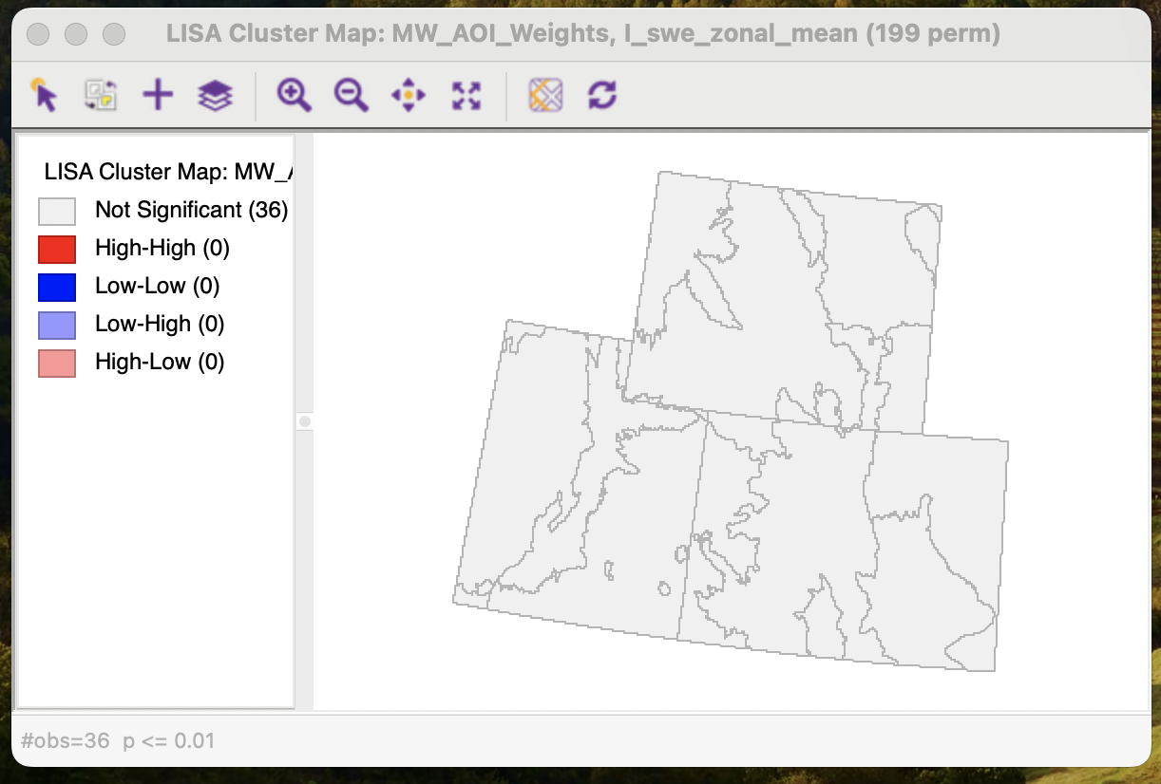

With 199 permutations and a significance level of 0.01, there are no spatial clusters. There are no spatial outliers. As previously discussed, I would have expected to see perhaps 1 or 2 High-Low outliers based on the histogram and boxplot I viewed during my ESDA process, but otherwise this looks like what I anticipated.

- How “stable” were your findings from the first map, based on what you observed after changing the permutations and significance thresholds in the second map? (2 points)
My findings from the first map were extremely stable, with only one polygon changing whether it was significant or not after adjusting the permutations and significant thresholds. Every other polygon remained not significant.

Extra Credit (5 points)
Save the LISA cluster results from the LISA cluster map that you feel reflects your findings best. Saving these results will append these findings to the attribute table of your data. Close GeoDa and then load the data into ArcMap (Desktop or Pro – your choice) and produce a map with all required cartographic elements. Place the map below:
