Griffin Shelor
ANSWER SHEET - Lab 2
Due 9/13/2024 at 5 P.M.
Complete your answers on this sheet. These correspond to the bold prompts in the main instructions document. Points allocated per answer and provided below. Upload to WebCampus as a Word Doc or PDF with any requested screenshots embedded into the document to complete your submission for Lab 1. Please type your answers in a readable color other than black.

- How many charging stations with outlets greater than 2 are there in the study area? Show a screenshot of the charging stations below. (3 point)
There are 135 charging stations with greater than 2 outlets in the study area.
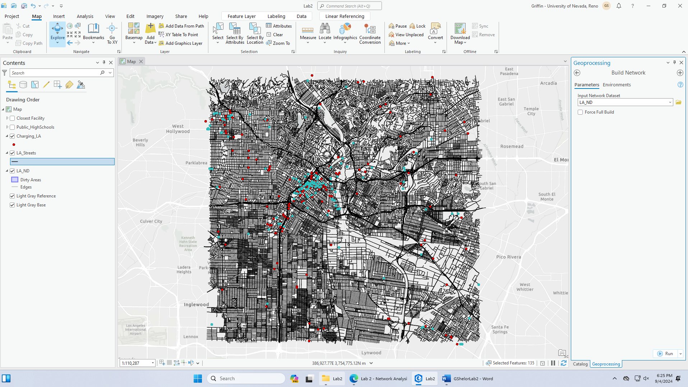

- Which school is farthest from a charging station based on time, and what is that time and distance between school and station? Which is closest based on time, and what's the travel time and distance? (2 points)
The school which is farthest from a charging station based on time is David Starr Jordan Senior High School. David Starr Jordan Senior HS is 7.328788 minutes away from a station and 5.053207 miles away. The closest school based on time is Maywood Academy High School. Maywood Academy is 0.028257 minutes and 0.011777 miles away from a charging station.

- How many of the total unique electric vehicle charging stations appear in the closest facility output? Hint: the summarize tool may be of some help (2 point)
There are 37 unique electric vehicle charging stations that appear in the closest facility output.

- Which charging station is the closest to the most schools? What is the average travel time of the routes from those schools to that station? (2 points)
The charging station closest to the most schools is the Department of Children and Family Services station. The average travel time is approximately 4.148492 minutes.

- Use the Service Area tool to generate an area for each EV charging station that has more than 2 charging outlets, setting the threshold for the service based on your answer in Question 4. Hint: you'll have to create a new service area layer using the dropdown menu from the Network Analysis on the Analysis tab. How many schools are covered by at least one service area? Place a screenshot below (3 points)
There are 104 schools covered by at least one service area.
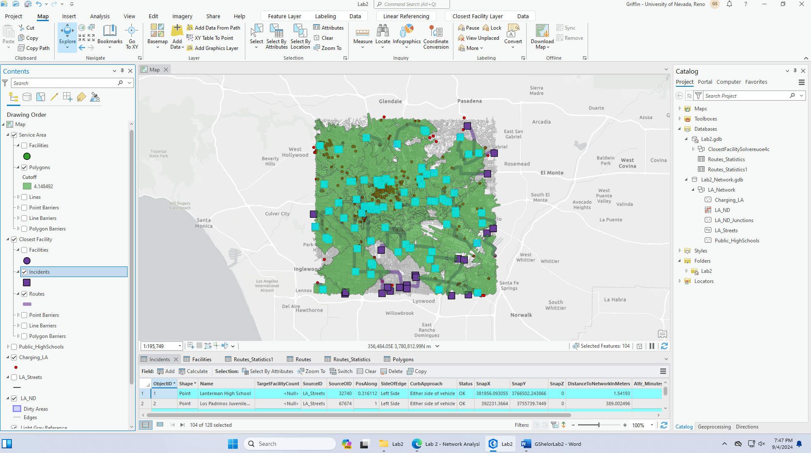
- What is the distance and travel time of the shortest path between USC and Dodger Stadium, using minutes (time) as the impedance? (3 points)
The distance between USC and Dodger Stadium is 19.948765 minutes and 6.00872 miles when minutes is the impedance.

- Provide a screenshot of the generated driving directions for the shortest path with travel time as the impedance value. (2 point)
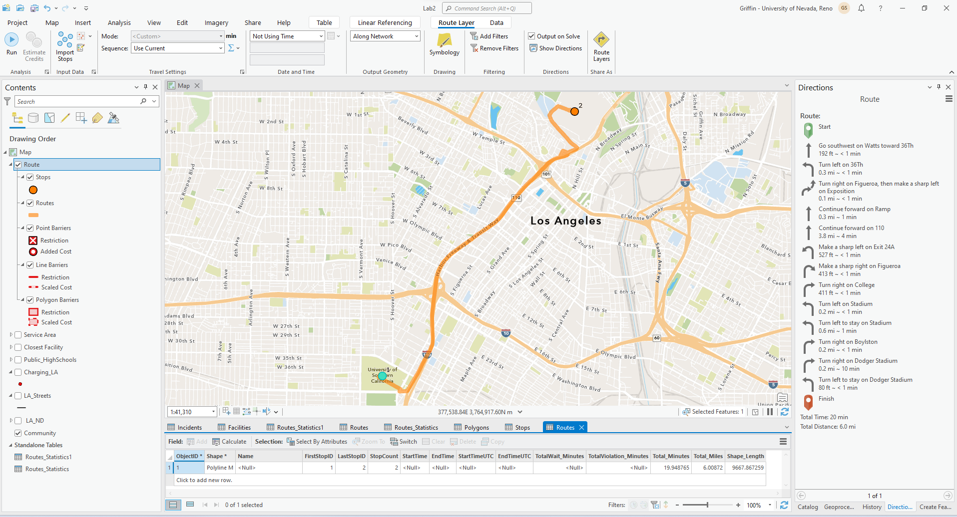
- What is the distance and travel time of the shortest path between USC and Dodger Stadium, using miles (distance) as the impedance? (2 points)
When miles is the impedance, the distance of the shortest path between USC and Dodger Stadium is 5.220356 miles and the travel time is 32.997661 minutes.
- Produce a professional map that includes both the shortest path route using time as the impedance and the shortest path route using distance as the impedance. (3 points)
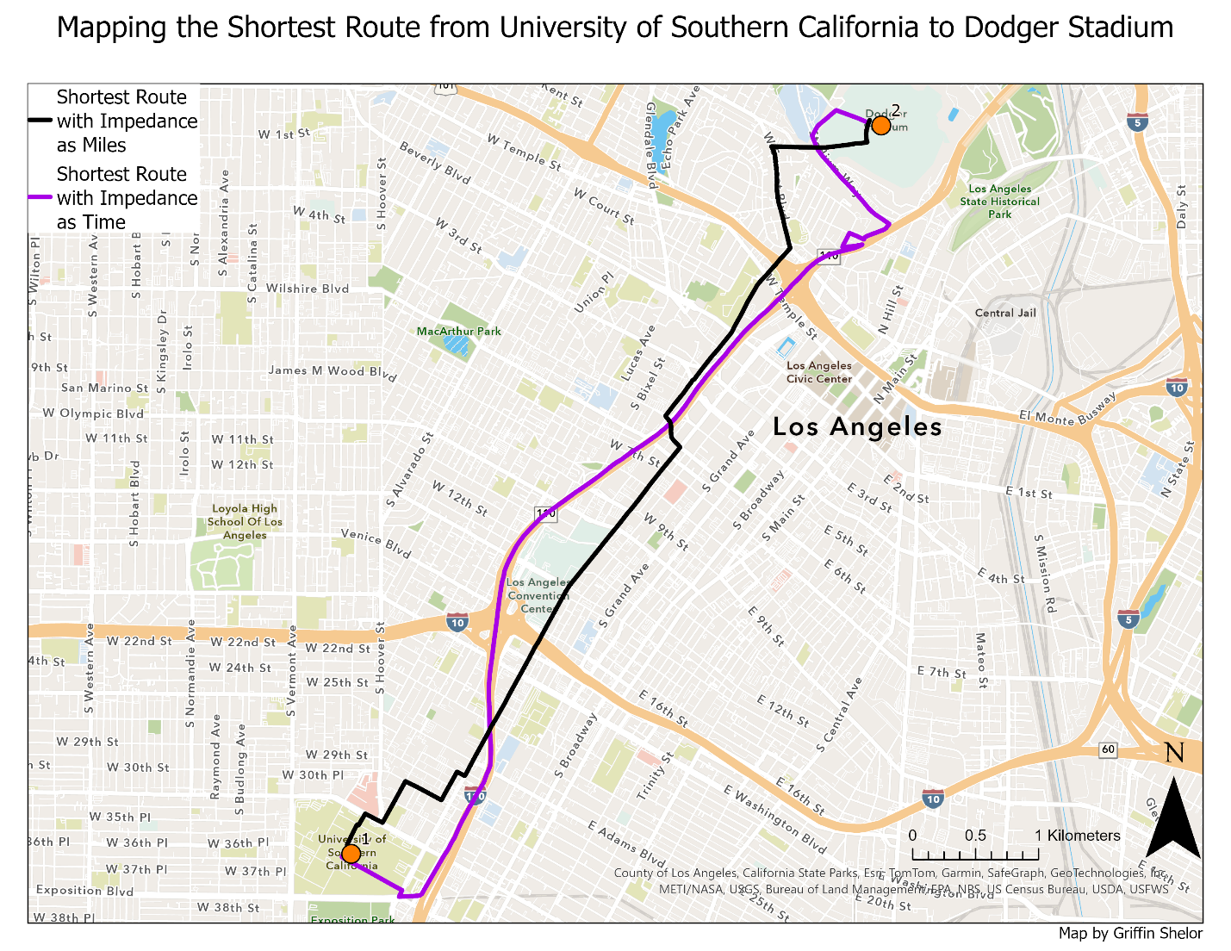
- In the network provided to you, what other factors that impact travel decisions are not currently accounted for in the network? Could this network be applied to traffic/travel analysis? Why or why not? (3 points)
Other factors that could impact travel decisions include current traffic conditions. It’s possible that the TravelTime field in the LA Streets layer may reflect average traffic conditions, but these can be highly variable throughout a given day or if there are unusual events happening in the area which may result in increased traffic. There could also be accidents which occur and slow traffic down in a particular direction. Roads with higher accident rates may be roads that a user of this network would want to avoid. This network could not be applied to traffic analysis because it represents an overly simplified version of the various impediments that will be experienced on LA Roads, as well as reflecting an assumed set of conditions underlying values like the TravelTime values when a traveler is about to travel along the network. If those conditions are not in place, the network falls apart and is much less usable.

