Griffin Shelor
ANSWER SHEET - Lab 3
Due 9/20/2024 at 5 pm
Complete your answers on this sheet. These correspond to the bold prompts in the main instructions document. Points allocated per answer and provided below. Upload to WebCampus as a Word Doc or PDF with any requested screenshots embedded into the document to complete your submission for Lab 3. Please type your answers in a readable color other than black.
Part 1 Deliverables (14 points)
- What projected coordinate system do you think will be better for the point feature layer (1 point)?
I think NAD 1983 UTM Zone 11N will be better for the point layer. It’s not perfect, as there is one point near Truckee, CA that is outside the zone, but it’s relatively close and all of the other points visually appear to fit inside the zone, and there’s not a clear obvious alternative.
- In your own words, describe the difference between deterministic and geostatistical interpolation methods. Name two methods of each type. (3 points)
The main difference between deterministic and geostatistical interpolation methods is that geostatistical methods incorporate spatial autocorrelation and a measure of uncertainty, meaning that the parameters of the method and the weights assigned to the input data are not directly selected by the user. Geostatistical methods assume that there is an underlying true population that can be modeled across the surface. 2 examples of deterministic methods include inverse distance weighting (IDW) and natural neighbor interpolation. 2 examples of geostatistical methods include kriging and areal interpolation, which is kriging-based.

- Describe how "edge effects" impact interpolation. (2 points)
Edge effects can have significant impacts on interpolation. Estimating values near the edge of our boundary of interest can be very challenging if there are not any points nearby to provide values which may be more useful in weighting than points further away but within our AOI. If points within our AOI are clustered, but not in an area near the edge of the AOI, we may be more likely to experience error in our predictions across that portion of the AOI.
- Produce a professional map of the IDW surface. Include a legend with the correct units. (2 points)
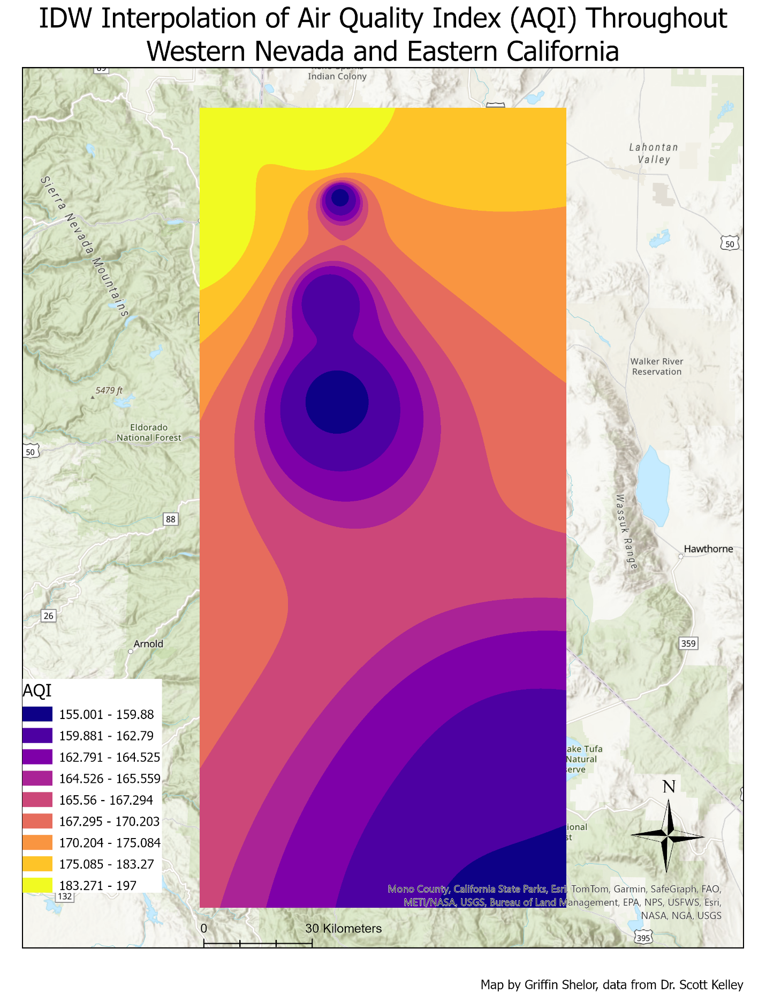
- Produce a professional map of the nearest neighbor surface. Include a legend with the correct units. (2 points)
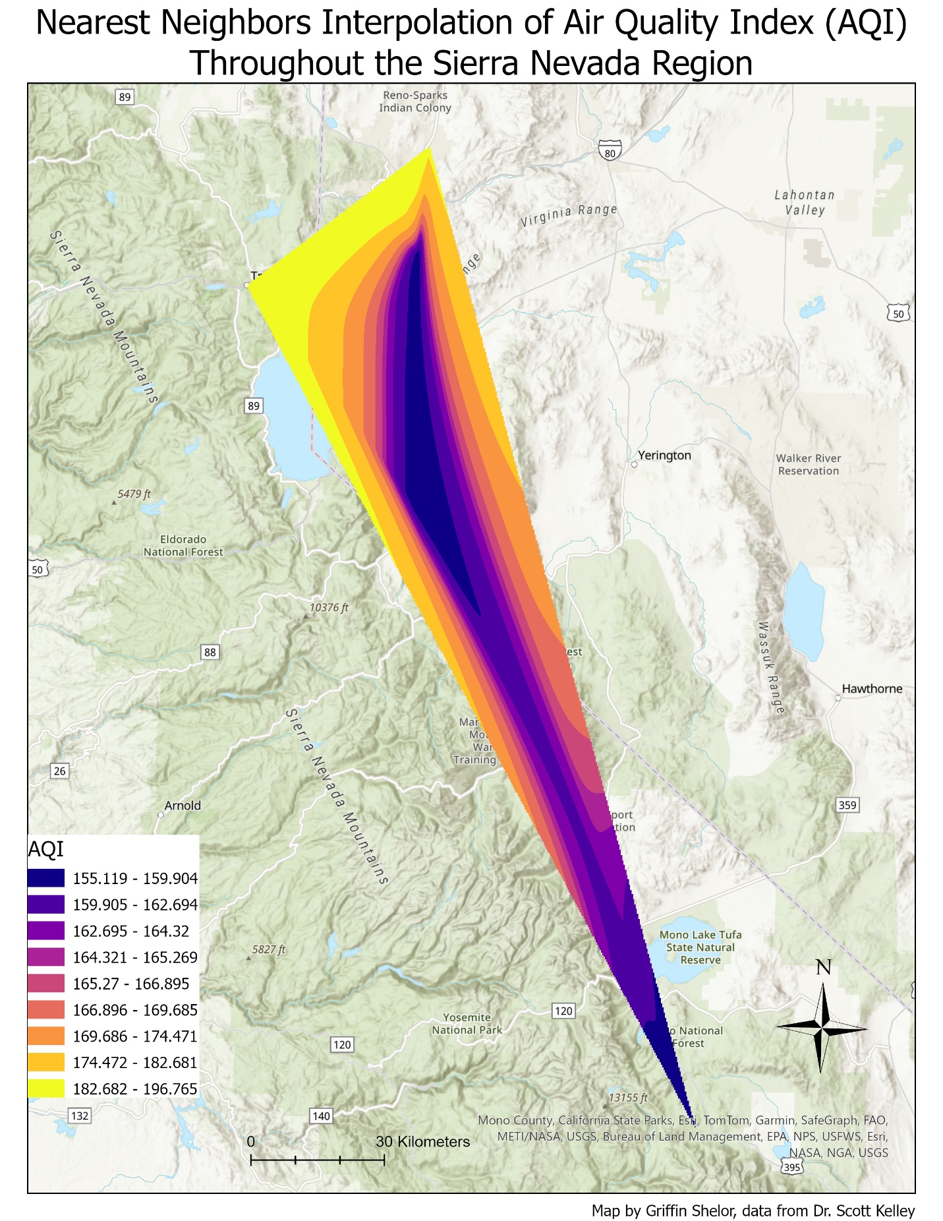
- Produce a professional map of the Kriging surface. Include a legend with the correct units. (2 points)
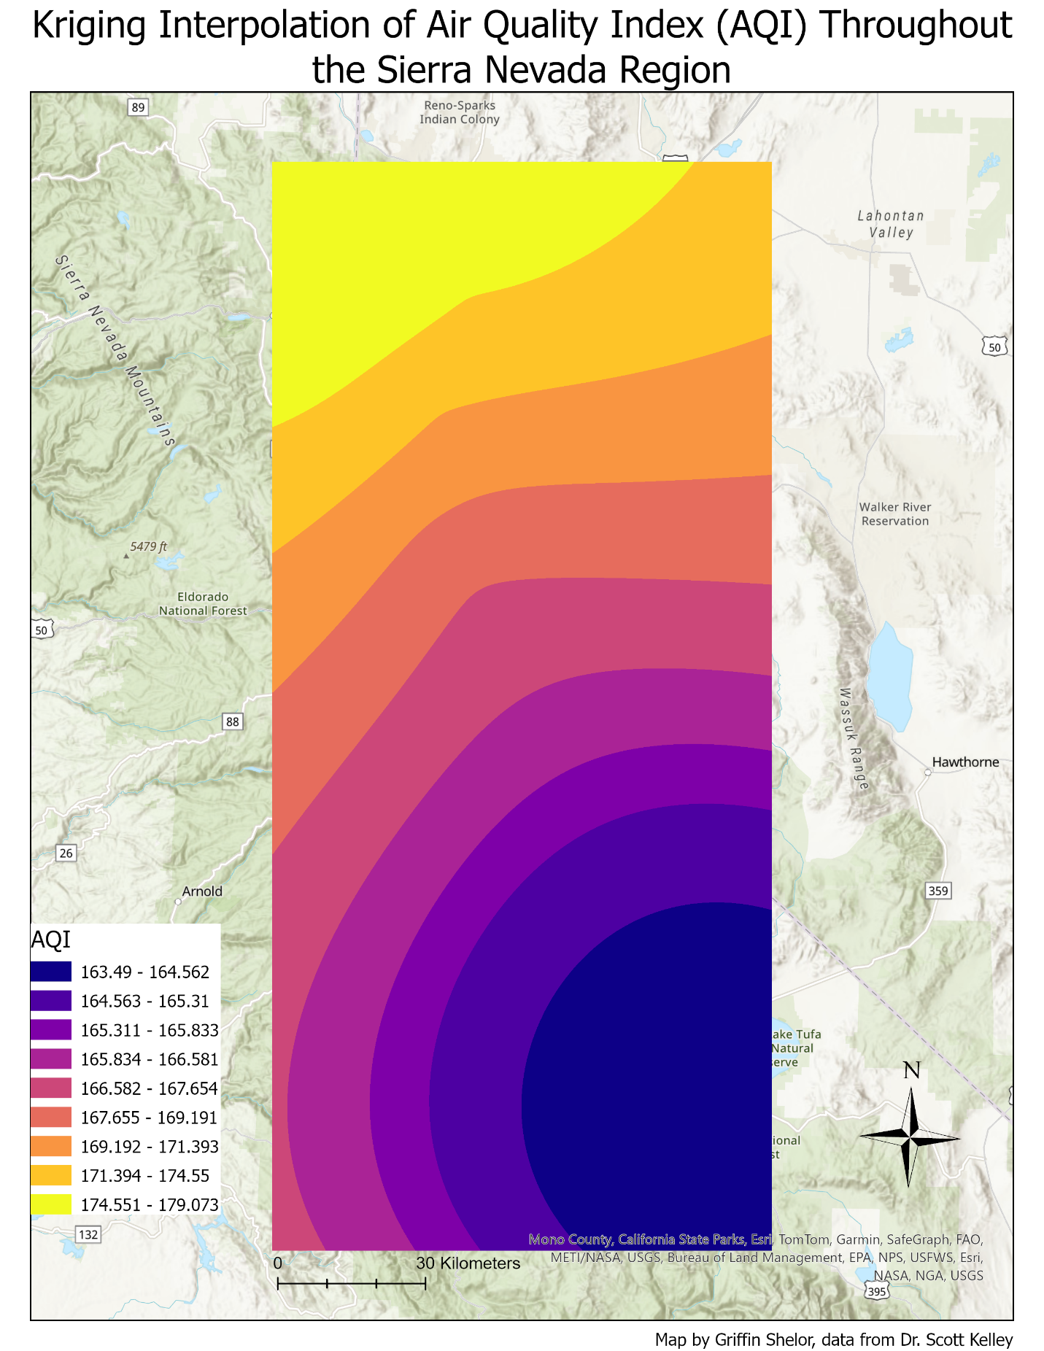

- Describe the patterns displayed in each output surface. How and why do the patterns differ between the three maps? How does the range of data values differ? (2 points)
The IDW output displays a bullseye pattern that reflects the fact that a major driver of IDW outputs is how far a given location is from nearby points. The further away a point is from a location being estimated, the less influence it will have. This creates a bullseye effect as the way weighting occurs in IDW allows points to each build an area of influence that decays based on a power level set by the user. The Natural Neighbors output builds areas of influence by putting each point inside of its own polygon such that no location within a given polygon is closest to a point other than the point inside of the same polygon. Instead of relying on distance from other points, Natural Neighbors weights the overlapping area from surrounding areas of influence for estimating a z-value at a given location. This creates less of a bullseye pattern but does still create a pattern where values cascade away from local minimum or maximum values, depending on how high or low the nearest known point’s z-value is. Kriging, however, combines both a distance-based or direction-based relationship with an understanding of the level of spatial autocorrelation in the data. In some forms of kriging, this allows for a spatial trend to be incorporated into the creation of a prediction surface which is smoother and avoids the bullseye effect of IDW. Ordinary kriging, however, does not assume an underlying trend or constant mean, which can lead to predicted surfaces looking more like broader trends across an area as opposed to a realistic-looking prediction surface. Given that IDW and Natural Neighbors rely on distance and area-based relationships respectively, the ranges of values created by those methods both follow the range of values present in the actual data, with no predictions outside of those ranges. Because kriging is a geostatistical method, it does not follow the range of known values so closely, making it possible to predict values outside of the known range. In this case, however, it predicted values within a narrower range than both IDW and Natural Neighbors. This could be due to the use of ordinary kriging, which does not assume as much of an underlying trend and thus creates a smoother surface instead of predicting values which may seem like outliers compared to the known data.

Part 2 – Interpolate your own data
Select your own study area and find point-based data on any topic that interests you. For example, you can find point precipitation, elevation, or pollution data. Make sure the data include both the location and value of each point.
Then, create a short report about the distribution of your data.
Part 2 Deliverables (9 points)
- Describe your input dataset (what is it? where is it? what attribute are you interpolating? what are some basic summary statistics of that attribute?) (3 points)
My input dataset is a collection of 100 points with each point representing the peak Snow Water Equivalent (SWE) for Water Year 1996 at a given SNOTEL site. These points all reside within a contiguous portion of the EPA Level III Ecoregion known as “Middle Rockies”. The attribute that I will be interpolating will be peak SWE in millimeters. The minimum peak SWE value for WY 1996 is 48.3 mm and the maximum value is 1897.4 mm. The mean and median peak SWE values are 593.02 mm and 501.65 mm respectively. The data does not obviously look spatially autocorrelated based on a visual examination but a further test such as Moran’s I would be able to examine that quality in the dataset more rigorously.
- Name the interpolation method you used. Describe, in your own words, how the interpolation method is calculated. (2 points)
The first interpolation method I used was Inverse Distance Weighting (IDW). IDW calculates predicted values by taking each known value from a user-set number of neighbors and dividing it by the distance it is from the location being predicted raised to a power set by the user. This power level dictates how rapidly the influence of distance decreases as the distance itself increases from the location being predicted.

- Describe the patterns in your output surface (such as, is it smooth or varying? Are there outliers?) (2 points)
The output surface does not contain any outliers, given IDW’s propensity to be relatively faithful to the known data, particularly in areas with a high density of points. It does seem to be mostly a smooth surface, with high values concentrating in the southeast and northwestern corners of the ecoregion, though there are some smaller pockets of lower peak SWE values located within some of the larger areas of relatively higher values.
- Produce a professional map of your surfaces. (2 points)
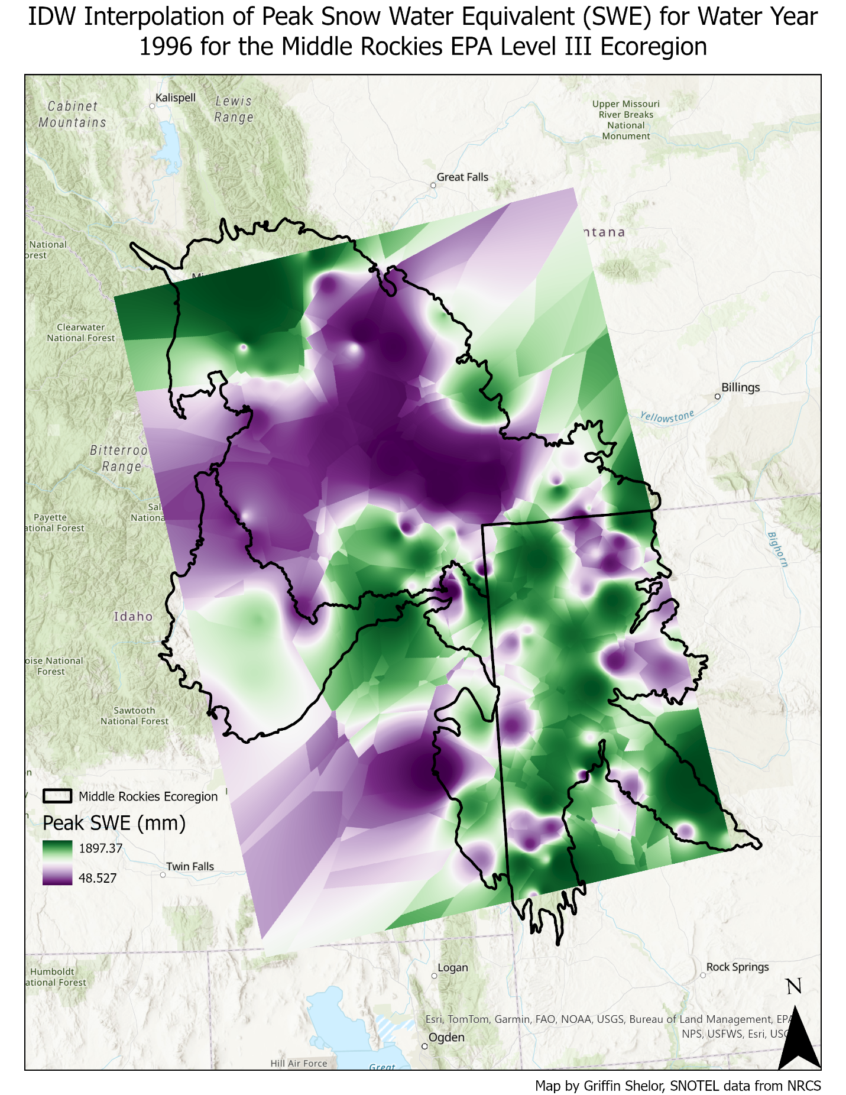

BONUS:
Run a second interpolation method on your data and describe how and why the patterns differ between the maps. (2 points)
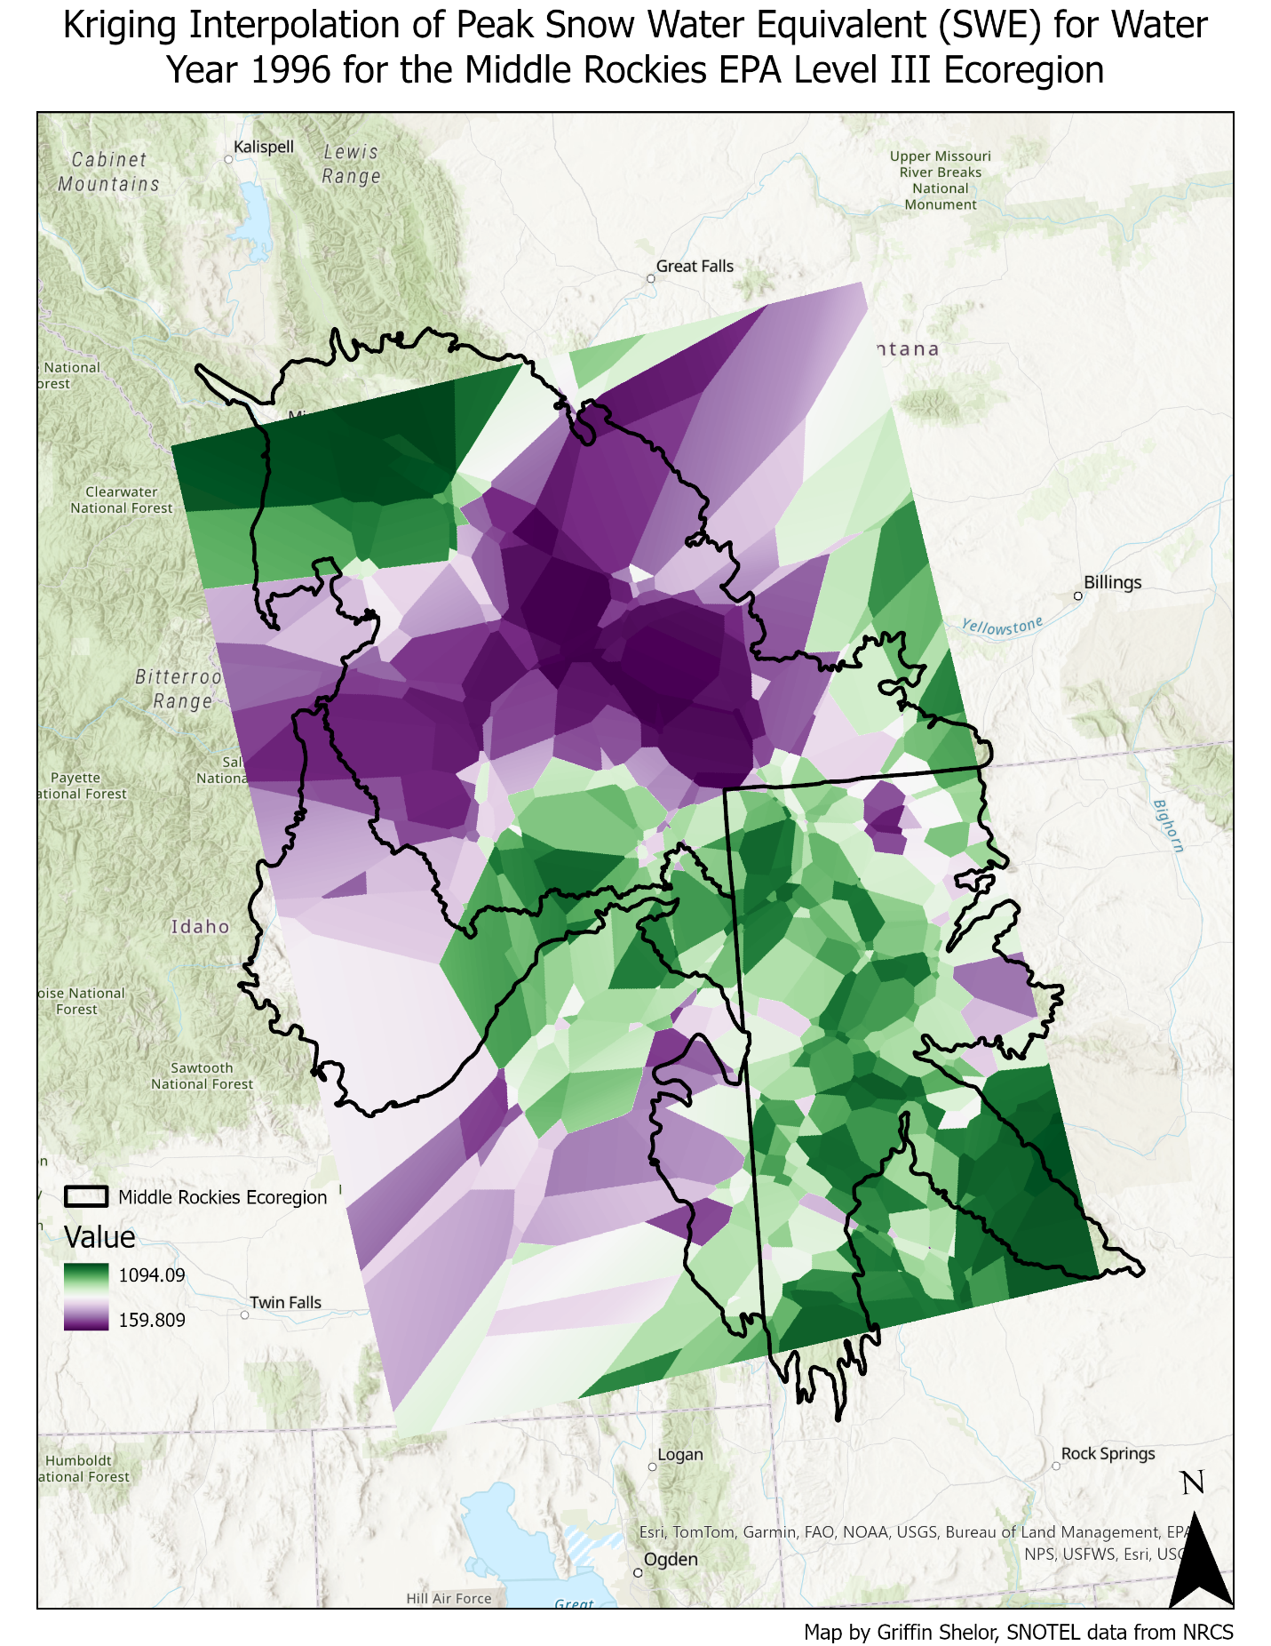
For the second interpolation, I used kriging. The biggest difference between the 2 interpolations is that the IDW interpolation appears to include stronger patterns of high values and stronger patterns of low values, with few “medium” values in between. This is especially true inside of the ecoregion itself, where all of the SNOTEL points are. By contrast, the kriging interpolation a few smaller portions of relatively large or small values, with a more noticeable gradient in between areas of high peak SWE and areas of low peak SWE. This is likely due to IDW’s reliance on the existing dataset both for values at or near the existing points as well as the dependence on distance from known points being used as weights to calculate unknown values at unmeasured locations. It is possible that this dataset has climatological outliers in it regarding peak SWE and that WY 1996 resulted in unusually high or low peak SWE values that could give those outlier points outsized influence on the rest of the surface that a geostatistical method like kriging would be able to minimize by finding a statistical relationship between points based on spatial autocorrelation.

