Griffin Shelor
ANSWER SHEET – Lab 1
Due 9/6/2024 at 5 pm
Complete your answers on this sheet. These correspond to the bold prompts in the main instructions document. Points allocated per answer and provided below. Upload to WebCampus to complete your submission for Lab 1. Please type your answers in a readable color other than black.
- What is the projection and coordinate system of RenoSampleData? (2 points)
The projection and coordinate system of RenoSampleData is USA Contiguous Albers Equal Area Conic.

- Looking at the data on your screen at this point, what is one key issue with re-projecting the RenoSampleData to UTM as-is? (1 point)
It includes census block groups in California.

- Take a screenshot of your project/map screen that now shows only the Block Groups in Nevada, with the file name “RenoAreaBGs.” (1 point)
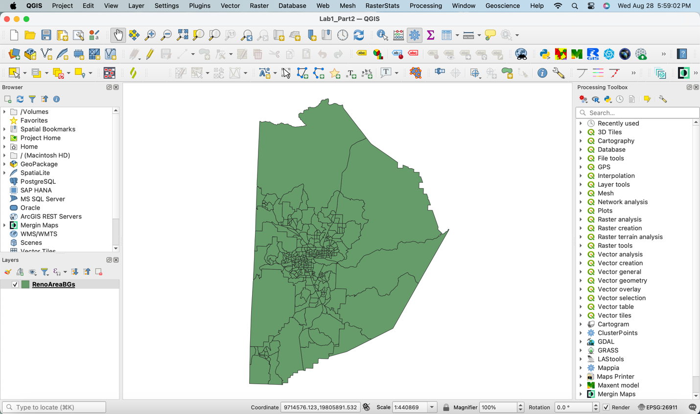

- What is the projection and coordinate system of the TRINA road segment data? (1 point)
The projection and coordinate system of the TRINA data is EPSG:28911 NAD 1983 UTM Zone 11N.

- Do we need to reproject the TRINA road segment data to match that of the block groups? Why or why not? (2 point)
No, we do not need to reproject the TRINA data because the EPSG code already matches that of the block groups.

- Place a screenshot below, confirming that the only layers you should now have in your project are the RenoAreaBGs and the RenoAreaTRINA data (i.e. show filenames). (1 point)
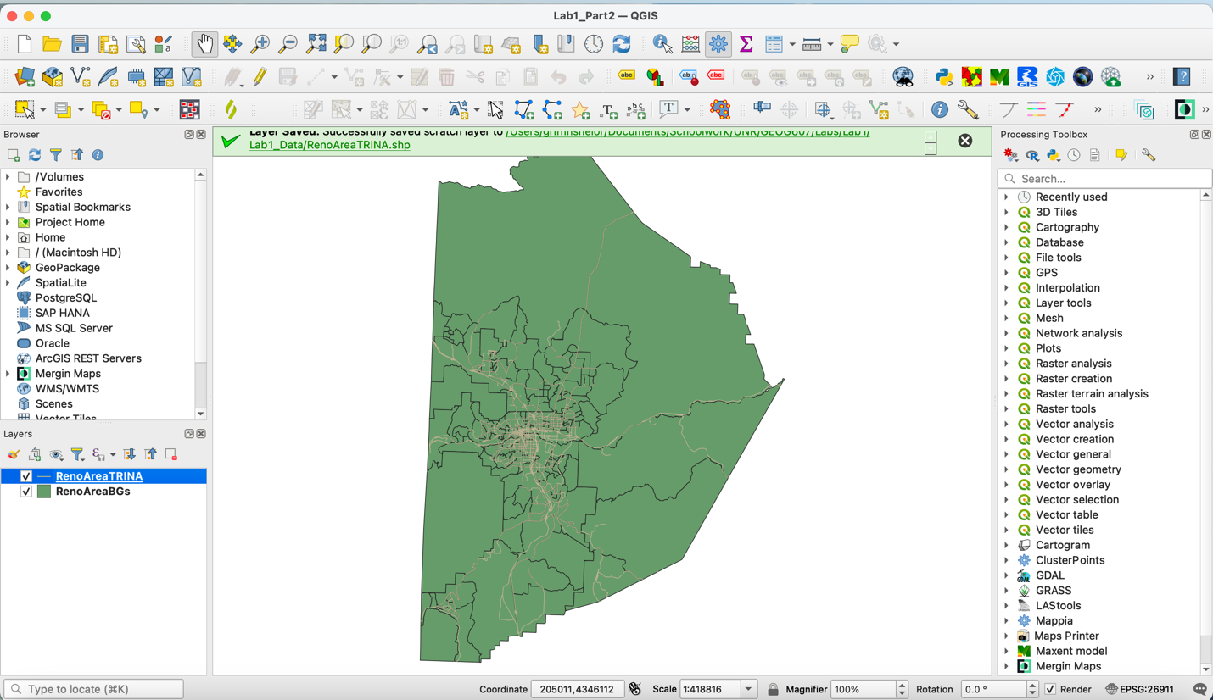

- What is the Raster Calculator Expression that you entered to convert the cell values from meters to feet? (2 points)
"USGS_13_n40w120@1" * 3.2808399

- What is the Raster Calculator Expression that you entered to isolate all raster cells with an elevation greater than 5,000 feet? (2 points)
"DEMft@1" >= 5000

- Take a screenshot and place below, showing these three layers on your map and the filenames (1 point).
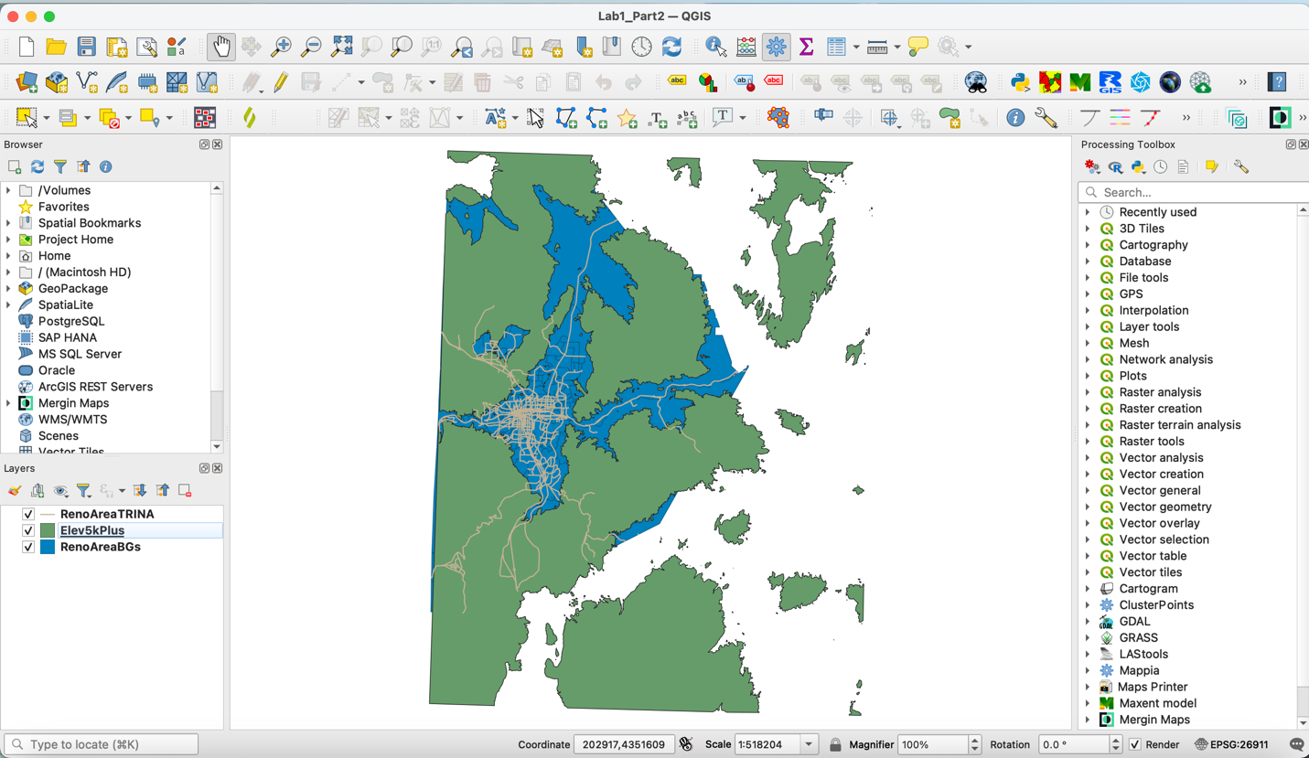

- Examine these – where are these road segments? What parts of our road network are they on? Are these areas where you have encountered problems when traveling through snow? (1 point)
These road segments are mostly in the southern and northern portions of the Reno area, moving in directions that head either to or away from the mountains located to the west in the Lake Tahoe area. They appear to be highways leading in and out of Reno. I have not encountered problems here when traveling through snow but that is largely because I am well aware I reasonably could encounter problems and so I simply avoid driving in these areas when it is snowing.

- How many block groups are there that intersect with the top 10 highest AADT road segments above 5000 feet in our region? (1 point)
There are 11 block groups which intersect with the top 10 highest AADT road segments above 5000 ft in our region.

- Take a screenshot of the map of selection output below, showing the block groups clearly. (1 point)
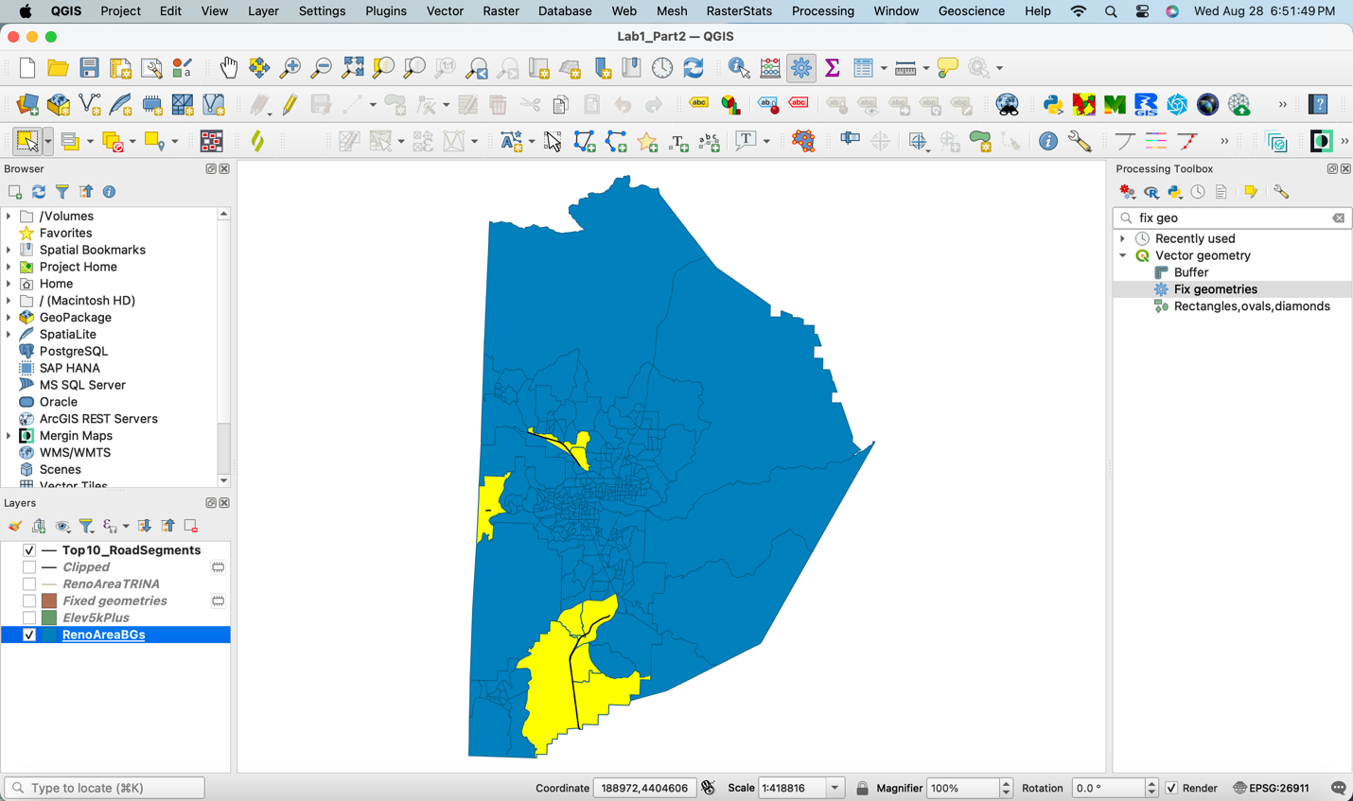

- Fill in the following table to complete the assignment. We want to produce some summary statistics for the block groups that intersect with the 10 highest AADT road segments above 5000 feet and compare these to the summary statistics of the other block groups in the region, to see if there are any notable differences. Several helpful tips to complete this can be found below the table.

(6 points, 1/3 point for each cell in the table)
 | Block Groups with 10 highest AADT road segments |  |  | Other Block Groups in the region
 | Median | Min | Max | Median | Min | Max
% of the Population with a Commute over 20 minutes (PctComm20) | 65.023 | 39.844 | 90.284 | 44.4715 | 0 | 100
% of the Population that drives alone to work (PctDrvAlon) | 82.737 | 65.032 | 92.264 | 78.622 | 25 | 100
% of the Population with a Bachelor’s Degree or higher (Pct Bach) | 27.01 | 3.69 | 62.604 | 27.990 | 0 | 94.139

- Describe the findings a little bit. Are there major differences in the three population characteristics of interest (commutes over 20 minutes, driving alone to work, and having a bachelor's degree or higher) between block groups with relatively high passing traffic volumes susceptible to snowfall (and subsequently, impacts of snow on travel in the winter), and those that don’t? What might be an explanation for any of the differences you see? Just speculate here – no need to dig into any research online. (3 points)
The biggest difference between the block groups intersecting the top 10 highest is the ranges between the min and maximum percentages of population fitting each characteristic of interest. In block groups intersecting the top 10 roads, there is generally a much smaller range between the min and max values, especially for the percentage of people who drive alone, where even the population in the top 10 block group with the lowest percentage of the population that drives alone is still more likely to drive alone than not. This may be due to these block groups being more rural and having less access to public transit and carpools and thus containing people who must be more independent in how they commute to work. Block groups intersecting the top 10 most highly travelled roadways also have noticeably higher minimum and median percentages of the population with a commute over 20 minutes, further indicating the possibility that they are further removed from areas with higher urbanization and thus less convenient access to places they may work. There is also a large gap in the maximum percentage of the population who has a college degree, with the block groups intersecting the top 10 roadways having a much lower maximum percentage than the other block groups. People in rural areas are typically less likely to have a college degree compared to urban area, so this gap could potentially be explained by a systemic gap between rural and urban areas as well.

