Griffin Shelor
16-10-24
Lab 6 Answer Sheet
Due 10/28/2024 at 5 pm
Complete your answers on this sheet. These correspond to the prompts in the main instructions document. Points allocated per answer and provided below. Upload to WebCampus as a Word Doc or PDF with any requested screenshots embedded into the document to complete your submission for Lab 6. Please type your answers in a readable color other than black. When in doubt, attach a screenshot.
Question 1a (3 points):
What is the distribution of the population density? Show the histogram and box-plot for the population density, and interpret the two graphics. Be sure that the axis values are legible in your screenshots.

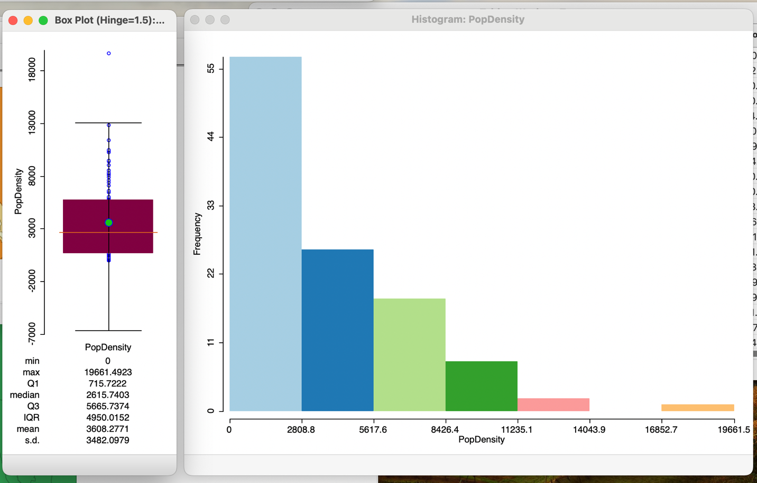

The distribution of population density across the census tracts does not follow a normal distribution. There is significant skew in the positive direction, with the mean population density being nearly 1000 people per square mile greater than the median. Just over half of the census tracts having a population density between 0 and 2808.8 people per square mile. According to the boxplot, approximately 75% of the census tracts have a population density less than 5665.74 people per square mile.

Question 1b (2 points):
Select all of the values in the lower quartile of the Boxplot. Where do these highlight on the map? Based on this information, do you think the population density is randomly distributed in the county? Yes or no, and why? Include a screenshot of the selection in the boxplot and the map.

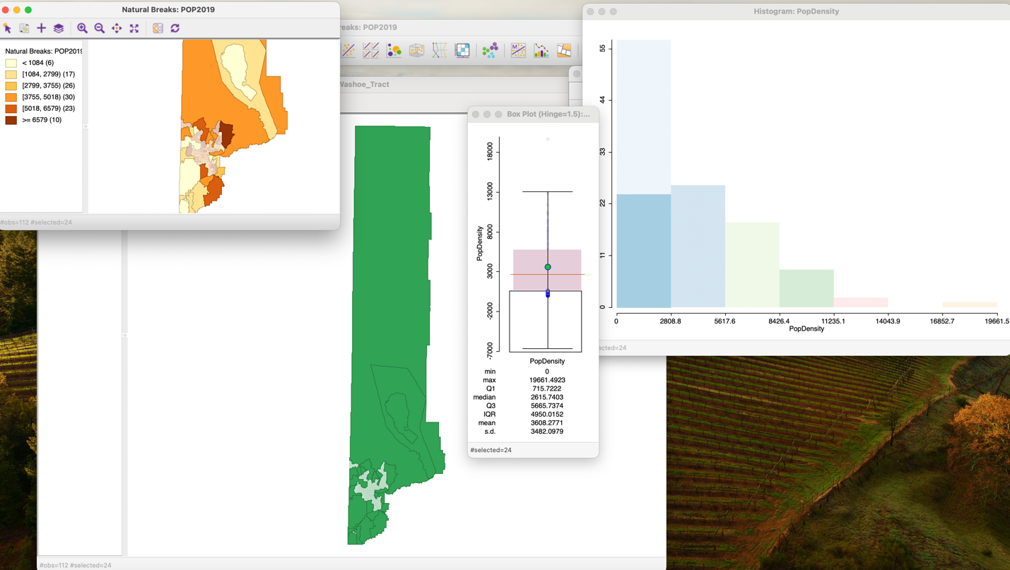

This selection highlights nearly all of the areas outside of Reno and Sparks, in addition to a few census tracts on the outskirts of this urban area. Based on this information I do not think that population density is randomly distributed in the county, since this selection indicates that more densely populated census tracts are concentrated in a specific small area of the county, with less densely populated tracts clustering around it.

Question 2a (2 points):
In this dataset, what is the maximum number of connected polygons (largest number of neighbors) for a single polygon? Provide a screenshot of the map and the histogram with the feature with the most neighbors selected.

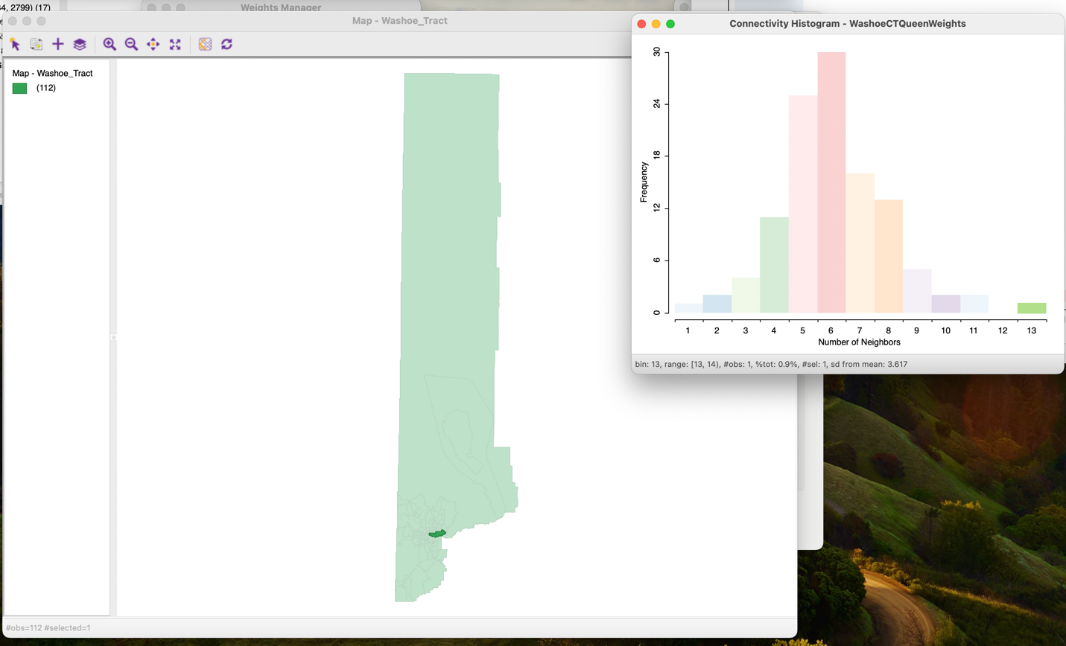

The largest number of neighbors is 13 neighbors.

Question 2b (2 points):
Which connectivity category has the most polygons?
The connectivity category with the most polygons is the category with 6 neighbors. There are 30 polygons with 6 neighbors.

What is the spatial distribution of those polygons over the entire map? Provide a screenshot of the map and the histogram with the feature with the most neighbors selected.

The spatial distribution of these polygons is that they are located in southern Washoe County, with some of the polygons appearing to be located inside of Reno and Sparks.

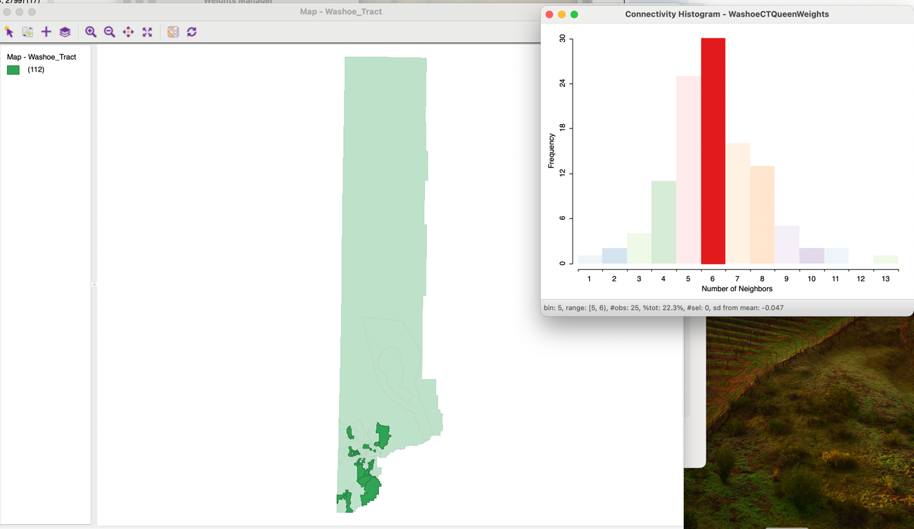

Question 3a (1 point):
Report the value of Moran's I, the global spatial autocorrelation statistic, of the population density.
The value of Moran’s I is 0.434.

Question 3b (1 point):
Describe the location of the high-high polygons in the map and show a screenshot of the selected map and scatterplot.
The high-high polygons are located within the heart of the Reno-Sparks area in southern Washoe County.

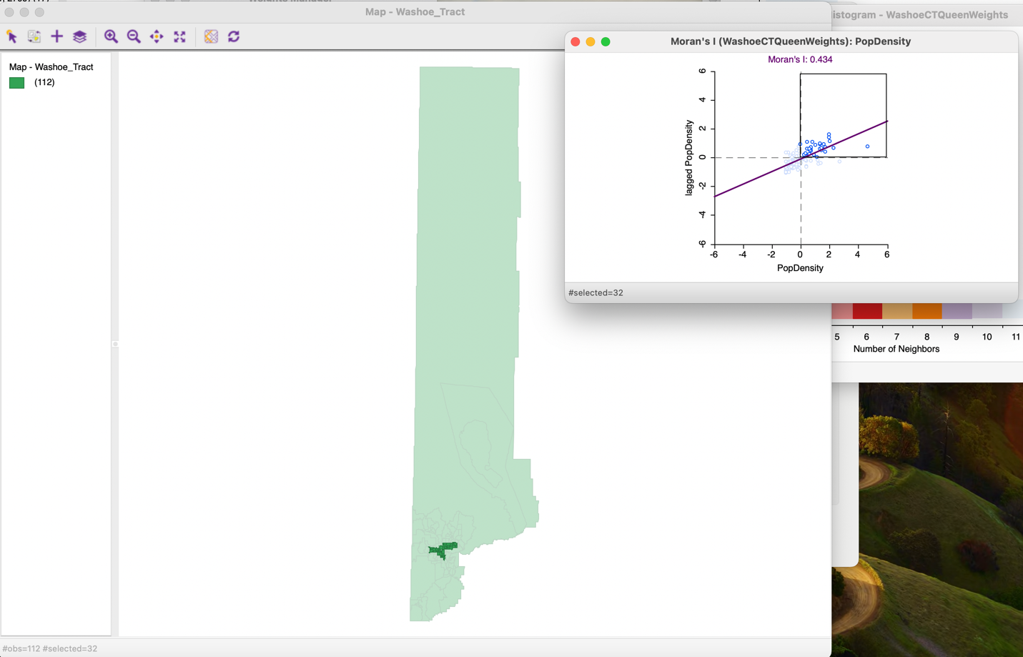

Question 3c (1 point):
Describe the location of the low-low polygons in the map and show a screenshot of the selected map and scatterplot.
The low-low polygons are the polygons surrounding the Reno-Sparks urban area, and span the extent of the county except for a hole where Reno and Sparks are as well as a few extra polygons in the vicinity of Reno and Sparks.

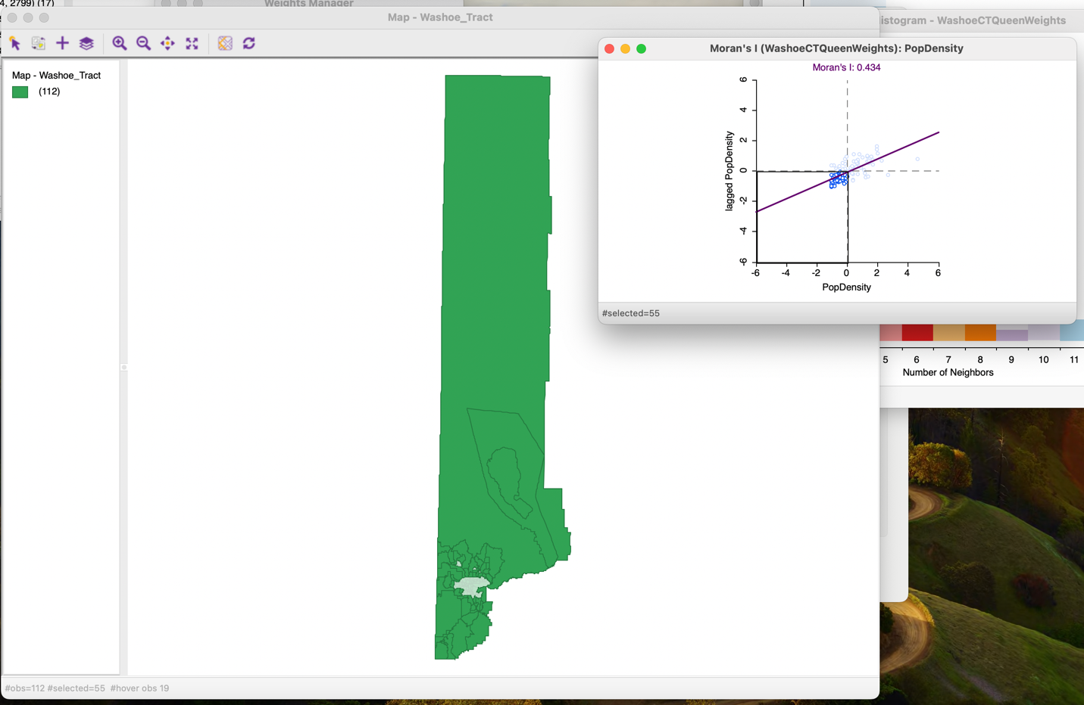

Question 3d(1 point):
Based on your answers to 3b and 3c, does it look like the population density values in Washoe County are spatially auto-correlated?
Given that high-high polygons appear to cluster together spatially with low-low polygons appearing clustered around them, it does look like the population density values in Washoe County are spatially autocorrelated.

Question 4a (2 points):
Examine the histogram of simulated Moran's I values. Does the value of your actual Moran's I look like it falls within the normal distribution from the random permutations of the data? If not, is it higher or lower? Is there global spatial auto-correlation in this dataset? Provide a screenshot.
My actual Moran’s I does not appear to fall within the normal distribution from the random permutations of the dataset. It is higher than the distribution from the permutations. This indicates that there is global spatial autocorrelation in this dataset.

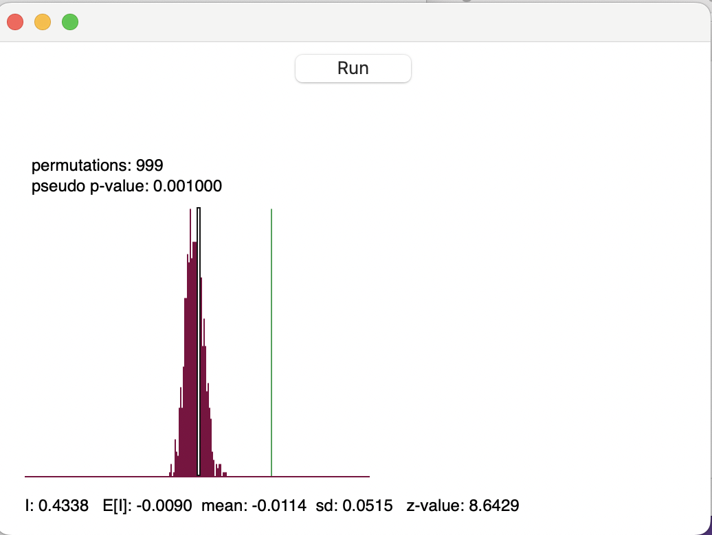

Question 4b (2 point):
What is the pseudo-p value for 199 permutations? for 499 permutations? Show a screen-shot of each. Can you reject the null hypothesis that at the global level, density values are randomly distributed?
The pseudo p-value for 199 permutations is 0.005.
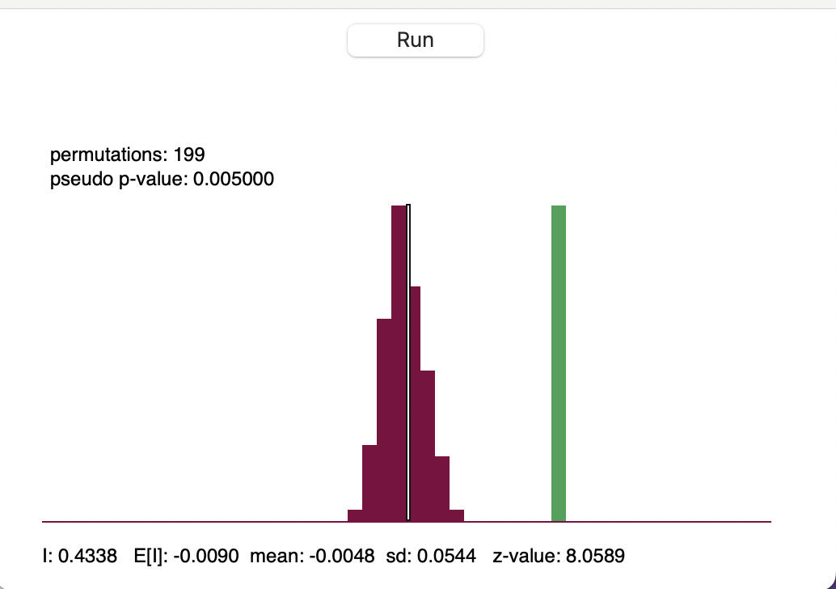

The pseudo p-value for 499 permutations is 0.002.

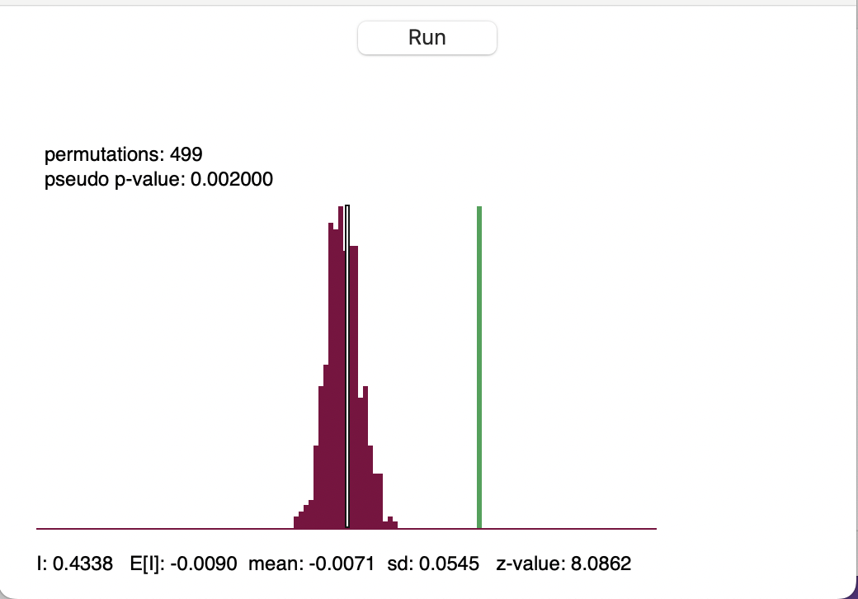

Given these pseudo p-values, I can reject the null hypothesis that at the global level, population density values are randomly distributed.

Question 5a (2 points):
How many features do not exhibit significant spatial clustering at the p=0.05 level? At the p=0.01 level?
At the p=0.05 level, there are 67 features which do not exhibit statistically significant spatial clustering. At the p = 0.01 level, there are 96 features which do not exhibit statistically significant spatial clustering.

Question 5b (4 points):
Interpret the results of the maps. Where are there hotspots? Where are there coldspots? What do the term hotspots and coldspots mean in the context of this dataset? Are there any outliers? Use screenshots to support your answers.
There are hotspots in the urban core of Reno and Sparks in both maps (shown in a more prominent red), with the hotspot being smaller in the map with the significance level set to 0.01 due to the higher threshold for significance. The coldspots (shown in a more prominent blue) are in the larger-area polygons surrounding Reno/Sparks which are likely rural areas with much lower populations. In the context of this dataset, hotspots would be areas with high population density nearby or adjacent to other areas with high population density. Coldspots would be polygons with low population density surrounded by other areas of low population density. At the 0.05 significance level, there are 2 outliers which are low areas surrounded by high outliers. At the 0.01 significance level, there are only hotspots, coldspots, and areas of no significance.

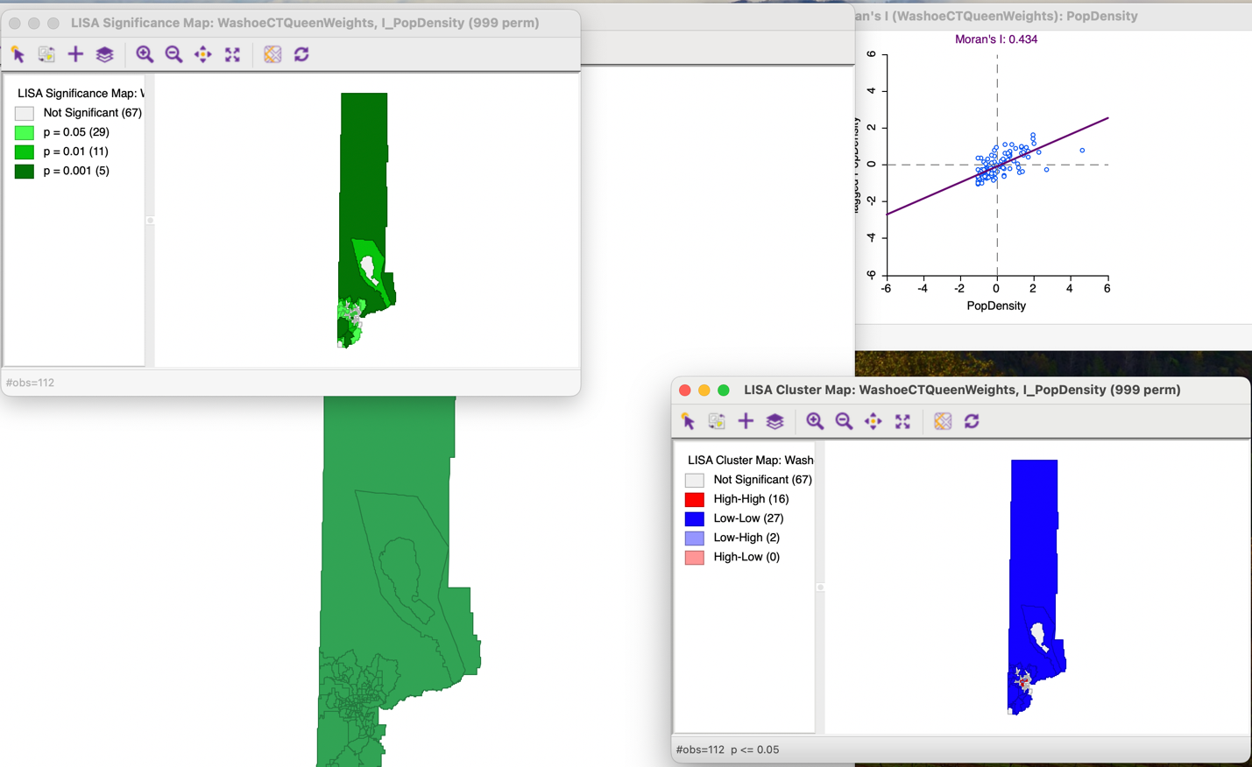
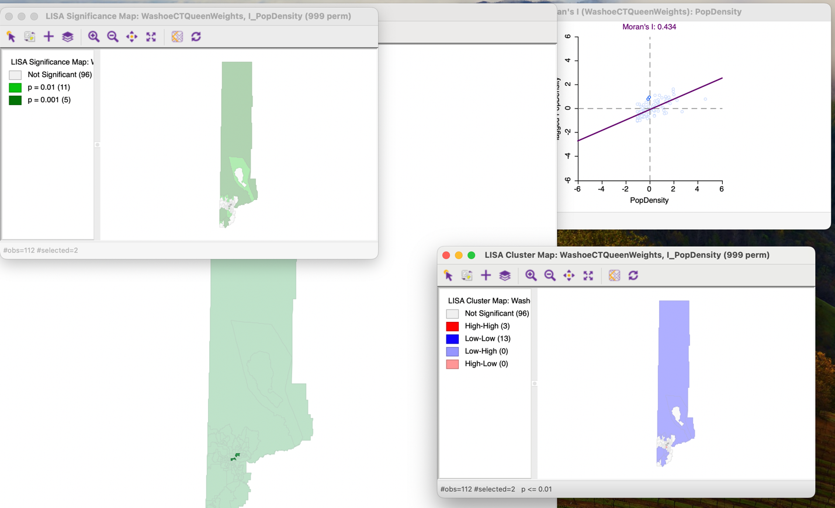

Question 6 (2 points):
Use the same shapefile in ArcGIS Pro to calculate the Global Moran's I value. What conceptualization of spatial relationships do you choose to evaluate the autocorrelation? Why did you choose it? What is Moran's I value? Include a screenshot of the Global Moran’s I Summary.
The conceptualization of spatial relationships that I chose was Contiguity edges corners. I chose this conceptualization because it seemed better for polygon data like these census tracts in that it incorporates direct neighbors to each polygon when computing spatial autocorrelation. I also chose it because I did not want to use a distance-based method like inverse distance squared because I don’t know where the starting point would be when that distance is calculated, and that starting point could potentially be very influential in deciding whether the dataset is exhibiting spatial autocorrelation or not. The Moran’s I value is 0.433825, which may not be a necessarily strong indicator of positive spatial autocorrelation, but is statistically significant due to it being very far from what we would expect if population density were truly distributed randomly.

