Project Report Template

1 INTRODUCTION

1.1 Overview

A brief description about your project

1.2 Purpose

The use of this project. What can be achieved using this.

2 Problem Definition & Design Thinking

2.1 Empathy Map

Paste the empathy map screenshot

2.2 Ideation & Brainstorming Map

Paste the Ideation & brainstorming map screenshot

3 RESULT

Final findings (Output) of the project along with screenshots.

4 ADVANTAGES & DISADVANTAGES

List of advantages and disadvantages of the proposed solution

5 APPLICATIONS

The areas where this solution can be applied

6 CONCLUSION

Conclusion summarizing the entire work and findings.

7 FUTURE SCOPE

Enhancements that can be made in the future.

8 APPENDIX A. Source Code

Attach the code for the solution built.

**1.Introduction**

**1.1Overview:**

The number of email applications is expected to grow by another 300 million by 2023. So one is clear the email is not going anywhere.We use our emails to handle everything from works, projects, finance, personal connections and more. And now than ever, we want to able to quickly browse emails right from our smartphone.

This is a implementation of the reply material, an email client app that focuses on adaptive design for mobile, tablets and foldables.

Modern digital life is hectic. Users are constantly switching between devices, apps, and services to get their job done. Adaptive cards help you increase engagement and efficiency by injecting your actionable content directly into the apps they use every day**. This adaptive email covers the fundamentals of designing and building a mobile-friendly email.**

**Five reasons** for choose adaptive mail

**1. Modernize** your internal email campaigns with powerfulaudience segmentation capabilities.

**2. Secure** information with the highest level of data security ensuring sensing information never leaves your data in cloud.

**3. Manage** complex internal campaigns effortlessly withy best tools.

**4. Enable** simplified send and view mail options.

**5.**continually **improve** email communication.

# 1.2Purpose:

Adaptive Mail app is a sample project that demonstrates how to use the Android Compose UI toolkit to build a conversational UI. The app simulates a messaging interface, allowing the user to send and receive messages, and view a history of previous messages. It showcases some of the key features of the Compose UI toolkit, data management, and user interactions.

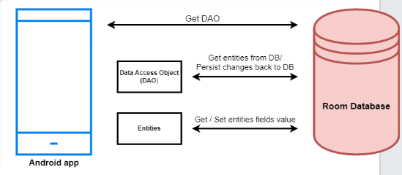

**2 Problem Definition & design thinking**

**2.1 Empathy map**

**Gain:** More times to focus on important task reduce stress and anxiety, and increase productivity.

**Pain:** Too many emails to manage efficiently, difficulty in identifying important emails, and need to constantly adjust priorities throughout the day.

**Does:** skims through email quickly, uses filters and labels to organize emails, and response from promptly to urgent emails.

**Feels:** Frustrated when important emails get buried in the inbox and overwhelmed with the amount of email received daily.

**User:** A busy professional who receives a large volume of emails daily and needs to prioritize and manage them efficiently.

**Says:”** I need and email system that can adapt to my changing priorities throughout the day”

**Think:** I don’t want to waste time shifting through mails that are not important or urgent. I need a system that can help me quickly identify the most important emails.

**2.2 Ideation & Brainstorming Map**

Personalization

Customized email categories based on user preferences

Ability to create custom tags for emails

Machine learning-based email sorting

Option to prioritize certain contacts or senders

User Interface

Clean and simple UI

Ability to customize the layout and colors

Option to view emails by conversation or individually

Security

Two-factor authentication for account security

Option to encrypt emails

Spam and phishing protection

Smart Features

Suggest replies based on email content

Reminders to follow-up on important emails

Automatic email categorization based on content

Ability to schedule emails to be sent at a later time

Integration

Sync with multiple email accounts (Gmail, Outlook, etc.)

Integration with calendar apps

Ability to add attachments from cloud storage services like Google Drive or Dropbox

Analytics

View email open rates and response rates

Insights into email usage patterns

Ability to track the success of email campaigns

**3 RESULT:**

**Home page:**

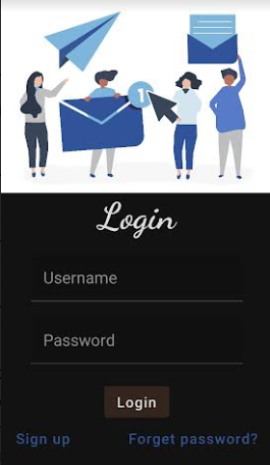

**Register page:**

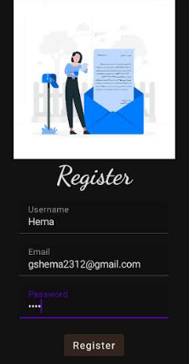

**Login page**

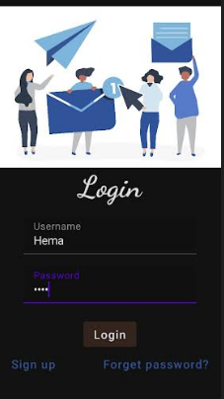

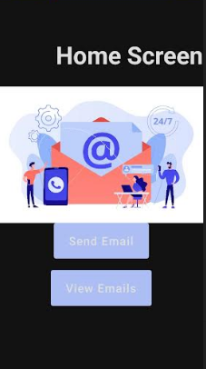

**Send mail:**

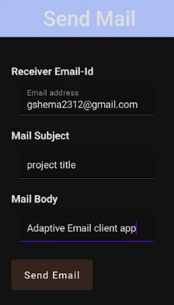

**View mail:**

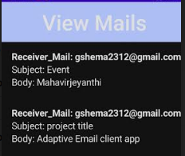

**4 Advantages and disadvantages:**

ADVANTAGE:

**Targeted for each user:** This creates different versions of website for different devices for increasing user experience at individual devices. On each device, user should have a positive experience. In this web design, one can customize and change page content, layout to best fit screen and improve user experience.

**Increase load time:**Adaptive web design create different layout for different devices and display features that are best for specific website. Whenever user load website on their device, then layout that fit best on device screen gets loaded. This increase loading speed as traffic is decreased. Even, server detect device size and then provide layout that will fit best on device screen. It provides high resolution graphics only when it detects high-density screen.

**Reusable existing websites:**Some of complex websites are developed using legacy code i.e., source code written using out-dated technology or is no longer supported and is incomprehensible. Adaptive websites have different versions of layout for different devices. So, if one wants to change or update something, then they do not need to go back to drawing board and again re-code existing website from starting point.

**Advertising monetization:** Monetizing websites with ads will only lead to more money and give more opportunities for earning. Adaptive website is the best way to optimize advertise options as adaptive websites are designed to fit best on device it is viewed on. There is no need to chan5ge or replace ratio of banners, images, etc., for smaller resolutions to display best on screen because smaller versions of websites are available.

DISADVANTAGE:

It is difficult for a user interface designer to design different types of interfaces for different levels of tasks and types of users.

The time spends on the app development increases because there is a lot of work to be done.

The overall code of the website and the size ofthe app **increases** if the user interface is adaptive.

The apps and websites using adaptive user interfaces use more computer resources.

The RAM and processing speed than normal apps.

So user hesitates to provide such private information.

This information is used by the app for showing different items on the screen**.**

**Labour intensive to create:** Adaptive web design are not easy to create. It requires great thinking skills and more labours to create. Adaptive web design requires more time and effort as different website layouts are created to best fit on screen. Different website layout means different html code, and more will be code, then more will be labours required to develop it.

**Expensive:**Adaptive web design is labour intensive I.e., requires a greater number of developers or labours to create it and also requires a lot of budgets to handle complexity. Adaptive design is complex and complicated and therefore it is expensive. It is more expensive to build and maintain.

 **Harder to maintain and is complex:**Adaptive websites are not easy to maintain as it is not easy to maintain all website versions at same level. One has to update and maintain each version of website individually whenever required.

**5 Application**

An adaptive email application is an application that learns from a user's email behaviour and adapts to their preferences and needs over time. This type of application can help users manage their email more efficiently by automatically prioritizing important messages, sorting them into categories, and suggesting responses.

One way to apply an adaptive email application solution is by using machine learning algorithms to analyze the user's email behavior, such as which messages they read and respond to quickly and which ones they tend to ignore. The application can then use this information to suggest ways to organize the user's inbox, such as creating filters to automatically sort emails into different folders or highlighting important messages.

Another way to apply an adaptive email application is by using natural language processing (NLP) techniques to understand the content of the emails and suggest relevant responses. For example, if the user receives an email asking for a meeting, the application can suggest a few potential meeting times based on the user's calendar availability.

Overall, an adaptive email application can provide users with a more personalized and efficient email experience, saving them time and helping them stay organized.

**6 Conclusions**

In conclusion, an adaptive email application is an application that uses machine learning algorithms and natural language processing techniques to learn from a user's email behavior and adapt to their preferences and needs over time. By analyzing which messages, the user reads and responds to quickly, the application can suggest ways to organize their inbox, such as creating filters to sort emails into different folders, highlighting important messages, and suggesting relevant responses based on the email content.

An adaptive email application can provide users with a more personalized and efficient email experience, saving them time and helping them stay organized. It has the potential to improve productivity and reduce stress associated with managing a large volume of emails. However, the effectiveness of an adaptive email application largely depends on the quality of its machine learning algorithms and NLP techniques, as well as its ability to protect user privacy and data.

In conclusion, an adaptive email application is an exciting area of development for email management and has the potential to revolutionize how we interact with our inbox.

**7 Future scopes**:

Changes will be happen quicker than we think. The future of adaptive emails look bright it’s an essential tool for internal and external communication. In the adaptive email client app in future we should add delete option. Now the project contains send and view mail options. When the delete option is added to this it become more flexible and user friendly one. In normal Gmail it contain many facilities like spam mail, junk mails and etc. We also add the feature to view the deleted mails and add the option to restore it. When these types of features are added together with this adaptive mail it become more user friendly one. Since most users tend to look at promotional emails in the same as spam, future emails should aim to be more personalized. In future it will be more customized according to the ability and requirement of each client than the existing one.

**8 APPENDIX**

Source code in zip file format