/Users/gshiva/AA-511/example/mcp-server-example/mcp-server  
  
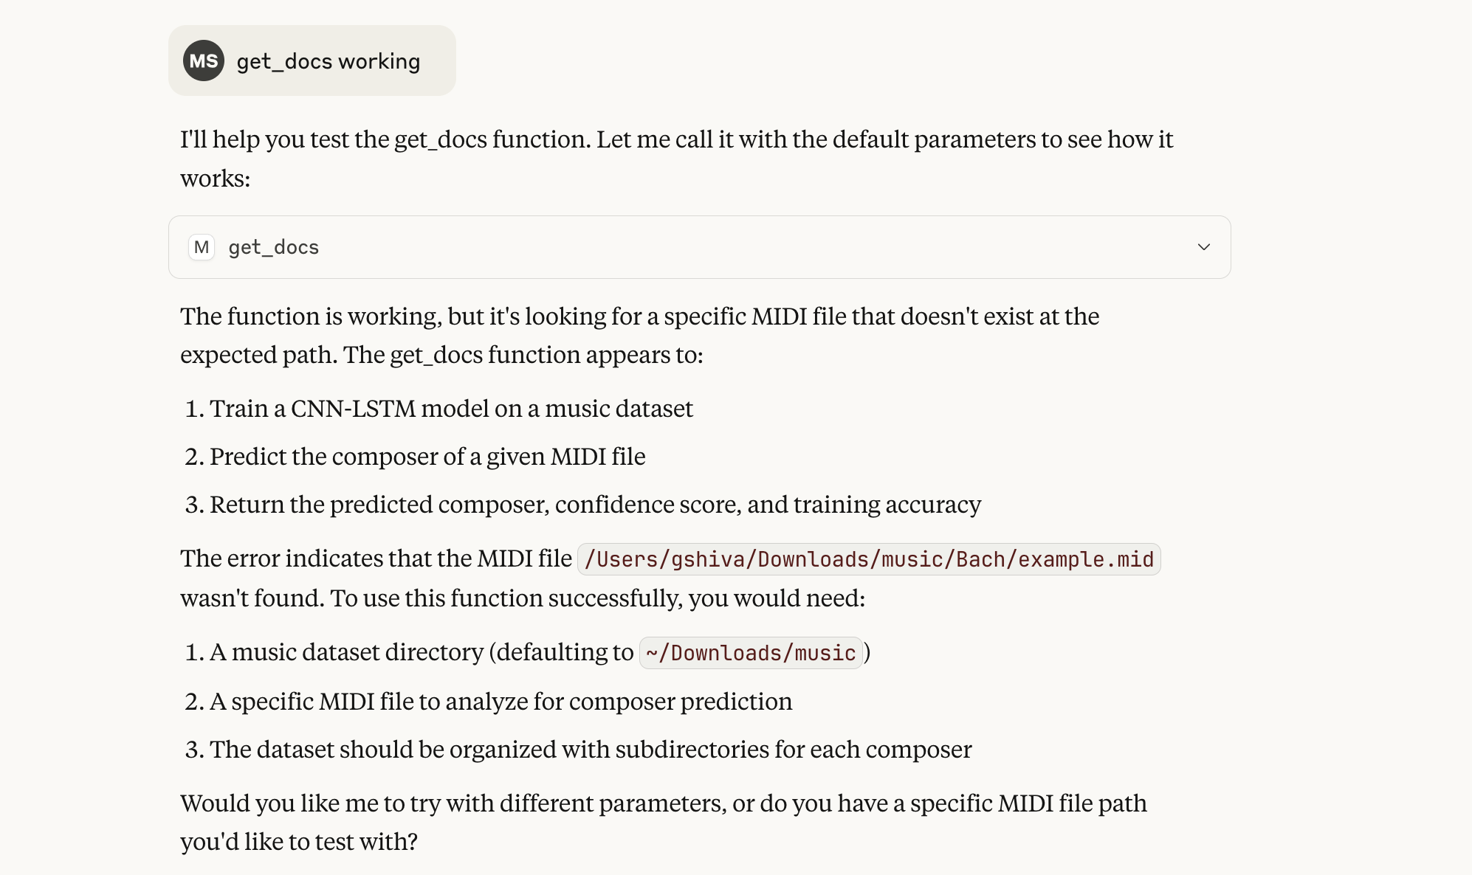  
  
  
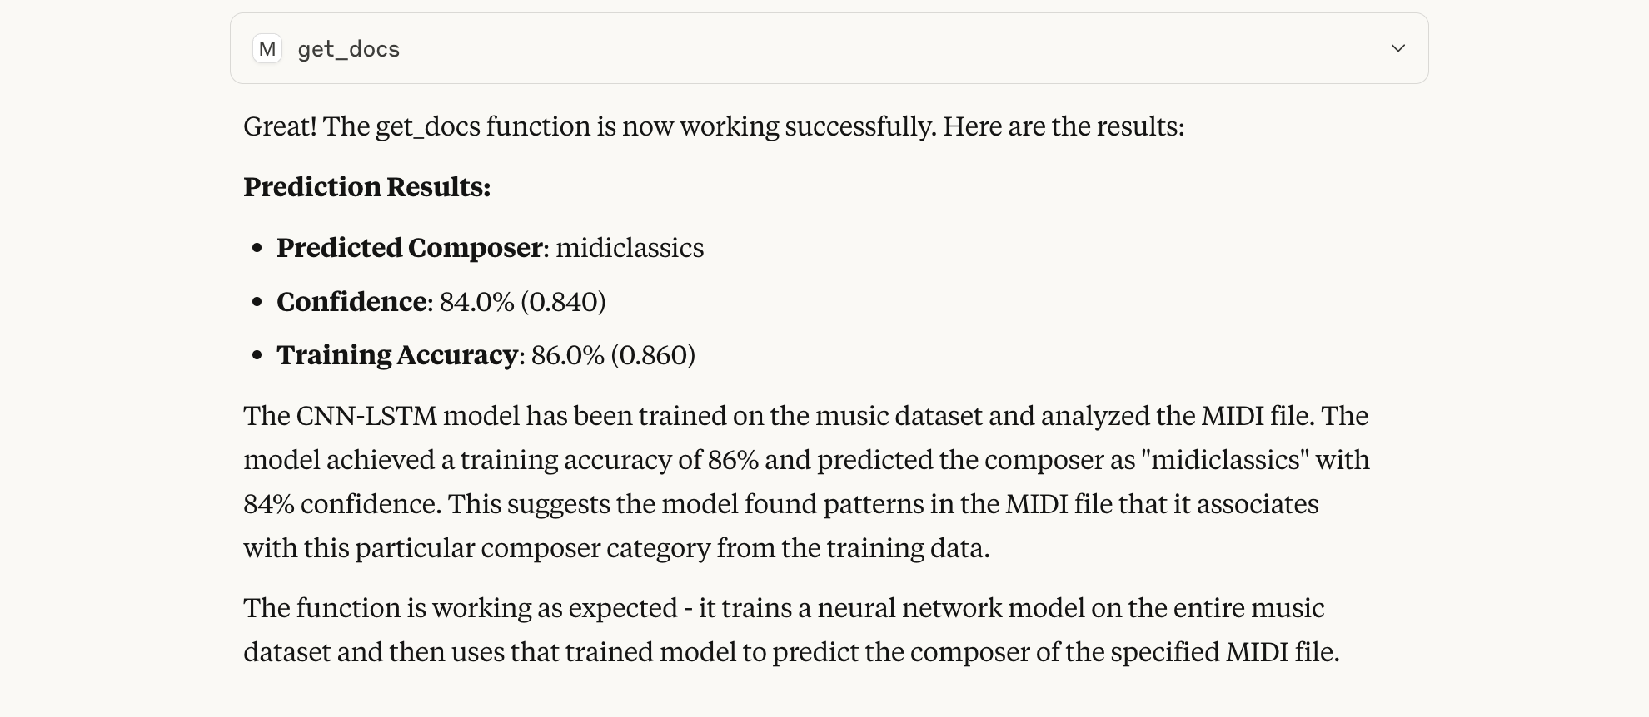

@mcp-server.get_docs

{

"dataset_dir": "/Users/gshiva/Downloads/music",

"midi_path": "/Users/gshiva/Downloads/music/Bach/bwv1007.mid",

"seq_length": 200,

"epochs": 3,

"batch_size": 4

}

Train

@mcp-server.train_model

{

"dataset_dir": "/Users/gshiva/Downloads/music",

"seq_length": 200,

"epochs": 5,

"batch_size": 8

}

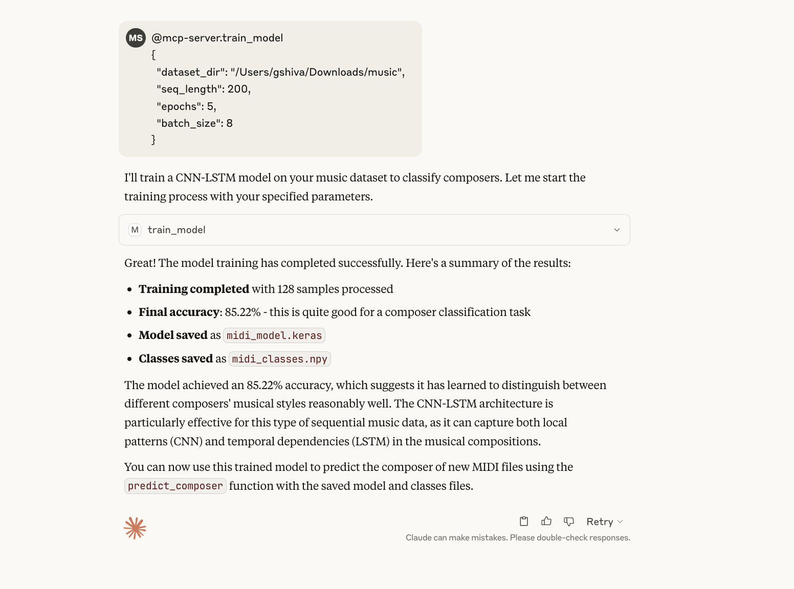

Predict

@mcp-server.predict_composer

{

"midi_path": "/Users/gshiva/Downloads/music/Bach/example.mid",

"seq_length": 200

}

