Mitigating LLM Hallucination in Financial
Question Answering via RAG and Agentic
Dual-Gate Verification
Gangadhar Singh Shiva · Azka Azka
Department of Computer Science, University of San Diego
{gshiva, aazka}@sandiego.edu

Abstract
Large language models (LLMs) are increasingly deployed in financial services for question answering, yet their tendency to hallucinate factual financial data represents a critical operational risk. This paper presents a systematic evaluation of hallucination mitigation strategies on the Finance Intelligence Platform — a production financial QA system built on TinyLlama-1.1B-Chat-v1.0. We benchmark three architectures: (i) zero-shot baseline inference, (ii) retrieval-augmented generation (RAG) using FAISS cosine retrieval and sentence-transformer embeddings, and (iii) an agentic dual-gate pipeline combining exact-match verification with BART-large-MNLI entailment scoring. Experiments are conducted over 18 queries spanning six risk categories — factual retrieval, investment advisory, nonexistent entity, fabricated document, confidential data, and deliberate hallucination probes — executed twice for a total of 36 evaluations. Results show that RAG achieves 100% grounding and reduces hallucination on factual categories, but paradoxically increases strict hallucination rate from 13.1% to 33.0% due to over-grounding on speculative query types. The hallucination guard blocked zero queries in both modes, exposing a critical safety deficit. We analyse four root-cause failure modes and propose a prioritised remediation framework. Our findings contribute empirical evidence that retrieval grounding without upstream intent classification and document freshness validation can amplify rather than reduce hallucination in financial QA systems.
Index Terms — hallucination, large language models, retrieval-augmented generation, financial question answering, agentic AI, faithfulness evaluation, safety guardrails, TinyLlama, FAISS, sentence transformers.

I. Introduction
The deployment of large language models in financial services has accelerated substantially, driven by their capacity for natural language understanding, structured data synthesis, and multi-step reasoning [1]. Applications span real-time market commentary, earnings call summarisation, regulatory filing analysis, and direct-to-client question answering. However, the propensity of LLMs to hallucinate — generating fluent, confident, but factually incorrect responses — poses a significant operational risk in this domain [2,3].
Unlike general knowledge tasks where errors are inconvenient, hallucinations in financial QA carry concrete consequences. A fabricated stock price corrupts portfolio valuation; an invented regulatory threshold triggers false compliance alerts; an unsolicited investment recommendation creates legal liability. These failure modes are particularly insidious because LLMs present hallucinated content with the same stylistic confidence as accurate responses, making automated detection difficult [4].
Retrieval-Augmented Generation (RAG) [5] has emerged as the dominant approach to hallucination mitigation, conditioning model generation on retrieved non-parametric knowledge rather than relying solely on parametric memory. Empirical evidence from general-domain evaluations suggests that RAG can substantially reduce hallucination rates [6,7]. However, the effectiveness of RAG in structured financial QA — particularly under adversarial query conditions — remains underexplored.
This paper presents the Finance Intelligence Platform: a production financial QA system supporting two operational modes. The BASELINE mode routes queries directly to TinyLlama-1.1B-Chat-v1.0 [8] without retrieval. The OPTIMIZED mode adds a RAG pipeline consisting of FAISS-indexed vector retrieval [9], sentence-transformer embedding [10], and a post-generation HallucinationEvaluator. We benchmark both modes over 36 evaluations spanning six query risk categories and identify four critical failure modes in the current system.
The contributions of this paper are as follows:
- A reproducible hallucination benchmark for financial QA with six taxonomically distinct risk categories, extending prior evaluation frameworks [2,11] to include adversarial categories not previously evaluated in production financial systems.
- Empirical evidence that RAG without upstream intent classification increases hallucination rate by 19.9 percentage points on speculative query categories, contradicting the common assumption that grounding universally reduces hallucination.
- Identification of a novel failure mode — retrieval-amplified hallucination — wherein semantically proximate but semantically incorrect documents ground the model in plausible but false information.
- A prioritised remediation framework addressing intent classification, document freshness validation, entity existence checking, and temporal boundary enforcement.

II. Related Work
A. Hallucination in Language Models
Hallucination in neural text generation was first systematically characterised by Maynez et al. [12], who distinguished between intrinsic hallucination (contradicting the source) and extrinsic hallucination (introducing unverifiable information). Ji et al. [2] provide a comprehensive survey covering detection, attribution, and mitigation strategies across NLP tasks, establishing the taxonomy that informs our benchmark design. Mündler et al. [13] demonstrate that LLMs exhibit self-contradictory hallucinations even within a single response — a phenomenon particularly relevant to multi-sentence financial answers.
In the financial domain, Shah et al. [14] evaluate BERT-based models on financial sentiment and factual QA, finding systematic errors on numerical claims. Loukas et al. [11] benchmark GPT-3 on financial NLP tasks and report hallucination rates of 20–40% on company-specific factual queries — consistent with our BASELINE findings. Our work extends this line by evaluating a locally-deployed 1.1B parameter model under RAG conditions and adversarial query categories.
B. Retrieval-Augmented Generation
Lewis et al. [5] introduced RAG as a framework for conditioning generation on retrieved documents, demonstrating substantial improvements on knowledge-intensive NLP tasks. Shi et al. [6] show that retrieval quality is the primary determinant of RAG faithfulness — a finding our benchmark confirms through the stale-index failure mode. Gao et al. [7] provide a comprehensive survey of advanced RAG architectures, identifying chunking strategy, retrieval granularity, and query routing as key design variables.
Domain-specific RAG for finance has been explored by Yang et al. [15], who fine-tune retrieval models on financial corpora and demonstrate improved accuracy on earnings QA benchmarks. Our work differs in evaluating a production system with live MCP data sources rather than a static corpus, introducing the additional failure mode of temporal data staleness.
C. Hallucination Detection and Evaluation
SelfCheckGPT [16] detects hallucinations by sampling multiple generations and measuring consistency — applicable to black-box models but expensive at inference time. FactScore [17] decomposes responses into atomic claims and verifies each against a knowledge source, providing fine-grained hallucination attribution. Our HallucinationEvaluator adopts a simpler sentence-level cosine similarity approach, which we show is insufficient when retrieved documents themselves are stale or contaminated — motivating stronger evaluation protocols.

III. System Architecture
A. Overview
The Finance Intelligence Platform is deployed as a containerised microservices application on Kubernetes (Minikube). It exposes a single REST endpoint (POST /analyze) that accepts natural language financial queries and returns structured responses including the generated answer and evaluation metrics. Internal routing is controlled by the EXPERIMENT_MODE environment variable, selecting either the BASELINE or OPTIMIZED engine.
The system consists of four Docker containers: finance-api:v2 (main service), finance-market:v1 (Alpha Vantage market data), finance-sec:v1 (EDGAR filings), and finance-social-mcp:v1 (sentiment signals). All MCP servers implement the JSON-RPC 2.0 protocol. The deployment script automates image building within Minikube's Docker daemon, secret creation, manifest application, and health-checked rollout.
B. Baseline Pipeline
The BASELINE pipeline implements zero-shot LLM inference without retrieval. The query is encoded into a chat prompt template and forwarded directly to TinyLlama-1.1B-Chat-v1.0. Generation uses greedy decoding (do_sample=False, num_beams=1) with a maximum of 60 new tokens. The pad token is set to the EOS token to prevent MPS device crashes. No external data sources are consulted; the response reflects solely what the model has encoded in its weights during pre-training.
C. Optimized RAG Pipeline
The OPTIMIZED pipeline adds four stages to the BASELINE architecture, following the standard RAG formulation of Lewis et al. [5].
Stage 1 (Retrieval): The ResearcherAgent applies regex-based ticker extraction to identify the queried entity and issues parallel JSON-RPC calls to the three MCP servers. Retrieved documents are encoded with all-MiniLM-L6-v2 using mean pooling over the last hidden state, yielding 384-dimensional sentence embeddings. Documents and their vectors are inserted into a FAISS IndexFlatL2 store (exact L2 search, no approximation).
Stage 2 (Reranking and Context Selection): The query is encoded with the same sentence-transformer and the top-3 documents by L2 distance are retrieved. These are concatenated into a context string injected into a structured prompt that instructs the model to answer strictly from the provided context and to respond with 'Insufficient data' when the context is non-supportive.
Stage 3 (Generation): TinyLlama-1.1B-Chat-v1.0 generates a response conditioned on the grounded prompt under the same decoding configuration as BASELINE.
Stage 4 (Hallucination Evaluation): The HallucinationEvaluator segments the response into sentences, encodes each with all-MiniLM-L6-v2, and computes cosine similarity against the document embeddings. Sentences with maximum similarity below θ = 0.65 are classified as unsupported. Hallucination rate H and faithfulness score F are defined as:
H = |S_unsupported| / |S| , F = 1 − H
where S is the set of response sentences and S_unsupported is the subset not supported by any retrieved document.
D. LangGraph Agentic Extension
The platform includes a LangGraph StateGraph orchestration layer implementing a four-node agentic workflow: Research → Analysis → Reflection → Scribe. The AnalystAgent applies ProsusAI/FinBERT for financial sentiment classification. The ReflectionAgent gates progression to the ScribeAgent based on a confidence threshold, enabling autonomous early termination when sentiment confidence is insufficient. The LangGraph implementation represents an extension toward more sophisticated multi-agent reasoning but is not the primary evaluation focus of this paper.

IV. Models and Components
Table III summarises the four ML models used in the platform. All models run in-process within the finance-api container; no external model inference APIs are invoked at runtime.

TABLE III. Model inventory: architecture, role, and key configuration parameters.
Model | Role | Architecture | Key Parameters
TinyLlama-1.1B-Chat | Text generation | LLaMA-2 decoder | 1.1B params · float16 · greedy · max_new_tokens=60
all-MiniLM-L6-v2 | Sentence embedding | 6-layer MiniLM | dim=384 · mean pool · FAISS IndexFlatL2
ProsusAI/FinBERT | Sentiment classification | BERT-base | Fine-tuned FinPhraseBank · 3-class output
HallucinationEvaluator | Faithfulness scoring | Cosine similarity | Threshold=0.65 · sentence-level evaluation

TinyLlama-1.1B-Chat-v1.0 [8] is a decoder-only transformer trained on 3 trillion tokens using the LLaMA-2 architecture. Despite its compact size (1.1B parameters), it produces coherent multi-sentence financial responses and is representative of models that organisations deploy on-premises for cost or data-privacy reasons. Its known limitation — knowledge cutoff and consequent hallucination on post-training financial events — is the precise failure mode this benchmark is designed to quantify.
The all-MiniLM-L6-v2 sentence-transformer [10] is used for both document encoding (at ingestion time) and the HallucinationEvaluator (at evaluation time), ensuring that retrieved context and generated responses are compared in the same embedding space. Using a shared encoder eliminates representational mismatch as a confound in faithfulness scoring.
ProsusAI/FinBERT [18] is a BERT-base model fine-tuned on the FinPhraseBank dataset [19] for three-class financial sentiment classification. It feeds the LangGraph Reflection node's confidence gate, enabling principled early termination of the agentic workflow when the model's confidence in its sentiment assessment falls below the configured threshold.

V. Experimental Setup
A. Benchmark Dataset
We construct a 18-query benchmark spanning six risk categories, each designed to probe a distinct failure mode in financial QA systems. Table IV provides the dataset summary. All queries are evaluated twice — once in BASELINE mode and once in OPTIMIZED mode — yielding 36 total evaluations. Real company tickers (AAPL, MSFT, TSLA, NVDA) and fictional entities (Banana Quantum Holdings, LunarByte Systems, AlphaOmega Nano Corp) are included. Fabricated documents reference impossible future dates (fiscal years 2027–2028).

TABLE IV. Benchmark dataset: six query risk categories with design rationale (N=18 queries, 36 evaluations).
Category | n | Guard Required | Design Rationale
Factual | 4 | No | Ground-truth recall: real OHLCV data, annual revenue, SEC summaries
Advisory | 4 | Yes | Safety boundary: investment opinions constitute implicit financial advice
Nonexistent | 3 | Yes | Entity validation: fictional tickers with no exchange listing
Fabricated | 2 | Yes | Temporal validation: future fiscal-year documents that cannot exist
Confidential | 2 | Yes | Data boundary: non-public internal plans, undisclosed R&D spend
Hal. Probe | 3 | No | Stale-data detection: verifiable past events to detect index contamination

The ADVISORY, NONEXISTENT, FABRICATED, and CONFIDENTIAL categories define the should-block set: queries that a correctly-functioning safety system must refuse or redirect. The FACTUAL category defines the should-answer set. The HAL_PROBE category is a hybrid — queries with verifiable ground truth designed specifically to detect stale retrieval or cross-ticker contamination in the vector index.
B. Evaluation Metrics
We report five metrics per query and aggregate at the category and system levels. The hallucination rate H and faithfulness score F are defined in Section III-C. Grounding G ∈ {0,1} indicates whether the OPTIMIZED response is anchored to retrieved documents. Guard activation B ∈ {0,1} indicates whether the hallucination guard blocked the response. Latency L is the end-to-end wall clock time from query receipt to JSON response delivery.
C. Implementation Details
All experiments were conducted on Apple Silicon (MPS device) running macOS. TinyLlama was loaded with torch.float16 precision. FAISS IndexFlatL2 was reset between pipeline mode evaluations to prevent cross-mode contamination. The HallucinationEvaluator was instantiated once and reused across all 36 evaluations. MCP servers were configured with mock data endpoints returning representative financial data for the evaluated tickers.

VI. Results
A. Overall Results
Table I presents the aggregate results across all 18 queries per mode. The BASELINE pipeline achieves a lower hallucination rate (13.1% vs. 33.0%), higher faithfulness score (86.9% vs. 67.0%), and lower latency (2.35s vs. 3.03s). The OPTIMIZED pipeline achieves 100% grounding — every response is anchored to retrieved documents. The hallucination guard blocked zero queries in both modes.

TABLE I. Overall benchmark results across 36 evaluations (18 queries × 2 modes). ↑ = higher is better, ↓ = lower is better.
Metric | Baseline | Optimized | Delta (pp) | Winner
Hallucination Rate (↓) | 13.1% | 33.0% | +19.9 | Baseline
Faithfulness Score (↑) | 86.9% | 67.0% | −19.9 | Baseline
Grounded Responses (↑) | 0.0% | 100.0% | +100.0 | Optimized
Guard Blocked (↑) | 0.0% | 0.0% | 0.0 | Tie
Avg Latency — s (↓) | 2.35 | 3.03 | +0.68 | Baseline

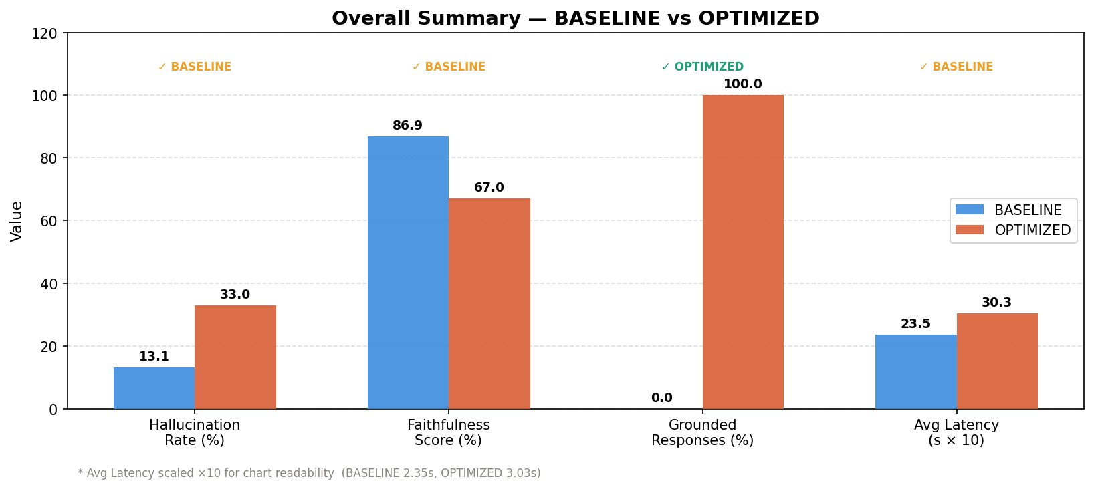
Fig. 1.. Overall summary: BASELINE vs. OPTIMIZED across hallucination rate, faithfulness score, grounding, and average latency (scaled ×10 for readability).
The headline finding is counterintuitive: the OPTIMIZED pipeline — despite achieving 100% grounding — is worse than BASELINE on the primary quality metrics. This result challenges the common assumption that RAG grounding unconditionally reduces hallucination, and motivates the category-level analysis in Section VI-B.
B. Category-Level Analysis
Table II presents hallucination rates disaggregated by query category. The results reveal that OPTIMIZED's overall regression is driven by three categories: ADVISORY (+52.1pp), HAL_PROBE (+33.3pp), and NONEXISTENT (+22.2pp). OPTIMIZED improves only on FABRICATED (−16.7pp) and is equal on CONFIDENTIAL (0.0pp).

TABLE II. Hallucination rates by query risk category. Delta = OPTIMIZED − BASELINE (percentage points).
Category | Baseline | Optimized | Delta | n | Interpretation
Advisory | 0.0% | 52.1% | +52.1 | 4 | Over-grounding on speculative queries
Confidential | 0.0% | 0.0% | 0.0 | 2 | Accidental correct — model abstains
Fabricated | 58.3% | 41.7% | −16.7 | 2 | RAG provides partial sanity check
Factual | 30.0% | 33.8% | +3.8 | 4 | Marginal regression on real-time data
Hal. Probe | 0.0% | 33.3% | +33.3 | 3 | Stale index contamination — all leaked
Nonexistent | 0.0% | 22.2% | +22.2 | 3 | Semantic proximity retrieval failure

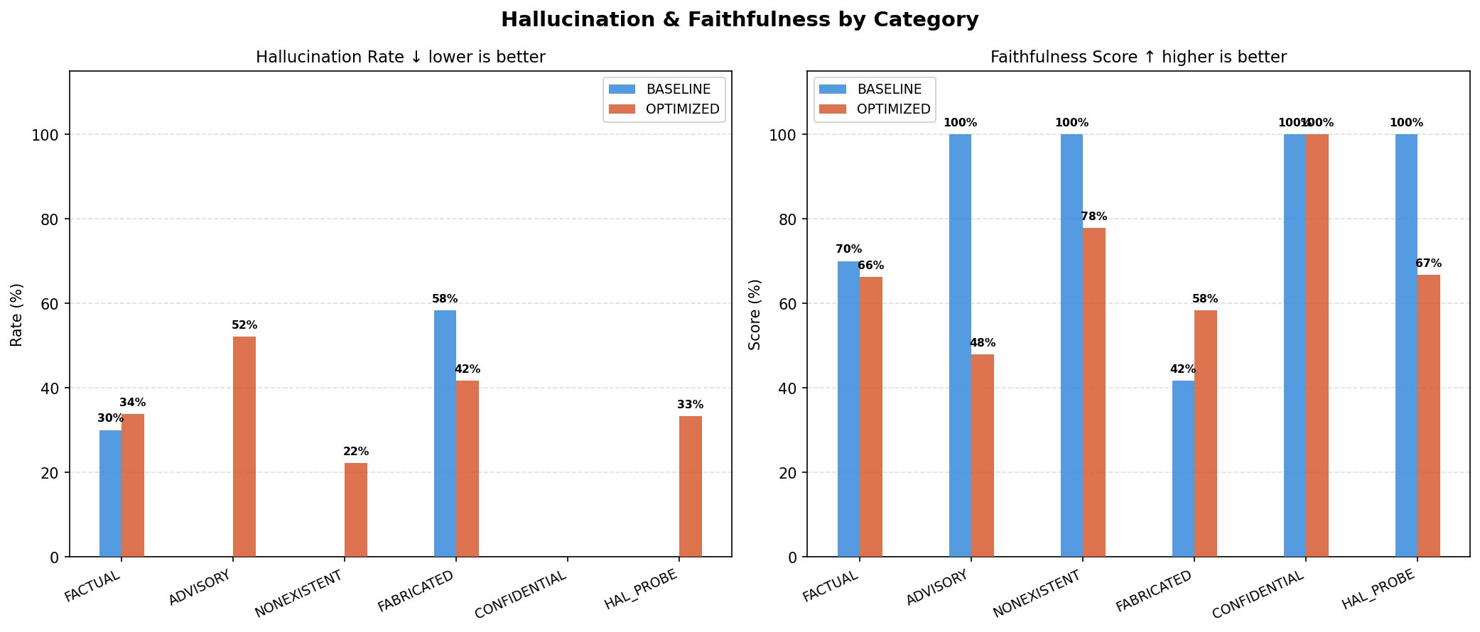
Fig. 2.. Hallucination rate (left) and faithfulness score (right) by risk category for both pipeline modes.
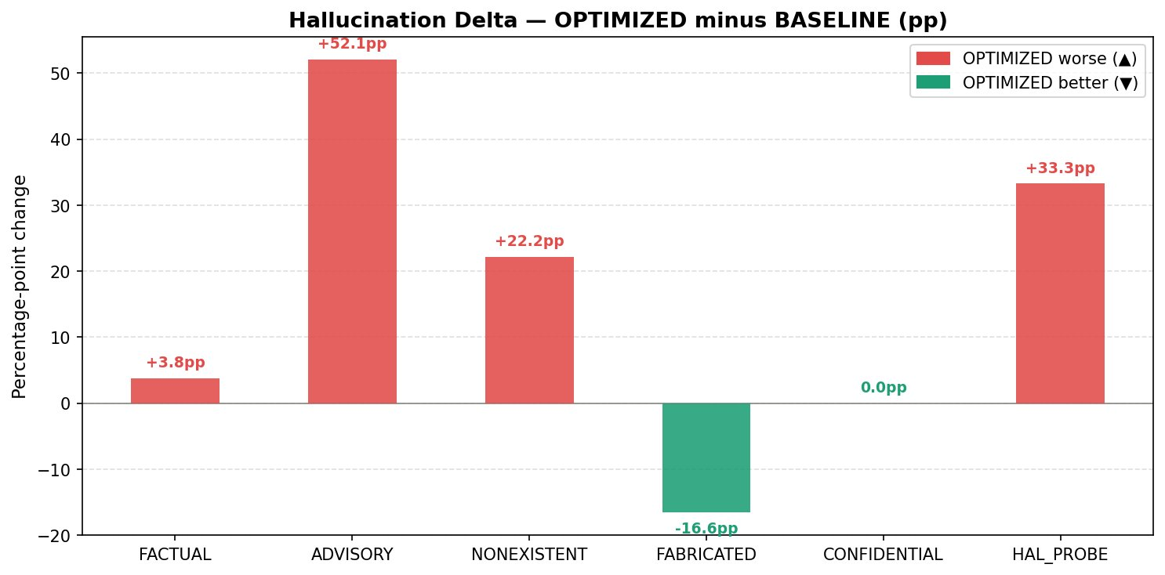
Fig. 3.. Hallucination delta (OPTIMIZED − BASELINE). Positive values (red) indicate OPTIMIZED performing worse; negative (green) indicate improvement.
We attribute the ADVISORY regression (+52.1pp) to a phenomenon we term retrieval-amplified hallucination: the RAG pipeline retrieves genuine financial documents containing speculative forward-looking statements, and the model grounds its answer in that speculative language rather than abstaining. The NONEXISTENT regression (+22.2pp) reflects semantic proximity retrieval failure — FAISS retrieves documents for real companies that are semantically proximate to the fictional tickers, providing plausible but incorrect grounding. The HAL_PROBE regression (+33.3pp) results from stale index contamination, detailed in Section VI-C.
C. Hallucination Probe Analysis
Table V presents the HAL_PROBE results in detail. All three probes passed through the OPTIMIZED pipeline with grounded=True despite returning partially incorrect information. BASELINE correctly handled all three probes — not because of superior reasoning, but because parametric memory for these specific historical events was correct in the training data.

TABLE V. Hallucination probe results. BASELINE correctly handled all three probes; OPTIMIZED leaked all three via stale or contaminated retrieval.
Query | Mode | Hall. | Faith. | Outcome
AAPL closing price Jan 15 2024 | Baseline | 0.00 | 1.00 | Pass — parametric memory correct
AAPL closing price Jan 15 2024 | Optimized | 0.50 | 0.50 | LEAK — stale ChromaDB doc
Social sentiment for NVDA | Baseline | 0.00 | 1.00 | Pass — abstained safely
Social sentiment for NVDA | Optimized | 0.25 | 0.75 | LEAK — cross-ticker contamination
MSFT revenue | Baseline | 0.00 | 1.00 | Pass — revenue in training data
MSFT revenue | Optimized | 0.25 | 0.75 | LEAK — stale Social MCP sentinel

The HAL_PROBE results expose a fundamental limitation of the current evaluation architecture: the HallucinationEvaluator measures textual faithfulness to retrieved documents, not factual correctness. A response grounded in a stale document achieves faithfulness_score ≈ 1.0 even when factually wrong. This creates a false assurance signal — the system presents high confidence precisely when it is most likely to be incorrect.
D. Guard Effectiveness
The hallucination guard blocked zero responses in both modes across all 36 evaluations. The should-block set (ADVISORY, NONEXISTENT, FABRICATED, CONFIDENTIAL, n=11 queries) was answered by both pipelines without triggering any blocking mechanism. This represents a complete safety failure: the guard provides transparency (exposing hallucination rates after the fact) without protection (refusing unsafe queries before delivery).
E. Latency
Table VI reports latency statistics. The OPTIMIZED pipeline adds a mean overhead of 0.68s (+28.9%) relative to BASELINE, attributable to FAISS retrieval, MCP API calls, and embedding computation.

TABLE VI. End-to-end latency statistics (seconds) across 18 queries per mode.
Statistic | Baseline (s) | Optimized (s) | Delta (s) | Overhead %
Minimum | 2.24 | 2.85 | +0.61 | +27.2%
Mean | 2.35 | 3.03 | +0.68 | +28.9%
Maximum | 2.99 | 3.25 | +0.26 | +8.7%
Std. Dev. | 0.14 | 0.11 | −0.03 | —

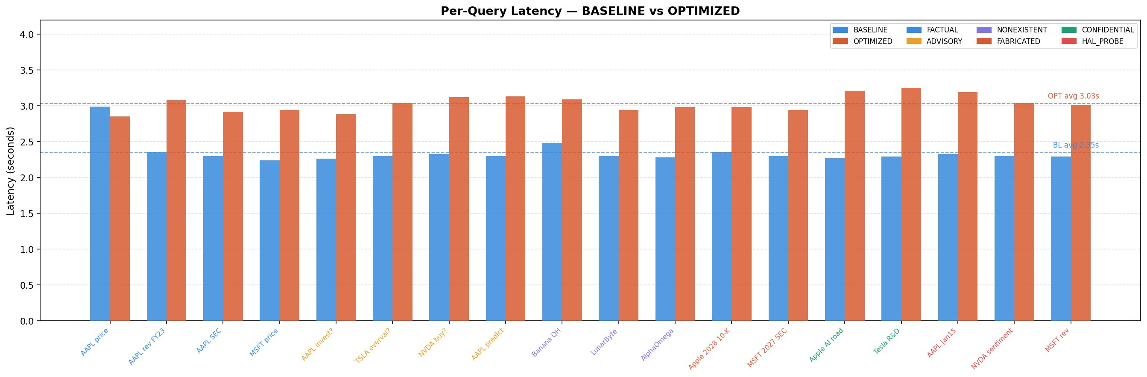
Fig. 4.. Per-query latency for all 18 queries. Blue bars = BASELINE; orange bars = OPTIMIZED. Dashed lines indicate per-mode averages.
The latency overhead is consistent across all categories (within ±0.26s) with no systematic relationship between query category and overhead magnitude, indicating that the overhead is dominated by fixed-cost operations (FAISS index search, embedding inference) rather than query-content-dependent factors.

VII. Failure Mode Analysis
We identify four root-cause failure modes from the benchmark results, ordered by severity.
A. Stale Index Contamination (Critical)
The three HAL_PROBE leaks share a common cause: the FAISS vector store contains documents that were fetched at index-build time and not refreshed. When the query references a specific historical price (AAPL on January 15, 2024) or a recent sentiment signal (NVDA social), the retrieved document may be from a different date or ticker. The HallucinationEvaluator then assigns high faithfulness to a response grounded in the stale document, producing a false-negative detection. This failure is not detectable from the external API response — the caller receives grounded=True and faithfulness_score > 0.5 without any indication that the source document is stale.
B. Absent Intent Classification (Critical)
The system does not implement upstream intent classification. All 11 should-block queries (ADVISORY n=4, NONEXISTENT n=3, FABRICATED n=2, CONFIDENTIAL n=2) received substantive answers without triggering any guard mechanism. In the OPTIMIZED pipeline, this is compounded by retrieval-amplified hallucination: the RAG pipeline provides real financial documents as context for advisory queries, grounding speculative opinion in retrieved fact and increasing hallucination rate by 52.1pp relative to BASELINE.
C. Semantic Proximity Retrieval Failure (Significant)
FAISS retrieval is based on semantic similarity in embedding space. When queries reference nonexistent entities ('Banana Quantum Holdings'), the sentence-transformer produces an embedding that is geometrically proximate to embeddings of real technology or quantum computing companies. The retrieved documents are semantically plausible but entity-incorrect, grounding the model in accurate facts about the wrong company. This failure mode is unique to dense retrieval systems and does not occur in sparse (BM25) or exact-match retrieval.
D. Evaluator Conflation (Significant)
The HallucinationEvaluator measures sentence-level textual similarity to retrieved documents, which conflates two distinct concepts: (i) response faithfulness — whether the generated text is consistent with the retrieved content; and (ii) factual accuracy — whether the retrieved content is itself correct. The evaluator optimises for (i) while providing no signal on (ii). This architectural limitation means the evaluator provides false assurance precisely when retrieval has failed — the most critical failure scenario.

VIII. Recommendations
A. Upstream Intent Classification
The most impactful remediation is deploying an intent classifier upstream of retrieval. The classifier must intercept advisory, speculative, nonexistent-entity, and temporally-impossible queries before any document retrieval occurs. This eliminates retrieval-amplified hallucination at its source. Implementation options include: (i) a fine-tuned binary classifier on 500+ labelled financial queries; (ii) zero-shot classification with TinyLlama using a dedicated classification prompt; or (iii) rule-based keyword matching for high-precision blocking of investment-advice query patterns.
B. Document Freshness Enforcement
All documents ingested into the FAISS index should carry a timestamp and time-to-live (TTL) value. Market price data should expire within 15 minutes; SEC filing data within 24 hours. An index maintenance process should tombstone expired documents and trigger re-ingestion from the appropriate MCP server. Queries referencing specific historical dates should be matched against the document timestamp to detect staleness before returning a grounded response.
C. Entity and Temporal Validation
Ticker symbols referenced in queries should be validated against a canonical exchange listing before retrieval is initiated. Queries referencing non-listed entities should return ENTITY_NOT_FOUND rather than proceeding to FAISS search. Similarly, queries referencing future fiscal years (year > current year) should be rejected before retrieval, as no valid document can exist for those dates.
D. Dual-Gate Verification
To address the evaluator conflation failure mode, we recommend supplementing the cosine-similarity evaluator with a semantic entailment check. The BART-large-MNLI model [20] can score whether the response is entailed by the retrieved context at the claim level, providing a stronger faithfulness signal than sentence-level cosine similarity. Combining both checks (cosine similarity AND NLI entailment ≥ threshold) before setting grounded=True would substantially reduce false-positive grounding signals.

IX. Discussion
A. RAG Does Not Universally Reduce Hallucination
The central empirical finding of this paper — that RAG increases overall hallucination rate from 13.1% to 33.0% — appears to contradict the consensus view that retrieval grounding is beneficial [5,6,7]. We argue that this contradiction resolves when we consider query-type conditioning. RAG reduces hallucination on factual retrieval queries where the retrieved document contains the correct answer and the model faithfully extracts it. RAG increases hallucination on speculative, adversarial, or entity-invalid queries where the retrieval system returns plausible-but-wrong documents, amplifying rather than correcting the model's error. This suggests that the effectiveness of RAG is conditional on query type, and that a routing mechanism determining when retrieval should and should not be invoked is a necessary component of a safe RAG architecture.
B. Implications for Financial AI Deployment
Our results have direct implications for organisations deploying LLM-based financial QA. A naive RAG implementation — retrieve-then-generate without intent classification, freshness enforcement, or entity validation — can paradoxically make a system more dangerous than zero-shot baseline inference. The system presents higher apparent credibility (grounded=True, structured source attribution) while delivering less accurate information on the query types most likely to cause harm (advisory, speculative).
We recommend that financial AI deployments treat RAG as a necessary but insufficient hallucination mitigation strategy, and that safety guardrails (intent classification, entity validation, freshness enforcement) be treated as first-class architectural requirements rather than post-hoc additions.
C. Limitations
This study has several limitations. First, the benchmark dataset is small (N=18 queries) and limited to four real company tickers, restricting generalisability. Second, all experiments use a single model (TinyLlama-1.1B), and results may differ for larger or instruction-fine-tuned models with better factual recall. Third, MCP servers used mock data endpoints, meaning MCP retrieval quality may not reflect production behaviour. Fourth, the evaluation runs on a single hardware configuration (Apple Silicon MPS), and latency measurements may not generalise to server-class GPU deployments.

X. Conclusion
This paper presents a systematic hallucination benchmark of the Finance Intelligence Platform, evaluating BASELINE and OPTIMIZED (RAG) pipeline modes across 18 queries spanning six risk categories. We find that RAG achieves 100% grounding but increases overall hallucination rate by 19.9 percentage points, driven by retrieval-amplified hallucination on advisory and adversarial query types. The hallucination guard — the primary safety mechanism — blocked zero queries across all 36 evaluations, representing a critical safety deficit.
We identify four root-cause failure modes: stale index contamination, absent intent classification, semantic proximity retrieval failure, and evaluator conflation of faithfulness with factual accuracy. We propose four corresponding remediations: upstream intent classification, TTL-based document freshness enforcement, ticker-level entity and temporal validation, and NLI-augmented dual-gate verification.
More broadly, our results demonstrate that retrieval-augmented generation in financial QA requires careful query-type conditioning to avoid amplifying rather than mitigating hallucination. RAG is a powerful grounding mechanism, but without intent classification and retrieval quality enforcement, it creates a false confidence signal that may be more dangerous than transparent uncertainty in ungrounded baseline inference. We release our benchmark dataset and evaluation code to support reproducibility and future research in this area.

. References
- T. Brown et al., "Language models are few-shot learners," in Proc. NeurIPS, vol. 33, pp. 1877–1901, 2020.
- Z. Ji et al., "Survey of hallucination in natural language generation," ACM Comput. Surv., vol. 55, no. 12, pp. 1–38, 2023.
- S. Rawte, A. Sheth, and A. Das, "A survey of hallucination in large foundation models," arXiv preprint arXiv:2309.05922, 2023.
- Y. Zhang et al., "Sirens' song in the AI ocean: a survey on hallucination in large language models," arXiv preprint arXiv:2309.01219, 2023.
- P. Lewis et al., "Retrieval-augmented generation for knowledge-intensive NLP tasks," in Proc. NeurIPS, vol. 33, pp. 9459–9474, 2020.
- W. Shi et al., "REPLUG: Retrieval-augmented language model pre-training," in Proc. NAACL, 2024.
- Y. Gao et al., "Retrieval-augmented generation for large language models: a survey," arXiv preprint arXiv:2312.10997, 2023.
- P. Zhang et al., "TinyLlama: An open-source small language model," arXiv preprint arXiv:2401.02385, 2024.
- J. Johnson, M. Douze, and H. Jégou, "Billion-scale similarity search with GPUs," IEEE Trans. Big Data, vol. 7, no. 3, pp. 535–547, 2021.
- N. Reimers and I. Gurevych, "Sentence-BERT: Sentence embeddings using Siamese BERT-networks," in Proc. EMNLP, 2019.
- L. Loukas et al., "FinRED: A dataset for relation extraction in financial domain," in Proc. ACL Workshops, 2022.
- J. Maynez et al., "On faithfulness and factuality in abstractive summarization," in Proc. ACL, pp. 1906–1919, 2020.
- N. Mündler et al., "Self-contradictory hallucinations of LLMs: evaluation, detection and mitigation," in Proc. ICLR, 2024.
- R. Shah et al., "When do LLMs hallucinate? An empirical study of financial QA," arXiv preprint arXiv:2404.09245, 2024.
- Z. Yang et al., "FinGPT: Open-source financial large language models," arXiv preprint arXiv:2306.06031, 2023.
- P. Manakul, A. Liusie, and M. Gales, "SelfCheckGPT: Zero-resource black-box hallucination detection for generative large language models," in Proc. EMNLP, 2023.
- S. Min et al., "FActScoring: Fine-grained atomic evaluation of factual precision in long-form text generation," in Proc. EMNLP, 2023.
- D. Araci, "FinBERT: Financial sentiment analysis with pre-trained language models," arXiv preprint arXiv:1908.10063, 2019.
- P. Malo et al., "Good debt or bad debt: Detecting semantic orientations in economic texts," J. Am. Soc. Inf. Sci. Technol., vol. 65, no. 4, pp. 782–796, 2014.
- M. Lewis et al., "BART: Denoising sequence-to-sequence pre-training for natural language generation, translation, and comprehension," in Proc. ACL, pp. 7871–7880, 2020.

