A
Project report
on

MECHANISATION OF HYDROPONICS CULTIVATION

Submitted in partial fulfillment for the award of the degree of

Bachelor of technology

in

Mechanical Engineering

Under the guidance of

Prof. (Dr.) J.P. Yadav

(Head of Mechanical Engineering)



Baba Saheb Dr. B.R. Ambedkar College of Agricultural Engineering and Technology, Etawah-206001
(C.S.A. University of Agriculture & Technology, Kanpur)
2017-18

Submitted to- Submitted by-
Prof. (Dr.) J.P. YADAV Damini Singh Gaur (CT-2343/14)
(Head of Mechanical Engineering) Rahul Raj Dravid (CT-2345/14)
Swaranjali Maurya (CT-2346/14)
Mukul Km. Gangwar (CT-2352/14)
Ashish (CT-2359/14)
Shivam Gautam (CT-2361/14)

1. Introduction
The Greek word ‘’hydroponics’’ is made of two words first is ‘hydro’ means water and second is ‘’ponos’’ means labour. Hydroponics technology gives the method of growing plants under controlled climatic states .The word hydroponic is marked out by Dr. W.F. Gericke in 1930[1].He made a water based culture from outside of lab and turn it into the commercial scale operation [2].
An English scientist W.J. Shalto Duglas introduced this technology in the year 1946.He established a workshop in Kalimpong area, West Bengal. With this he produced 180 tons tomatoes in other hand only 5 to 10 tons tomatoes produced by conventional method. After this result many countries as Denmark, Arizona, Belgium, Abu Dhabi, Italy, California, Germany, Holland, Japan, Russia and some other countries applied this technology and solve the food problem.[18]
Hydroponics has been popular in the polyhouse as well as in the plant factory. In order to identify the physhrometric dynamics of the plant cultivated in hydroponics, we have to make use of the diurnal changes for the plant responses. The humidity and temperature of a laboratory scale polyhouse are controlled using a rule-based expert system. The measured inside and outside temperatures of the greenhouse are used with a linearized set of relations of the standard Psychrometric chart in order to predict the internal and external relative humidities.

2. Objective
- Design and fabrication of experimental setup of hydroponic system.
- To maintain an artificial climate in polyhouse by using inexpensive equipments.
- Experiment on plants growth and production without dependency on soil.
- Trial on cherry tomato, melon, cucumber and spinach.
- To monitor the artificial climatic state under psychrometric study.
- Economic analysis of traditional and hydroponic system.
3. Review of Literature
The idea of controlling climate for growing plant is not new it was practicing since Roman times. In fact, evidence exist that the hanging gardens of Babylon, which date back to 600 B.C. , depend on the hydroponic culture[1]. But now a days with using several modern techniques such as polyhouse, artificial light source, water lifting system make it very convenient. Now hydroponic is frequently used in polyhouses.
The army of USA used hydroponic technology during World War 2nd for his soldiers, he grow fresh tomato and lettuce on Pacific Islands[1].They grow edibles on large scale using this technology during 1940-1944 on Pacific Islands and on ships[1].Different civilization used this technology, in Africa and Asia.
The Israeli researcher Dr.Hillel Soffer from University of California at Davis developed a hydroponic system in 1986, that system was able to control the climate in indoor and change growth rate of plants [1].
In last few decades the American space agency NASA has done ambient researches on hydroponic technology by controlling ecological climate in cells. They are preparing for Mars mission [15].
Due to merits of this technology ICAR support it. ICAR’s represented go to several states such Goa, Punjab, Haryana, Rajasthan and Maharashtra, Government provide subsidy for it.[9][2].
Hydroponic technic used to produce high and quantity edibles, it is applicable without any dependency on soil although practical on roof tops[3]. It saves water and nutrient consumption [3].

4. Methodology
The detailed methodology of hydroponic system is depicts below in the block diagram.
Types Of Hydroponic System

Passive System

Active system
Deep water culture
Nutrient Film technique

Ebb and Flow

Aeroponics

Drip system
Recovery tested system
Non recovery tested system
Wick System

4.1 Passive system – This is also known as wick system. In this system nutrient solution is supplied to the plant roots by capillary force principal. One wick dipped in the water solution and other go to the plant roots in net pot [3][4].

4.2 Active system – The circulation of nutrient solution is carried by mechanical work [3].
Actually there are five type of hydroponic active system. These are:-
- Deep water culture
- Nutrient film technique
- Ebb and flow
- Aeroponic
- Drip system

Now the brief knowledge on above
4.2.1 Deep water culture
This is the simplest hydroponic technique the plants are fixed on a floating platform and the platform float on water. The plants roots directly placed in the water. We use water pump for dissolving oxygen in the water [8][3].
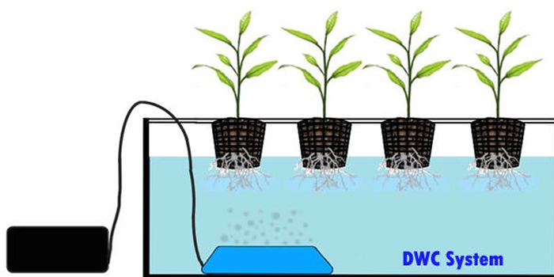

Fig 4.2.a Deep water culture

4.2.2 Nutrient Film Technique
This system supplies water solution to the plants roots with the help of pump and no timer used for alternate delivery. In this system no growing media, the plant are gently suspended in plastic trays with roots hanging in the water solution [4].
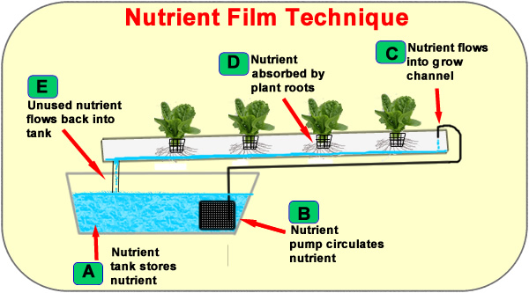

Fig 4.2.b Nutrient Film Technique

4.2.3 Ebb and Flow
This system also known as Flood and Drain system. This is a bed system which was developed by US researcher Robert and Alice at Purdue University.[1]
The nutrient solution is supply to the plant roots in the trays and then flows over in to the tank the process is operated by timer for automatic control. When timer is on pump supply nutrient solution to roots, the overflow water nutrient come back to reservoir. The trays on the benches still incline at 10 degree due to this solution drained out in to the tank [4].

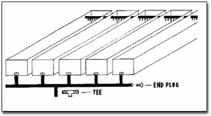

Fig 4.2.c Ebb And Flow System

4.2.4 Aeroponic Hydroponic system
This is the newer and advanced technology based system. No use of growing media as like used in the NFT. The plant roots are suspended in the air. Nutrient, oxygen and moisture is sprayed on hanging roots in form of mist with the help of nozzle. The timer ensures the pump supply and spray of mist for every few minute [4].
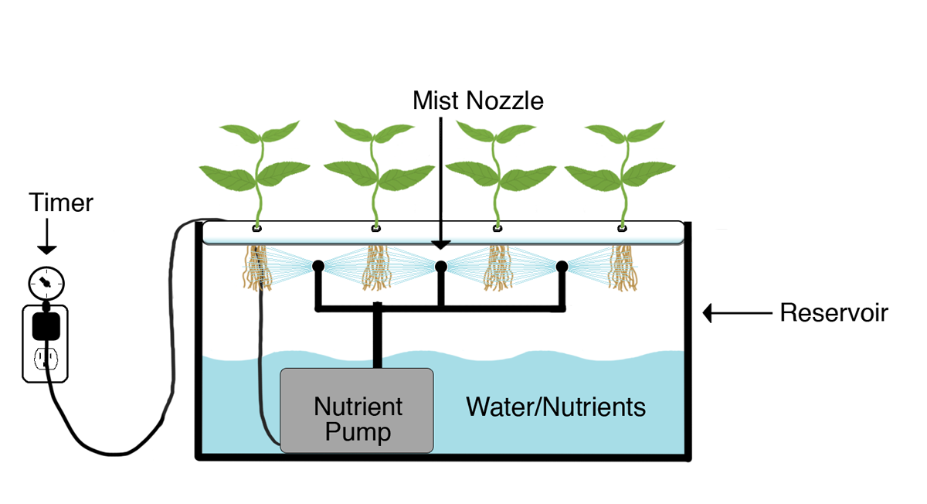
Fig 4.2.d Aeroponic Hydroponic System

4.2.5 Drip System
A timer and pump setup supply the nutrient solution to the base of every plant through drippers. There are two types.
- Recovery based system – the nutrient solution returned to the reservoir. It is costly and run on high maintenance but having high efficiency.
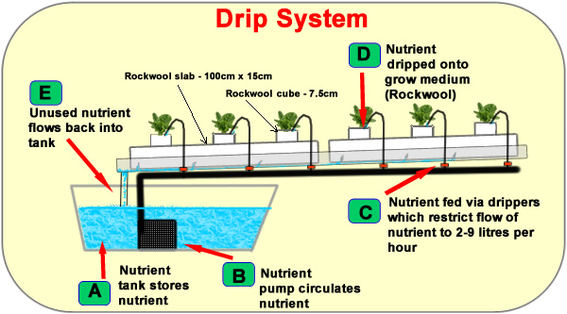
- Non–recovery system – the nutrient solution run off and waste. It needs low maintenance [4].

Fig 4.2.e Drip System

5. Components for Drip andEbb and Flow Hydroponic System:
  - Civil work and component
5.1.1 Water tank tower 20 feet and this tower is made by bamboo poles-
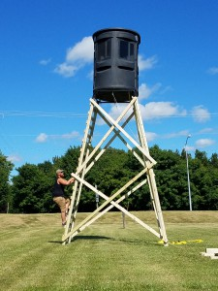
On the basis of mechanics, we may make truss based bamboo structure up to 15-25 feet according to the requirement.

Fig 5.1.2 Water tank

  - Mechanical work and component:
    - Curtain rolling system
Curtain rolling system is use for air ventilation from hydroponic polyhouse. Plants can sudden decrease carbon dioxide level and suffer by suffocation. Open curtain provide air including with carbon dioxide [5].

    - Nut and bolt (6 inch)
Nut and bolts are used to held bamboos together in the structure of shed

5.2.3 Fogger for winter use
In the winter session on low temperature and due to frost heave plant leaf become yellow and

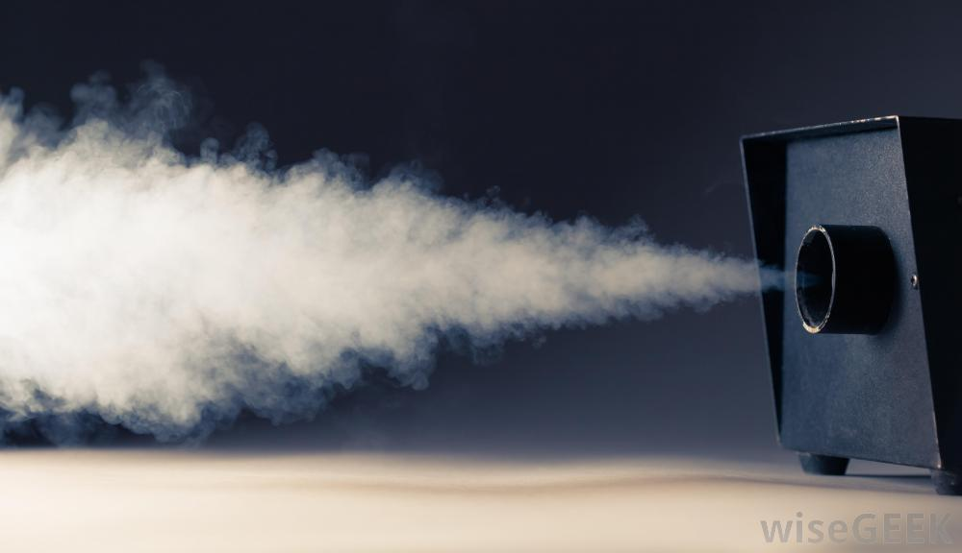
Fig 5.2.5 Fogger for winter use

photosynthesis restricted due to this the plant dies for preventing this the fogger release hot steam in the polyhouse and control climate as our desire.

5.3. Electrical component
5.3.1 solar panel
In unavailability of traditional electric supply, we can use solar panels. Solar panel change solar energy into electric energy in order to reduces the dependency of turbulence power source.
5.3.2 LED bulb / Lighting
These are known as grower light. Lighted bulb are artificial source of sun light by using this technic plants grows due to photosynthesis at night. Low consuming electricity LED bulbs emit only spectrum which are required for plant photosynthesis [7][18].
These are characterised in four parts
- 250 watt (for beginners)
- 400 watt (for low scale commercial purpose)
- 600watt (for moderate commercial purpose)
- 1000watt (for large scale commercial purpose )
250 Watt Lighting System
Good for beginners and small hydroponic systems
(i.) 250 watt sodium bulb
a. It produce “dual spectrum” so uses are limited but these are very cheaper.
b. Good for flowering plant and it work for any type of plant of flowering stage.

(ii.)250 watt metal halide bulb
It produces broader spectrum of light and it is more suitable for fruit production rather than
leaves production.

400 watt lighting system
These system run with metal halide and sodium bulbs. These systems are excellent for both vegetables and flowering growth.

600 watt lighting system
These are the most popular lighting system for hydroponically growing. We can use sodium bulb and “metal halide bulb” both in this system.
These lighting system cover more area, we can use multi lighting for as per our requirement and also this can be installed in the budget.

1000 watt lighting system
a. These are the most powerful lighting system which are commonly used for commercial hydroponic installation, these are so expensive.These system run on both type of bulb such as sodium bulb as well as metal halide. This system is best for growing a lot of plants.
b. But there is a problem with 1000 watt lighting system, it produces heat which is good for cold region but during summer and in hot climate access amount of heat harm to the plant which causes deadly in plants. If we have proper ventilation, mist and cooling system then we can resolve over heating problem in the greenhouse.

Replacement of bulbs / lamps
a.The light quality decreases and spectrum deteriorates with bulb age. So we will change the bulbs in every 9 months if we use the bulbs 12 hours a day. We cannot feel itself but plant struggle to grow well.
b. Replacement of bulb and lamps in every 9 months is costly work and sodium, metal halide bulbs are consume much electricity which is so expensive.
Then what is solution? The answer is lighting system.
c. mix up of metal halide and sodium light is ideal for flowering plants.

Metal halides
These lamps have blue light as major portion but have fuel spectrum. These lights are great for vegetation growth.
Metal halides lamps have lower human level in compare to sodium lamps so growth rate is slower. In lighting of metal halide plants be bushy and do not stretch upwards.

Halide pressure sodium lamp (HPS)
It requires a control box for ignition.
The benefits of high pressure sodium light over metal halides are as follows.
(i.) These lamps have a lot of “red spectrum” in light which is ideal for fruiting and good for flowering.
(ii.) These lamps also have a high lumen output as well as richness of yellow and orange light which our plants use to photosynthesis.
(iii.)This can be also used for vegetative growth because HPS lamps produces broad spectrum of light with richness of red and blue light too. HPS produces broad spectrum of light which helps to healthy growth and also develop amazing green color due to this we get high yield.
Finally HPS is used for all purpose of lighting system.
It can be use at any stage for fruiting, flowering as well as vegetation too.

5.3.3 Timer programmable controller
In the timer programmable controller the time control can be realized easily by a simple dial setting. In the application of hydroponics there is a little bit problem of multi timing watering, to maintain desire temperature range, this can't be easily handle by human. Into a controller that can automatically provide nutrients solution to the plants for 50 seconds every 2 hour using common essential equipment.

5.3.4 Hygrometer
Hygrometer is essential device for polyhouse hydro culture because moisture in to the indoor environment causes great effect on plants growth. Relative humidity of atmosphere is measured by hygrometer in %[9].

5.3.5 Weather Thermometer
Warm season plants such as tomatoes, peppers grow better within temperature range 70-80ºF.Cold climate plants such as leafy lettuce enjoy the temperature range 60-70ºF.The safe temperature range of plants is higher 5°C to lower 35°C[5][14].

5.3.6 UV bulb
Instead of chemical pesticide trend of UV disinfection technique used in hydroponic polyhouses now days, it kill the waterborne pathogens recirculating in the system. It is beneficial because of no use of chemicals, no external heaters use, no effect on pH level of water and no temperature fluctuation occur [9].

5.3.7 Air Pump
To oxygenate the water for better growth of roots.

5.3.8 EC meter
This meter measure electrical conductivity of nutrient solution which is control to growth as well as production of plants. This work on ‘osmotic pressure(OP).The colligative range for better of EC is 0.8 to 1.30,above this range plants deadly started[10].

5.4 Hydro culture component:
5.4.1 Seedlings trays:
Seedlings trays are just seems as egg storage box, these are light weight, can make several vertically layers on benches. The cones of tray filled with high porosity media just as rice husk and coco pit, the seeds are sowing in it. When roots comes out from seeds they bind with media and make root bunch, now these bunches are ready for further plantation.
Holey cups
Holey cups are used to grow the seeds individually. Commonly they are used in NFT, DWC, aeroponics hydroculture.
Water pipes
Water pipes bring water from the water tank to the polyhouse. Secondary pipe lines distribute the water from jet pump to trays of the benches. The wastage water reaches to the treating chamber for filteration.
Optimum PH level
Maintain pH range in between 5.5 to 6.5 plants grow better in this range[5].

Substrates
Sand, rice husk, Pumice, Coconut Fiber[8], Ex Clay, Pebbles, panded Clay Perlite, Rockwool, Sand Vermiculite[10].

Plants to Grow Hydroponically Indoors / Greenhouse
Suitable climatic state is basic requirement for plant growth, there is no means that climate is natural or artificially maintained. Although it is seems in man made climate plants grow faster rather than natural. They need light for photosynthesis, doesn’t mater it is sun light or LED light. And humidity help to clean the pores of leaf for proper photosynthesis. Because of growing in water they need structural support for standing, air require for carbon dioxide and nutrient requirement is the factor determine the development of plant, yield and quality[18]Leafy plants grow well in hydroponic system, cabbage, lettuce, basil, roses, tomatoes, okra, cantaloupe and bell peppers are best growing plants[6].

- Spinach
The health benefits of spinach make this leafy green vegetable a great addition to almost any healthy diet, but the unassuming spinach is also right there on top of the list of the best plants you can grow hydroponically at home. Not only does spinach grow well in most water-based gardens. You can harvest your hydroponically-grown spinach all at once, or snip off a bit at a time. The young leaves of the spinach plant make a particularly versatile ingredient as they can be eaten both raw and cooked (see different ways to use baby spinach).

- Tomatoes
In Indoor farming, cherry tomatoes give almost same no. of fruits as well as same no of flowerings. It happens because of no insect enter in polyhouse. Vein are reached upto 30 to 40 feet in hydroponic polyhouse.[13]

- Peppers
By using hydroponics we can grow several variety of pepper which are not possible to grow in open field. With this type of indoor growing system, it is possible to increase pepper size and production.

6. Need of Psychrometry
A psychrometry gives knowledge about physical and thermal properties of moist air in a graphical form. It can be very helpful in troubleshooting polyhouse or livestock building environmental problems and in determining solutions. Psychrometric charts helps visualization of environmental control concepts such as why heated air can hold more moisture and conversely, how allowing moist air to cool will result in condensation.
A dry-bulb temperature scale on the horizontal axis, a humidity ratio (moisture content) scale on the vertical axis, and an upper curved boundary which represents saturated air or 100 percent moisture holding capacity. The chart also shows other moist air properties such as humidity ratio, enthalpy, relative humidity, dew point temperature and wet bulb temperature.
To control the humidity and temperature, it is very necessary for proper plant growth. Hydroponics conditions should reproduce their habitat. Because many plants have evolved from species found in tropical or semitropical locales.
High humidity will actually suffocate the plants so relative humidity level should be monitor and control. To maximize nutrient intake and promote optimal vegetative growth and flowering hydroponics garden should be kept at a relative humidity range of about 40-80% and 50% being optimal. Plants are also very sensitive to temperature and must avoid extreme hot or cold at all costs.
S.No. | Crop | Temperature | Humidity
1. | Spinach | 10⁰C to 28⁰C (50 F to 82 F) | 50% to 70%
2. | Cherry tomato | 26⁰C to 32⁰C (79 F to 90 F) | 40% to 55%
3. | Cucumber | 19⁰C to 28⁰C (66 F to 82 F) | 75% to 95%
4. | Melon | 26⁰C to32⁰C (79 F to 90F) | 40% to 50%
7. Comparisons of Traditional farming and Hydroponic System

Sl. | Attributes | Convectional of green fodder | Hydroponics green fodder | Savings on
1 | Area | 10000  Sq. ft. | Working area=108 sq.ft.  Acquired area=235.2 sq. ft. | Land
2 | Fodder production in days (growth period) | 60-70 days | 7days | Time saved on growth period
3 | Water and electricity requirement | Very high | Very low | Water and power saving
4 | Land fertility | Essential | Not essential | Soil conditioning
5 | Fertilisers | Required | Not required | Saving on fertilisers
6 | Foder yield dependency | On climate, rain, water, etc | In controlled environment | No dependency
7 | Fodder utilization by animals | Partial | Complete | Saving on labour
8 | Labour requirement | More | Less | Saving on labour
9 | Fencing and protection | Required | Not required | Saving on fencing
10 | Fodder feeding practices | By chopping | Not required | Saves chopping time and labour

1.Bamboo
Bamboo is a wood-like plant that is a part of the grass family, consisting of a cylindrical hollowshoot, or culm. This culm is covered with a waxy surface, which prevents moisture from escaping. At intervals, the culm has raised ridges called nodes, from which branches will offshoot. The general physical features of bamboo are shown in Figure 1. The plant grows up from a throng of underground stems and roots, called rhizomes. Some species can grow to a height of up to 30.5 m, with a diameter as great as 305 mm. Bamboo is a natural resource with very rapid renewability. Indeed, bamboo can have a very high growth rate, with some species growing up to 600 mm per day. However,it still takes four to five years for the bast fibers, or so-called wood fibers to mature.
From time immemorial, man has used bamboo for construction purposes(poles, rafters, trusses, purlins), fence, scaffolding, woven products (mats,baskets), agricultural implements, ladders, props, etc. As bamboo was cheaper than expensive construction materials like timber, steel, etc., it was referred as 'poor man's timber'. Now, efforts are being made to bringout a bamboo building code so as to promote bamboo as an engineering material.
So Bamboo can be used in environmentally friendly constructions as structural elements, or as a substitute for steel reinforcement rebars in low-cost buildings. However, like timber or the most of bio-based materials, bamboo is sensitive to water and moisture; it can absorb or release water/moisture depending on its environment.

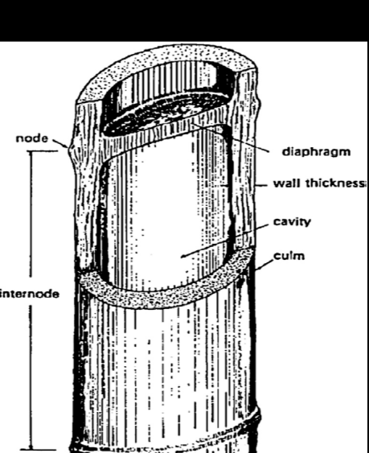

Fig 1: Bamboo Structure

2. Properties of Bamboo
- TENSILE STRENGTH
Bamboo is able to resist more tension than compression. The fibres of bamboo run axial. In the outer zone are highly elastic vascular bundle, that have a high tensile strength. The tensile strength of these fibres is higher than that of steel, but it’s not possible to construct connections that can transfer this tensile strength. Slimmer tubes are superior in this aspect too. Inside the silicated outer skin, axial parallel elastical fibers with a tensile strength upto 400 N/mm² can be found. As a comparison, extremely strong wood fibers can resist a tension upto 50 N /mm².

- COMPRESSIVE STRENGTH
Compressive strength lie between 40N/mm² to 80N/mm² which is twice to four times than other timber species.

- ELASTIC MODULUS
The accumulation of highly strong fibers in the outer parts of the tube wall also work positive in connection with the elastic modulus like it does for the tension, shear and bending strength. The higher the elastic modulus, the higher is the quality of the bamboo. Enormous elasticity makes it a very useful building material in areas with very high risks of earthquakes.

- ANISOTROPIC PROPERTIES
Bamboo is an anisotropic material. Properties in the longitudinal direction are completely different from those in the transversal direction. There are cellulose fibers in the longitudinal direction, which is strong and stiff and in the transverse direction there is lignin, which is soft and brittle.

- SHRINKAGE
Bamboo shrinks more than wood when it loses water. The canes can tear apart at the nodes. Bamboo shrinks in a cross section of 10-16 % and a wall thickness of 15-17 %. Therefore it is necessary to take necessary measures to prevent water loss when used as a building material.

- FIRE RESISTANCE
The fire resistance is very good because of the high content of silicate acid. Filled up with water, it can stand a temperature of 400° C while the water cooks inside.

3. Advantages and disadvantages of Bamboo

- Advantages of Bamboo
The major advantages of Bamboo are as follows:-
- Light, strong and versatile
- Environment friendly
- Self renewing resource
- Fast growing
- Highly productive
- Production of 1 ton of steel emits more than 2 ton of CO2 in the atmosphere while production of 1 ton of bamboo consumes more than1 ton of CO2 of the atmosphere.

- Disadvantages of Bamboo
The major disadvantages of bamboo are as follows:
- Requires preservation
- Shaped by nature
- Durability–bamboo is subjected to attack by fungi, insects; for this reason, untreated bamboo structures are viewed as temporary with an expected life ofnot more than 5 years.
- Jointing–although many jointing techniques exist, their structural efficiency islow.
- Lack of design guidance and codes.
- Prone to catch fire very fast by the friction among the culms during wind, andis seen to cause forest fires.

THE WORKING OF BAMBOO
METHODS
1) Splitting
The cane is split in halves and quarters and then driven apart by a wedge. It can also be split with a knife frame into four or eight segments as shown in fig . By means of splitting you get halved canes, strips and battens. To get planks, all the nodes are smashed and the wall of the pole is split over its entire length and forced open until the wall of the pole lies flat. Up to the age of 18 months, the canes can be peeled. The strips can be used as ties or be woven to make strings and ropes.
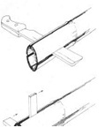
Fig 2(a) Splitting of a bamboo cane.

Preservation of bamboo

Bamboo is subject to attack by microorganisms and insects in almost any construction applications. The decay and biodegradation of bamboo culms during outdoor storage can be checked to a great extend by adopting a good storage yard practices. Culms should be stacked horizontally over raised wall to facilitate water drainage and air circulation. For reed bamboos, vertical stacking results in a small gain in pulp yield over horizontal stacking because the former suffers less fungal damage. The service life of bamboo is therefore, mainly determined by the rate of attack. A variety of methods to improve the durability of bamboo have however, been developed. Basically, there are two methods for increasing the durability of bamboo. These are chemical and non chemical method but we use chemical method to preserve the bamboo.

- Boucherie method
The Boucherie method requires the culms to be in a green condition. The water-transporting part of the culm can be penetrated completely and the treatment itself is applied by an inexpensive installation.Preservative is fed by gravity from a container placed at a higher level than the culm through pipes into its base end (figure 3). The culms are fastened to the tubes by rubber sheaths and clamps. It is also possible to hang the culm vertically and to scratch the inner wall of the top internode in order to use it as a reservoir for treatment. The treatment is terminated when the solution at the dripping end shows a sufficiently high concentration of chemicals. The duration and success of the treatment process depends on the type of preservative, its adhesion and precipitation, and the swelling influences on the cell wall. Preservatives with high adhesion can stop flowing through the culm in a relatively short period of time, blocking the vessels and pits. Also, if the moisture content of the culm is too low, water is withdrawn from the preservative solution causing precipitation and blocking the vessels. The best results are therefore obtained during or shortly after the rainy season, using younger culms with a higher moisture content. Following the treatment process, the run-through preservative solution can be filtered and re-used. Burial in the ground is also common, but this practice is clearly undesirable and effort should be directed at 14 providing alternative solutions to the problem of disposal. Allowing the bamboo to dry slowly in the shade for a period of at least two weeks after treatment ensures that the solution diffuses into all of the tissue surrounding the vessels drum.

- Modified Baucherie Method
The basic Boucherie method has been improved by method the introduction of pneumatic pressure over the preservative fluid in a reservoir, for example by using an air pum or electric pump. The preservative is forced axially through the culm by the air pressure in the reservoir. In this way the time of treatment can be reduced from several days to 3-8 hours. In the Boucherie method, the sap is displaced by preservative chemicals by gravity. The culm is connected to a container of preservative solution kept at a higher level. In the modified Boucherie method (Purushotham et al,1953), pressure is applied in the range of 100-140 kPa. Even a simple hand pump can be used for the purpose or a centrifugal pump for commercial scale operation. Also, the bamboo culm can be with or without branches and leaves. The water-transporting part of the culm can be penetrated completely by this method. At the beginning of the treatment, the solution dripping from the top end will be mainly sap and subsequently the preservative. This can be collected, filtered and mixed with fresh preservative for reuse. The treatment is said to be completed when the concentration of the solution at the dripping end is almost equalto that of the preservative solution.

Advantages
The equipment used for this method is simple, low-cost and can be built anywhere with easily available materials. Furthermore, it can be built in different scales, from a portable equipment to treat a few culms to a largescale, permanent plant to treat hundreds of culms per day (Gonzalez and Gutierrez, 1996). In terms of penetration, distribution and retention of preservatives, this method is one of the best. Laxamana (1970) found the modified Boucherie method, among the different methods investigated, the most effective.

Components used in Modified Baucherie method
- Chemical Reservoir:-
This is a high pressure cylinder reservoir which can bear pressure upto 70psi.
But we use thick iron cylinder which can bear more than ten times as we need. High pressurable cylinder used for safety precaution. This reservoir contains three valves. These are-
- Inlet Valve, through which chemical can enters.
- Air pressure valve, through which air pressure can be maintained.
- Outlet Valve, which is attached with rubber hose.
- Rubber Hose
This is a high pressure rubber tube which can bear upto 120psi and having outer diameter of 1.5cm and inner diameter of 1cm.
- Iron hose
This is the R-socket type hose having small diameter of 1cm and outer diameter of 6.6cm. A lever is connected to smaller diameter of iron hose which is used to regulate the supply of chemical in Bamboo.
- Coupling
This is made up of high strength elasto-polymer which can bear pressure upto 100psi. For prevention of bamboo slacking, under high pressure, one end of coupling is fitted to larger diameter of socket with the help of turbo clip and other end is connected to node end of the bamboo.
- Pressure pump
Generally, we use paddle operated air pressure pump which can fill the air in reservoir at required pressure and having a range of 100psi.

Steps involved in Bamboo treatment using modified Baucherie method
- Firstly, we close the outlet valve of reservoir and open both air pressure and inlet valve then we fill the reservoir with chemical solution( Boric acid and Borax) of 1/4th volume of chemical reservoir and also additional amount of 1 ½^{th} volume of reservoir as per each coupling is filled to fill the hose cavity.
- Now, we create pressure upto 21 to 45 psi in the chemical reservoir with the help of paddle operator pressure pump.

21-45 psi
Air pressure

Air pressure pump
Air pressure valve
Chemical reservoir
Inlet Valve
Lever
Outlet Valve
Rubber Hose
Iron Hose
Air exhaust valve
Lever
Turbo Clip
Chemical Solution

Fig: Schematic diagram of Baucherie Method

- Remove the unwanted air from exhaust air valve of iron hose.
- Open the lever of both iron hose and rubber hose which allow the chemical solution to flow into the bamboo without any restrictions and after treating the bamboo, chemical solution gets stored.
- When bamboo is fully treated, then close the lever of iron hose which restricts the flow of chemical in bamboo.

Table :- Stages
S.No. | Chemical Reservoir |  | Rubber  Hose | Iron  Hose | Coupling
S.No. | Upper part | Lower part | Rubber  Hose | Iron  Hose | Coupling
1. | Air at atmospheric pressure | 1/4th chemical solution at atm. Pressure | Air at atm. Pressure | Air at atm. Pressure | Air at atm. Pressure
2. | Air at 21-45 psi  (Outlet lever off) | 1/4th chemical solution at 21-45 psi | Air at atm. Pressure | Air at atm. Pressure | Air at atm. Pressure
2. | Air at 21-45 psi  (Outlet lever on) | 1/4th chemical solution at 21-45 psi | Air at 21- 45 psi | Air at 21- 45 psi | Air at 21- 45 psi
3 | Air at 21-45 psi  (refuse air packets from iron hose and rubber hose by escape valve) | 1/4th chemical solution at 21-45 psi | chemical solution at  21-45 psi | chemical solution at  21-45 psi | chemical solution at  21-45 psi

Precaution while treating the Bamboo
- While filling the chemical reservoir, if air pressure valve is closed then chemical enters in the chemical reservoir through inlet valve and replaces the air but there is single way for refusing the air which is same as chemical incoming way( inlet valve). Due to this air bubbles created which causes splash during chemical solution filling and restricts the chemical solution inflow.
- To remove the unwanted air form iron hose, air exhaust valve of iron hose should be towards sky because air is lighter then the boric acid solution and air is floated over the chemical solution and can remove easily from exhaust valve.
- Practically, when we refuse air packets from iron hose then void space created and additional amount of chemical solution is required to fill up the rubber and iron hose. If we do not add the additional amount of chemical solution then it causes lacking of chemical solution in chemical reservoir.

Basic Principle, Bamboo cuts and Jointing technique of bamboo

Basic Principle of Bamboo
- Do not use green, fresh cut bamboos. Bamboo has to be completely dry before using it in construction (preferable air dried). During the drying process, the diameter shrinks, so when bamboo is used in joinery this will result in lose and weak joints after a few weeks.
- Do not use bamboo when it is less than 3 years of age. Only use mature bamboo of 4-6 years.
- DO not use bamboo infected by insects. Bamboo must be preservative by using some methods.
- Do not use bamboo that has flourished. Rest assured bamboo only flourishes once in a lifetime (60 -120 years).
- Do not use bamboo poles with profound vertical cracks.
- Use appropriate cuts and joints when building with bamboo.
- Use bamboo with the right diameter and wall thickness for our project.
- When using bamboo as a column make sure that the lower part connecting with the surface end with a node, if not the bamboo will splinter when struck.
- When connecting bamboo poles with bolts, make sure to bolt them together in between 2 nodes, otherwise bamboo may crush

Bamboo Cuts:
There are the most common cuts to use when making bamboo joints. These are as follows:-
- One ear
- Two ear
- Beveled
- Flute mouth
- Fish mouth
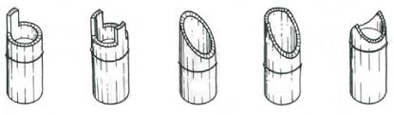
Fig: Bamboo Cuts: one ear, two ear, beveled, flute mouth and fish mouth

Jointing Technique of Bamboo:

Effective jointing is fundamental to the structural integrity of a framed construction. Furthermore, the suitability of a material for use in framing is largely dependent upon the ease with which joints can be formed. Because of its round, tubular form, jointing of two or more bamboo members requires a different approach to that adopted for, say, solid timber. Despite its relatively high strength, bamboo is susceptible to crushing, particularly of open ends. It is also characterized by a tendency to split; the use of nails, pegs, notches or mortises can therefore result in considerable reductions in strength. Connections must also cope with variations in diameter, wall thickness and straightness. Clearly, these limitations have not presented an obstacle to the use of bamboo in traditional forms of construction. However, the building of structurally efficient, more durable and possibly larger and more economical bamboo structures will depend to a large extent on improvements and developments in jointing technology.
Some jointing technique are as follows:-

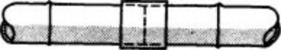
1.Sleeves and inserts: short lengths of bamboo of appropriate diameter are used either externally or internally to join two culms together.
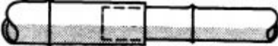
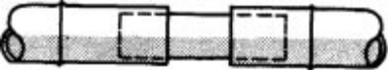
Fig: Sleeve and insert
2. Butt joint: The simplest form of butt joint comprises a horizontal member supported directly on top of a 66 vertical member. Typical examples would be roof eaves beams on posts or floor beams on intermediate posts. The top of the post can be cut to form a saddle to ensure secure seating of the beam and good load transfer. The saddle should be close to a node to reduce the risk of splitting. A variation on the saddle involves the cutting of a long, integral tongue which is bent right over the transverse member and tied back. Other details include square no tched ends, side plates and tenons .
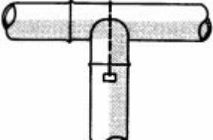
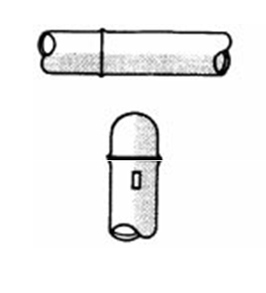
Butt joint (T-shaped) by using wire clamp tightening tool by using following process:-
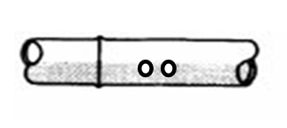
- Take the two measured bamboo and make the hole in both horizontal and vertical bamboos near the node as shown in figure.
- Take the vertical bamboo and cut the end in concave shape. Connect the horizontal and vertical bottom by passing the wire through the hole and locking bolt for prevention of slipping of wire.
Wire and locking bolt for
Prevention of slipping of wire

- Bamboo embedding via nut bolt at the corners:-
a. Take the two measured bamboo and make a hole in both bamboos at corners near the node.
b. Join these two bamboos by nut bolt and tightening it with wire using wire clamp tightening tool.

3. Angled joints
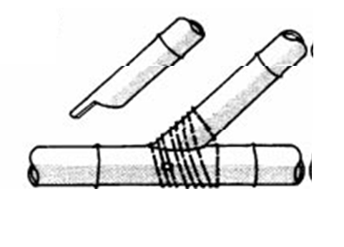
Angled joints are formed where two or more members meet or cross other than at right angles. For butt joints, the ends of the member can be shaped to fit in much the same way as an orthogonal saddle joint. Horns (integral tenons) might also be used but fabrication is time consuming. Examples would include web members in trusses. Angled crossovers can be dealt with in much the same way as orthogonal crossovers, for example the diagonal bracing in the plane of a roof.

4. Through Joints: Members of differing diameters can be joined by passing the smaller through a hole drilled in the larger. The joint is secured by a dowel passing through both members. Applications for this type of joint might include partitions, doors and window framing.

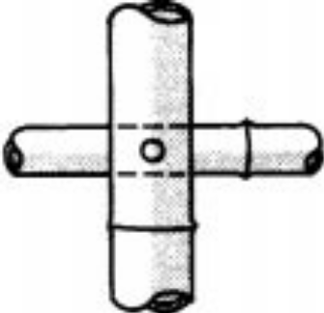

Polyshed bamboo structure

Steps involved in making polished bamboo structure:-
1. Make two holes of the diameter 10mm at the bottom side from the base first is at 6” above and the other one is 18 inch in number of required (four) bamboo.
6”
18”

2. Take another two bamboo and make a two hole in each bamboo of 10 mm diameter from both end 6 inch apart.

6”
6”

3. For lower inclined section, take another two bamboo and make hole of 10mm diameter from 1 feet(12 inch) apart at the lower end.

12’’
12’’

4. Assembling operation of bamboo are as follows:-
- Take two drilled vertical and one drilled horizontal bamboo, Horizontal bamboo assembled in between vertical two bamboo at the lower hole via 10mm nut bolt.

- Now other end of horizontal bamboo is assembled by another remaining two vertical bamboo at the bottom hole.

c. Now assembled inclined bamboo to the hole of 12 inch above from the base of vertical bamboos by 10mm thick nut bolt.

d. Now assembled one horizontal bamboo at the top of both vertical bamboo.

e. Now Join one vertical bamboo at the middle of the upper horizontal bamboo.

f. Now assembled two inclined bamboo at the end of the vertical bamboo.

g. Now bind the end of inclined bamboos with each other with temporary rope for proper positioning. When it become proper tight then remove the binding rope and finally tighten the all nut bolts. And hence our structure get ready.
This type of structure hardly used so we have invented and experimented.

h. Assemble all the part after assembling polyhouse shed structure was ready as shown in figure.
i.Covering this structure with polythene sheet.

Calculation Of structure
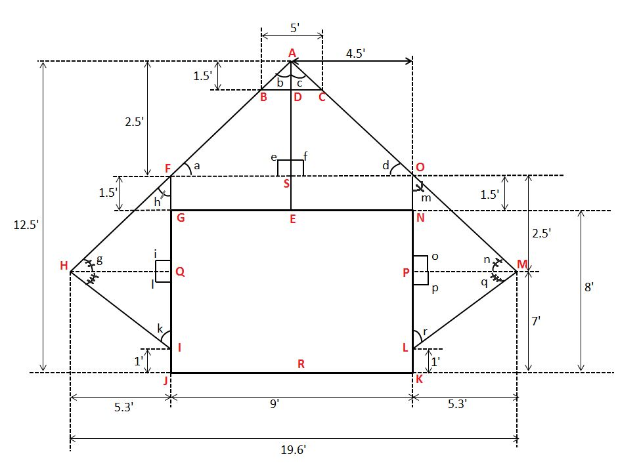

Theory:-
- This is a structure which have zero degree of freedom.
- All members of the structure are rigid because all are connects with the fixed joints.
- The members are connected to each other in a rigid manner which formed a zero degree of freedom structure.
- It can’t be super structure because it doesn’t consist negative DOF.

Calculation:-
Value measured:-
AD= 1.5 feet
BC = 5 feet
EG = 1.5 feet = ON
GI =NL = 4 feet
IJ =LK = 1 feet
NK = GJ = 8 feet
OP = FQ =2.5 feet
NP = GQ = 1 feet
JK = GN = 9 feet
HQ = PM = 5.3 feet
HM = 19.6 feet
AR = 12 feet
- To find:- AB, AC, AF, AO, FH, OM, HI, ML
- In ∆ABD,
AB = √[AD² + BD² ] = √ [1.5 ² + 2.5² ]=√8.5 = 2.91 feet
Hence,
In ∆ADC,
AC= 2.91 feet
- In ∆FHQ,
FH = √[HQ² +FQ² ]= √[5.3² + 2.5² ] = 5.86 feet
a
b
c
A
F
S
In ∆HQI,
HI = √ [HQ² + QI²] = √[ 5.3² + 6²] = 8 feet
Similarly, In ∆OPM and ∆PML, we get
OM = FH = 5.86 feet
ML = HI = 8.06 feet
- By pythogorous theorem,
IN ∆ AFS, AF = √[4.5² + 2.5 ²] = 5.14 feet
In ∆ASO, AO = 5.14 feet

- To find angles,
- In ∆AFS,
C= 90⁰
tan a = AS/FS = 2.5 / 4.5
a= tan⁻¹(2.5/4.5) =29.0⁰
Now, b=180⁰ –a – 90 = 90 – 29= 61⁰
- Similarly ,in ∆ASO as ∆AFS ≈ ∆ASO
f=90⁰
d=29⁰
e=61
g
h
i
F
H
Q
- IN ∆HQF:
tan h = 5.3/2.5= 2.08
h = tan ⁻¹2.08=64⁰
i=90⁰
g= 180-h-i=180-90-64= 26⁰
- In ∆HQI,
j
k
l
I
H
Q
l=90⁰,
tan j = 6/5.3
j= tan⁻¹(6/5.3)=48⁰
k = 180 – j – l = 180 – 90- 48 =42 ⁰

- In ∆OPM,
0 = 90⁰
n= 26⁰ (as n ≈ g)
m= 64⁰ (as m ≈ h)
- In ∆OML,
p=90⁰,
q= 48⁰, (as q ≈ j)
r=42⁰ (as r ≈ k)

Growing bed
- The growing bed made of treated bamboos. The plateform of bed should be 1.5 feet apart to each other by this way the grown fodder grow up to full length and proper sunlight. Within 8 to 10 days the fodder reaches upto 1 feet above and the remaining 0.5 feet used for proper ventilation. The ventilation prevent to plants for suffocation and good ventilation, have good air flow which provide proper amount of CO₂ and O_{2.}Also proper ventilation prevent harmful mould attack on fodder.
The plateform should be inclined 5⁰ to 6⁰ which provide proper water flow throw tray when fodder grow in.

- Due to proper height, the misting water reaches to every place in the tray.

- If we stable two growing beds then space between them should be 4 to 5 to feet, this gap provide proper working space and light reaches to every tray for natural photosynthesis. Because of by proper working space we feel comfort to do the job, the good ventilation prevents the unwanted mould attack and for proper sunlight entry do necessary photosynthesis which generate green and lushy fodder. The tray and it make a root wet then due to inclined tray water flow from high altitude to low and this flowly water irrigate to the root mot of fodder, in this inclined irrigation the remaining/ excess water drain cut from the holes of trays at low altitude. This technique consume very less amount of water for irrigation.

- If we will leave the space more than 5 feet between two growing beds then it may be difficult to maintain temperature and humidity, in general above like condition the temperature raise and humidity decreases so don’t do like this.
- Normally a 1 x 2 Feet² tray have 8 to 11 kg grown fodder so check and be sure that making bed can bear the load of putting number of trays.
- Construction of 4 layer bed:-
- Bamboo requirement and its cost
Formula used-
(Crop between bed layer) x ( no. of layer) + ( height of footstool)
= (height of vertical column)
Length of one bamboo is given by,
1.5 x 4 + 0.5 = 6.5 feet
Total length of 6 bamboo= 6 x 6.5 = 39.0 feet………………………………………………………………………………………..i
From length side of the growing bed,
Length of horizontal bamboo = 8 feet
For 1 plateform, need of bamboo= 3
No. of plateform = 4
So total no. of bamboos = Length of horizontal bamboo x need of bamboo
for 1plateform x no of plateform
= 8 x 4 x 3 = 96 feet
From breadth side of the growing bed,
Breadth of horizontal bamboo = 4 feet
For 1 plateform need of bamboos= 2
No. of plateform = 4
So total no. of bamboos = Length of horizontal bamboo x need of bamboo
for 1plateform x no of plateform
=4x4x2=32feet ……………………………...……..ii
Half splited strips of bamboo to fill the space and holding the trays.
Length of 1 strip = 1.2 feet
Spacing of each strip = 4 inch
The length of plateform = 8 feet= 8 x 12= 96inch
Then number of strips in one plateform one side = 96/4= 24
No. of strips in one plateform both side = 24 x 2 = 48
Length of 1 strip = 1.2 feet.
Length of 48 strip = 48x1.2=57.6=approx. 58feet (of strip)……………………….………………………………………………………….iii
Single bamboo can be splitted into 2 part.
So require length of entire bamboo for one plateform = 58/2= 29 feet
No. of plateform = 4
Total require length of entire bamboo for all 4 plateform
=29 x 4= 116feet………….…………iv
Length of diagonal in front side= Length of AE and HD

G
H
E
AE
DE
F
BE
CE

HD = AE = √[(HE)² + (DE)²]
HD = AF = √[8² + (6-5)²]
HD = AB = 10.4 feet
But we use 11 feet bamboo instead of 10.4 feet remaining 0.6 feet be use as margin at both end.
So diagonal length in front side = 11feet
Total no of bamboos in front and backward side as diagonal=4x11=44feet…………………………………………..……………………..v
Length of diagonal bamboo in breadth side = Length of DF & FC
G
H
E
AE
DE
F
BE
CE

DF = EC = √[(EF)² + (ED)²]
DF = EC = √[ 4² + 6.5²]
HD = EC = 7.6 feet
But we use 8 feet for diagonal bamboo instead of 7.6feet remaining 0.4 feet be use as margin at both end.
So diagonal length in breadth side = 8 feet
Total no. of bamboos in length and right side in breadth side as diagonal
=8x4=32feet…………………………………………vi
Hence, a total requirement of bamboo length
= summation of equation [ i + ii + iii + iv + v + vi ]
= 39 + 32 + 58 + 116 + 44 + 32
= 321 feet
Average cost of bamboo per foot = Rs.3/-
Hence total cost of bamboo = 321 x 3 = Rs.963/-
- Nut bolt requirement and cost:
Need of 10 mm diameter nut bolt = 1 kg
And Worth of = Rs.80/-

Need of 5 inch nail = 1 kg
And Worth of = Rs.120/-
Need of washers = 100 unit = Rs.100/-
Hence total expenditure of growing bed = 963 + 80 + 120 + 100 =₹1263
Single plateform can hold of no of trays = 14
All 4 plateform hold no. of trays =14 x 4 = 56 trays
One try can grow 8 to 41 kg fodder,
56 tray grow = 56 x 8 to 56 x 11= 448 kg to 616 kg
“ Full load capacity with 56 trays the growing bed can produce 448kg to 616kg fodder within every 9 days”

4 feet
1.5 feet
1.5 feet
1.5 feet
4.5
8 feet

s

Mist cooling system
The process of misting or fogging is used in a variety of applications to control humidity and temperature, improve air quality, and even provide visual effects. High pressure misting is accomplished by spraying water through nozzles with tiny orifices which are specially selected for each type of application. Each misting or fogging system is different in design and sophistication. A basic system will include a high pressure pump, motor, atomizing nozzles, and plumbing including some form of water quality control.
Misting or fogging systems typically run at pressures of 1000 to 3000 psi and are significantly more cost effective than traditional cooling systems.

Components used in mist cooling system

- Nozzle
Nozzle is a device that increases the velocity of fluid at the expense of pressure. The cross sectional area of a nozzle decreases in the flow direction for subsonic flows and increase for supersonic flows.
The rate of heat transfer between the fluid flowing through a nozzle and surrounding is usually very small (Q≈0). Since the fluid has high velocities and thus it does not spend enough time in the device for any significant heat transfer to take place. Nozzle involves no work (W=0) and any change in potential energy is negligible.
But nozzle involve very high velocities and as a fluid passes through a nozzle, it experiences large changes in its velocity. Kinetic energy changes must be accounted for in analyzing the flow through this device.

V₁
V₂

We use low pressure misting nozzle for fodder which may work on 150psi and high pressure misting nozzles for cooling to indoor climate of greenhouse, because of high pressure misting nozzles spray fine droplets of water which are easily vaporizes and easy to exhaust.

- Throttle valve
The throttling valve is a mechanical device that restricting flow which causes a significant pressure drop in the fluid.
For example, ordinary adjustable valves, capillary tubes, porous plug.
The pressure drop in the fluid is often accompanied by a large drop in temperature .The magnitude of temp. drop or rise during throttling process is governed by property called Joule Thomsan coefficient.
In throttling device, flow is adiabatic (q=0), no work done (w=0), change in potential energy is negligible(P.E.=0), kinetic energy is also insignificant(K.E.=0)

- Foot valve
Foot valve must be constricted with filter screen which filters the sediments and devices into the water tank. This filtered water through the very small orifice of nozzle if any type of sediments passes through orifice then it may be join to the orifice which can deform spray angle and shape.

Working of mist cooling system

The jet pump is used to lift water from tank. Our specially modified jet pump is engineered to utilization of venturi effect. The venturi effect reduces fluid pressure, when incompressible fluid flows through the constricted section of pipe and now the jet pump to start working. This needs a filled water tank, suction and device line. As the water tank, suction and device line connect to the centrifugal pump it push out the water.
In this way, some amount of water is discharged to the misting nozzle and remaining is recirculated into the device line. When water enters into the nozzle, it is forced through the venturi which draws the water up from water tank through a foot valve.
When water passes through the venture tube in the suction line. A sufficient pressure increased to force water back into the pump impeller.
The foot valve is a crucial part of jet pump assembly. Foot valve is fitted below the pump at the bottom of the water tank. The foot valve leads many key functions and it is the first “mechanical” component which have direct contact with water tank.
The foot valve perform three main functions:-
- Foot valve takes water from water tank and feeds the jet pump
- It filters the sediments and devices into the water tank and keeps it away from the pump.
- If water tank have no water and seeming dry, dry seeming harm to the pump. The foot valve prevent the back flow of water from suction line to water tank.

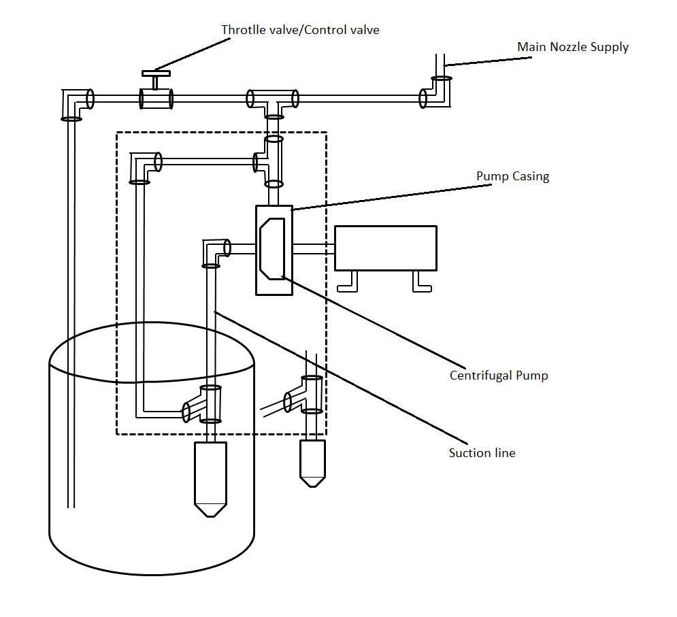

Misting arrangement in polyhouse
Mist should be covering every place in the shed house/greenhouse uniformely.

4-5 feet
12 feet

Case 1
- Working pressure 200psi/146/
- Nozzle orifice 0.3mm
- Spray angle is 80º
80⁰

Case 2
- Working pressure 400psi/2db
- Nozzle orifice is 0.3mm
- Spray angle is 100⁰-110⁰
100⁰-110⁰

The mist tends to form fog:
- The fogging system includes several parts and misting nozzle is most crucial part to determine the fogging result.
- Nozzle should be have and deep mechanism impeller compression ratio. So if nozzle tip get too light it will not spray and in the case of too loose it will get leak.
- The nozzle should be properly gripped to socket otherwise it will leak through gap and reduces the required pressure for misting.
- Used filter having standard mesh restrict to flow of unwanted particle and prevent to orifice jam of nozzle.
Here, 1 mesh = 0.07mm to 0.08mm
- The filter should have even surface where water flow in which provide stable flow rate otherwise uneven affect to the stability of flow rate and hence it causes to the excess load on jet pump.
- Some times salts of hard water lumped over the orifices of nozzle wheel may from it and restrict to its proper flow.
- We should be aware in selection of misting nozzle. The flow of water per minute should be low and spray angle should be high this specification of nozzle will consume less amount of water and cover more area for cooling with fine droplets.
Benefits of Mist cooling system
• Provide more uniform humidification and cooling
• Improve energy efficiency
• Decrease water consumption and need for chemicals
• Improve indoor and outdoor air quality and comfort
• Help minimize brittleness and static electricity
• Increase germination and propagation
• Diminish the risk of respiratory infections
• Control unwanted odors
• Enhance surroundings
• Minimize damage to equipment and materials in a fire

Mechanical parameters for hydroponic plants/fodder in polyhouse/greenhouse

- Temperature inside and outside of polyhouse.
- Temperature of a water solution for plant roots.
- Temperature of misting/sprinkiling/spraying/fogging water.

Atmosphere at temperature T₁
Water droplets at temperature T₂

Here, T₂<T_{1.}
Due to heat flow from high temperature to low temperature, atmosphere heat absorbed by fine water droplets to evaporate itself.
- Temperature of ventilation winds.
- Temperature variation through radiation (Energy only)
Greenhouse / Polyhouse
Polyhouse is a type of greenhouse made of polythene. The general consideration is a polyhouse is a confined structure without crop and plant while greenhouse is a covered structure having crop/plants.
On the basis of covering we can divide it in two ways. These are:-
a. Unilayered covered polyhouse : It is covered with single layer of polyfilm. This is cheap in installation cost in in compare to doubly layered covering polyhouse by covering we make controlled volume.
b. Doubly layered polyhouse: Air is bad conductor of heat so when we make doubly layered polysheet then air pocket fill out between the layers which resist to the heat flow within itself.
Conservation of mass in greenhouse and mass balance equation
Mass never be create nor be destroyed so we should be know how much mass ( in form humidity and water vapour) come in the greenhouse and how much go out. Within this calculation we also consider mass generated by plants during evapotranspiration and consumed mass during condensation. Mass can be generated naturally generated water vapour and forcely generated water mist.
m_{in} - m_{out} + m_{gen} - m_{con} = dm/dt
where, m_{gen} = Generation of water vapour due to evapotranspiration from plants in greenhouse.
m_{con} = Consumption of water vapour due to condensation.
m_{in} = Mass flux in ( the rate of mass flow per unit area). Mass flux is measurement of amount of
mass passing in/out through the controlled volume.
m_{out} = Mass flux out
M= V C_{a}
Where, V= Controlled Volume of ABCDEFG (the amount of matter inside the predetermined volume)
C_{a}= Concentration

E
A
B
C
D
F
G
m_{gen}
m_{con}
m_{in}
m_{out}

Use bamboo poles instead of iron poles
There are several benefits to use bamboo poles over iron poles in construction of structure of polyhouse.
a.Conduction
The bamboo are made of wood and wood is bad conductor of heat transfer.
So rate of heat transfer by conduction in bamboo is too small in comparasion to heat transfer via conduction in iron poles.
Hot Cold
q_{conduction} (W/m²)
dx

So at microscopic level,
dT=T_{hot} – T_{cold}

Here, dx is thickness of material in which heat transfer takes place.
Heat flux via conduction is given by,
q_{conduction} = -λ dT/dx
where, λ= thermal conductivity (W/m K)
and negative sign indicate that heat transfer is in decreasing direction of temperature.
(Stefann boltzman’s law : good emitter be a good absorber)
For same dx, q_{conduction} is much more than for iron/steel poles in comparasion to bamboo poles.

b.Benefits of air packet in bamboo
Naturally bamboo have a closed air packet almost at each one or more two feet range and these aie packets lie within each two nodes.
Hollow post
Node
Thickness of bamboo meat

NOTE: We punches the node to make a small hole in bamboo pole to drain out the water if any water reach in it. By this way we can prevent unnecessary rottening in bamboo.
a. Bamboo is bad conductor of heat, due to which, it is not much affected by radiation i.e., it doesn’t absorbs much radiation. And also the outer surface is too smooth and reflecting in nature so it is not get heated due to radiation.
Radiation incident
Reflected radiation

The radiation between surfaces takes places via electromagnetic wave. But iron pole absorbs much more radiation and get warmer. The iron poles affected by outer temperature, so take the heat from outside and emitted to inside the polyhouse.

Forced convection
A mechanism or type of transport in which fluid motion is generated by an external source (like a pump, fan, suction devices, etc) . It is consider to be main method for heat transfer.

In our project i.e. mechanism of hydroponics cultivation, forced convection occur in following way –

Construction: Project includes mist system, trays, benches of bamboo, shed cover with polythene, water tank, exhaust fan.
Nozzle involved under the mist system which is heated at the upperside of the shed under polythene. The exhaust fan is situated at the front face of the shed.

Working: When the mist sprayed water (in form of fog) on the surface like (tray, polythene, water tank, bamboo, land), then the hot surface begins to absorb and transfer energy.
The water transfer its energy to the surface and surface transfer its energy to the water.
Hence, the surface becomes cool and water becomes warm.
This warm water rises up as vapourisation .The vapourisation from every surface increases inside temperature and humidity too.
The increases in humidity helps to grow plant in good condition but increases in temperature is harmful for plants.
To decrease the temperature, exhaust fan is used which force fully out the vapourisation water and hence inside temperature decreases and humidity increases.
In this way forced convection occurs in our project.

* Energy transfer mechanism - Advection
Receiving heat and bulk motion of vaporized water molecules via advection is takes place inside the polyhouse.
T∞
T_{s}

Hence, transportation of heat energy and mass (air/humidity) by the flow from one place to another in the direction to the flow which take place from ventilator window to another ventilator window.
q_{advection} = ʄ_{volume} c_{p} (T_{in} – T_{out})
where, ʄ_{volume} = air volumetric flow rate (m₃/s)
q_{advection} = Heat via advection (W)
c_{p} = Volumetric air specific heat (J/m³ K)
T_{in} – T_{out} = Temperature differences (K)

T_{in}
q_{advection}
T_{out}

* Mass transport mechanism- Advection
C_{in}
m_{advection}
C_{out}

m_{advection} = mass via advection(Kg/s)
ʄ_{volume} = air volumetric flow rate (m³/s)
C_{in}= Concentration of water vapour, air, CO₂ and O₂ inside the polyhouse.

Mass and energy transport mechanism- convection
Convection = Conduction + Advection

C_{s}
Surface
T_{s}
T_{f}
Fluid
C_{f}

Due to evopotranspiration by plants, misting by cooling system and vaporization through wet ground surface inside the greenhouse change the concentration of fluid and fluid temperature.

Greenhouse Effect
A process of warming of surface and lower atmosphereof planet (such as earth) i.e. caused by conversion of solar radiation into heat in a process involving transmission of short wave solar radiation by atmosphere, its absorbtion by palnet’s surface and rearadition as infrared which is absorbed and partly reradiated back to surface by atmosphere gases.
Greenhouse effect is warming effect of sun on greenhouse gases like CO₂ that act to trap this heat in our atmosphere.

How greenhouse work?
- The sunlight passes through polysheet.
- Some light energy absorbed by bamboos, soil/ground, plants, growing bed and polysheet.
- Ground soil and plants get warm they give off heat due to this greenhouse have warm climate inside than outside.
- To get rid this problem we use mist cooling system.
How greenhouse effect relates to our project?
When the sun’s radiation comes the it frstly incident on the green net and polythene. Some of the radiation firstly absorbed by the green net & polythene (i.e. surface) and transferred some of the radiations involve the surface (i.e. atmosphere).
Now, as we know plants emits CO₂ i.e.reradiation. At the same time, some of the gases also referred back to the atmosphere as infrared waves. The reradition causes increase in temperature of shed, which may harmful of plant growth. Hence, exhaust farm forcely out the warm inside air, causes to maintain temperature as well as humidity of atmosphere.
This is how greenhouse effect our project.

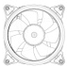
High tech “Semi closed” Greenhouse

Cooler +fan
Air treatment unit
Outside air
Air
inlet
Air outlet

- Air treatment
- Humidification
- Cooling
- Dehumidification
- Heating
- Natural ventilation
- Forced ventilation
How Plants xylem works
Some amount of water is used for photosynthesis by chlorophyll in the presence of sunlight or grower light and remaining water evaporate from leaves up to 99% of water which is absorbed by roots is lost via transpiration through the leaves of plant. Plants losses liters of water every day through transpiration process and the evaporation of water from plants mainly through the pores in their leaves.
Due to transpiration, the plants emitted a lot of humidity and in greenhouse because of covered structure the transpiration of plants causes a lot of humidity.
To much humidity resist to the evaporation from plants leaves. And when evaporation resist from leaves its affect to the working of system because the xylem pull the water and liquid nutrients from roots to the leaves.
Due to high humidity air saturation takes place in the climate by this deed water doesn’t evaporate from leaves. By this xylem doesn’t work with full efficiency and nutrients with water flow. Resisted this phenomenon and restrict plants growth even start deadly.

Root hair
(Water enters in the root hair by osmosis)

Due to transpiration stem pulls water up through the stem.

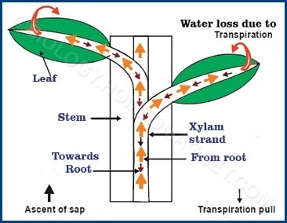

Plants need
- Fresh air including oxygen and carbon dioxide
- Need of O₂ : Plants need oxygen to support cellular respiration.
- Need of CO₂: Carbon dioxide carry photosynthesis

Photosynthesis
6 + 6 +

6 CO₂ + 6H₂O C₆H₁₂O₆ + 6O₂
(Sugar storing
in plants)

Cellular Respiration

+ 6 6 + 6 + ATP

C₆H₁₂O₆ + 6O₂ 6 CO₂ + 6H₂O + Energy in ATP

Working of phloem
Phloem is complex tissues, which acts a transport system for soluble organic compounds within vascular plants. Phloem transports food from the leaves to the rest of the plant. Transpiration is the process by which water evaporates from the leaves, which results in more water being drawn up from the roots. In our project, root hair takes water with the help of mist sytem which sprays water into the entire shed.
When the plant takes water from the root hairs, xylem moves the water from the roots to the leaves in upward direction. It helps plant to make their food through photosynthesis. Now, Phloem move that food (sucrouse) to rest of the plant. While happening of this process, 95% of water vapourised from stomach of plant which increases the humidity and temperature of atmosphere. Then a moment will came in which plants tendency is fulfilled for the food. Still the root hair takes water continuously but that water is difficult to evaporates because of saturation of humidity in closed climate. Due to this stomach of the plant is blocked and plants may cause to deadly.
To maintain excess in humidity and temperature, exhaust fan is used. Through the forced convection heat transfer process, the exhaust fan forcely out the vapourised water and plants begins their movement as usually they do.
Why plants grow rapidly in hydroponic greenhouses ?
In conventional condition

- In conventional condition plants faces served difficulties to grow itself. In open climatic condition plants did not get desirable humidity and temperature its vary time to time depending on weather conditions. Plants are unable to feed.

Feed the soil microbiology
The soil microbiology feeds to plants

Pros of hydroponics system

1. Grow anywhere without dependency of soil.
2. Water can be reused by simple treatment process.
3. It requires upto 20 times less water consumption than soil based culture.
4. Nutrients can be provide by leaching and misting way. So need less amount of nutrients and hence save money.
5. Plants grow in acarpouse atmosphere. So no require of pesticides.
6. Less labour required hard works such as cultivating, killing, mulching and fumigation or not required for hydroponics system.
7. While controlling climate, we can grow around the year season change is not be a problem.
8. Root hair of plant get nutrient very easily. So crops grow much faster in hydroponic system than in soil based growing media.

Cons of hydroponic system
1. Initial cost of installing hydroponic system is expensive than conventional culture but it is one time investment.
2. Skilled supervision is required.
3. Hydroponic system are affected by power shortage.
4. Water born diseases may spread.

Conclusion
We can grow plants without any dependency of soil. We use water and dilute nutrient solution instead of soil. Root hairs of plans absorbs nutrients very quickly, so the plants grow faster and healthier.
This is the system which can be installed in vertical layers, so reduces much space. Experiments shows that tomatoes like plant have large production than open field farming.

