**Comparative Performance Analysis of One-Dimensional Convolutional Neural Networks and Artificial Neural Networks for Centrifugal Pump Diagnosis based on Vibration, Pressure, and Current Data Signals**

*A thesis report submitted*

*in partial fulfilment of the requirements*

*for the degree of*

**MASTER OF TECHNOLOGY**

*by*

**Shivam Gautam**

**Roll No: 214103432**

*Under the supervision of*

**Prof. Rajiv Tiwari**

**and**

**Dr. D. J. Bordoloi**

**DEPARTMENT OF MECHANICAL ENGINEERING**

**INDIAN INSTITUTE OF TECHNOLOGY GUWAHATI**

**June 2023**

|  |  |
| --- | --- |
|  | **Department of Mechanical Engineering**  **Indian Institute of Technology Guwahati**  **Guwahati-781039**  **INDIA** |

# Certificate

This is to certify that the work contained in this thesis titled “**Comparative Performance Analysis of One-Dimensional Convolutional Neural Networks and Artificial Neural Networks for Centrifugal Pump Diagnosis based on Vibration, Pressure, and Current Data Signals”** by **Shivam Gautam (214103432),** a student of the Department of Mechanical Engineering, Indian Institute of Technology Guwahati, for the award of degree of Master of Technology has been carried out under my supervision and that this work has not been submitted elsewhere for any degree.

|  |  |
| --- | --- |
| **Prof. Rajiv Tiwari** | **Dr. Dhruba Jyoti Bordoloi** |
| Professor | Technical Officer |
| Department of Mechanical Engineering | Department of Mechanical Engineering |
| Indian Institute of Technology Guwahati | Indian Institute of Technology Guwahati |
| Guwahati-781039, Assam | Guwahati-781039, Assam |
| INDIA | INDIA |
| June2023 | June 2023 |

**Acknowledgements**

I would like to express my deepest gratitude and appreciation to all those who have supported and contributed to the completion of this thesis.

First and foremost, I extend my heartfelt thanks to my supervisor Prof. R. Tiwari, Professor, Department of Mechanical Engineering, IIT Guwahati and Dr. Dhruba Jyoti Bordoloi, Technical officer, Department of Mechanical Engineering, IIT Guwahati for their guidance, expertise, and invaluable insights throughout the entire research process. Their unwavering support and constructive feedback have been instrumental in shaping the direction and quality of this work. I am also indebted to faculty of IIT Guwahati and Vibration and Acoustic laboratory members, whose knowledge, expertise, and teachings have provided a strong foundation for my academic and research pursuits. Their dedication to fostering intellectual growth and critical thinking has been invaluable in shaping my research skills.

I would like to express my sincere appreciation to my family and friends for their unwavering support, encouragement, and understanding during this challenging journey. Their constant belief in my abilities has been a constant source of motivation and inspiration. Finally, I would like to acknowledge the broader scientific community whose contributions, through research papers, publications, and conferences, have laid the groundwork for this study. Their collective efforts have shaped the field and inspired new avenues of exploration.

The scholarship received from MHRD (Ministry of Human Resource Development), Government of India during my M.Tech is gratefully acknowledged. I also gratefully acknowledge Mechanical Department of Indian Institute of Technology Guwahati for the continuous support during the tenure of my M.Tech.

In conclusion, this thesis would not have been possible without the collective support and encouragement of all those mentioned above. I am sincerely grateful for their assistance, and I hope that this work contributes positively to the field of centrifugal pump analysis.

**Abstract**

The efficiency of centrifugal pumps (CPs) can be greatly affected by the presence of flaws, resulting in reduced performance, increased vibration and noise, and potential system failure. To mitigate these issues, it is essential to develop a system for monitoring and maintaining CPs. This study focuses on the identification and severity assessment of various flaws, comparing the performance with existing literature. Experimental tests were conducted on the CP, operating at different obstruction levels and frequencies, while collecting data from multiple sensors. Vibration signals, motor current signals, and pressure signals, which exhibit transient characteristics, were utilized for fault categorization. Statistical features were extracted from the time-domain data to enhance the diagnostic capabilities. Among these features, namely standard deviation, mean, and entropy, exhibited superior performance and selected for further analysis. These features were then inputted into an artificial neural network (ANN) model and One-Dimensional Convolutional Neural Networks (1DCNN), which was developed for fault detection. Optimal parameters for the ANN and 1DCNN model, including the number of hidden layers, neurons, and epochs, were determined. The results demonstrated that the combination of multiple sensor types significantly improved the accuracy of obstruction level prediction. Through inspections, it was confirmed that the proposed fault detection methodology outperformed previous techniques in terms of efficiency. This research highlights the importance of continuously monitoring the condition of CPs and provides valuable insights into flaw identification and severity determination. By leveraging the power of these advanced algorithms, a comparative analysis between ANN model and 1D-CNN model is conducted to evaluate their performance in detecting and categorizing faults within CPs. The findings of this study contribute to the field of CP maintenance and offer valuable insights for improving reliability.

Keywords: Centrifugal Pumps, Flaw Detection, Multiple Sensors, Deep Learning, Artificial Neural Network, One-Dimensional Convolutional Neural Networks

*List of Figures*

|  |  |  |
| --- | --- | --- |
| **S.no.** | **Description** | **Page No.** |
| 1. | Experimental set-up | 8 |
| 2. | Mechanical modulating valves and marking over defining the obstruction level | 8 |
| 3. | Three axial accelerometers glued to the pump | 9 |
| 4. | Pressure Transducers mounted on the pump | 9 |
| 5. | Current probes |  |
| 6. | Dspace for gathering the data | 10 |
| 7. | Three wiring setup | 11 |
| 8. | Simulink Mode | 12 |
| 9. | Impeller fault (left) and Cover plate fault(right) | 12 |
| 10. | View of the Control Desk of each signal | 13 |
| 11. | Optimized 1D CNN network structure | 16 |
| 12. | Classification accuracies for different individually statistical features | 20 |
| 13. | Classification accuracy versus Frequency with combination of features | 20 |
| 14. | Classification accuracy versus Frequency with all the features | 21 |
| 15. | Structure of Artificial Neural Network model | 22 |
| 16. | Structure of One-dimensional convolution neural network | 23 |
| 17. | Performance while making the NN and 1D CNN | 27 |
| 18. | Classification accuracy versus blockage level with single feature | 28 |
| 19. | Classification accuracy versus blockage level with a combination of features | 29 |
| 20. | Classification accuracy versus blockage level with all the features | 30 |
| 21. | A comparison of classification report in graphical format (a) Precision (b) Recall (c) F1-score | 32 |
| 22. | Overall Fault set performance by different algorithms | 32 |

*List of Tables*

|  |  |  |
| --- | --- | --- |
| **S.no.** | **Description** | **Page No.** |
| 1. | Nomenclature | 7 |
| 2. | Data acquisition details | 10 |
| 3. | Description of Simulink model | 11 |
| 4. | Description of Figure 10 | 13 |
| 5. | Fault sets description | 14 |
| 6. | Description of Random Forest | 20 |
| 7. | Configuration of the neural network used | 22 |
| 8. | Iteration for the best parameters in 1D CNN | 24 |
| 9. | Confusion Matrix for all combined features (ANN) | 30 |
| 10. | Confusion Matrix for all combined features (1DCNN) | 31 |

Content

1. List of Figures……………………………………………………………….…5
2. List of Tables…………………………………………………………………...6
3. Introduction…………………………………………………………………8-10
4. Experimental setup and experimentation description……………………..11-17
   1. Description of experimentation………………………………………..13
   2. Measurement Procedure……………………………………………….14
   3. Description of Fault set……………………………………………...…17
5. Data classification methodology………………………………………..…17-19
6. Results and discussions…………………………………………...…….…19-34
   1. Feature Introduction………………………………………………...…21
   2. Test of feature performance…………………………………......…22-24
      1. Individual performance of features………………………...………22
      2. Combination performance of features…………………...…………23
      3. Performance of all features………………………………..……23-24
   3. Classification algorithms for blockage severity…………….…………25
   4. Steps for tunning ANN………………….. ……………………………25
   5. Steps for tunning the 1D CNN………………………………...…...26-28
      1. Final pre-processing step – Feature scaling……………..…………28
      2. Selection of the training testing ratio………………………………28
      3. Selection of the optimization algorithm……………………………28
      4. Selection of Network weight initialization………………...………28
      5. Selection of the activation function…………………………..……28
   6. Test of blockage severity level……………………………………...…31
      1. Blockage Severity Level with the single feature………...………...31
      2. Blockage Severity Level with the combination of features…...…...32
      3. Blockage Severity Level with the all of features………….……34-36
7. Conclusions……………………………………………………………………36
8. Future Scope…………………………………………………………..………37
9. References…………………………………………………………………38-39

**1.** **Introduction**

Centrifugal pumps (CPs) are essential components in many industrial and manufacturing applications because of their functionality and service life. The general purpose of centrifugal pumps is to carry liquid and deliver it to the higher head. The liquid enters in the suction pipe and then moves to the central part of the pump, called as ‘eye’ and passes through a number of blades, called ‘impeller’. Impeller accelerates it in the radially outward direction because of the centrifugal force imparted by the rotating blades, which leads liquid into a casing, from where it exits into the downstream piping system. Pumping liquid in industrial applications may contain various types of impurities in the form of solid particles. The presence of impurities may cause a blockage in the pipe, resulting in flow instabilities in the pump. A blockage in the pump reduces its efficiency and causes early failure of the components, increasing the cost of operation. As a result, centrifugal pump health monitoring is critical not only to extend the life of the components but also to reduce operating costs. [1]

CP faults are most typically caused by flow disruptions (cavitation and flow recirculation) or mechanical failures (cracked impellers, bearing faults, and bent rotors) or leakages and blockages. The flaws could also be caused by more than one. Suction blockage faults may occur as a result of the use of contaminated working fluids or pipe surface damage. When such an obstruction to flow occurs, the flow rate decreases and a secondary flow known as recirculation flow develops. As flow separation increases, vortices form, resulting in a drop in local pressure and the formation of vapour bubbles. [2] Furthermore, any bubble formation in a CP is undesirable because it reduces the developed head and creates pits on the CP surfaces due to the formation of micro-jets. Treating CP faults as stand-alone faults is thus impractical. The presence of one flaw can amplify the appearance of another. To maintain the assets in the industries, maintenance strategies available.[3] For rotating machines, one of the most promising and widely used predictive maintenance strategy is condition-based health monitoring or condition-based maintenance (CBM).

In the literature review we observed that Dewangan and Tiwari utilized ANNs to detect and classify cavitation and blockage faults using time-domain analysis. Classification accuracy and confusion matrix obtained for the different condition with frequency and without consideration of frequency as input and found that the prediction of the blockage level using the pressure sensor was less accurate compared to accelerometer and current sensor data and by using the frequency as input feature, the blockage level detection accuracy of the sensor can be improved [4]. Widodo and Yang [5] presented a survey of the machine condition monitoring and fault diagnosis using the SVM. Bordoloi and Tiwari [6], In order to determine the severity of the suction blockage and cavitation, vibration signals from the pump casing and bearing blocks were analyzed using support vector machines (SVMs). Rapur and Tiwari [3], classified a fault condition, such as impeller faults, cover plate faults, and discharge blockages. The same author [7] considered suction blockage and impeller crack to classify the faults of pump using vibration signal. The classification accuracy of B3 and B4 has been observed to be consistently high. It can be said that the classification accuracy is independent of the rotor speed. A threshold limit of 65% may be set on the classification accuracy, so as to understand the inception of severe blockage. This may be used as an indicative measure, and hence progression to more acute states may be restricted. Nasiri et al. [8], Using vibration signals, they detected cavitation severity and suggested that vibration sensors are most effective when they are located radially. Azadeh et al. [9], Using support vector machines and artificial neural networks, we developed an algorithm to classify two distinct faults in centrifugal pumps to handle noisy data. CJ Dister [10], For predictive maintenance, vibration and line current data had been used and also techniques were suggested for online health monitoring of pumps using currents, vibrations, acoustics, and pressure variations. Yaguo Lei et al. [11], utilized traditional machine learning theories, the diagnosis models are able to automatically recognize the health states of machines. To bridge the gap, transfer learning theories are promising to construct diagnosis models, in which the diagnosis knowledge can be transferred across multiple diagnosis tasks. Raziyeh Azizi et al. [12], diagnosed a mono-block centrifugal pump fault which is essential to use the right classification algorithm in order to achieve the best accuracy score with the help of SVM algorithm. Wong [13] presented work on detection applied to vibration signal monitoring and mono-block centrifugal pump with defective bearings, seals, impellers, and cavitation was used as a test to predict pump performance due to these faults and found that measuring high frequency noise was a convenient way of detecting cavitation. Samanta et al. [14], presented his work by conducting comparisons between neural networks (NNs) and support vector machines (SVMs) based on bearing fault data and to optimize performance genetic algorithm is used. It was revealed that the selection of features significantly influences the classifier's performance. Tabar et al. [2], The compensation distance evaluation approach was used to identify the cavitation severity in the pump. Lu et al. [15], analyzed the pressure pulsation at the pump inlet and outlet used to develop the cavitation by numerical simulation and experimental investigation. Furthermore, the domain in which the data is present before it is used for feature extraction matters as well as choosing the method of collecting data and debating which physical signal (or their combination) will give better results. Abdulkarem et al. [16] used time and frequency domain vibration analysis, we investigated the impeller fault of a centrifugal pump. For power spectrum and the vibration index at specified frequency as the fault indicator in frequency and time domain, respectively and presented a neural network and fuzzy-neural network for the diagnosis of pumps. Zouari R [17], developed a system using a Labview/Matlab solution and tested on a Networks, one for each flaws to facilitate data learning in an industrial environment. An interesting point was the use of fuzzy NN in order to take into account the "unlearned" states, especially for faults with multiple stages. Special attention was paid to the performance of the system under different conditions and able to "adapt" some learning data to other operating conditions. Algorithms all have their own pros and cons, so which algorithm is the best for a particular task depends on the type of data, the number of features, the degree of flexibility, and the amount of data presented. Rajakarunakaran et al [18] used the artificial neural network for fault detection in centrifugal pump and used adaptive resonance network models based on feed-forward and back-propagation algorithms were used for this study. Zhao et al. [19], Datasets from planetary gearboxes and rolling element bearings were used to diagnose faults. Janani Shruti Rapur [20], a new statistical feature σ-1 (inverse of standard deviation) has been introduced in this paper. This feature, while retaining the trends of standard deviation, reduces the variation in it and is found to demonstrate great potential in fault diagnosis. Furthermore, the combination of vibration data and line current signature is found to be very promising for CP fault classification study. The SVM classifier developed using μ and σ-1 features could perform all the multiclass classifications with near perfect accuracies. Chudina [21], detected cavitation with acoustics, the study related cavitation to noise spectra and focused on the cavitation and related it with noise spectra to detect cavitation using acoustics. Sakthivel et al. [22], Cavitation noise was differentiated from other types of noise using noise detection techniques and employing vibration signal to diagnose mono block centrifugal pump defects and monitoring the health of the pump included taking into consideration faults in the bearing, seal, and impeller.

Literature highlights the untapped potential of using pressure, acceleration, and motor line current signals collectively for blockage detection in centrifugal pumps. Recent advances in algorithms and data classification techniques show improved performance compared to previous methods. Limited research exists on identifying blockages in the pump's inlet pipe, indicating room for enhanced accuracy in detection and prediction. These factors drive researchers to explore blockage detection in the inlet pipe. This study stands out by simultaneously utilizing acceleration, pressure, and motor line current data with a deep learning algorithm. Additionally, various features extracted from raw data, both individually and in combination, contribute to accurate blockage detection levels.

In this study, we aim to investigate and compare the performance of 1DCNNs and ANNs for centrifugal pump diagnosis based on vibration, pressure, and current data signals. By leveraging the multi-channel inputs of these signals, we seek to develop a comprehensive and robust diagnostic framework capable of accurately identifying and classifying various faults in centrifugal pumps.

*Table 1: Nomenclature*

|  |  |
| --- | --- |
| *σ* | *Standard Deviation* |
| *µ* | *Mean* |
| *κ* | *Kurtosis* |
| *χ* | *Skewness* |
| *x* | *Input to the neural network* |
| *w* | Weight vector |
| *b* | Bias vector |
|  | Predicted class |
| *J* | Loss function |
| *N* | Number of input data points in each training set |
| *n* | Number of data points in one raw data set |

This paper is separated into the following sections: Section 2 discusses the experimental setup and data capture. The methodology of data classification is briefly covered in Section 3. Section 4 addresses fault prediction accuracy, and the performance of the used model. Section 5 presents the final conclusions.

**2.** **Experimental setup and experimentation description**

Machine Fault Simulator (MFS) provided by Spectra-QuestTM is used for experimentation. Figure 1 shows the experimental setup and the close look of centrifugal pump. A pump is installed on the MFS's fixed base and is driven by a double-belt pulley system. In the machine fault simulator (MFS), a 3-phase induction motor is connected to a rotor via a flexible coupling. The rotor is mounted on two bearings at its ends. The bearing housings are rigidly mounted on a fixed plate in between. To drive the centrifugal pump, its shaft is connected to the rotor shaft by means of belt drives. The speed of the pump can be varied by varying the motor frequency using a variable frequency drive (VFD).

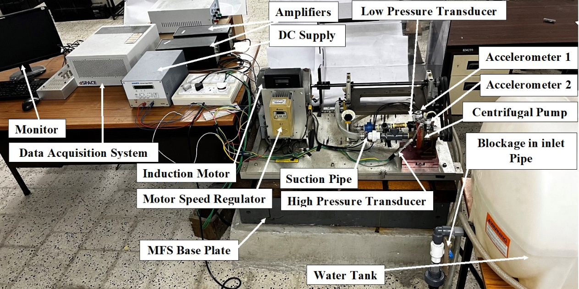

*Figure 1: Experimental set-up*

The pump is ensured to have leak-proof fittings. At the inlet and the outlet of the water tank, a manual modulating valve is provided to regulate the flow as shown in Figure 2. . To avoid the associated cavitation, the water tank is positioned so that there is sufficient head at the pump inlet. By using a mechanical modulation valve at the suction and discharge ends of the line connected to the pump outlet, the pressure can be varied. The data is acquired at with 5000 samples in each set. A total of 150 s of data are taken with a time span of 0.1 s in one set of data, so total 150 sets of data are collected for each pump operating condition.

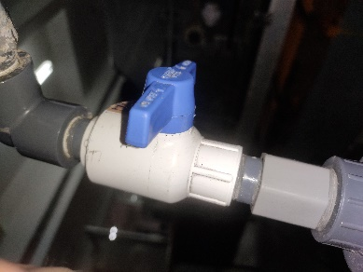 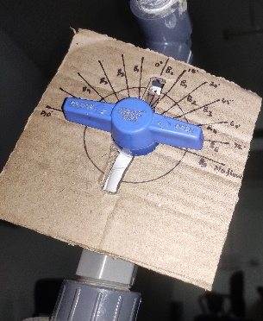

(a)Inlet Valve (b)Obstruction markings on the valve

*Figure 2**: Mechanical modulating valves and marking over defining the obstruction* *level (a)Inlet Valve (b)Obstruction markings on the valve*

Six equal intervals are marked on the mechanical modulation valve, so that different degrees of clogging can be achieved by regulating the valve in these intervals. B0 shows 0% clogging (full flow/no disturbance), B1 shows 16.7% clogging, B2-33.3%, B3-50%, B4-66.6%, and B5-83.33% clogging. The pump is operated at a frequencyof 30 Hz to 60 Hz with an interval of 5 Hz. Since the motor heats up at a frequencyhigher than 60 Hz.

*Accelerometers:* Two tri-axial accelerometers mounted on the pump have sensitivity 100.3, 100.7, 101.4 mV/g (accelerometer-1) along x, *y*, *z* directions respectively, and 101, 101.1, 101.4 mV/g (accelerometer-2) along x, *y*, *z* directions respectively, were used for acceleration measurement. Accelerometers and the directions are shown in figure 3.

*Pressure Transducers:* A sensitive silicon chip employed two pressure transducers supplied by ‘Nictech’ (India) were used for liquid pressure measurement. Response from the pressure sensors in the working range (0–60 psi) can be obtained in the form of current fluctuation (4–20 mA). High- and low-Pressure transducers are shown in figure 4.

*Current sensing probes:* ‘The Keysight 1146B’ current probes were used for measurement of the motor line current, show in Figure 5. Current probes can measure the current from 100 mA to 10 A rms.

*Data Acquisition System:*The NI PXI - 4472 is an 8-channel and NI PXI -6251 is a 16-channel dynamic signal acquisition module for high accuracy frequency domain measurements. The eight channels of the NI PXI -4472 and the 16 channels of the NI PXI -6251 simultaneously digitize input signals over a bandwidth of DC to 45 kHz. Data Acquisition System is shown in figure 6.

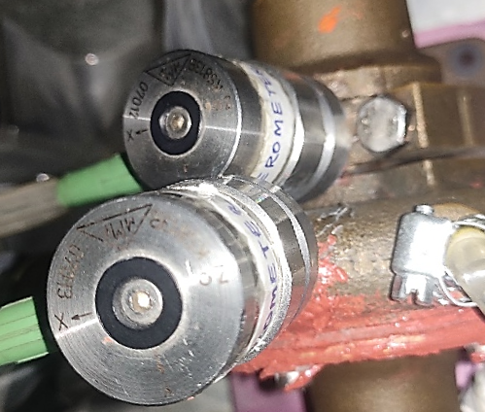

*Figure 3: Three axial accelerometers glued to the pump*

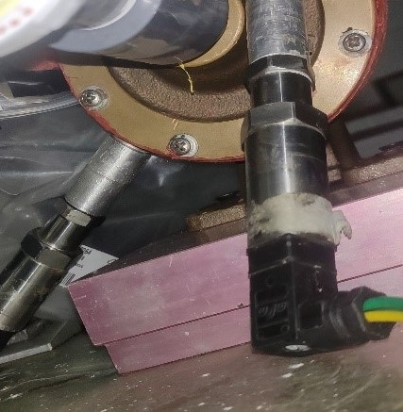

*Figure 4:* *Pressure Transducers mounted on the pump*

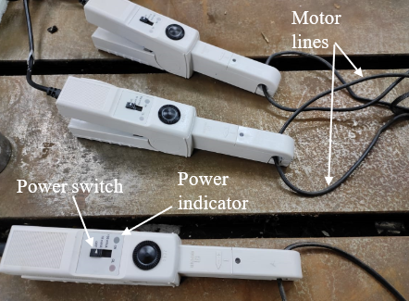 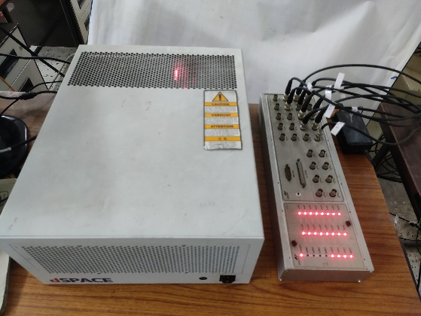

*Figure 5:* *Current probes Figure 6: Dspace for gathering the data*

***2.1. Description of experimentation***

Experiment was performed on the MFS for data collection at different blockage levels. Data collection was done for each combination of blockage level (see Fig. 4 (b)) and running speed of the pump. Statistical details of the data acquisition are given in Table 1. In order to have complete information about the fault, three different types of measurements (acceleration, fluid pressure and motor line current) with different types of sensors (accelerometers, pressure transducers and current probes), were taken. For measurement of the pump vibration, one accelerometer (accelerometer-1) was installed on the casing of the pump, and another accelerometer (accelerometer-2) was installed on the bearing housing of the pump (Fig. 2 (left)). Two pressure transducers were installed on the pump casing, as shown in Fig. 2. Measurement of the motor line current was done using three current probes (Fig. 3 (right)). All the sensors were connected to the different channels of the DAQ system to acquire the data. Control desk software was used to store the data acquired from the sensors, in the computer. The details of DAQ is given in the Table 2.

*Table 2: Data acquisition details*

|  |  |
| --- | --- |
| Blockage levels | B0 (No blockage), B1 (16.6% blockage), B2 (33.3% blockage), B3 (50% blockage), B4 (66.6% blockage), B5 (83.3% blockage) |
| Pump running frequencys (Hz) | 30, 35, 40, 45, 50, 55, 60 |
| Total number of fault conditions | 6 * 7 = 42 |
| Number of measurements sets for each combination of blockage and frequency | 150 |
| Sampling frequency | 5000 |
| Time taken for one data set measurement | 1 s |
| Data collection time for each fault combination | 150 s |

*Three-wire setup:* Pressure sensor have output in the ampere form which cannot measure by the DAQ so to make it possible we have to convert the signals into the voltage and it can be possible by the connection shown in the Figure 7 with the help of resistor connected in the bread board. According to the ohm’s law, the voltage across a conductor is directly proportional to the current flowing through it, provided all physical conditions and temperatures remain constant. This setup is called the three-wire setup.

*Simulink Model:* Simulink is a MATLAB-based graphical programming environment for modeling, simulating and analysing multidomain dynamical systems and it is shown in Figure 8. The description of the model is given in the Table 3.

*Table 3: Description of Simulink model*

|  |  |
| --- | --- |
| Step size | 0.0001 |
| Time | Infinity |
| Time step | Fixed step |
| Solver | Ode (Runga-kutta) |

***2.2.*** ***Measurement Procedure***

Vibration, pressure, and current signatures were used for fault diagnosis. Control Desk software was used to configure data acquisition. For a time domain measurement, 5000 samples were collected at a sampling rate of 5000 per second. Data were collected for 150 seconds. A total of 5000×150 non-overlapping data points were collected for each of the sensors.

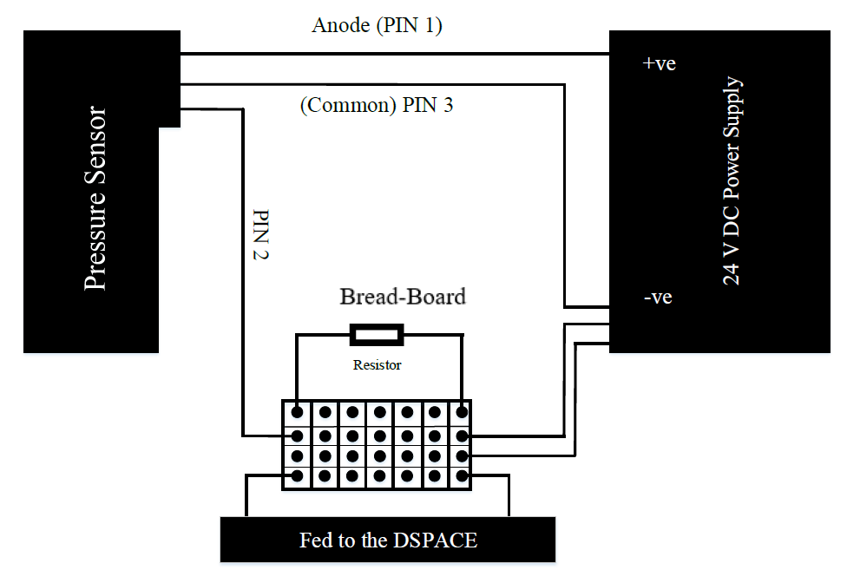

*Figure 7: Three wiring setup*

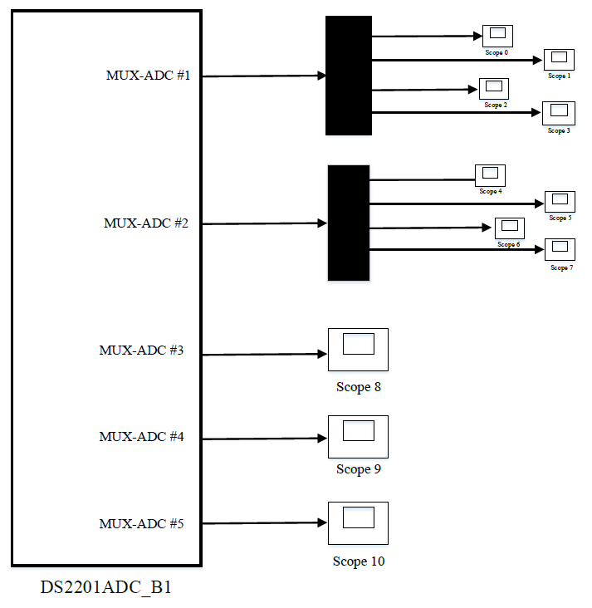

*Figure 8: Simulink Mode*

The data were stored on the system hard drive, saved in separate DAQ measurement files in .csv files for each disturbance at individual centrifugal pump speeds. The time domain data can later be converted to any domain using various transformations.

A healthy pump, a pump with an impeller defect, and a pump with a cover plate defect were sequentially mounted on the MFS. Impeller fault and cover plate fault is shown in the Figure 9.

The impeller plate has cuts on the blades and the cover plate fault has number of pits on it and these are supposed to formed due to the high-pressure bubbles burst and hits the metal wall in the form of micro jets. For each of these 3 pump conditions, a suction blockage defect with six severity levels was introduced.

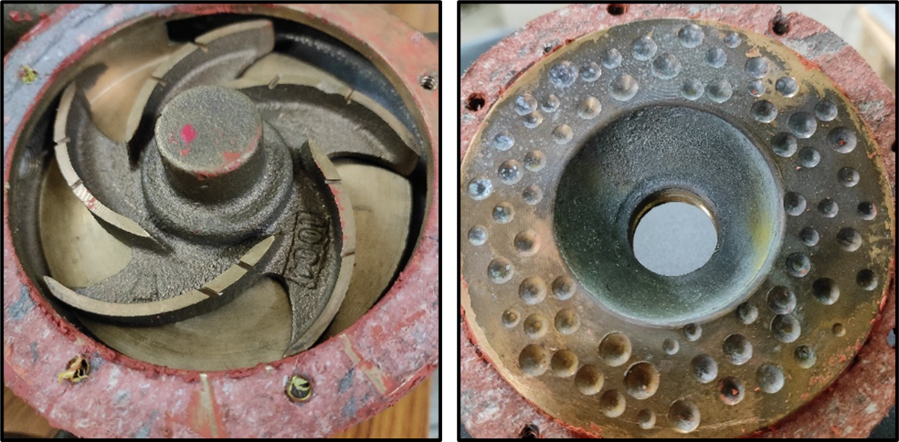

*Figure 9:* *Impeller fault (left) and Cover plate fault(right)*

In each pump state, the pump was operated at a series of different speeds. A variable frequency drive is used to operate the induction motor from 1800 rpm (30 Hz) to 3600 rpm (60 Hz) in steps of 300 rpm (5 Hz). Vibration, pressure, and current signatures were used for fault diagnosis. For each faulty condition, data were collected at 5000 samples/s and 5000 samples/record. Data for each condition was collected for 150 seconds, resulting in a total of 150 records collected for each fault condition. When the pump is healthy and the suction clogging level is 0 (full flow) and the signatures of vibration, pressure, and line current at 30Hz of healthy pump configurations are shown in Figure 10. The description of each pump condition corresponding to each figure can be found in Table 4.

*Table 4: Description of Figure 10*

|  |  |  |
| --- | --- | --- |
| Figure No. | Signal | Blockage Levels |
| 10(a) | Pressure | 0 |
| 10(b) | Pressure | 5 |
| 10(c) | Vibration | 0 |
| 10(d) | Vibration | 5 |
| 10(e) | Current | 0 |
| 10(f) | Current | 5 |

|  |  |
| --- | --- |
| (a) | (b) |
| (c) | (d) |
| (e) | (f) |

*Figure 10: View of the Control Desk of each signal*

***2.3.*** ***Description of Fault set***

A total of 18 different fault conditions of the CP have been considered in this study. Healthy pump with no blockage (HP0), healthy pump with suction blockages (HPb), Impeller fault with no blockage (IF0), impeller fault with suction blockages (IFb), cover plate fault with no blockage (CP0) and cover plate fault with suction blockages (CPb), where *b = 1,2,3,4,5*. With these conditions, Fault sets can be formed by bracketing the fault conditions into appropriate classes. The fault has six classes. The six levels of suction blockage contribute a total of 6 classes in this set. The different fault sets and the fault conditions that make up these sets have been explained in Table 5.

*Table 5: Fault sets description*

|  |  |
| --- | --- |
| Fault Set | Classes (labels) |
| 1 | Class 1(B0): HP0, CP0, IF0  Class 2(B1): HP1, CP1, IF1  Class 3(B2): HP2, CP2, IF2  Class 4(B3): HP3, CP3, IF3  Class 5(B4): HP4, CP4, IF4  Class 6(B5): HP5, CP5, IF5 |

**3.** **Data classification methodology**

The experiments yielded pressure, acceleration, and current signatures that were used for fault categorization at various frequency. Deep learning-based neural networks are employed for fault classification. A machine learning method called deep learning enables computer systems to get better with practise and data. When solving challenging environmental issues in the real world, this method works incredibly well. Supervised learning and unsupervised learning are two subcategories of machine learning algorithms. In this study, supervised learning has been used to achieve its goals. The programme is instructed to separate/classify the data based on various characteristics. The algorithm generates a function/model y = f(x), which connects (input) to y. (output category). Deep learning uses optimization algorithms to enhance the performance of fault classification. A machine learning algorithm is created by combining various optimization algorithm elements, such as an optimization method, a model, and a dataset. In real-world scenarios, the algorithm seeks to reduce training error rather than finding the optimum function. The various hyperparameters can also be tuned to enhance the performance of a learning algorithm.

*ANN:* Deep learning (DL) is a subfield of machine learning. Deep learning algorithms are inspired by the human brain and are used to perform logical and data-driven tasks. Deep learning employs artificial neural networks (ANNs). The network receives input x from the input layer. After the input layer, a series of hidden layers extract data that is more and more valuable. Finally, the output layer predicts the input's kind of class. A network can be trained in supervised learning by using labelled (known category) data sets. During the training process, the network attempts to map the input data vector x to the labelled category y. Mapping begins with the neurons of the first hidden layer computing a simple vector function z (weighted sum of input x with bias). The expression for z is as follows:

 (1)

where w and b are the weight and bias vectors, and superscript T represents the transpose.

The activation function is applied to the computed vector function z.

In this work, the 'Rectified linear unit' (ReLU) activation function is found which perform best over all other activation function taken into consideration in the network's hidden layers by which z passes by. The next hidden layer receives the weighted sum of the activation function's output with bias. Finally, data categorization can be obtained from the output layer. The 'SoftMax' activation function is found which perform best in the output layer for multi class classification because it provides the probability distribution of the event over different events and provides values ranging from 0 to 1. To put another way, this function returns the probabilities of each target class across all possible target classes. The discussed process aids in the completion of a complex mapping using some simple mapping.

 (2)

If represents the network's computed output and y represents the actual output, then the loss function can be used to compute the deviation (error) of the predicted output from the actual output. For error computation, the sparse categorical cross entropy loss function is used in this work. The weights and biases of the neural network's nodes will be adjusted in accordance with the law of gradient descent.

 (3)

where, is the updated weight, α is the learning rate, w is the previous weight and dw is the partial derivative of the cost function w.r.t the weight. Also, is the updated bias, b is the previous bias and db is the partial derivative of the cost function w.r.t the bias.

The local sparse categorical cross entropy loss function is used to prevent situations from developing.

As our data classes are mutually exclusive, we use sparse categorical loss function as its computation is faster. Expression for this loss function is:

 (4)

where s represents samples, c refers to classes, and addresses to sample s belongs to class c.

*1DCNN:* One-Dimensional Convolutional Neural Networks (1D CNNs) have gained prominence in analysing sequential data due to their ability to capture local patterns and dependencies. Originally used for image recognition, 1D CNNs have shown promise in signal processing tasks such as time series analysis and sensor data analysis. Their hierarchical architecture enables the extraction of meaningful features and automated analysis of sensor signals for fault diagnosis and performance analysis. This study explores the potential of 1D CNNs in engineering systems for real-time monitoring, diagnosis, and maintenance. To effectively handle the one-dimensional signals, a dedicated one-dimensional model is utilized. The optimized model comprises an input layer, a CNN layer group consisting of a convolution layer and a pooling layer, a fully connected layer, and an output layer. The complexity of the required classification data determines the number of CNN group layers, with this model employing two layers. [23]

In the first layer, N1 convolution kernels are applied, followed by N2 convolution kernels in the second layer. Each kernel is associated with a weight vector (W) and a bias value (b). Assuming a classification problem with multiple classes, the model is designed to handle class k as shown in Figure 11 [24] and the output of softmax function can be calculated as follows-

 (5)

where W and b are weight matrix and bias respectively, and O is the final output of CNN.

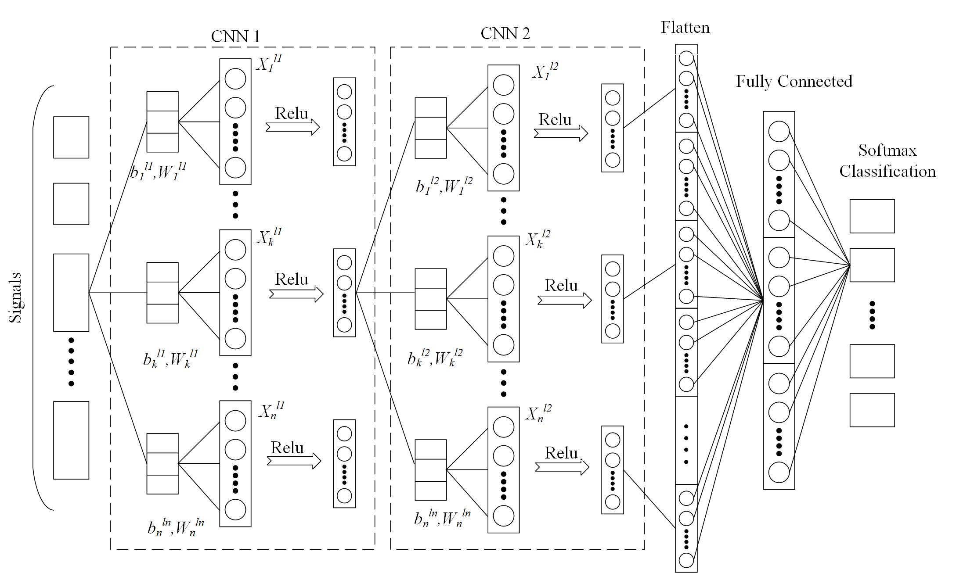

*Figure 11: Optimized 1D CNN network structure*

 is obtained after the first layer of convolution for the intercepted signal Si, where .

To enhance the nonlinear characteristics of the model, an activation function is applied before pooling the  data. The widely used Rectified Linear Unit (ReLU) function, Relu (max(0, x)), is chosen for this purpose. Additionally, to improve training speed and promote sparsity, a de-averaging operation is incorporated after the activation function is applied to . Therefore, the output of the

first CNN layer group is:

 (6)

In the second CNN layer group, the  is computed as the average of N1 outputs obtained from the first layer after the convolution operation.

 (7)

The output of the second CNN layer is-

 (8)

The fully connected layer, middle layer, and output layer form a conventional neural network component. The primary objective of training the convolutional neural network (CNN) is to minimize the overall loss function. In this model, the chosen loss function is categorical cross entropy, which measures the dissimilarity between predicted and actual outputs. To optimize the performance of model, the Adam optimizer is employed as the optimizer.

Classifier performance can be improved further by adjusting some hyper-parameters. Improper tuning of the hyper-parameters results in 'under fit' (low training and testing accuracies) or 'over fit' (high training but low testing accuracies) situations. In this paper, the open-source deep learning libraries 'Keras' and 'Scikit learn' are used in Python (Jupyter) software used for multiclass classification.

**4.** **Results and discussions**

As stated previously, the purpose of this study is to identify the severity of the blockage level using multiclass classification with the help of sensor data. To avoid the unnecessary redundancy in the input data, only six statistical features are considered and extracted from raw sensor data. There is no set rule for selecting features for given data and fault. As a result, features such as mean (µ), standard deviation (σ), mode(M), Entropy(S), kurtosis (κ), and skewness (χ) are considered, which can indicate various aspects of the data. As a result, only six features are examined.

***4.1.*** ***Feature Introduction***

*Mean (µ):* Mean represents the statistical average of values of the data points of pressure signal.

 (5)

where n is the total number of data points in a collection and xi is each data point's amplitude.

*Standard Deviation (σ):* Standard deviation is the measure of the deviation of the amplitude of the data point values from the mean value of data set.

 (6)

*Entropy (S):* The entropy is a generic measure of system disorganization and is mathematically presented as

 (7)

*skewness (χ):* Skewness is the measure of the degree of the asymmetry of the probability distribution around the mean.

 (8)

*kurtosis (κ):* Kurtosis is the measure of the extent of spikiness or flatness of the data points.

 (9)

***4.2.*** ***Test of feature performance***

The performance of the extracted statistical features tested in three modes: first individual sensor data are considered separately, second is the combination of the few best performing features, and lastly on all of the best features.

***4.2.1.*** ***Individual performance of features***

It can be computationally expensive to use raw data directly. Additionally, it can contain redundant data, which would have an impact on how the network is trained. The size of the data and the temporal complexity can be reduced while still capturing meaningful information by extracting features. The different statistical features considered in this study are Standard deviation, Variance, Mean, Median, Mode, Kurtosis and Skewness. As there is no specific rule to choose the algorithm therefore these extracted features fed as input to a Kernel Support Vector Machine (SVM), Random Forest (RF), Logistic Regression algorithm. To get the more accurate result we will check it at three different frequency that is 30Hz, 45Hz, 60Hz and take the average of them. Each individual feature is tested for their performance at different algorithm. The performance for the individual features is shown in Figure 12.

It is found that Random Forest performs better than all other algorithms. Also, in the random forest model, mean with accuracies of 98.2% at 30 Hz, 98.87% at 45 Hz and 99.81% at 60 Hz, averages an accuracy of 98.96 % which is the highest amongst all the statistical features considered. So, random forest model is considered for further combination of feature calculations and mean is consider as the best statistical feature among all others but standard deviation and entropy are also close to mean. So, mean, standard deviation and entropy will take into consideration while finding the blockage severity accuracy. The description of the random forest is given in the Table 6. We can see that features provide less accuracy at low frequency (30Hz, 45Hz, and 60Hz), i.e., classification accuracy at low frequency is less dependent on the nature of the feature and also does not vary with frequency, but it does vary at higher frequency. This demonstrates that at low running frequency, the signals pulsation varies slightly. More bubbles were discovered to form at a high rate of frequency during the experiment. This observation provides a sense of how the classification accuracy varies with the defect (cavitation) severity because the classification accuracy is also changing more quickly.

***4.2.2.*** ***Combination performance of features***

A single feature is insufficient at slow frequency to gather any insightful data. Various combinations of these qualities are tested to overcome this issue, one can observe that by using the combination of the features there is an improvement in the performance of the classifier. Now there is pattern can be observed that is by increasing the frequency, the performance of the classifier is increasing. It is clearly seen that the combination of features gives better result. The combination feature which performs best is Standard Deviation and Mean, with accuracies of 98.80% at 30 Hz, 99.05% at 45 Hz and 99.35% at 60 Hz, and with an average of accuracy of 99.06% which is the highest amongst all the statistical features considered. Now all two best feature combination are chosen which is shown in Figure 13. The classification accuracy can be further increased by combining all of these features.

***4.2.3.*** ***Performance of all features***

Standard Deviation and Mean and entropy with accuracies of 98.86% at 30 Hz, 99.44% at 45 Hz and 99.67% at 60 Hz, averages an accuracy of 99.26% which is the highest amongst all the statistical features considered. After considering all three features, the difference in accuracy with frequencies depicted. It is evident that classification accuracy is rising with speed, which is a sign that cavitation severity is enhancing classification accuracy. Considerable classification accuracy reveals high signal variation as a result of numerous bubble formation while low classification accuracy reveals normal signal fluctuation.

These three characteristics are sufficient to provide pertinent details regarding cavitation and bubble formation. The depicted performance of all features is shown in Figure 14. As a result, all the features are chosen at once for the remaining of the study.

|  |  |
| --- | --- |
| *(a)Kernel SVM* | (b)  *Logistic Regression* |
| (c)  *Random Forest* | |

*Figure12: Classification accuracies for different individually statistical features (a)Performance of Kernel SVM (b) Performance of Logistic Regression (c) Performance of Random Forest*

*Table 6: Description of Random Forest*

|  |  |
| --- | --- |
| Estimator | 10 |
| Cross Validation Fold | 55 |
| Criteria | Entropy |

*Figure 13: Classification accuracy versus Frequency with combination of features*

*Figure 14: Classification accuracy versus Frequency with all the features*

***4.3.*** ***Classification algorithms for blockage severity***

A variety of methods can be applied for classification purposes for a given input. Determining the best algorithm for the application in issue is essential. XGBoost (XGB), Decision Tree, K-Nearest Neighbours (KNN), Random Forest (RF), and Artificial Neural Network (ANN) are the many classification techniques taken into consideration in this study. Data from all operating frequency is used. All signals are also taken into consideration. The accuracy of classification of these algorithms have been presented in Figure 7(a). All classification methods are tuned, and their classification accuracy can be raised even more. The neural network shows to be the best classifier in a tuned state. The neural network exceeds all other classification techniques with a fault set accuracy of 99.38%.

From section 4.4, the steps of tunning the Neural Networks are described and then this model is used to predict the blockage severity which is of five classes as class 1 is ignored because it is without any disturbance (fully flow). So, classes from class 2 to class 6 is taken into consideration.

***4.4.*** ***Steps for*** ***tunning the Artificial Neural Network***

Before going to start tunning process, few things we have taken into consideration by working iteratively again and again over the model. We have considered six hidden layers because it is found that less than the six hidden layers are not performed that much better as six hidden layers do. The number of neurons set in each hidden layer is 55 and the output layer has 5 neurons as five classes (B1 to B5). In the hidden layer Relu activation function is used and for the output layer, softmax activation function is used as it is found that both of them have the best combination. The no of epochs found to be 130 as at this number model performance is at peak. It is found that if we increased the epochs greater than the 130 then the performance started decline. 40 minibatch sizes were found by iteratively performing. The configuration of the tuned neural network model is given in the Table 7. The Structure of Artificial Neural Network model can be shown in the Figure 15. To avoid the overfitting, dropout regularization is also used which it randomly drops a number of neurons in a neural network during model training on the basis of probability. In this model, we found 0.5 works best as dropout regularization probability.

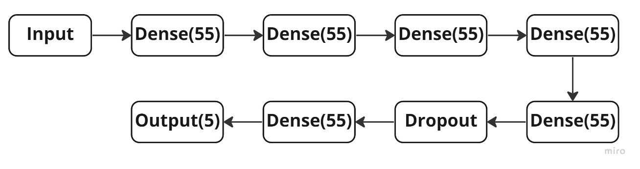*Figure 15: Structure of Artificial Neural Network model*

Table 7: *Configuration of the neural network used*

|  |  |
| --- | --- |
| Hidden layers | 6 |
| No. of neurons in each hidden layer | 55 |
| Activation function used in each hidden layer | Relu |
| Activation function used in output layer | Softmax |
| Optimizer | Nadam |
| No. of epochs performed | 130 |
| Mini batch size | 40 |
| Weight initialisation type | Lecun Uniform |
| Signals used | All |
| Frequency considered | 30Hz-60Hz |

***4.5.*** ***Steps for tunning the One-Dimensional Convolution Neural Network***

The tuning process for a 1D CNN model involves adjusting various hyperparameters to improve its performance. These hyperparameters include the number and size of filters, the filter stride, activation functions, pooling layers, learning rate, batch size, and the number of epochs. We have used two convolution layer and pooling layer in which each convolution layer has 250 filters with the kernel size 3. After flattening, we have used the 4 dense layer in which different number of neurons found outperformed. The number of neurons used in the dense layer are 130, 100, 85, 45. Figure 16 depicted the schematic diagram of one-dimensional convolution neural network.

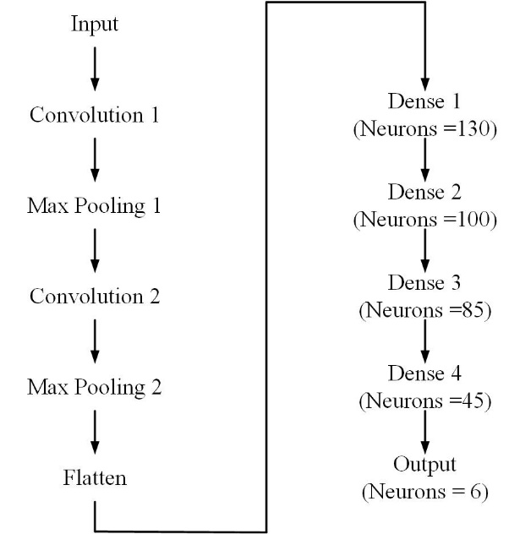

*Figure 16: Structure of One-dimensional convolution neural network*

It took many numbers of iteration to reach the best accuracy. Firstly, we began with the one filter and The process of attaining the optimal accuracy involved conducting multiple iterations. Initially, a configuration consisting of one filter and one dense layer was implemented, but it did not yield satisfactory results. Subsequently, a systematic exploration of various parameters was undertaken, encompassing factors such as learning rate, filter selection, number of dense layers and neurons, epochs, and activation functions. Through this iterative refinement process, the aim was to identify the combination of parameters that would ultimately deliver the highest level of accuracy. Table 8 is showing the path to reach the best performed model.

*Table 8: Iteration for the best parameters in 1D CNN*

|  |  |  |  |  |  |  |  |  |  |
| --- | --- | --- | --- | --- | --- | --- | --- | --- | --- |
| Iterations  S.no. | CNN | | | ANN | |  | | | |
| Filter Number | Filter size | Kernel size | Dense layer | Number of Neurons | Epochs | Learning Rate | Training Accuracy | Testing Accuracy |
| 1 | 1 | 32 | 10 | 1 | 8 | 50 | 10-4 | 66.09 | 66.46 |
| 2 | 1 | 32 | 10 | 2 | 16,8 | 50 | 10-4 | 44.1 | 45.22 |
| 3 | 1 | 64 | 10 | 1 | 32 | 50 | 10-3 | 66.29 | 66.64 |
| 4 | 1 | 64 | 10 | 2 | 32,32 | 50 | 10-3 | 73 | 73.46 |
| 5 | 1 | 64 | 10 | 3 | 32,32,32 | 50 | 10-3 | 73.8 | 73.62 |
| 6 | 1 | 64 | 10 | 2 | 32,32 | 50 | 10-4 | 72.91 | 73.36 |
| 7 | 2 | 100,50 | 5 | 2 | 32,32 | 50 | 10-4 | 71.81 | 72.21 |
| 8 | 1 | 100 | 3 | 3 | 50,30,10 | 40 | 10-4 | 74.51 | 75.04 |
| 9 | 1 | 250 | 3 | 4 | 130,100,85,45 | 120 | 10-5 | 76.213 | 76.73 |
| 10 | 2 | 250,250 | 3 | 4 | 130,100,85,46 | 120 | 10-5 | 80.3 | 80.31 |
| 11 | 2 | 260,260 | 3 | 4 | 140,90,55,35 | 200 | 10-5 | 81.9 | 16.67 |

***4.5.1.*** ***Final pre-processing step – Feature scaling***

When numerical input variables are scaled to a standard range, many machine learning algorithms perform better. In this investigation, distinct signatures had quite diverse numerical values. This might result in various gradient descent step sizes for certain features. Feature scaling is used to make the gradient descent to the minima more flexible. The feature scaling method used in this study is standard scaling, often known as standardisation. Mathematically standardization represents as

 (10)

***4.5.2.*** ***Selection of the training testing ratio***

In neural networks, various training testing ratio like as 25:75, 30:70, 50:50, 80:20, 90:10 is tested to get the best classification accuracy. Over all of the consideration, 80:20 training testing ratio worked best. So, 80:20 training testing ratio is taken into consideration in further neural network. The accuracy of 80:20 ratio trigged with the 92.16% in the ANN model. In 1D CNN model, 75:25 train test ratio outperformed with the accuracy of 80.31%. The comparative of both models is given in the Figure 17(b).

***4.5.3.*** ***Selection of the optimization algorithm***

In neural networks, optimization algorithms train the weights and biases associated with each network neuron in an effort to lower the cost function. For this study, many optimization methods, including stochastic gradient descent (SDG), RMSprop, Adadelta, Adam, and Nadam. However, Nadam have been taken into consideration as it performs best in all other in ANN model but in 1D CNN model, Adam perfomed best in all other as shown in the Figure 17(c).

***4.5.4.*** ***Selection of Network weight initialization***

It's crucial to initialise network weights correctly to prevent gradients from inflating and disappearing. It may also have further effects on how the network is trained. This study takes into account several weight initialization methods, including Uniform, Lecun Uniform, Normal, Zero, Glorot Normal, Glorot Uniform, He Normal, and He Uniform. The classification accuracies of the models using these weight initializations have been presented in Figure 17(d). Lecun uniform with a classification training accuracy of 97.43% and classification testing accuracy of 91.45% performs the best amongst all the weight initializers considered and hence chosen for further analysis. It has hence been selected as the choice of weight initialization technique in further analysis, slightly edging out Glorot Normal which has classification accuracy of 91.41% in ANN model but in 1D CNN, it is chosen as by default via keras library.

***4.5.5.*** ***Selection of the activation function***

When creating any neural network, the activation function must be carefully chosen. How well the network model learns the training dataset is determined by the activation function of the hidden layer. The kind of output we can get depends on the activation function in the output layer. In both the models, output layer of the algorithm uses the Softmax activation function because this is a multiclass classification

|  |  |
| --- | --- |
| (a) | (b) |
| (c) | (d) |
| (e) | |

*Figure 17: Performance while making the NN and 1D CNN (a) algorithm (b)Train-test ratio (c)optimizers (d) Weight Initializers (e)* *Activation Function*

problem. It involves testing each of the available relevant functions to find the one that is most suited to the application before deciding on the activation function for hidden layers. For this aim, many activation functions like Softmax, Softplus, Softsign, RELU, Tanh, Sigmoid, Hard-sigmoid, and Linear activation function are taken into consideration. The classification accuracies of the models using these weight initializations have been presented in Figure 17(e). Relu activation function is most effective for this application, with a classification accuracy of 97.41% in ANN model and 80.31% in 1D CNN model. Additionally, it should be mentioned that the Lecun uniform weight initialization method complements the Relu activation function the best.

***4.6.*** ***Test of blockage severity level***

The effectiveness of the features is also evaluated at various levels of obstruction (B1, B2, B3, B4 and B5). The blockage level is tested in the range of frequency from 30Hz to 60Hz at the step size of 5Hz.

***4.6.1.*** ***Blockage Severity Level with the single feature***

The blockage severity levels are predicted under the single feature which perform best in all other that is standard deviation, mean, and entropy. We predicted the five-blockage level from B1(Low severity level) to B5(High severity level).

|  |  |
| --- | --- |
| (a) | (b) |
| (c) | |

*Figure 18: Classification accuracy versus blockage level with single feature (a)* *Performance of blockage levels by a single feature, Entropy (b)* *Performance of blockage levels by a single feature, Mean (c)* *Performance of blockage levels by a single feature, Standard deviation*

Figure 18 displays the categorization accuracy provided by each feature at various levels of obstruction across the whole frequency range (30Hz, 35Hz, 40Hz, 45Hz, 50Hz, 55Hz and 60Hz) and with all the sensor data together. One can see that the classification accuracy does not follow a set pattern when only taking into account one characteristic.

***4.6.2.*** ***Blockage Severity Level with the combination of features***

Combinations of these traits can be employed to provide results that are more dependable. Figure 19 displays the fluctuation in classification accuracy with the extent of blockage for several feature combinations. There is a pattern formed can be seen in the Figure 19. The pattern of increasing the accuracy of the severity level as the blockage level is elevating. Now like as in individual feature, there is no peaks and valleys found. It can be seen that the classification accuracy for all of the classes is implying that the level of blockage can be detected more accurately. We can also observe that the classification accuracies for the same type of accelerometer, pressure, motor current sensor data are very close, indicating that the test results can repeatable. The relationship between the categorization accuracy and blockage level can be seen to follow a pattern. We can see that most blockage levels can now be detected more accurately across with the combination of features.

|  |  |
| --- | --- |
| (a) | (b) |
| (c) | |

*Figure 19: Classification accuracy versus blockage level with a combination of features (a)* *Performance of blockage levels by the combination of two features, Mean and entropy (b)* *Performance of blockage levels by the combination of two features, Mean and standard deviation (c)* *Performance of blockage levels by the combination of two features, Entropy and standard deviation*

Additionally, the inaccuracy in blockage level detection is limited to the immediate vicinity of the actual blockage level, indicating qualitative improvement. The degree of blockage has an effect on how accurately the classification is made. When all the features are considered, the classifier will perform better. The performance of 1D CNN is far better than the ANN model in Figure 19(b) which shows that it extracted the better feature than ANN.

***4.6.3.*** ***Blockage Severity Level with the all of features***

In this subsection, blockage severity level is elevating as the number of blockage severity level is increased, demonstrated in Figure 20. The investigation of the features' performance reveals that when used collectively, these features improve data comprehension and defect prediction.

*Figure 20: Classification accuracy versus blockage level with all the features*

The classification accuracy is high for greater blockage levels (i.e., the high fault severity condition). This implies that one may forecast the severity of the blockage issue based on the classification accuracy. All of these features will therefore be combined in the data classification for the remaining study. The confusion matrix of the model for all feature blockage level (B1, B2, B3, B4, B5) is presented in the Table 9 (ANN) and in Table 10 (1DCNN). A confusion matrix is provided to identify the accuracy with which each blockage level is predicted. A confusion matrix is a two-dimensional matrix with one dimension devoted to actual labels and the other to predicted labels. It displays how many predicted categories or classes are correct and how many are incorrect. Table 9 shows the classification confusion matrix when all statistical features are considered by the classifier. We can see that the classifier's performance for predicting blockage level has improved. This early diagnosis of the level of blockage is advantageous since it allows us to maintain the pump and prevent it from breaking down and perhaps shutting down business.

*Table 9: Confusion Matrix for all combined features (ANN)*

|  |  |  |  |  |  |
| --- | --- | --- | --- | --- | --- |
| Actual Levels | Predicted Levels | | | | |
| **2369** | 0 | 32 | 0 | 52 |
| 0 | **2365** | 26 | 43 | 7 |
| 0 | 25 | **2246** | 0 | 25 |
| 9 | 2 | 9 | **2286** | 0 |
| 0 | 5 | 0 | 7 | **2285** |

*Table 10: Confusion Matrix for all combined features (1DCNN)*

|  |  |  |  |  |  |
| --- | --- | --- | --- | --- | --- |
| Actual Levels | Predicted Levels | | | | |
| **2066** | 0 | 87 | 0 | 211 |
| **0** | **2055** | 209 | 58 | 0 |
| 195 | 512 | **1246** | 21 | 321 |
| 0 | 189 | 102 | **1710** | 26 |
| 73 | 0 | 25 | 13 | **2220** |

The confusion matrix indicates the best blockage level prediction compared to all previous cases, and the incorrect predictions are still limited to the immediate vicinity of the actual blockage level. Also, the comparison between the precision, recall and f1-score from the classification report is also shown in the Figure 21. Overall Fault set performance by different algorithms is given in the Figure 20 which shows that the accuracy of the ANN model is 97.94% and 1DCNN shows the accuracy with 81.99%. ANN performed well than the 1DCNN in this centrifugal pump fault diagnosis dataset. It is because of the CNN models are performed well for the images, so 1DCNN performance may increase when it grouped with the time series model that is LSTM or any other.

|  |  |
| --- | --- |
| (a) | (b) |
| (c) | |

*Figure 21: A comparison of classification report in graphical format (a)* *Precision (b) Recall* *(c)* *F1-score*

*Figure 22: Overall Fault set performance by different algorithms*

In this study, a deep learning model has been developed for efficient pump health diagnosis. The decision-making steps that went into selecting the input signals, the feature used for extraction, the optimization algorithm, network weight initialization, activation function, and the number of hidden layers, number of neurons used in each layer, dropout regularization technique to be used for avoid overfitting in the model. These all contributed to the creation of the final tuned ANN and 1DCNN model. Pressure, vibration, and current motor signal are utilized to illustrate the interdependence between the obstruction and blockage severity.

***5.*** ***Conclusions***

Successful deep learning-based fault diagnosis in the centrifugal pumps using time domain sensors data are presented. A pump blockage is thought to be progressive in its nature and is extremely likely to be the cause of cavitation. Hence, early detection of blockage is important. Impeller fault, cover plate fault of varying severity, occurring individually and coexisting, were the faults under focus in this study. The faults are induced artificially on a healthy pump. B1, B2, B3, B4, B5 fault classes are considered. The centrifugal pump's obstruction and cavitation severity can be identified by the successful application of pressure signatures from pressure transducers, vibration signatures from accelerometers, and current signatures from motor current. The use of multiple sensors for data collection (multi-source data collection) improves fault prediction accuracy. The combination of various sensors and features yields a better improved accuracy. Mean, standard deviation, Entropy, Mode, kurtosis, and skewness are taken from the time-domain signals representing to all the signals. It has been discovered that the combination of these features provides accurate fault severity identification. Mean was the best individually feature used to extract information from this data in time domain. A combination of standard deviation, mean, and entropy is found best for the all-combined features for both models. Development of the artificial neural network model and one-dimensional convolution neural network is done successfully. Standardization was then done to scale the different input features as a part of feature scaling. Hyperparameter tuning was done to improve the classification accuracy of the model. The tuned model predicted the severity of suction blockages with an accuracy of 99.49% for the ANN model and 95.32% in 1D CNN. The overall accuracy of ANN model is 97.94% and 1DCNN shows the accuracy with 81.99%. It was discovered that ANN model outperformed 1D CNN in the dataset of centrifugal pump diagnosis. Local patterns and spatial correlations in sequential data are exceptionally well captured by 1D CNNs. However, an ANN may perform better if the dataset lacks obvious geographical links or if the pertinent patterns are not local in nature.

The experimental findings imply that multi-channel inputs enable the 1D-CNN model to be more resilient against noise than single-channel input. It has also been observed that the more severe the blockage, the more classifiable it becomes. The obtained accuracy was good enough to predict the blockage level, and the results also show that collecting data from multiple sources is always advantageous. The classification accuracy and confusion matrix inferred from accelerometer sensor, motor current sensor, and pressure sensor data indicate that all these signals can be used to determine the severity level of the blockage (high or low).  There was also a qualitative (incorrect prediction limited to the vicinity of the actual blockage level) and quantifiable (prediction of the actual blockage level) improvement in fault prediction.

***6.*** ***Future Scope***

The current analysis is performed on time domain data. In the future, the same comparison can be done by the model of time series such as LSTM, etc. and the outcomes can be compared. ELU function can be used instead of the ReLU activation function. Different features derived from the same sensor data can be tested for blockage detection using the same data classification technique. There are currently emerging deep learning technologies like transfer learning that can further used.

**References**

[1] D. Hellmann, “Early fault detection - An overview,” *World Pumps*, no. 428, pp. 54–57, 2002.

[2] M. T. S. Tabar, S. H. Majidi, and Z. Poursharifi, “Investigation of recirculation effects on the formation of vapor bubbles in centrifugal pump blades,” *World Acad. Sci. Eng. Technol.*, vol. 73, no. January 2011, pp. 521–526, 2011.

[3] J. S. Rapur and R. Tiwari, “Experimental time-domain vibration- based fault diagnosis of centrifugal pumps using support vector machine,” *ASCE-ASME J. Risk Uncertain. Eng. Syst. Part B Mech. Eng.*, vol. 3, no. 4, 2017, doi: 10.1115/1.4035440.

[4] D. Kumar, A. Dewangan, R. Tiwari, and D. J. Bordoloi, “Identification of inlet pipe blockage level in centrifugal pump over a range of speeds by deep learning algorithm using multi-source data,” *Meas. J. Int. Meas. Confed.*, vol. 186, no. September, p. 110146, 2021, doi: 10.1016/j.measurement.2021.110146.

[5] A. Widodo and B. S. Yang, “Support vector machine in machine condition monitoring and fault diagnosis,” *Mechanical Systems and Signal Processing*, vol. 21, no. 6. pp. 2560–2574, Aug. 2007. doi: 10.1016/j.ymssp.2006.12.007.

[6] D. J. Bordoloi and R. Tiwari, “Identification of suction flow blockages and casing cavitations in centrifugal pumps by optimal support vector machine techniques,” *J. Brazilian Soc. Mech. Sci. Eng.*, vol. 39, no. 8, pp. 2957–2968, 2017, doi: 10.1007/s40430-017-0714-z.

[7] S. Rapur and R. Tiwari, “Severity Assessment and Classification of Blockage of Centrifugal Pumps in Frequency Domain of Vibration Data Using Support Vector Machine Algorithms Severity assessment and classification of blockage of centrifugal pumps in frequency domain of vibration ,” no. September, 2016.

[8] M. R. Nasiri, M. J. Mahjoob, and H. Vahid-Alizadeh, “Vibration signature analysis for detecting cavitation in centrifugal pumps using neural networks,” *2011 IEEE Int. Conf. Mechatronics, ICM 2011 - Proc.*, pp. 632–635, 2011, doi: 10.1109/ICMECH.2011.5971192.

[9] A. Azadeh, M. Saberi, A. Kazem, V. Ebrahimipour, A. Nourmohammadzadeh, and Z. Saberi, “A flexible algorithm for fault diagnosis in a centrifugal pump with corrupted data and noise based on ANN and support vector machine with hyper-parameters optimization,” *Appl. Soft Comput. J.*, vol. 13, no. 3, pp. 1478–1485, 2013, doi: 10.1016/j.asoc.2012.06.020.

[10] C. J. Dister, “On-line health assessment of integrated pumps,” *IEEE Aerosp. Conf. Proc.*, vol. 7, pp. 3289–3294, 2003, doi: 10.1109/AERO.2003.1234172.

[11] Y. Lei, B. Yang, X. Jiang, F. Jia, N. Li, and A. K. Nandi, “Applications of machine learning to machine fault diagnosis : A review and roadmap,” *Mech. Syst. Signal Process.*, vol. 138, p. 106587, 2020, doi: 10.1016/j.ymssp.2019.106587.

[12] R. Azizi, B. Attaran, A. Hajnayeb, A. Ghanbarzadeh, and M. Changizian, “Improving accuracy of cavitation severity detection in centrifugal pumps using a hybrid feature selection technique,” *Meas. J. Int. Meas. Confed.*, vol. 108, pp. 9–17, 2017, doi: 10.1016/j.measurement.2017.05.020.

[13] M. L. D. Wong, L. B. Jack, and A. K. Nandi, “Modified self-organising map for automated novelty detection applied to vibration signal monitoring,” *Mech. Syst. Signal Process.*, vol. 20, no. 3, pp. 593–610, Apr. 2006, doi: 10.1016/j.ymssp.2005.01.008.

[14] B. Samanta, K. R. Al-Balushi, and S. A. Al-Araimi, “Artificial neural networks and support vector machines with genetic algorithm for bearing fault detection,” *Eng. Appl. Artif. Intell.*, vol. 16, no. 7–8, pp. 657–665, Oct. 2003, doi: 10.1016/j.engappai.2003.09.006.

[15] J. Lu, S. Yuan, Y. Luo, J. Yuan, B. Zhou, and H. Sun, “Numerical and experimental investigation on the development of cavitation in a centrifugal pump,” *Proc. Inst. Mech. Eng. Part E J. Process Mech. Eng.*, vol. 230, no. 3, pp. 171–182, 2016, doi: 10.1177/0954408914557877.

[16] and K. F. A.-R. Waleed Abdulkarem, Rajakannu Amuthakkannan, “Centrifugal Pump Impeller Crack Detection Using Vibration Analysis,” International Institute of Engineers, Mar. 2014. doi: 10.15242/iie.e0314606.

[17] R. Zouari, S. Sieg-Zieba, and M. Sidahmed, “FAULT DETECTION SYSTEM FOR CENTRIFUGAL PUMPS USING NEURAL NETWORKS AND NEURO-FUZZY TECHNIQUES.”

[18] S. Rajakarunakaran, P. Venkumar, D. Devaraj, and K. S. P. Rao, “Artificial neural network approach for fault detection in rotary system,” *Appl. Soft Comput. J.*, vol. 8, no. 1, pp. 740–748, Jan. 2008, doi: 10.1016/j.asoc.2007.06.002.

[19] L. L. Zhao W., Wang Z., Lu C., Ma J., “Fault diagnosis for centrifugal pumps using deep learning and softmax regression,” *Proc. World Congr. Intell. Control Autom.*, vol. 2016-Septe, pp. 165–169, 2016, doi: 10.1109/WCICA.2016.7578673.

[20] J. S. Rapur and R. Tiwari, “On-line Time Domain Vibration and Current Signals Based Multi-fault Diagnosis of Centrifugal Pumps Using Support Vector Machines,” *J. Nondestruct. Eval.*, vol. 38, no. 1, 2018, doi: 10.1007/s10921-018-0544-7.

[21] M. Chudina, “1.1591303 Noise as an Indicator of Cavitation in a Centrifugal Pump”.

[22] N. R. Sakthivel, V. Sugumaran, and S. Babudevasenapati, “Vibration based fault diagnosis of monoblock centrifugal pump using decision tree,” *Expert Syst. Appl.*, vol. 37, no. 6, pp. 4040–4049, Jun. 2010, doi: 10.1016/j.eswa.2009.10.002.

[23] B. Hu, J. Liu, R. Zhao, Y. Xu, and T. Huo, “A New Fault Diagnosis Method for Unbalanced Data Based on 1DCNN and L2-SVM,” *Appl. Sci.*, vol. 12, no. 19, 2022, doi: 10.3390/app12199880.

[24] C. Wu, P. Jiang, C. Ding, F. Feng, and T. Chen, “Intelligent fault diagnosis of rotating machinery based on one-dimensional convolutional neural network,” *Comput. Ind.*, vol. 108, pp. 53–61, 2019, doi: 10.1016/j.compind.2018.12.001.