**Performance of different Statistical Features**

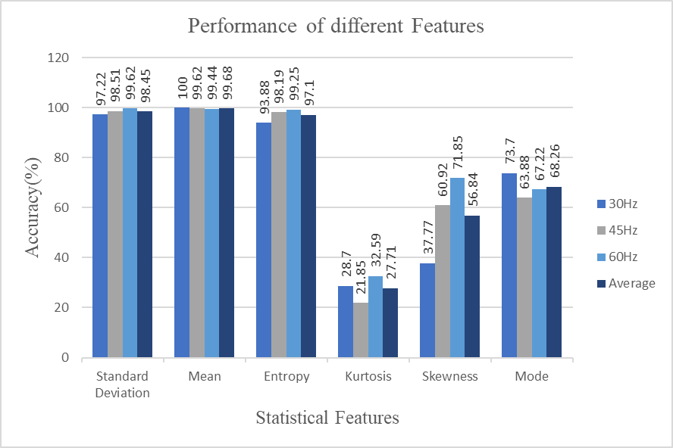

**Best performance: Mean** with an average accuracy of **99.68%.**

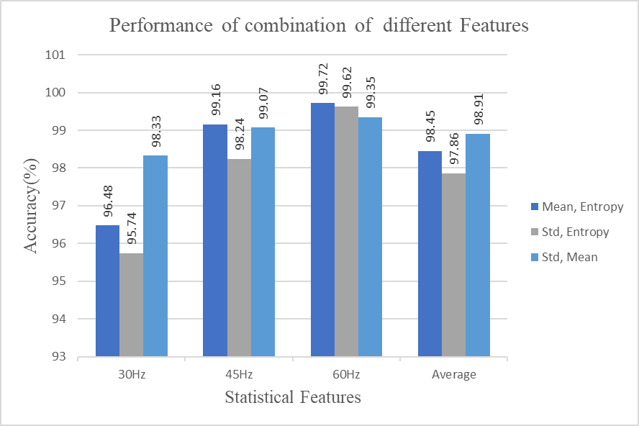

**Best performance: Standard Deviation** and **Mean** combination with an average accuracy of **98.91%.**

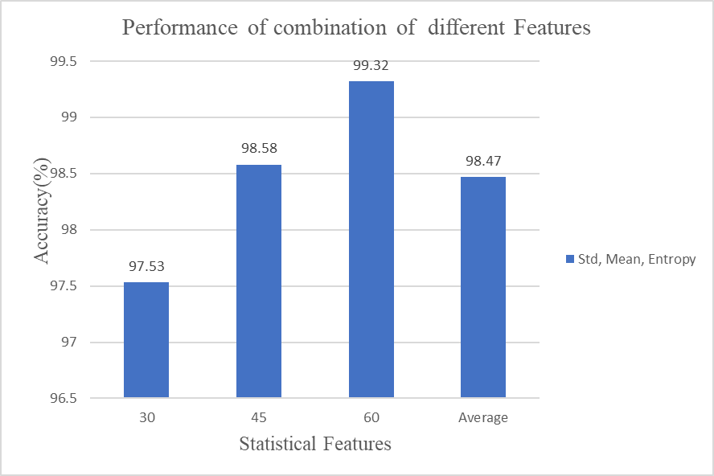

**Best performance: Standard Deviation**, **Mean** and **Entropy** combination with an average accuracy of **99.32%.**

**Best performance among all:**

**Mean** with an average accuracy of **99.68%** and also consider the combination of **standard deviation and mean** which has average accuracy of **98.91%** and also consider the combination of **standard deviation, mean and entropy** which has average accuracy of **98.47%.**

As the raw data cannot insert into model, that’s why we will take mean of the raw data into further calculations.

Fault Set:

All speed varies from 30hz to 60hz in a blockage level which varies from b0 to b6 and each dataset consists of all pump (i.e. Healthy pump, cover plate fault, Impeller Fault)

B0: HP0. CP0, IF0

And similarly for others, also each dataset of HP0, CP0, IF0 includes the mean, standard deviation, entropy and the combination of these three.

In these three combination, blockage classification accuracy is predicted.

**Classification accuracy versus blockage level with single feature**

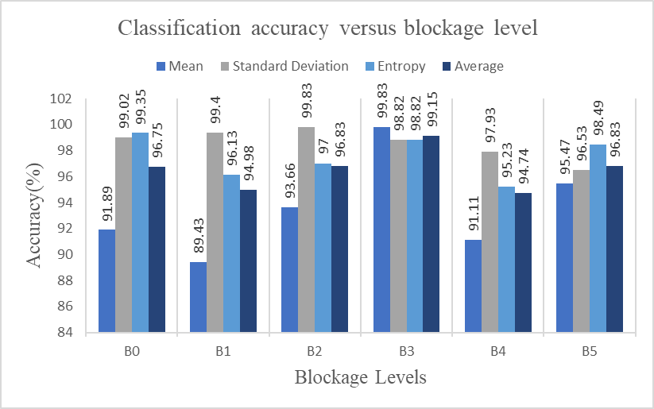

Here in the single feature blockage level B3 has highest classification accuracy with **99.15%.**

**Classification accuracy versus blockage level with a combination of features**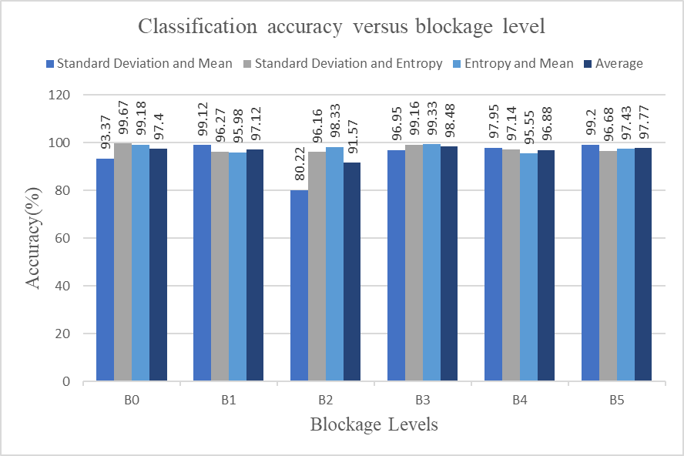

Here in the combination of features, again B3 blockage level has the highest classification accuracy with **98.48%.**

**Classification accuracy versus blockage level with all the features**

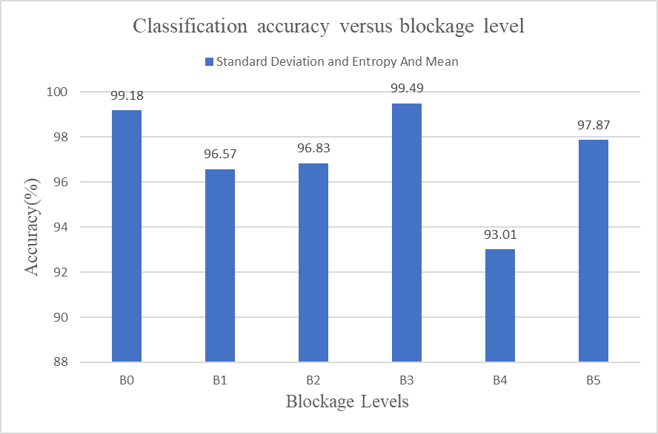

Here in all the features, again B3 blockage level has the highest classification accuracy with **99.49%.**

**Final model performance**

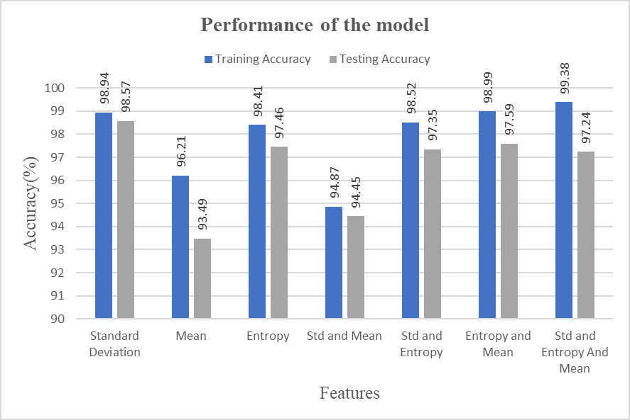

**Confusion Matrix and Classification Report**

* Standard Deviation and Mean:
* Standard Deviation and Entropy And Mean:

