**Project Assignment - Use Case Analysis**

Team Members:

* Mounika Dantuluru
* Joy Machado Francesca
* Shivani Gowrishankar

1. **Use Case:** Guest Registration [userRegistration]

**Description:** Guest wants to register to the web application

**Actors:** Customer

**Preconditions:** A user with same credentials should not exist

**Steps:**

**Actor Actions**: Guest Submits Details

**System Responses:** Guest successfully registered as user

**Post Condition:** User directed to login page

**Alternate paths:**  Guest submits user name that already exists

**Error Message:** User name already exists

2. **Use Case:** User Login[userLogin]

**Description:** User wants to login

**Actors:** Customer

**Preconditions:** User name should exist and password should match

**Steps:**

**Actor Actions:**  User submits login details

**System Responses:** User authentication passed

**Post Condition:** User directed to his profile page

**Alternate paths:** User authentication fails

**Error Message:** The username or password you entered is incorrect

3. **Use Case:** Search for Flights[flightSearch]

**Description:** User wants to search for flights

**Actors:** Customer

**Preconditions:** Flights for the requested dates should have seats available

**Steps:**

**Actor Actions:** User selects arrival, departure dates and boarding,destination locations

**System Responses:** Flight details displayed

**Post Condition:** User should give the dates of travel and location of departure and arrival

**Alternate Paths:** No flights available for the user entered details

**Error Message:** Flights not available

4. **Use Case:** Select a flight[selectFlight]

**Description:** User selects a flight from the search results

**Actors:** Customer

**Preconditions:** Flights for the requested dates should have seats available

**Steps:**

**Actor Actions:** User selects a flight from the search results

**System Responses:** Gives the flight journey details

**Post Condition:** Displays the flight journey details like time of departure, arrival and stops etc.

**5. Use Case:** Book Seats [seatsBooking]

**Description:** User selects the number of seats(i.e passengers traveling) and books them

**Actors:** Customer

**Preconditions:** User should select the number of passengers traveling

**Steps:**

**Actor Actions:** User clicks the book button

**System Responses:** booking details are displayed

**Post Condition:** The tickets are purchased and are added to his booking list

**Alternate Paths:** User booking fails as number of seats requested are no longer available

**Error Message:**  Booking failed

**6. Use Case:** View Booking History [viewBooking]

**Description:** User wants to view an booking history and is displayed in descending order of date of booking (i.e latest transaction first)

**Actors:** Customer

**Preconditions:** Orders exists, customer authenticated

**Steps:**

**Actor Actions:** User requests booking history

**System Responses:** All booking details are displayed

**Post Condition:** all orders are displayed in descending order of date of booking (i.e latest transaction first)

**Alternate path:** User requests booking history, no history found

**Error message:** No purchases made

**7**. **Use Case:** View Travel Details [Travel Details]

**Description:** User selects travel details of a particular journey from his booking history

**Actors:** Customer

**Preconditions:** should be present in the booking history

**Steps:**

**Actor Actions:** User clicks on the travel ID from the booking history

**System Responses:** Displays the journey details

**Post Condition:** System displays all the journey details related to that booking i.e travel id

**Alternate Paths:** Booking has been canceled

**Error Message:** Shows all the journey details with the message “This is no longer available as the order has been canceled”

**8. Use Case:** Cancel a Booking[cancelBooking]

**Description:** User selects a travel id of upcoming journey and selects the cancel button for that passenger or the complete travel

**Actors:** Customer

**Preconditions:** The journey should be upcoming

**Steps:**

**Actor Actions:** User selects either a particular passenger or the whole travel

**System Responses:** Cancels order

**Post Condition:** The journey details are still visible but the order is canceled for a selected passenger or the whole travel

**Alternate Paths:** If the travel id is of past journey

**Error Message:** Order cannot be canceled as it is a past journey

**9. Use Case:** Comment on Airlines [viewComments]

**Description:** A user can comment about his experience during the journey with a particular airlines

**Actors:** Customer

**Preconditions:** the airlines should be displayed

**Steps:**

**Actor Actions:** User selects a particular airlines and comment there

**System Responses:** the comment if it is posted

**Post Condition:** The posted comment is displayed under the airlines reviews

**Alternate Paths:** If there is no text

**Error Message:** Comment cannot be posted as there is no description

**10.** **Use Case:** Rate an Airline [rating]

**Description:** A user can rate a particular airlines

**Actors:** Customer

**Preconditions:** the airlines should be displayed

**Steps:**

**Actor Actions:** User can give a rating of 0 to 5 for a particular airlines

**System Responses:** The rating of the user is posted

**Post Condition:** The average rating of all customers is displayed

**Alternate Paths:**

**Error Message:**

**11. Use Case**: View Frequent flier points

**Description**: User views the frequent flier points

**Actors:** Customer

**Precondition:** User must have points in their profile

**Steps**:

**Actor actions**– User views the profile

**System Responses** – frequent flier points are displayed for a user

profile

**Post condition**: frequent flier points displayed to the user profile

**12. Use Case:** Update Profile

**Description:** A user can edit and update his profile

**Actors:** Customer

**Preconditions:** The user should have authentication to login,

**Steps:**

**Actor Actions:** User can add new information or can edit previous data

**System Responses:** The updated information is stored

**Post Condition:** Displays the updated information on his profile

**Alternate Paths:**

**Error Message:**

**13. Use Case:** Delete Profile

**Description:** A user can request to delete his profile

**Actors:** Customer

**Preconditions:** The user should have authentication to login,user authentication, no pending orders

**Steps:**

**Actor Actions:** User can request to delete his profile

**System Responses:** the user request to delete his profile is sent to DBA

**Post Condition:** The user is no longer able to access his profile

**Alternate Paths:**

**Error Message:**

**14. Use Case:** View Airline [viewAirline]

**Description:** User requests to view airline

**Actors:** Customer

**Preconditions:** the airline should be present in the search results or in the booking history

**Steps:**

**Actor Actions:** The user should select an airline

**System Responses:** Displays the airlines ratings and comments

**Alternate Paths:** The airlines has no related data (i.e comments and ratings)

**Error Message:** No reviews about this airlines

15. **Use Case:** Add User(addUser)

**Description:** A DBA can add user once the guest user registers

**Actors:** Database Administrator

**Preconditions:** A guest user should sign up,DBA authenticated

**Steps:**

**Actor Actions:** A DBA will check the details and add the user

**System Responses:** The user is given permission to access once the user is verified

**Post Condition:** The user is given permission and is authenticated

**Alternate Paths:** The user also exist.

**Error Message:** Duplicate user profile

**16. Use Case:** Delete User

**Description:** A DBA can delete user if the user wants to delete his/her profile

**Actors:** Database Administrator

**Preconditions:** the user should request for deleting his/her profile,DBA authenticated

**Steps:**

**Actor Actions:** A DBA will check the details and delete the user

**System Responses:** The user is denied permission to access

**Post Condition:** The user is no longer allowed to login

**Alternate Paths:** User profile does not exist

**Error Message:** User profile does not exist

**17. Use Case:** View all Comments [Comments]

**Description:** The DBA can view all the comments on different airlines at once, DBA authenticated

**Actors:** Database Administrator

**Preconditions:** Users should post comments

**Steps:**

**Actor Actions:** DBA will request to view comments

**System Responses:** Displays all the comments from different users to different airlines

**Alternate Paths:** There are no comments posted by any user

**Error Message:** No comments to display

**18. Use Case:** Delete Comment [deleteComment]

**Description:** A DBA can delete a comment if it is inappropriate or a spam

**Actors:** Database Administrator

**Preconditions:** DBA authenticated

**Steps:**

**Actor Actions:** DBA selects a comment to delete

**System Responses:** the comment is deleted

**Post Condition:** The comment is no longer displayed

**Alternate Paths:**

**Error Message:**

**19. Use Case:** View all Booking[Booking]

**Description:** A DBA should be authenticated and there should be at least one booking

**Actors:** Database Administrator

**Preconditions:** DBA authentication, and booking should be present

**Steps:**

**Actor Actions:** DBA requests to view all bookings

**System Responses:** Displays all bookings

**Alternate Paths:** There are no existing booking

**Error Message:** No booking to display

**20. Use Case:** Edit Comment [editComment]

**Description:** A customer can edit a comment if it is necessary

**Actors:** Customer

**Preconditions:** customer should have created a comment

**Steps:**

**Actor Actions:** Customer selects a comment to edit

**System Responses:** the comment is edited

**Post Condition:** The comment is edited

**Alternate Paths:**

**Error Message:**

**Use Case UML diagram**

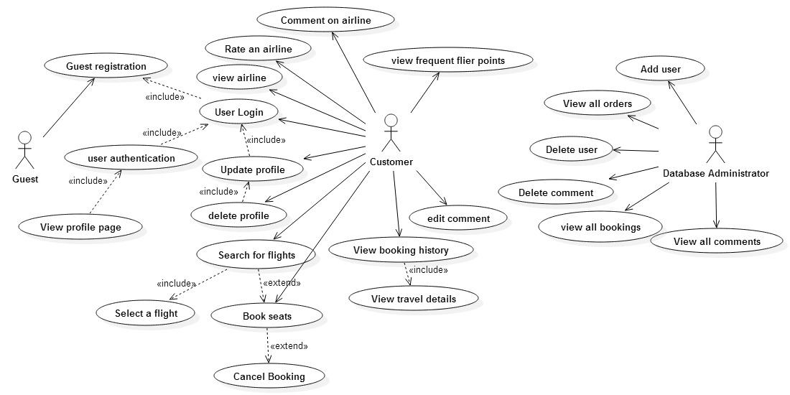

**filter**