

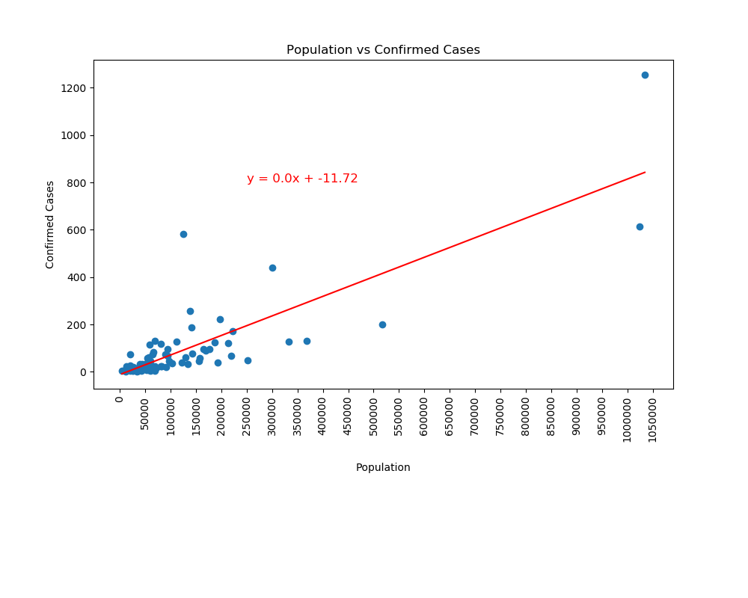

rValue=0.8313895548758251, pValue=6.013486530977201e-25, stderr5.787128770157872e-05, r^2=0.6912085919566227

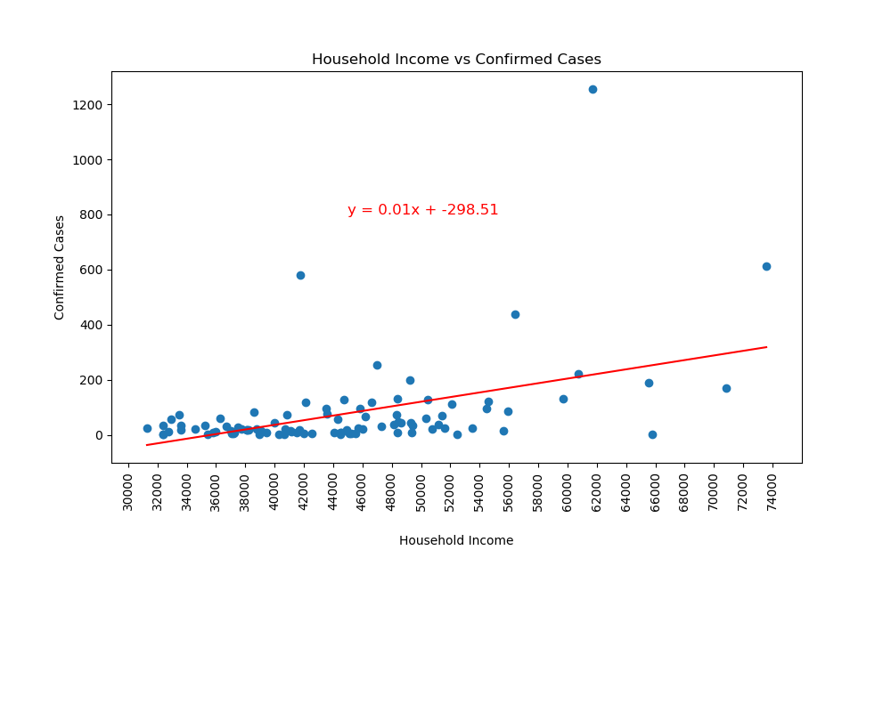

rValue=0.45362252299115907, pValue=4.960436170984484e-06, stderr0.0017276512304536808, r^2=0.20577339336486464

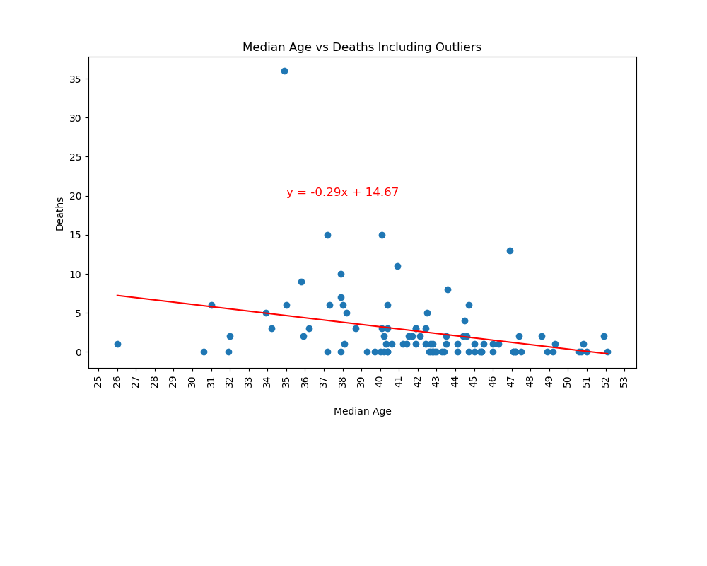

rValue=-0.2993940068872654, pValue=0.003552445715470932, stderr0.09554412124709358, r^2=0.08963677136001193

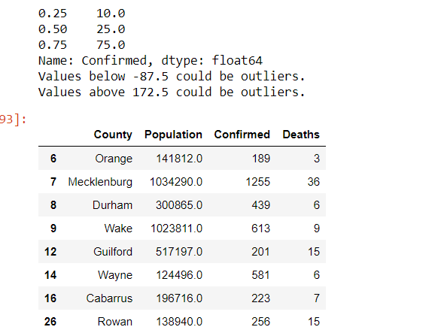

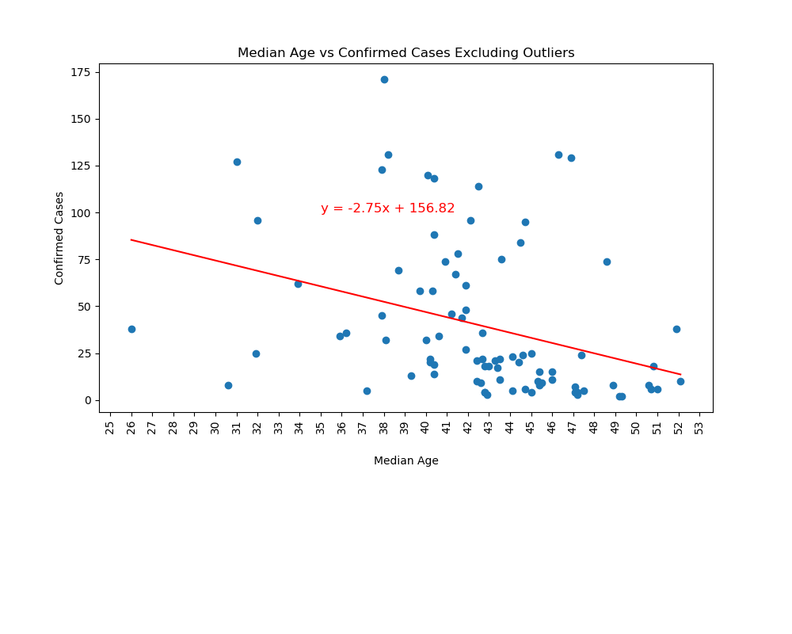

rValue=-0.33675106523487186, pValue=0.001625432193064707, stderr0.8435253502693736, r^2=0.11340127993682092