Digital CoE
AI-DLC Technical Playbook
Engineering Standards · Patterns · Guardrails · Operating Rules for Mendix and Bespoke Delivery
Version | 1.0 Draft
Owner | Digital CoE – Architecture / AI-DLC Working Group
Audience | Architects, TPMs, Developers, QA, DevOps, Security, Partner Teams
Scope | Mendix CLI + VS Code + GitHub Copilot workflows, and Bespoke engineering using VS Code + GitHub Copilot
Review Cadence | Monthly until policy stabilizes, then quarterly
Classification | Internal

Authoritative position: this playbook is the baseline technical standard for AI-assisted engineering in Digital CoE. Deviations require documented exception review by Architecture and the relevant control function.

1. Scope and Intent 2
1.1 Objectives 3
2. Canonical Tool Stack and Platform Positioning 3
2.1 Tool Selection Rules 3
3. Foundational AI Engineering Principles 4
4. Standard AI-DLC Lifecycle 4
5. What AI is Allowed to Do and What AI Must Not Do 4
5.1 Allowed Uses 5
5.2 Explicitly Disallowed Uses 5
6. Final phase-level best practices 5
1. Requirements and specification 5
2. Architecture and solution design 5
3. Planning and context engineering 6
4. Development and build 6
5. Quality and engineering review 6
6. Testing and QA 7
7. Security, privacy and compliance 7
8. Deployment, operations and improvement 7
7. Stack-Specific Technical Rules 8
7.1 Mendix AI-DLC Rules 8
Mendix – Explicitly Prohibited Anti-Patterns 8
7.2 Bespoke Engineering Rules 8
Bespoke – Explicitly Prohibited Anti-Patterns 8

1. Scope and Intent
This playbook defines the canonical engineering standards, approved usage patterns, and non-negotiable guardrails for adopting AI across the software development lifecycle in Digital CoE. It is written in a technical-operating style, so delivery teams know exactly what to use, what not to use, how to use AI safely, and what evidence is required before code moves across environments.
The playbook covers two technology paths under a single governance model: (1) Mendix delivery using Mendix CLI (mxcli), VS Code, and GitHub Copilot; and (2) Bespoke engineering using VS Code and GitHub Copilot. It also defines how reusable skills, prompt patterns, stage gates, and human approvals are to be applied consistently across both paths.

1.1 Objectives
- Accelerate delivery while retaining engineering discipline, human accountability, and release of safety.
- Constrain tool usage to an approved stack and reduce uncontrolled experimentation in delivery teams.
- Standardize prompting, context preparation, review, testing, documentation, and production readiness.
- Make AI-assisted delivery auditable through code provenance, review logs, skill execution evidence, and gate records.
- Provide an organization-wide playbook that delivery teams can adopt without ambiguity.

2. Canonical Tool Stack and Platform Positioning
Digital CoE intentionally constrains the tool landscape to reduce fragmentation, training overhead, and governance risk.
Layer | Approved Tool | Applies To | Policy Position | Why | Do Not Use For
IDE / Workspace | VS Code | Mendix + Bespoke | Standard | Approved as the common engineering workspace with extensions, terminal, and Copilot support. | Do not use non-approved IDE extensions that bypass repository or security controls.
AI Coding Assistant | GitHub Copilot | Mendix + Bespoke | Standard | Default AI assistant for iterative coding, planning, refactoring, PR assistance, and instruction-driven development. | Do not treat Copilot output as final or merge without human review.
Mendix AI Build Engine | Mendix CLI (mxcli) | Mendix only | Standard | Approved Mendix AI-DLC accelerator with context-driven generation and broad artifact support. | Do not run generation without backup, approved context, and post-generation review.
Native Mendix Assistant | Maia | Mendix only | Supplement only | Can help with light-weight assistance inside Mendix Studio Pro. | Do not position as the primary SDLC engine or bypass standard AI-DLC controls.

2.1 Tool Selection Rules
- If the delivery stack is Mendix, use mxcli + VS Code + GitHub Copilot as the default baseline. Maia is an optional supplementary assist only.
- If the delivery stack is Bespoke engineering, use VS Code + GitHub Copilot as the default baseline.
- If a team requests any alternative tool, the request is treated as an exception and must document functional need, security considerations, licensing implications, and governance impact.
- Tool convenience is not a valid reason to bypass the canonical stack.

3. Foundational AI Engineering Principles
Principle | Mandate
Spec-driven first | AI execution begins only after minimum specification, and architecture context exists.
Human accountability is non-delegable | Architecture, security, code review, QA sign-off, and production approval remain in human responsibilities.
Context quality determines output quality | AI output must be driven by curated context, not vague prompts.
Shift-left on quality and security | Validation skills and checks run before commit/merge, not after defects reach QA or production.
Traceability is mandatory | All AI-assisted changes must be traceable through PR notes, commit tags, prompt references, and review evidence.
Stack discipline over tool sprawl | The approved toolchain is preferred over parallel experimentation in production programs.
Reusable patterns beat ad hoc prompting | Prompts, instruction files, skill packs, and stage-gate checklists must be reused and governed centrally.

4. Standard AI-DLC Lifecycle
The AI-Driven Development Lifecycle (AI-DLC) defines the standard approach for using AI across software delivery in a controlled, traceable, and secure manner. It applies to all fit-for-purpose development initiatives across the organization, including Mendix, bespoke engineering, data engineering, analytics, AI/ML, RAG/LLM, and API/integration initiatives.
AI-DLC is not a replacement for SDLC governance. It is an AI-assisted delivery model that accelerates planning, design, development, testing and documentation while retaining human accountability for architecture, security, quality, compliance, and production release.
The lifecycle is jointly governed by Digital CoE and Analytics & Data CoE, with Architecture, Infosec, DevSecOps, QA, DevOps, TPMs and delivery teams playing defined roles across the lifecycle.
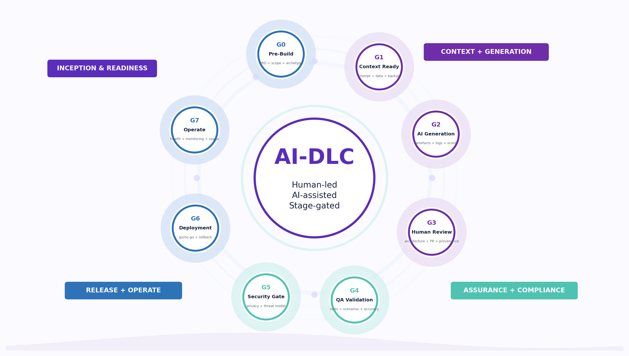

5. What AI is Allowed to Do and What AI Must Not Do

5.1 Allowed Uses
- Generate a draft implementation plan from an approved BRD / PRD / backlog.
- Scaffold code, pages, domain models, test cases, API adapters, documentation, or review summaries from approved technical context.
- Assist with refactoring, code explanation, summarization, gap detection, and repetitive engineering tasks.
- Generate test skeletons, TDD (Technical Design Document) drafts, review reports, and release-note draft that are subsequently reviewed by engineers.
- Run governed by reusable skills such as code review scoring, security scanning, prompt compliance checks, and API contract validation.

5.2 Explicitly Disallowed Uses
- Do not expose restricted or sensitive information to AI systems. Follow Prompt & Data Handling Standards.

6. Final phase-level best practices

1. Requirements and specification
Make requirements precise enough for AI-assisted planning and generation.
Do | Do Not
Use BRD/PRD, backlog item, user story pack or architecture-approved scope note as source of truth. | Do not treat vague email, chat or meeting notes as final build instructions.
Capture personas, roles, journeys, integrations, NFRs, acceptance criteria, assumptions and open questions. | Do not allow AI to invent scope, regulatory obligations, business rules or NFRs.
Use AI for summarization, ambiguity detection, story drafting, and acceptance criteria for refinement. | Do not include secrets, tokens, patients, employees, customer or restricted business data in prompts.
Every AI-assisted work item must originate from an approved BRD, PRD, User Story, Backlog Item, or Architecture-approved scope document.
Maintain traceability between requirements, generated artifacts, test cases, and deployment of deliverables.

2. Architecture and solution design
Create design boundaries before generation starts.
Do | Do Not
Define architecture pattern, domain/data model, security model, API contracts, integration boundaries and deployment assumptions. | Do not let AI make final architecture, security, privacy, compliance, or release decisions.
Use AI to compare design options, draft TDD sections, identify design gaps, and produce review questions. | Do not generate service/controller/integration logic before API contracts, and schema expectations are clear.
Manually confirm authentication, authorization, audit trail, RBAC/ABAC, and data-access decisions. | Do not accept generic AI design as enterprise architecture without architect review.
Select AI models based on business criticality, quality expectations, security requirements, latency targets, and cost considerations.
Use premium models for architecture design, regulatory documentation, security reviews, and complex reasoning.
Use cost-efficient models for summarization, classification, metadata extraction, test generation, and repetitive tasks.

3. Planning and context engineering
Prepare a controlled execution baseline for AI-assisted development.
Do | Do Not
Create a plan.md or equivalent implementation plan with bounded implementation slices and traceability to scope. | Do not overload prompts with unrelated enterprise documents or noisy context bundles.
Prepare targeted context packs: requirement, design, repo/module structure, coding standards, API/interface definitions, and constraints. | Do not assume AI knows local naming, security, integration or DRL design-system conventions.
Use approved prompt patterns, instruction files and prompt/version identifiers where available. | Do not run large generation without feature branch, backup/restore readiness and rollback thinking.
For Mendix, create backup or restore point before major mxcli generation. | Do not mix confidential project values into reusable generic prompts.
Use approved prompt templates and instruction files wherever possible.
Version prompts and maintains change history similar to source code.

4. Development and build
Accelerate implementation while preserving engineering discipline.
Do | Do Not
Generate small vertical slices aligned to plan.md, story, module or bounded change request. | Do not commit raw AI output directly to protected branches.
Inspect generated artifacts before committing; treat Copilot/mxcli output as draft. | Do not ask AI to rewrite full repositories, full apps or large cross-module scope in one prompt.
Capture AI provenance in PR description, commit tag, change log or generation log for substantial generated work. | Do not embed credentials, real connection strings, tokens or production payloads in code, prompts or examples.
For Mendix, manually verify roles, access rules, navigation, XPath constraints, validations, pages, and microflows. | Do not generate infrastructure, auth, session or secrets-handling logic without platform/security review.
For bespoke, retain linting, type checks, unit tests, dependency scan, secret scan and protected branch policies. | Do not skip tests because the code is AI-generated.

5. Quality and engineering review
Validate AI output through normal engineering quality controls.
Do | Do Not
Use peer review, architect review, and automated quality checks before merging. | Do not approve PRs only because code compiles or AI confidence appears high.
Review logic correctness, maintainability, complexity, naming, duplication, architecture fit, secure defaults, error handling and observability. | Do not let AI review/scoring replace named human reviewers.
Use AI to prepare review summaries, quality scoring, gap detection, and remediation notes. | Do not bypass review for architecture, security, integration, RBAC/ABAC, microflow or data-access changes.
Make generated vs manually modified artifacts identifiable where practical. | Do not leave known AI-generated defects or remediation decisions undocumented.

6. Testing and QA
Prove functional readiness, not just generated code completeness.
Do | Do Not
Use AI to draft unit, integration, regression, negative-path and E2E test cases. | Do not assume generated tests provide complete coverage.
Validate generated tests against business scenarios, edge cases, and acceptance criteria. | Do not skip manual validation of critical business workflows.
Use synthetic, masked, sampled, or schema-faithful test data when real data is restricted. | Do not use restricted production datasets in prompts or examples without an approved masking route.
Document QA evidence, failed cases, fixes and retest outcomes. | Do not promote release when defects, coverage, or regression expectations remain unresolved.

7. Security, privacy and compliance
Keep AI-assisted delivery aligned with security and data-handling expectations.
Do | Do Not
Run applicable SAST, SCA, secret scan, container scan, and DAST/VAPT based on project criticality. | Do not paste keys, tokens, credentials, raw logs, screenshots or restricted data into prompts.
Review prompts/context for secrets, tokens, PII/PHI, restricted business data, screenshots, and unsafe logs. | Do not merge critical/high vulnerabilities unless formally an exception is approved.
Validate authentication, RBAC/ABAC, session lifecycle, audit trail, privilege boundaries, API security, retry/timeout/fallback and error mapping. | Do not ship AI-generated auth, integration, security or compliance flows without manual validation.
Track exceptions with owner, risk, expiry, and compensating controls in the separate governance process. | Do not treat prompt safety as optional for production or regulated use cases.

8. Deployment, operations and improvement
Release safely and improve reusable AI-DLC practices after go-live.
Do | Do Not
Prepare release notes, rollback notes, support handover, monitoring readiness and operational runbooks where applicable. | Do not let AI make go/no-go production release decisions.
Use AI to draft deployment summaries, runbooks and incident notes; keep human review mandatory. | Do not deploy without rollback clarity, observability and support ownership.
Monitor runtime health, errors, logs, latency, cost, token/model usage and user/business impact where applicable. | Do not log sensitive information while adding observability.
Feed lessons learned into prompt library, reusable skills, context templates and best-practice updates. | Do not keep ineffective prompts, agents or skills without review, version cleanup or retirement.
Monitor AI solutions for cost, performance, latency, token consumption, prompt effectiveness, hallucination trends, and operational reliability through appropriate dashboards and alerts.
Optimize AI consumption by selecting fit-for-purpose models, minimizing unnecessary context, reusing cached responses where applicable, and continuously tracking business value versus cost.
Implement governed agentic AI patterns with defined execution boundaries, approval controls, and human oversight for critical business actions.

7. Stack-Specific Technical Rules

7.1 Mendix AI-DLC Rules
- Generate small, bounded slices: domain model, pages, microflows, validations, integrations, and documentation.
- Always verify security model completeness manually: roles, access rules, navigation, XPath constraints, and exposure paths.
- Expect manual correction for complex XPath expressions, nuanced business logic, user-role mapping, edge validations, and non-trivial microflow cleanup.
- Review generated pages for DRL Design System alignment, UX consistency, and naming conventions.
- Run best-practice validation and remove unused activities, duplicate logic, and anti-patterns before QA promotion.

Mendix – Explicitly Prohibited Anti-Patterns
- Running mxcli without an MPR backup.
- Allowing generated navigation, roles, or security rules to enter QA without manual verification.
- Generating large cross-module changes in one step with no restore point.
- Assuming domain model generation is correct without relationship and ownership review.
- Promoting pages or microflows that fail to design system, readability, or security checks.

7.2 Bespoke Engineering Rules
- Start with repository and architecture structure before business logic generation: package layout, service boundaries, configuration model, test strategy, CI expectations.
- Generate vertical slices or module boundaries; avoid asking for the whole application in one prompt.
- Define API contracts, schema expectations, and integration boundaries before generating service or controller logic.
- Retain standard engineering controls such as linting, type checking, unit tests, integration tests, dependency scanning, secret scanning, and protected branch policies.
- Review AI-generated code for defensive programming, observability, error handling, retries, resource handling, and secure defaults.

Bespoke – Explicitly Prohibited Anti-Patterns
- Committing unreviewed AI-generated code to protected branches.
- Generating infrastructure-as-code, pipeline definitions, or secret-handling logic without platform-owner review.
- Embedding credentials or real connection values in code, prompts, examples, or config committed to repositories.
- Skipping tests because the AI-generated code “looks right”.
- Allowing contract-breaking API changes without versioning and consumer review.

