Smith MSIS Alumni Database

**Project 0504**

**Team-05**

**Members:**

Shruti Gupta

Mohini Saxena

Gauri Yewale

Priya Ashok

Divya Chhabra

**1.Determine a meaning brand name for your project.**

Smith MSIS Alumni Database.

**2. Describe business functions and transactions in sentences**

Business Functions:

To provide Smith MSIS alumni contact database as a part of information systems (IS)

consulting to a locally based small to medium-sized business or organization.

1. Each alumnus is described by a unique uid, name, birth date, gender, address, email address, phone number, visa status.

2. Each alumnus has expertise in one or more languages, soft skills and has completed some certifications.

3. SmithAlumni DB maintains alumnus information even though he/she is not employed.

4. Each company is described by a unique sequence number, company name, and visa sponsorship details.

5. Each employee can have either an internship or a job.

6. Several alumni can who work for a company, and each company has at least one alumnus. However, companies are not independent of alumnus.

7. When an alumnus is deleted from the database, the corresponding alumnus and Smith information should be deleted.

8. When an alumnus is deleted from the database, there is no action on the corresponding company, job and expertise information.

9. When an alumnus procures a new job/internship, the corresponding company and job information should be added, no action on the existing data.

10. When an alumnus procures a new skill/expertise, the corresponding expertise table should be updated.

11. When any information regarding the alumnus is updated, there is no action on the

corresponding Smith information.

Business Transactions:

1. *What is the First name, Last name, contact number, Visa status, Job title, Network, Industry and Company of an Alumni whose First Name is ‘John’?*

***SELECT ALMFNAME,ALMLNAME,PHONE,INITIALVISASTATUS,JOBTITLE,***

***NETWORK,INDUSTRY, COMNAME***

***FROM SMITH_ALL***

***WHERE ALMFNAME ='JOHN';***

1. *What is the First name, Last name, contact number, Visa status, Job title, Network, Industry and Company of all the Alumni whose Company is ‘ZS’?*

***SELECT ALMFNAME, ALMLNAME, PHONE, INITIALVISASTATUS, JOBTITLE, NETWORK, INDUSTRY, COMNAME***

***FROM SMITH_ALL***

***WHERE COMNAME='ZS';***

1. *What is the First name, Last name, contact number, Visa status, Job title, Network, Industry and Company of all the Alumni whose Initial Visa Status is ‘F1’?*

***SELECT ALMFNAME, ALMLNAME, PHONE, INITIALVISASTATUS, JOBTITLE, NETWORK, INDUSTRY, COMNAME***

***FROM SMITH_ALL***

***WHERE INITIALVISASTATUS='F1'****;*

1. *What is the First name, Last name, contact number, Job title and Company of all the Alumni whose Job title contains the word ‘analyst’?*

***SELECT ALMFNAME, ALMLNAME, JOBTITLE, COMNAME***

***FROM SMITH_ALL***

***WHERE JOBTITLE LIKE '%ANALYST%';***

1. *What is the First name, Last name, Company Name, Job title and Salary of all the Alumni for the top 5 salaries?*

***SELECT DISTINCT TOP 5 ALMFNAME, ALMLNAME, COMNAME, JOBTITLE, SALARY FROM SMITH_ALL***

***ORDER BY SALARY DESC;***

1. *What is the average salary for the full-time job profile?*

***SELECT AVG(SALARY) AS ‘AVERAGE SALARY’***

***FROM [SMITH.WORKFULLTIME];***

1. *What is the First name, Last name, Company Name of all the Alumni who work in the ‘consulting’ industry?*

***SELECT ALMFNAME, ALMLNAME, COMNAME***

***FROM SMITH_ALL***

***WHERE INDUSTRY='CONSULTING';***

**3. Identify at least five entity types.**

* Alumni
* SchoolInformation
* Company
* Expertise
* Job
* JobStatus
* WorkFullTime
* WorkInternship

**4. Identify relationship types including at least one many-to-many  
binary or higher degree**relationship type - no singleton entity type.

Works_for: binary relationship

1 Alumnus to 0 or more JobStatus

1 JobStatus to 1 and only 1 Alumnus

Exhibits: binary relationship

1 Alumnus exhibits 0 or more of Expertise

1 set of Expertise belongs to 1 and only 1 Alumnus

Part_of: binary relationship

1 Alumnus part of 1 and only 1 SchoolInformation record

1 SchoolInformation belongs to 1 and only 1 Alumnus

Has: binary relationship

1 Alumnus has 0 or more Job

1 Job has 0 or more Alumnus

Provides: binary relationship

1 Company provides 1 or more Job.

1 Job belongs to 1 and only 1 Company

**5. Perform database analysis on entity and relationship types, i.e. ER schema.**

Entities, Attributes and Primary Keys

Alumni (**uid**, firstName, middleName, lastName, dOB, gender, address, emailId, phoneNum,

initialVisaStatus, alumniLinkdn)

Company (**seqNum**, comName, visaSponsorship)

Expertise (technicalSkill {0..3}, softSkillPrimary, softSkillSecondary, certification)

SchoolInformation (startDate, endDate, gPA, elective, assistantship)

Job (**jobId,** jobTitle, network, jobDesc, rating, industry)

JobStatus (**jobId**, **uid**)

WorkFullTime (salary, startDate)

WorkIternship (payPerHour, startDate, endDate)

**6. Design an ER diagram.**

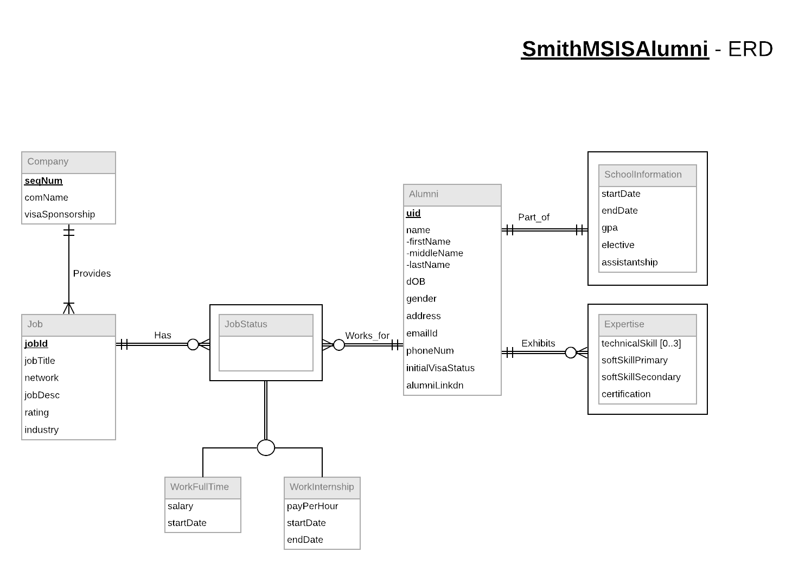

7.**State mission statement(s) for the client.**

We are a global technology consulting firm helping clients with their IS needs. For this project, our mission is to deliver to the client, the required Smith School Alumni Contacts Database, enabling them to improve the effectiveness of their business potential, by using this database as an input for providing customized solutions to students and deliver value to their customers.

**8. State mission objectives for the client**

* To satisfy the need to offer a full-time consulting product for small to medium size businesses
* To provide an umbrella to develop and grow the client base and requiring a team effort to satisfy client requirements
* To develop and maintain a broad Smith MS in Information Systems Alumni Contacts Database
* To provide Alumni’s personal contact information such as address, contact details, Visa status etc.
* To provide Alumni’s job information, both for internships and jobs (whichever is applicable), along with the Company and its location
* To provide Alumni’s Smith School related information such as course Period, courses taken, GPA etc.
* To maintain an environment which is conducive to innovative thinking and solutions.
* To work towards excellence and achievement.

**9.Convert ER model into relational schema and identify primary and foreign keys**

Alumni (**uid**, firstName, middleName, lastName, dOB, gender, address, emailId, phoneNum, initialVisaStatus, alumniLinkdn)

Company (**seqNum**, comName, visaSponsorship)

Expertise (***uid*,** technicalSkill{0..3}, softSkillPrimary, softSkillSecondary, certification)

SchoolInformation (***uid*,** startDate, endDate, gpa, elective, assistantship)

Job (**jobId**, **seqNum**, jobTitle, network, jobDesc, rating, industry)

JobStatus (***jobId***, ***uid***)

WorkFullTime (salary, startDate)

WorkIternship (payPerHour, startDate, endDate)

**10.Determine functional dependencies and perform normalization to 3NF**

uid -> firstName, middleName, lastName, dOB, gender, address, email, phoneNum,

InitialVisaStatus, alumniLinkdn

seqNum -> comName, visaSponsorship

uid -> technicalSkill, softSkillPrimary, softSkillSecondary, certification

uid -> startDate, endDate, gpa, elective, assistanship

jobId, uid, seqNum -> jobTitle, network, jobDesc, rating, industry

uid, jobId -> salary, startDate

uid, jobId -> payPerHour, startDate, endDate

uid, jobId ->

**11.Generate Business Rules and determine referential integrity**

1. When company information is updated, no action on the job information.
2. When company information is deleted, the job information should be deleted from the database.
3. When the job information is updated, no action on the company information.
4. When the job information is deleted, no action on the company information and it is retained.
5. When alumni information is updated, the expertise is also updated.
6. When alumni information is deleted, their expertise is also deleted.
7. When expertise is updated, no action on the alumni information.
8. When expertise is deleted, no action is taken on the alumni information.
9. When alumni information is updated, the school information remains the same and no action is taken.
10. When alumni information deleted, the school information should be deleted.
11. When school information is updated, the alumni information should be updated.
12. When school information is deleted, the alumni information is deleted from the database as well.
13. When alumni information is updated, the jobStatus information should be updated as well.
14. When the alumni information is deleted, the jobStatus information is deleted as well.
15. When the jobStatus information is updated, no action on the alumni information and it remains the same.
16. When jobStatus information is deleted, no action on the alumni information and it remains the same.
17. When job information is updated, jobStatus information is updated as well.
18. When job information is deleted, corresponding jobStatus information is deleted.
19. When jobStatus information is updated, no action is taken on job information.
20. When jobStatus information is deleted, no action is taken on the job information.

**Referential Integrity:**

|  |  |  |  |  |  |  |  |
| --- | --- | --- | --- | --- | --- | --- | --- |
| Relation | Foreign Key | Base Relation | Primary Key | Business Rule | Constraint: ON DELETE | Business Rule | Constraint: ON UPDATE |
| Company | seqNum | Job | seqNum | R1 | NO ACTION | R3 | NO ACTION |
| Company | seqNum | Job | seqNum | R2 | CASCADE | R4 | NO ACTION |
| Alumni | uid | Expertise | uid | R5 | CASCADE | R6 | CASCADE |
| Expertise | uid | Alumni | uid | R7 | NO ACTION | R8 | NO ACTION |
| SchoolInformation | uid | Alumni | uid | R9 | NO ACTION | R10 | CASCADE |
| Alumni | uid | SchoolInformation | uid | R11 | CASCADE | R12 | CASCADE |
| Job | uid | Alumni | uid | R13 | CASCADE | R14 | CASCADE |
| Alumni | uid | Job | uid | R15 | NO ACTION | R16 | NO ACTION |
| JobStatus | jobid  uid | Job | jobid | R17 | CASCADE | R18 | CASCADE |
| Job | jobid | JobStatus | jobid  uid | R19 | NO ACTION | R20 | NO ACTION |

**13.Describe sample data for every relation**

|  |  |  |
| --- | --- | --- |
| Company | | |
| SeqNum ("001") | comName ("Wayfair") | visaSponsorship ("Yes") |

|  |  |  |  |  |  |  |  |  |  |  |
| --- | --- | --- | --- | --- | --- | --- | --- | --- | --- | --- |
| Alumni | | | | | | | | | | |
| uid ("9563456") | firstname ("Gautam") | secondname | lastname ("Rachakonda") | dob ("11/03/1990") | gender ("Male") | address ("5184, 40th Aveneue, Seattle, WA") | emailid ("gautam.rachakonda@rhsmith.umd.edu") | phoneNum (+12404080678) | initialVisaStatus ("F1-Student") | alumniLinkedin ("https://www.linkedin.com/in/gautam-rachakonda") |

|  |  |  |  |  |  |
| --- | --- | --- | --- | --- | --- |
| SchoolInformation | | | | | |
| uid ("9563456") | startDate ("08/27/2016") | endDate ("12/20/2017") | gpa ("3.8") | elective ("Google Analytics") | assistantship ("Yes") |

|  |  |  |  |  |
| --- | --- | --- | --- | --- |
| Expertise | | | | |
| uid ("9563456") | technicalSkills ("SQL", "Google Adwords, "Google Analytics") | softSkillPrimary ("Leadership") | softSkillSecondary ("Communication Skills") | certification ("Google Analytics") |

|  |  |  |  |  |  |
| --- | --- | --- | --- | --- | --- |
| Job | | | | | |
| jobId ("0102") | jobTitle ("Senior Product Associate") | network ("LinkedIn") | jobDesc ("Developing Budgets,Coaching,supervision ,project planning, performance management, resource allocation,inventory control,process improvement") | rating ("4.2") | industry ("E-commerce") |
| jobId ("0101") | jobTitle ("Senior Product Manager Intern") | network ("Referral") | jobDesc ("Assist in project planning, performance management, resource allocation,inventory control,process improvement") | rating ("4.0") | industry ("E-commerce") |

|  |  |
| --- | --- |
| JobStatus | |
| uid ("9563456") | jobId ("0102") |

|  |  |
| --- | --- |
| WorkFullTime | |
| salary ("$95,000") | startDate ("03/21/2018") |

|  |  |  |
| --- | --- | --- |
| WorkInternship | | |
| payPerHour ("$35") | startDate ("06/01/2017") | endDate ("08/20/2017") |