TASCA Go4 Analysis
OpenOffice document tascaGo4intro.odt
H.Essel, 8. May 2009

Setups

Set up account
The tasca account should be customized for more convenience. One should define a variable for the repository path:
export SVN=https://subversion:443/goofy/go4/applications/tasca
Then one can use svn commands like
svn list $SVN
to get a listing of the subversion repository. Some useful alias:
svndiff='svn diff --diff-cmd /usr/bin/diff -x "-EwbB" '
svndiffl='svn diff --diff-cmd /usr/bin/diff -x "-qEwbB" '
On a workspace directory these give a list of files different from repository (second line file list only).
Above has been added to .bashrc file (HE). Other useful alias can be defined here.

Set up working directory
Once the directory is made an svn working directory (by checking out a repository to it) there are few commands to deal with the repository:
svn info
show the repository the workspace belongs to
svn list $SVN
list of repository
svn update
update workspace from repository
svn commit -m “enter here comment” [file]
copies all changed files to repository. If a file is specified, only this file is copied (if modified).

After login
Setup everything for Go4 (now already done in .bashrc)
. go4login 402-00
(Note the space behind the dot.)

The Go4 analysis
To build the Tasca analysis, simply:
make
The executable made is
MainUserAnalysis
It can be called from shell or is started from GUI. In principle it does the same in both cases. The analysis is steered by a ROOT macro file setup.C. You can edit this file before running the analysis. There are the following lines:
TString unpackProcess("yes");
TString unpackStore("no");
TString unpackOverWrite("yes");

TString caliProcess("yes");
TString caliStore("no");
TString caliOverWrite("yes");

TString analysisProcess("yes");
TString analysisStore("no");
TString analysisOverWrite("yes");

TString autosave("yes");
Int_t autosaveinterval=0; // after n seconds, 0 = at termination of event loop

Batch mode
Examples:
MainUserAnalysis -f file.lmd
processes file
MainUserAnalysis -t r4-4 10000
connects to MBS transport node R4-4 and processes 10000 events.
Usually in batch mode one either writes an auto-save file (containing all histograms, parameters, etc.), and/or any event file. The auto-save file name and the event file names are prefixed by the input file or node name
b_r4-4_AS.root, b_r4-4_Unpacked.root, b_r4-4_Calibrated.root, b_r4-4_Analysis.root
The b_ is added in batch mode only. Any of these can be opened by ROOT or in the GUI.

Interactive mode
In interactive mode the analysis is started by the GUI. In this case, the file name prefix is the analysis name specified in the Start Client panel. This name is saved by Save Settings. In addition the prefix b_ is changed to i_.Further setup is specified in the configuration panel coming up after starting the analysis. Default settings are the ones from setup.C. This setup can be modified interactively and can be stored in
Go4AnalysisPrefs.root
from where it is retrieved next time the analysis is started. If this file is present, the settings from setup.C are overwritten.
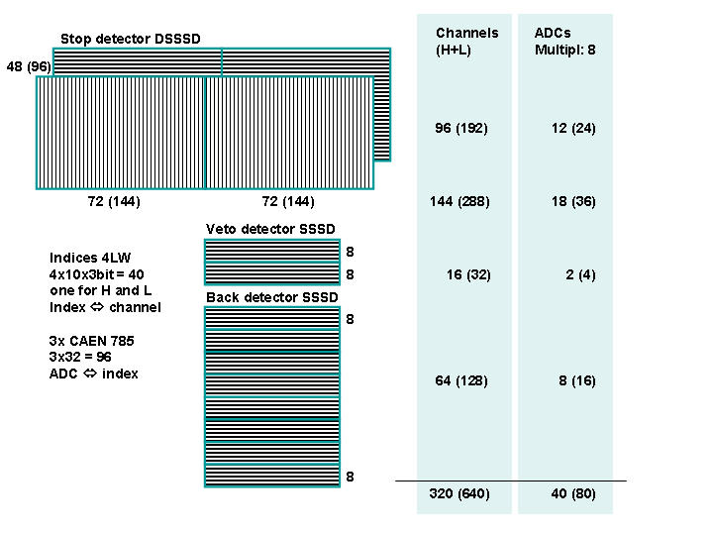

The analysis steps
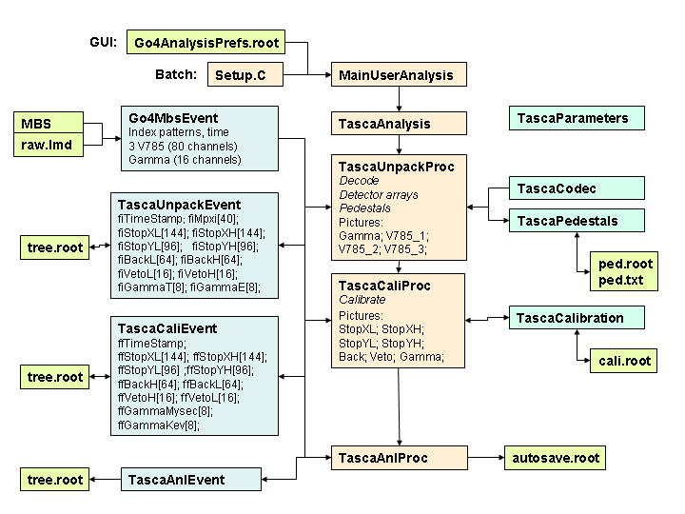
The analysis is divided into three steps as shown in the figure.

Unpack step
Input: LMD file or MBS (transport, stream server, event server)
Output: ROOT tree with values of all detector channels and detector hit lists. Details in TascaUnpackEvent.h
Autosave: Controls, Parameters, Pedestals and Codec
Histograms in directory Unpack: Adc_nn GammaE_n GammaT_n Pedestals Contents AdcAllRaw AdcAllCal TraceRaw_nn TraceE_nn Hist_nn Pileup_nn
Processing: TascaUnpackProc constructor creates the parameters, histograms and pictures. Method TascaUnpack uses parameter class TascaCodec to decode Adc values, gamma values, and fills the data fields of TascaUnpackEvent. TascaCodec also contains the mapping tables for the multiplexed channels.

Calibration step
Input: TascaUnpackEvent (from Unpack step or from file)
Output: ROOT tree with calibrated values of all detector channels and gammas. Hit indices of all detectors and their values. Details in TascaCaliEvent.h
Autosave: Controls, Calibration
Histograms in directory Cali: All detector channels, gamma channels, Sum of detector channels.
Processing: Filling histograms and TascaCaliEvent data fields.

Analysis step
Input: TascaAnlEvent (from Calibration step or from file)
Output: ROOT tree with data from TascaAnlEvent.h (currently none)
Autosave: Creates parameters Controls, Parameters
Histograms in directory Anl: 2d histograms of stop detector (Energy-Xstripe) for each Ystripe.
Processing: Fills histograms

Calibration
Class TascaCalibration is a parameter class with the purpose of performing calibration. This parameter is used in the TascaCaliProc processor of the second step. Calculating calibration parameters is done in two steps. First we need a histogram with the measured lines and a text file calilines.txt with the energies of these lines and their channel number. These are present in arrays inside the parameter. First fitter fxLinesFinder is used to find out true channel numbers for corresponding lines in calibration spectrum. This fit should be done interactively on the GUI side:
- Get parameter from analysis
- Get calibration spectrum ("Cr1Ch01" here, note that this does not match the physics of the x-ray lines example, but it is sufficient to show the principle)
- Double click on the fxLinesFinder fitter in the parameter editor. Fit panel will open showing the current settings of the fitter. Use Use pad of the fit panel to assign this fitter to the view panel containing the calibration spectrum.
- In the models field of the fit panel, enable or disable the lines that are present in the calibration spectrum. Only enabled lines are fitted.
- Do Fit. If the positions of the lines are fitted correctly, copy the fitter back to the calibration parameter: right mouse button click on fxLinesfinder, select Get from FitPanel.
- Set boolean field fbRecalibrate in parameter to 1 (true). Don not forget <RET>.
- Now press left arrow button. This will perform fit of the calibration curve (linear by default, but any polynomial is possible) in the UpdateFrom() method of TascaCalibration on the analysis side.
- Pressing right arrow button will get the results of the calibration, present in the polynomial coefficients fdA[0]...fdA[3] and in the fxCalibrator fitter.
- The corresponding TGraph is UserObjects/Calibration and is displayed by double click. Then double click on the fxCalibrator fitter in the parameter editor to open in a fit panel, press Use Pad and Draw. This will draw the calibration polynomial over the points which indicate the energy/channel of the calibration lines.
- Once the calibration is correct, fbRecalibrate can be set to false to prevent recalibration each time the parameter is updated (i.e. reloading it from auto-save file or sending it to analysis)
- The calibration is used in the method float TascaCalibration::Energy(int) which calculates the energy from a given channel number. Histograms in TascaCaliProc are filled using this method.
- Set boolean field fbReadDatabase in parameter to 1 (true) if the calibration lines shall be reread from file. This will overwrite any settings and fits performed with the fxLinesFinder fitter on the GUI before! Note that channel numbers of lines are not found automatically in UpdateFrom, this is left to the interactive GUI.
- Note that calibration coefficients fdA[] in parameter may be entered also manually, i.e. with fbRecalibrate set to false, the user has full control of the calibration function

