**Validation of freeware-based midventilation CT calculation for upper abdominal cancer patients**

S. Vieira, J. Stroom, K. Anderle, B. Salas, N. Pimentel, C. Greco

Corresponding author: sandra.vieira@fundacaochampalimaud.pt

**Purpose**: Most institutes use the ITV approach to account for breathing motion into treatment planning, generally yielding too large treatment volumes. Recent publications showed that use of a midventilation CT (midV CT) instead for hypo-fractionated treatments led to high tumor control and overall survival. However, midV CT is not available commercially yet. In this work we perform a marker-based validation of our open-source software to generate a midV CT for upper abdomen cancer patients.

**Material and Methods**: Planning data from ten upper abdominal cancer patients (seven liver- and three pancreatic patients) were used for this study. These patients were treated with the ITV approach using hypo-fractionated schemes (ranging from 5x7.5 Gy to 1x24Gy). Each patient had a gold marker implanted close to the CTV center of mass (COM). 4DCT data consisted of ten amplitude-based breathing phases (CT BrillianceTM, Phillips Healthcare). In our planning system (EclipseTM,Varian Medical Systems), the position of the marker was measured by hand for each breathing phase and patient. In 3DSlicer, B-spline (non-rigid) deformations are used to register the plan CT and the different phases of the 4DCT. The resulting transformation matrices are then used by our own 3DSlicer modules to automatic generate the midV CT and the COM motions of any planning volume or marker. Subsequently, the marker position in the midV CT was compared to the average marker position in Eclipse. Furthermore, the Eclipse marker motion curves and amplitudes were compared with the marker and CTV motions from 3DSlicer. Additionally, treatments plans were generated for two patients using the midV CT and evaluated against our ITV-based clinical plan.

**Results**: The mean CTV volume was 24.7±22.0 cc (1SD) and the mean marker to CTV COM distance was 12.7±6.2mm (1SD). The midV CTs are currently generated by 3DSlicer within 30 minutes using a PC. Motion validation results are in Table 1. Differences in the mean position of the marker in Eclipse and in midV CT are within 1mm, indicating an accurate midV CT generation by our software. Average amplitude differences are within 1mm but Eclipse motions tend to be slightly larger, possibly due to the uncertainty in the manual marker COM definition in the 4D phases. Mean differences between the 3DSlicer breathing motion curves for the CTV and the marker are submillimeter suggesting that well-placed markers can be used to estimate CTV motions. Larger differences were found for motion curve differences between Eclipse and 3DSlicer: again, may be due to finding manually the marker COM.

**Conclusions**: Accurate midV CT can be generated using free, open-source software. This opens the prospect for the use of midV CT in our clinical practice, allowing hypo-fractionated treatments in the upper abdomen with more adequate CTV-to-PTV margins. For lung ca patients this approach should work even better due to the higher contrast images.

**Table1.** Differences in breathing motion data for all patients between the marker position as measured in 3DSlicer (MS) and CTV position (CS), with respect to the marker as measured in Eclipse (ME).

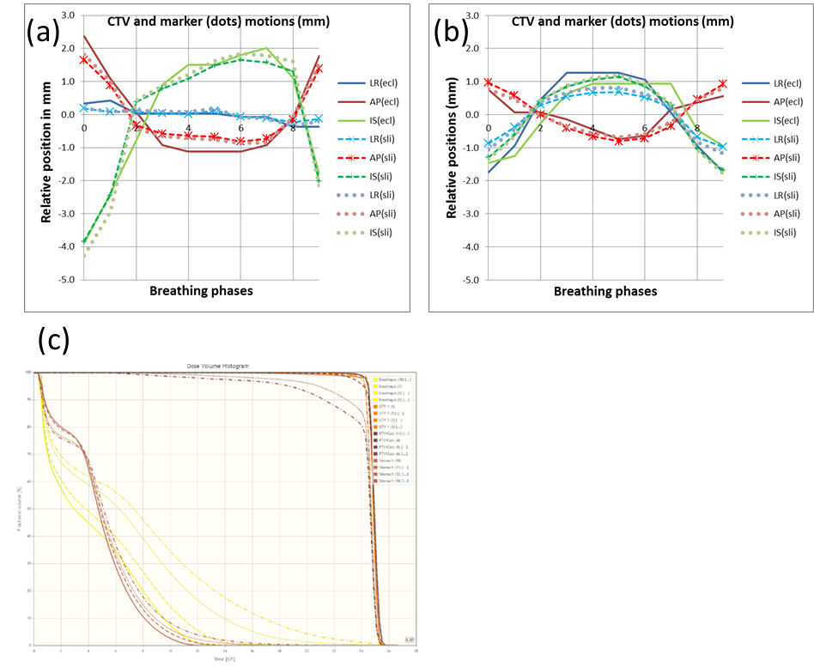

**Figure1.** Breathing motion curves of (a) patient 6 and (b) patient 7. (c) Dose volume histograms using midV CT and the ITV-based irradiated plans for patient 1. The solid line refers to the irradiated plan with clinical contours; the dashed line to the calculated midV CT plan using clinical contours; the dotted line to the irradiated plan with midV CT contours; and the dashed dotted line to the midV CT-based plan with midV CT contours.