Lift Distribution Tailoring Using TE Coanda Jet
Julian Pabon¹
University of Dayton, Dayton, Ohio, 45469, United States
Charles B. Cain²
University of Dayton, Dayton, Ohio, 45469, United States
and
Sidaard Gunasekaran³
University of Dayton, Dayton, Ohio, 45469, United States

Wings designed with a Prandtl bell-shaped lift distribution exhibit unique wake characteristics such as the absence of wingtip vortices, a parabolic downwash with upwash near the wingtips, and reduced induced drag for a fixed structural bending moment. Conventionally, this distribution is achieved through fixed geometric twist, taper, or aerodynamic twist, which fixes the design lift coefficient. This study presents an alternative approach in which a trailing edge Coanda jet is used to tailor the spanwise lift distribution on a half-span NACA 0009 wing, with the long-term goal of dynamically achieving a bell-shaped distribution. The Coanda jet is fed by a closed-loop controlled continuous circulation pump and discharges tangentially over a rounded trailing edge. An internal flow conditioning cavity featuring turning vanes, a perforated plate, a diffuser, and straightening vanes is designed to produce a spanwise-uniform jet. Two-dimensional, steady, incompressible Reynolds-Averaged Navier-Stokes simulations are conducted in scFLOW. A grid convergence study under laminar assumptions yields a jet exit uniformity index of 0.948 with a Richardson-extrapolated value of 0.965. Streamwise particle image velocimetry at four spanwise stations of the half-span NACA 0009 wing in the University of Dayton Water Tunnel demonstrates qualitatively consistent wake modifications, supporting spanwise-uniform Coanda actuation at the slot.

Nomenclature
AR = aspect ratio
b = wingspan, m
c = chord length, m
CL = lift coefficient
Cμ = jet momentum coefficient
Di = induced drag, N
h = Coanda jet slot height, m
L = lift force, N
ṁ = mass flow rate, kg/s
N = number of mesh elements
p = pressure, Pa
Rec = chord-based Reynolds number
r = Coanda surface radius, m
Ui = local velocity magnitude, m/s
Ū = average velocity along jet exit, m/s
U∞ = freestream velocity, m/s
Vjet = Coanda jet exit velocity, m/s
y+ = non-dimensional wall distance
α = angle of attack, deg
γ = area-weighted uniformity index
Γ = spanwise circulation, m²/s
μ = lift distribution ratio
ξ = normalized spanwise location, 2y/b
ρ = density, kg/m³
I. Introduction and Background
The spanwise lift distribution of a wing has a first-order influence on its induced drag, downwash field, structural loading, and wake topology. Following Prandtl’s classical lifting-line theory, the elliptical lift distribution minimizes induced drag for a fixed wingspan¹. However, a fixed-wingspan elliptical loading produces a strong wingtip vortex with an abrupt switch from downwash inboard to upwash beyond the wingtip, which causes a number of undesirable side effects including induced drag, wake hazards to trailing aircraft, and adverse yaw on roll-control surfaces. In a less well-known 1933 paper, Prandtl showed that if one instead constrains the wing root bending moment, the minimum-induced-drag solution becomes a non-elliptical, bell-shaped lift distribution that can be carried by a wing with a 22.5% larger span and produces approximately 11% less induced drag than the elliptical case at the same structural weight². The bell-shaped distribution also produces a parabolic downwash field, with a smooth transition to upwash inboard of the wingtip near the 70% half-span location, which has been argued to be the primary mechanism responsible for proverse yaw observed on bell-loaded flying wings¹.
NASA’s PRANDTL-D series of flying-wing demonstrators, developed by Bowers et al., was the first modern aircraft explicitly designed for a bell-shaped lift distribution¹. High-fidelity RANS computations by Hammer and Garmann on the PRANDTL-D3C planform later confirmed several non-intuitive flow features tied to the bell loading³. At the bell-shape design incidence, a clearly defined wingtip vortex is absent from the near wake; below the design condition, a tip vortex of opposite sense (an underside tip vortex) forms; and above the design condition, the wingtip vortex returns with the conventional sign. The wake at the design point consists of a thin, weakly rolled vorticity sheet rather than a discrete pair of trailing vortices, consistent with the parabolic downwash field. Independent wind-tunnel and panel-method studies by Cain and Gunasekaran on a straight, twist-only rectangular wing reproduced this absence of a near-wake wingtip vortex at the bell-shape design condition and showed that the same wake structure emerged in a simple two-dimensional vortex model⁴. These studies collectively establish that the bell-shaped lift distribution produces a qualitatively distinct wake that is of clear interest for drag reduction, formation flight, and wake-vortex hazard mitigation.
Conventional approaches to obtain a bell-shaped lift distribution rely on fixed geometric twist, planform taper, aerodynamic twist, or a combination of these features^{1,3}. A consequence of this design philosophy is that the bell-shape distribution is rigidly tied to a single design lift coefficient. At off-design incidence, a wingtip vortex returns, with continuous variation in strength and sense across angle of attack^{3,4}. The motivation of the present work is to explore whether an active flow control (AFC) strategy can tailor the spanwise lift distribution to a target shape (including a bell-shaped distribution) across a range of angles of attack on a single, geometrically simple wing, and thereby preserve the favorable wake characteristics over a broader flight envelope.
Among AFC strategies, circulation control using a Coanda jet is particularly attractive for tailoring lift. A Coanda jet emits a thin, high-momentum wall jet tangentially over a rounded convex trailing edge surface. Because the curvature of the surface produces a wall-normal pressure gradient that balances the centrifugal acceleration of the jet (dp/dr = ρu²/r), the jet remains attached to the surface and turns through a large angle before separating^{5,8}. The jet entrains the external flow, shifts the rear stagnation point and aft loading, and changes the bound circulation, thereby altering the lift produced by the section. The earliest large-scale aerodynamic exploitation of this concept came through Englar and co-workers’ work on circulation control wings, including the A-6/CCW flight demonstrator and a wide variety of subsequent test articles⁵. Englar and Jones extended this to pulsed Coanda actuation for high-lift augmentation⁶, and Greenblatt and Wygnanski reviewed the broader use of periodic excitation for separation control⁷.
More recent work has focused on Coanda actuation as a fluidic replacement for moving control surfaces and as a means to alleviate gust and maneuver loads. Düssler, Siebert, and Bauknecht integrated a Coanda flow actuator on the lower surface of a NACA 2412 airfoil and demonstrated steady-blowing lift decrements exceeding typical gust-induced loads, with characteristic onset times short enough to compete with gust-load-alleviation requirements⁸. Warsop and Crowther summarized the use of fluidic effectors for flight control of tailless aircraft such as the MAGMA and DEMON UAVs, where Coanda valves replace conventional ailerons and rudders entirely⁹. Closed-loop Coanda actuation studies by Williams et al. have shown that the actuator bandwidth and response time can be sufficient for active alleviation of unsteady aerodynamic loads¹⁰. On the modeling side, Henry, Williams, and Borrelli have proposed an empirical model that captures how lift augmentation by trailing-edge circulation control effectors scales with the span fraction occupied by the actuator, opening the way to using partial-span Coanda jets as targeted lift effectors¹¹. Yan, McCrink, and Bons have extended the trailing-edge Coanda concept to the propeller slipstream of a VTOL tail-sitter, replacing the elevon on a NACA 0012 section¹². Numerically, Rizzetta and Garmann have performed high-fidelity unsteady simulations of Coanda-jet flow control on a wing section, including segmented and sweeping-jet arrangements that reduce mass-flow requirements while maintaining lift augmentation¹³. Traub and Biegner demonstrated that a self-contained circulation control wing carrying its own onboard pumping is viable at sub-scale wind-tunnel sizes¹⁴, while Murnieks et al. studied the placement of TE Coanda actuators relative to upstream propellers¹⁵.
Despite this body of literature, very few studies have explicitly used a trailing edge Coanda jet to target a specific spanwise lift distribution. In typical circulation-control applications, the Coanda jet is either applied over the full span as a lift-augmentation flap^{5,6,8,13} or as a fluidic effector that replaces a discrete control surface such as an aileron^{9,11,12}. The literature on partial-span effectors shows that the local circulation increment scales with both jet momentum coefficient Cμ and the spanwise extent of the slot¹¹, which suggests that a partial-span Coanda jet can produce a controlled, localized change in spanwise loading. The present work builds on this observation. By placing a partial-span trailing edge Coanda jet on an otherwise untwisted, rectangular NACA 0009 wing and adjusting jet momentum, the spanwise circulation distribution can be shifted away from the elliptic/uniform shape that the untwisted wing would naturally produce, and toward the bell-shaped distribution characterized in^{3,4}. If successful, this approach decouples the bell-shape target from a single design lift coefficient and removes the need for permanent geometric twist.
The present paper reports on the design and computational validation of the internal flow conditioning cavity required to feed a uniform Coanda jet for these wake-tailoring experiments. The same closed-loop pump system that was previously characterized for active flow control on a 60° delta wing¹⁶ is reused here, and is described briefly in the Experimental Setup section. The planned particle image velocimetry test matrix at four spanwise stations in the University of Dayton Water Tunnel is then presented. Two-dimensional, steady, incompressible RANS simulations of the internal cavity under both laminar and SST k-ω turbulent assumptions are reported, with the laminar grid-convergent solution used to justify the production of a near-uniform jet at the slot exit. Experimental PIV validation of the resulting wake and the lift redistribution will follow in a future companion paper.
II. Experimental Setup
A. University of Dayton Water Tunnel
All experiments are performed at the University of Dayton Water Tunnel (UDWT). A detailed description of the facility and its closed-loop motion stage is given in Pabon and Gunasekaran¹⁶ and Mongin and Gunasekaran¹⁷. The UDWT is a horizontal, free-surface water tunnel with a 6:1 contraction and a test section 38 cm wide, 46 cm tall, and 152 cm long. The free-surface speed range is 7.5–38 cm/s. The facility is equipped with a one-degree-of-freedom motion stage consisting of a H2W Technologies linear motor driven by a Xenus XTL-230-18 motor driver (Copley Controls). The motor drives a rack-and-pinion gear that converts linear motion into rotational motion, allowing the wing model to be pitched statically or dynamically within the test section. Closed-loop feedback and control are handled by a dSPACE MicroLabBox running MATLAB Simulink. Force and torque are measured with an ATI Mini40 sensor read through a NET F/T box interfaced to the MicroLabBox via the dSPACE Ethernet Blockset. The wing model is mounted on the force sensor and the linear actuator is used to change the angle of attack. The use of a half-span model is noted to weaken leading-edge-vortex (LEV) formation due to the absence of asymmetric vibrations that aid full-span models¹⁶, a consideration that is less critical for the NACA 0009 rectangular wing used here but is mentioned for completeness.
B. Test Article: NACA 0009 Wing with Internal Coanda Cavity
The test article is a half-span rectangular wing with a NACA 0009 cross-section, fabricated using fused deposition modeling. The wing is hollow and contains an internal flow conditioning cavity that supplies the trailing edge Coanda jet. Figure 1 shows the CAD geometry in top and orthogonal views. Water is supplied to the wing through a feed line at the wing root and follows a 90° bend at the root before passing through a series of internal flow conditioning features: a set of turning vanes inside the elbow, a perforated plate that establishes upstream pressure recovery, a wide-angle diffuser, and a row of straightening vanes located near the jet exit. The flow then discharges as a thin, spanwise-uniform jet over a rounded trailing edge surface, exploiting the Coanda effect to remain attached to the curved aft body before separating from the wing^{5,8}. The Coanda jet is partial-span and is centered along the spanwise direction of the wing in order to allow tailoring of the lift distribution toward a bell-shape target, following the partial-span scaling arguments of Henry et al.¹¹. The slot height is set to 0.25 mm in the as-built geometry to provide a thin, high-momentum jet within the bounds imposed by additive-manufacturing tolerances.
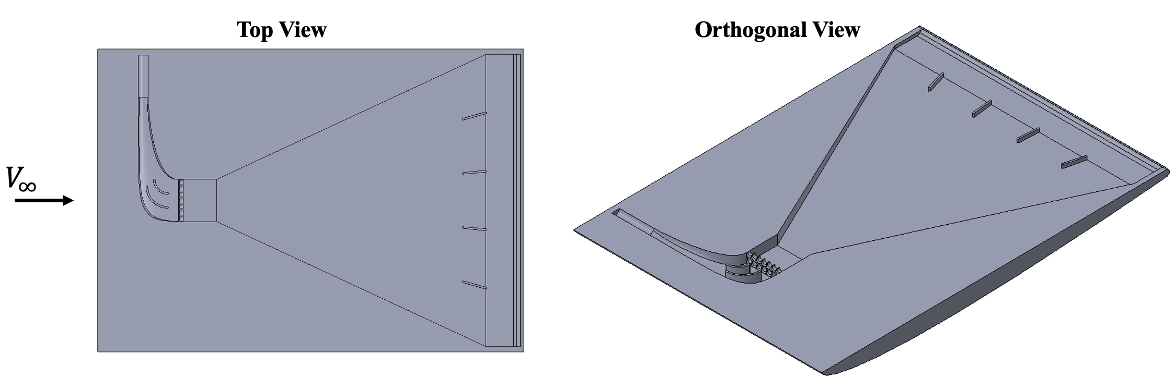
Fig. 1 CAD geometry of the half-span NACA 0009 wing with internal Coanda jet cavity. Top view (left) and orthogonal view (right) showing the internal channel routing from root to trailing edge.
Figure 2 shows the two-dimensional layout of the internal cavity in the spanwise mid-plane. Flow enters through the root inlet, turns 90° through a curved duct that is equipped with two turning vanes, and then passes through a perforated plate. The perforated plate sets a streamwise pressure drop that promotes spanwise pressure recovery and breaks up the strong gradients introduced by the 90° turn. The flow then enters a wide-angle diffuser that decelerates the bulk flow and increases the effective cross-sectional area. A set of four straightening vanes oriented along the desired discharge direction is placed within the diffuser to suppress cross-streamwise flow and recirculation, before the flow exits through the rectangular jet slot at the trailing edge. The same flow conditioning topology (turning vanes, perforated plate, diffuser, straightening vanes) was identified by Yan et al.¹² as an effective internal layout for trailing-edge Coanda actuators and is adapted here for the half-span NACA 0009 geometry.
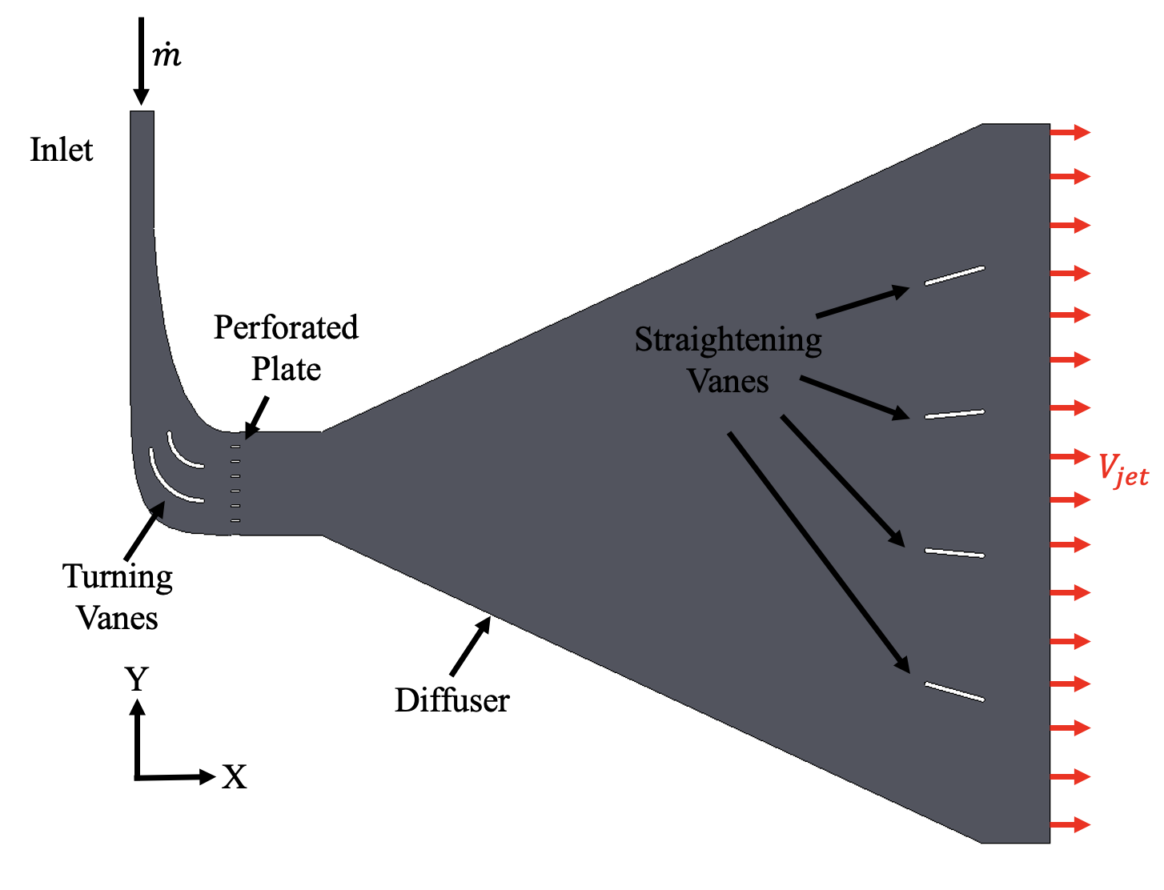
Fig. 2 Two-dimensional internal geometry of the trailing edge Coanda cavity showing the inlet, turning vanes, perforated plate, wide-angle diffuser, straightening vanes, and the spanwise-uniform jet exit.
C. Closed-Loop Coanda Jet System
The Coanda jet is supplied by a closed-loop controlled DC pump system that is reused from the prior delta-wing blown-jet investigation of Pabon and Gunasekaran¹⁶. In that prior work, the same pump and feedback architecture were used to drive a blown jet on a 60° sharp-edged delta wing in order to delay leading-edge-vortex breakdown and to redistribute non-circulatory and circulatory lift during static and dynamic pitching maneuvers. The closed-loop architecture was shown to deliver a repeatable mass flow rate at momentum coefficients between zero and Cμ ≈ 0.063 across both quasi-steady (k = 0.025) and unsteady (k = 0.05, 0.075) pitching profiles, indicating that the controller and pump are capable of sustained, low-variability blowing during dynamic maneuvers. The present work inherits that same pump, flow sensor, and Arduino/dSPACE bridge with no architectural change; only the actuator port (a single-port blown jet) is replaced with the spanwise Coanda slot described above.
The pump system, schematically shown in Figure 3, comprises four major components. A SEN-HW06K hall-effect flow sensor measures the volumetric flow rate from the pump and outputs a square pulse whose frequency varies between approximately 15 and 75 Hz over the operating range. An Arduino Uno R3 applies a calibration to the sensor signal and produces a corresponding 0–5 V analog output to the dSPACE MicroLabBox using an MCP4725 breakout board. The pump itself is a DC50E continuous circulation pump capable of flow rates up to 26 L/min while maintaining a consistent delivery pressure. The pump motor is commanded with a 5 V analog signal that determines the motor speed. Based on the measured flow rate, the MicroLabBox closed-loop throttles the pump to track the desired flow rate. A 5 PSI pressure transducer is included downstream of the pump for diagnostics. The system is designed with modular hardware interfaces so that an Arduino, a Raspberry Pi, or a dSPACE MicroLabBox can serve as the controller.
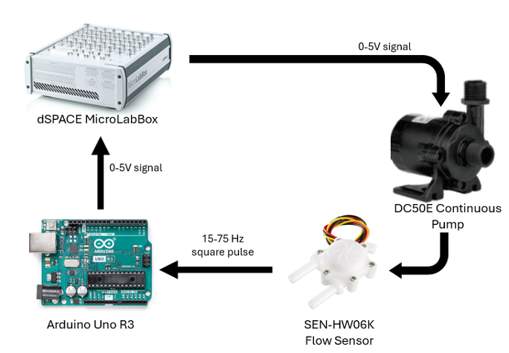
Fig. 3 Closed-loop visualization of the Coanda jet pump system, including the dSPACE MicroLabBox controller, DC50E continuous circulation pump, SEN-HW06K hall-effect flow sensor, and Arduino Uno R3 signal-conditioning bridge.
The flow sensor is calibrated by operating the motor and flow meter in open loop and comparing the manually measured flow rate against the sensor output frequency. Water is pumped at fixed motor commands into a bucket while the mass is recorded with a scale and timer, and the Arduino simultaneously logs the flow-meter pulse frequency. The resulting calibration curve is shown in Figure 4 and is applied during all closed-loop experiments. The calibration is highly linear across the operating range, which confirms that the hall-effect sensor output frequency is a faithful proxy for the volumetric flow rate.
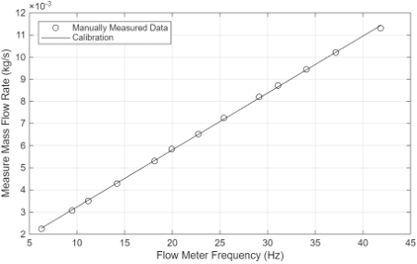
Fig. 4 Flow meter calibration curve showing the measured mass flow rate versus flow-meter pulse frequency. The fit is used to convert the sensor signal into a closed-loop feedback variable.
D. Particle Image Velocimetry Setup
Streamwise particle image velocimetry (PIV) is conducted with a LaVision DaVis 10 acquisition and processing system. A Photron FastCam Mini WX camera with a 2061 × 2061-pixel sensor and a 105 mm Nikkor lens images the field of view around the wing. Calibration with a machined dot plate yields a spatial resolution of 8.66 pix/mm. The image acquisition frame rate is adjusted to produce an 8–10 pix particle displacement between image pairs. A 2.4 W, 532 nm continuous laser from LaVision is combined with a Powell lens to form the laser sheet, which illuminates 60 μm polyamide seed particles that are evenly dispersed in the tunnel. The camera and laser are mounted to a vertically traversing optical bench, so that the laser-sheet plane and camera field of view remain aligned while traversing to any spanwise station of interest along the wing. Figure 5 shows the PIV test setup, with the laser sheet illuminated and the field of view (FOV) framed near the wing trailing edge.
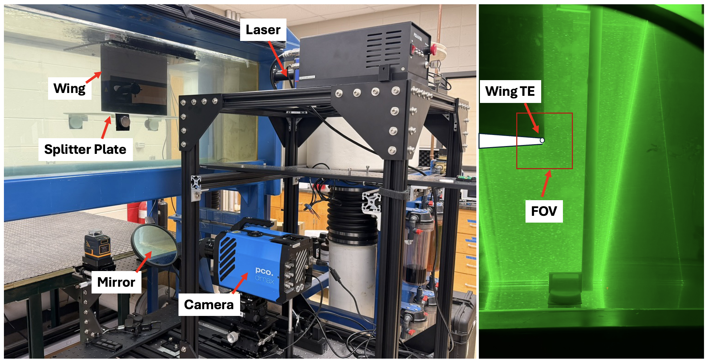
Fig. 5 PIV test setup at the UDWT. Left: the wing, splitter plate, traversing optical bench, camera, and mirror used to fold the laser sheet under the test section. Right: laser-sheet view showing the wing trailing edge (TE) and the framed PIV field of view (FOV).
E. Test Matrix
Streamwise PIV is performed at four spanwise stations of the half-span NACA 0009 wing in order to characterize the local wake and to assess the spanwise re-distribution of circulation produced by the Coanda jet. Stations are reported as a fraction of the half-span, measured from the wing root. At each station, paired runs are acquired with the Coanda jet on and off so that the change in the wake velocity field can be directly attributed to the Coanda actuation while holding all other settings fixed. The freestream velocity is held at 0.34 m/s for all PIV runs, which corresponds to the highest freestream speed available in the UDWT that still permits adequate PIV image-pair displacement at the present camera frame rate. The full eight-run PIV test matrix is summarized in Table 1.
Table 1 PIV test matrix at the UDWT (freestream velocity in m/s).
Run | % Span | Freestream (m/s) | Coanda Jet
1 | 20% | 0.34 | On
2 | 20% | 0.34 | Off
3 | 40% | 0.34 | On
4 | 40% | 0.34 | Off
5 | 60% | 0.34 | On
6 | 60% | 0.34 | Off
7 | 80% | 0.34 | On
8 | 80% | 0.34 | Off

The four spanwise stations were chosen to span both the inboard region (20% and 40%), where the bell-shape distribution carries most of the circulation, and the outboard region (60% and 80%), where the bell-shape distribution transitions toward zero loading and where the absence of a wingtip vortex is most clearly observed^{3,4}. Paired On/Off runs at each station allow direct comparison of the cross-stream wake topology with and without Coanda actuation, mirroring the wake comparison strategy employed in the bell-shape lift PIV study of Cain and Gunasekaran⁴. Additional spanwise stations and additional momentum coefficients are reserved for a future expansion of the test campaign once the present test matrix has been completed.
III. Computational Setup
Numerical simulations of the internal Coanda cavity were carried out to verify that the proposed flow conditioning produces a near-uniform jet at the trailing edge slot before fabrication and PIV measurement of the wing in the UDWT. The cavity geometry shown in Figure 2 is intrinsically three-dimensional, but the height of the embedded channel is small and the design intent is to produce a spanwise-uniform jet at the wing trailing edge. To keep the analysis tractable within the present project scope, the geometry is reduced to its two-dimensional spanwise mid-plane representation. This 2D simplification removes the chord-normal contraction at the jet exit, but it retains all of the flow conditioning features upstream of the slot. The simulated “jet exit” is therefore taken just upstream of the slot contraction; the underlying claim is that if the simulated jet exit is uniform, then the corresponding physical slot will also produce a uniform jet.
Steady, incompressible flow of water at 20°C is modeled in Cradle scFLOW using the built-in material definition. Convergence is monitored using a relative residual criterion of 1 × 10⁻⁴. Boundary conditions are assigned through the scFLOW Condition Wizard. At the inlet, a y-component velocity of −0.6328 m/s is imposed, derived from the design mass flow rate of 0.02 kg/s through the inlet cross-section. The outlet is held at a static pressure of 0 Pa. The default boundary is assigned a free-slip condition. The wall, vane, and perforated wall regions are stationary no-slip walls. Two turbulence treatments are considered: a laminar (no-model) flow and the SST k–ω turbulence model. The latter is selected because the chord-based Reynolds number at the cavity inlet is approximately 65,000, which is consistent with the low-to-moderate-Reynolds regime where the SST formulation is typically employed.
Meshing is performed with the scFLOW octree mesher with prism layer insertion at all no-slip walls. A baseline minimum octant size of 1.5 mm is used, and boundary refinement is applied twice to the wall, vane, and perforated-wall surfaces by selecting the wall regions, expanding to neighboring nodes, and applying refinement. The mesh is generated using the sweep method to produce a pseudo-2D mesh. Prism layer insertion uses an angle setting of 360° for both selected and unselected model edges, with a maximum insertion angle of 180°. For the laminar grid convergence study, three meshes are generated: coarse, medium, and fine. Each successive mesh increases the global refinement passes and reduces the wall octant size, while the first prism-layer thickness is recomputed in each case as one-third of the measured wall octant size to maintain a consistent relative wall resolution. Table 2 lists the resulting mesh parameters. For the turbulent grid convergence study, a finer near-wall mesh is required to resolve the boundary layer; the corresponding mesh settings are given in Table 3. The number of prism layers is doubled at each refinement (8 → 16 → 32) in both studies.
Table 2 Laminar mesh settings for the three grid-convergence cases.
Parameter | Coarse | Medium | Fine
Global refinement passes | 1 | 2 | 3
Wall octant size [m] | 1.875×10⁻⁴ | 9.37×10⁻⁵ | 4.68×10⁻⁵
First prism layer thickness [m] | 6.25×10⁻⁵ | 3.13×10⁻⁵ | 1.56×10⁻⁵
y⁺ | 1.23 | 0.61 | 0.31
Prism layer growth rate | 1.10 | 1.07 | 1.05
Number of prism layers | 8 | 16 | 32
Total elements | 219,316 | 691,480 | 2,043,278

Table 3 Turbulent (SST k-ω) mesh settings for the three grid-convergence cases.
Parameter | Coarse | Medium | Fine
Global refinement passes | 0 | 1 | 2
Wall octant size [m] | 9.38×10⁻⁵ | 4.69×10⁻⁵ | 2.34×10⁻⁵
First prism layer thickness [m] | 3.13×10⁻⁵ | 1.56×10⁻⁵ | 7.81×10⁻⁶
y⁺ | 0.61 | 0.31 | 0.16
Prism layer growth rate | 1.10 | 1.07 | 1.05
Number of prism layers | 8 | 16 | 32
Total elements | 79,856 | 322,230 | 740,716

Representative mesh cross-sections in the region between the turning vanes and the perforated plate are shown in Figure 6 for the laminar grid study and Figure 7 for the turbulent grid study. Three regions of varying refinement are visible near the surface, corresponding to the two-level boundary refinement applied to all no-slip walls. The turbulent meshes show the additional near-wall clustering that drives y⁺ below unity in all cases.
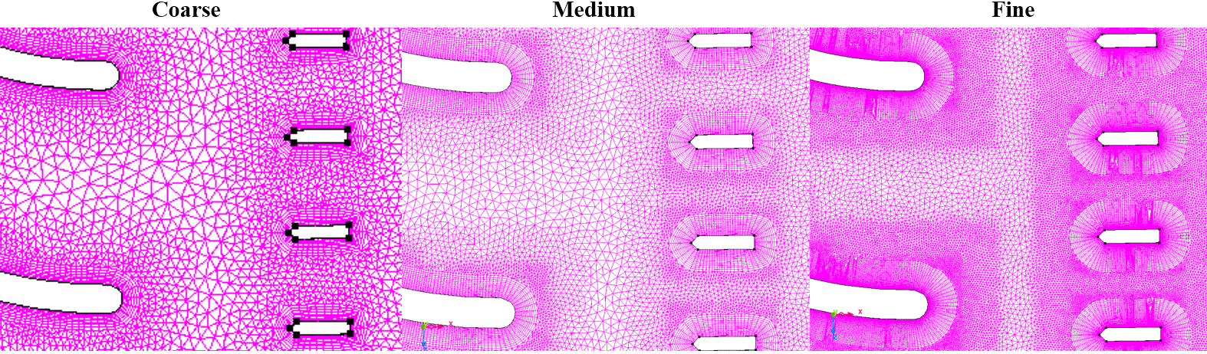
Fig. 6 Octree mesh comparison between coarse, medium, and fine grids used in the laminar grid-convergence study, zoomed in on the region between the turning vanes and the perforated plate.
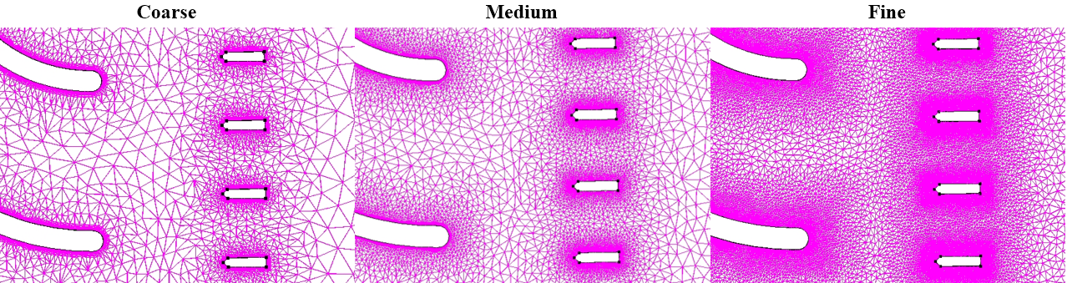
Fig. 7 Octree mesh comparison between coarse, medium, and fine grids used in the SST k-ω grid-convergence study. Near-wall clustering is increased relative to the laminar cases to drive y⁺ below unity.
To evaluate spanwise uniformity at the jet exit, the discrete area-weighted uniformity index is computed from the local velocity magnitude profile at the slot, following the standard form used in commercial CFD post-processors and in prior internal-flow studies¹²:
γ = 1 − Σ_{i=1}^{N} |U_{i} − Ū| / (2ŪN) (1)
In Eq. (1), U_{i} is the local velocity magnitude at sample point i along the jet exit line, Ū is the average velocity along that line, and N is the number of sample points. A value of γ = 1 corresponds to a perfectly uniform jet; γ → 0 corresponds to a highly non-uniform jet.
IV. Results
The two turbulence treatments produce strikingly different solutions for the same cavity geometry, mass-flow inlet, and outlet pressure boundary. Figure 8 places the fine-mesh laminar and SST k-ω turbulent velocity magnitude contours side by side, with streamlines overlaid in both panels to highlight the bulk flow topology. The laminar solution (left panel) is nearly symmetric about the channel centerline: streamlines pass through the turning vanes and the perforated plate, spread smoothly through the wide-angle diffuser, and arrive at the jet exit with a velocity magnitude that is low in absolute terms but uniform across the slot. The straightening vanes near the trailing edge appear to act as designed, partitioning the diffuser flow into roughly equal lanes that exit the cavity together. There is no clearly visible recirculation, the flow turns through the 90° root bend without strong separation, and the flow conditioning elements (turning vanes, perforated plate, diffuser, straightening vanes) collectively deliver the spanwise-uniform jet that the design was intended to produce.
The turbulent solution (right panel of Figure 8) is qualitatively different. The flow turns through the root bend and remains tightly attached to the upper wall of the bend; on entering the diffuser, the flow forms a curved, high-velocity sheet that hugs the upper diffuser wall and persists nearly all the way to the jet exit, while the lower portion of the diffuser is occupied by slow-moving fluid and small-scale recirculation. The turning vanes and the perforated plate appear to have little effect on redirecting or homogenizing the bulk flow in this case, in contrast to their clear role in the laminar solution. The asymmetric upper-wall jet survives all the way to the slot, which produces a jet exit profile that is strongly biased toward one end of the slot rather than being spanwise-uniform. The same qualitative behavior persists across the turbulent coarse and medium meshes (not shown for brevity); none of the SST k-ω solutions delivers a uniform jet.
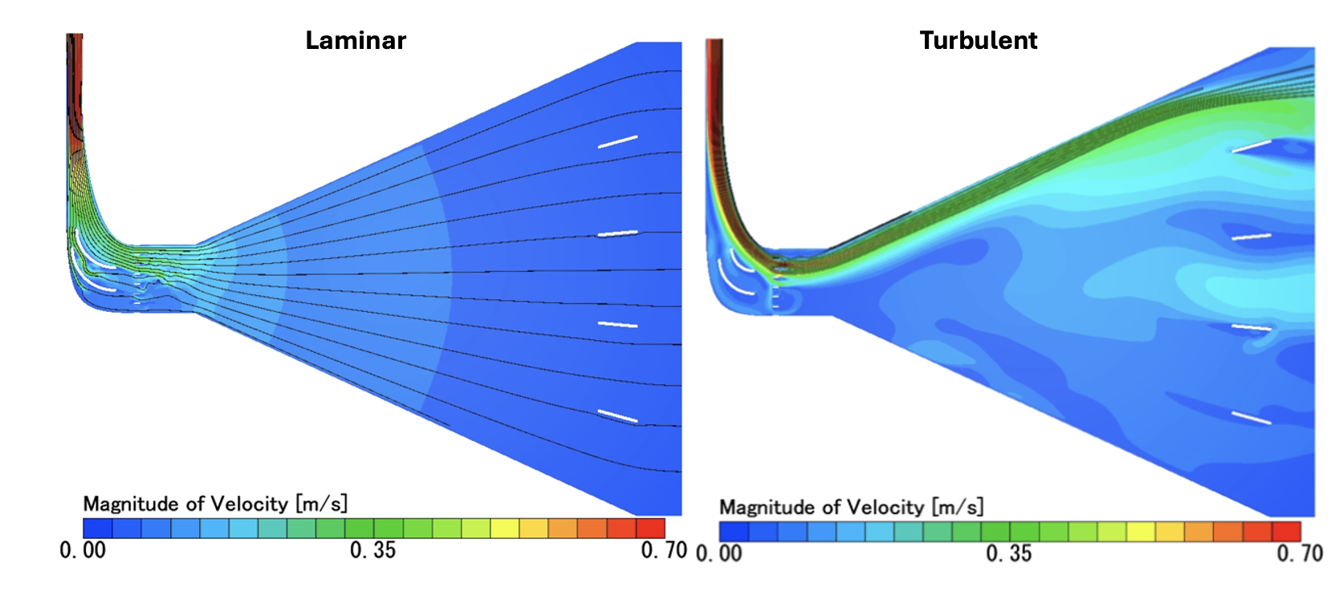
Fig. 8 Velocity magnitude contours with overlaid streamlines for the fine grid under laminar (left) and SST k-ω turbulent (right) assumptions. The laminar solution is nearly symmetric about the channel centerline and delivers a spanwise-uniform jet at the slot, while the turbulent solution forms a curved upper-wall jet that bypasses the flow conditioning and produces a strongly non-uniform jet exit.
The qualitative difference between the laminar and turbulent flow fields is reflected quantitatively in the area-weighted uniformity index γ defined in Eq. (1). Figure 9 presents γ as a function of mesh refinement for both turbulence treatments. For the laminar case (left panel), γ rises monotonically from 0.7883 on the coarse mesh, to 0.9062 on the medium mesh, to 0.9476 on the fine mesh. The largest jump (Δγ ≈ 0.118) occurs between the coarse and medium meshes and the next jump (Δγ ≈ 0.041) is smaller, which is the diminishing-increment behavior expected of a converging numerical solution. A Richardson extrapolation of these three values gives γ = 0.9647 at N⁻¹ → 0, placing the fine-mesh laminar solution within Δγ ≈ 0.017 of the extrapolated value. From a design-verification standpoint this is the key result of the present computational campaign: the proposed internal flow conditioning topology delivers a spanwise jet whose uniformity is above 0.94 on a converged mesh, which is sufficient to faithfully execute the bell-shape wake-tailoring strategy.
The turbulent uniformity index, shown in the right panel of Figure 9, tells a very different story. The coarse and fine SST k-ω meshes yield γ = 0.6470 and 0.6434 respectively, while the medium mesh drops to γ = 0.5624. The trend is non-monotonic — the medium mesh sits well below both the coarse and fine meshes — and all three turbulent values lie roughly 0.30 below the corresponding laminar values across the board. Because the trend is not monotonic, a Richardson extrapolation cannot be meaningfully applied to the turbulent data. Several adjustments were attempted to improve the turbulent results, including switching from SST k-ω to the standard k-ε turbulence model, replacing the outlet pressure condition with a natural inflow/outflow boundary, applying additional boundary refinement on all wall surfaces, and extending the outlet further downstream to move the boundary condition away from the region of interest. None of these adjustments produced a meaningful improvement, and the turbulent results therefore remain unsatisfactory within the scope of the present analysis. Possible explanations include under-resolution of the perforated-plate hole wakes by SST k-ω at the present low Reynolds number, the strong streamline curvature in the diffuser, and limitations of the 2D approximation when the underlying turbulent flow is inherently three-dimensional. A more rigorous treatment with full 3D meshing and possibly a hybrid RANS/LES turbulence model is reserved for future work. The design-verification conclusion of this paper rests on the converged laminar fine-mesh value of γ = 0.948 (Richardson-extrapolated 0.965), which is taken as sufficient evidence that the as-built cavity will deliver a near-uniform Coanda jet at the design mass flow rate.
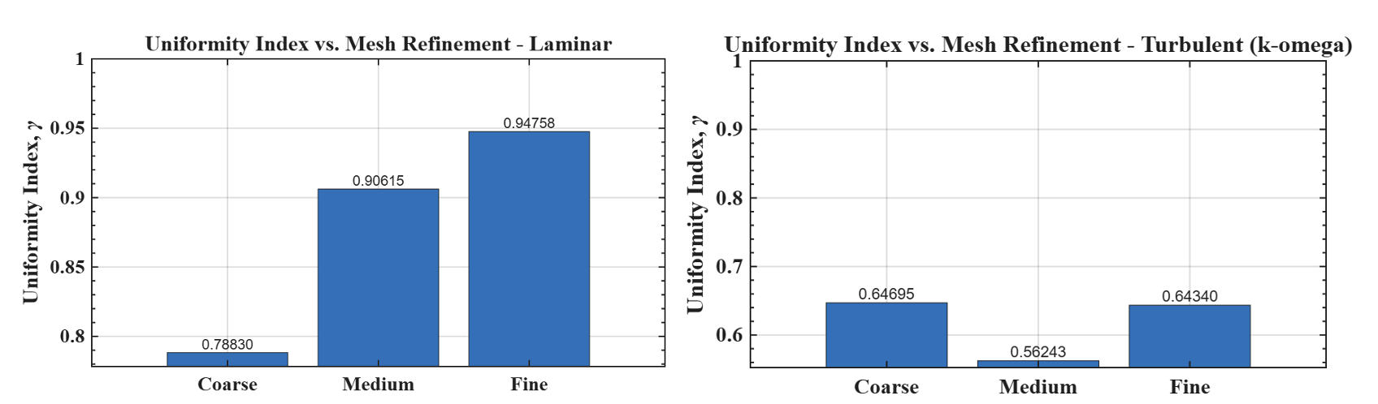
Fig. 9 Area-weighted uniformity index γ as a function of mesh refinement under laminar (left) and SST k-ω turbulent (right) assumptions. The laminar case converges monotonically toward γ = 0.948 on the fine mesh, whereas the turbulent case is non-monotonic with γ ≈ 0.56–0.65 across the three meshes.
C. Experimental PIV Wake Characterization
The internal-cavity simulations described above predict that the proposed flow conditioning will deliver a near-uniform jet at the slot. The aerodynamic question that this prediction enables is whether the resulting wake is itself modified in a spanwise-uniform manner. To address this, streamwise PIV was acquired at the four spanwise stations listed in Table 1 (20%, 40%, 60%, and 80% of the half-span), with paired runs at each station with the Coanda jet on and off. Figures 10, 11, and 12 present the normalized streamwise velocity ($U/U_{∞}$), normalized vertical velocity ($V/U_{∞}$) and normalized spanwise vorticity ($ωc/U_{∞}$), respectively. The top row of every figure shows the wake without AFC and the bottom row shows the wake with AFC, while the four columns correspond to the four spanwise stations from inboard (20%) to outboard (80%).
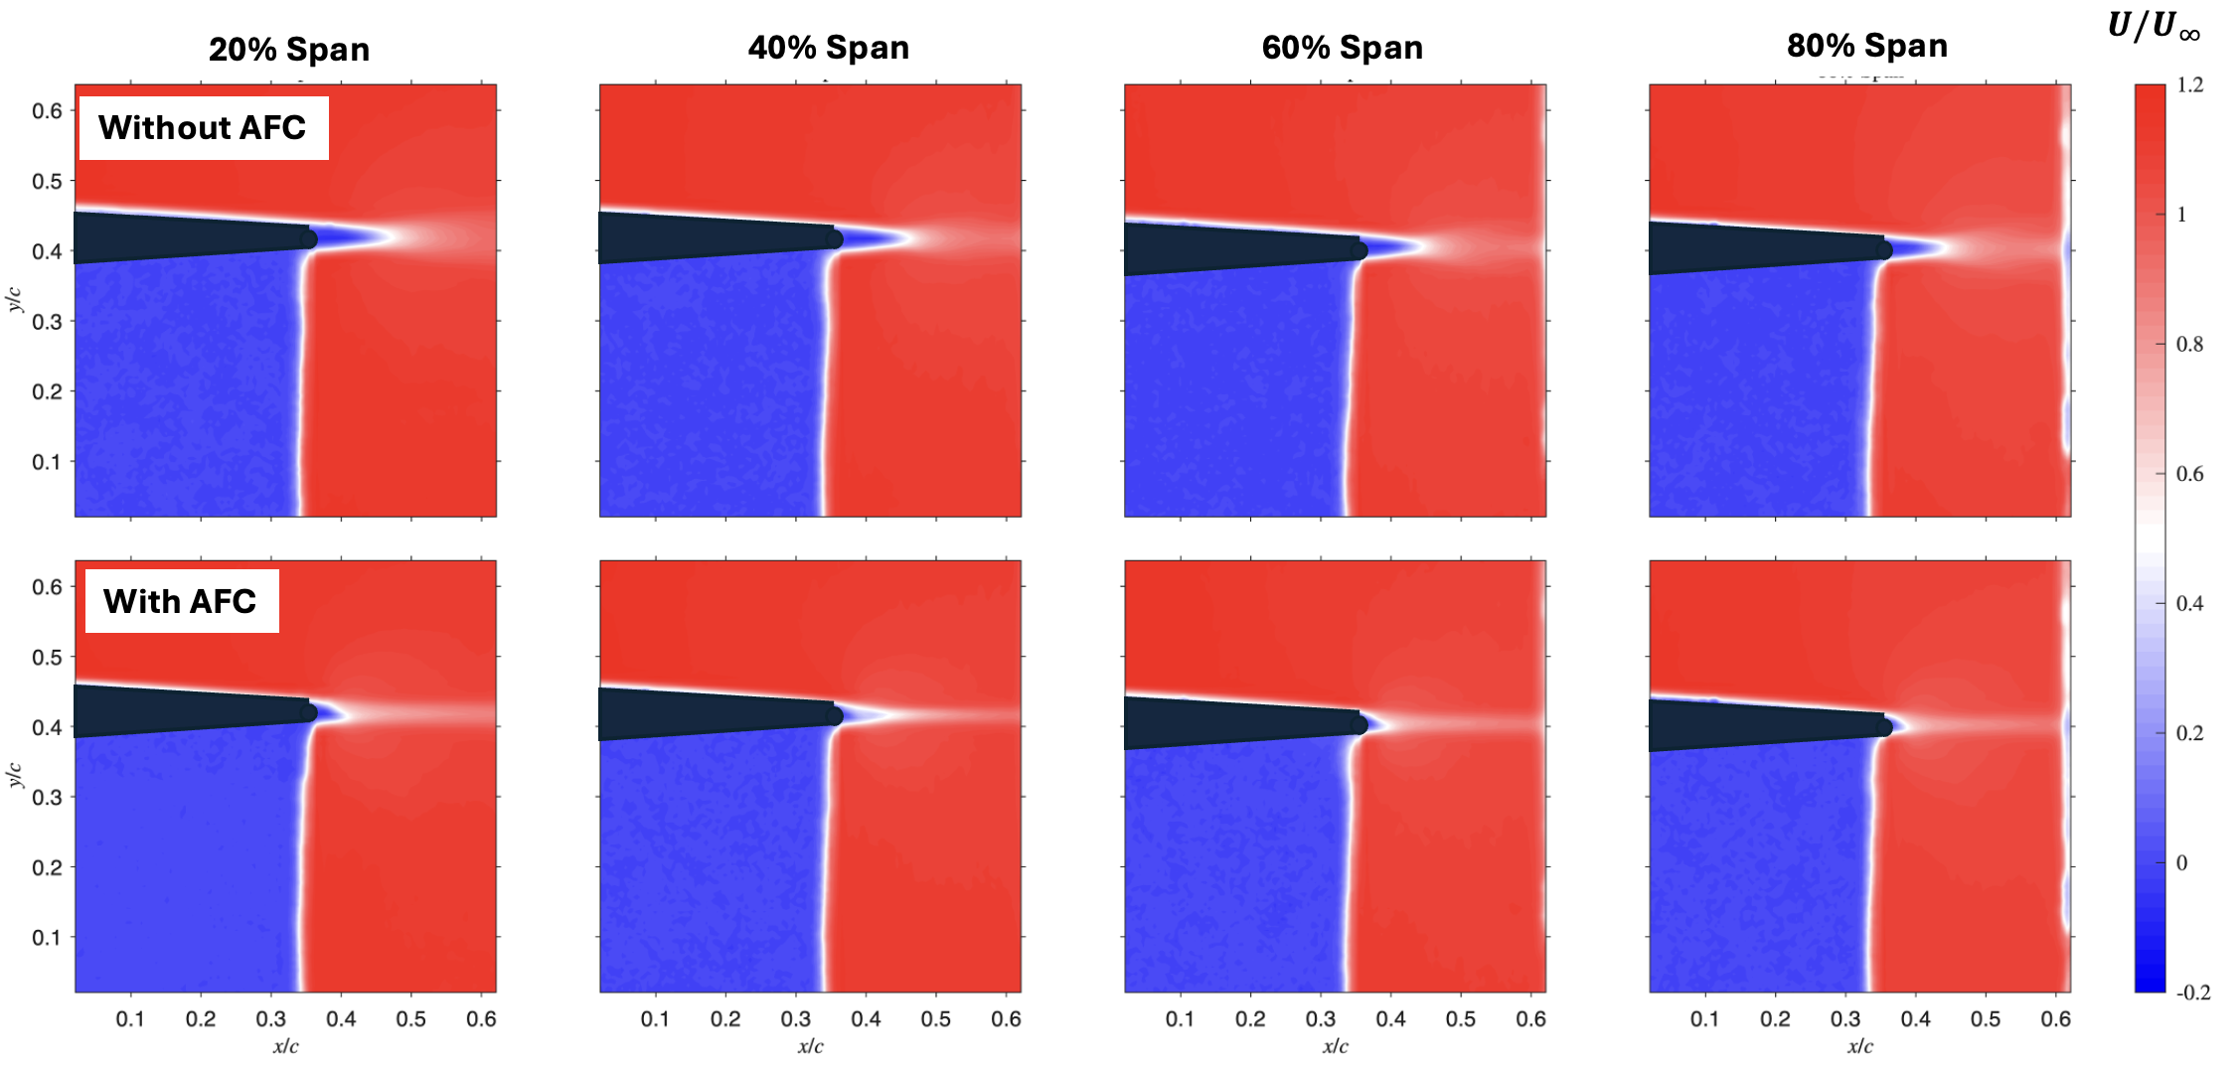
Fig. 10 Normalized streamwise velocity $U/U_{∞}$ contours at the four spanwise stations without AFC (top row) and with AFC (bottom row). The wake just aft of the trailing edge narrows and the low-momentum core is filled in with the Coanda jet on, and the modification is qualitatively the same across the four spanwise stations.
Figure 10 shows the streamwise-velocity contours. Comparing the top (no AFC) and bottom (with AFC) rows at each station, the wake just aft of the trailing edge is visibly narrower with AFC. The low-momentum core is shorter in the streamwise direction, and the wake centerline shifts slightly toward the lower (pressure) side. Both observations are consistent with the trailing-edge Coanda jet entraining the upper-surface flow, injecting streamwise momentum into the near wake, and turning the rear-stagnation streamline downward, behaving as a virtual aft flap. Across the four spanwise stations from 20% to 80%, the size, shape, and downward shift of the with-AFC wake are essentially the same. No spanwise station shows a markedly weaker or stronger response. This row-to-row similarity is the primary visual evidence that the actuator delivers a spanwise-uniform jet at the slot.
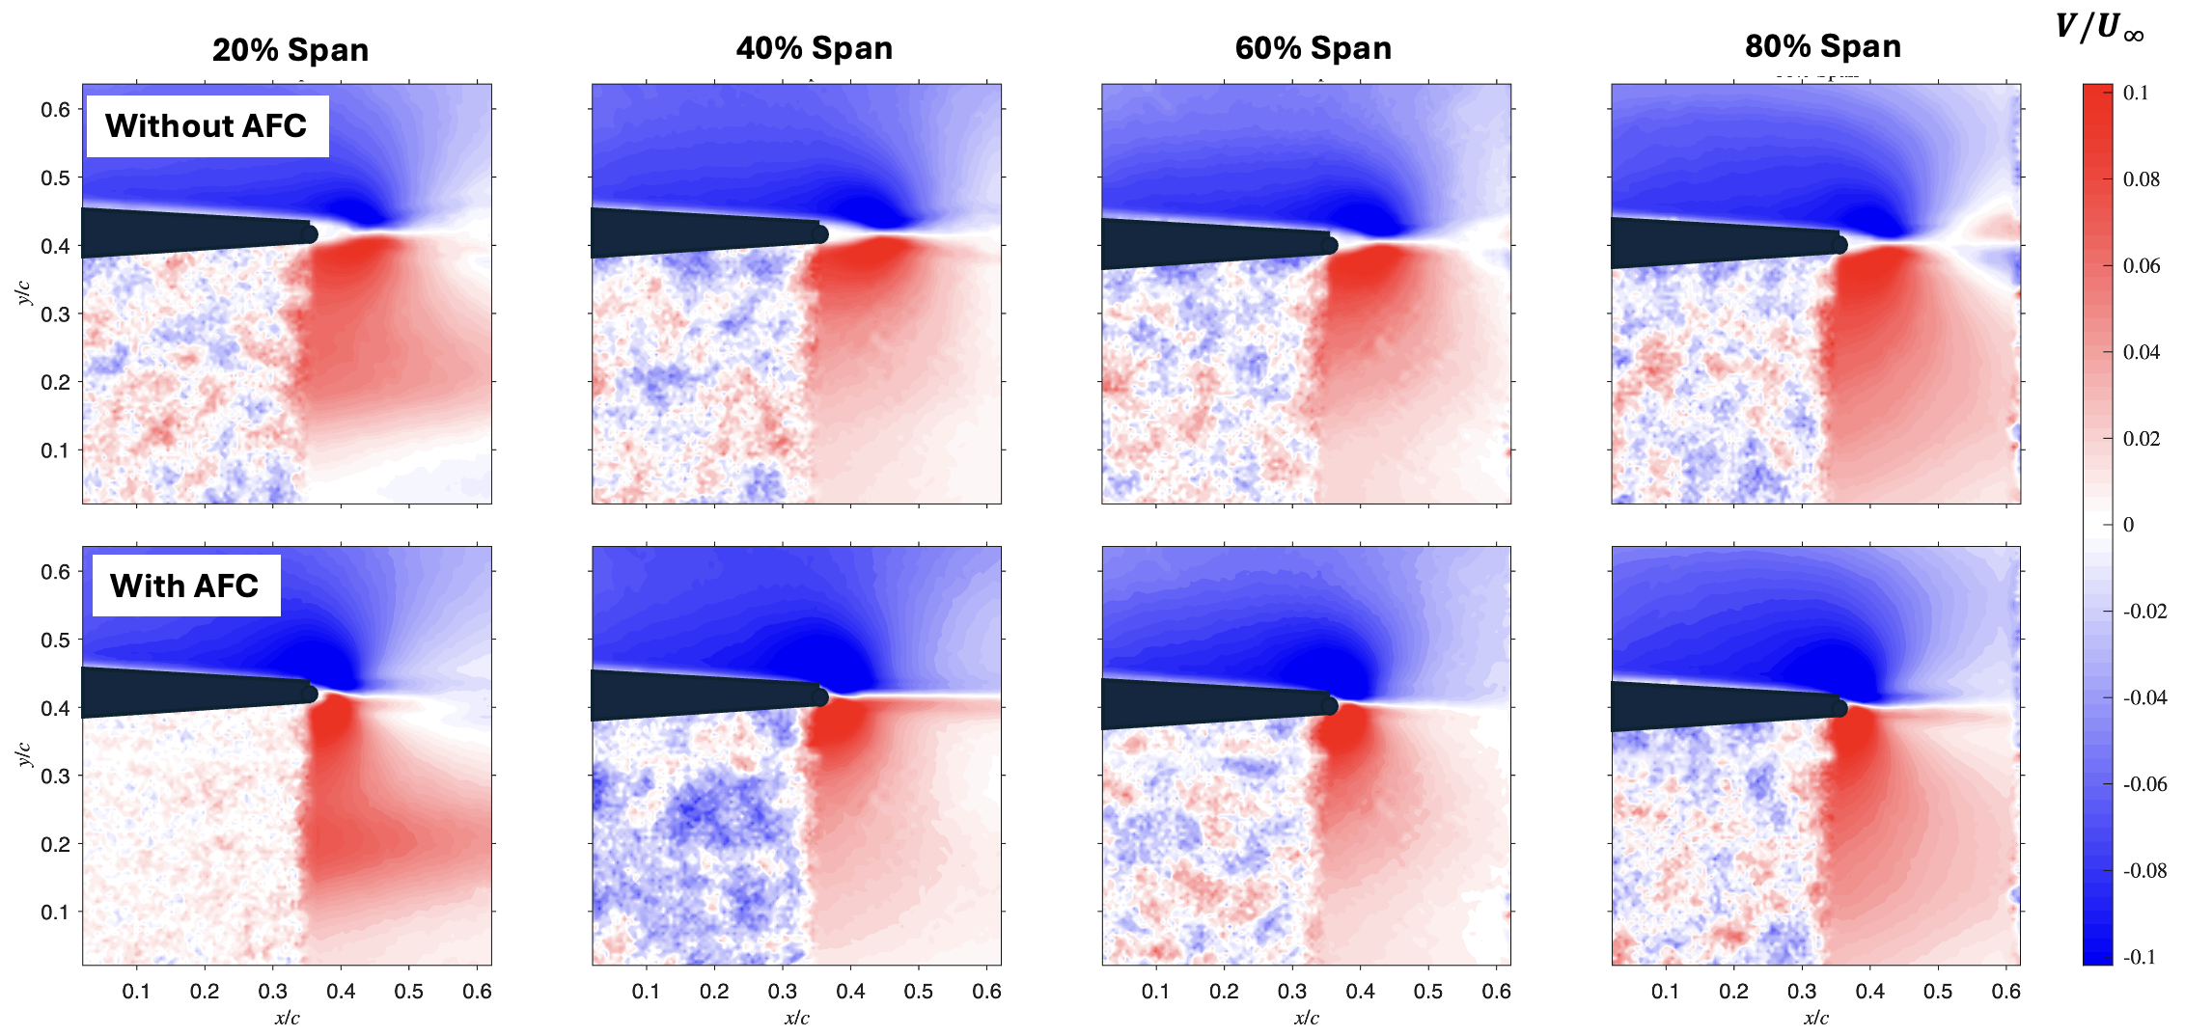
Fig. 11 Normalized vertical velocity $V/U_{∞}$ contours at the four spanwise stations without AFC (top row) and with AFC (bottom row). The downwash on the upper trailing-edge side and the upwash on the lower trailing-edge side both intensify with AFC, indicating an increase in aft loading. The modification is consistent across span.
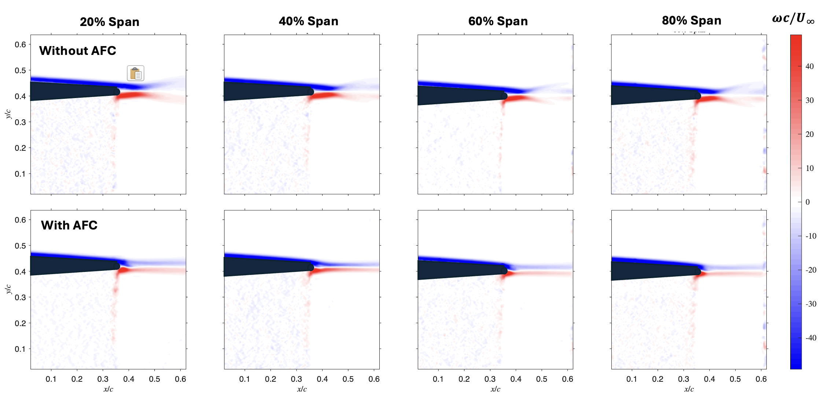
Fig. 12 Normalized spanwise vorticity ωc/U∞ contours at the four spanwise stations without AFC (top row) and with AFC (bottom row). The trailing-edge shear layers tighten and intensify with AFC, and the modification is qualitatively the same at all four spanwise stations.
Figure 11 shows the chord-normal velocity component, which is the more sensitive indicator of circulation change. Comparing the top and bottom rows, both red and blue zones intensify with AFC closer to the trailing edge at every spanwise station: the blue downward-V region above the trailing edge becomes darker and extends further into the wake, and the red upward-V region just below the trailing edge is enhanced. The strengthening of both red and blue regions appears equally at the 20%, 40%, 60%, and 80% stations, again indicating that the Coanda jet acts uniformly along the span of the actuator.
Figure 12 shows the normalized spanwise vorticity ($ωc/U_{∞}$), which isolates the trailing-edge shear layers from top and bottom surfaces of the airfoil. Without AFC, these two layers are visible but relatively diffuse, particularly the positive-ω lower-side layer, which is broadened by the recovery of the lower-surface boundary layer into the near wake. With AFC, both shear layers become noticeably thinner and more sharply concentrated, especially the positive-$ω$ layer on the lower side. The magnitude of the peak vorticity within each layer also increases. This is consistent with the Coanda jet accelerating the upper-surface and lower-surface flows asymmetrically through the trailing-edge region, sharpening the shear discontinuity and reducing the size of the wake deficit. The tightening of the trailing-edge shear layers occurs at every spanwise station and is visually indistinguishable from one column to the next, completing a third independent observation of the spanwise uniformity of the Coanda actuation.
Taken together, the three PIV datasets in Figures 10–12 support two complementary conclusions. First, the trailing-edge Coanda jet produces a measurable, repeatable change in the local wake structure: a narrowing of the streamwise wake, a stronger trailing-edge flow turning visible in the vertical-velocity field, and a tightening of the trailing-edge shear layers. All three changes are kinematically consistent with a circulation-control actuator that increases aft loading and bound circulation at the wing section where it is applied. Second, the qualitative behavior is essentially the same at all four spanwise stations from 20% to 80% of the half-span. No single station shows a weaker or stronger response than its neighbors. A more quantitative extraction of the wake-deficit-derived sectional drag, the circulation change, and the resulting spanwise lift redistribution toward a bell-shape target is reserved for the final version of the paper.

V. Conclusion
.
References
¹Bowers, A. H., Murillo, O. J., Jensen, R., Eslinger, B., and Gelzer, C., “On Wings of the Minimum Induced Drag: Spanload Implications for Aircraft and Birds,” NASA/TP-2016-219072, March 2016.
²Prandtl, L., “Über Tragflügel kleinsten induzierten Widerstandes,” Zeitschrift für Flugtechnik und Motorluftschiffahrt, Vol. 24, 1933, pp. 305–306.
³Hammer, P. R., and Garmann, D. J., “Wake-Structure of the Prandtl-D,” AIAA Paper 2023-4003, AIAA AVIATION 2023 Forum, San Diego, CA, June 2023.
⁴Cain, C. B., and Gunasekaran, S., “Wake Characteristics of a Bell-Shaped Lift Distribution,” AIAA Paper 2026-2327, AIAA SciTech 2026 Forum, Orlando, FL, January 2026.
⁵Englar, R. J., “Circulation Control Pneumatic Aerodynamics: Blown Force and Moment Augmentation and Modification; Past, Present, and Future,” AIAA Paper 2000-2541, June 2000.
⁶Jones, G. S., and Englar, R. J., “Advances in Pneumatic Controlled High Lift Systems Through Pulsed Blowing,” AIAA Paper 2003-3411, June 2003.
⁷Greenblatt, D., and Wygnanski, I. J., “The Control of Flow Separation by Periodic Excitation,” Progress in Aerospace Sciences, Vol. 36, No. 7, 2000, pp. 487–545.
⁸Düssler, S., Siebert, F., and Bauknecht, A., “Coandă-Type Flow Actuation for Load Alleviation,” Journal of Aircraft, Vol. 59, No. 5, 2022, pp. 1303–1316.
⁹Warsop, C., and Crowther, W. J., “Fluidic Flow Control Effectors for Flight Control,” AIAA Journal, Vol. 56, No. 10, 2018, pp. 3808–3824.
¹⁰Williams, D. R., Quach, V., Kerstens, W., Buntain, S., Heinz, G., Tadmor, G., and Colonius, T., “Alleviating Unsteady Aerodynamic Loads with Closed-Loop Flow Control,” AIAA Paper, AIAA Aerospace Sciences Meeting, January 2009.
¹¹Henry, J., Williams, D., and Borrelli, J., “A Model for the Scaling of Partial-Span Circulation Control Effectors,” AIAA Paper 2025-2050, AIAA SciTech 2025 Forum, Orlando, FL, January 2025.
¹²Yan, X., McCrink, M., and Bons, J., “The Application of Trailing Edge Coandă AFC in a Propeller Slipstream,” AIAA Paper 2025-2052, AIAA SciTech 2025 Forum, Orlando, FL, January 2025.
¹³Rizzetta, D. P., and Garmann, D. J., “Numerical Simulation of Unsteady Coanda-Jet Flow Control for a Wing Section,” AIAA Journal, 2025 (Article in Advance).
¹⁴Traub, L. W., and Biegner, M., “Experimental Evaluation of a Self-Contained Circulation Control Wing,” Journal of Aircraft, 2013.
¹⁵Murnieks, P., et al., “Wing Trailing-Edge Coanda Flow Control: Effect of Actuator Placement Relative to Upstream Propeller,” 2024.
¹⁶Pabon, J., and Gunasekaran, S., “Experimental Investigation of Dynamic Pitching Effects on a Delta Wing with Blown Jet,” AIAA Paper 2026-0285, AIAA SciTech 2026 Forum, Orlando, FL, January 2026.
¹⁷Mongin, J., and Gunasekaran, S., “Description of the University of Dayton Water Tunnel Facility and Force-Measurement Methodology,” University of Dayton (full citation TBD).

