
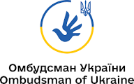
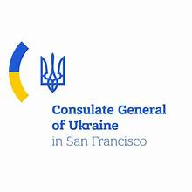

Invitation to a High-Level Policy Briefing on
Ukrainian Prisoners of War and Abducted Children

Dear Colleagues,
The Office of the Ukrainian Parliament Commissioner for Human Rights, in cooperation with the U.S.-based nonprofit organization Go Ukraina, has the honor to invite you to participate in a high-level virtual policy briefing with the Ukrainian Ombudsman, Mr. Dmytro Lubinets.
This briefing will address urgent humanitarian priorities arising from the ongoing war against Ukraine, specifically:
- efforts to secure the release of Ukrainian prisoners of war
- the return of Ukrainian children unlawfully deported or forcibly transferred
Participants will receive a direct institutional update from representatives of the Ombudsman’s Office regarding:
- documented violations of international humanitarian and human rights law, including torture and inhumane treatment
- the systematic deportation and forced transfer of Ukrainian children
- international legal mechanisms and accountability processes
- diplomatic and humanitarian coordination efforts

- opportunities for engagement and cooperation with U.S. policy institutions, advocacy organizations, and humanitarian partners
The purpose of this briefing is to strengthen transatlantic cooperation and support coordinated advocacy efforts aimed at protecting fundamental human rights and advancing humanitarian outcomes for Ukraine.
Briefing Details:
Format: Virtual Policy Briefing (Zoom)
Host: Office of the Ukrainian Parliament Commissioner for Human Rights
Co-Organizer: Go Ukraina (United States)
Speaker: Mr. Dmytro Lubinets, Ukrainian Parliament Commissioner for Human Rights
Duration: 45–60 minutes, including moderated Q&A
Working Language: Ukrainian (English translation)
Date and Time: To be confirmed upon registration
Kindly confirm your participation by replying to this invitation. Access details and background materials will be shared with confirmed participants in advance.
The Office of the Ukrainian Parliament Commissioner for Human Rights and Go Ukraina would highly value your participation and partnership in advancing international awareness and coordinated action on these critical humanitarian issues.


Respectfully,
Olena Simakovski
President & Co-founder
Go Ukraina Inc

