Machine Learning Operations (AIMLCZG523)
Assignment 1
Heart Disease Risk Prediction — End-to-End MLOps Pipeline
Model development, experiment tracking, CI/CD, containerisation, Kubernetes deployment and monitoring
Student | Sivaram Gudlavalleti
BITS ID | 2025ae05220
Course | Machine Learning Operations — AIMLCZG523
Dataset | UCI Heart Disease (Cleveland), 303 patients, 13 features
Code repository | https://github.com/gsivaram/2025ae05220MLOpsAssignment1
Video walkthrough | Google Drive — pipeline walkthrough video
Execution environment | BITS lab VM — Rocky Linux 9.5 (x86_64), Python 3.12.9, Docker 28.0.1, Minikube v1.39 / Kubernetes v1.37. All results and screenshots in this report were produced on the lab VM.
Date | October 2026

1. Overview
Objective. Build a classifier that predicts the presence of heart disease from routine clinical measurements and run it as a reproducible, tested, containerised and monitored API — following MLOps practice from raw data to a production-style Kubernetes deployment.
Approach. One Python package (src/heartrisk) holds all logic — data cleaning, features, training, evaluation, the API and its monitoring — so the same code is unit-tested, used by the notebook, executed in CI and shipped in the Docker image. Every stage is a single, repeatable command, and one runner (scripts/run_pipeline.py) executes the whole pipeline in the lab and records where and how it ran.
Area | Outcome
Selected model | L2 logistic regression (C = 0.3, balanced classes) — CV ROC-AUC 0.907 ± 0.019, test ROC-AUC 0.961, test recall 0.93
Experiment tracking | MLflow: 120 runs per pipeline execution (3 model families, 116 grid configurations, 1 selection run) with params, metrics, plots and model
Quality gates | 79 pytest tests, 98 % coverage; GitHub Actions lint → test → train → docker on every push / PR
Serving | FastAPI /predict with validation, confidence and risk band; slim, non-root Docker image with health check
Deployment | Minikube v1.39 / Kubernetes v1.37: 2–5 replicas (HPA, scaled to 3 under load), Service, NGINX Ingress, PDB, probes
Monitoring | Prometheus v3.15 (pod discovery, alert rules — down-alert verified firing) + Grafana 13.2 13-panel dashboard; JSON request logs
Table 1. Summary of results.
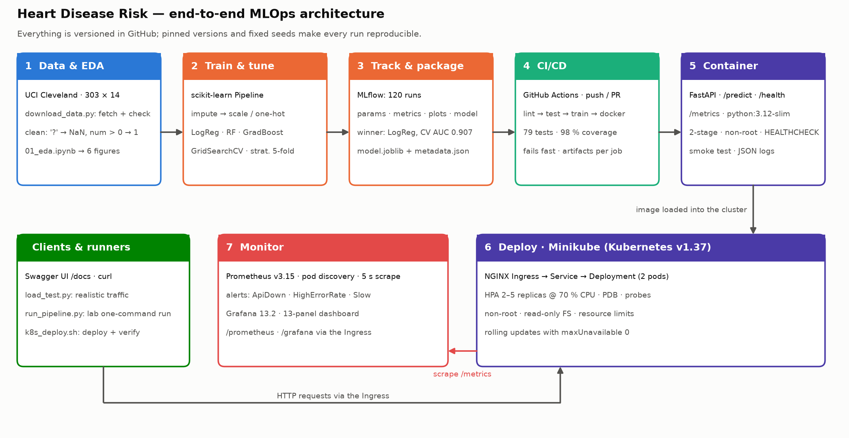
Figure 1. System architecture — numbered stages follow the life of the model from raw data to monitored service.

2. Setup and installation
Prerequisites: Python ≥ 3.10 (3.12 used), git, Docker (user in the docker group). Kubernetes tools are installed automatically into ~/.local/bin without sudo. All Python dependencies are pinned to exact versions in requirements.txt (serving subset in requirements-serve.txt) — important because a pickled scikit-learn model must be loaded with the version that saved it.
git clone https://github.com/gsivaram/2025ae05220MLOpsAssignment1.git && cd 2025ae05220MLOpsAssignment1
conda activate base && python -m venv .venv && conda deactivate # lab: system python3 is 3.9
source .venv/bin/activate
pip install -r requirements.txt && pip install -e .

python scripts/run_pipeline.py # lint → data → eda → train → test → predict → docker
bash scripts/k8s_deploy.sh all # minikube + app + Prometheus/Grafana, verified end-to-end
python scripts/load_test.py --url http://$(minikube -p heartrisk ip) --duration 300 --rps 10
Lab notes. On the lab VM the system python3 is 3.9, so the virtual environment is created from conda's Python 3.12 and conda is then deactivated. The lab VM can change between sessions (the project folder persists), so k8s_deploy.sh recreates the cluster from scratch in about six minutes when needed. LAB_RUNBOOK.md lists every command.

3. Data acquisition and exploratory analysis
scripts/download_data.py downloads processed.cleveland.data from the UCI repository (falling back to the committed copy if the network blocks it), logs its SHA-256 and writes data/processed/heart_clean.csv. Cleaning rules live in heartrisk.data.clean() and are unit-tested:
Raw-data issue | Handling
No header row | Column names assigned from the UCI documentation
? placeholders in ca (4) and thal (2) | Parsed as missing; imputed inside the model pipeline (fitted on training folds only — no leakage)
Target num is a 0–4 severity | Binarised: disease present if num > 0 → 139 positive / 164 negative (46 %)
Codes outside documented domain, zero BP/cholesterol | Set to missing (none in Cleveland, guarded for new data)
Duplicates, rows without target | Dropped (none found)
Table 2. Data cleaning decisions.
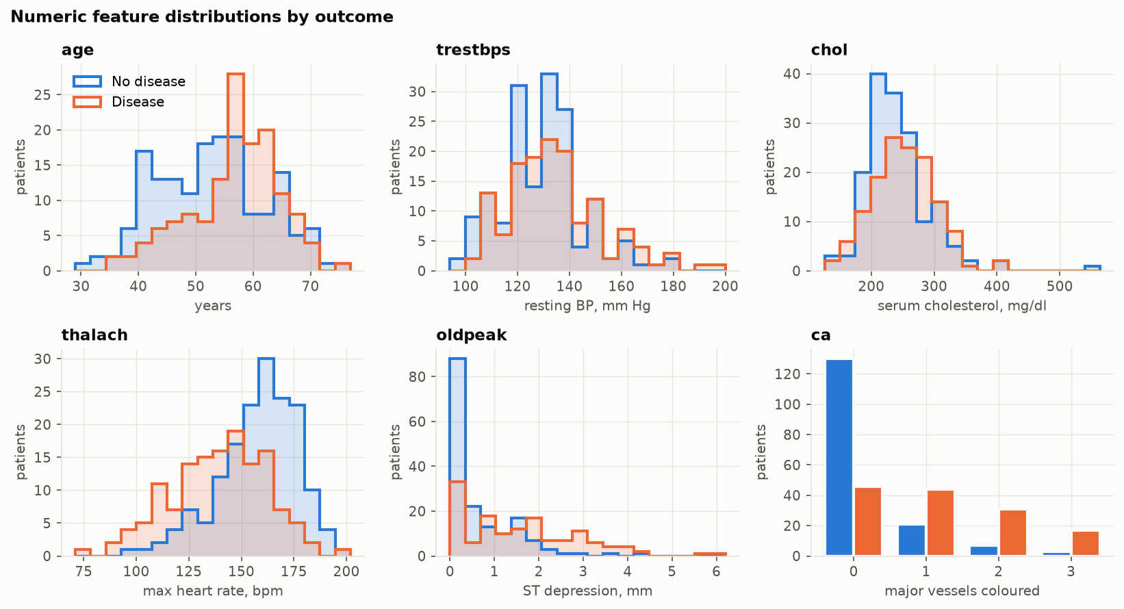 | 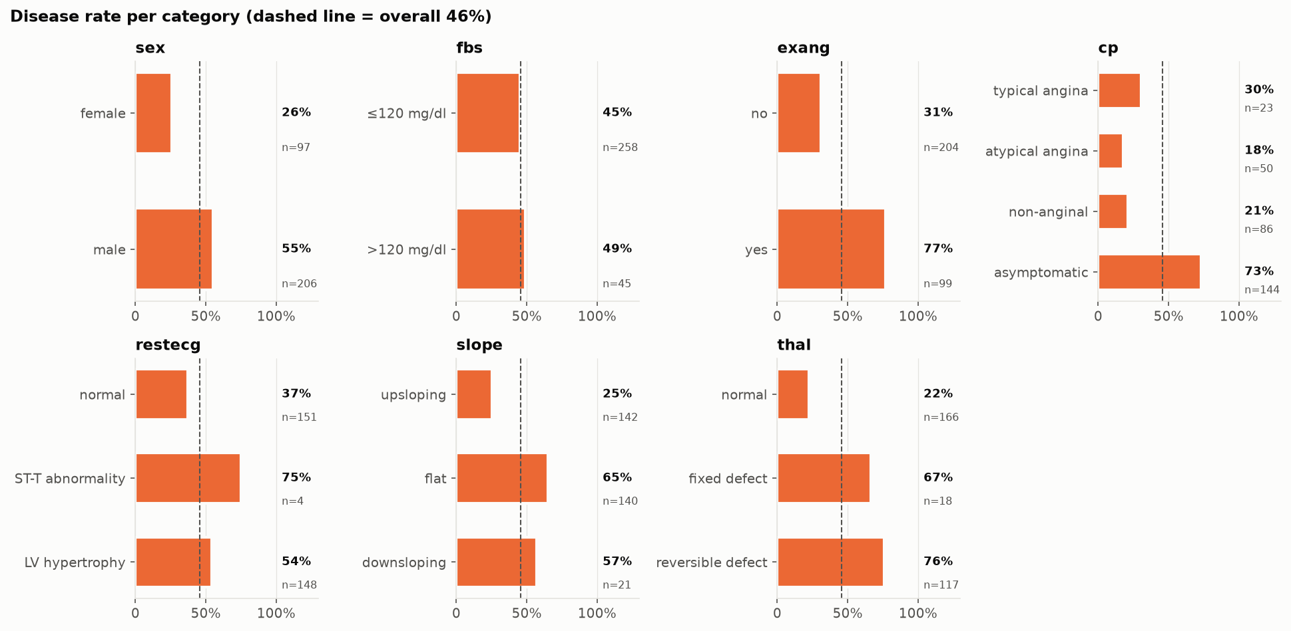
Figure 2. Left: numeric features by outcome — max heart rate shifts down and ST depression up with disease. Right: disease rate per category against the 46 % baseline.
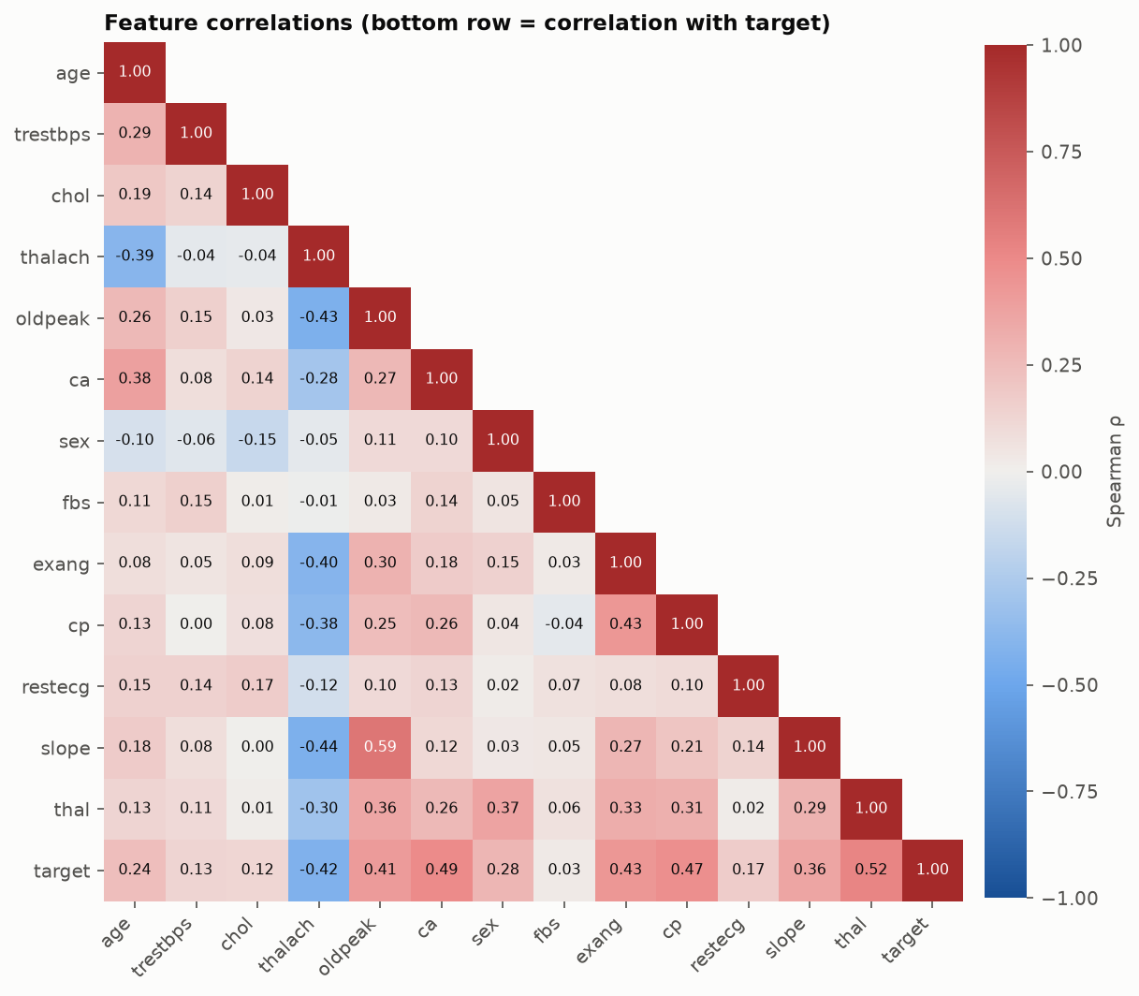 | 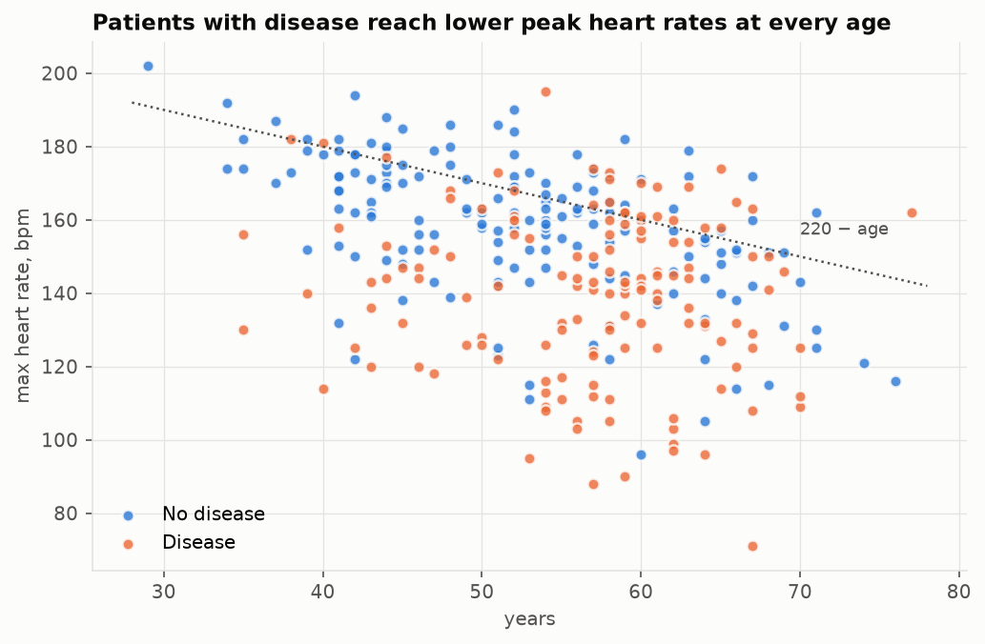
Figure 3. Left: Spearman correlations (bottom row vs. target). Right: diseased patients peak well below the age-predicted maximum heart rate.
- Classes are close to balanced (54 / 46), so accuracy is meaningful, but recall (missed patients are the costly error) and ROC-AUC are tracked too, with stratified CV.
- Strongest signals: thal (ρ 0.52), ca (0.49), cp (0.47), exang, thalach (−0.42), oldpeak; weakest: fbs (0.03) and chol (0.12).
- No pair of features exceeds |ρ| = 0.6 (max oldpeak–slope 0.59): no multicollinearity concern. Clinically plausible outliers are kept.

4. Feature engineering and model development
One pipeline for training and serving. build_pipeline() chains ClinicalFeatures (adds hr_reserve = thalach / (220 − age), motivated by the right panel of Figure 3) → a ColumnTransformer (median-impute + standard-scale numerics, most-frequent-impute + one-hot nominal codes cp, restecg, slope, thal, impute binaries) → classifier. The fitted Pipeline is the saved artefact, so preprocessing can never drift between training and inference.
Model selection and tuning. Data is split 80/20 (stratified, seed 42). Each candidate is tuned with GridSearchCV on stratified 5-fold CV of the training split, refitting on mean CV ROC-AUC; the held-out 20 % is only used for reporting. Whether the engineered feature is used is itself a grid parameter, so its value is measured rather than assumed.
Model | Grid (116 configurations in total) | Best parameters
Logistic regression | C ∈ {0.01…3}, L1/L2, class_weight ∈ {none, balanced}, hr_reserve on/off (48) | C = 0.3, L2, balanced, no hr_reserve
Random forest | 300 trees, depth ∈ {None, 4, 6}, min leaf ∈ {1, 3, 5}, max_features ∈ {sqrt, 0.5}, hr_reserve (36) | depth 6, min leaf 3, sqrt
Gradient boosting | 100/250 trees, lr ∈ {0.03, 0.1}, depth ∈ {2, 3}, subsample ∈ {0.7, 1}, hr_reserve (32) | 100 trees, lr 0.03, depth 2, subsample 0.7
Table 3. Search spaces and selected hyper-parameters.
Model | CV ROC-AUC | CV accuracy | CV precision | CV recall | Test ROC-AUC | Test recall
Logistic regression | 0.907 ± 0.019 | 0.855 | 0.882 | 0.801 | 0.961 | 0.929
Random forest | 0.901 ± 0.025 | 0.822 | 0.831 | 0.774 | 0.951 | 0.929
Gradient boosting | 0.887 ± 0.023 | 0.826 | 0.844 | 0.774 | 0.959 | 0.929
Table 4. Cross-validated (5-fold, training split) and held-out test metrics (identical in both lab executions).
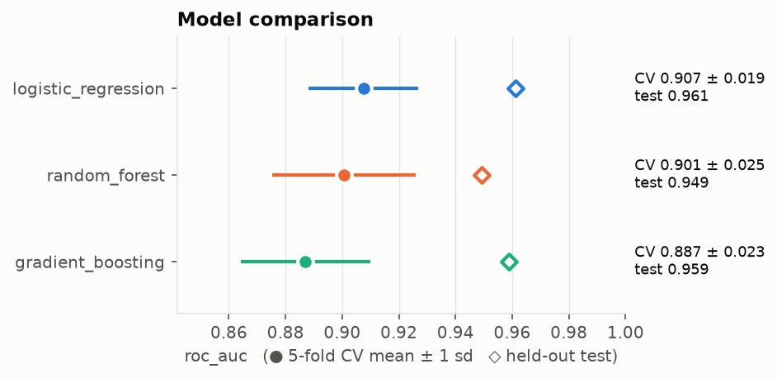 | 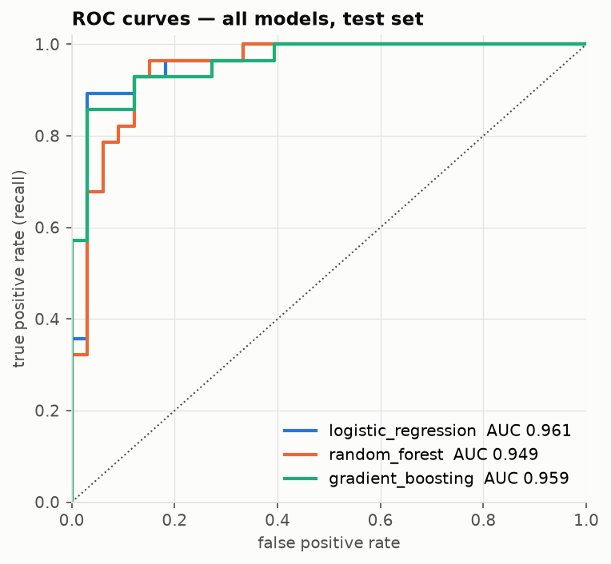
Figure 4. Left: CV mean ± 1 sd (dots) and test score (diamonds). Right: ROC curves of all three models on the test set.
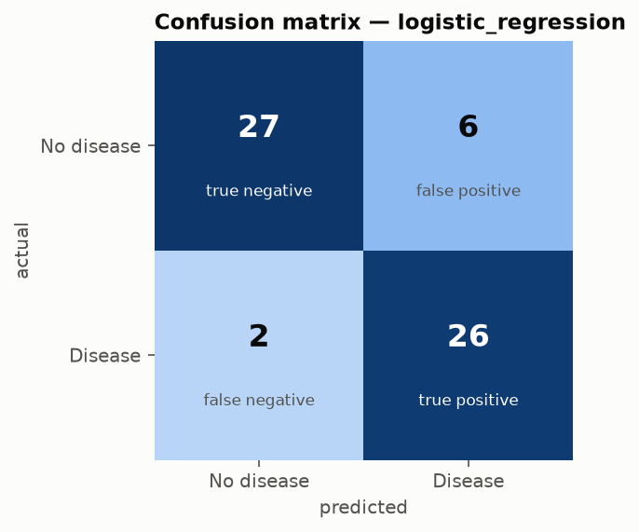 | 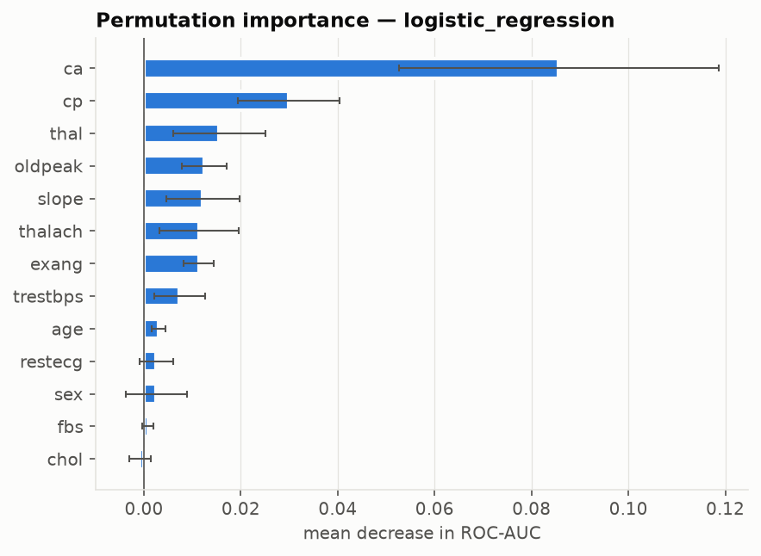
Figure 5. Selected model on the test set: 2 missed patients and 6 false alarms out of 61; ca, cp and thal matter most.
- Simplest model wins. With 242 training rows the regularised linear model has the best CV ROC-AUC, the lowest variance and the best CV recall; tree ensembles add variance without gain.
- The engineered feature did not help any model (best CV ROC-AUC with vs. without it differs by ≤ 0.002), so the grid dropped it — a useful negative result: the models already capture it from age and thalach.
- Test > CV is noise, not leakage: 61 test rows give a wide confidence interval, which is why selection uses CV only.

5. Experiment tracking with MLflow
Experiment heart-disease-risk has three levels: one parent run per model family (best params, CV mean/sd and test metrics, ROC, PR, confusion and permutation-importance plots, the CV table and the logged model with signature, input example, bundled code and pinned requirements), a nested child run for each of the 116 grid configurations, and a `model_selection` run with the comparison plots. The winning run is tagged selected=true and its id is written into models/metadata.json, linking the deployed model back to its experiment. The lab store shows 240 runs because the pipeline was executed twice on the lab VM (a checkpoint and the final run); both produced identical metrics.
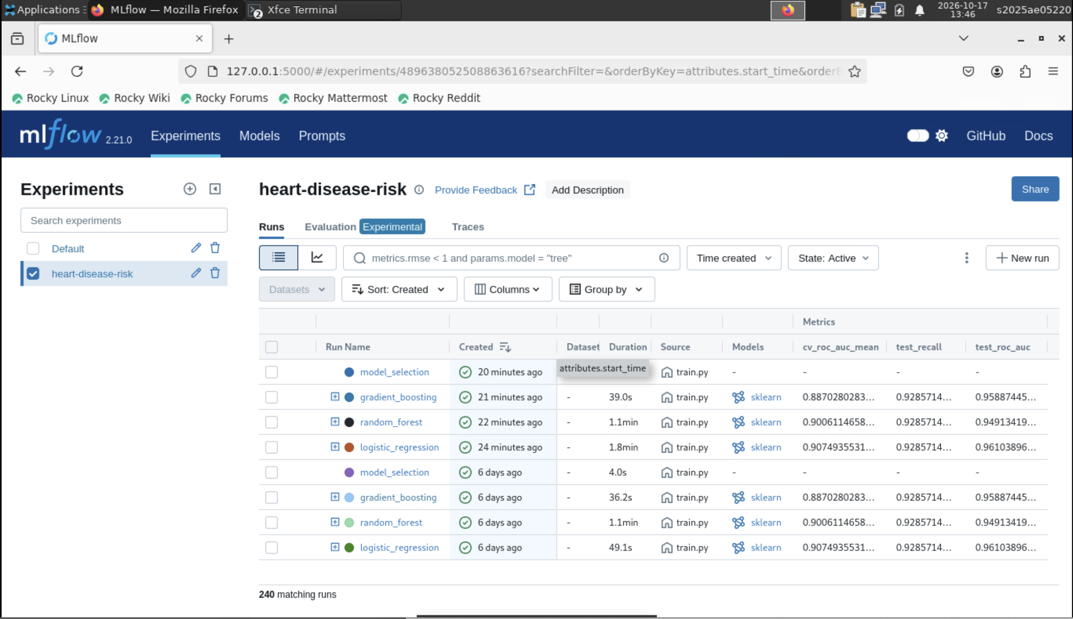
Figure 6. MLflow runs table on the lab VM: parent runs per model family with CV and test metrics.
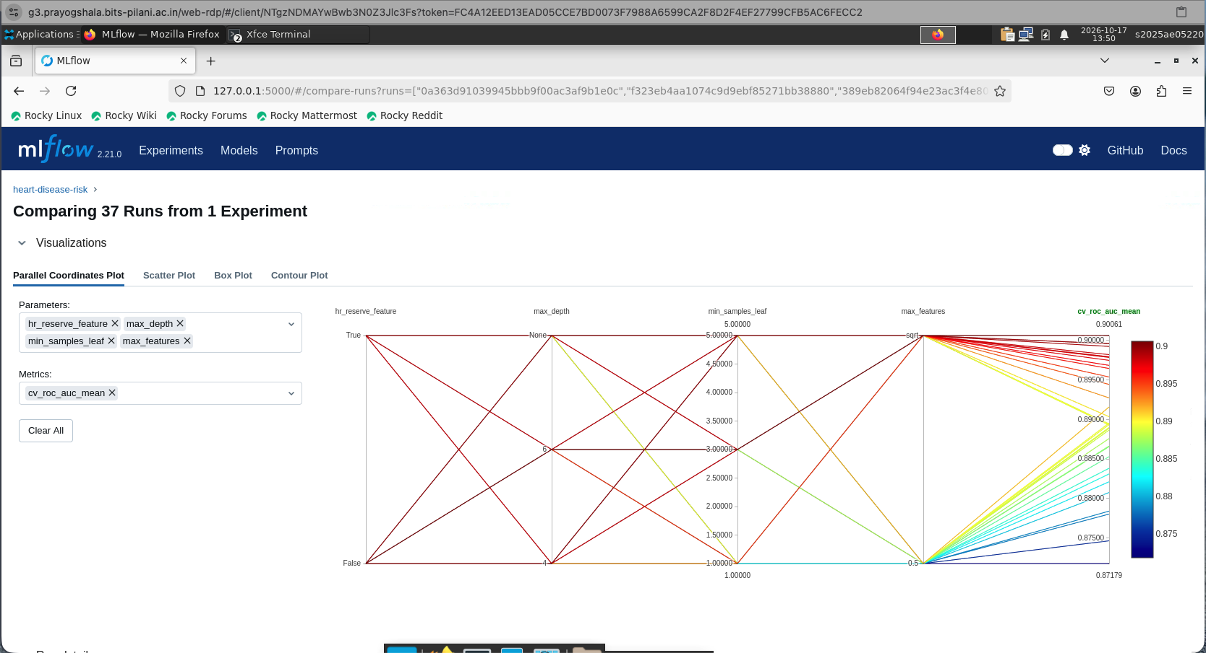 | 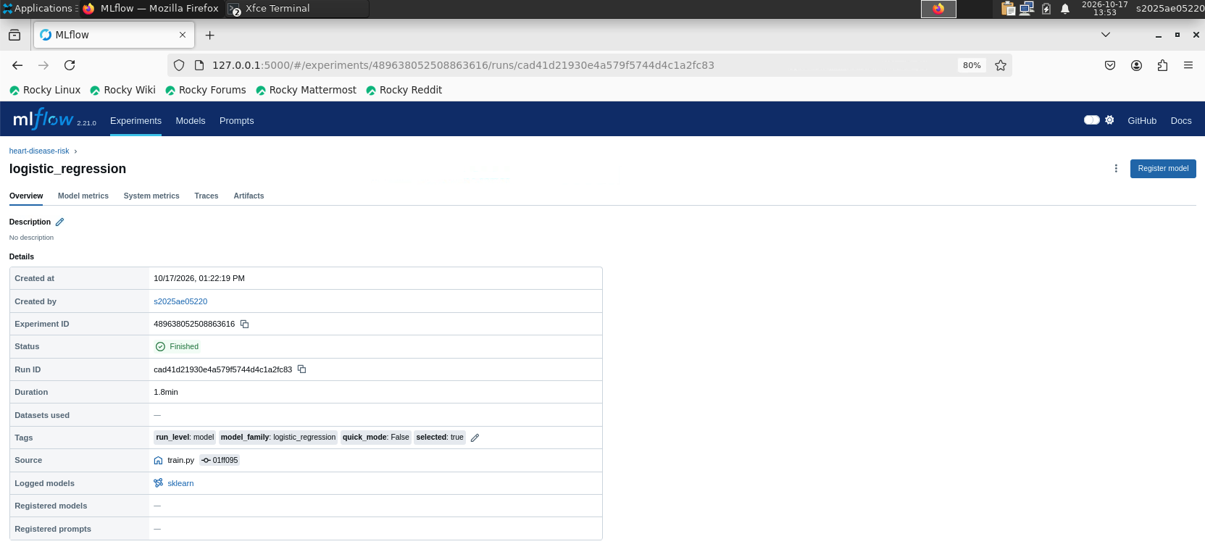
Figure 7. Left: parallel coordinates of the random-forest grid vs. CV ROC-AUC. Right: the selected run with its parameters, metrics and selected=true tag.

6. Model packaging and reproducibility
Artefact | Purpose
models/model.joblib | Complete fitted pipeline (features + preprocessing + classifier) — the unit that is served
models/metadata.json | Model name/version, threshold, features, best params, CV + test metrics, MLflow run id, Python/sklearn versions
MLflow model/ artefact | Same pipeline in MLflow format with signature, input example, bundled heartrisk code and pinned requirements — loads with mlflow.pyfunc.load_model in a clean environment
requirements*.txt, pyproject.toml | Exact pins for training / serving; package installable with pip install -e .
Table 5. Packaged artefacts.
- Determinism: fixed seeds for split, CV and models. A test trains twice independently and asserts identical predictions; both lab executions produced the same metrics to four decimals.
- Clean-setup execution: run_pipeline.py runs every step from a fresh clone, saves per-step logs and writes reports/run/run_summary.md with host, OS, Python, package and Docker versions and the git commit — committed from the lab as evidence of execution (Figures 8–9).
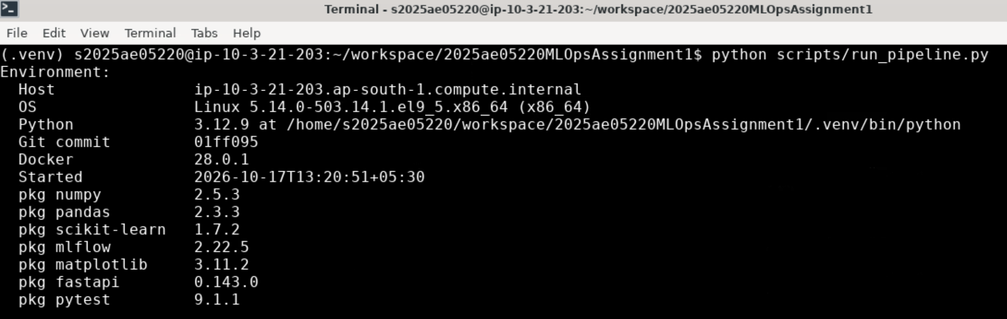
Figure 8. Environment recorded by the runner on the lab VM (host, OS, Python, commit, package versions).
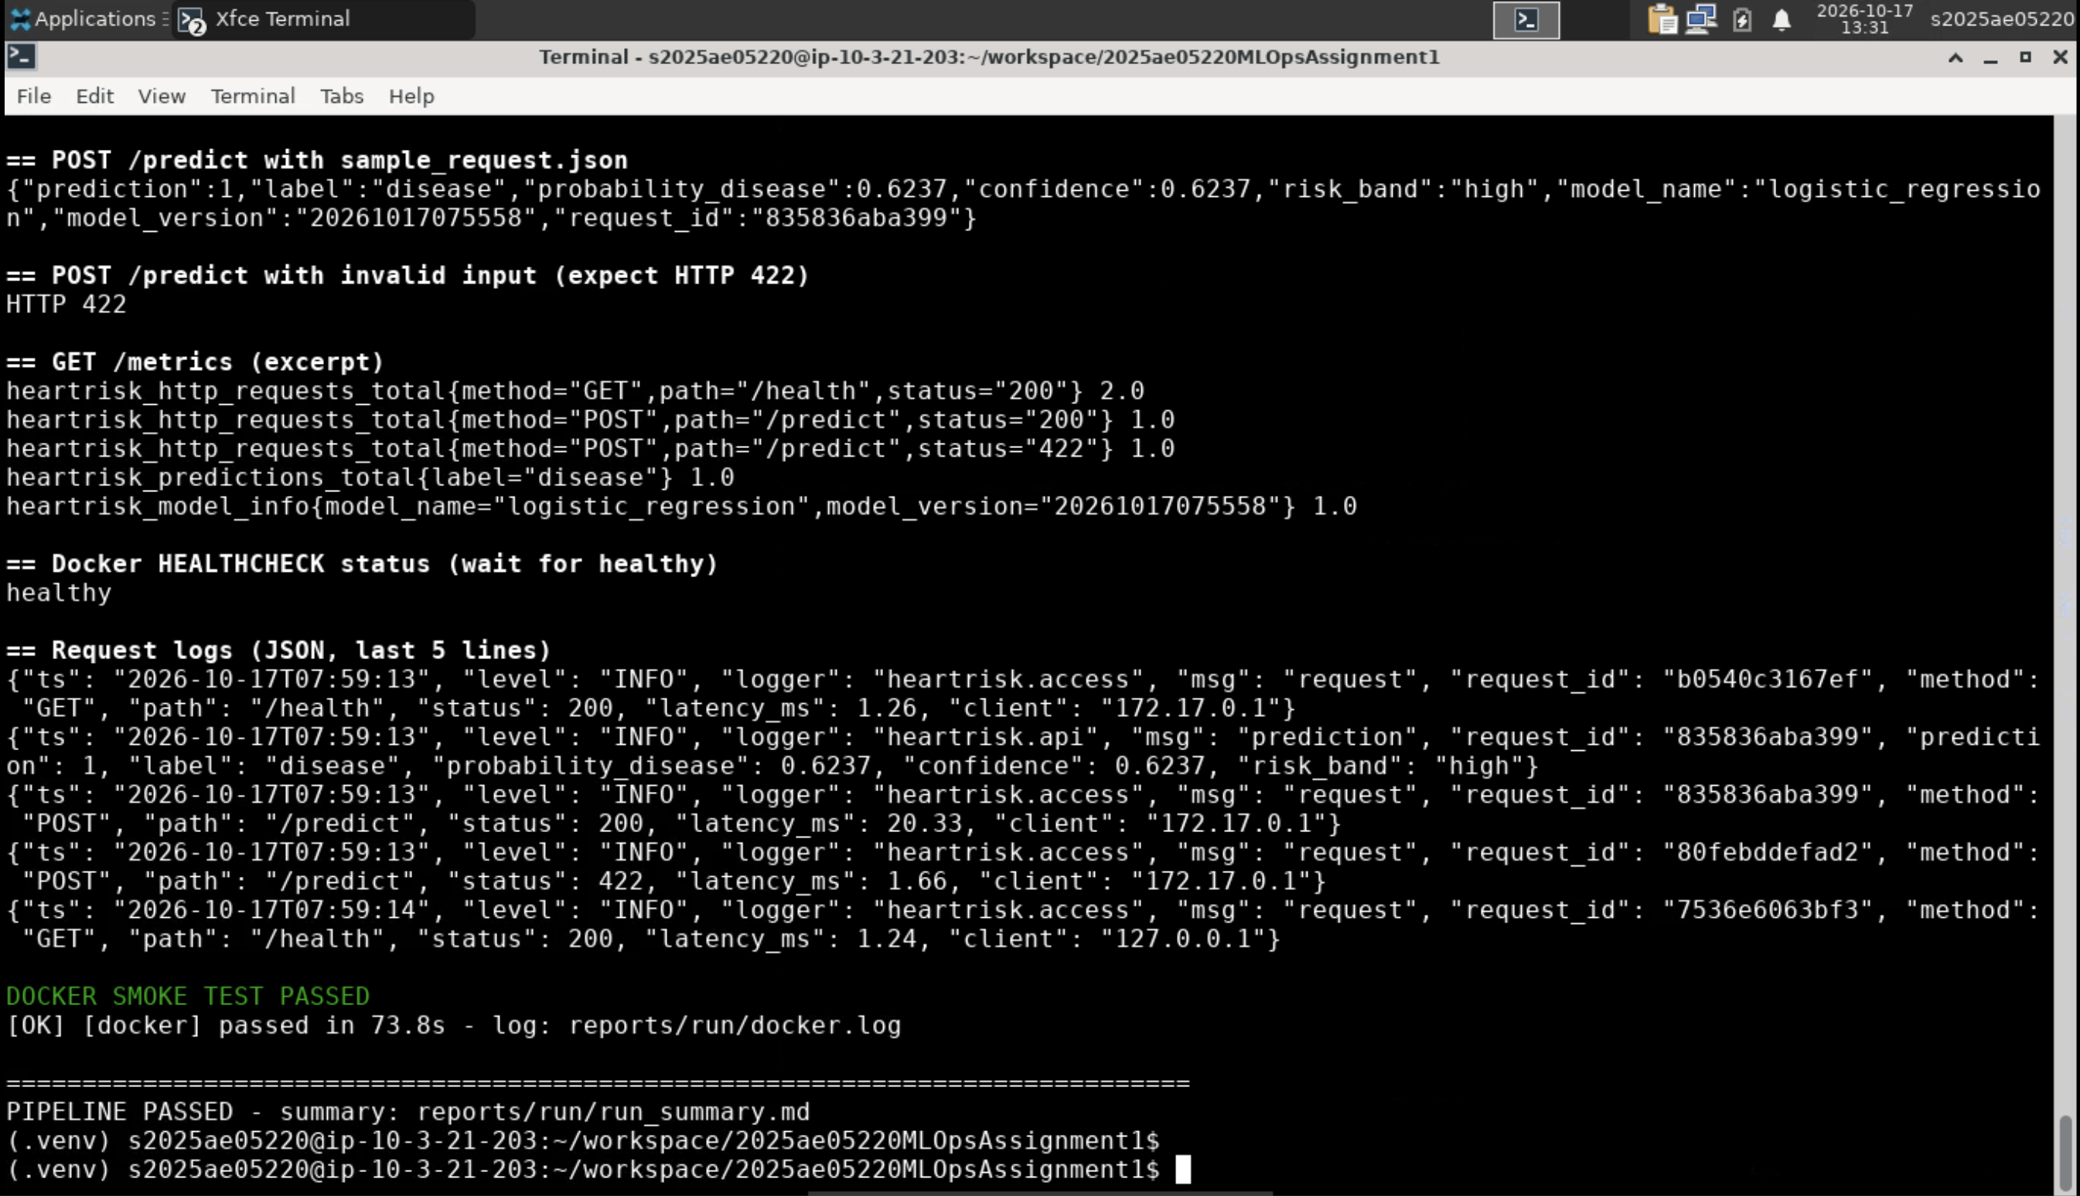
Figure 9. End of the one-command pipeline on the lab VM: Docker smoke test passed and PIPELINE PASSED.

7. CI/CD pipeline and automated testing
Test module | What it checks
test_data.py (23) | ? → NaN, target binarisation, domain validation, zero readings, duplicates, schema errors, download incl. offline fallback (network mocked)
test_features.py (8) | engineered-feature maths, stable column layout, no NaN after imputation, scaling, unseen categories
test_train.py (7) | sandboxed training run: all models trained, ROC-AUC > 0.8, best-on-CV selected, artefacts + MLflow runs, reproducibility
test_api.py (20) | predict / batch contract, parity with the offline pipeline, 422 validation, request id, JSON logs, metrics, 503 without model
test_k8s_manifests.py, test_monitoring_manifests.py (16) | probes hit real routes, selectors/ports/Ingress agree, hardening; dashboard and alert queries use metrics the API really exports
test_evaluation.py, test_eda.py (5) | metric edge cases, every figure renders
Table 6. Unit tests — 79 in total, 98 % line coverage.
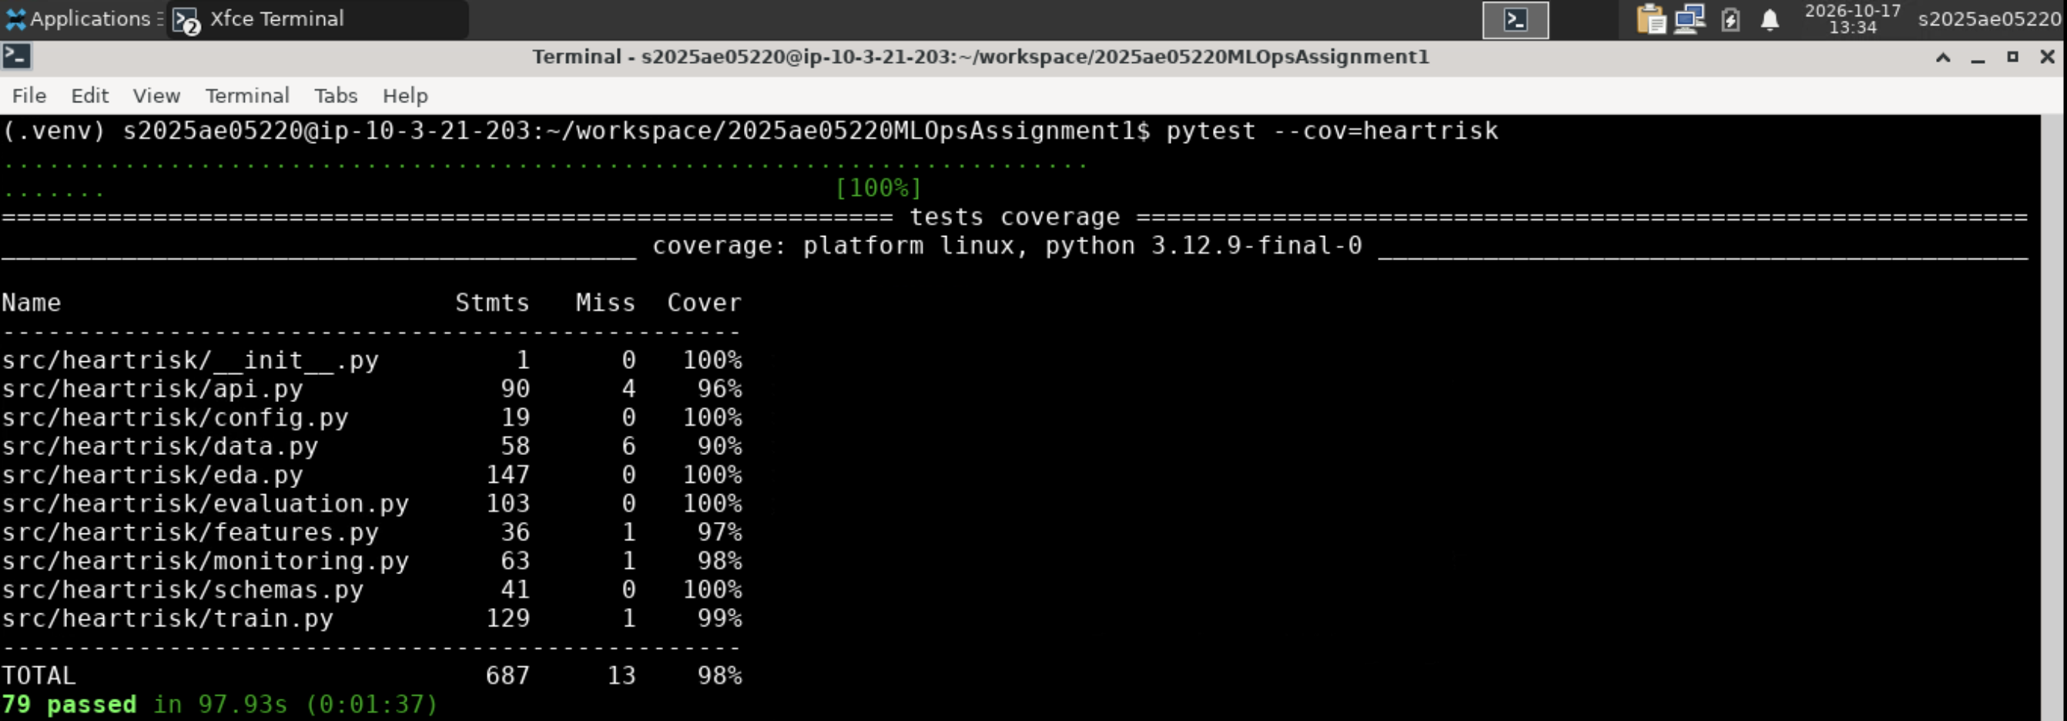
Figure 10. pytest on the lab VM: 79 passed, 98 % coverage.
.github/workflows/ci.yml runs on every push and pull request to main on a pinned ubuntu-24.04 runner: lint (ruff, errors annotated inline) → test (coverage XML/HTML, JUnit) → train (full grid search, MLflow, sanity prediction, fails if CV ROC-AUC < 0.85) → docker (builds the image with the model trained in that same run and executes the smoke test). Each job uploads its logs and outputs as artefacts even on failure and writes a summary (test counts, coverage, model metrics, image size).
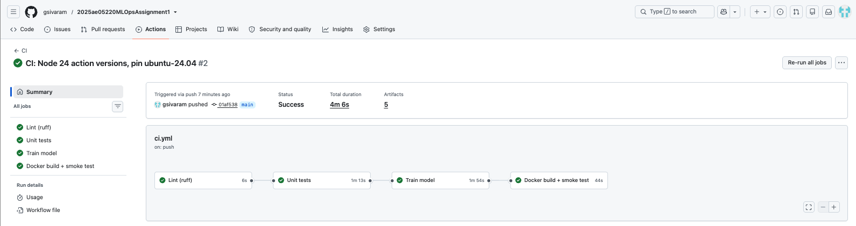
Figure 11. Successful GitHub Actions run: four dependent jobs.
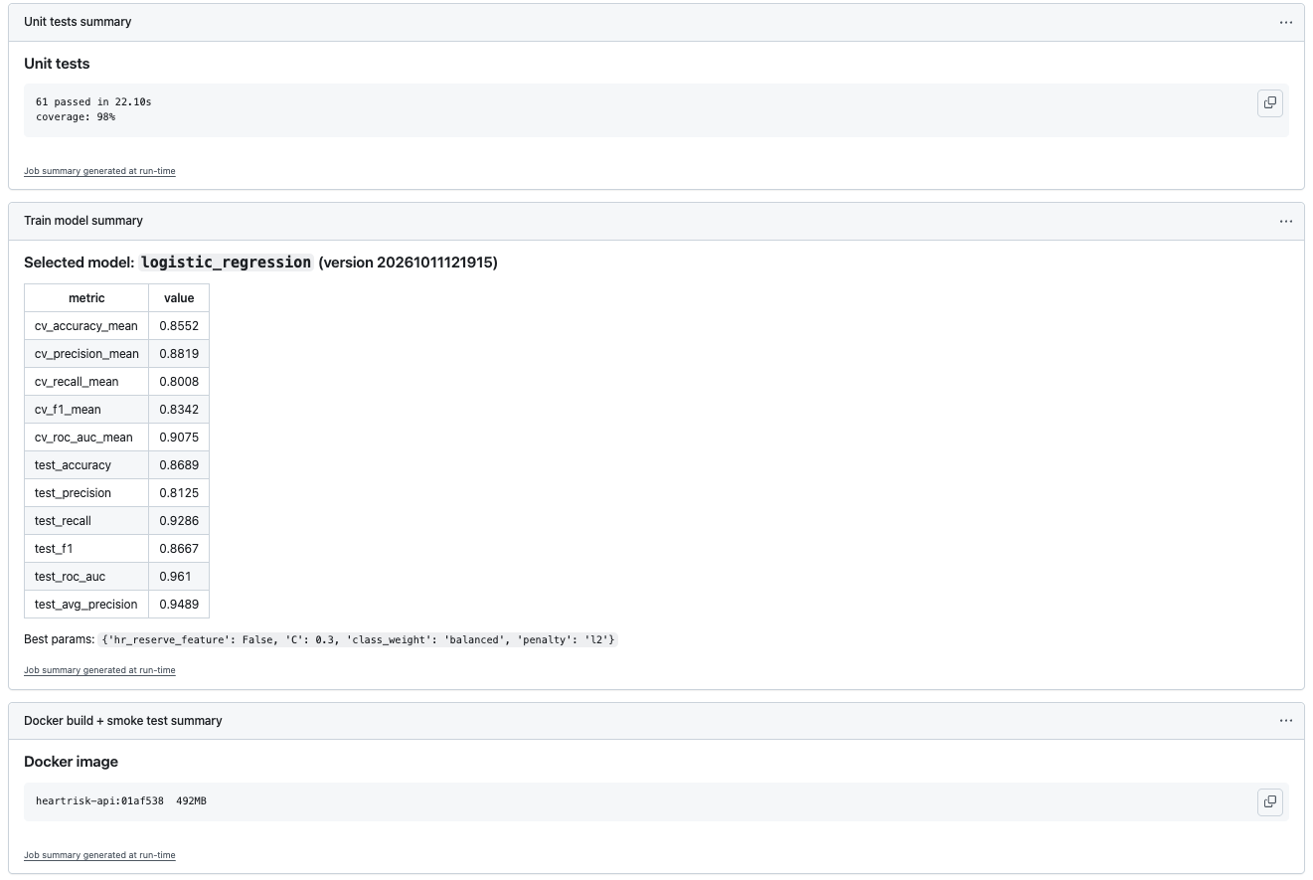 | 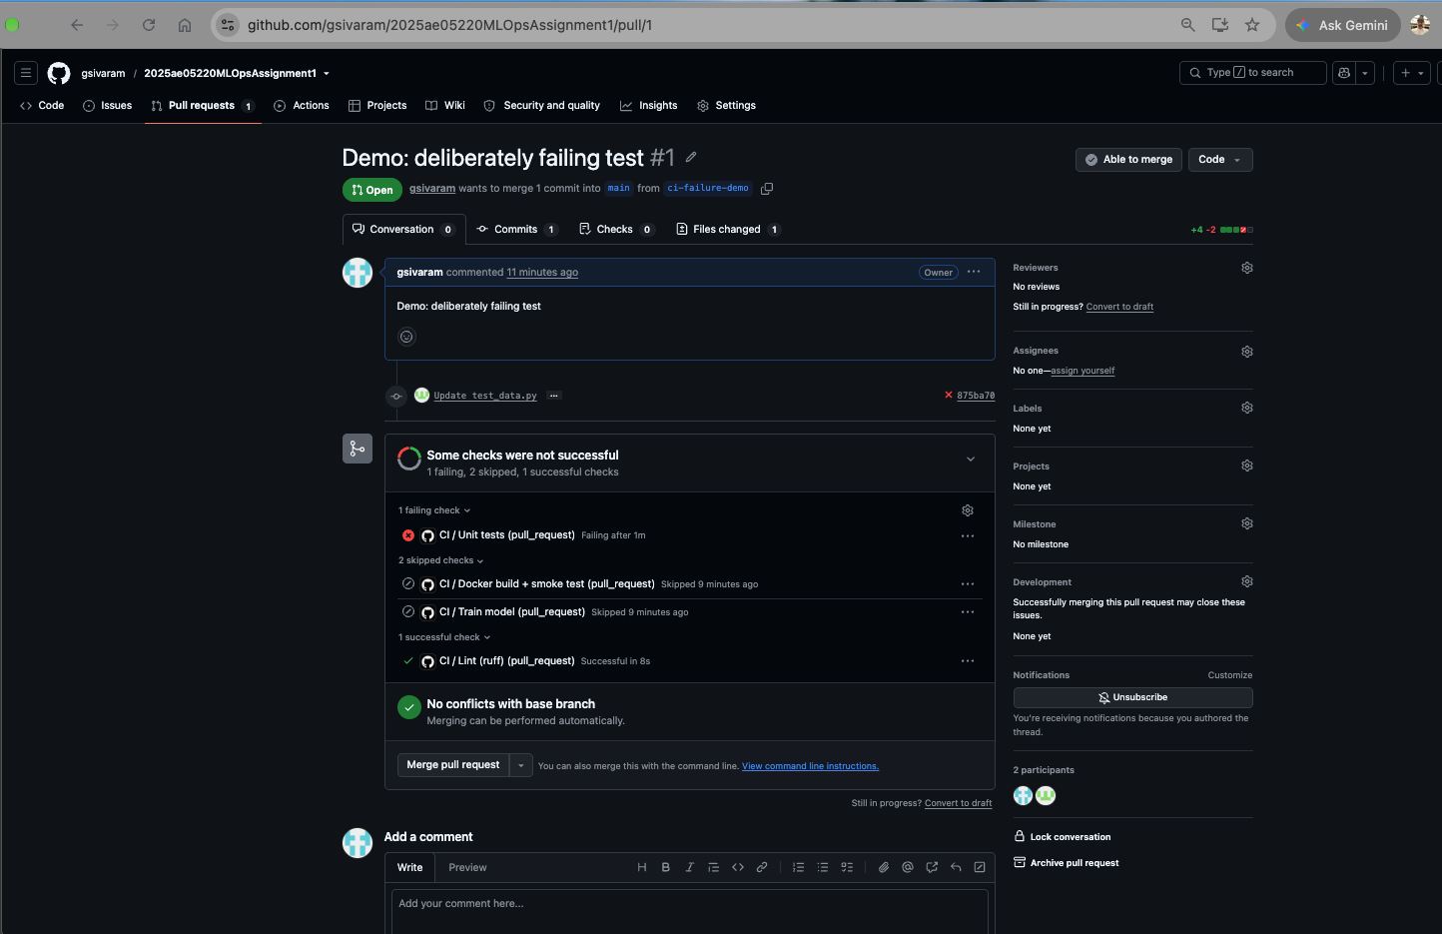
Figure 12. Left: job summaries (tests, coverage, selected model). Right: a deliberately broken test on a PR — the test job fails and training/docker are skipped.

8. Model containerisation
Endpoint | Behaviour
POST /predict | one patient → prediction, label, probability_disease, confidence, risk_band, model version, request id
POST /predict/batch | 1–100 patients
GET /health, GET /model | liveness + model status (Docker/Kubernetes probes); loaded model metadata
GET /metrics, GET /docs | Prometheus metrics; Swagger UI
Table 7. API surface (FastAPI).
Inputs are validated against clinical ranges with Pydantic (HTTP 422 with a field-level message, unknown fields rejected); ca and thal are optional and imputed exactly as in training. The image is a two-stage build on python:3.12-slim with serving dependencies only, a non-root user, the model baked in (a tag always serves the same model) and a HEALTHCHECK. scripts/docker_smoke_test.sh builds and runs it, then checks /health, /predict with sample_request.json, the 422 path, /metrics and the health status.
curl -X POST localhost:8000/predict -H 'Content-Type: application/json' -d @sample_request.json
{"prediction":1,"label":"disease","probability_disease":0.6237,"confidence":0.6237,
"risk_band":"high","model_name":"logistic_regression","model_version":"…","request_id":"…"}
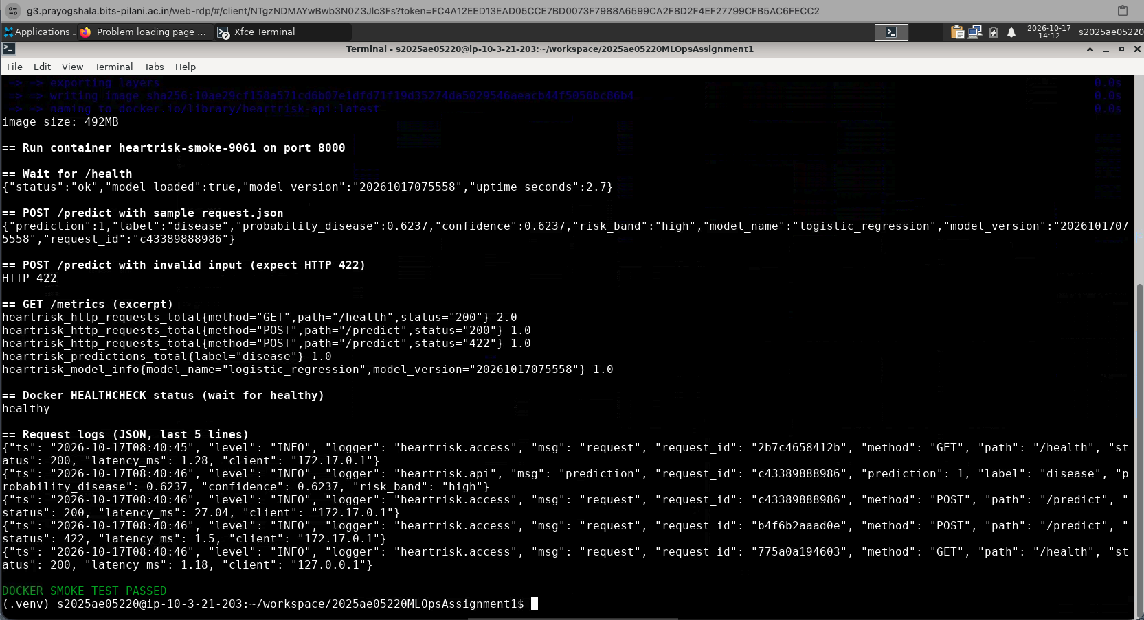
Figure 13. Container smoke test on the lab VM: health, prediction, 422 on invalid input, metrics, healthy status, JSON request logs.

9. Production deployment on Kubernetes
scripts/k8s_deploy.sh installs pinned minikube v1.39.0 / kubectl v1.37.1 if needed (recreating a cluster built by a different version — the lab VM shipped minikube 1.35), starts Minikube with the Ingress and metrics-server add-ons, builds the image and loads it into the cluster, renders the Kustomize manifests with the exact image tag, waits for the rollout and verifies the endpoints through the Ingress, including how 20 requests are spread across replicas (each response carries X-Served-By: <pod>).
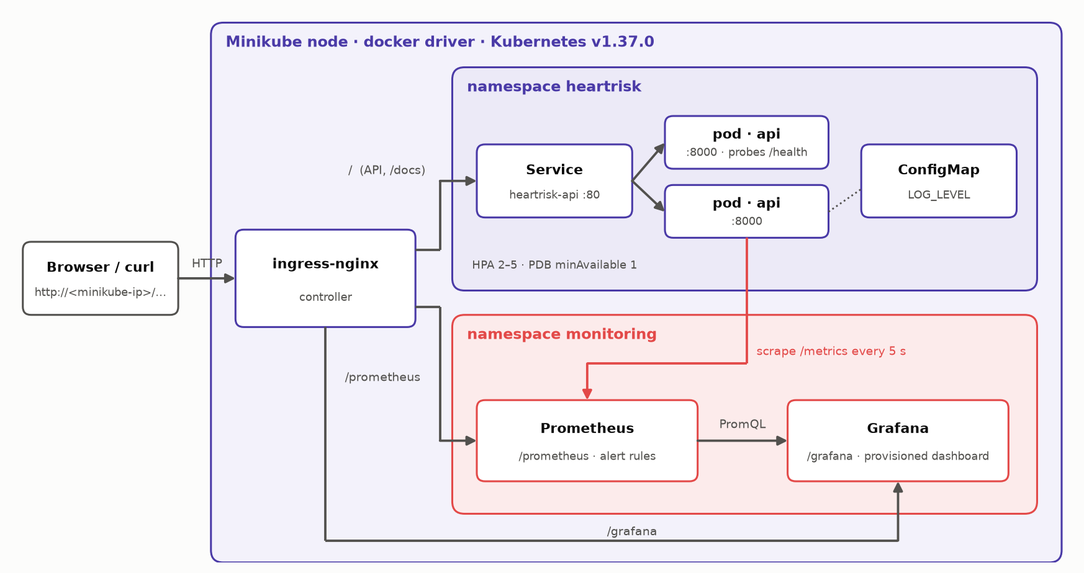
Figure 14. Runtime topology inside Minikube.
Manifest | Key settings
deployment.yaml | 2 replicas; rolling update maxUnavailable: 0; startup/readiness/liveness probes on /health; requests/limits; non-root, read-only root FS, no capabilities; Prometheus annotations
service.yaml, ingress.yaml | ClusterIP load balancing; NGINX Ingress with heartrisk.local host rule plus an IP rule for browser access
hpa.yaml, pdb.yaml, configmap.yaml | 2–5 replicas at 70 % CPU; at least one replica during disruptions; runtime config outside the image
Table 8. Kubernetes manifests (k8s/, applied with kubectl apply -k).
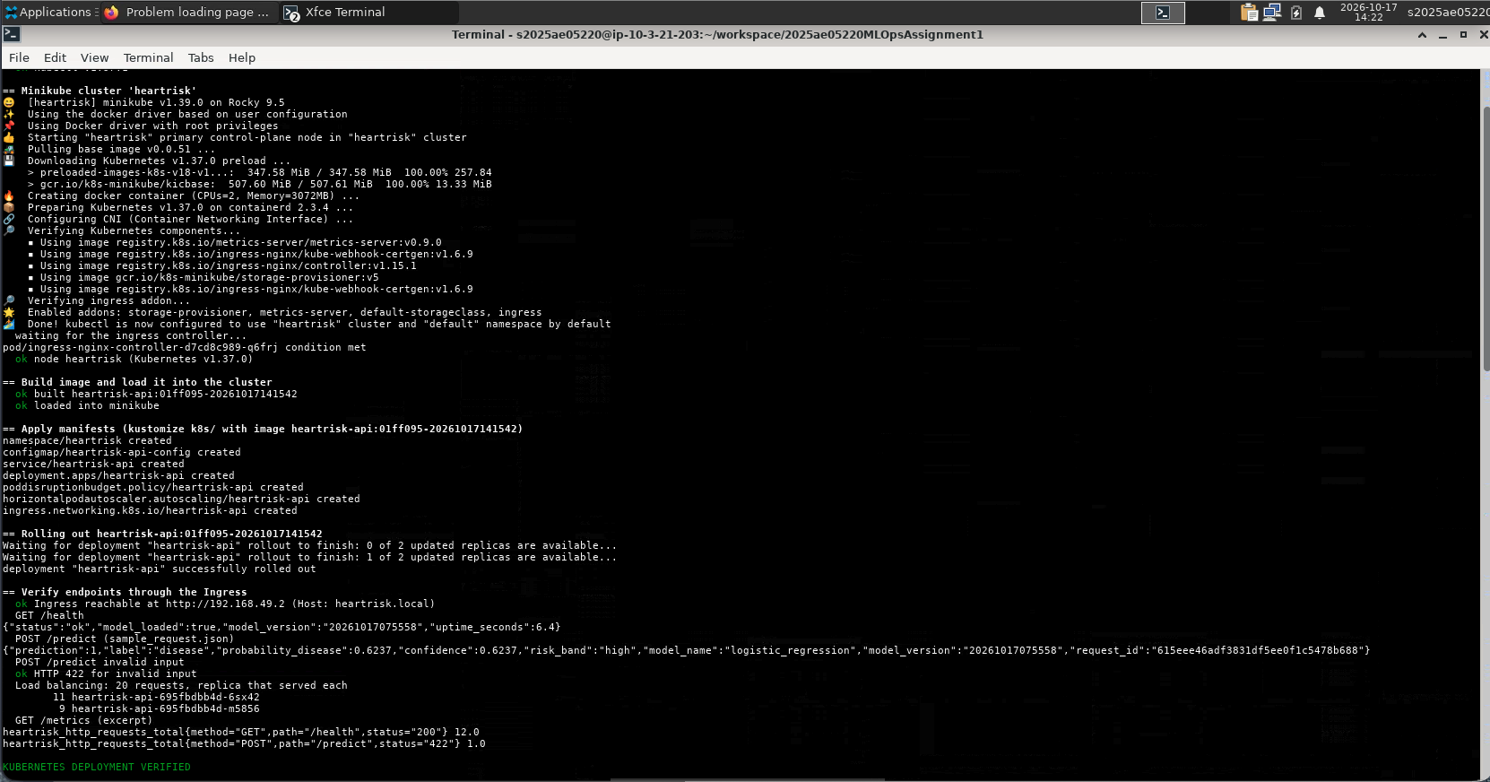 | 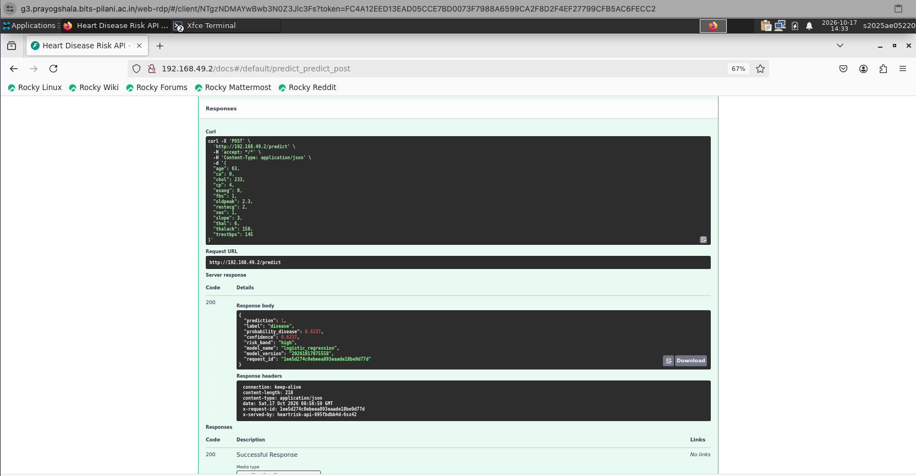
Figure 15. Left: deploy script on the lab VM — rollout, checks through the Ingress, KUBERNETES DEPLOYMENT VERIFIED. Right: POST /predict from Firefox via the Ingress.
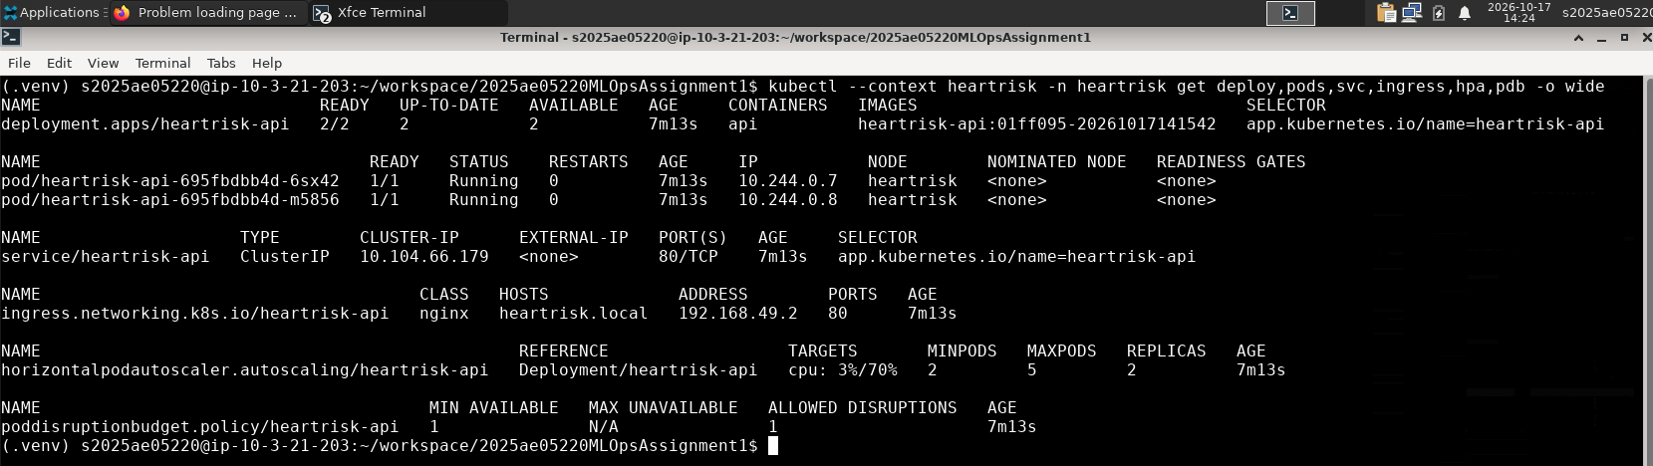
Figure 16. Cluster objects: Deployment (2/2), pods, Service, Ingress, HPA and PDB.
Autoscaling under load. During the lab load test the pods reached 62 % of their CPU request and the HPA recorded New size: 3; reason: cpu resource utilization above target; Prometheus discovered and scraped the new pod without any configuration change. The FailedGetResourceMetric warnings at the top are metrics-server warming up right after the cluster started.
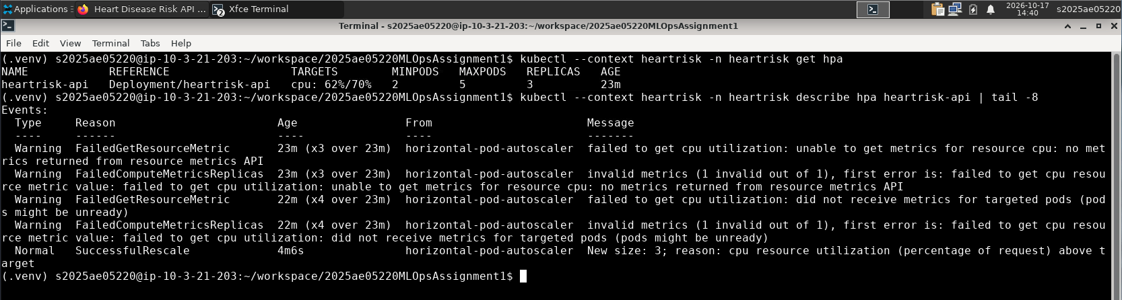
Figure 17. Horizontal pod autoscaler scaling the API from 2 to 3 replicas.

10. Monitoring and logging
Logging. Middleware writes one JSON line per request (request_id, method, route template, status, latency, client) and each prediction (probability, label, band). The request id generated by the NGINX Ingress is kept, so a request can be followed from the Ingress to the pod log.
Metrics. /metrics exposes request counters by route and status, a latency histogram, in-flight requests, predictions by label, a histogram of predicted probabilities (a simple drift signal) and the loaded model version. Prometheus v3.15 discovers pods through their annotations (a Role limited to the app namespace), scrapes every 5 s and evaluates three alerts — API down, error rate > 5 %, p95 latency > 500 ms. Grafana 13.2 is provisioned with the datasource and dashboard; both are served under /prometheus and /grafana on the same Ingress. scripts/load_test.py produces realistic traffic (dataset-based patients, 10 % invalid, 5 % batch).
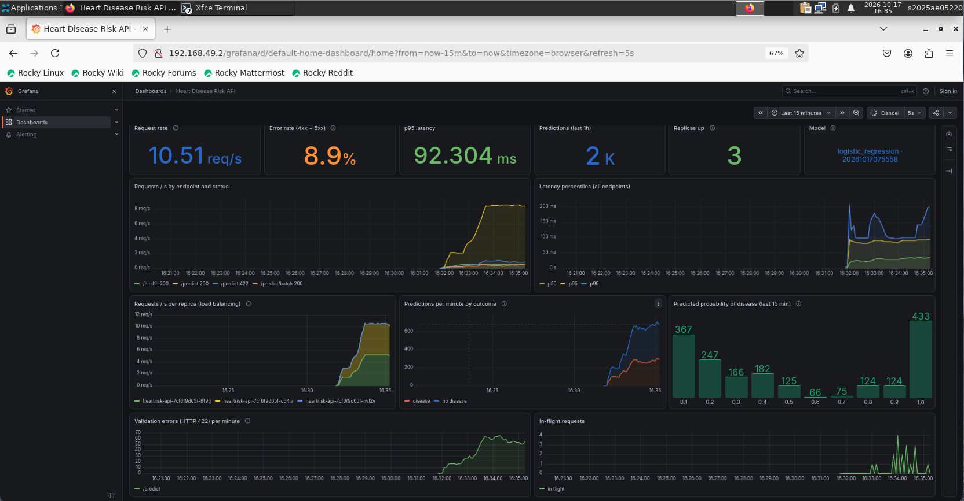
Figure 18. Grafana dashboard on the lab VM under load: rate, errors (the deliberate 10 % invalid requests), latency, 3 replicas, model version, per-pod traffic, prediction mix and probability distribution.
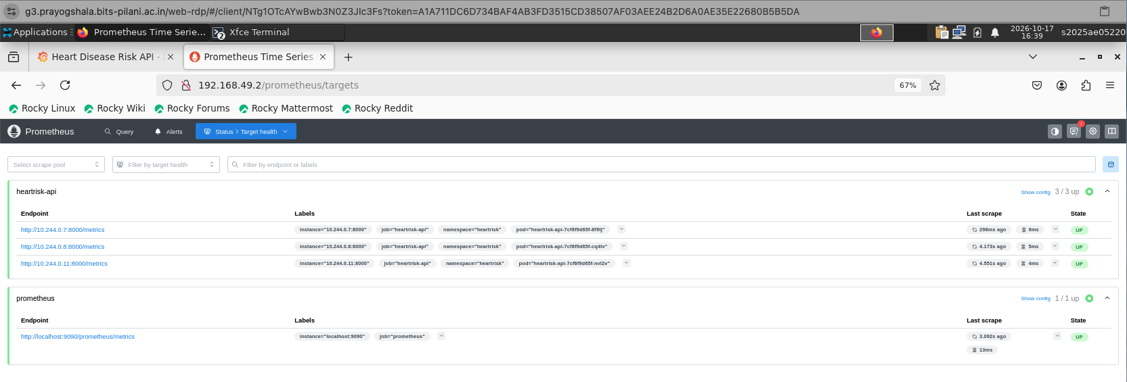
Figure 19. Prometheus target health: all three API pods discovered and UP.
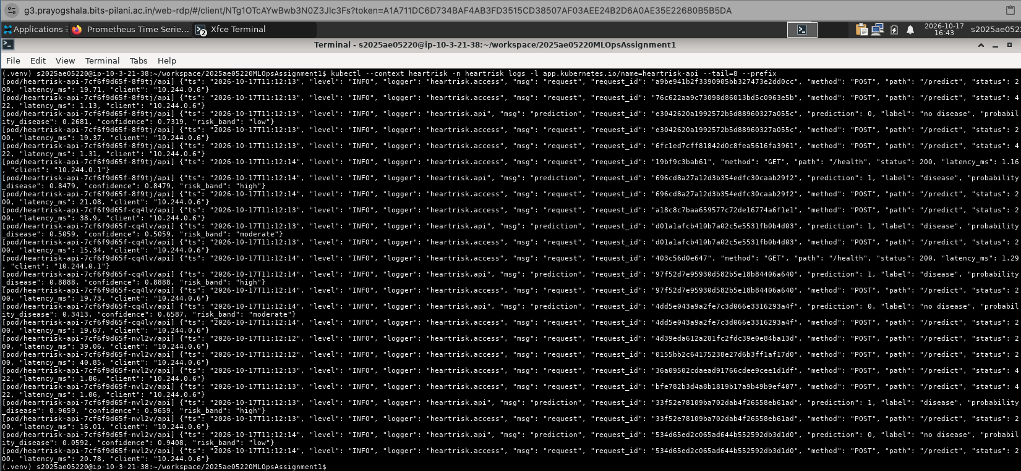 | 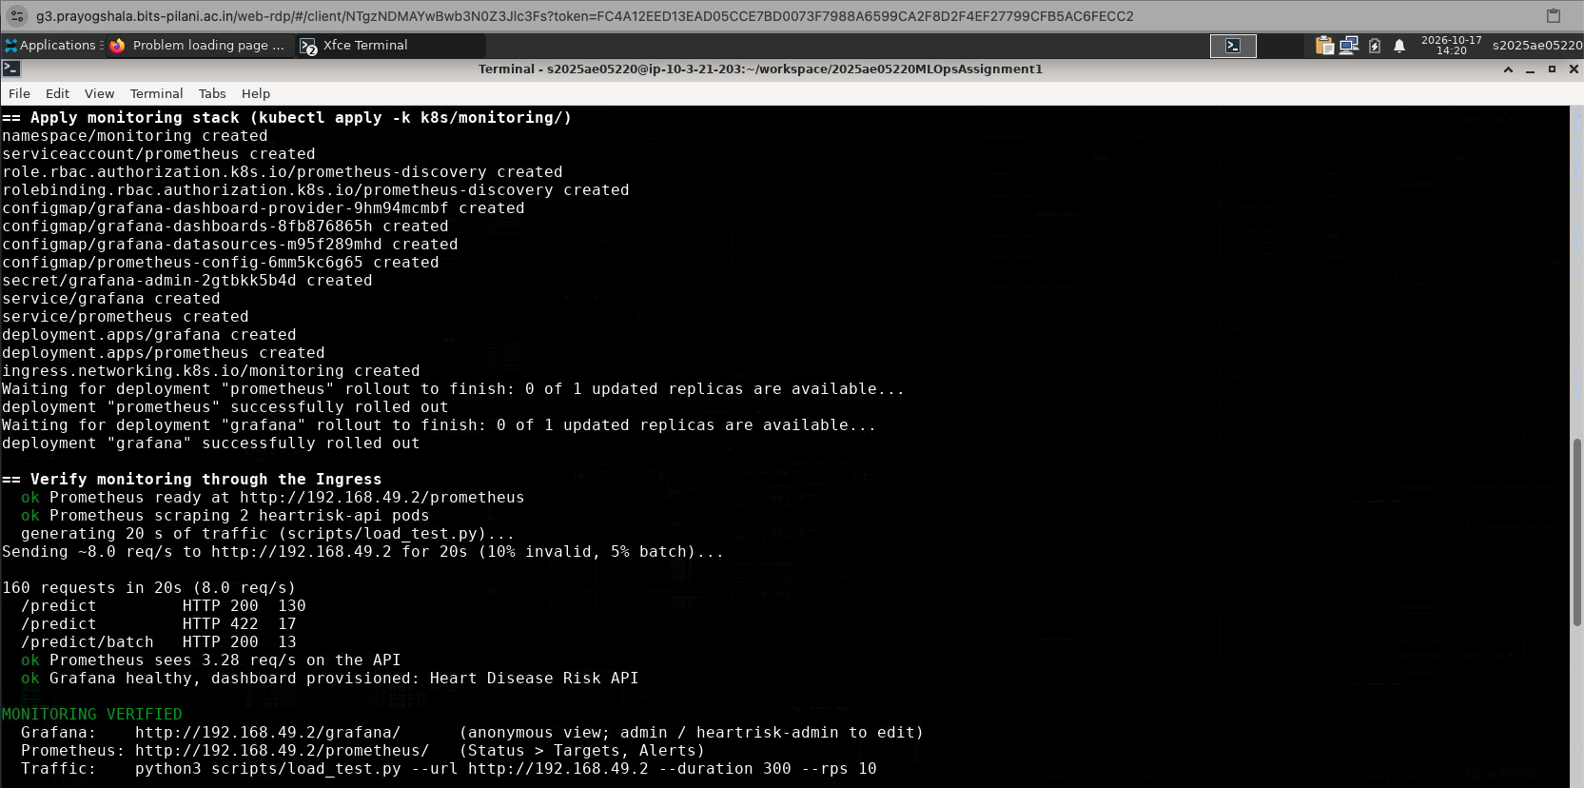
Figure 20. Left: structured JSON request and prediction logs from the pods. Right: monitoring verification — 2 pods scraped, live traffic seen, dashboard provisioned.
Alerting verified. Scaling the deployment to zero replicas moved HeartRiskApiDown from inactive to pending and then firing after its one-minute hold; restoring two replicas cleared it.
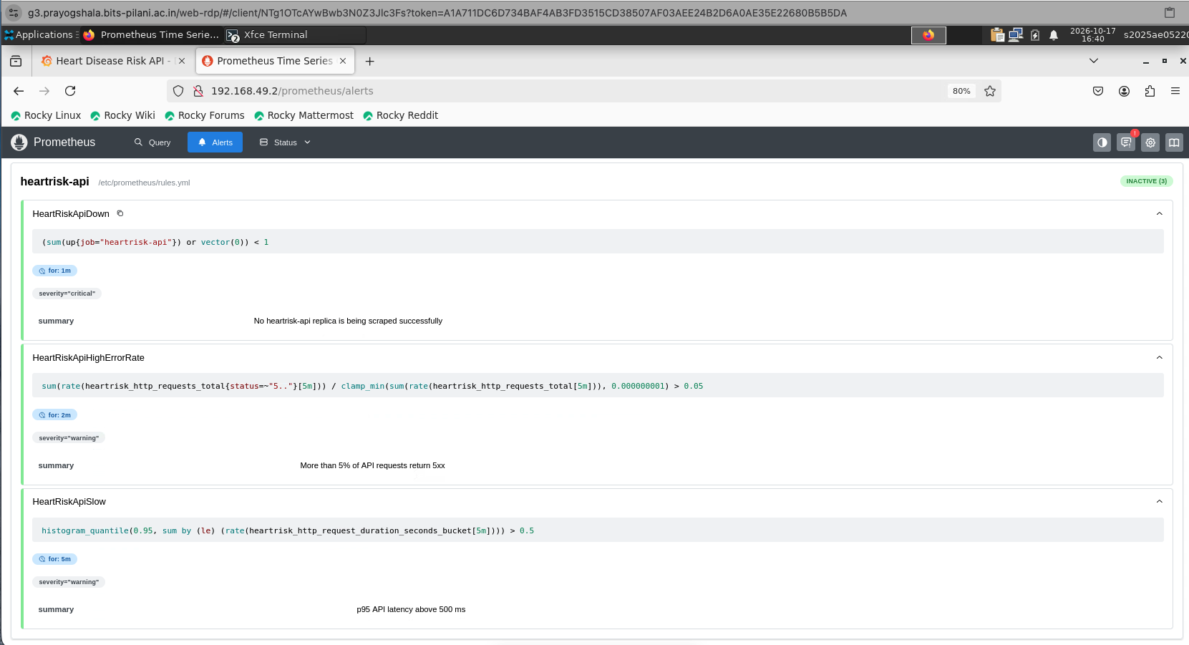 | 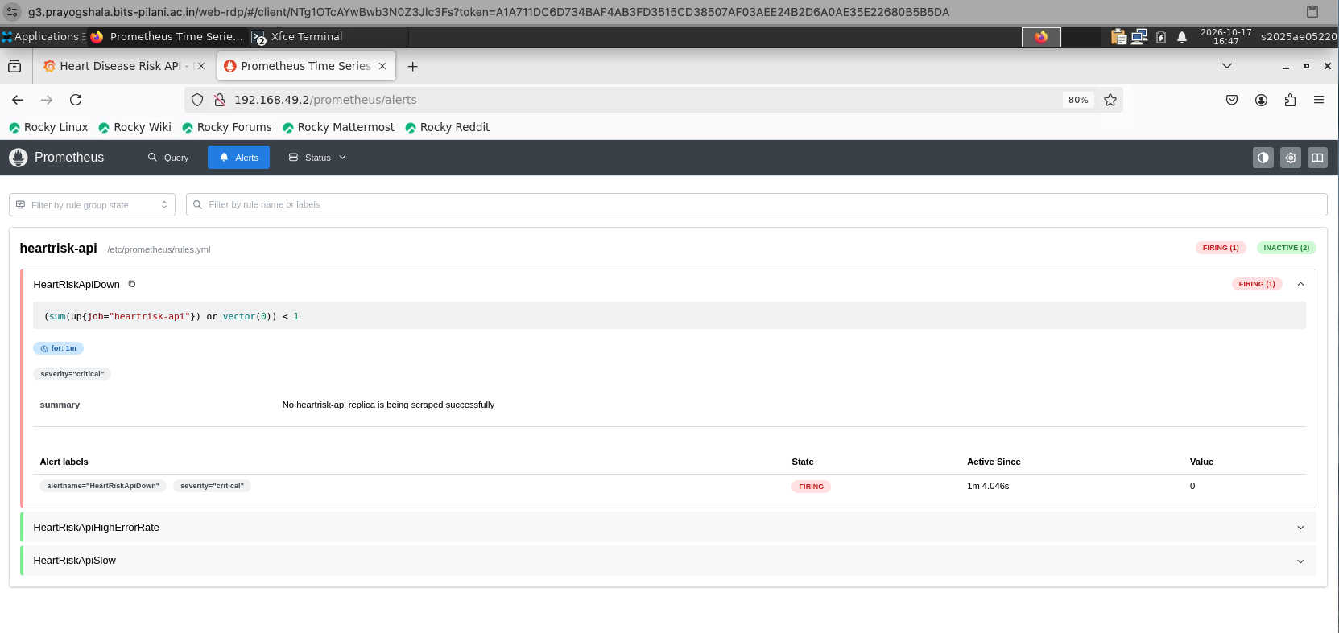
Figure 21. Left: the three alert rules, inactive (healthy). Right: HeartRiskApiDown firing during the scale-to-zero test.

11. Challenges and lessons learned
Running every stage for real — on the lab VM and in CI — surfaced issues that static review would have missed:
Issue found | Fix
Lab python3 is 3.9; conda base is 3.12 | venv built from conda's interpreter; requires-python >= 3.10 gives a clear error otherwise
Notebook kernel picked a different Python than the venv | runner puts the venv first on PATH for every step
Pickled model needs the same scikit-learn version | exact pins shared by training and serving requirements
Docker image twice its size (wheels copied into a layer) | BuildKit bind-mount for the install step
Lab shipped an old minikube (Kubernetes v1.32) | script installs pinned versions and recreates mismatched clusters
HeartRiskApiDown could never fire with zero pods (empty vector) | or vector(0); verified by scaling to 0 — alert pending → firing
Prometheus scrapes counted as in-flight requests | /metrics excluded from request metrics
Lab sessions end and the VM changes | results pushed to git immediately; one command recreates the cluster
Table 9. Issues found by executing the pipeline end to end.
Future work: a model registry with promotion stages, data-drift tests on the probability histogram, pushing images to a registry from CI, and branch protection requiring CI before merge (not available for private repositories on the free plan).

12. Repository, deliverables and access
Code repository: https://github.com/gsivaram/2025ae05220MLOpsAssignment1
Video walkthrough: https://drive.google.com/file/d/1c4eUDCULMt9sefN-8uZ82uGOMmleSzB_/view?usp=drive_link
Deliverable | Location in the repository
Code, Dockerfile, requirements | src/heartrisk/, scripts/, Dockerfile, requirements.txt, requirements-serve.txt
Cleaned dataset + download script | data/raw/, data/processed/heart_clean.csv, scripts/download_data.py
Notebooks / scripts (EDA, training, inference) | notebooks/01_eda.ipynb, scripts/train.py, scripts/predict.py
Unit tests | tests/ (79 tests)
CI workflow | .github/workflows/ci.yml
Deployment manifests | k8s/ (app) and k8s/monitoring/ (Prometheus + Grafana)
Screenshots / figures | screenshots/, reports/figures/
Run evidence and runbook | reports/run/run_summary.md, LAB_RUNBOOK.md, README.md
Table 10. Deliverables map.
Access (local Kubernetes, no public URL): after bash scripts/k8s_deploy.sh all the API is at http://<minikube ip>/ (Swagger at /docs), Grafana at /grafana/ and Prometheus at /prometheus/; from the command line curl -H 'Host: heartrisk.local' http://$(minikube -p heartrisk ip)/health.

Appendix A. Screenshot evidence index
All screenshots are in the repository's screenshots/ folder; lab captures were taken on the BITS lab VM on 17 October 2026.
File | Figure | Section
mlflow_01_experiment_runs.png | 6 | 5
mlflow_04_parallel_coords.png | 7 | 5
mlflow_05_selected_run_overview.png | 7 | 5
lab_00_environment.png | 8 | 6
lab_01_pipeline_passed.png | 9 | 6
tests_01_pytest_coverage.png | 10 | 7
ci_01_pipeline_graph.png | 11 | 7
ci_02_summary.png | 12 | 7
ci_05_failure.png | 12 | 7
docker_02_smoke_test.png | 13 | 8
k8s_01_deploy_verified.png | 15 | 9
k8s_05_browser_docs.png | 15 | 9
k8s_02_objects.png | 16 | 9
mon_07_hpa_autoscaling.png | 17 | 9
mon_02_grafana_dashboard.png | 18 | 10
mon_03_prometheus_targets.png | 19 | 10
mon_06_api_logs.png | 20 | 10
mon_01_verified.png | 20 | 10
mon_05_prometheus_alerts.png | 21 | 10
mon_08_alert_firing.png | 21 | 10
Table 11. Screenshots used in this report.
Additional file (repository only) | Shows
mlflow_02_child_runs.png | nested child runs of a grid search
mlflow_03_chart_view.png | MLflow chart comparison of runs
mlflow_06_artifacts_plots.png | plots stored as run artefacts
mlflow_07_logged_model.png | logged model with signature
mlflow_08_model_selection.png | model_selection run comparison plot
ci_03_job_log.png, ci_04_artifacts.png, ci_06_failure_log.png | CI job log, artefacts list, failing-test log
mon_04_prometheus_query.png | PromQL request rate per pod
Table 12. Further evidence in the repository.

