EduAssist AI: API Cost, Latency and Prompt Version Management
MLOps (AIMLCZG523), Experiential Learning Assignment 2
Sivaram Gudlavalleti (2025ae05220) | 31 October 2026

1. Setup
- LLMOps builds on MLOps. Prompts and model versions are versioned, and cost, latency and tokens are tracked for each request.
- The use case is EduAssist AI, an assistant that answers academic questions.
- All results below come from one run on the BITS MLOps lab VM.
Table 1. Run details
Item | Details
Model | gemini-3.5-flash-lite
API version | Gemini API v1beta (google-genai 2.34.0)
Settings | Temperature 0, maximum 2,048 output tokens
Pricing | $0.30 input and $2.50 output per million tokens (USD)
Pricing date | 30 October 2026
Billing | Free tier was used, so costs shown are at paid-tier rates
Lab environment | BITS MLOps lab VM, Python 3.12.9, MLflow 3.17.2
API key | Read from an environment variable; a scan found it in no output file

2. Task 1: Latency
Table 2. Latency for five questions (prompt v1, all requests successful)
ID | Question topic | Latency (s) | Input tokens | Output tokens
Q1 | Overfitting and prevention | 4.448 | 25 | 680
Q2 | TCP versus UDP | 3.645 | 20 | 566
Q3 | Photosynthesis | 2.124 | 15 | 208
Q4 | Binary search complexity | 3.957 | 23 | 547
Q5 | 2008 financial crisis | 3.825 | 28 | 844
Latency summary (seconds): mean 3.600, median 3.825, minimum 2.124, maximum 4.448, standard deviation 0.877.
Why Q1 was the slowest (4.45 s):
- Longer answers generally took longer (r = 0.83), because the model writes one token at a time.
- Length is not the full reason. Q5 gave more tokens than Q1 but finished sooner.
- Q1 was the first call of the run, so connection set-up probably added time.
- Server load and network delay may also have played a part.

3. Task 2: Tokens and Cost
Table 3. Tokens and cost per request (prompt v1)
ID | Input tokens | Output tokens | Total tokens | Cost (USD)
Q1 | 25 | 680 | 705 | 0.001708
Q2 | 20 | 566 | 586 | 0.001421
Q3 | 15 | 208 | 223 | 0.000525
Q4 | 23 | 547 | 570 | 0.001374
Q5 | 28 | 844 | 872 | 0.002118
Average | 22.2 | 569.0 | 591.2 | 0.001429
Monthly projection: $0.001429 × 10,000 requests = $14.29.
Recommendation: shorten the answers.
- Output tokens make up over 99% of the cost. They are priced 8.3 times higher than input tokens, and answers averaged 569 tokens.
- A 250-token limit would bring the monthly cost down by 57%, to $6.11 (based on the measured tokens).
- Sending simple questions to gemini-3.1-flash-lite would save 40%, or 74% together with the limit.
- Cutting context or caching prompts would save very little, as input is a tiny part of the bill.

4. Task 3: Prompt Evaluation and Promotion
- Created the MLflow experiment eduassist_llmops_assignment.
- Registered v1, v2 and v3 as eduassist-academic-qa, each with a commit message.
- Loaded each prompt from the registry and ran it on the same five questions.
- Calculated valid_json as valid JSON responses divided by total responses.
Table 4. Prompt comparison
Version | Avg latency (s) | Avg input tokens | Avg output tokens | Avg cost (USD) | Valid JSON rate | Recommended?
v1 | 2.435 | 22.2 | 607.8 | 0.001526 | 0% | No
v2 | 1.931 | 46.2 | 376.4 | 0.000955 | 0% | No
v3 | 1.323 | 87.2 | 150.8 | 0.000403 | 100% | Yes
Promotion justification: v3 now has the production alias.
- Selection rule: a prompt must pass the JSON check first. Coverage, cost and latency are compared after that.
- JSON validity: the app reads every reply as JSON. v1 and v2 scored 0%, so they would break it. v3 scored 100% and matched the schema on all five questions.
- Quality: v3 covered 92% of expected concepts, while v1 and v2 covered 100%. We accept this gap because the app cannot use an answer it cannot read. v3 also gives key points and a confidence level.
- Latency: v3 averaged 1.32 s, which is 46% faster than v1.
- Tokens: v3 uses about four times the input of v1 but only a quarter of the output. Output is what drives time and cost, and the schema keeps answers short.
- Cost: v3 comes to $4.03 per 10,000 requests, against $15.26 for v1 and $9.55 for v2. That is 74% cheaper than v1. The extra input tokens are cheap, so they add very little.
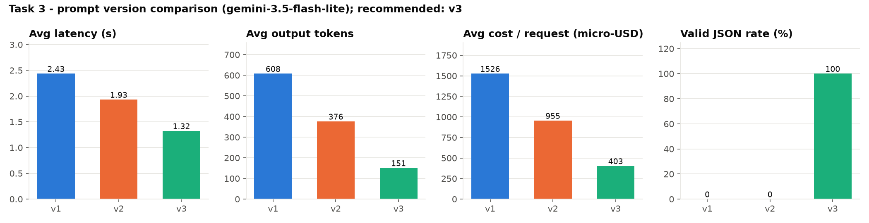
Figure 1. Prompt comparison from the promotion_decision run in MLflow.
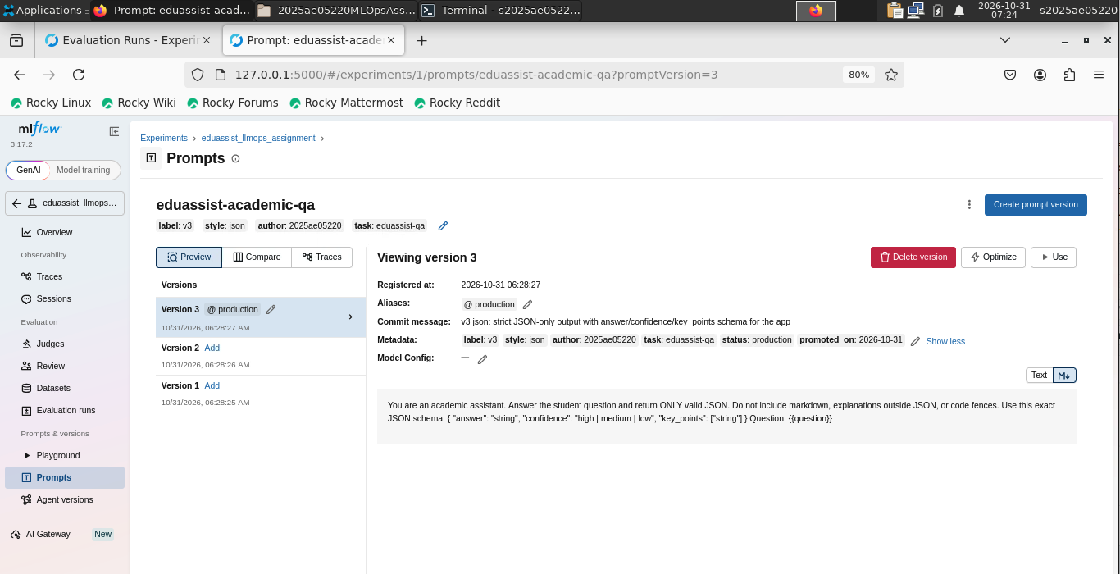
Figure 2. Prompt Registry showing version 3 with the production alias.

5. Limitations
- Five questions and one run is a small sample.
- Results can change between runs. Prompt v1 ran twice: 3.60 s and $14.29 in Task 1, then 2.43 s and $15.26 in Task 3.
- Keyword coverage is only a rough measure of quality.
- Next steps: use more questions, add human review, and monitor valid_json in production.
- The app loads the prompt by alias, so rollback needs just one alias change.

6. Evidence
All files are in the submission ZIP and at github.com/gsivaram/2025ae05220MLOpsAssignment2.
Table 5. Evidence by section
Section | File name
Setup and reproduction | README.md  requirements.txt
Lab run | screenshots/lab_00_environment.png  screenshots/lab_01_pipeline_passed.png  reports/run/run_summary.md
All tasks (code and outputs) | notebooks/EduAssist_LLMOps_Assignment2.ipynb  reports/EduAssist_LLMOps_Assignment2.html
Task 1: Latency | outputs/latency_tokens_cost.csv  outputs/latency_summary.csv  outputs/figures/task1_latency.png
Task 2: Tokens and cost | outputs/latency_tokens_cost.csv  outputs/figures/task2_cost_per_request.png
Task 3: Runs and metrics | screenshots/mlflow_01_experiment_runs.png  screenshots/mlflow_02a_metrics_compare_v1_v2.png  screenshots/mlflow_02b_metrics_compare_v2_v3.png  screenshots/mlflow_03a_run_overview.png  screenshots/mlflow_03b_run_overview.png
Task 3: Evaluation | screenshots/mlflow_04_evaluation.png  outputs/prompt_evaluation_results.csv  outputs/prompt_evaluation_details.csv
Task 3: Prompt Registry | screenshots/mlflow_05_prompt_registry_v1.png  screenshots/mlflow_05_prompt_registry_v2.png  screenshots/mlflow_05_prompt_registry_v3.png
Task 3: Prompt diff | screenshots/mlflow_06a_prompt_diff.png  screenshots/mlflow_06b_prompt_diff.png  outputs/prompt_diffs.txt
Task 3: Production alias | screenshots/mlflow_07_production_alias.png
Task 3: Promotion decision | screenshots/mlflow_08_promotion_run.png  outputs/promotion_justification.md

