OAuth2

Claude on OAuth2
A quick analogy before we start: think of OAuth here like a bouncer checking a wristband — Discord issues the wristband (token) after the user logs in, and your app calls Discord's API to see which "clubs" (guilds) that wristband belongs to

OAuth2 Setup on Discord
The Discord Developer Portal: https://discord.com/developers/applications
Some setup on Discord is needed before using OAuth2. You must have an application set up. And all the normal stuff must be configured for the Bot. Additionally; you need to do the following on the OAuth tab:
- Enter a redirect URL: http://localhost:8080/callback (yes, exactly like that). You can enter more than one…
- copy Client ID, this is the same client id that is on the General Information tab
- generate and copy the Client Secret. This is different than the Bot token
Then from the Bot Tab:
- Copy the Bot Token from where you previously stored it, or generate it again and copy it now.
Then go to the Discord Sever (aka Discord Guild) where the bot has been added.
- If the bot has not been added to the Guild, do so now by going to the OAuth2 Tab -> OAuth2 URL generator-> select bot from the list of scopes check boxes. Cut and paste the generated URL from a browser tab where you are logged into Discord as the Guild Admin.
- Then get the server id for the Guild (right click on the icon for the guild and then copy server info -> copy server id).

Python Setup
Install the following python packages:
- nicegui
- python-dotenv
- httpx
- fastapi
Generate a nicegui storage secret using:
uv run python -c "import secrets; print(secrets.token_urlsafe(32))"
create a .env file with:
- DISCORD_CLIENT_ID (from OAuth2/General Information tab)
- DISCORD_CLIENT_SECRET (from OAuth2 tab)
- DISCORD_BOT_TOKEN (from the Bot tab)
- DISCORD_GUILD_ID (from the Icon of the Discord Server/Guild in the discord client)
- DISCORD_REDIRECT_URI (from the OAuth2 tab)
- NICEGUI_STORAGE_SECRET (from the previous step)

Screen Shots
What the Web App displays when you’re not logged in:
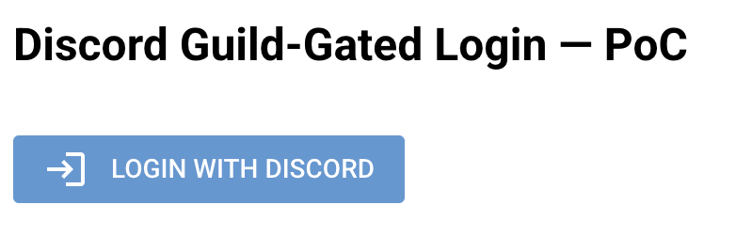
What Discord displays when you invoke the OAuth2 process:
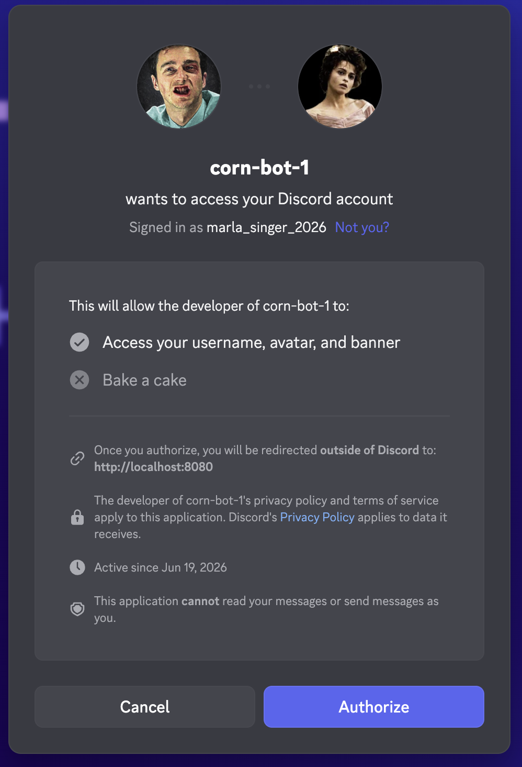
What the Web App displays when successful.
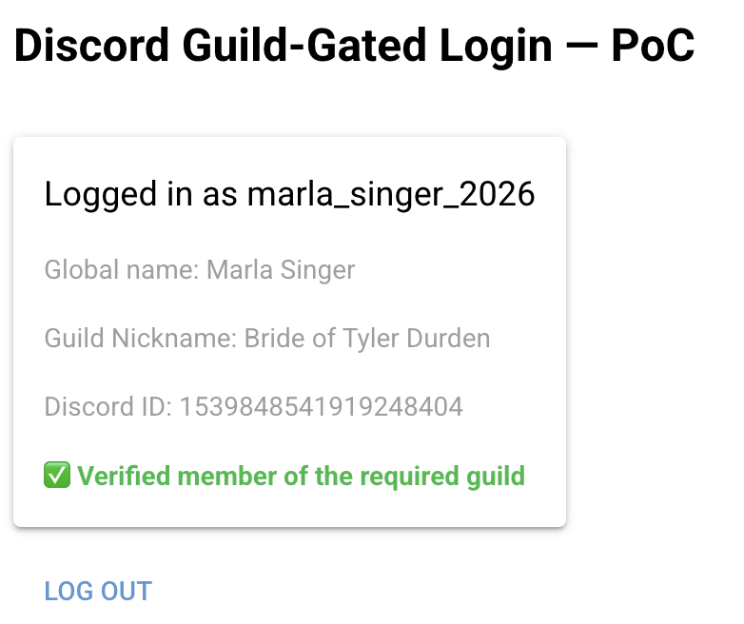
What the web app displays when the user isn’t part of the guild
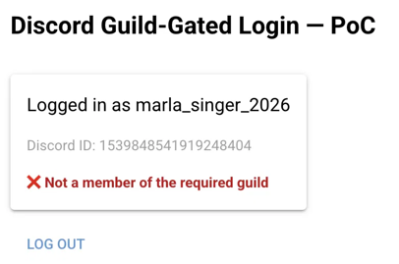
What is shown by discord when the user hasn’t verify their email address:
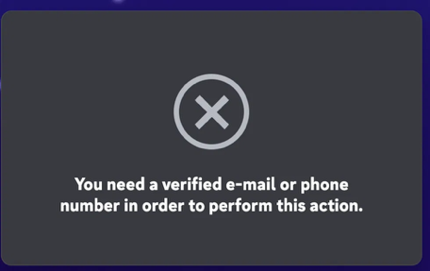

Details
There is a generated state “code” that is embedded in the login button’s URL. Its generated using the Python secrets package: secrets.token_urlsafe(16)
https://discord.com/oauth2/authorize?client_id=1517614609907974405&redirect_uri=http%3A%2F%2Flocalhost%3A8080%2Fcallback&response_type=code&scope=identify&state=LpnNADIqiaT-sj4aNoKOdQ
- AUTHORIZE_URL: https://discord.com/oauth2/authorize
- client id: 1517614609907974405 (from discord portal -> OAuth2 tab)
- redirect url: http://localhost:8080/callbac (url encoded)
- response type: code
- scope: identify
- state: LpnNADIqiaT-sj4aNoKOdQ (generated dynamically at runtime by script)
This is the complete url including the query params returned by the Discord when the user clicks the Authorize button.
http://localhost:8080/callback?code=TfFZyuf3ecP9EnNlc37HnHJYevc2lW&state=C1TNvyfDmBQb-M_tVxGGxQ
- The code is a one-time use authorization code from discord
- We use the authorization code
  - when we do an http post to: https://discord.com/api/v10/oauth2/token
  - along with
    - our OAuth2 client_id: xxx
    - our OAuth2 client_secret: xxx
    - grant_type: ‘authorization_code’
    - redirect_uri: xxx
  - The post returns JSON containing:
    - token_type: Bearer
    - access_token: xxxx
    - expires_in: 604,800 seconds (7 days)
    - refresh_token: xxxx
    - scope: identify
- The state must match the value from one of the previous values the _show_login_button() function generated.
We use the Bearer access_token to get the user’s identity details from Discord by doing a http get from:
- https://discord.com/api/v10/users/@me
- Where the access token is included in an Authorization header
- The JSON response contains the user’s details, such as:
  - Discord id
  - Discord username
  - Global name (the default value people on the server will see when the user posts a message unless the user has created a server specific profile name)
We then attempt to get the users details from the specified discord Guild by doing an http get from:
- https://discord.com/api/v10/guilds/<GUILD_ID>/members/<discord_user_id>
- Where the Bot’s token is included in an Authorization header
- If the http response code is 200 then the discord user is a member of the discord guild (server).
- The response JSON payload contains member details, such as the user’s discord guild’s nick name (nick) and roles (???)

Questions to Ask Claude
- what is the refresh_token that is returned in the JSON payload in step #1 - exchange the authorization code for an access token.
- How is the state secure when we pass it to discord in the url encoded parameters as the state parameter to the https://discord.com/oauth2/authorize URL. Cant the code be seen by anyone because it is plain text?
- Why do we in step 1 of the OAuth2 discord_callback function have to send the redirect_uri that we previously used in the initial login button?
- How should we maintain the fact whether or not a given user is logged in? Secure. Best practices.
- What should our web app do when the user clicks the logout button?
- If the user Deauthorizes our web app through their Discord user settings, what do they need to do to access the web app again?
- How should a well organized NiceGui app have its code structured/organized?
- If I know the value used by nicegui to sign the cookie, can I decrypt the data? How?

Notes from Clause
- Discord users can manage the apps they have authorized in their discord user settings.
  - User Settings (gear icon) → Connected Apps → Authorized App section
  - Select the app to be deauthorized & click the Deauthorize button
  - This will log the user out from the web app. I’m assuming if the user want to, they can go through the OAuth2 step again?
- This OAuth2 integration with Discord provides user authentication for our web app
  - We do not have to build our own signup/password system
  - Discord provides our web app with a verified Discord Username + Discord ID

Future Enhancements Suggested by Claude
- Role-gating — check for a specific role within the guild, not just membership
- Handle edge cases — what happens if the user denies authorization, or the bot gets kicked from the guild, etc.
- Move off some-random-string — swap in the secrets.token_urlsafe(32) value we generated earlier, if you haven't already
- Missing functionality:
  - Persistent accounts — right now a Discord ID isn't tied to anything in a database; nothing remembers this user between sessions beyond the login cookie
  - Token refresh — the access token expires; we never store/use the refresh_token Discord also returns
  - Multi-worker state — the _pending_states CSRF set is an in-memory Python set; fine for one process, breaks if you ever run multiple workers
  - Role-based gating — currently binary (member / not member); no distinction between roles yet
  - Error handling — denied authorization, revoked access, bot removed from guild, rate limits — none of that is handled gracefully yet
- Short coming on how nicegui does cookie signing ???
  - One nuance worth flagging since you're on a single dev machine now but might scale later:
  - this cookie-signing approach is inherently stateless on the server — the server doesn't keep a database of "active sessions,"
  - it just re-verifies the signature on each request.
  - That's convenient (no session-store infrastructure needed) but it also means: if you ever need to force-revoke one specific user's session server-side (e.g., "kick this one logged-in user"), you can't just delete a row somewhere — you'd need to rotate the whole secret (logs everyone out) or add your own revocation list.
  - How do we remediate this?
- When performing a Guild Membership lookup/check…
  - The success of the lookup/check is dependent on the bot staying in the guild with an active token.
  - If the bot is kicked, banned, or its token is reset/revoked, the lookup will fail
  - It is worth wrapping in error handling eventually
  - the script just treats non-200 [~NOT OK] as "not a member" and 200 [OK] as “is a member”
  - This would be wrong in that failure scenario - a 403 [FORBIDDEN] /500 [INTERNAL SERVER ERROR] isn't the same as a 404 [NOT FOUND].
  - We need to tighten up the callback so it distinguishes "definitely not a member" 404 from "the check itself failed" (or any other errors)

Needed Features
- When registering a new account (aka OAuth2 through Discord)
  - User must first enter their KingShot Kingdom number: i.e., #1467 or #1542
  - Then the user must select their KingShot Alliance: i.e., UFC or PHX
  - These 2 values will be used to determine the Discord Guild ID used to validate the user belongs to the given guild that is run by the KingShot Alliance they say they belong to.
- Every page
  - must require the user to be logged in
  - check the “site status” for their alliance
  - ensure the user type requirements are met for the given page being accessed.
- I need to be able to support the following types of users, each allowed to do specific actions in the web app
  - Normal user
    - can only maintain their data
    - can view some details about other users within their alliance
  - Scheduling Admin user
    - can add/edit KingShot events (e.g., BT)
    - run the scheduling job
    - select the “best times” for KingShot events
    - publish the times for KingShot events
  - Admin User
    - Can add/edit: accounts / players / time slot availability on the behalf other users

  - Super Admin User
    - Assing the user type to an user

