New account registration
Account registration use cases:
- Not a discord user – do we still want to allow admins to register accounts for non-discord using users?
- Does not belong to the alliance guild – user needs to join the discord guild (sever) corresponding to the king shot alliance. After the user joins the guild, then the user can register themselves directly
- Belongs to the alliance guild – user can register themselves directly

ACCOUNTS table
account_id | PK
account_type | Deprecated ??? [discord-user | manual-user]
discord_id | The discord id returned by the OAuth2 discord integration (discord_user)
discord_name  discord_username | The discord username returned by the OAuth2 discord integration (discord_user object) [rename this column] → user_name (no spaces or dashes, only lower case leters and numbers 0 thru 9)
discord_global_name | The discord global_name returned by the OAuth2 discord integration (discord_user object) [add this column] → display_name
account_name | Should be set to the Discord username if a self registered account or to the value entered by the admin if a manual registration (also discord_id, discord_username and discord_global_name are set to NULL).
discord_nick | The discord guild nick returned by the server side bot token integration (discord_member object) → guild_display_name [move to players table]
account_tz | The IANA timezone name (string) used with the dateutil.tz module to convert a local time to UTC. Consists of time-zone region and time-zone location (see the timezone table)  time_zone = tz.gettz(account_tz)  local_dt = local_dt.replace(tzinfo= time_zone) # if naive datetime  local_dt.astimezone(timezone.utc)
create_account_id | The account_id that created the account – 0 if the account was created by the user  This column can be deprecated if we do not allow admins to manually register accounts for non-discord users.
create_date_time | Create date & time
update_account_id | The account_id that last updated the account
update_date_time | Last update date & time

TIMEZONE table
timezone_id | PK
region | Examples: Africa, America, Asia, Australia, Europe, Indian
location | Examples: Amsterdam, Athens, Baghdad, Brisbane, Bucharest, Calcutta, Chicago, Denver, Dublin, Fiji, Gaza, Guatemala, Havana, Hong_Kong, Istanbul, Johannesburg, Kiev, Kuwait, Lisbon, London, Madrid, Malta, Melbourne, Mexico_City, Montreal, Moscow, New_York, Oslo, Paris, Prague, Rome, Samoa, Sao_Paulo, Seoul, Sydney, Tahiti, Tehran, Tel_Aviv, Timbuktu, Toronto, Zurich

The Discord Integration
- Present the “Login With Discord” button
- User clicks button
- Is user logged into discord on the web
  - No
    - the user can provide their email address if it has been validated (or phone number if validated) and password then clicks the login button. Go to 3.b below.
    - or the user can scan the QR code with their phone if they have the mobile discord app and are logged in. After scanning the QR code in the discord app on the users phone, the user will be presented with a pop-up asking them if they want to sign into a new device, they click the “log in” button. The user is then presented with a pop-up asking for their password, the users enters it and then clicks the “submit” button. Finally, the user is presented with a confirmation pop-up, the user clicks the “start talking button”. Go to 3.b below.
    - or there is a third option to sign in with a passkey. The user clicks the link and the browser displays the sign in with a passkey GUI. The user then click the “Sign In” button. Go to 3.b below.
  - Yes – user is presented with the authorize pop-up in the web browser, user clicks the “Authorize button.
- The web app performs the following steps
  - exchange the authorization code for an access token
  - fetch the user's identity
  - verify guild membership server-side with the BOT token
- xxx
Figure 1. user not logged into discord when they press the login with discord button
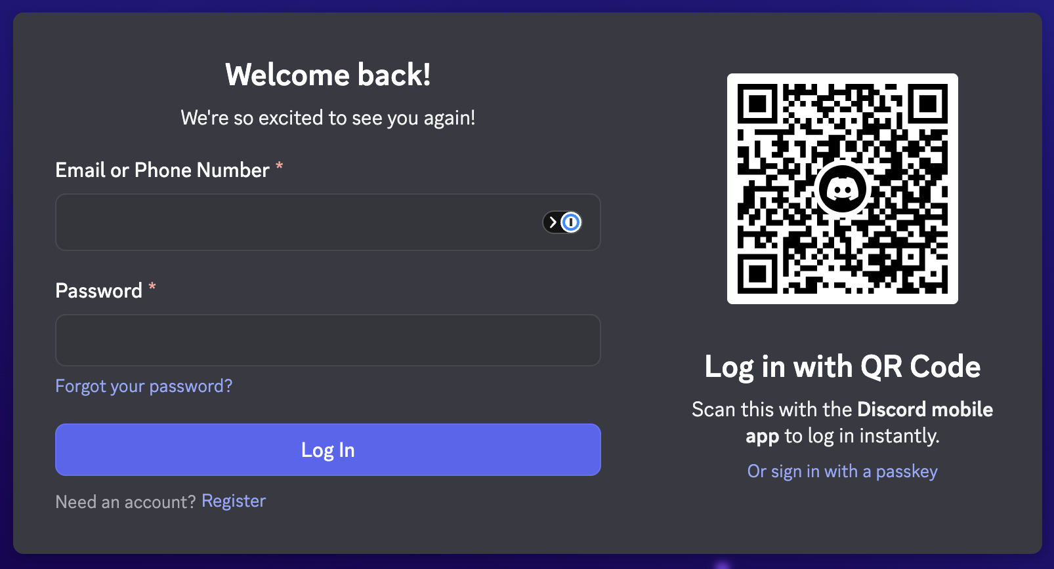
Figure 2. after user logs into discord or if user is already logged into discord on the web
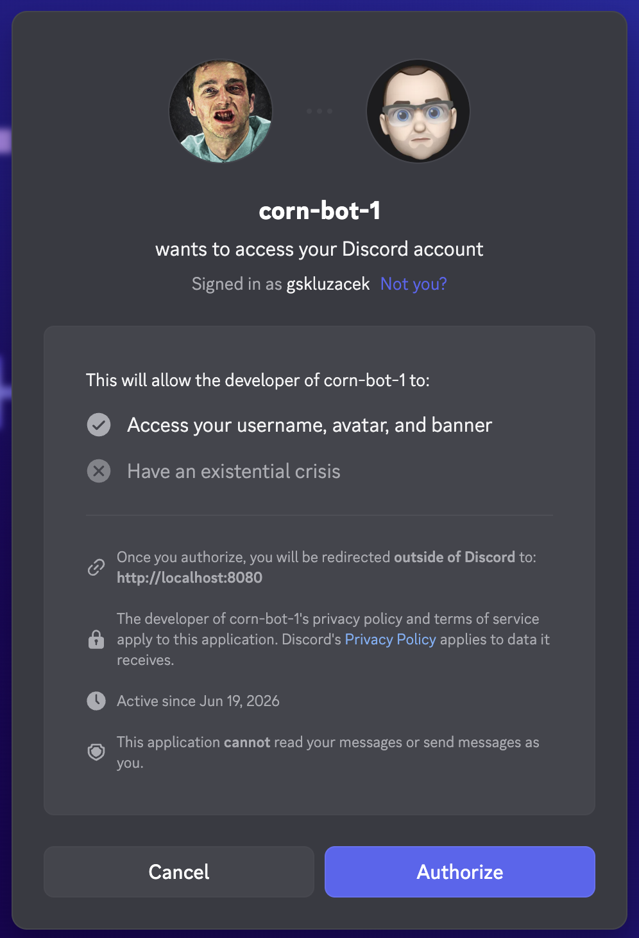
Figure 3a. passkey GUI – macOS 1password app
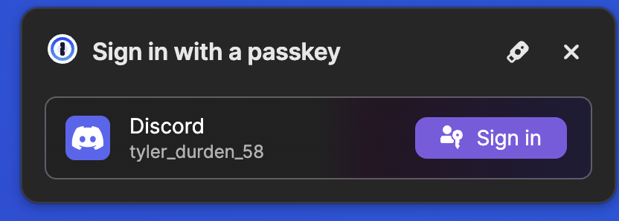
Figure 3b. passkey GUI – macOS password app
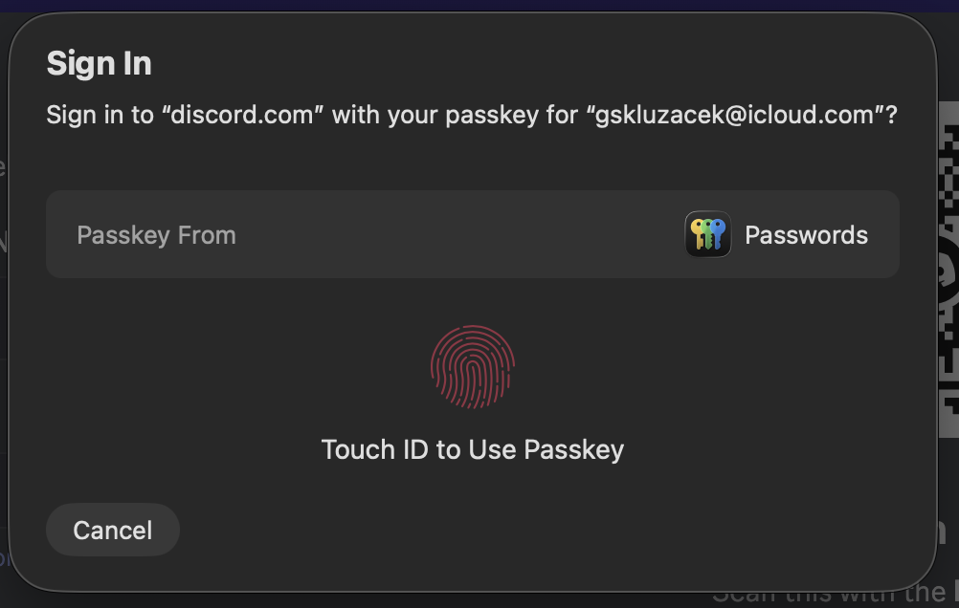
Figure 3c. passkey GUI – macOS Microsoft Edge app
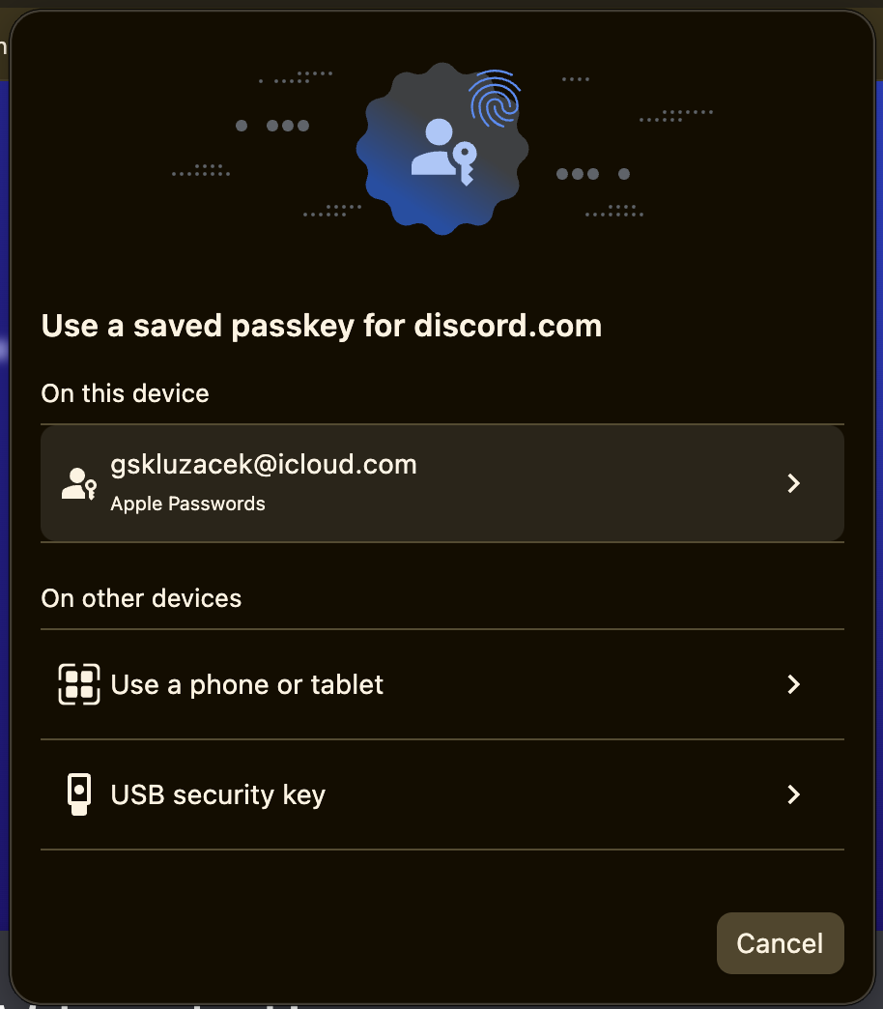
Figure 4a. iOS discord mobile app – log in to a new device pop-up
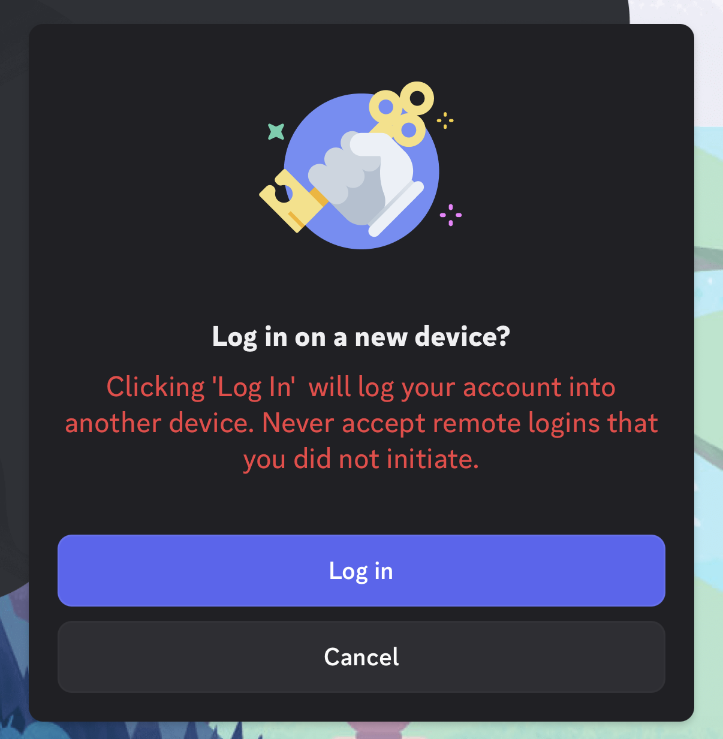
Figure 4b. iOS discord mobile app – enter password pop-up
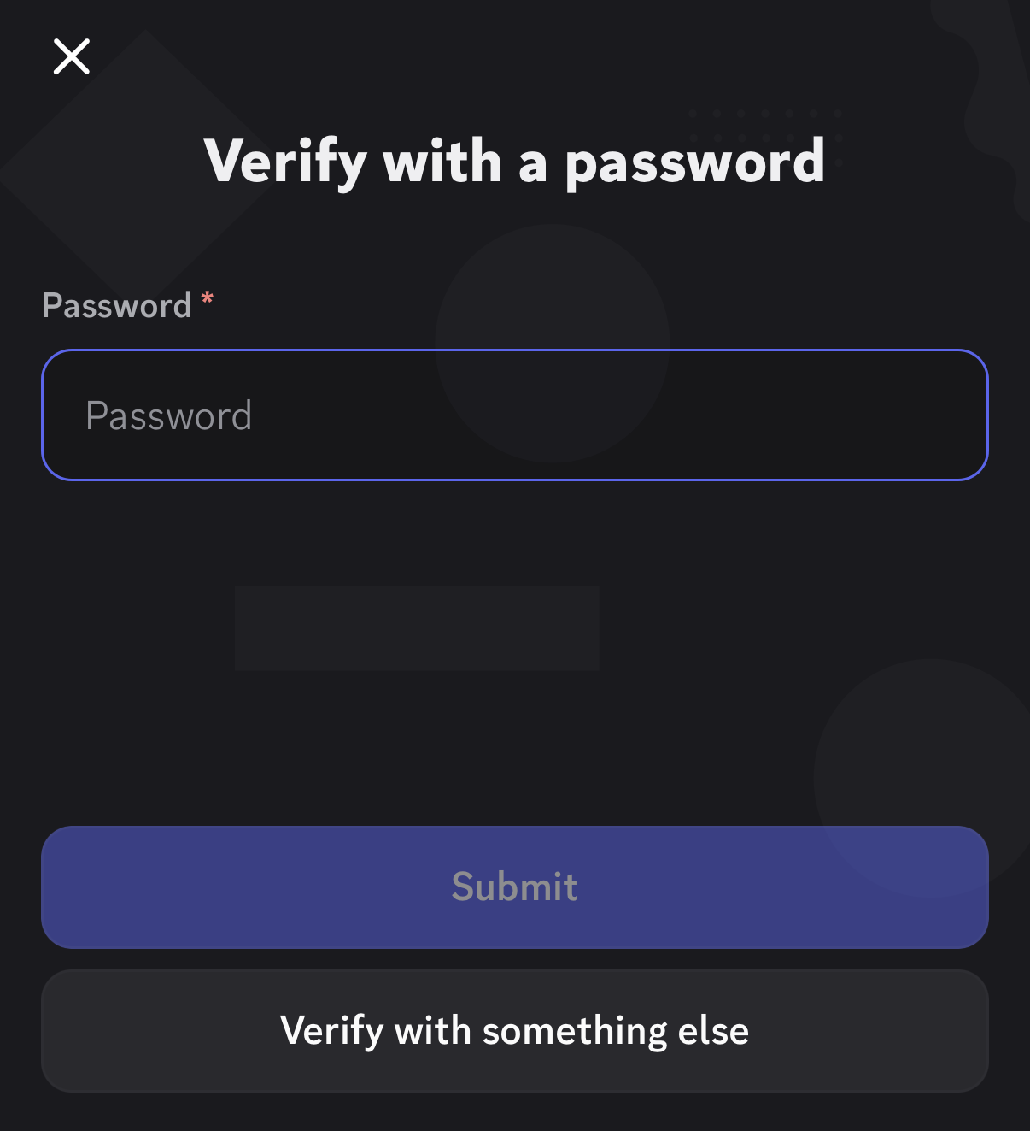

Figure 4c. iOS discord mobile app – confirmation pop-up
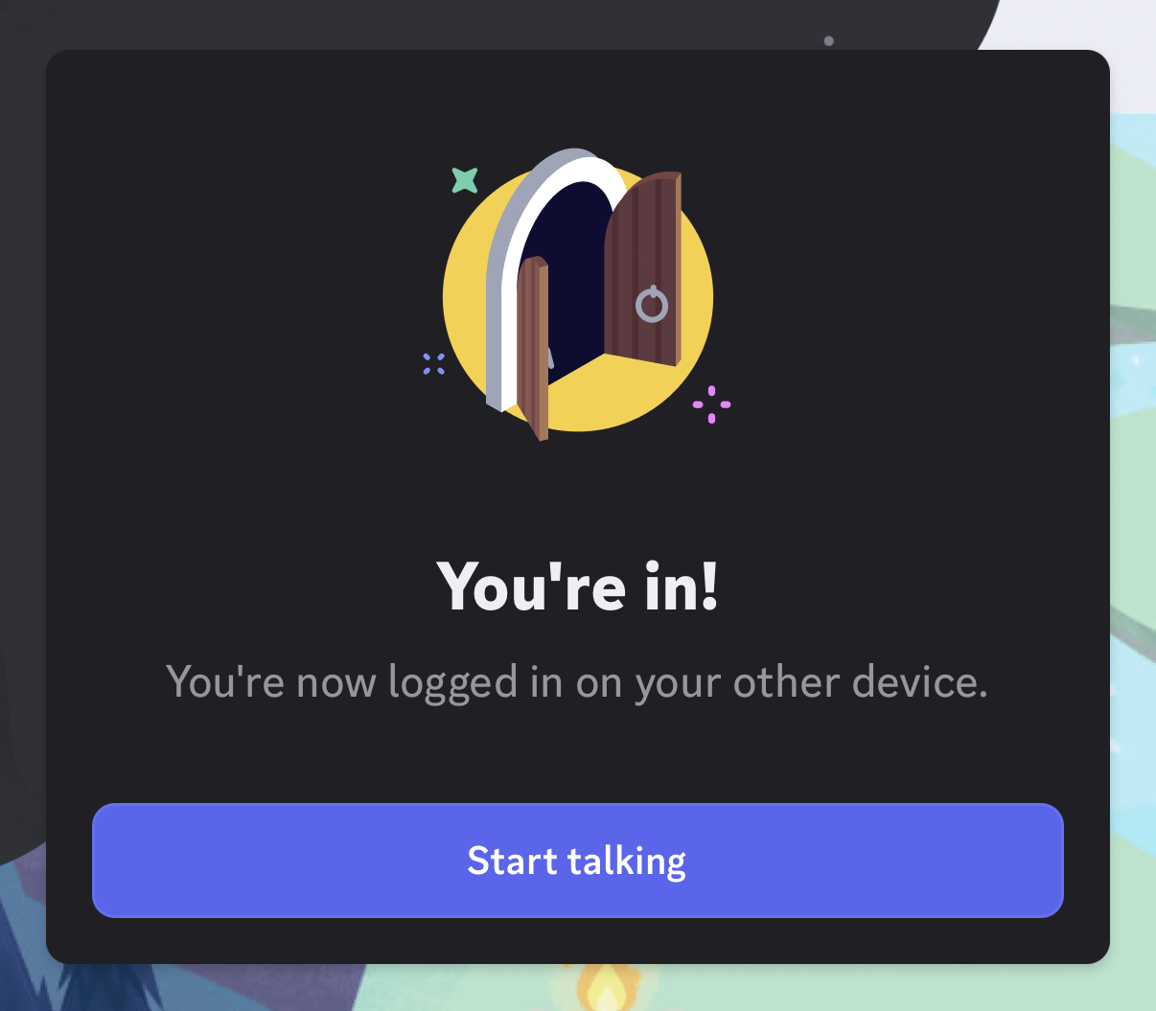
Figure 5 – web app has received the user’s discord user & member objects and has displayed the details
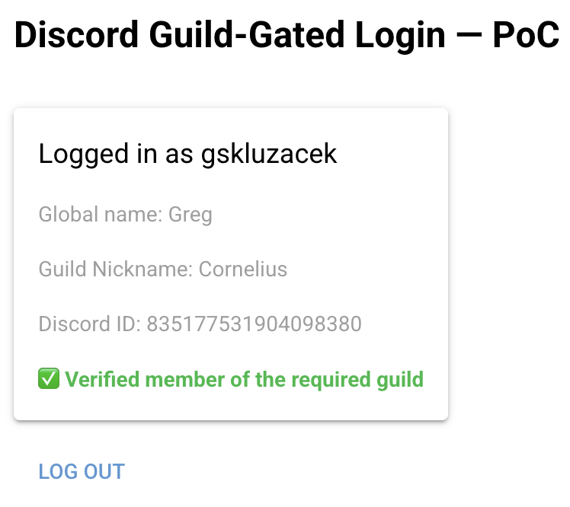
Scratch all that…

Registration process:
- user lands on home page
- click register account nav item – redirect to the register account page
- register account page & displays login with discord button
- user clicks the login with discord button
- user is either already logged into Discord on the web and is presented the Discord authorization pop-up. OR… the user is not logged into Discord and Discord Login pop-up. User logs in & then is presented the the Discord authorization pop-up.
- The user clicks the Authorize button on the Discord authorization pop-up.
- Discord redirects to the configured Redirect URL
- The web app directs to the appropriate FastAPI route, where it
  - exchange the authorization code for an access token
  - fetch the user's identity which returns the user’s discord user object containing the user’s: Discord user id (discord_id), Discord username (discord_username) and Discord global name (discord_display_name)
- We prompt the user to select
  - A time zone region from the time zone region drop down
  - A time zone location from the time zone location drop down
  - And then click the Finish Account Registration button
- Insert the user’s account record into the database.

Add King Shot Player Process
- We prompt the user to select
  - A king shot kingdom from the king shot kingdom drop down
  - A King Shot alliance from the king shot alliance drop down
- The Discord Guild (server) that corresponds to the selected king shot kingdom and alliance is displayed along with a Verify Guild Membership button.
- User clicks the Verify Guild Membership button, the web app performs
  - verify guild membership server-side with the BOT token
  - we get confirmation that the discord user belongs to the discord Guild 200 [OK]
  - or we get a 404 [NOT FOUND] – does not belong
  - or possibly a 403 [FORBIDDEN] – Something wrong with the Bot credentials
  - or even a 500 [INTERNAL SERVER ERROR] – something wrong with the request, maybe the bot was removed from the guild?
- We get the discord user’s member object containing user’s guild nick (discord_nick_name on the specified guild).
- We the prompt the user for their:
  - Kingshot id (from game)
  - Kingshot name (from game)
  - Power (from game)
  - Town Center level – select from a drop down (from game)
  - Other…
- Insert the user’s player record into the players table.

PLAYERS table
player_id | PK
account_id | FK to accounts table
discord_nick | The discord guild nick returned by the server side bot token integration (discord_member object) → guild_display_name [moved from accounts table]
kingdom | From king shot kingdom drop down value
alliance | From king shot alliance drop down value
kingshot_id
kingshot_name
power
town_center_level
create_account_id
create_date_time
update_account_id
update_date_time

