**Derby JDBC Provider**

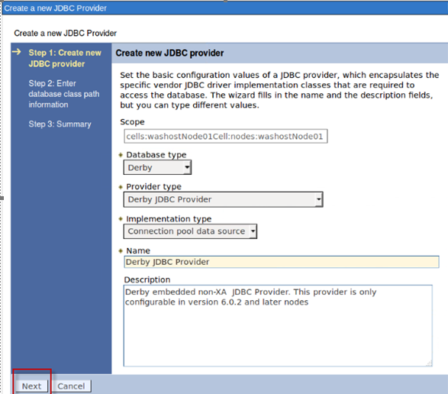

**Data source**

The embedded database is in the EAR that you deploy.

Database name: **${APP_INSTALL_ROOT}/${CELL}/DefaultApplication.ear.ear/DefaultDB**

JNDI Name**: DefaultDatasource**

