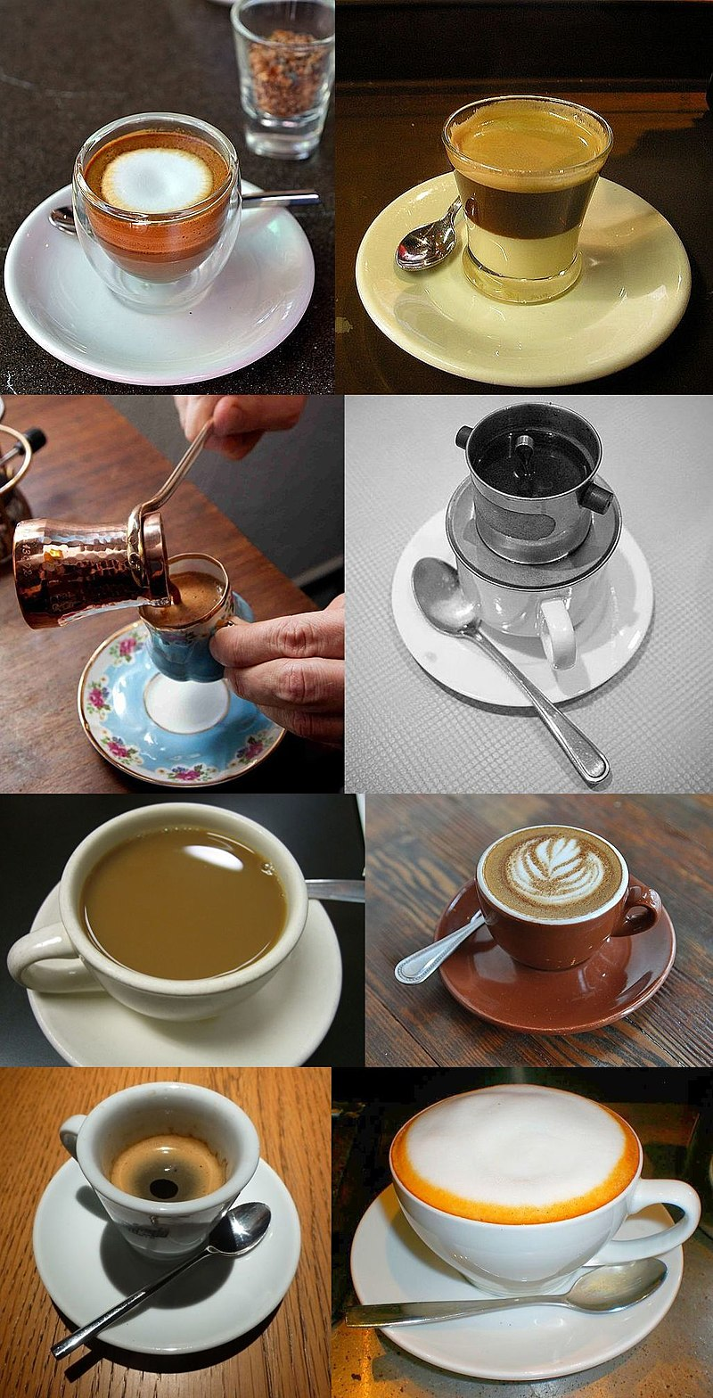Content outline

Grace Lancaster

11/8/2017

**Project Title: Types of coffee drinks**

**Home Page/Intro page**- this will be the first page with lots of visuals to draw the viewer into the content. It will have images and infographics about overview of coffee drinks/ coffee brewing methods.

**History:** A small blurb about coffee bean cultivation and production and the economy of coffee trade. A bit about coffee economy- how much coffee is consumed each year ?

**Infused**- give a brief overview of the brewing process, equipment, preparations, and perhaps reviews or links to the best places to order a cup!

**Espresso-** give a brief overview of the brewing process, equipment, preparations, and perhaps reviews or links to the best places to order a cup!

**Au Lait** – Same^

**Iced** – Same ^

**Coffee Culture**- Countries have cultivated coffee beans into various vehicles to satisfy needs unique to each country. Whether it be for energy, socialization, or tradition, the cultivation of coffee has served as a motivating force of the world. The modernization of coffee and its unique forms across cultures are markers of tradition and modern changes across continents. Coffee culture appears in the way in which people consume coffee, the way they make it, and where coffee is served and shared. Each of these factors combined reflects the lives of the people in these countries and the importance of coffee across the world.

**References:**

<https://www.huffingtonpost.com/2014/04/30/best-coffee-brewing-method_n_5233438.html>

<https://en.wikipedia.org/wiki/List_of_coffee_drinks>

<https://en.wikipedia.org/wiki/Coffee>

<https://en.wikipedia.org/wiki/Coffee_in_world_cultures>