APPENDIX 1

TITLE OF PROJECT:

ONLINE BOOK PURCHASING WEBSITE

END TERM REPORT

by

# *GODITHI SRI LAKSHMI PRASANNA*

# *SAURABH SINGH VERMA*

NAME OF THE CANDIDATE(S)

SAURAB SINGH VERMA.

GODITHI SRI LAKSHMI PRASANNA

SECTION: K19EG

ROLL NUMBER(S):65,66

GROUP: 2



DEPARTMENT OF INTELLIGENT SYSTEMS

SCHOOL OF COMPUTER SCIENCE ENGINEERING

LOVELY PROFESSIONAL UNIVERSITY, JALANNDHAR

MONTH-YEAR:04-2020

APPENDIX 2

STUDENT DECLARATION

This is to declare that this report has been written by us. No part of the report is copied from other sources. All information included from other sources have been duly acknowledged. We aver that if any part of the report is found to be copied, we are shall take full responsibility for it.

Signature of student: G.S.L. Prasanna

Name of student: Godithi Sri Lakshmi Prasanna

Roll number: 66

Signature of student: verma

Name of student: saurabh singh verma

Roll number: 65

Place: Jalandhar

Date:

APPENDIX 3

TABLES OF CONTENT

TITLE PAGE NO.

1. BACKGROUND AND OBJECTIVES OF PROJECT ASSIGNED
   1. INTRODUCTION
   2. BACKGROUND
   3. PURPOSE AND MOTIVATION
   4. OUTCOMES OF THE PROJECT
   5. CONCRETE GOALS AND OBJECTIVES
2. DESCRIPTION OF PROJECT:
   1. DATA FLOW DIAGRAM (DFD)
3. DISCRIPTION OF WORK DIVISION IN TERMS OF ROLES AMONG STUDENTS
4. IMPLEMENTATION OF SCHEDULED WORK OF PROJECT
   1. HOME PAGE
   2. LOGIN PAGE
   3. SIGN UP PAGE
   4. PATMENT PAGE
   5. REVIEWS PAGE
   6. ABOUT US PAGE
5. TECHNOLOGIES AND FRAMEWORK TO BE USED
6. SWOT ANALYSIS ACHALYSIS ACHIEVED IN PROJECT:
   1. STRENGTHS
   2. WEAKNESS
   3. APPLICATIONS:
   4. CONCLUSION:

APPENDIX 4

BONAFIDE CERTIFICATE

Certified that this project report “ONLINE BOOK PURCHASING WEBSITE” is the bonafide work of “GODITHI SRI LAKSHMI PRASANNA & SAURABH SINGH VERMA” who carried out the project work under my supervision.

Signature of the supervisor:

Name of the supervisor:

Academic Designation:

ID of supervisor:

Department of supervisor:

1. BACKGROUND AND OBJECTIVES OF PROJECT ASSIGNED:
   1. INTRODUCTION:

The main objective of the project is to create an online book store that allows users to

search and purchase a book online based on title, author and subject. The selected books

are displayed in a tabular format and the user can order their books online through credit

card payment. Using this Website, the user can purchase a book online instead of

going out to a book store and wasting time.

There are many online book websites like Powell’s, Amazon which were designed

using Html. I want to develop a similar website using HTML, CSS, JAVA SCRIPT.

Book shopping App allows users to check for various Books Instruments and can purchase them. The project consists of list of Books displayed in various models and designs. The user may browse through these products as per categories. If the user likes a product, he may add it to his shopping cart. The User can view the items based on their names.

This App has an Innovative Floating Cart, which pops up showing the Items that are

currently in the cart with minimum details. The User must register into the system and

then is eligible to check out the products. The User has 3 kinds of payment method

namely; Debit, Credit card or Cash on Delivery.

An online book store is a virtual store on the Internet where customers can browse the

catalog and select books of interest. The selected books may be collected in a shopping

cart. At checkout time, the items in the shopping cart will be presented as an order. At

that time, more information will be needed to complete the transaction. Usually, the

customer will be asked to fill or select a billing address, a shipping address, a shipping

option, and payment information such as credit card number. An e- mail notification is to

the customer as soon as the order is placed.

The Online Book Store Website provides customers with online shopping through a web

browser. A customer can, create, sign in to his account, place items into a shopping cart

and purchase using his credit card details.

* 1. BACKGROUND:

The Front End of the App is done using HTML, CSS, JAVA SCRIPT and BOOTSTRAP. Thus the online book purchasing website project brings an entire Books Store online and makes it easy for both buyer and seller to make deals on Books.

The HOME page is created by using HTML and CSS code. The LOGIN page is created by using HTML, CSS and JAVASCRIPT. The SIGN UP page is created by using HTML, CSS and JAVASCRIPT. The PAYMENT LOGIN page is created by using HTML, CSS and JAVASCRIPT. The REVIEWS LOGIN page is created by using HTML, CSS and JAVASCRIPT. The ABOUT US LOGIN page is created by using HTML and BOOTSTRAP.

Online Book store is an online web application where the customer can purchase books online. Through a web browser the customers can search for a book by its title or author, later can add to the shopping cart and finally purchase using credit card transaction. The user can login using his account details or new customers can set up an account very quickly. They should give the details of their name, contact number and shipping address. The user can also give feedback to a book by giving ratings on a score of five.

This project has the following functionalities:

1. A Home page with product catalog:

This is the page where the user will be navigated after a successful login. It will display all the book categories and will have a search keyword option to search for the required book. It also includes some special sections like recommended titles, weekly special books.

1. Search:

A search by keyword option is provided to the user using a textbox. The

keyword to be entered should be the book title.

1. User Voting:

The user can give rating to a book based on his interest. He can rate it by giving a score of five as Excellent, four for very good, three for good, two for regular and one for deficient. The final rating of a book will depend on all the individual user rating.

1. Shopping Cart:

The user can manage a shopping cart which will include all the books he selected. The user can edit, delete and update his shopping cart. A final shopping cart summary is displayed which includes all the items the user selected and the final total cost.

5) Managing user accounts:

Each user should have an account to access all the functionalities of website. User can login using login page. All the user sessions will be saved in the database.

* 1. PURPOSE AND MOTIVATION:

The main objective of the project is to create an online book store that allows users to search and purchase a book based on title, author and subject. The selected books are displayed in a tabular format and the user can order their books online through credit card payment.

The motivation to create this project has many sources

* Interest to develop a good user friendly website with many online transactions using a database.
* To increase my knowledge horizon in technologies like JAVA SCRIPT, BOOTSTRAP, CSS, HTML.
* To gain good experience in .NET, BOOTSTRAP before joining in a full time job.
* To gain expertise using Data Grid, Data Set, Data Table, Data Adapter and Data Readers.
  1. OUTCOMES OF THE PROJECT:

The outcomes of this Online Book Purchasing Website are it will provide customers with online shopping through a web browser. A customer can, create, sign in to his account, place items into a shopping cart and purchase using his credit card details. Online Book store is an online web application where the customer can purchase books online. Through a web browser the customers can search for a book by its title or author, later can add to the shopping cart and finally purchase using credit card transaction. The user can login using his account details or new customers can set up an account very quickly. They should give the details of their name, contact number and shipping address. The user can also give feedback to a book by giving ratings on a score of five.

* 1. CONCRETE GOALS AND OBJECTIVES:

The main goals of this project are

* Maximize search options-

1. By author’s name.
2. By book’s title.
3. By subject.

* Delivery at your doorstep.
* Time saving.

The main **objective** of the **Online Book Store** is to manage the details of **Books**, Customer, Payment, Delivery, Bills. It manages all the information about **Books**, Stock, Bills, **Books**.

1. DESCRIPTION OF PROJECT:
   1. Data Flow Diagram (DFD):

Data Flow Diagrams show the flow of data from external entities into the system, and from one process to another within the system.

1. ZERO LEVEL DED

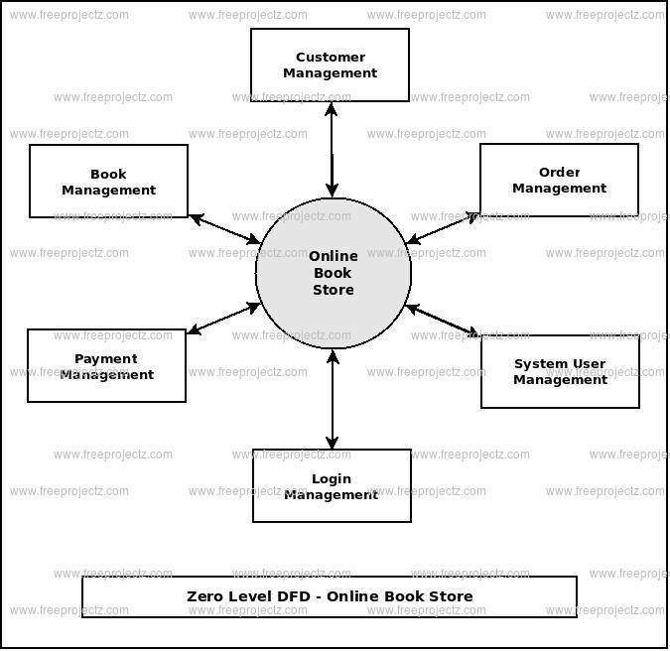

1. HOME PAGE

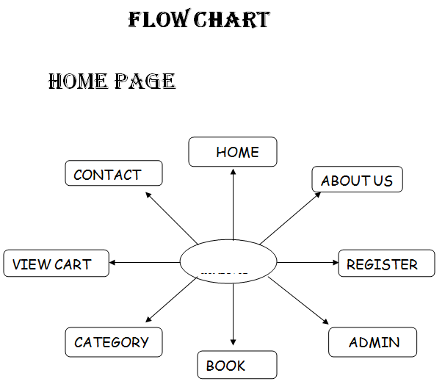

1. REGISTRATION PAGE

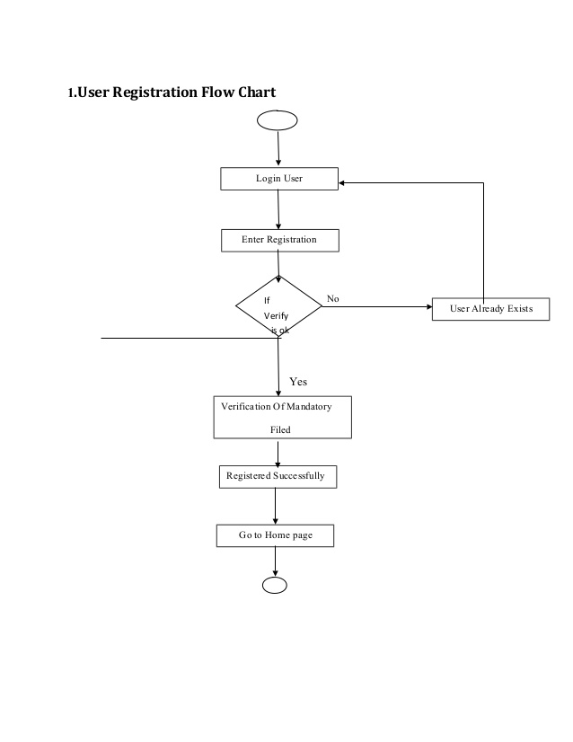

1. DATA FLOW DIAGRAM

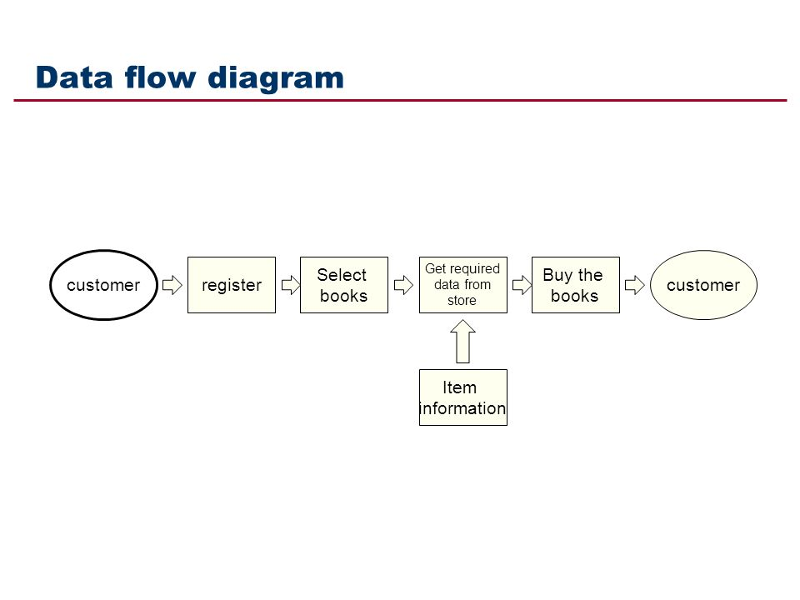

1. DATA FLOW DIAGRAM FOR LOGIN

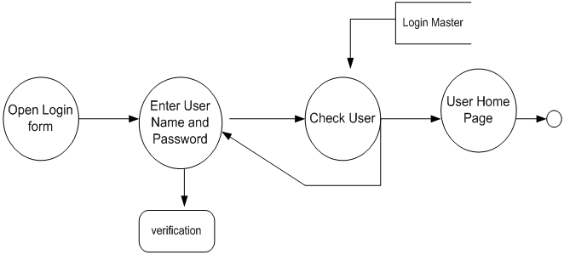

1. DISCRIPTION OF WORK DIVISION IN TERMS OF ROLES AMONG STUDENTS

* GODITHI SRI LAKSHMI PRASANNA: In this project I wrote all the and few pages of report.

I done all the coding part of the project.

* SAURABH SINGH VERMA: In this project I wrote the synopsis and few pages of report.

1. IMPLEMENTATION OF SCHEDULED WORK OF PROJECT
   1. HOME PAGE:

It consists of all options of the website like login, signup, payment, products category, reviews, about us.

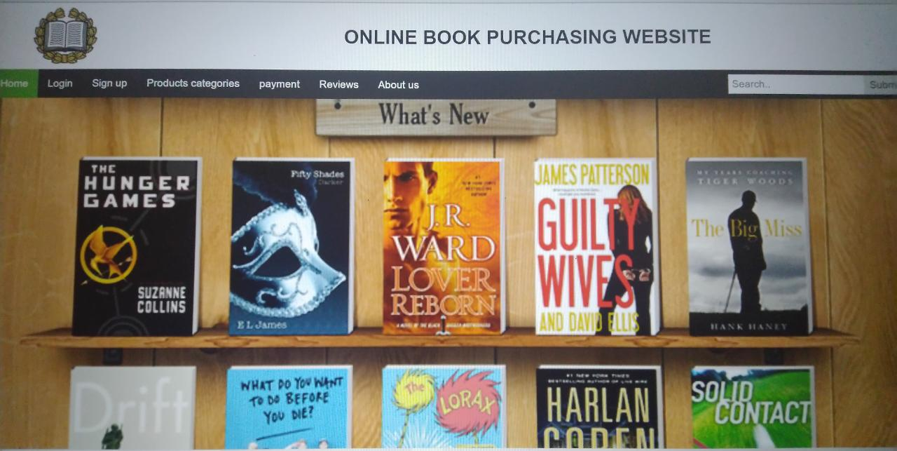

* 1. LOGIN PAGE:

Logging in is usually used to enter a specific page, website or application, which trespassers cannot see. Once the user is logged in, the login token may be used to track

what actions the user has taken while connected to the site what actions the user has taken while connected to the site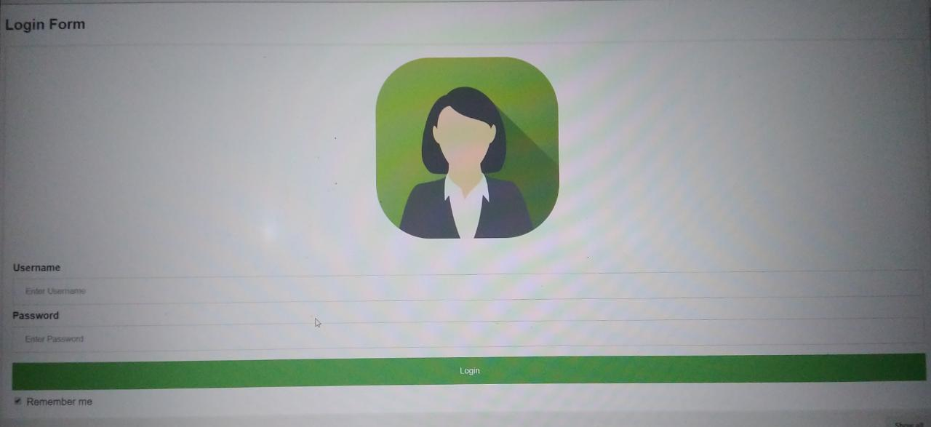.

* 1. SIGN UP PAGE:

The user can create an account to enter into the website.

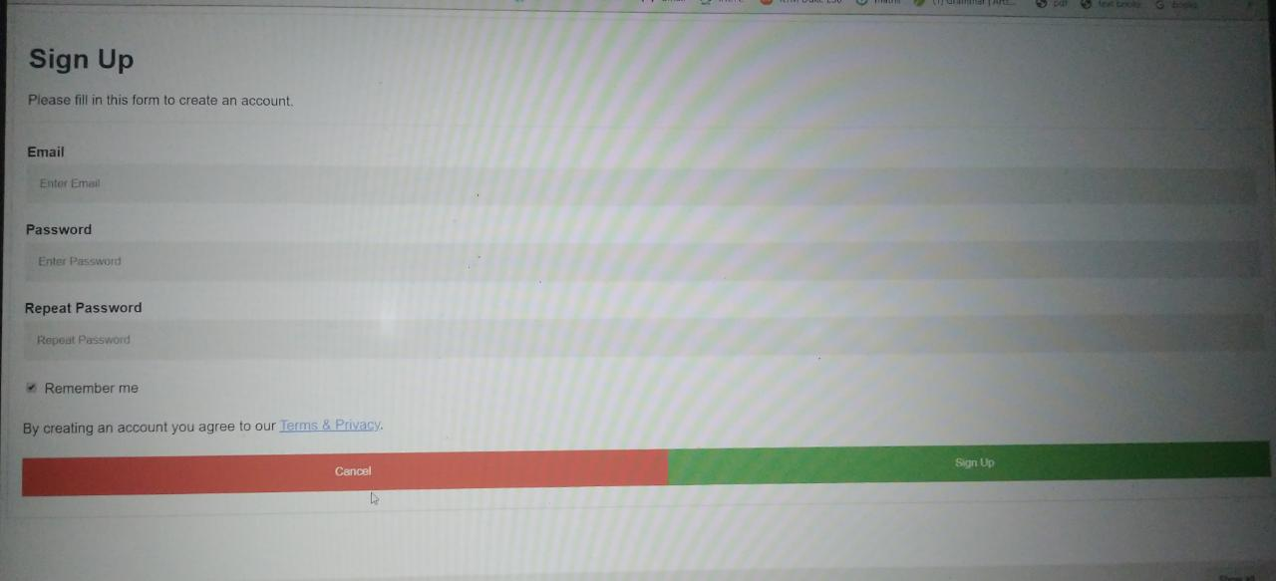

* 1. PATMENT PAGE:

Here the users can pay money with the different card options.

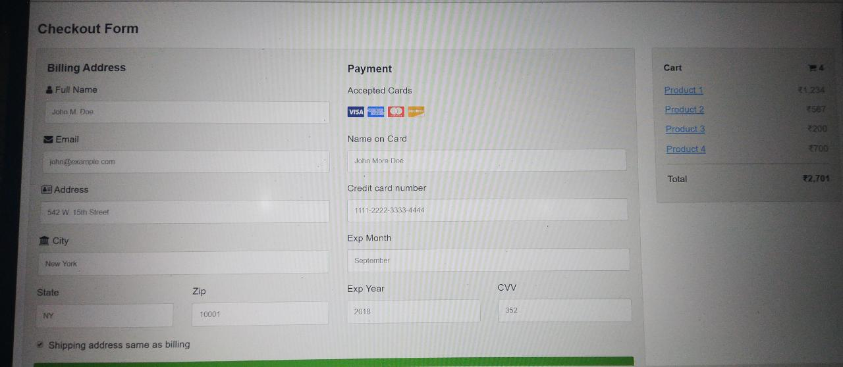

* 1. REVIEWS PAGE:

The user can give rating to a book based on his interest. He can rate it by giving a score of five as Excellent, four for very good, three for good, two for regular and one for deficient. The final rating of a book will depend on all the individual user rating.

Source code:

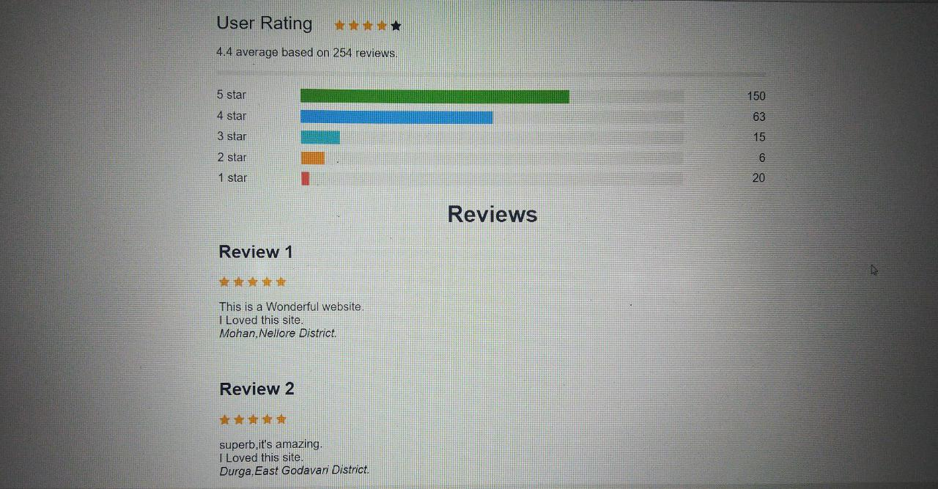

* 1. ABOUT US PAGE:

It will tell about the creators of website.

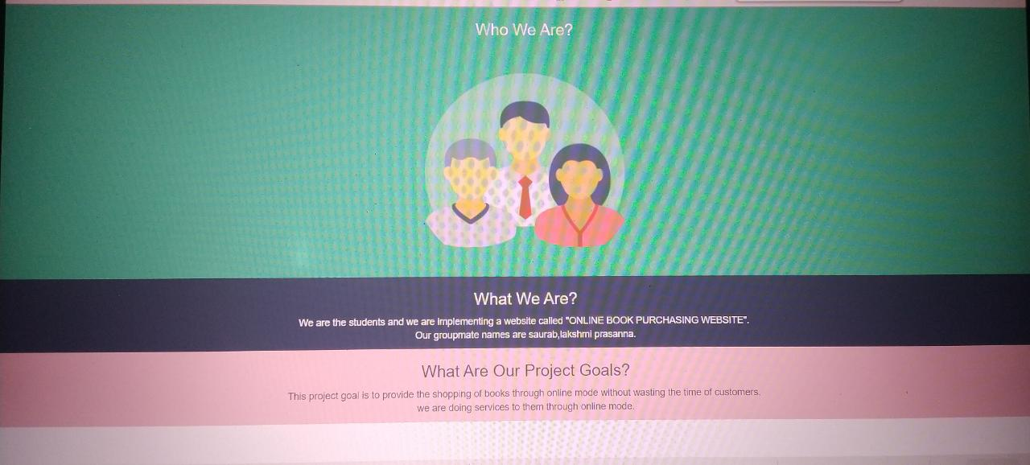

1. TECHNOLOGIES AND FRAMEWORK TO BE USED:

* Windows 10(ultimate, enterprise)
* Notepad
* HTML
* CSS
* JAVASCRIPT
* BOOTSTRAP

**Hardware Components:**

* Processor – i3
* Hard Disk – 5 GB
* Memory – 1GB RAM

1. SWOT Analysis achieved in project:
   1. STRENGTHS:

* Helps Books Store to automate furniture selling online.
* Helps Books Store to take cc payments.
* User can check items in the cart on any page.
* Filters help the user to look for items according to his convenience.
  1. WEAKNESS:
* Does not keep track of stock.
* No email or Message Confirmation of the order.
  1. APPLICATIONS:
* This system can be limited to particular books by Author or Books Store or can be used on global scale.
* This system can be used to sell like chain of Books Store from a website.
  1. CONCLUSION:

Online Book Purchasing Website are it will provide customers with online shopping through a web browser. A customer can, create, sign in to his account, place items into a shopping cart and purchase using his credit card details. Online Book store is an online web application where the customer can purchase books online. Through a web browser the customers can search for a book by its title or author, later can add to the shopping cart and finally purchase using credit card transaction. The user can login using his account details or new customers can set up an account very quickly.