Winspell32 v 1.00 Help
Index
- Installing Winspell32
- Converting a Text File
- Opening and Saving Data Files
- Working With The Spell List
- The Minimizing/Sort System
- Printing and Exporting Text Files
- Editing Spells
- Changing Colors and Fonts

Installing Winspell32
To use winspell32, you must have win95, at least 8 MB of Ram and a speedy hard disk.
Follow these instruction to install it:
- Unzip the winspell.zip file into a the directory you wish to run the program from.
- If you intend to use a datafile you created using the older versions, run them, and save the list to a text file, with description (using the print feature in dos version), with 1 empty line between spells. and go to Converting a Text File.
- If you intend to use the datafile which comes with the program, unzip the spelllst.zip file, copy the 2 files into the same directory as the program, and follow instructions in Opening and Saving Data Files.
- Drag the winspell.exe icon, from the explorer onto the START menu or DESKTOP to get an icon shortcut to the program.

File Description
winspell.exe The winspell exe file
winspell.col Color File - Hold the color information. Delete to rest colors to standard windows colors.
winspell.ini Holds basic information for winspell, like windows sizes & positions.
winspell.doc Word6 help file.
Files formed after 1st time of running winspell:
winspell.lst The recently opened file list. Erase file, if you want to reset the list.
winspell.key When this file is present, with correct data, winspell will not show the license part of the flash screen.

Datafiles:
spelllist.dat The winspell data file, which comes with over 2400 spells, prayers and psionics. (note that it will take about 20 seconds to load).
spelllist.SBK This file is formed after the first time a datfile is saved. It holds the spellbook information for that list. Erasing this file will reset the spellbooks for the list, but is not recommended, as the spells will still belong to a book. Its better you use the program to erase the books you create.
spelllist.SBN This file contains the information regarding the number of spells learned for each spell in a spell book. Deleting the file, will reset all spell numbers to 0. The program creates this file, when saving a spell book in data format..
Converting a Text File
Winspell can import an Ascii text file, as saved in the spellview5.0 Dos version (The convert spell in windows version doesn't enter the priest school correctly), using the save to file feature. You can also prepare those files yourself as follows:

ÄÄÄÄÄÄÄÄÄÄÄÄÄÄÄÄÄÄÄÄÄÄÄÄÄÄÄÄÄÄÄÄÄÄÄÄÄÄÄÄÄÄÄÄÄÄÄÄÄÄÄÄÄÄÄÄÄÄÄÄÄÄÄÄÄÄÄÄÄÄÄÄÄÄÄÄÄÄÄÄÄÄÄÄÄÄÄÄÄÄÄÄ (A line - of at least 10 chars long (copy this line))
Name (Sphere/Discipline in parenthesis) Reversible
<empty line>
Nth <or First, Second....> Level <type = Wizard Spell/Priest Prayer> or Psionic <Devotion/Science/Info> Power
<empty line>
<empty line>
Any one of the following, in any order, followed by ': ' (':' followed by 1 space):
Wizard and Priest spells
Range
Components
Duration
Casting Time
Area Of Effect or AOE
Saving Throw
School <or> Priest School <or> Sphere <or> Priest Sphere

Psionic Powers
Power Score
Initial Cost
Maintenance
Range
Preparation Time
Prerequisites
ÄÄÄÄÄÄÄÄÄÄÄÄÄÄÄÄÄÄÄÄÄÄÄÄÄÄÄÄÄÄÄÄÄÄÄÄÄÄÄÄÄÄÄÄÄÄÄÄÄÄÄÄÄÄÄÄÄÄÄÄÄÄÄÄÄÄÄÄÄÄÄÄÄÄÄÄÄÄÄÄÄÄÄÄÄÄÄÄÄÄÄÄ (A line - of at least 10 chars long (copy this line))
Author: (':' + 2 spaces) <author of spell or spell source, up to 2 lines>
<empty line (only if author field was added)>
Description (any number of lines, with any number of spaces). The program will stop looking for the description as soon as it reaches the line of the next spell, or the end of the file.
For Example:
ÄÄÄÄÄÄÄÄÄÄÄÄÄÄÄÄÄÄÄÄÄÄÄÄÄÄÄÄÄÄÄÄÄÄÄÄÄÄÄÄÄÄÄÄÄÄÄÄÄÄÄÄÄÄÄÄÄÄÄÄÄÄÄÄÄÄÄÄÄÄÄÄÄÄÄÄÄÄÄ
Selene's Reattachment (Necromancy) Reversible

Sixth Level Priest Prayer

Range : 0
Components : V, S
Duration : Permanent
Casting Time : 1 round
Area of Effect : Creature touched
Saving Throw : None
Priest School : Necromantic
ÄÄÄÄÄÄÄÄÄÄÄÄÄÄÄÄÄÄÄÄÄÄÄÄÄÄÄÄÄÄÄÄÄÄÄÄÄÄÄÄÄÄÄÄÄÄÄÄÄÄÄÄÄÄÄÄÄÄÄÄÄÄÄÄÄÄÄÄÄÄÄÄÄÄÄÄÄÄÄ
Author: Joe Colleran <jnc4p@uva.pcmail.virginia.edu>

This spell is a less potent version of the 7th-level priest spell regenerate.
The spell will allow the priest to reattach a severed limb to an individual
provided the limb is present and the spell is cast not more than 1 turn per 3
levels of the priest after the limb was severed. The process of reattachment
takes but 1 round, but the limb is not usable for any purpose until after the
victim has rested for 1 day. No system shock or resurrection roll is needed
.....
off. Creatures making their saving throws still take damage equal to a cause
critical wounds, i.e. 3d8+3. Selene's detachment has no effect on nonliving
creatures (undead, constructs, etc.) or on creatures from other planes (cf.
cure light wounds).

ÄÄÄÄÄÄÄÄÄÄÄÄÄÄÄÄÄÄÄÄÄÄÄÄÄÄÄÄÄÄÄÄÄÄÄÄÄÄÄÄÄÄÄÄÄÄÄÄÄÄÄÄÄÄÄÄÄÄÄÄÄÄÄÄÄÄÄÄÄÄÄÄÄÄÄÄÄÄÄ
Cold Shield (Psycokinesis)

Psionic Devotion

Range : 0
Preparation Time : 1
Maintanance Cost : 10/round
Initial Cost : 25
Area of Effect : Personal
Power Score : Wis -4
ÄÄÄÄÄÄÄÄÄÄÄÄÄÄÄÄÄÄÄÄÄÄÄÄÄÄÄÄÄÄÄÄÄÄÄÄÄÄÄÄÄÄÄÄÄÄÄÄÄÄÄÄÄÄÄÄÄÄÄÄÄÄÄÄÄÄÄÄÄÄÄÄÄÄÄÄÄÄÄ

This power will create a shield of cold air around the psionicist
that will absorb heat around the psionicist. It will reduce the
damage of heat based attacks by 1 hp/die or give a +1 to any
....

Power Score: The power is doubly effective, causing 2d6 points of
damage, conferring a +2 bonus and saving 2 hp/die.

20: Heat Shield power is activated instead, even if the character
does not know it.

Importing The File into Winspell
In the program you have the  icon. Press on it and you will get an OpenFile dialogue. It is recomended you save your Ascii file with a *.TXT suffix, and that it be in the same directory of the program for easy access. Then find the file you want to import and choose it, press ok. The program will then convert it, and save it with the same name but with a .DAT suffix. Now it is in the correct data format and can be loaded normally. In addition the file name will be added to the Combo box on the top left, for easy access. Just click on it, choose the file, and it will be loaded into winspell.

Opening and Saving Data Files
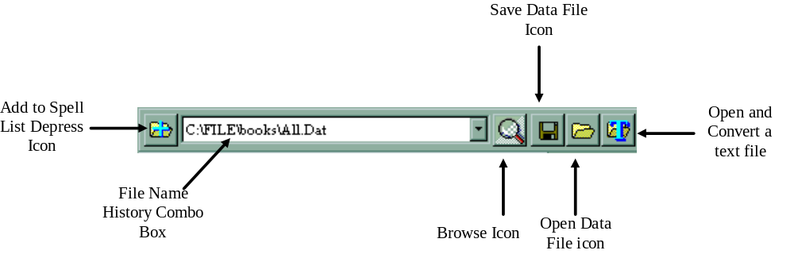
The first time you run winspell, the File Name combo box will be empty. So either use the browse icon, to look for the datafile which comes with the program, or open and convert a text file you exported or created.
After that is done, choose a datafile from the list, and it will be automatically opened.
Pressing the Save icon, will save the datafile, currently selected in the File Name History Combo Box.
Pressing the Open icon, will open the datafile, currently selected in the File Name History Combo Box.
When you exit the program, you will be prompted if to save the datafile or not. Saving it will save it under the name of the file currently selected in the File Name History Combo Box.
Press down the Add to Spell icon, to open another datafile, and add its spells to the current list. You can then save it under the same name, or choose the browse icon, and enter a new filename, press OK, and then the Save icon. This way you can merger a few datafiles into one. Notice that spellbook files will not be merged.

Working With The Spell List
The spell list window looks like this:
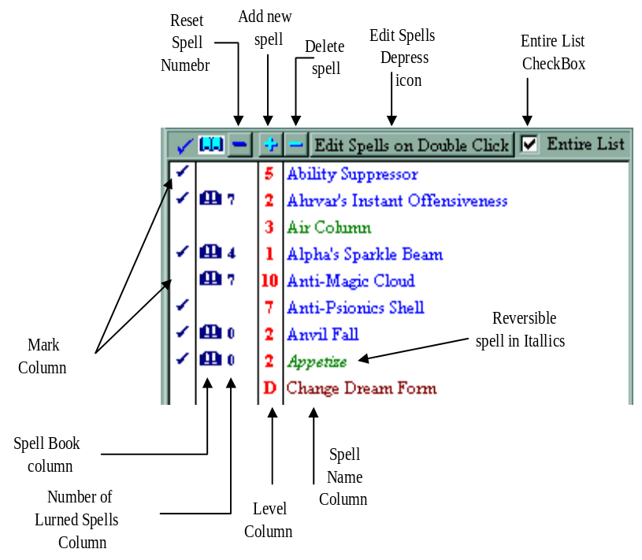
Wizard spells are in Blue, Priest spells are in green, and Psionic Powers in Marron. The level is C (Cantrip), D (Devotion), S (Science) and I (Info).
The ü appears near a spell, when you mark it, by clicking once in the mark column. You unmark the spell by clicking again.
The & appears near a spell, in the spell book column, when you click in that column, and only if a book is selected in the Spell Book combo box. In addition, a Zero or Number appears near the book, indicating how many spells are learned. Pressing on the Number with the Left mouse button, will increase the number by one, while pressing with the Right mouse button, will decrease the number by one.
Pressing the Reset Spell Number button, will reset all spells of that spellbook to Zero.
Click on a spell name, to see the info about that spell in the quick view window. If You don't see it at the moment, click on the  icon (Top right), to bring it to the front.
When the Edit Spells On Double Click icon is up, when you double click the lits, you will get a permanent quick view window with that spell. When it is down, you will be able to edit the spell.
The Entire List checkbox is explained under The minimizing/sort technique.
In the quickview window, in the bottom left part, you have a small icon, which is depressed. When down the spell description will be shown.

The Minimizing/Sort System
All the icons regarding the minimizing/sorting of the spell list are located just above the spell list.
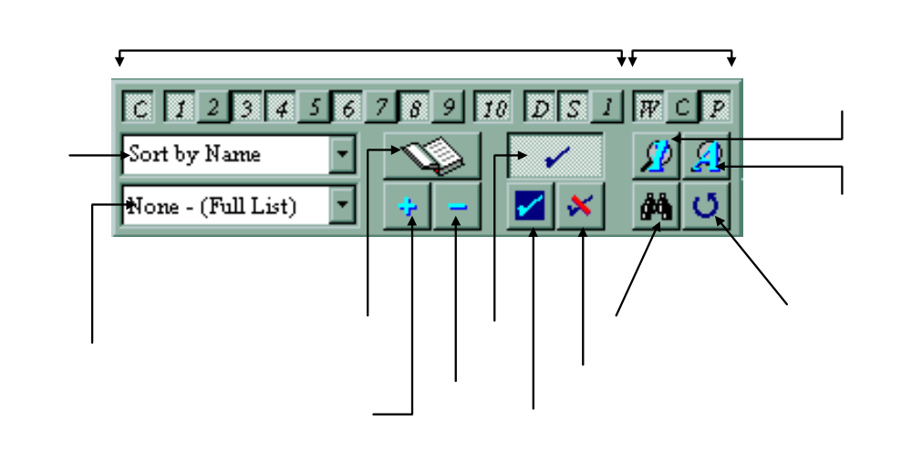
All the Level, Spell Type, Mark, Spell Book icons can be either pressed, or not. When down, it means that spells of that level, type, marked spells, or spells in the current book, will be shown.
The Show Only icon, when down, enables you to choose only 1 spell level. The Show All icon, depresses all level & spell type icons. (it is enabled only when the Show Only icon is up).
The Mark icon, when down, will leave only marked spells on the list. The Mark icon can only be down, if at least 1 spell is selected. The Reverse Mark icon will make unmarked spells marked and marked spells unmarked. The Unmark icon, removes marking from spells in all the list (not just spells currently showing).
The Spell Book icon will leave only spells of the book selected in the List of Books combobox. To first use this icon, you must create at least one new book, and select at lease one spell for it. To create a book, press the Add Book icon, enter a book name (one that doesn't exist), and press OK. Notice that the book will now appear in the List of Books combo box. To remove a book from the list, select it in the list, and press the Delete Book icon.

Minimization Routine:
- Push down any level icons you want shown.
- Push down the spell types icons you want shown.
- If you have marked spells, and want only them to be seen, press the Mark icon.
- If you want only spells of a specific spell book shown, select the spell book in the List of Books, and then push down the Spell Book icon.
- Select the sorting technique in the Sorting Technique combo box: By Level (first by level, and then in each level by name), By Name (normal alphabetical order), By Type (Wizard spells, Priest Prayers, Psionic Powers, by name), By Type By Level (In each type, sorts by level).
- Check or Uncheck the Entire List checkbox, meaning that the minimization/search will work on the current list (when unchecked), instead on the full list (When Checked).
- Press either on the EXE icon, to execute the minimization, or press the Search icon, to first search for a string and then minimize the list, from those spells who matched the search. You will get a message regarding the minimization, and then either the you will get the matching spells or, if no spells match, then the full list will be shown.

Editing Spells
You can now easily edit spells, by pressing down the Edit Spell on Double Click icon, and double clicking the spell you want to edit. You will then get the edit form.
The top part consists of 4 buttons, which decide the type of spell you are editing. You can change the type anytime, by pressing the appropriate button. Notice that part of the screen, and editing options will change according to the type of spell.
Notice that most input areas, have comboboxes, which enable you to either choose one of the items in the list, usually items which are most used to fill that part, or just enter the text you want to fill in.
The only different fillouts that are select only are the Level Combobox and the Sphere/School/Discipline select fields.
In the Level combobox, simply select the level you want for the spell/psionic power.
The Sphere & School areas:
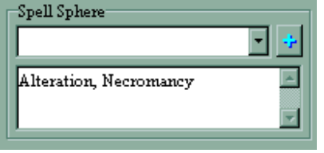
The top combo box holds a list of used schools/spheres, as in the TOME OF MAGIC. you select one from that list and then press the '+' icon to add it to the edit area. You can however, simply write directly in the edit area.
The Discipline combobox is select only, as there can be only one discipline for each psionic power.

To make a spell Reverisble depress the Reverse icon.
Fill in the Description box, and then either press the OK icon, to accept changes to the spell, or Cancel to abort.
Printing and Exporting Text Files

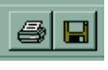
Use these 2 icons to print or save a text file (in the format mentioned in Opening and Saving Data Files). Once pressed you will get either the save or print form.
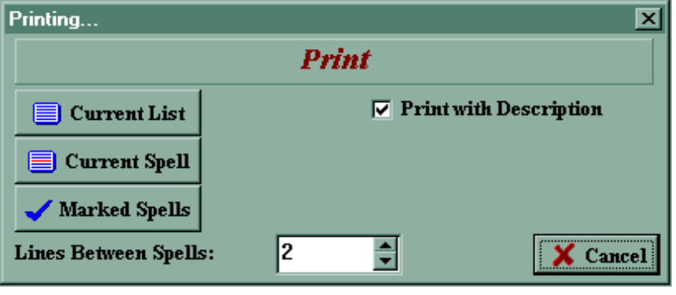
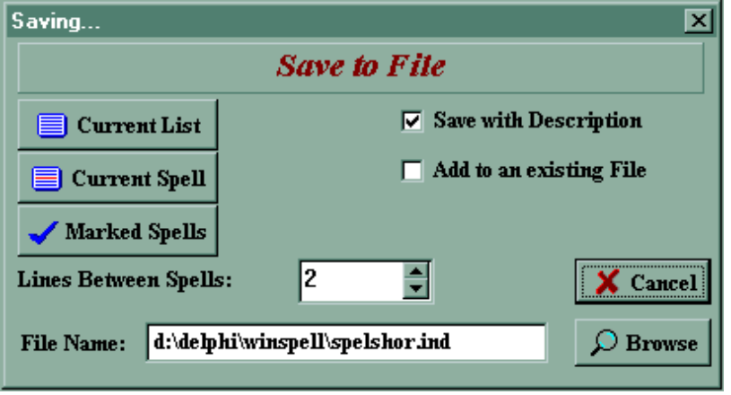
Before printing:
- Check or uncheck the Print/Save with Description check box, to print or save the file with spell description or as a spell list.
- If you are saving to file, then choose if you want to append to an existing file.
- Enter the number of empty lines between each spell (this option is only available when the save/print with description is checked).
- If you are saving to file, use the Browse to look for a file, or simply enter a different file name.
- Press either one of the 3 icons:
- Current List: Saves/Prints spells in the list, which is currently showing, sorted in the exact same way.
- Current Spell: Saves/Prints current spell.
- Marked Spells: Saves/Prints only marked spells in the current list.
Changing Colors and Fonts
To change the colors of text and windows (The quickview windows) or the fonts in the description and spell list, click on the  icon in the middle top icon bar.
Change the colors by clicking on the coloured pannels, and choosing the color you want.
Change the font by choosing the right font in either of the Comboboxes, and the size for the description.
Press the OK key when done.

