# Sections:

1. Vault setup & Secret creation in vault
2. Testing the config server & Vault integration
3. MongoDB set up & Secret creation
4. Testing config server with MongoDB + Vault

# 

# **Section # 1:** Vault Set up:

Prerequisite:

1. Install & kick start vault server -dev

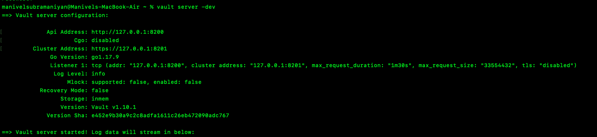

2. Create secret in vault:

Create the secret in vault using the below sample command in mac / windows terminal

vault kv put secret/gateway db-uname=db-name-dev-vault db-pw=db-pw-dev-vault

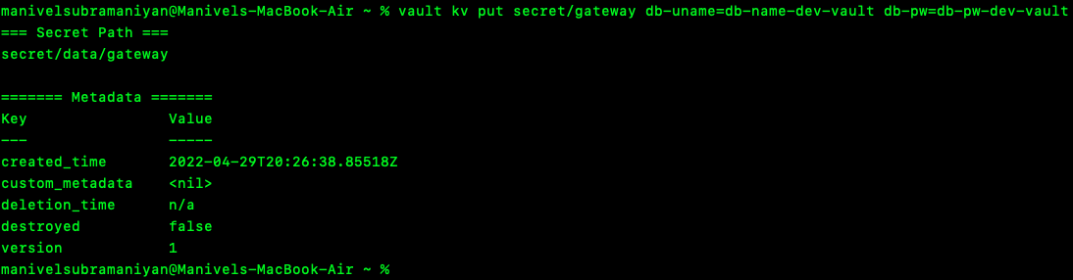

3. Verify the secret in terminal:

Verify the newly created secret in terminal using the command : vault kv get secret/gateway

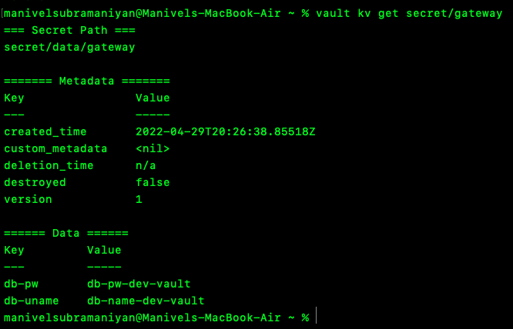

4. Verify the secret in UI (Optional)

Navigate to the URL: <http://localhost:8200/ui/>

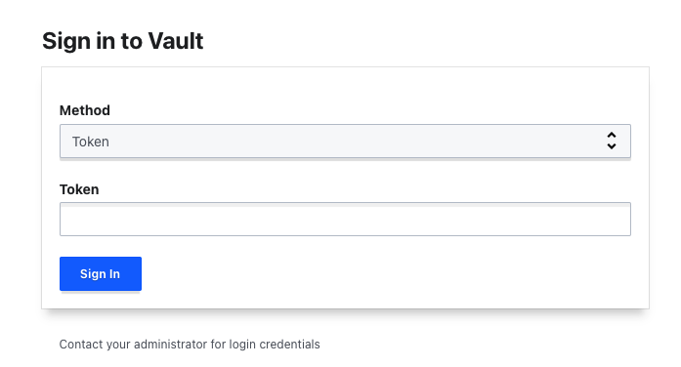

Enter the token (Token will be generated when we start the vault server)

Check the secret created for the application ‘gateway’ in the UI as mentioned below.

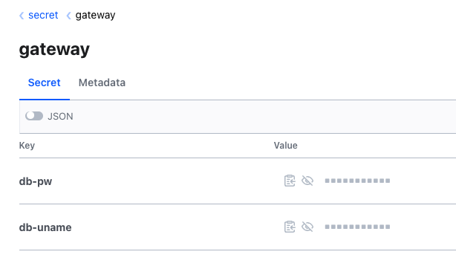

**Section # 2: Test the config-server & Vault Integration in postman**

1. Clone the github project in your local
2. <https://github.com/gsmanivel/config-server-vault-mongodb>
3. Run the project
4. Open postman
5. Make sure vault server is running
6. Make sure spring boot config server project is running
7. Create a request in postman using the endpoint : <http://localhost:8081/gateway/dev/>
8. Below response should be displayed in postman

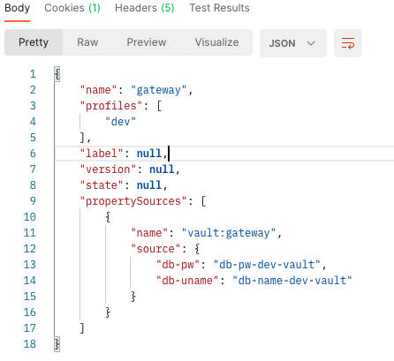

**Section # 3 ; MongoDB Setup & Secret Creation**

1. Install mongodb in your machine and start it
2. Install mongoDB Compass
3. Create a db called **manman**
4. Create a collection with name **gateway**
5. Create a document as mentioned below

{

"name": "gateway",

"label": "master",

"profile": "dev",

"source": {

"db-uname": "db-name-dev",

"db-pw": "db-pw-dev"

}

1. Note : If you create Database and Collectoin with different names , then you have to change that in the config-server project in the below places

src/main/resources/application.yaml – > line # 9 (DB-Name)

src/main/java/configserver/valutwithmongo/configuration/MongoEnvironmentRepository.java -> Line # 38 (Collection Name)

1. Open Postman and test using the below endpoint
2. <http://localhost:8081/gateway/dev/master>
3. You should get the response along with vault

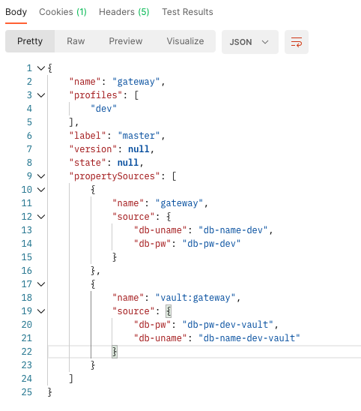

Need discussion on :

Query # 1:

<https://cloud.spring.io/spring-cloud-static/spring-cloud-config/2.0.1.RELEASE/single/spring-cloud-config.html#_multiple_properties_sources>

In the above link, please find Section : ​​2.1.4 Vault Backend

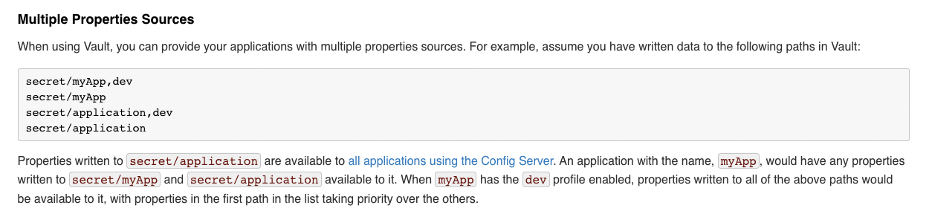

**Question**: They have mentioned how to use a profile. I am not able to implement that part

Query # 2

Scenario # 1: When you use the endpoint <http://localhost:8081/gateway/dev/master> , we will get combined response (MongoDB + Vault)

**Question:**

In the response payload to the above request,

Response for MongoDB portion is working expected

Response for Vault portion - We don't have a dev profile & master label for Vault. But still we get responses ?.

**Question:**

You will get the same response for all the below requests.It expects any string after the **gateway/ . we need to discuss this part**

[http://localhost:8081/gateway/dev](http://localhost:8081/gateway/dev/master)

<http://localhost:8081/gateway/default>

<http://localhost:8081/gateway/s>

<http://localhost:8081/gateway/asdsad>