WEEK 1 INTERNSHIP REPORT

DATA ACQUISITION, CLEANING AND PREPROCESSING

Dataset: Census Income Dataset

Submitted by: Manjot Kaur

Tools Used: Python, Pandas, NumPy, Matplotlib, Seaborn and Visual Studio Code

Dataset Source: UCI Machine Learning Repository

Project Objective: To acquire, clean and preprocess a public dataset using Python.

1. Introduction
Data is an important part of decision-making and analysis. However, real-world datasets may contain missing values, duplicate records, inconsistent entries, and extreme values that can affect the accuracy of analysis.
Data cleaning and preprocessing are essential steps in preparing a dataset for further analysis. These processes help improve data quality, consistency, and usability.
In this project, the Census Income dataset from the UCI Machine Learning Repository was used. The project involved loading the dataset into Python, exploring its structure, checking data quality, identifying potential outliers, handling duplicate records, and converting categorical variables into numerical form.
Python libraries such as Pandas and NumPy were used for data handling and preprocessing. Visual Studio Code was used to write and execute the Python script.

2. Objectives
The main objectives of this project were:
1. To acquire a public dataset from a reliable source.
2. To explore the dataset's rows, columns, and data types.
3. To identify missing values and duplicate records.
4. To identify potential outliers using the Interquartile Range (IQR) method.
5. To handle selected data quality issues.
6. To convert categorical variables into numerical form using one-hot encoding.
7. To save the cleaned dataset as a CSV file.
8. To compare the dataset before and after preprocessing.
9. To document the process, challenges, and results.

3. Dataset Source and Data Acquisition
3.1 Dataset Source
The dataset used in this project is the Census Income Dataset, obtained from the UCI Machine Learning Repository. It is a publicly available dataset commonly used for data analysis and machine learning tasks.
Dataset Name: Census Income Dataset
Source: UCI Machine Learning Repository
Dataset ID: 20
Dataset Link: https://archive.ics.uci.edu/dataset/20/census%2Bincome
3.2 Dataset Description
The Census Income Dataset contains demographic and employment-related information about individuals. It includes attributes such as age, workclass, education, marital status, occupation, sex, hours worked per week, and native country. The target variable, income, represents the income category of an individual.
The original dataset contains 48,842 records and 15 columns, including input features and the target variable.
3.3 Data Acquisition Method
The dataset was acquired directly from the UCI Machine Learning Repository using Python. The ucimlrepo library was used to fetch the dataset by its ID. Pandas was used to store the dataset in a DataFrame for further exploration and preprocessing.
The following Python code was used:
from ucimlrepo import fetch_ucirepo
census_income = fetch_ucirepo(id=20)
df = census_income.data.original
The dataset was then examined to understand its structure, column names, data types, and data quality before performing cleaning and preprocessing operations.
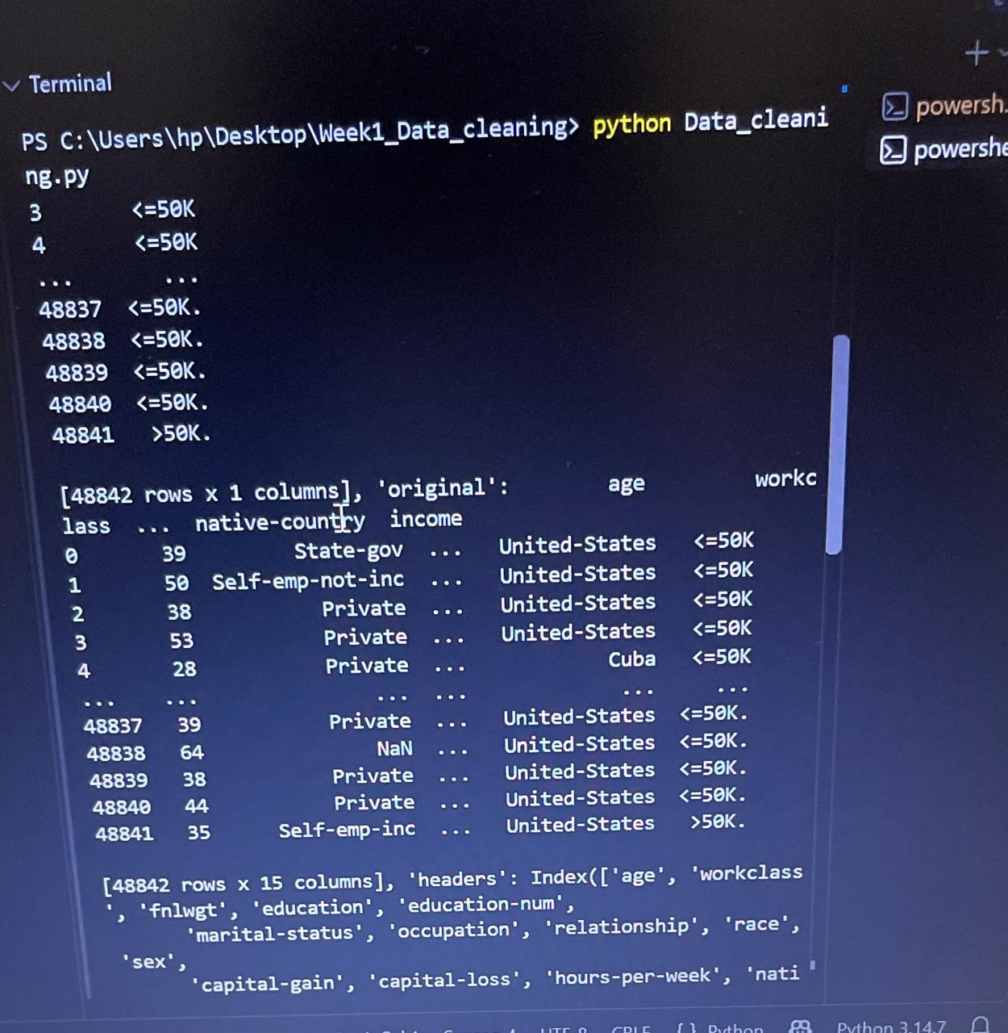
4. Tools and Technologies Used
The following tools and technologies were used to complete the data acquisition, cleaning, and preprocessing task.
1. Python
Python was used as the main programming language to load, explore, clean, and preprocess the dataset.
2. Pandas
Pandas was used to store the dataset in a DataFrame, examine rows and columns, check missing values and duplicates, handle numerical data, and save the processed dataset as a CSV file.
3. NumPy
NumPy supports numerical operations used in data processing and analysis.
4. Matplotlib and Seaborn
These libraries are useful for creating charts and visualizing data. They were included among the project tools for potential data visualization.
5. UCI ML Repository and ucimlrepo
The UCI Machine Learning Repository provided the dataset. The ucimlrepo Python library was used to fetch the Census Income Dataset.
6. Visual Studio Code
Visual Studio Code was used to write, edit, and execute the Python script.
7. CSV File
The processed dataset was saved in CSV format as cleaned_census_income.csv for future use and analysis.

5. Dataset Exploration
Before cleaning the dataset, an initial exploration was performed to understand its structure and contents. This step helped identify the number of records, column names, data types, and possible data quality issues.

5.1 Loading the Dataset
The dataset was loaded into a Pandas DataFrame using the ucimlrepo library.
from ucimlrepo import fetch_ucirepo
census_income = fetch_ucirepo(id=20)
df = census_income.data.original

5.2 Checking the Dataset Structure
The following commands were used to examine the first five records, dataset dimensions, and column names.
print(df.head())
print(df.shape)
print(df.columns)
The original dataset contained 48,842 records and 15 columns. The columns included demographic and employment-related attributes, along with the income category.

5.3 Checking Data Types and Summary Statistics
The data types of the columns were examined to understand which columns contained numerical or categorical information. Summary statistics were also generated for numerical columns.
print(df.dtypes)
print(df.describe())
This exploration helped identify the types of data present and provided an initial understanding of numerical ranges and distributions before cleaning and preprocessing.

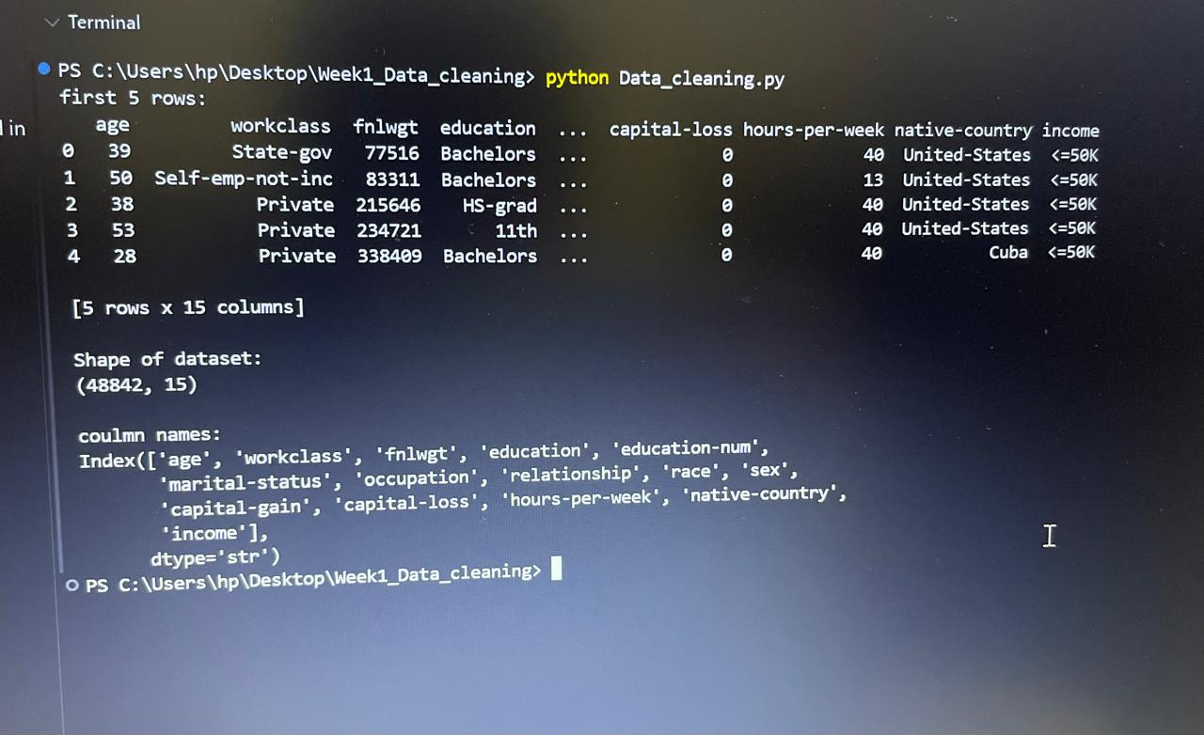
6. Missing Values Analysis
Missing values are entries that do not contain a recorded value. Identifying missing values is an important step in data cleaning because they can affect the quality and reliability of data analysis.

6.1 Identifying Missing Values
The following Pandas command was used to count missing values in each column.
print(df.isnull().sum())
The output showed missing values in the following columns:
- Workclass: 963
- Occupation: 966
- Native-country: 274
The other columns showed zero missing values in this check.

6.2 Importance of Missing Value Analysis
Missing values were examined to understand which columns required attention during preprocessing. In a complete cleaning process, missing entries should be handled using a suitable method, such as replacing them with an appropriate value or removing affected records when justified.
The missing-value check provided an initial assessment of data completeness before further preprocessing.

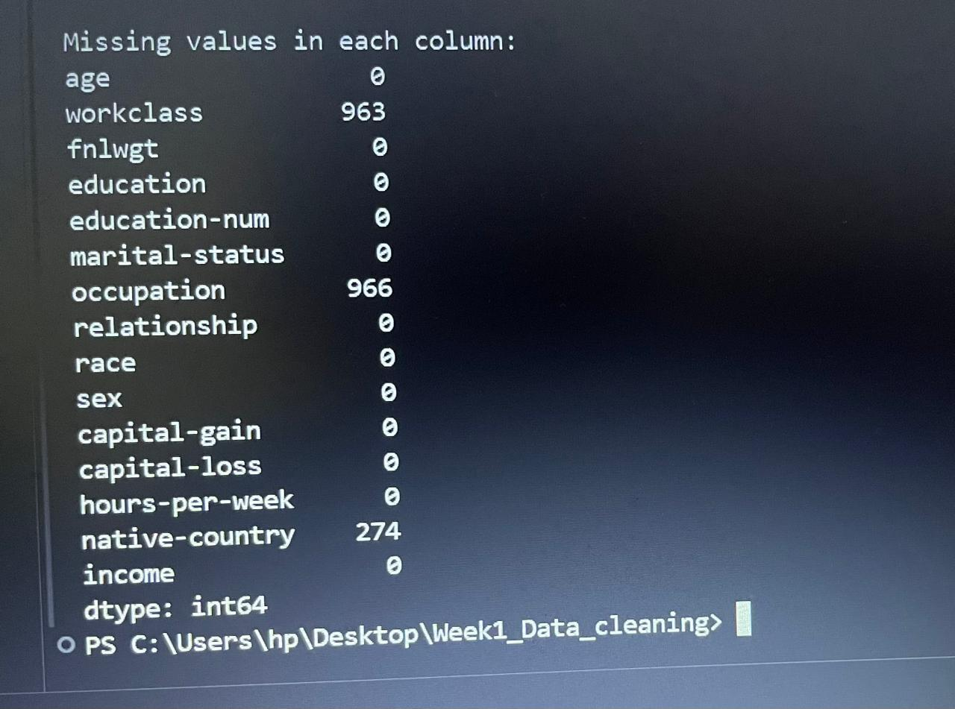

7. Duplicate Records Analysis
Duplicate records are repeated rows in a dataset. They may affect data analysis by counting the same observation more than once. Therefore, duplicate records were checked and removed during the data preprocessing process.

print(df.duplicated().sum())
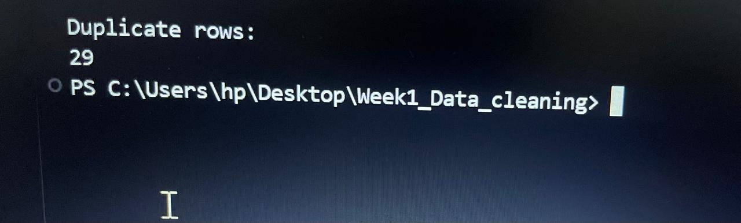
8. Outlier Detection and Handling
Outliers are data values that differ significantly from other observations in a dataset. They may represent genuine extreme values or unusual observations. In this project, the Interquartile Range (IQR) method was used to identify potential outliers in selected numerical columns.
The IQR is calculated by subtracting the first quartile (Q1) from the third quartile (Q3). Values below the lower bound or above the upper bound are identified as potential outliers.
The bounds are calculated using the following formulas:
- IQR = Q3 − Q1
- Lower Bound = Q1 − 1.5 × IQR
- Upper Bound = Q3 + 1.5 × IQR

Q1 = df[column].quantile(0.25)
Q3 = df[column].quantile(0.75)
IQR = Q3 - Q1

lower_bound = Q1 - 1.5 * IQR
upper_bound = Q3 + 1.5 * IQR

outliers = df[
(df[column] < lower_bound) |
(df[column] > upper_bound)
]
print(column, ":", len(outliers))
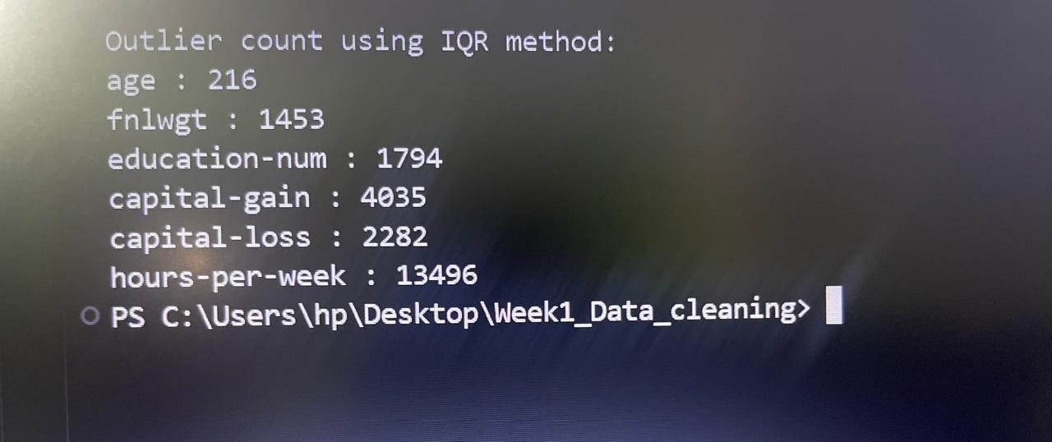
8.1 Handling Outliers Using IQR Capping
After identifying potential outliers, IQR capping was applied to the selected numerical columns. In this method, values below the lower bound were replaced with the lower bound, while values above the upper bound were replaced with the upper bound. This approach limits extreme values without deleting the corresponding rows from the dataset.

df[column] = df[column].clip(
lower=lower_bound,
upper=upper_bound
)
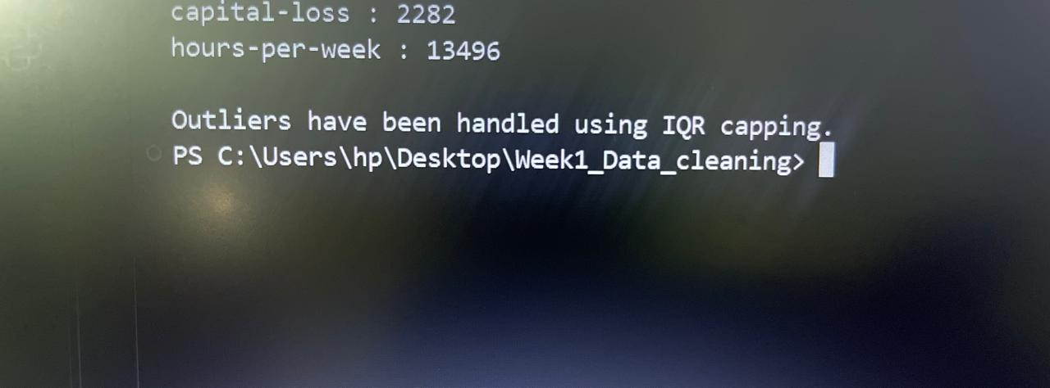

9. Categorical Data Encoding
Categorical data consists of values represented by labels or text, such as workclass, occupation and marital status. Many machine-learning algorithms require numerical input, so categorical variables need to be converted into numerical form.
In this project, One-Hot Encoding was performed using the Pandas library. This technique creates separate columns for categories and represents them using binary values. The drop_first=True option was used to omit one category from each encoded feature.
categorical_columns = df.select_dtypes(
include=['object']
).columns

df = pd.get_dummies(
df,
columns=categorical_columns,
drop_first=True
)
print("New shape of dataset:", df.shape)
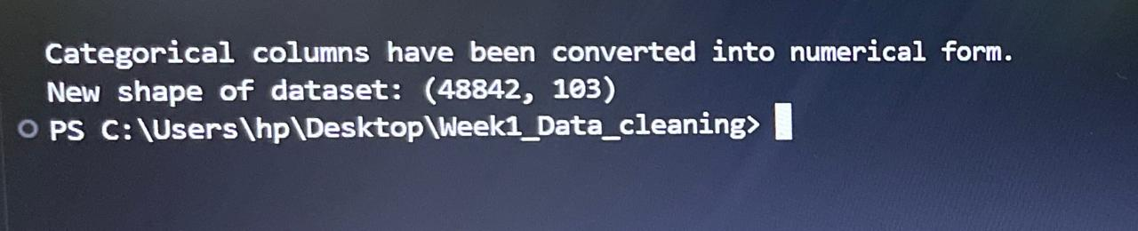
10. Final Dataset and Export
After the preprocessing steps, the processed dataset was saved as a CSV file named cleaned_census_income.csv. The CSV format makes the data easy to store, access and use in further analysis.
The dataset was exported using the Pandas to_csv() function. The index=False parameter was used to prevent Pandas from adding an extra index column to the output file.

df.to_csv("cleaned_census_income.csv", index=False)

print("Cleaned dataset has been saved successfully.")
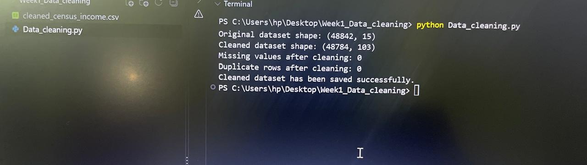

11. Before and After Comparison
The dataset was examined before and after preprocessing to review the changes made during the data-cleaning process. The comparison included the number of rows and columns, missing values and duplicate records. Categorical encoding increased the number of columns because text categories were converted into numerical indicator columns.
The final results should be verified using the actual output of the Python script. The comparison helps assess the changes made to the dataset during preprocessing.

print("Original dataset shape:", original_shape)
print("Cleaned dataset shape:", df.shape)
print("Missing values after cleaning:", df.isnull().sum().sum())
print("Duplicate rows after cleaning:", df.duplicated().sum())
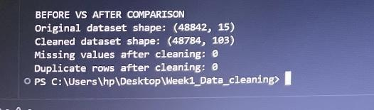

12. Challenges and Solutions
During the data preprocessing process, several tasks required careful handling:
1. Identifying Missing Values:
Missing values were checked using Pandas. The results were examined to identify columns requiring further attention.
2. Detecting Outliers:
The IQR method was used to identify potential outliers in numerical columns. IQR capping was applied to limit extreme values.
3. Handling Duplicate Records:
Duplicate rows were identified using Pandas and removed using the drop_duplicates() function.
4. Converting Categorical Data:
One-hot encoding was used to convert categorical columns into numerical indicator columns.
5. Verifying the Final Dataset:
The final dataset shape, missing-value count and duplicate count were checked to review the results of preprocessing.

13. Conclusion
This project provided practical experience in data acquisition, exploration, cleaning and preprocessing using Python. The Census Income Dataset was loaded from the UCI Machine Learning Repository and examined using Pandas.
The preprocessing workflow included checking missing values and duplicate records, identifying potential outliers using the IQR method, applying IQR capping, converting categorical variables into numerical form through one-hot encoding, and exporting the processed dataset as a CSV file.
Overall, the project helped develop an understanding of basic data-cleaning techniques and the importance of verifying data quality before performing further analysis. The final results should be checked against the actual program output before submission.

14. References
- UCI Machine Learning Repository. Census Income Dataset. https://archive.ics.uci.edu/dataset/20/census%2Bincome
- Pandas Documentation. Pandas: Python Data Analysis Library. https://pandas.pydata.org/docs/
- Python Documentation. Python Programming Language. https://docs.python.org/3/

