bamazon made and populated

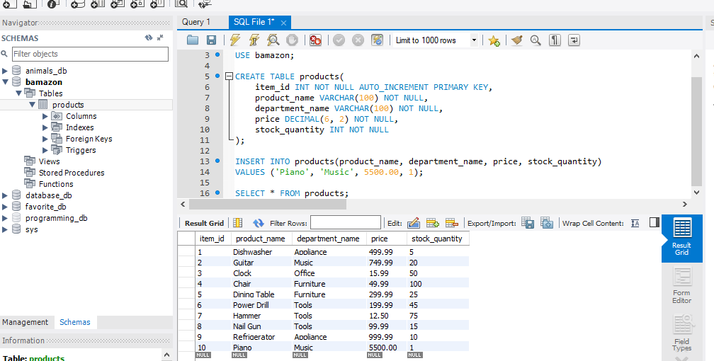

Running bamazonCustomer.js

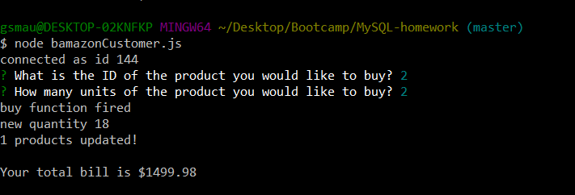

New table screenshot – notice the change in Guitar stock_quantity

