It is an error to use a section registered as allowDefinition='MachineToApplication' beyond application level. This error can be caused by a virtual directory not being configured as an application in IIS.

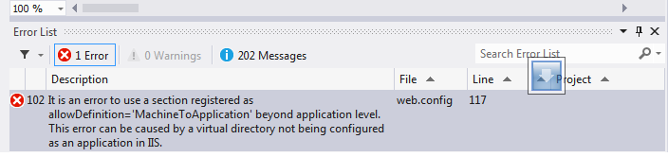

* Most likely you have nested web.config files. Remove or rename the one in a folder below or above your app. Most likely you have nested web.config files.  Remove or rename the one in a folder below or above your app.
* The IIS MMC has an application configuration section where you can set the folder as an Application root in the IIS MMC.

The error [It is an error to use a section registered as allowDefinition='MachineToApplication' beyond application level] does not occur only due to mis-configuration in web.config file.  The most important part we should care about is that the error mainly originates if we do not configure virtual directory. And you must notice that there is little bit difference in configuring [probabilités du poker](http://www.probabilites-du-poker.fr/) virtual directory in vista thatn in xp. Please search and apply the right method of publishing asp.net web project in asp.net.One more tip, is right version of asp.net enabled in your IIS? Please ensure this.Hope this helps. Please feel free to ask if any problem persists or if any help is required. Thanks.