Oracle Database

**19c**

**PL/SQL Fundamentals**

Oracle Database 19c PL/SQL Fundamentals - Installation & Setup Guide

This document provides a complete, step-by-step guide to setting up Oracle Database 19c (for PL/SQL), including SQL Developer and HR Schema. It also recommends using Oracle Developer VMs to simplify setup.

---

: Oracle Developer Day VM (All-in-One Setup)

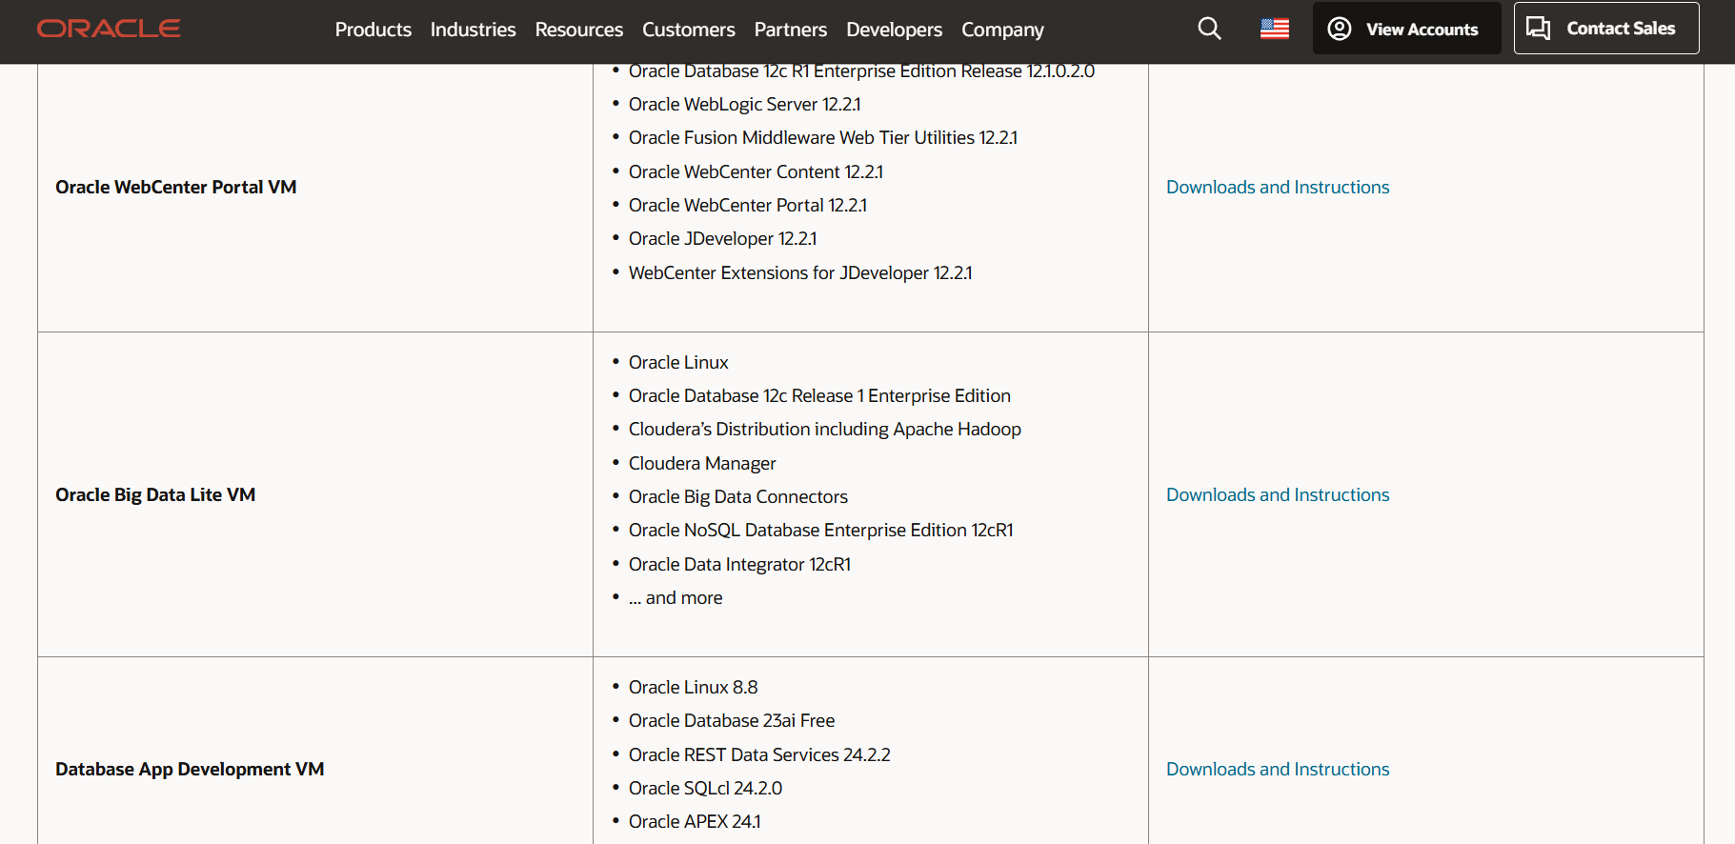

Oracle Developer Day VM includes:

- Oracle Database 19c

- SQL Developer preinstalled

- HR Schema preconfigured

- Oracle Linux OS

- Preconfigured users and services

Step-by-Step:

Step 1: Install Oracle VM VirtualBox

- Download: https://www.virtualbox.org

- Follow installation wizard to complete setup.

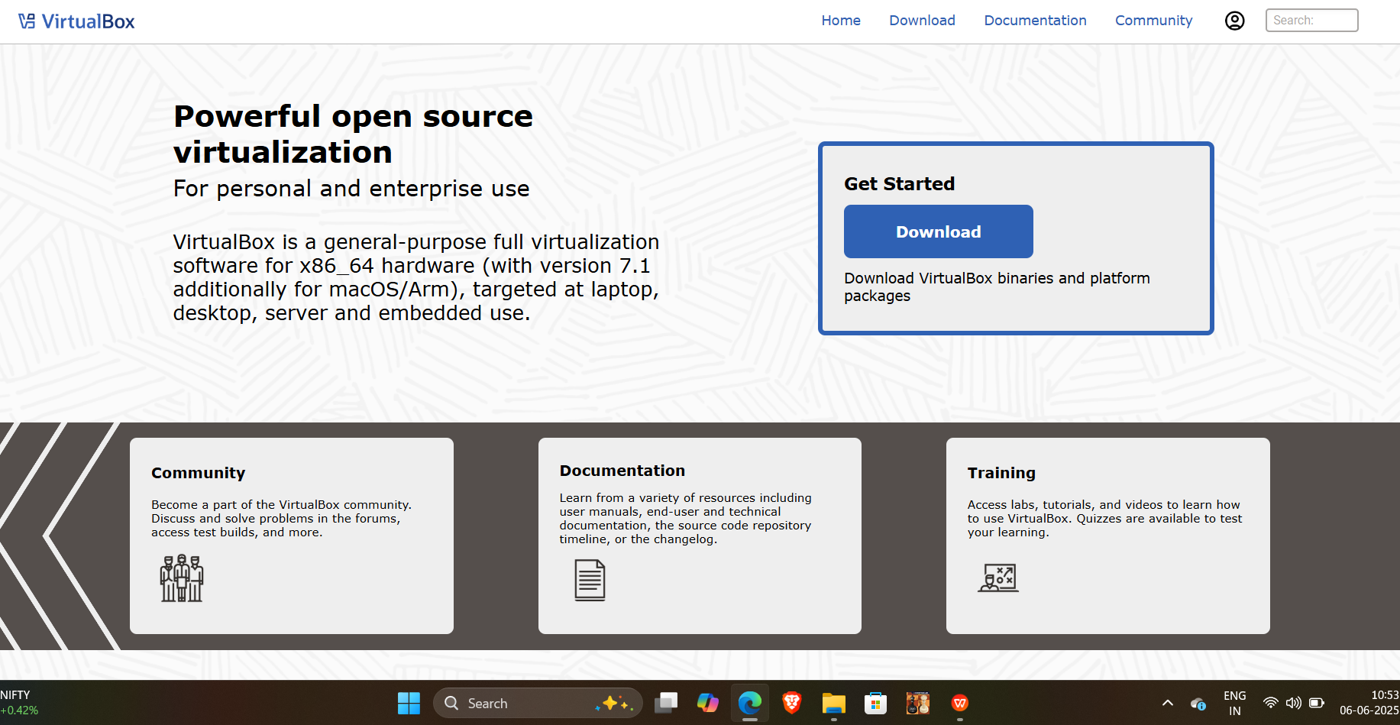

Step 2: Download Developer VM (OVA)

- Visit: https://www.oracle.com/downloads/developer-vm/community-downloads.html

- Download "Oracle Linux 8 Developer Day VM" OVA file.

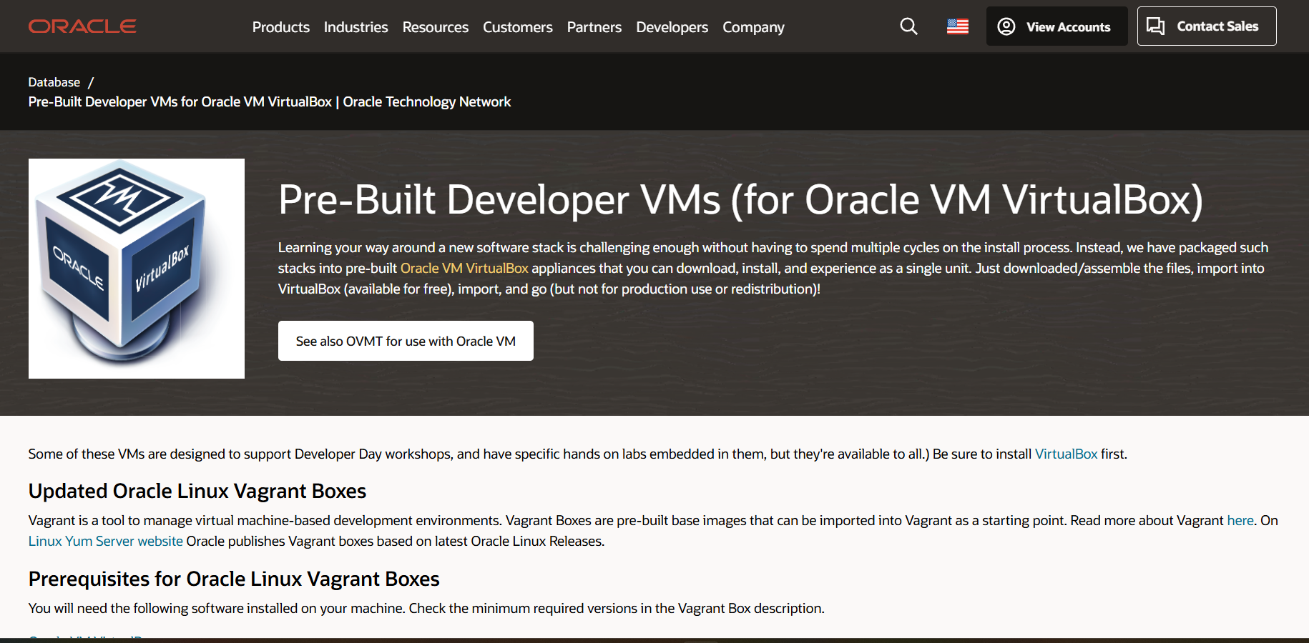

Step 3: Import OVA File into VirtualBox

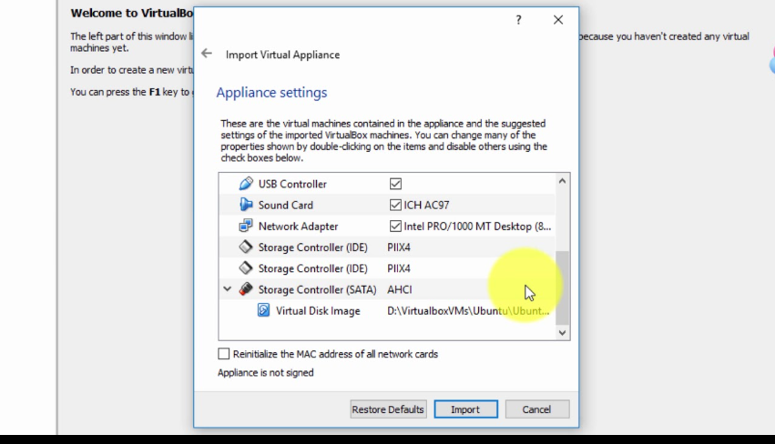

- Open VirtualBox > File > Import Appliance

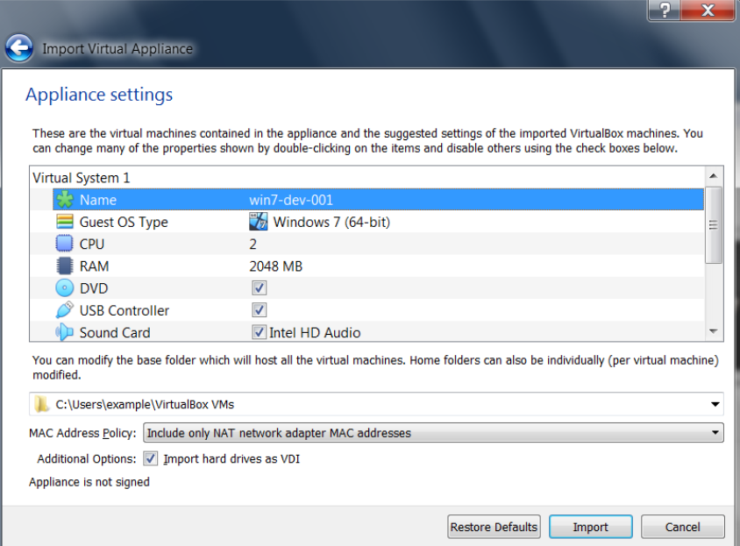

- Select downloaded `.ova` file > Proceed > Import

Step 4: Start the Virtual Machine

- Select the VM from VirtualBox list > Click "Start"

- Wait for it to boot into Oracle Linux desktop

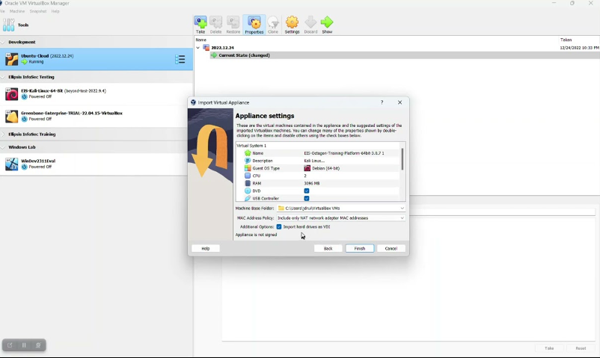

Step 5: Open SQL Developer and Connect to HR Schema

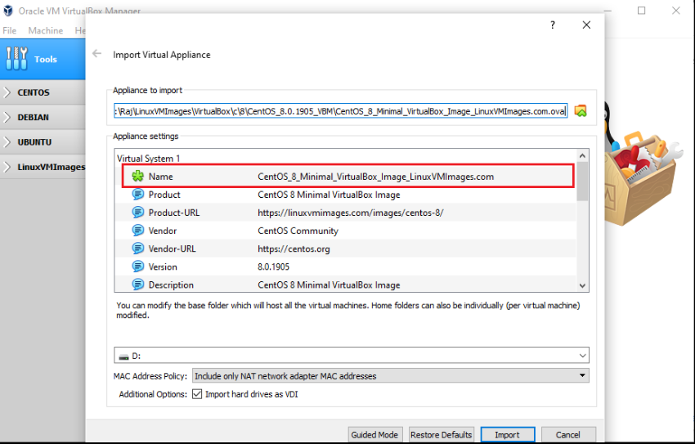

- Launch SQL

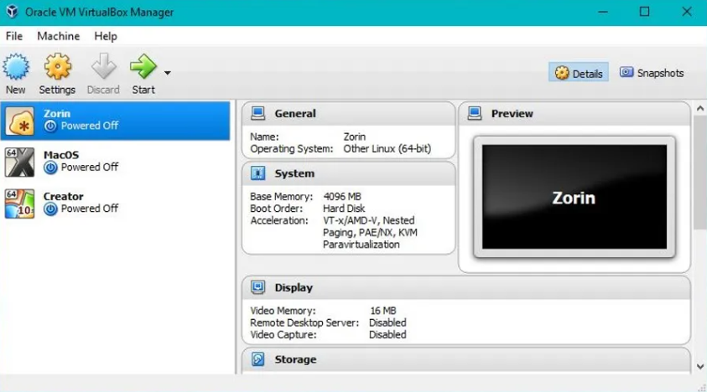

Developer (pre-installed inside VM)

- Create a connection with these details:

- Username: hr

- Password: oracle

- Hostname: localhost

- Port: 1521

- Service name: orcl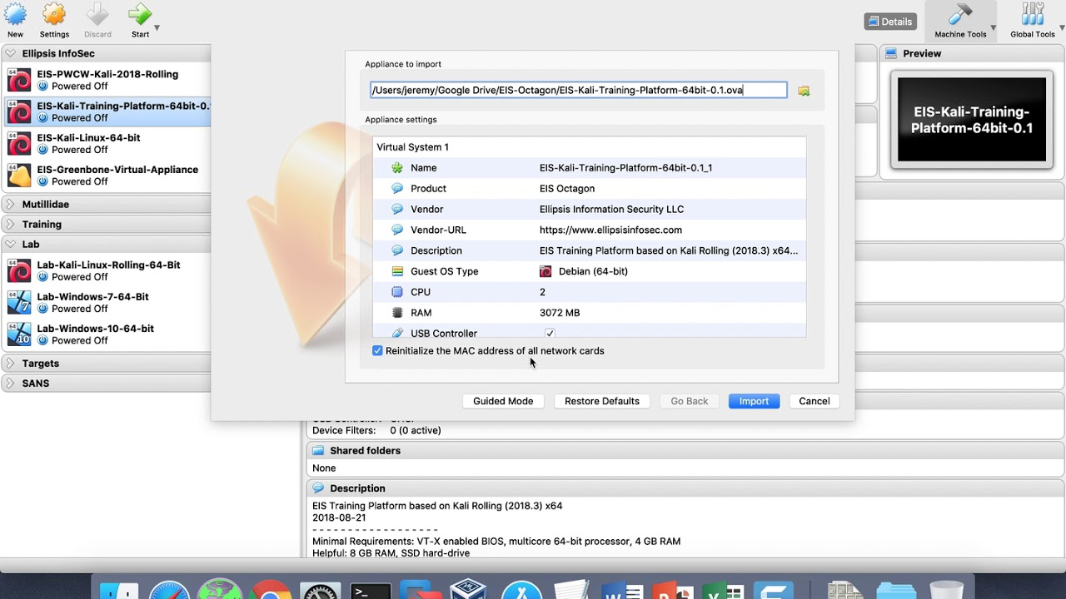

- Click Test > Connect

Now your environment is ready with SQL, PL/SQL, HR schema, and database tools.