Create a new repository on GitHub with any name [Assignment**-1**](https://github.com/gsnrobin/Assignment-1)

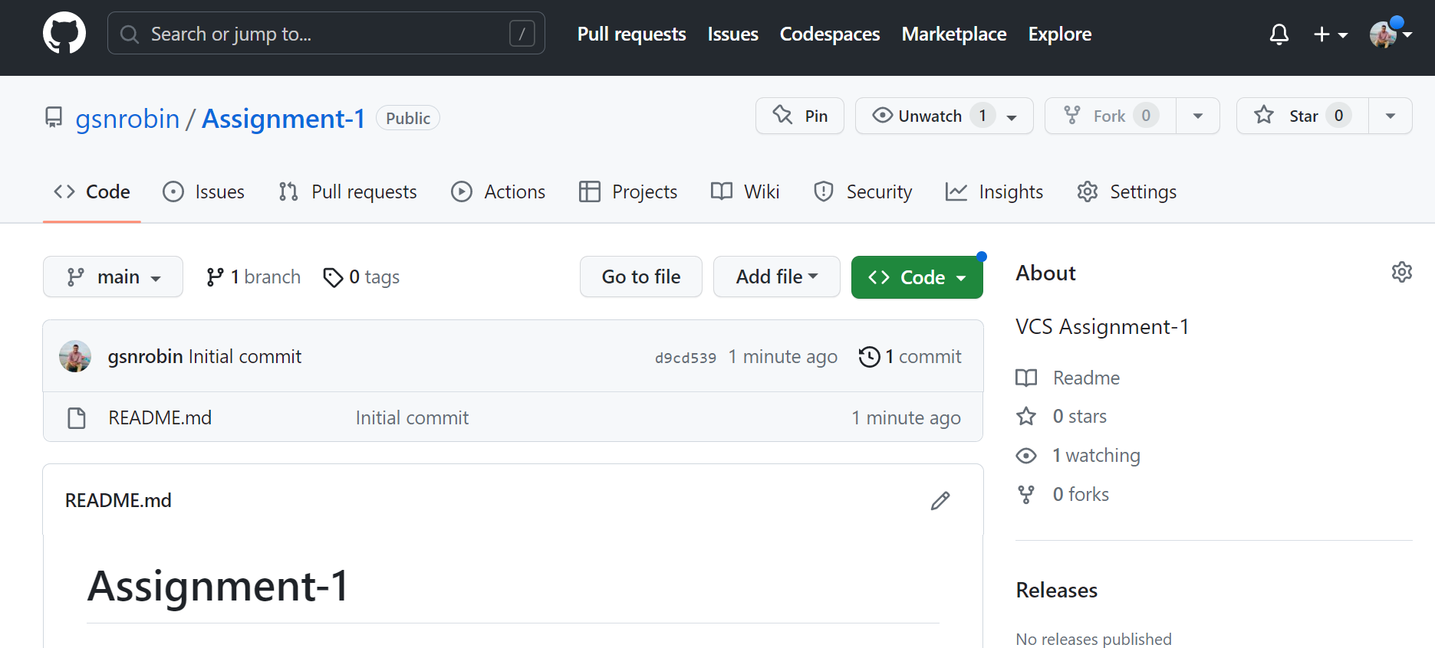

Clone the repository to your local machine.

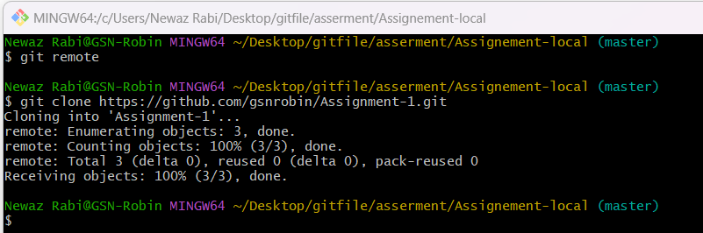

Create a file called "index.html

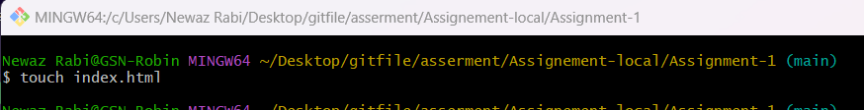

add some basic HTML code

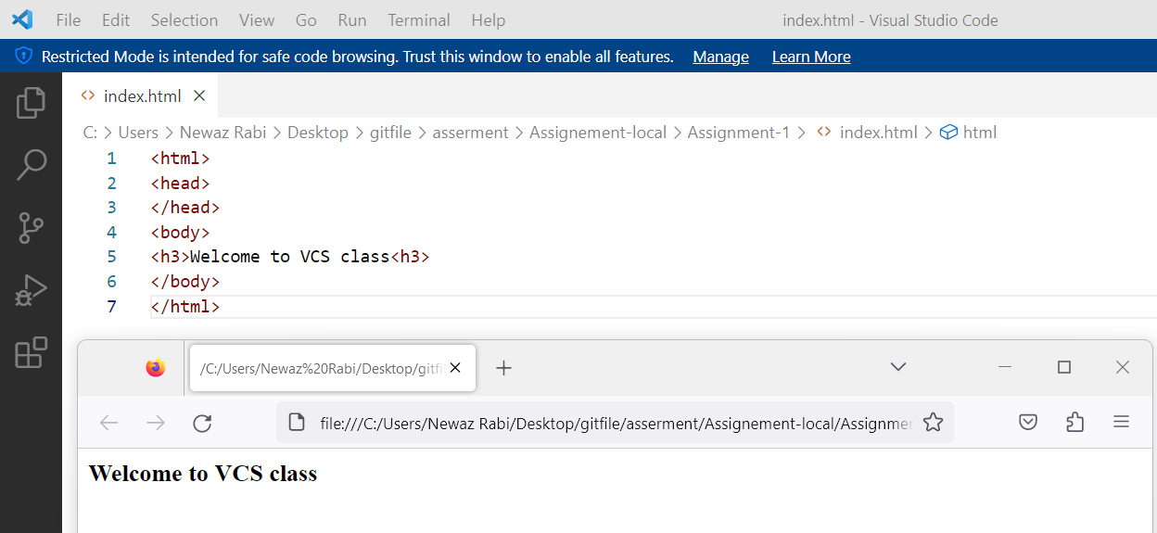

Initialize the local repository as a Git repository

Add the "index.html" file to the staging area.  
Commit the changes with an appropriate commit message.

L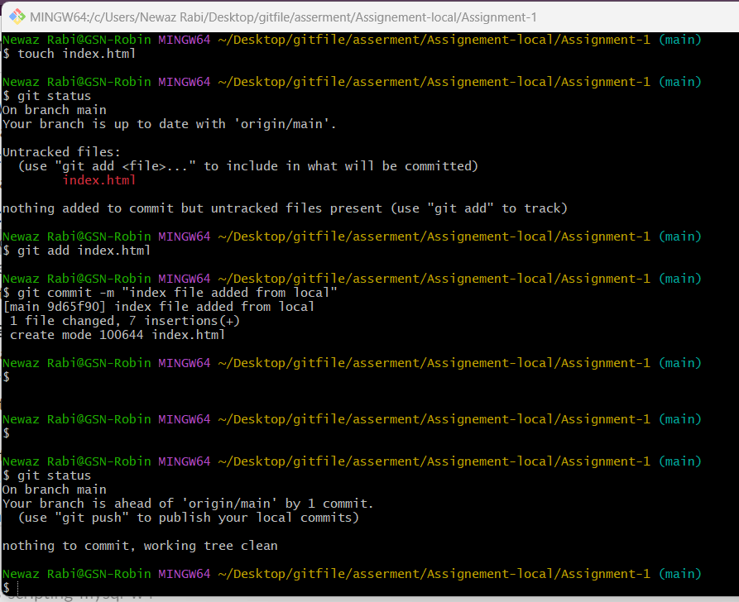

Create a new branch called "feature" and switch to it

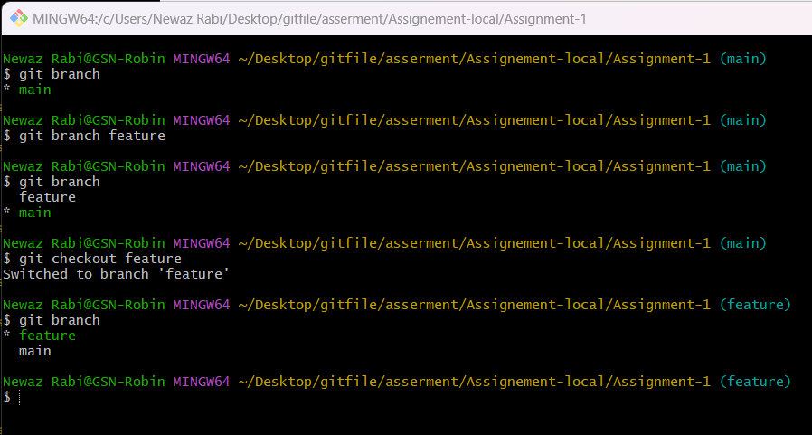

Modify the "index.html" file by adding additional content

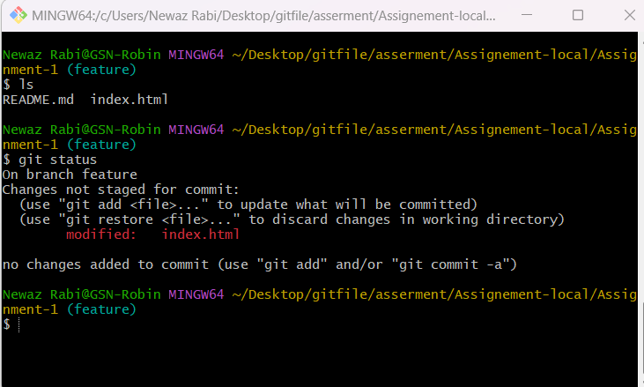

Commit the changes to the "feature" branch.

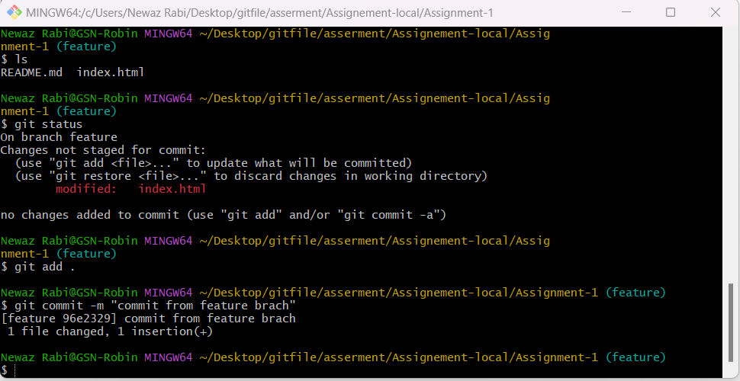

Merge the "feature" branch into the main branch

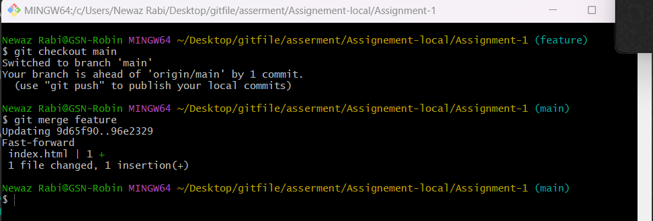

Invite a friend and [sanowertamjit@gmail.com](mailto:sanowertamjit@gmail.com) to collaborate on your GitHub repository

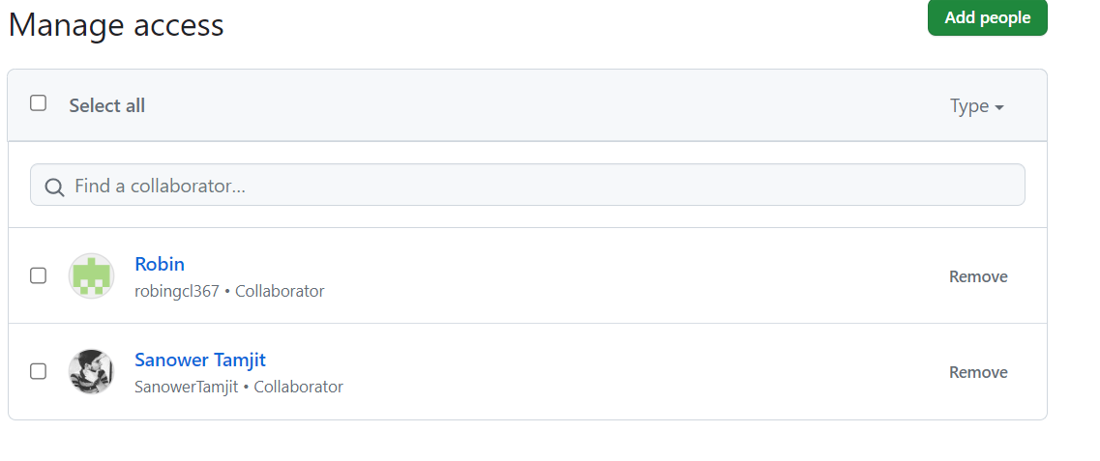

Have them clone the repository, create a new branch, make changes, and push them to the remote repository.

