# **Blinkit Analysis**

# Using SSMS (SQL SERVER MANAGEMENT SYSTEM)

1. 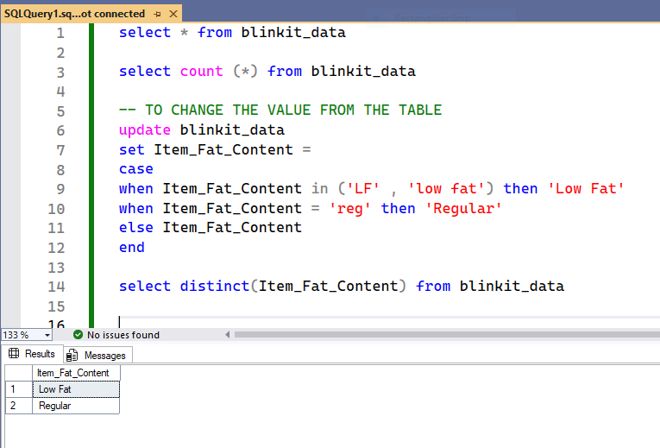To change the value from the table
2. 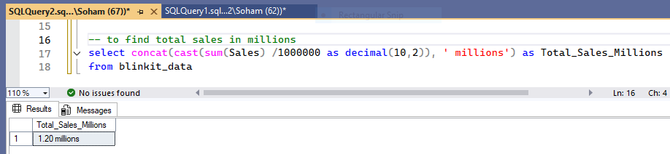To find total sales in millions
3. 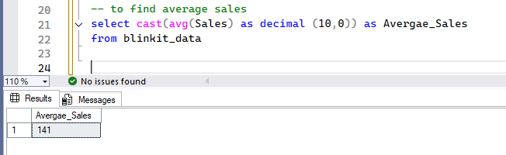To find average sales
4. Count no. outlets opened in year 2022

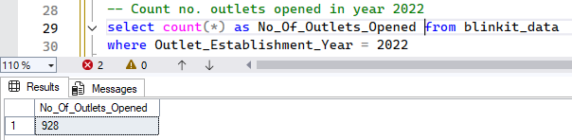

1. 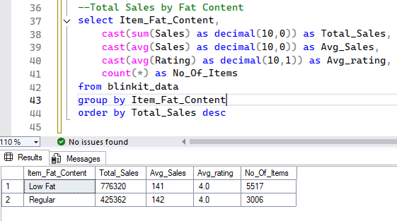Total Sales by Fat Content
2. 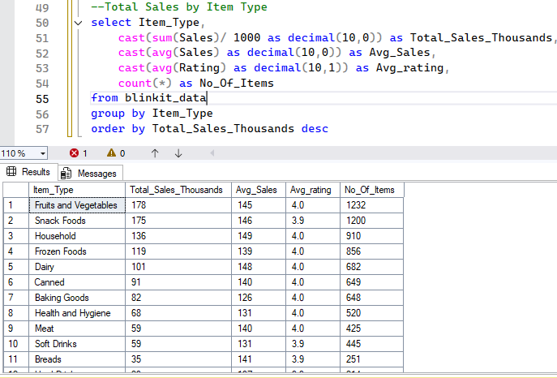Total Sales by Item Type
3. 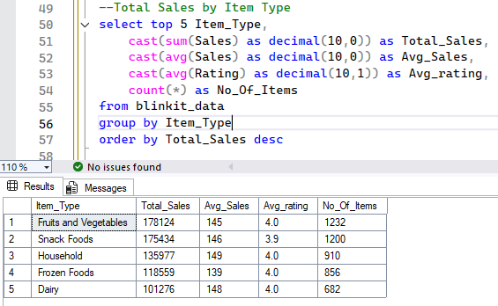Top 5 Sales Item
4. Total Sales by Outlet Establishment

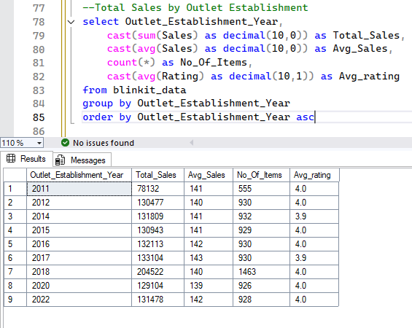

1. Percentage of Sales by Outlet’s Size

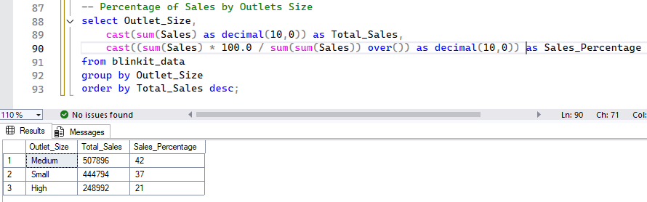Outlet’s Size are Small, Medium and Large

1. Sales by Outlet Location

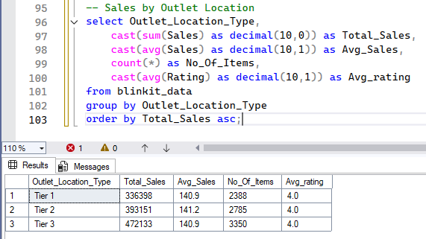

1. Sales by Outlet Location using WHERE clause

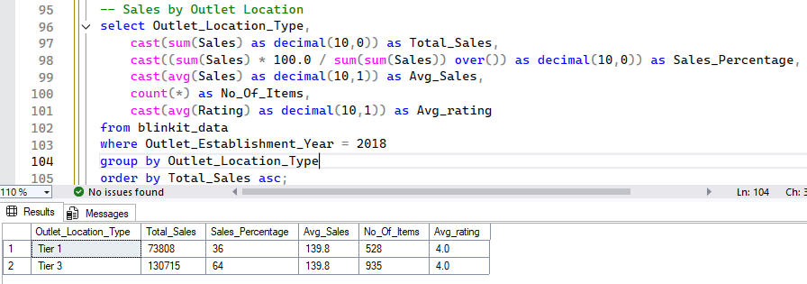

1. All Metrics by Outlet Type

