**C Sc 335 Analysis and Design Artifacts for Final Project**

**1. Team Name:**  __BulbaSquirtMander_________________________

**2. Project: _____Pokemon Safari Zone_______________________**

**3. Team Members**: ___Morgan__Henry____________ ___Gary Sousa____________________

______Brendon Hudnell_______ ___Stephen Nolan_________________

**4. Candidate Objects or Class Hierarchies**

List the most important objects, or an inheritance hierarchy name, and the single responsibility of each.

|  |  |
| --- | --- |
| **Candidate Object** | **Single Responsibility in 1 or 2 sentences** |
| Pokemon Abstract Class | Capture common Pokemon characteristics |
| Map | Contain game elements |
| Battle Screen | View/ GUI for Pokemon encounter |
| Pokemon Collection | Maintains caught pokemon |
| Item Collection | Maintains collected / stored items |
| Trainer | Coordinates activities / interacts with other objects |
| Item Abstract Class | Capture common item characteristics |
| Map Tile Enum | Contain tile characteristics |
|  |  |
|  |  |

**5. Sequence Diagram 1:** Your team UML Sequence Diagram should show the most important scenario you can think of. Your sequence diagram should show most of your objects from above and how they communicate with each other.

*This Sequence Diagram must be created with the sequence diagram editor* [https://www.websequencediagrams.com/#](https://www.websequencediagrams.com/)

*Export and Image and copy and paste it here*

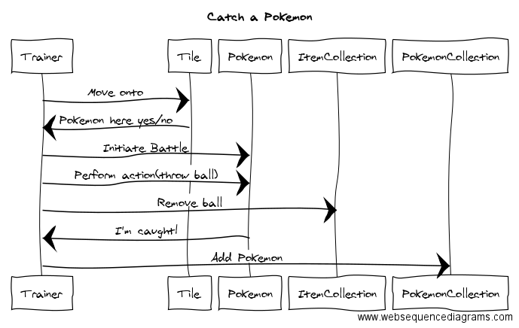

**6. Sequence Diagram 2:** Your team UML Sequence Diagram should show the seconf most important scenario you can think of. Your sequence diagram should show most of your objects from above and how they communicate with each other.

*This Sequence Diagram must be created with the sequence diagram editor* [https://www.websequencediagrams.com/#](https://www.websequencediagrams.com/)

*Export and Image and copy and paste it here*

