Demographics and Spending Habits of Heroes of Pymoli Users

Greg Spahlinger

Heroes of Pymoli is a free to play game, which makes its money using microtransactions. Through these microtransactions players can buy various items that enhance their in-game experience. In order to better understand how this business model is working, I have analyzed purchasing records to give insights into the spending behavior and demographic data of users. This is a brief report to explain the most important findings of that analysis.

Finding #1: Heroes of Pymoli Users are Mostly Young Men.

Analyzing sales data for gender and age group, I found very strong demographic biases. By age group, I found that users ranged from under 10 to mid-40s, but that almost half of users (44.79%) were between 20 and 24 years of age, with 15 – 19, and 25 – 29 being second and third most numerous respectively.

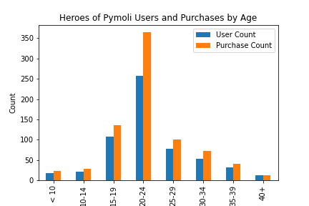

Figure1 – Most Users are in their Teens or 20s

In a similar analysis, users were grouped by gender (Male, Female, and Other / Non – Disclosed). We found that roughly 84% of users are male, while female users account for about 14% of the total. The remaining 2% are the other or non-disclosed users.

As can be seen from the histograms in Fig. 1 and Fig. 2, the number of purchases made by a group tracks relatively well with the number of people in that group. It does not appear that any particular subset of the user base accounts for an outsized proportion of the purchases.

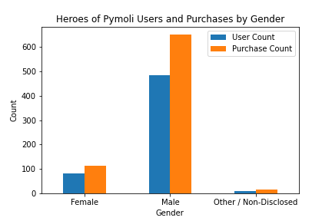

Figure 2 - Men Dominate the Userbase and Purchase Count

Finding #2 – Average User Spending is Consistent Across Demographic Groups

The total revenue generated by Heroes of Pymoli microtransactions to date is $2379.77. As you might expect, larger shares of that revenue were generated by the most populous demographic groups - $1967.64 by male users, and $1114.06 by users aged 20 – 24 years. Analysis of the average total expenditure (figure 3) shows that on average users in all demographic groups are spending between $3 and $5 total – so that finding is driven almost entirely by the number of users spending money, rather than the amount those users spend.

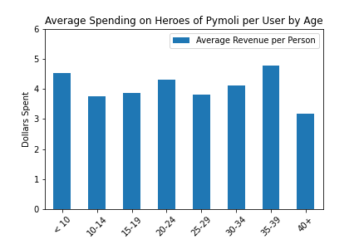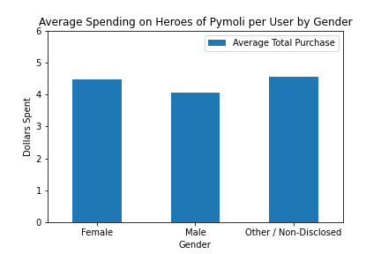

Figure 3 – Users Spend About the Same Amount Irrespective of Demographics

This conclusion is also supported by the stats on the biggest spenders. The top spender overall purchased a total of 5 items for a total price of $18.96, while the fifth largest spender bought 3 items for a total of $13.10. This tells you that the vast majority of users are buying 1 or 2 items and spending very modest amounts of money on the game.

Finding #3 – The Most Profitable Items are Both More Popular and More Expensive than Average.

When users enter the Heroes of Pymoli store, they have 179 unique items to choose from, at an average price of $3.04 per item. In our analysis we found that the average item sells between 3 and 4 times. Figure 4 shows a histogram with bins set by the number of sales for each item, which demonstrates this point. At the top level of popularity, 4 items have sold a total of 9 times, while the second most popular item sold 12 times and the most popular item (“Final Critic”) sold 13 times.

When one looks at the top six most profitable items, two of the most popular items (“Extraction, Quickblade of Trembling Hands”, and “Persuasion”) are no longer on the list. This is because these items are comparatively cheap ($3.53 and $3.22 respectively) and have been replaced by items that sold 8 times, but had prices over $4. The top 6 most profitable items had prices ranging from $4.23 to $4.90. These items have brought in between $33.84 and $59.99 each. Together, they earned $264.71, which means that the more typical items - and not the outliers - are bringing in most of the revenue.

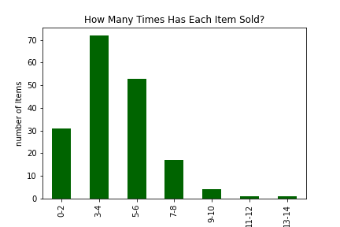

Figure 4 – The Average Item Sells 3 – 4 Times

Conclusions

Several conclusions are reached in this report. The first is that the user base of Heroes of Pymoli leans toward males and individuals who are in their late teens and early 20s. The purchasing habits of users are relatively consistent across the demographics studied. Most users spend a small amount of money on one or two items from the store. These users buy a wide range of items - the most profitable items are outliers which account for only about 10% of the overall revenue. The most profitable items are 1 – 2 dollars more expensive than the average though, and some are making more money than more popular items. This might suggest that a modest price hike could make a positive impact on revenue.